

FINAL YEAR PROJECT — INTERIM REPORT
Forest Restoration Using AI

Submitted by: Siddharth Choudhary
Matriculation Number: U2223021B
Supervisor: Prof Lee Yee Hui
Co-supervisor: Dr Ji-Jon Sit
Examiner: Prof Ding Zhiguo

School of Electrical & Electronic Engineering
Nanyang Technological University
AY2025/2026

Table of Contents
Chapter 1 Introduction 3
1.1 Project Background 3
1.2 Project Objectives and Scope 3
1.3 Project Timeline 5
1.4 Purpose of This Interim Report 5
Chapter 2 Work Done So Far 6
2.1 Dataset Overview 6
2.2 Data Cleaning Pipeline 7
2.3 Exploratory Data Analysis 8
2.4 Soil Moisture Drydown and Half-Life Analysis 14
2.5 Microclimate Driver Correlations 18
2.6 Challenges and Limitations 19
Chapter 3 Future Work 20
3.1 Remote Sensing Data Integration 20
3.2 Predictive Modelling 22
3.3 Final Report and Validation 23
Chapter 4 Conclusion 23
References 25
Abbreviations 25

Chapter 1 Introduction

1.1 Project Background
Singapore occupies a paradoxical position in terms of forest ecology. As one of the most densely developed nations in the world, it has retained less than 0.5% of its original primary forest cover — yet what remains is ecologically significant and actively studied. The Central Catchment Nature Reserve (CCNR), located at the geographic heart of the island, supports a mosaic of forest habitats spanning four successional stages: FT1 (open grassland and forest edge), FT2 (early secondary forest), FT3 (late secondary forest) and FT4 (mature primary dipterocarp forest). These stages represent a gradient of ecological recovery from human disturbance, each characterised by distinct canopy structure, species composition and — critically for this project — a distinct local microclimate.
Microclimate refers to the fine-scale atmospheric and soil conditions experienced within and immediately around a vegetation patch. In a tropical context, the variables of primary interest are air temperature, relative humidity (RH), vapour pressure deficit (VPD), photosynthetically active radiation (PAR) and volumetric soil moisture. These variables are not simply descriptors of an environment; they are direct drivers of plant physiology, seed germination, seedling survival and canopy water cycling. A primary forest plot in the CCNR is measurably cooler, more humid and darker than an adjacent grassland edge — and that difference has consequences for which species can survive there and how quickly a degraded patch can recover once planting begins. This relationship between forest structure and near-surface microclimate has been documented in comparable degraded tropical forest systems, where ground-level temperature and humidity conditions are shown to vary substantially with canopy cover and successional stage [1].
This project uses a network of microclimate sensors deployed across seven monitoring plots within the CCNR to quantify these differences systematically. The sensor data spans approximately 18 months of continuous hourly observations from August 2024 to February 2026, covering all four forest types. The analysis work completed to date focuses on characterising the microclimate of each forest type, understanding the dynamics of each measured variable across sites and laying the analytical groundwork for predictive modelling in the second semester.

1.2 Project Objectives and Scope
The central research question of this project is: can microclimate conditions in Singapore's forest types be modelled with sufficient accuracy to support data-driven reforestation planning? To address this, the project is structured around the following objectives:
- Develop a reproducible data cleaning and quality control pipeline for long-format, multi-parameter sensor data.
- Characterise the microclimate signature of each forest type and individual monitoring site through statistical and time-series analysis.
- Analyse soil moisture drydown dynamics — drying rates, half-lives and within-day variability — and relate these to forest type.
- Quantify the statistical coupling between microclimate variables at the overall and per-site level, identifying the most informative predictor variables for downstream modelling.
- Integrate airborne remote sensing data (LiDAR point clouds and multispectral imagery) to characterise canopy structure as an additional explanatory layer.
- Develop and evaluate predictive models for microclimate variables using leave-one-site-out cross-validation, with the aim of generalising to unseen locations.
- Apply validated models to support reforestation site assessments in the final semester.

The empirical scope of the project is defined by the CCNR sensor network. Seven monitoring plots — UP2 and US5 (FT1), CN2 (FT2), LP3 (FT3), and FT4MD, FT4MR and FT4TH (FT4) — provide hourly observations of five variables over the study period. The total cleaned dataset contains 725,852 records. Sensor coverage is not uniform: PAR and soil moisture instruments are absent or sparse at some plots, which constrains which analyses can be carried out at the cross-parameter level.
In addition to the sensor dataset, the project is in the process of integrating airborne remote sensing data from drone-based mapping missions carried out over portions of the CCNR in December 2024 and March 2026. This data will support canopy structural analysis and is described in the Future Work chapter.

1.3 Project Timeline
The project is carried out over two academic semesters. The first semester was focused on data preparation and exploratory analysis; the second semester will address modelling and the reforestation application.

Phase | Period | Key Activities
1 | Jan - Feb 2026 | Dataset acquisition and review, data cleaning pipeline development, exploratory data familiarisation
2 | Mar – Apr 2026 | Full exploratory data analysis across all five parameters, soil moisture drydown and half-life analysis, correlation analysis
3 | Aug – Sep 2026 | Remote sensing data integration (LiDAR and multispectral), canopy feature extraction, predictive model development and cross-validation
4 | Oct– Nov 2026 | Reforestation site assessment framework, final model evaluation, full report writing
Table 1: Project timeline by phase. Phases 1 and 2 are completed and documented in this report.

1.4 Purpose of This Interim Report
This report documents the work completed across Phases 1 and 2 — roughly the first half of the project. Its purpose is threefold: to demonstrate that the foundational analytical work has been carried out rigorously and independently; to present the key findings from the exploratory phase with sufficient technical detail to evaluate their quality; and to outline the plan for Phase 3 and 4, including the integration of newly received remote sensing data.
The report follows the structure of the NTU EEE FYP template. Code outputs and analytical results are presented where they are most relevant to the narrative, with references to the corresponding notebook cells for verification. The writing aims to be technically precise without overstating what the data shows at this stage — several open questions remain, and those are documented alongside the findings.

Chapter 2 Work Done So Far

2.1 Dataset Overview
The primary dataset for this project is microclimate_data.csv, a long-format table with 725,852 rows and 10 columns. Each row represents a single measurement of one parameter at one point in time from one sensor. The columns are: timestamp, unit, value, sensor serial number, plot code, a proximal flag, parameter name, sensor type, forest type label and successional stage. The dataset covers the period 14 August 2024 to 4 February 2026 — approximately 17.9 months — at an hourly sampling interval.
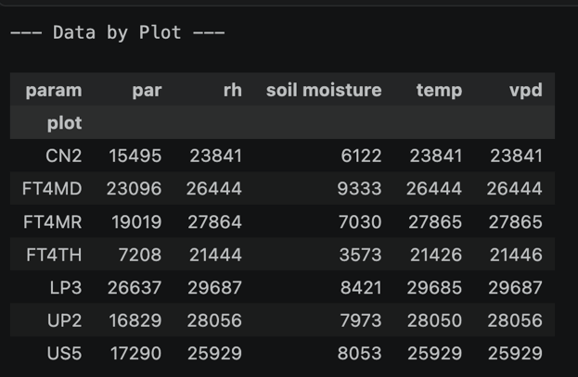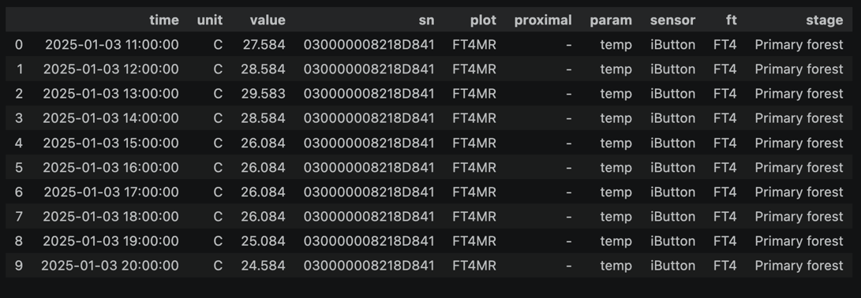
Working with data in long format requires reshaping before any cross-parameter analysis can be done. Correlating temperature with soil moisture at the same timestamp and site, for example, first requires a pivot operation that aligns records by time, plot and sensor. This restructuring step was one of the more time-consuming parts of the early analytical work and required careful handling to avoid silent data loss from timestamp mismatches between sensors.
Table 2 summarises the seven monitoring plots and their sensor coverage. PAR instruments are absent or have sparse records at some plots, and soil moisture coverage is lower than the atmospheric variables. These gaps are accounted for in the analysis — cross-parameter analyses are restricted to the subset of plots with adequate coverage for both variables involved.

Plot | Forest Type | Stage | Temp / RH / VPD | PAR | Soil Moisture
UP2 | FT1 | Open / edge | ✓ | ✓ | ✓
US5 | FT1 | Open / edge | ✓ | ✓ | ✓
CN2 | FT2 | Early secondary | ✓ | ✓ | ✓
LP3 | FT3 | Late secondary | ✓ | ✓ | ✓
FT4MD | FT4 | Primary forest | ✓ | ✓ | ✓
FT4MR | FT4 | Primary forest | ✓ | ✓ | ✓
FT4TH | FT4 | Primary forest | ✓ | Sparse | ✓
Table 2: Monitoring plot summary showing sensor coverage. ✓ indicates adequate records for analysis.

2.2 Data Cleaning Pipeline
A Python-based data cleaning pipeline was written and applied to the raw dataset before any analysis. The pipeline implements four quality control rules applied in sequence:
- Remove HOBO logger error codes: The value −888.88 is the HOBO logger's default error output. Any rows carrying this value are flagged and removed.
- Remove physically impossible soil moisture values: Negative volumetric soil moisture is not physically realisable and is treated as a sensor or logging artefact.
- Remove out-of-range temperature values: Readings below 15°C or above 50°C are removed as implausible for Singapore's tropical climate.
- Cap relative humidity at 100%: Values exceeding 100% RH are capped rather than removed, since minor over-readings typically reflect calibration drift in high-humidity conditions rather than a fundamental sensor failure.

When applied to the dataset, none of these rules triggered any removals — all 725,852 records passed every check. This is consistent with the data having been pre-processed before delivery, though the pipeline adds value regardless: it is version-controlled, fully documented in the project notebook and can be applied identically to any future data deliveries from the same network. It also serves as a formal statement of the quality assumptions made before analysis began.
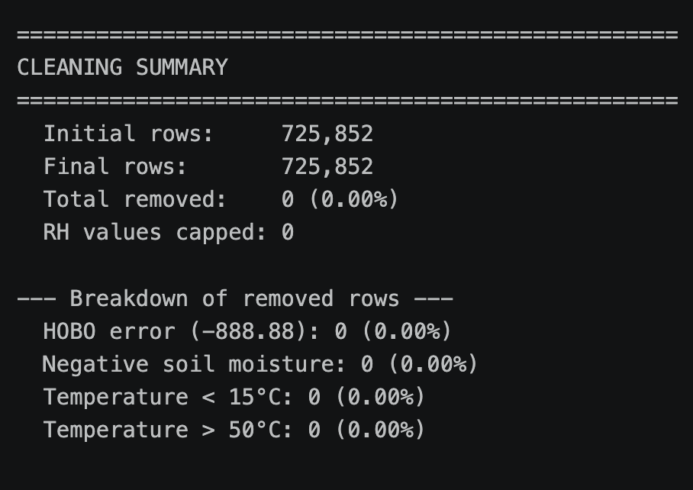
One unit conversion was necessary: VPD values are stored in Pascals in the raw file rather than the more standard kilopascals. All VPD figures in this report are in kPa (raw values divided by 1,000). A separate data gap analysis confirmed that average hourly coverage across all sites and parameters is 92.9%. A missing-at-random (MCAR) test found no systematic association between data gaps and weather conditions, which means the gaps are unlikely to bias the analysis.

2.3 Exploratory Data Analysis
The exploratory analysis examines each of the five measured parameters — temperature, relative humidity, vapour pressure deficit, PAR and soil moisture — across sites and forest types. The overarching finding is that a clear and consistent microclimate gradient runs from open FT1 sites (hotter, drier, brighter and more variable) to primary forest FT4 sites (cooler, more humid, darker and more buffered), with secondary forest sites falling in between. This gradient is ecologically expected and the data supports it quantitatively across all five variables.

2.3.1 Temperature
Dataset-wide temperature ranges from 20.1°C to 46.1°C, with a mean of 26.4°C and a standard deviation of 2.6°C. The forest-type gradient is consistent across sites, though two sites — US5 and FT4TH — show temperatures that do not fully align with their classifications and are discussed in Section 2.6.
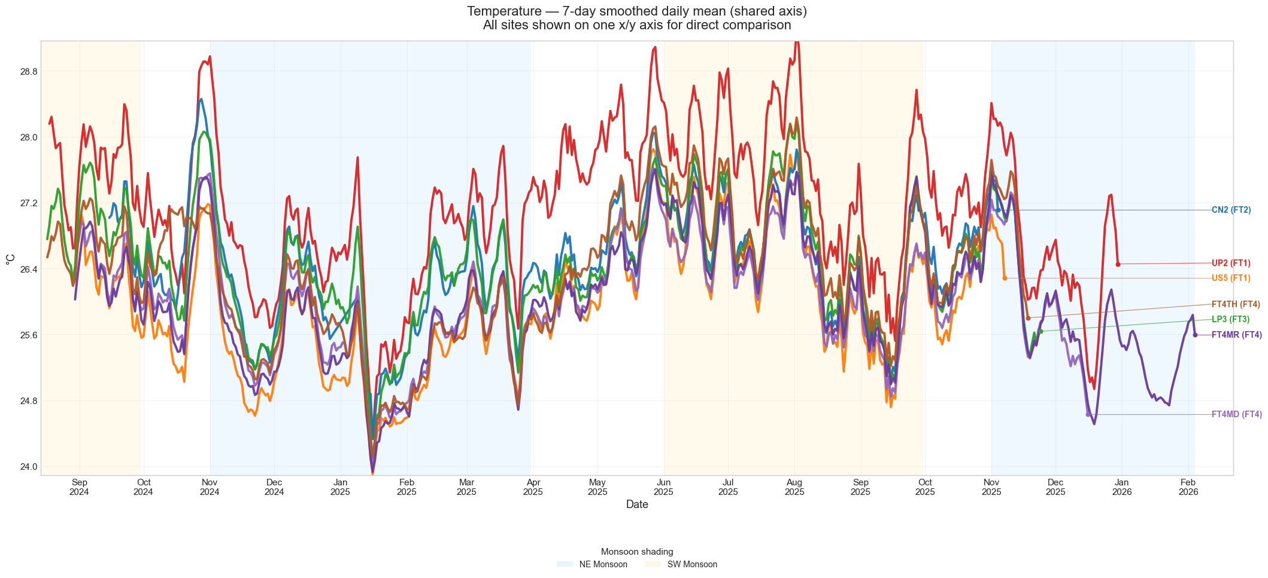
Figure 1: 7-day rolling mean temperature for all seven sites on a shared axis. UP2 (FT1) consistently records the highest temperatures; FT4MR records the lowest.
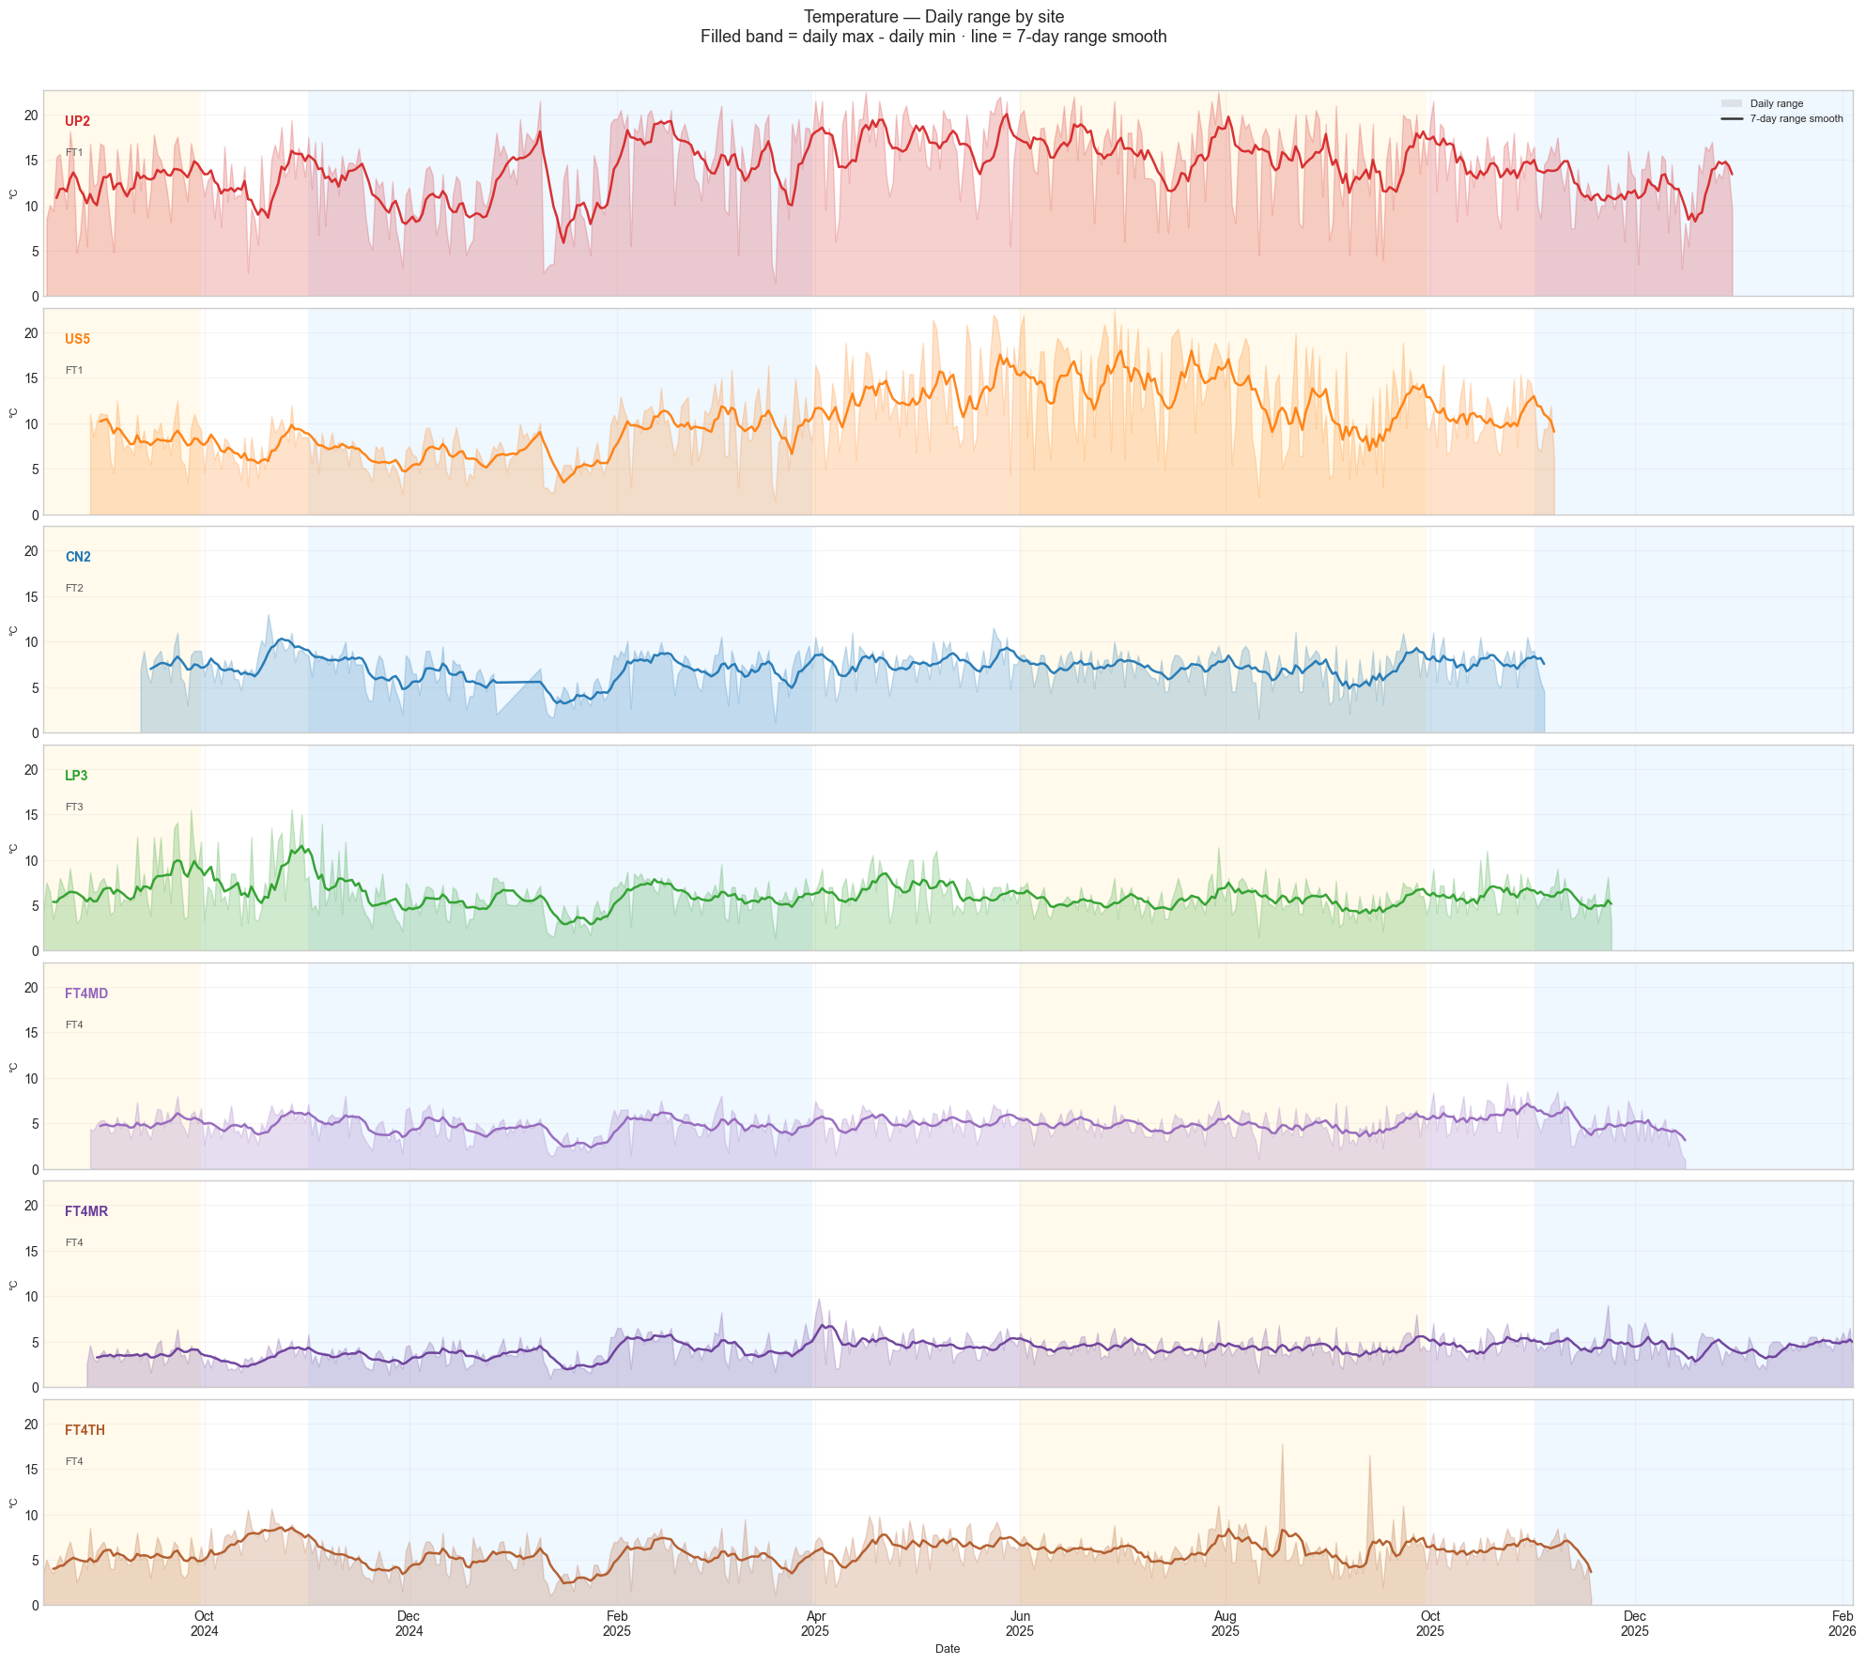
Figure 2: Faceted daily temperature range (daily maximum minus minimum) per site. FT1 sites show substantially wider within-day variation than primary forest sites.

Site | FT | Mean (°C) | Min (°C) | Max (°C) | Notes
UP2 | FT1 | 27.15 | 20.12 | 46.07 | Hottest site; widest daily range
US5 | FT1 | 25.95 | 20.54 | 43.12 | Cooler than expected for FT1
CN2 | FT2 | 26.46 | 20.89 | 41.33 | Mean tracks closely with LP3; intermediate daily range (~7°C), consistent with partial canopy shading
LP3 | FT3 | 26.46 | 21.15 | 39.78 | Similar mean to CN2 but slightly tighter daily range
FT4MD | FT4 | 26.04 | 21.28 | 38.45 | Narrower daily spread
FT4MR | FT4 | 25.99 | 21.43 | 37.91 | Coolest site overall
FT4TH | FT4 | 26.36 | 21.19 | 40.52 | Warmer than expected for FT4
Table 3: Temperature statistics by site.

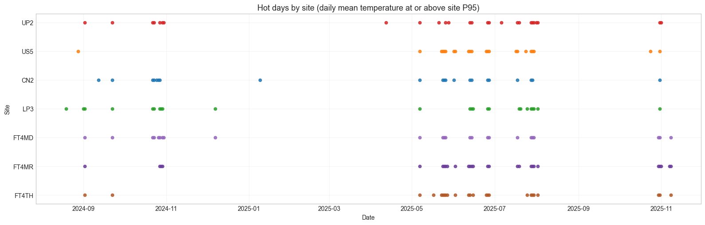
Figure 3: Hot-day counts per site: number of days where the daily mean temperature reached or exceeded the site's 95th percentile. UP2 accumulates significantly more hot days than primary forest sites.

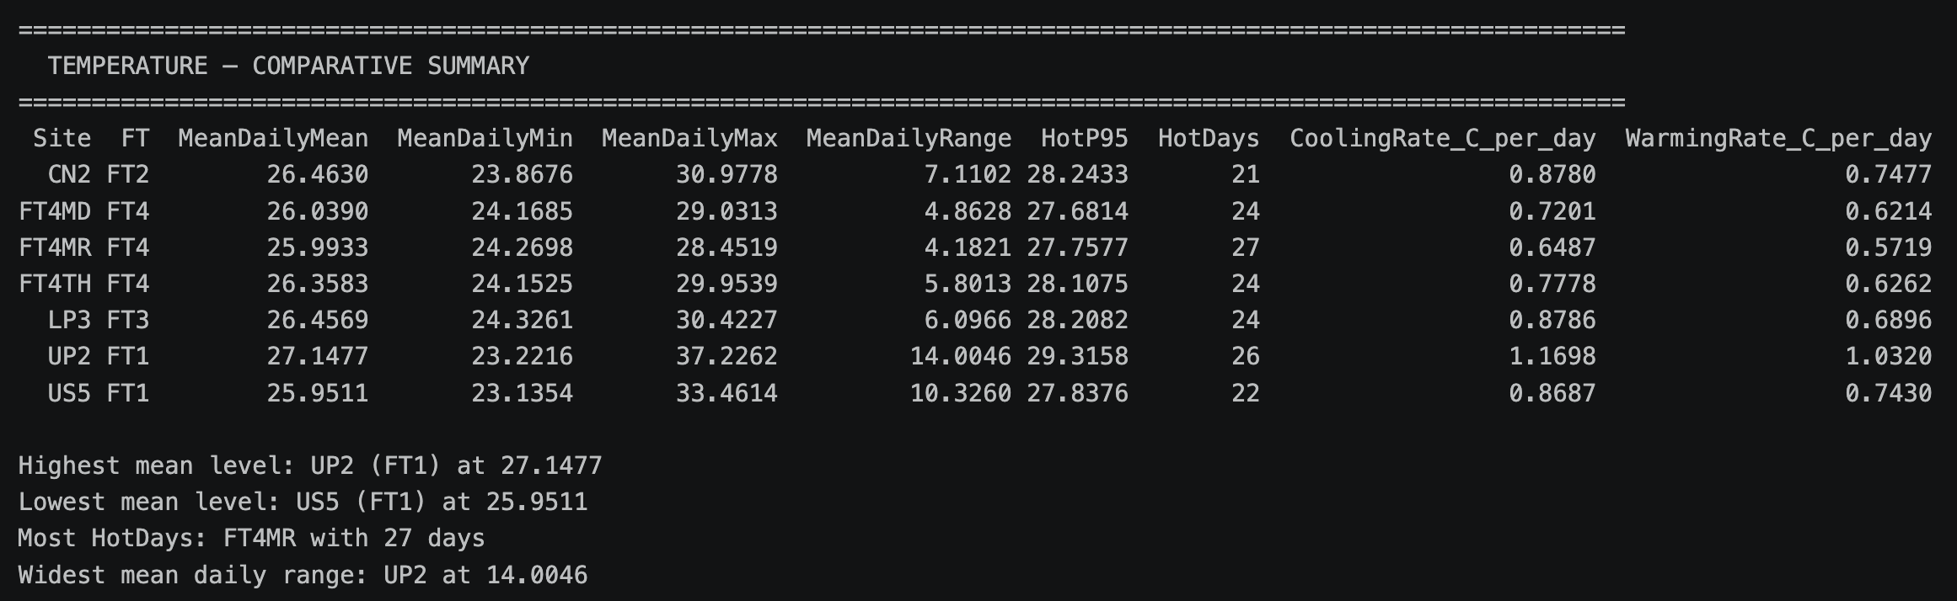
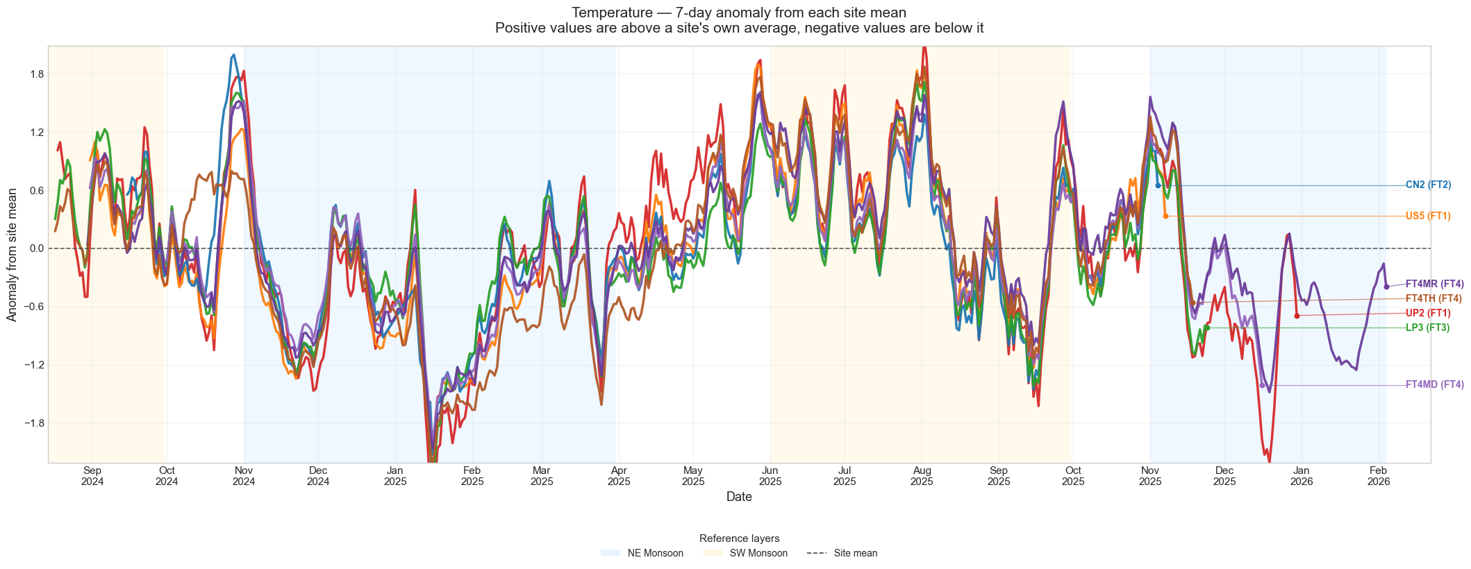
Figure 4: Temperature anomaly (7-day rolling mean minus long-term site average). Useful for identifying periods when a site is running warmer or cooler than its own baseline, independently of absolute temperature level.
The site means confirm the FT1 > FT2/FT3 > FT4 hierarchy for temperature. The anomaly time series in Figure 5 is particularly informative because it separates the question of a site's absolute temperature level from the question of whether it is currently running above or below its own average — which is relevant when comparing seasonal effects across forest types.

2.3.2 Relative Humidity
The dataset-wide mean RH is 91.9% with a median of 95.3%, reflecting Singapore's generally humid climate. The gradient across forest types is most pronounced in the lower tail of the distribution: FT1 sites experience regular afternoon humidity dips that primary forest sites do not, reflecting the greater buffering capacity of the closed canopy.
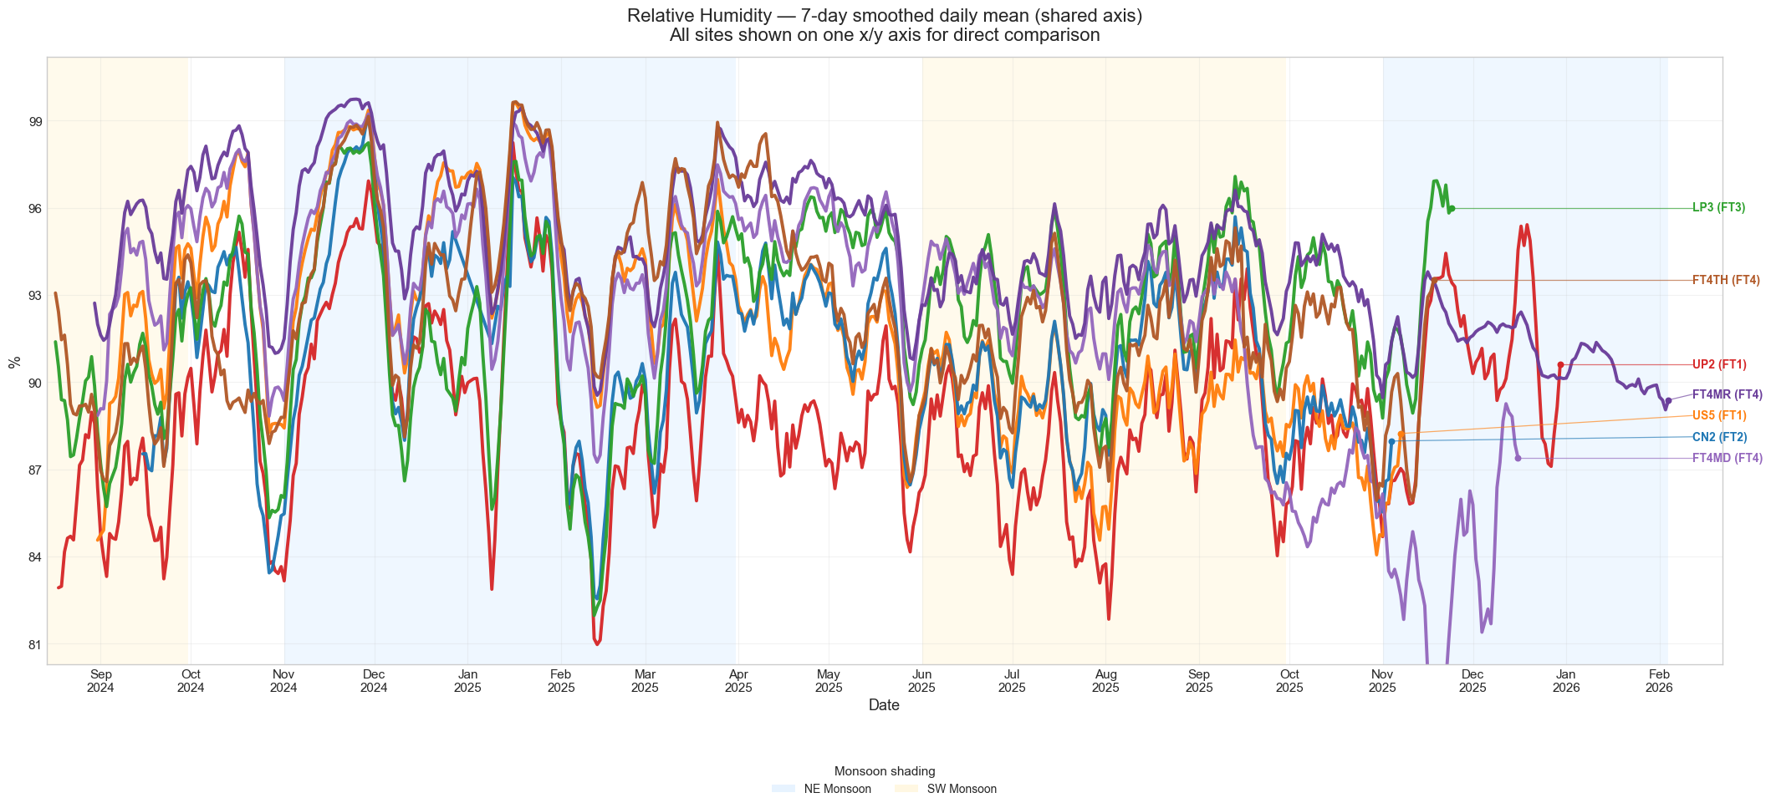
Figure 5: 7-day rolling mean RH for all sites on a shared axis. FT4MR consistently records the highest RH values; UP2 shows the most variability.

Site | FT | Mean RH (%) | IQR Lower (%) | IQR Upper (%) | Notes
UP2 | FT1 | 88.95 | 84.48 | 93.11 | Lowest; widest spread
US5 | FT1 | 91.84 | 87.60 | 96.90 | Higher than expected for FT1
CN2 | FT2 | 90.97 | 86.20 | 96.40 | Intermediate, daily range ~27 pp,
LP3 | FT3 | 92.22 | 88.10 | 97.50 | Frequently reaches near-saturation, daily swings moderate (~24 pp
FT4MD | FT4 | 92.32 | 88.80 | 97.10 | Daily range (~21 pp) is wider than FT4MR, shows prolonged low-RH episodes during Dec–Jan dry periods
FT4MR | FT4 | 94.38 | 91.30 | 98.60 | Highest; tightest spread
FT4TH | FT4 | 92.51 | 88.40 | 97.30 | Daily RH range (~23 pp) is closer to LP3, reflects canopy gap influence on daytime drying
Table 4: Relative humidity statistics by site.

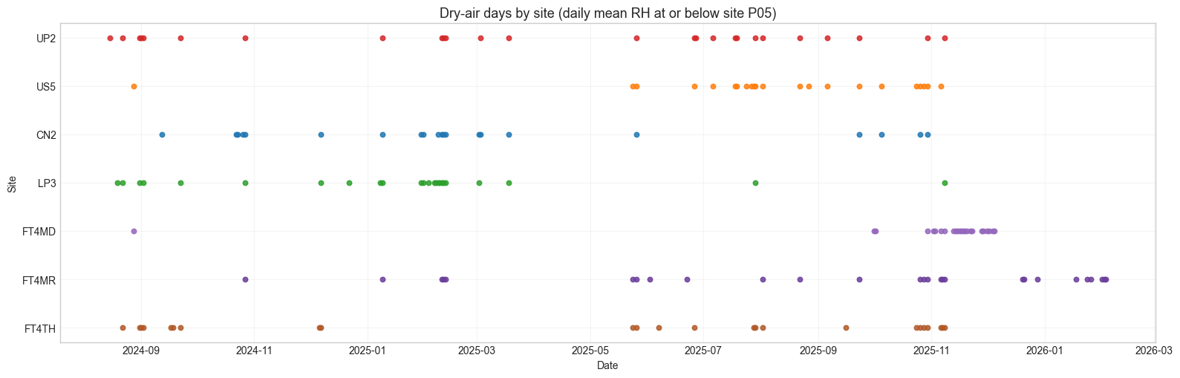
Figure 6: Dry-air day counts per site: days where daily mean RH fell at or below the site's 5th percentile. UP2 accumulates the most dry-air days.
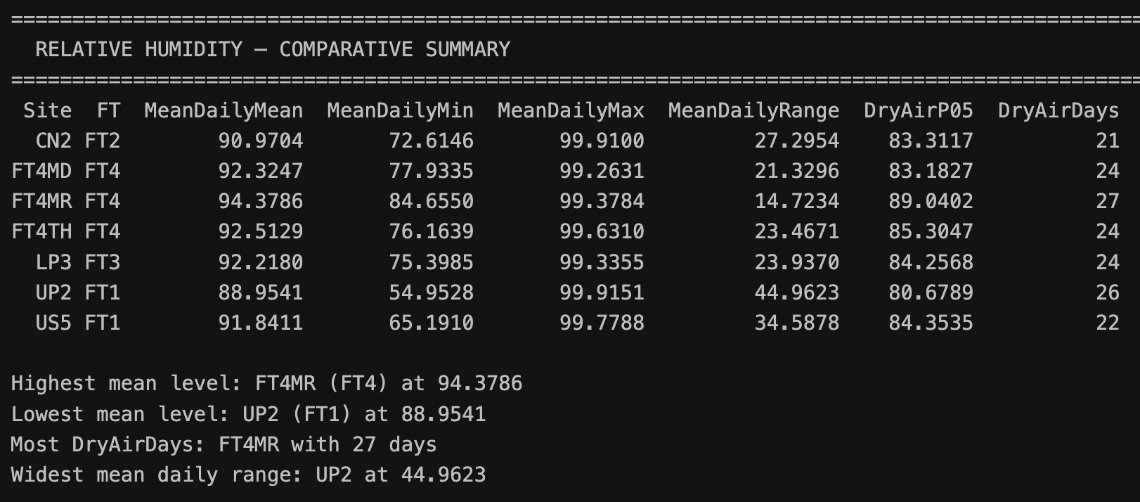
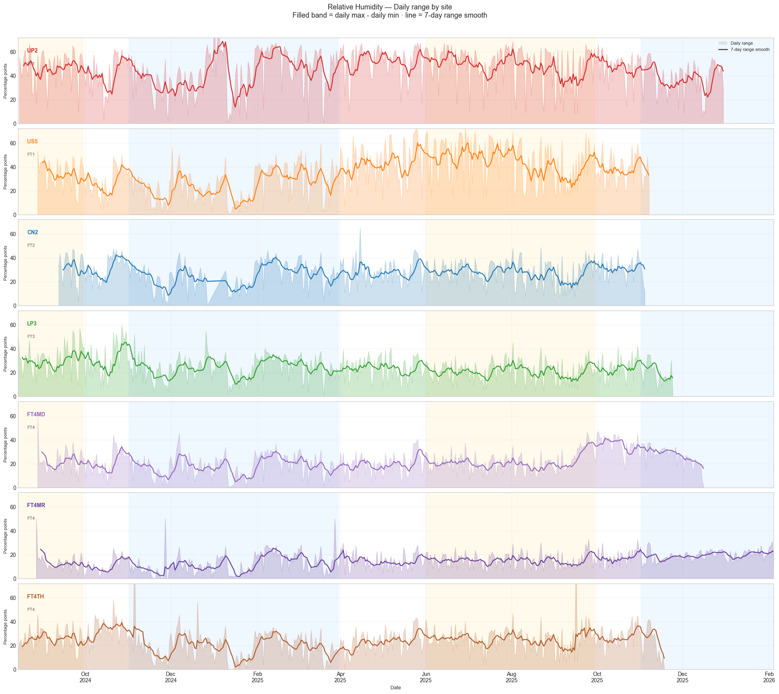
Figure 7: Faceted daily RH range (daily maximum minus minimum) per site. Open sites show much larger within-day swings, driven by afternoon solar heating and evapotranspiration.

2.3.3 Vapour Pressure Deficit (VPD)
VPD is arguably the most ecologically significant of the five variables because it integrates both temperature and humidity into a single measure of atmospheric evaporative demand. At high VPD, plants experience water stress and close their stomata — effectively halting growth. This pattern has been consistently observed across forest disturbance gradients, where VPD and related thermal proxies differ markedly between heavily logged and old-growth stands [2]. The forest-type gradient in VPD is the clearest of any variable in the dataset. All VPD values are reported in kPa.
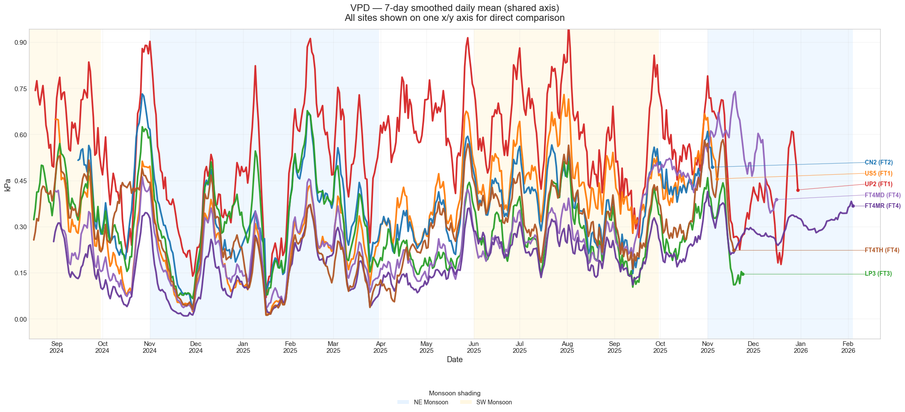
Figure 8: 7-day rolling mean VPD on a shared axis. The separation between UP2 (FT1) and FT4MR (FT4) is visually striking and ecologically meaningful.

Site | FT | Mean VPD (kPa) | P95 VPD (kPa) | Ecological significance
UP2 | FT1 | 0.545 | 1.031 | Chronic water stress conditions; only highly stress-tolerant species establish reliably
US5 | FT1 | 0.340 | 0.757 | Moderate; lower than expected for an open FT1 site
CN2 | FT2 | 0.361 | 0.696 | Trace overlaps with US5, peaks during SW monsoon inter-monsoon periods exceed LP3 despite lower forest type classification
LP3 | FT3 | 0.302 | 0.635 | Transitional conditions; mixed-species planting viable
FT4MD | FT4 | 0.277 | 0.602 | Low and buffered, trace stays tightly below 0.45 kPa for most.
FT4MR | FT4 | 0.201 | 0.406 | Most buffered site; suited to interior-forest specialist species
FT4TH | FT4 | 0.290 | 0.604 | Anomalously high for FT4; consistent with localised canopy gap  allowing greater evaporative demand
Table 5: VPD statistics by site. The mean VPD at UP2 is 2.7 times that of FT4MR, reflecting the scale of ecological divergence across the forest gradient.

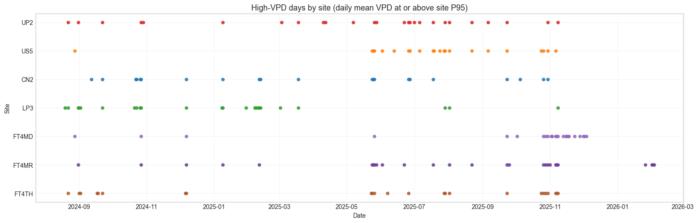
Figure 9: High-VPD stress day counts per site: days where daily mean VPD reached or exceeded the site's 95th percentile. UP2 records far more stress days than any FT4 site.
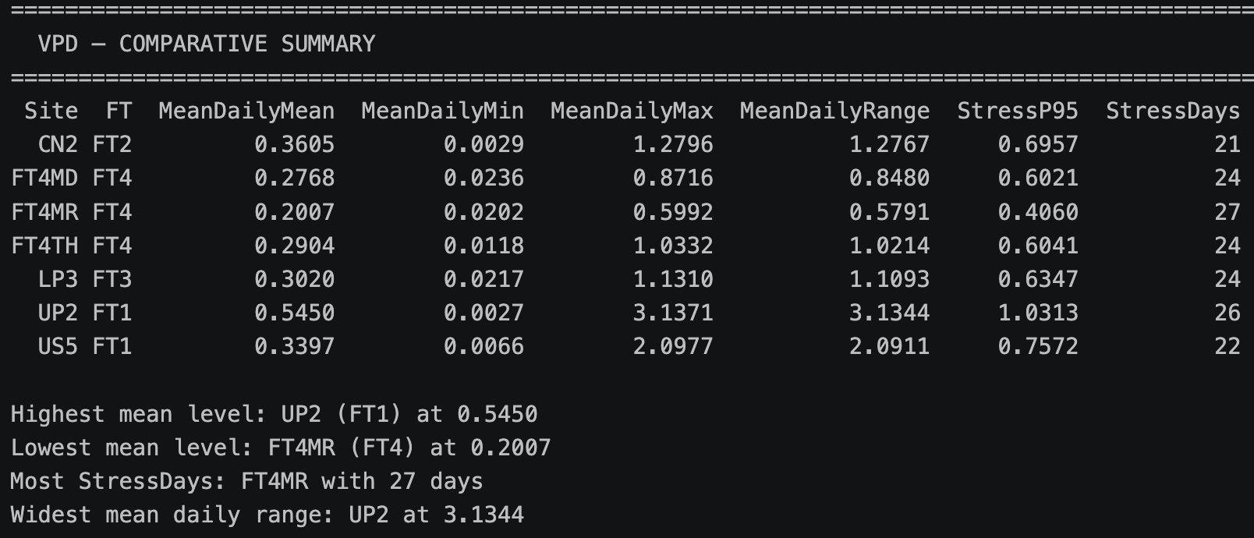
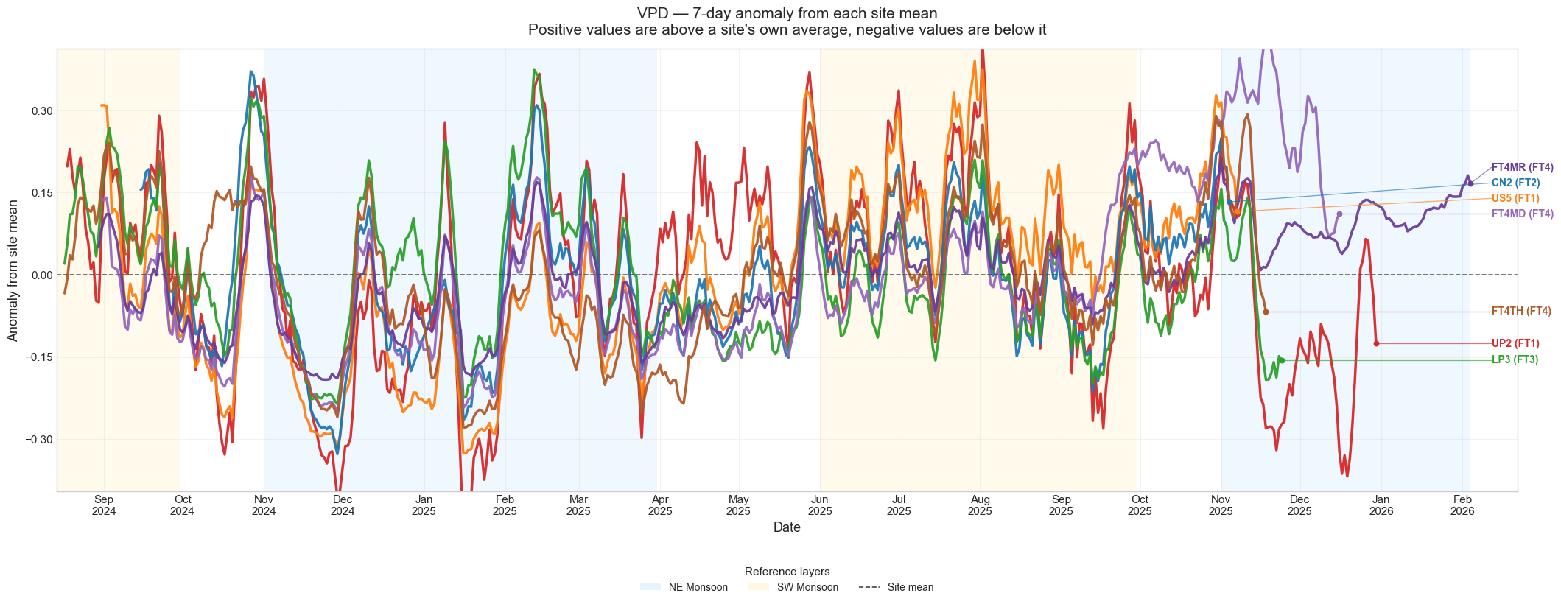
Figure 10: VPD anomaly time series: site deviations from long-term site average. When anomalies at multiple sites align, it indicates a regional weather event affecting the whole network.

2.3.4 Photosynthetically Active Radiation (PAR)
PAR measures the photon flux in the 400–700 nm waveband that drives photosynthesis. The range across sites is the most extreme of any variable: UP2 receives approximately 37 times more daily mean PAR than FT4MR. This reflects the near-total canopy closure of mature primary forest. The ecological implication is direct — species adapted to deep forest understory conditions are photoinhibited by open-canopy light levels.
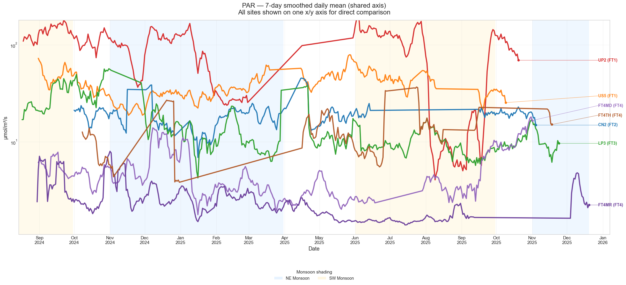
Figure 11: 7-day rolling mean PAR on a shared log-scale axis. The log scale is necessary because the linear range (2.5 to 92.1 μmol/m²/s) would compress the primary forest sites to invisibility.

Site | FT | Mean PAR (μmol/m²/s) | IQR (μmol/m²/s) | Notes
UP2 | FT1 | 92.12 | 30–108 | Open grassland; very high light load
US5 | FT1 | 38.90 | 10–54 | Lower than UP2 — likely partial canopy cover
CN2 | FT2 | 19.06 | 5–28 | Moderate light, higher values in dry inter-monsoon months
LP3 | FT3 | 15.42 | 3–21 | Similar mean to CN2 but PAR record shows more step-changes, suggesting occasional sensor gaps; generally consistent with partial canopy cover
FT4MD | FT4 | 5.07 | 1–8 | Low and stable; diurnal cycling is minimal, consistent with dense closed canopy attenuating nearly all direct radiation
FT4MR | FT4 | 2.50 | 0.5–4 | Darkest site in the network, full canopy closure confirmed
FT4TH | FT4 | 13.07 | 2–20 | Anomalously high — localised canopy gap suspected
Table 6: PAR statistics by site. FT4TH is a notable outlier within the primary forest category and is discussed in Section 2.6.

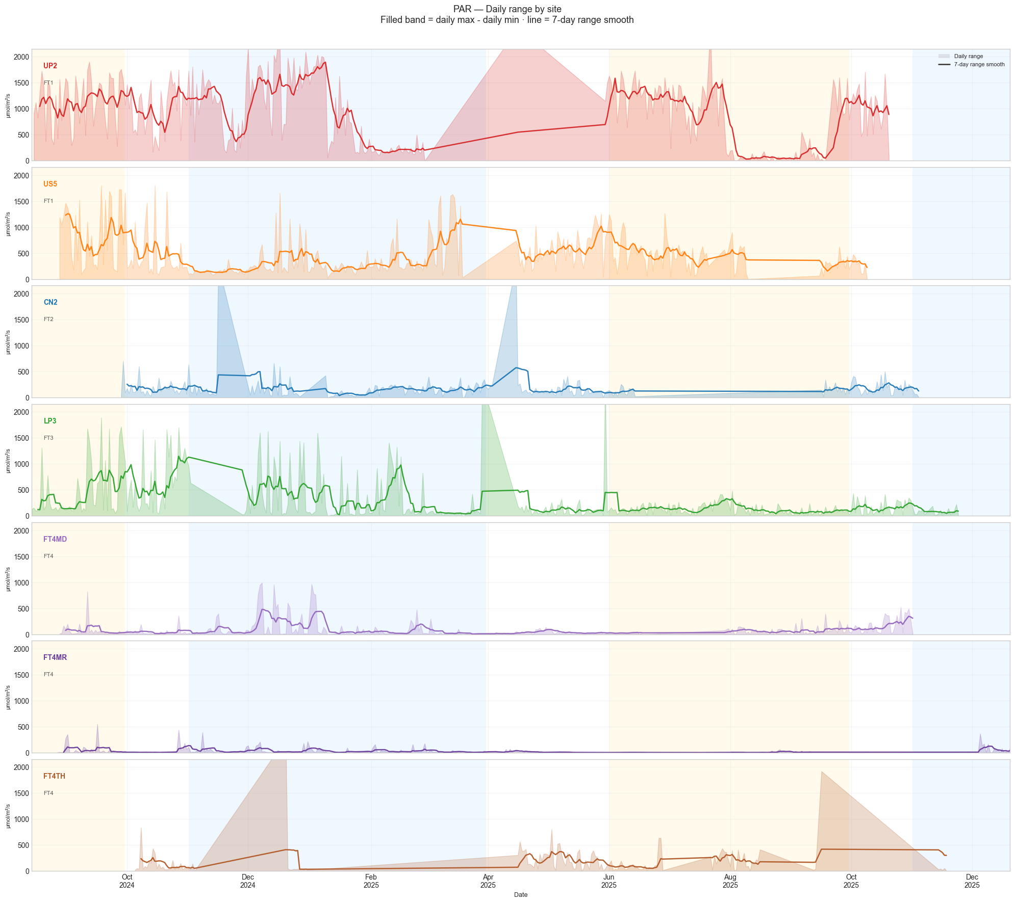
Figure 12: Faceted daily PAR range per site. FT1 sites show strong diurnal cycling driven by solar angle; FT4 interior sites show minimal daily fluctuation consistent with dense canopy filtering.

2.3.5 Soil Moisture
Soil moisture is the most spatially heterogeneous of the five variables. Unlike the atmospheric parameters, which are driven primarily by canopy cover and solar radiation, soil moisture also depends on soil texture, drainage characteristics, root architecture and microtopography. The FT1-to-FT4 gradient is present but less clean than for the atmospheric variables, and some of the more informative findings come from the drydown dynamics rather than the mean levels.
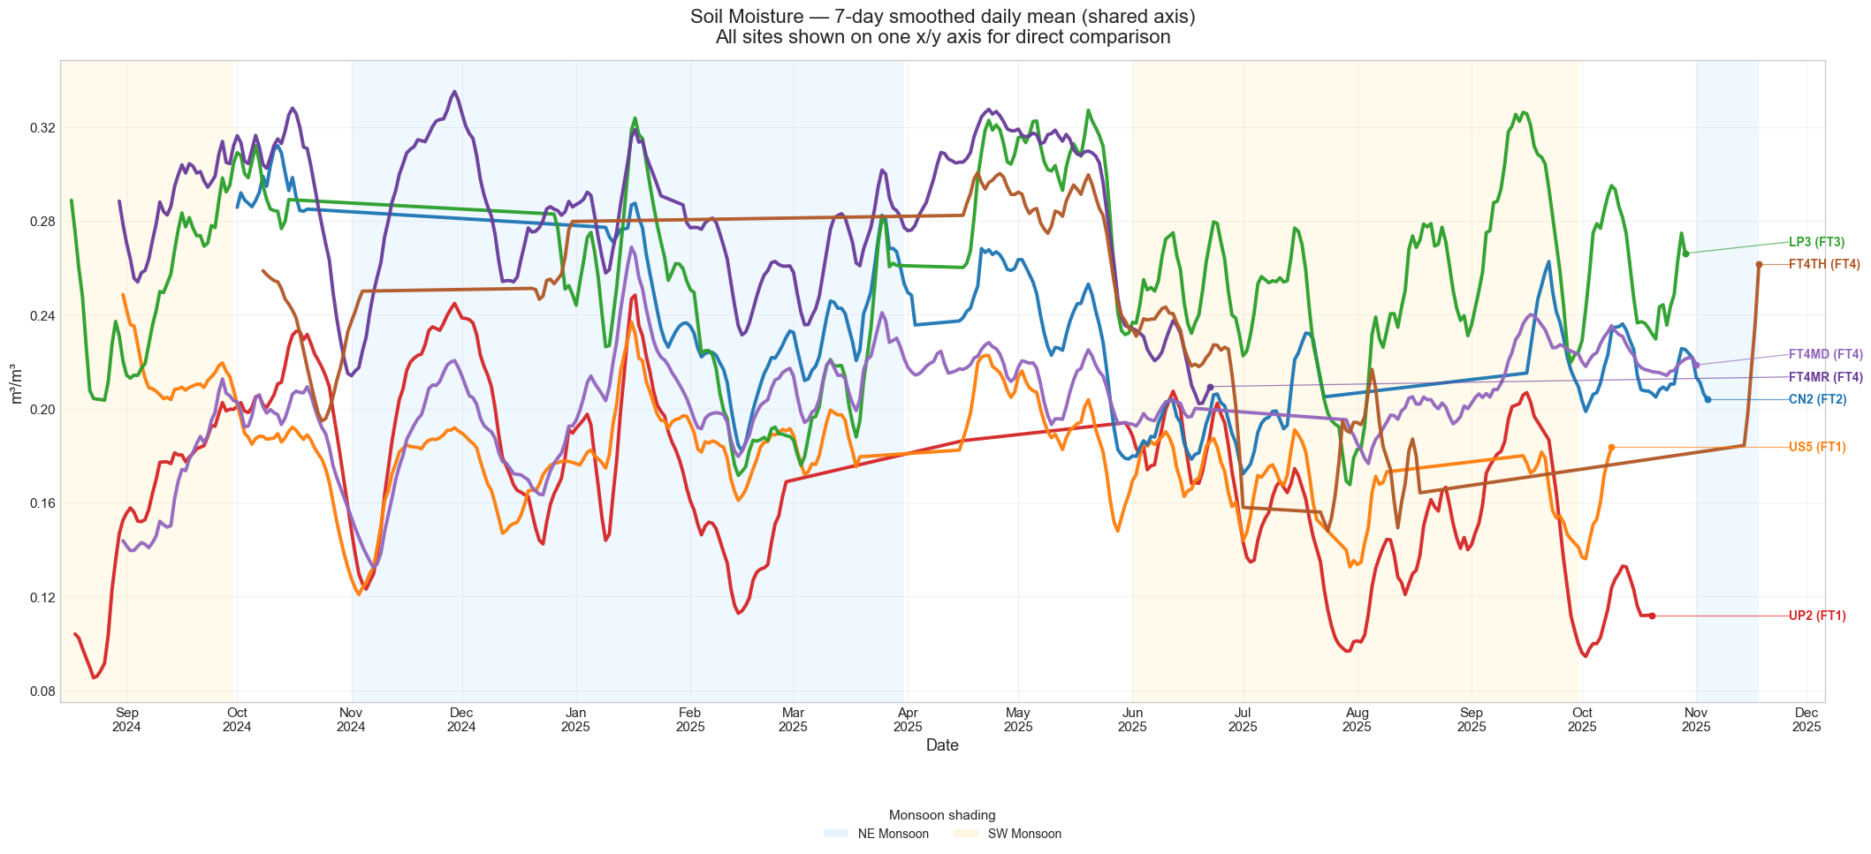
Figure 13: 7-day rolling mean volumetric soil moisture for all sites on a shared axis.

Site | FT | Mean SM (m³/m³) | Median SM | Notes
UP2 | FT1 | 0.167 | 0.163 | Driest site; high surface evaporation
US5 | FT1 | 0.182 | 0.178 | Slightly wetter than UP2; spikes suggesting faster rainfall infiltration than UP2
CN2 | FT2 | 0.230 | 0.225 | Moderate and relatively stable; long flat dry-season stretches visible Jan–Mar 2025
LP3 | FT3 | 0.255 | 0.252 | Wetter than FT1 but fastest-drying — see Section 2.4
FT4MR | FT4 | 0.281 | 0.280 | Wettest site overall
FT4MD | FT4 | 0.202 | 0.199 | Lowest mean among FT4 sites despite dense canopy; Slowest-drying site — see Section 2.4
FT4TH | FT4 | 0.240 | 0.239 | Moderate mean but long flat plateau from Jan–Apr 2025 indicates an extended period of near-zero sensor variation — possible sensor anomaly or very stable water table during that interval
Table 7: Soil moisture statistics by site. Mean level and drying dynamics are not always correlated — see Section 2.4 for the drydown analysis.

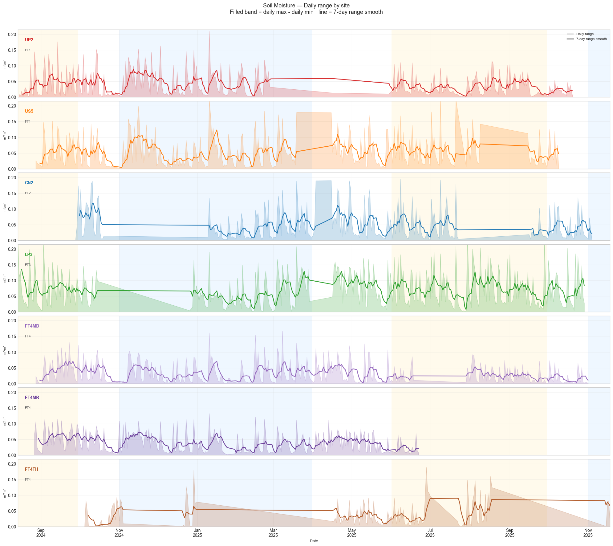
Figure 14: Faceted daily soil moisture range (daily maximum minus minimum) per site. LP3 shows notably wide within-day swings relative to its mean moisture level.
LP3 presents the most interesting finding in this subsection: it has a higher mean soil moisture than both FT1 sites yet shows the widest within-day moisture range in the network. This combination — high mean but high daily variability — points to active root water extraction rather than passive surface evaporation as the dominant drying mechanism. This is explored quantitatively in Section 2.4.

2.4 Soil Moisture Drydown and Half-Life Analysis
The drydown analysis examines how soil moisture declines after a rainfall-driven recharge event. Understanding these dynamics is important both for characterising the soil–plant–atmosphere interaction at each site and for building predictive models — the rate and shape of drydown after rain is a cleaner signal of site hydrology than the mean moisture level alone.
A drydown event is defined as a continuous decline in daily maximum soil moisture beginning at a local peak and ending at a local trough or the next recharge event. The detection algorithm uses the following thresholds: minimum event duration of four days, minimum total moisture loss of 0.015 m³/m³ and maximum rewetting step of 0.003 m³/m³ per day. These values were calibrated through iterative testing to reduce both false positives (noise flagged as drydown) and missed events (genuine drying periods below the detection threshold).
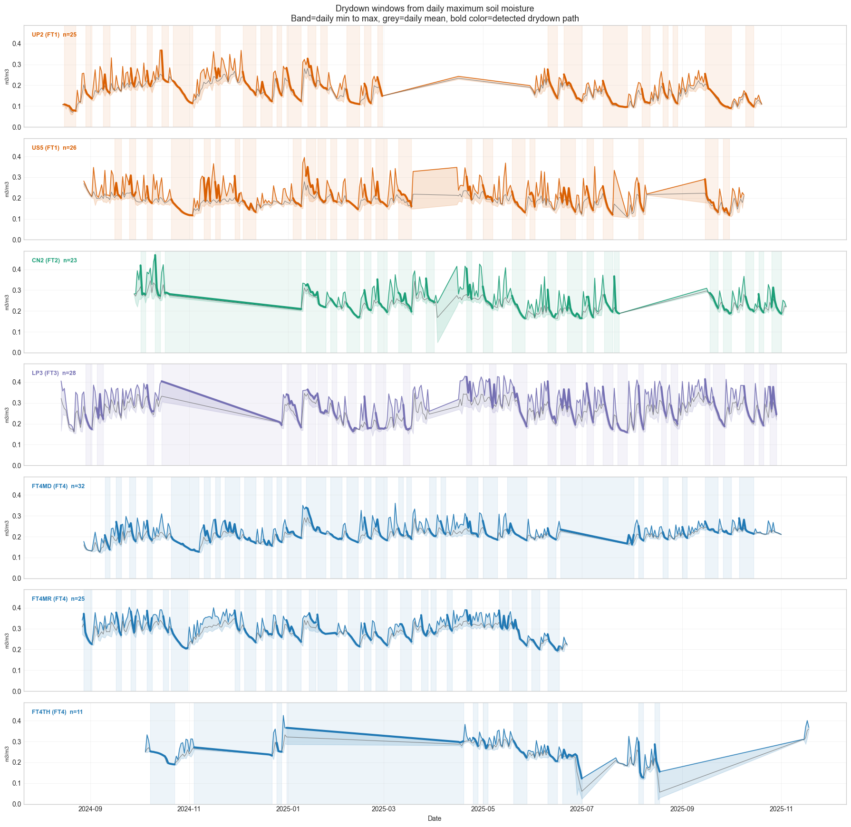
Figure 15: Timeline of detected drydown events across all seven sites. Each row represents one site; each segment represents one drydown event. The alignment of events across sites reflects common rainfall patterns across the network.

Site | FT | Events | Median Duration (days) | Median Drying Rate (m³/m³/day) | Half-life (days)
UP2 | FT1 | 25 | 6.0 | 0.0122 | 1.58
US5 | FT1 | 26 | 5.5 | 0.0152 | 1.64
CN2 | FT2 | 23 | 6.0 | 0.0155 | 1.31
LP3 | FT3 | 28 | 5.0 | 0.0243 * | 0.89 *
FT4MD | FT4 | 32 | 6.0 | 0.0104 † | 1.02
FT4MR | FT4 | 25 | 5.0 | 0.0115 | 0.87
FT4TH | FT4 | 11 | 4.0 | 0.0121 | 0.99
* LP3: fastest-drying site and shortest half-life across the network. † FT4MD: slowest-drying site.
Table 8: Soil moisture drydown summary. Drying rate is the median absolute linear decay slope across all detected events at each site. Half-life is the median empirical time for soil moisture to reach 50% of its initial post-rain level.

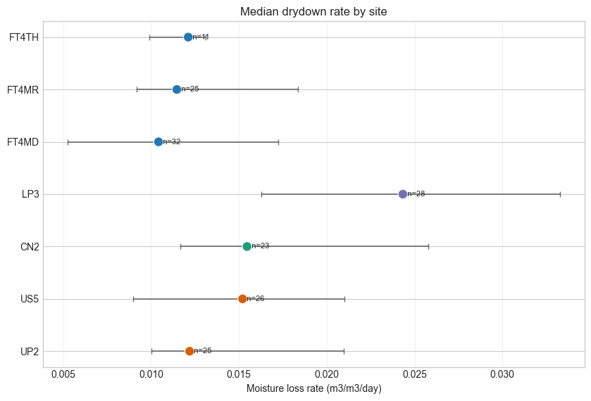
Figure 16: Median drying rate by site. LP3 dries significantly faster than any other site, including both FT1 sites, despite having a higher mean soil moisture level.
The most notable finding from this analysis is that LP3 is the fastest-drying site in the network despite not being the driest on average. Its median drying rate of 0.0243 m³/m³/day is substantially higher than the FT1 sites (0.0122–0.0152 m³/m³/day), and its empirical moisture half-life of 0.89 days is among the shortest observed (FT4MR records 0.87 days). FT4MD, by contrast, is the slowest-drying site. This dissociation between mean moisture level and drying rate indicates that the two metrics capture different aspects of site hydrology — mean level reflects long-term water balance, while drying rate reflects the dynamics of water extraction and loss once the soil is recharged.
One plausible explanation for LP3’s behaviour is that its denser late-secondary vegetation drives higher root water uptake relative to the more open FT1 sites, where drying is dominated by surface evaporation. This is consistent with findings from analogous studies, where forest structure parameters — including tree height, crown width and canopy density — have been shown to exert a measurable influence on soil water dynamics through transpiration-mediated pathways [1]. The LiDAR canopy structure data planned for Phase 3 should provide a way to test this, since higher leaf area index and greater root biomass at LP3 would be consistent with faster transpiration-driven drying.
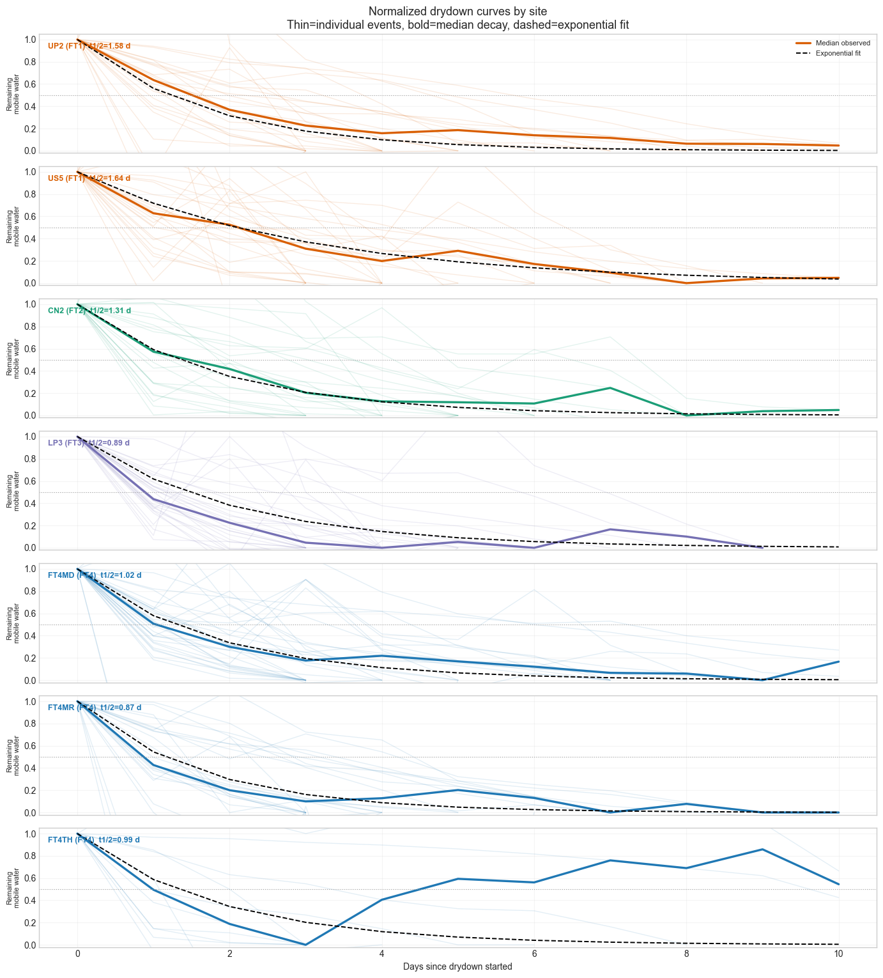
Figure 17: Normalised drydown curves per site. Each event is rescaled so that it starts at 1.0 (immediately after the moisture peak) and trends toward 0. This removes the effect of different absolute moisture levels and reveals how quickly the wet pulse dissipates at each site.
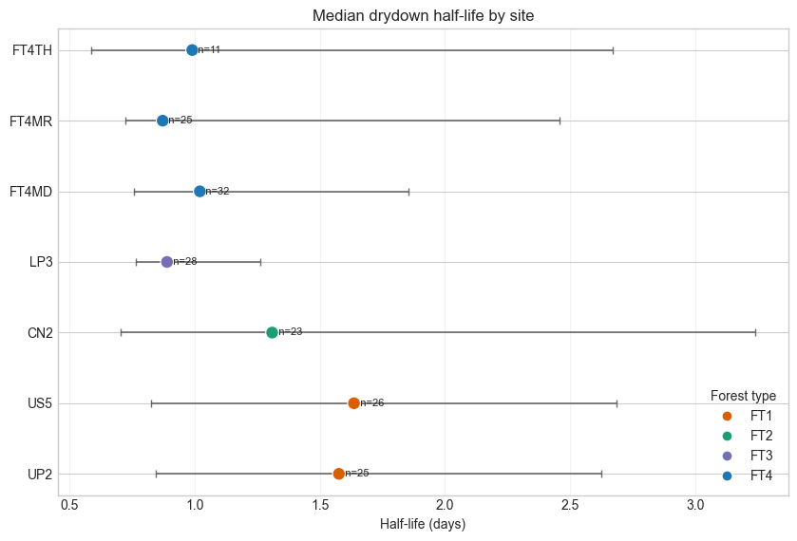
Figure 18: Empirical (observed) and exponential-fit half-life comparison by site. R² values for the exponential fits are high across all sites (median > 0.93), confirming that the exponential drydown model is appropriate for this dataset.
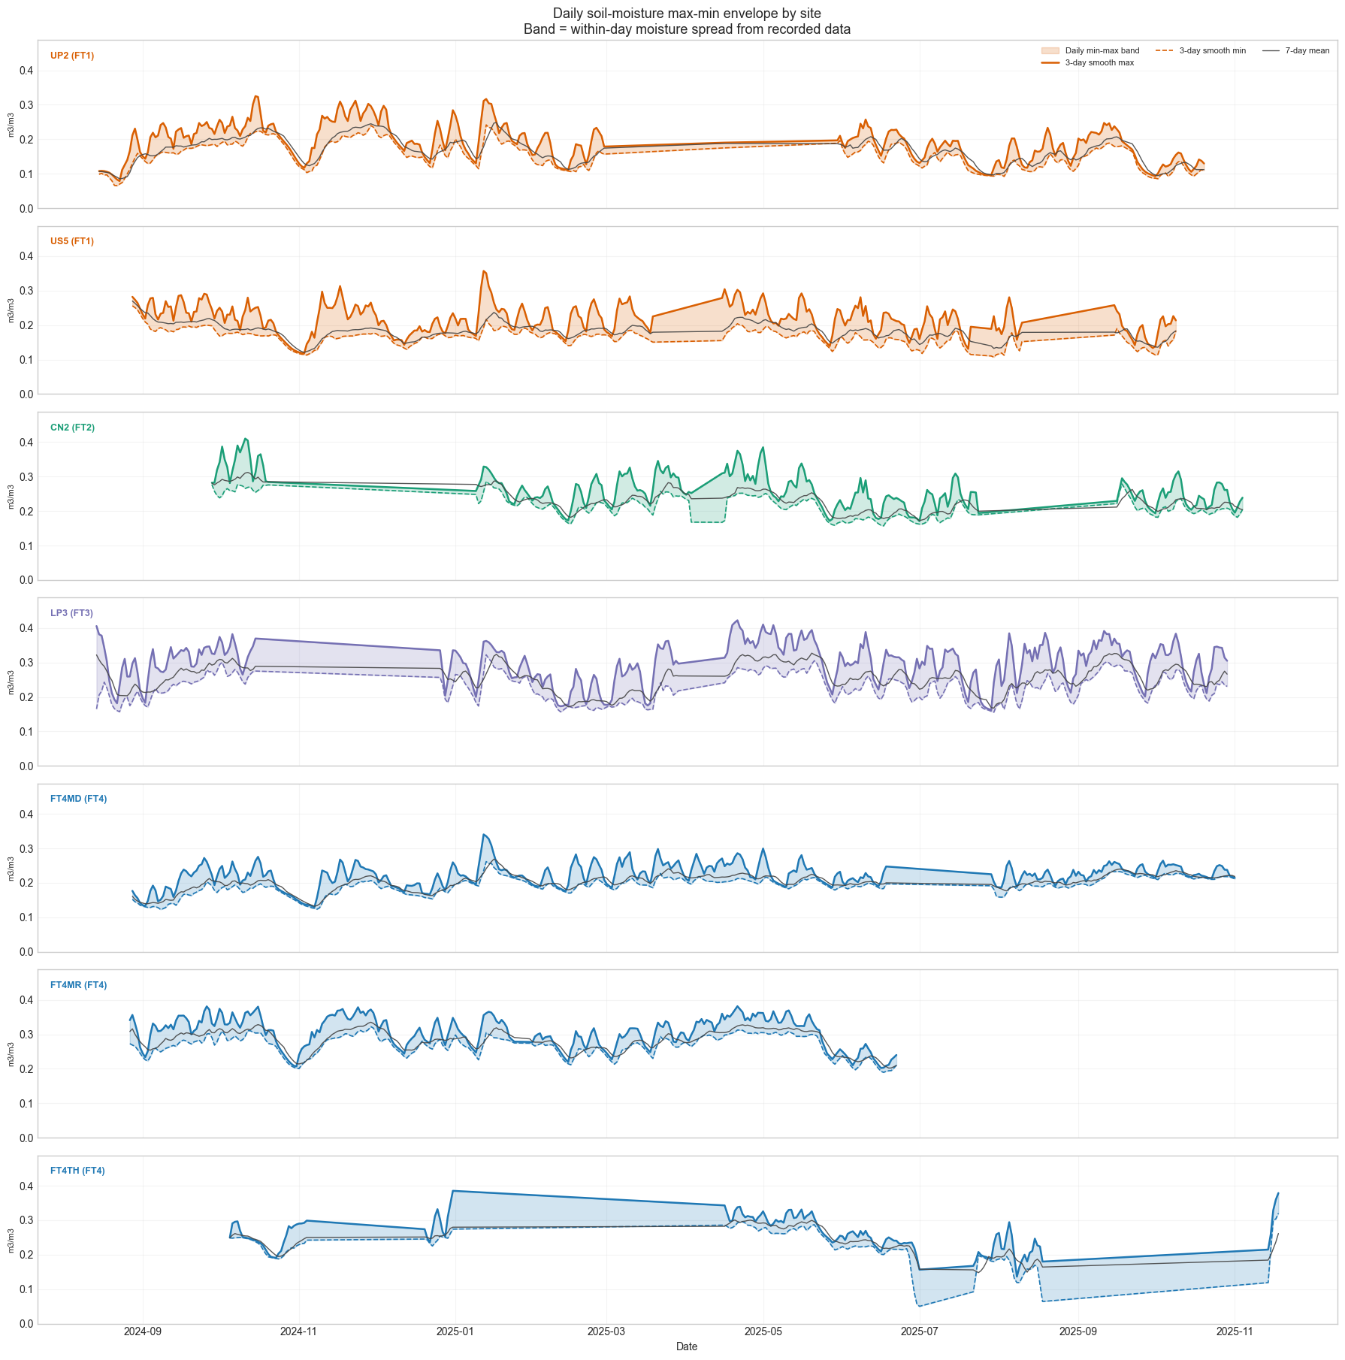
Figure 19: Daily maximum and minimum soil moisture envelope per site over the full study period. The width of the band reflects within-day moisture variability; LP3 shows the widest band relative to its mean level.
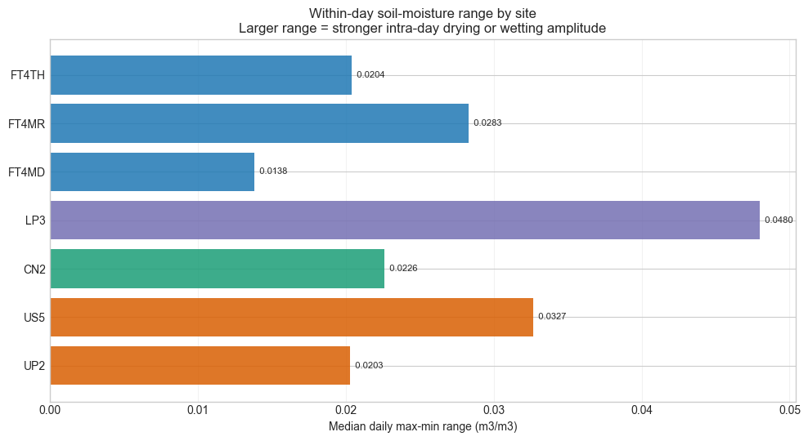
Figure 20: Median daily soil moisture range (daily max minus daily min) per site. LP3 has the widest within-day spread, corroborating the drydown rate finding.
A supplementary modelling test examined whether adding plot-level ecological trait data (stem density, basal area, mortality rate and species diversity) could improve leave-one-site-out predictions of drying rate and half-life beyond the event-level data alone. The result was that the event-only baseline outperformed the augmented model on both targets. The trait data did, however, improve interpretability — faster-drying sites tended to show higher mortality rates and lower species diversity, which is ecologically coherent. This suggests the traits are more useful as explanatory variables than as predictors at the current sample size of seven sites.
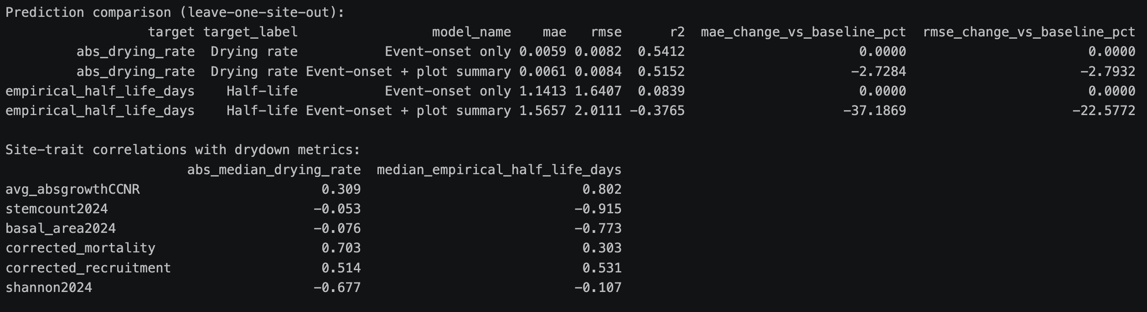
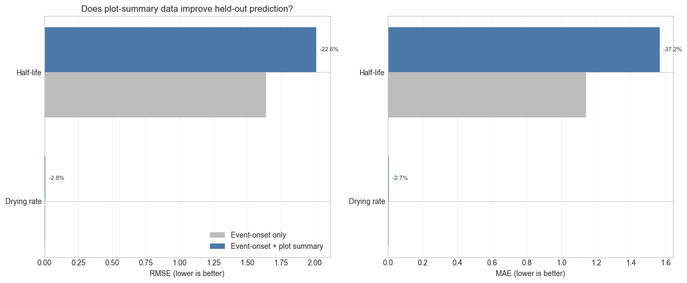
Figure 21: Leave-one-site-out prediction comparison: event-only model versus event + ecological traits model. MAE and RMSE are shown for drying rate and half-life. The event-only model performs comparably or better on held-out sites.
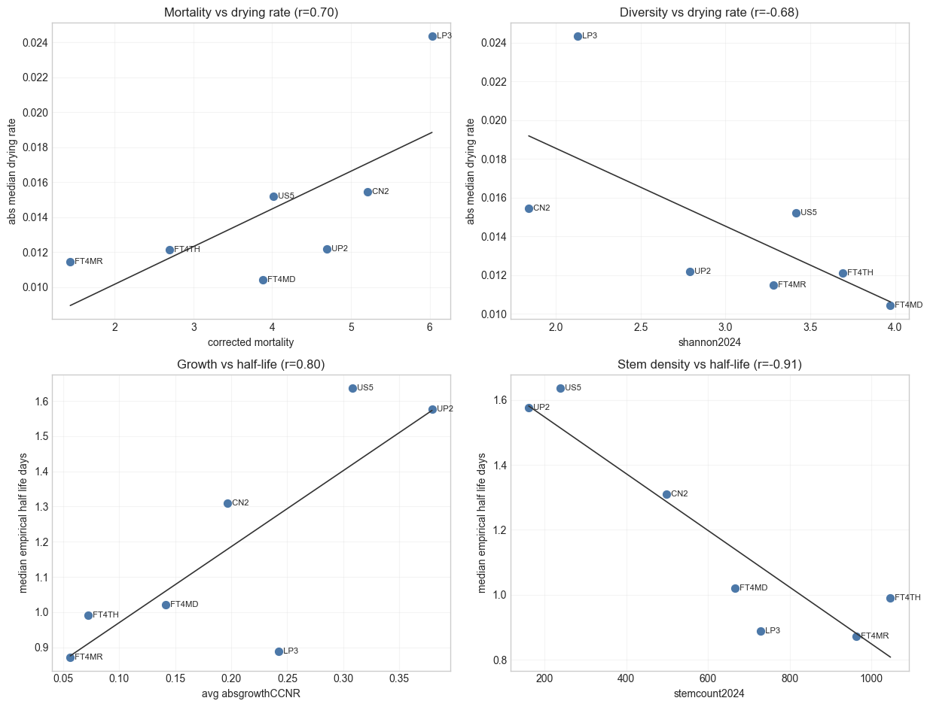
Figure 22: Ecological trait associations with drying rate and half-life by site. Higher mortality rates and lower diversity index correspond loosely with faster drying, providing an ecologically interpretable pattern even where prediction does not improve.

2.5 Microclimate Driver Correlations
Pairwise Pearson correlation analysis was carried out on the five microclimate variables, both for the full dataset and separately for each site. The analysis was performed on the wide-format version of the dataset, with records matched by timestamp and plot. The overall correlations with soil moisture are: RH +0.28, VPD −0.27, temperature −0.21 and PAR −0.08. These signs and magnitudes are consistent with the physical relationships: higher soil moisture accompanies cooler, more humid, lower-evaporative-demand conditions.
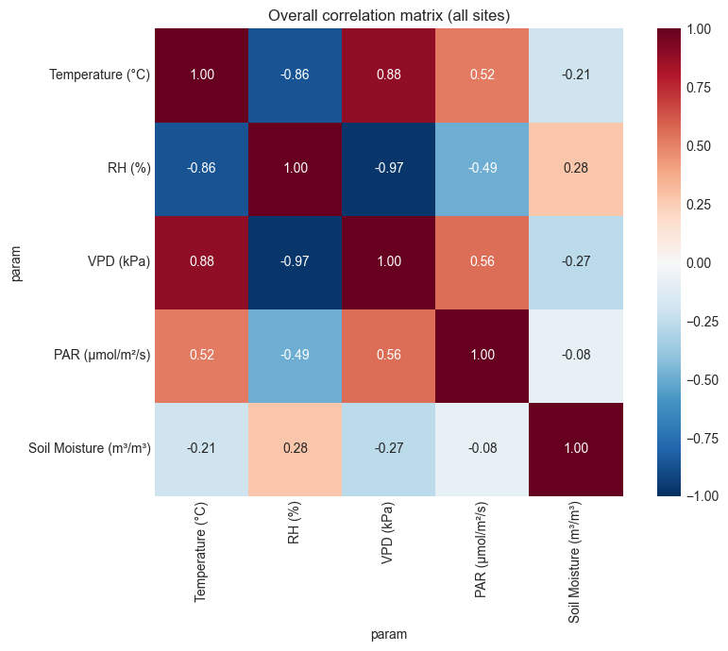
Figure 23: Overall Pearson correlation heatmap for all five microclimate variables. The strong RH–VPD and temperature–VPD relationships (both physically determined) are visible, as is the moderate soil moisture correlation with the atmospheric drivers.
The per-site results are more informative for the modelling phase than the overall matrix. The coupling strength between atmospheric drivers and soil moisture varies considerably across sites:
- LP3 (FT3): RH +0.42, VPD −0.39, temperature −0.36 — the strongest atmospheric-soil coupling in the network, consistent with active transpiration-driven drying.
- FT4MR (FT4): RH +0.50, VPD −0.48 — the weakest atmospheric–soil coupling among the non-FT4MD sites, though absolute values remain moderate; consistent with a highly buffered site where short-term atmospheric variation has reduced influence on soil moisture.
- FT1 sites (UP2, US5): intermediate coupling, dominated more by surface evaporation than root uptake.

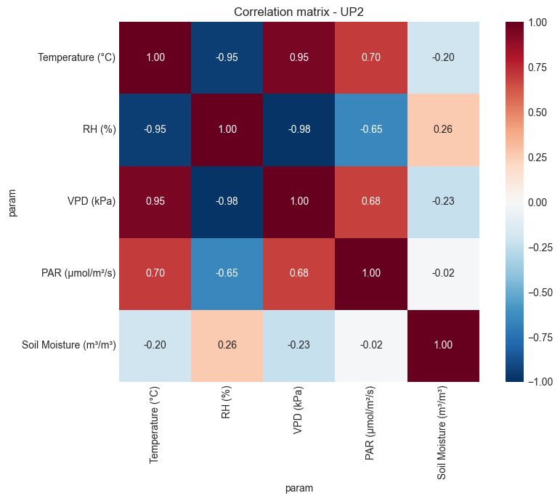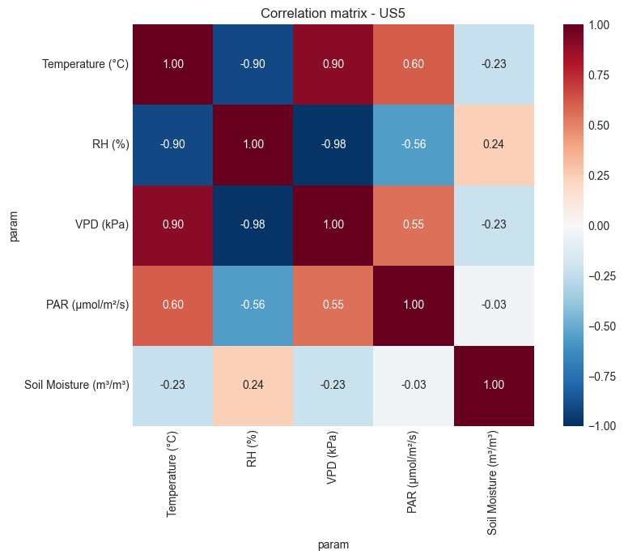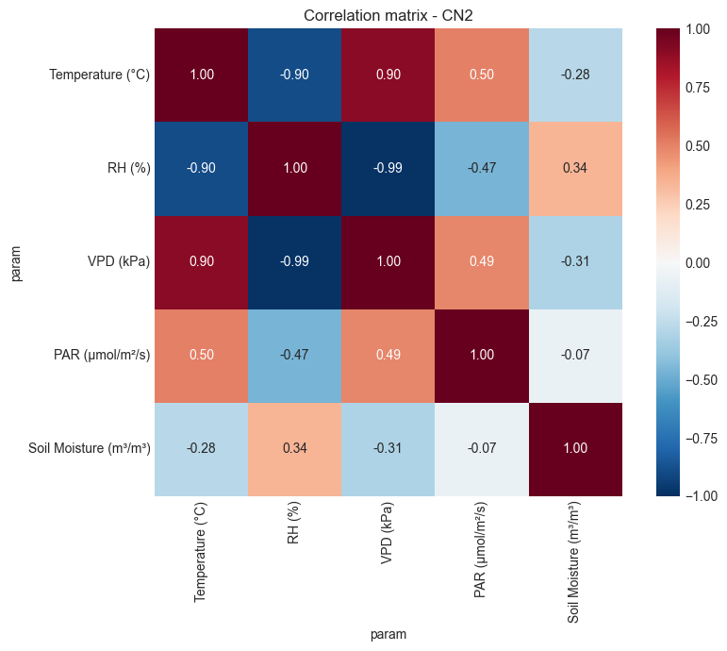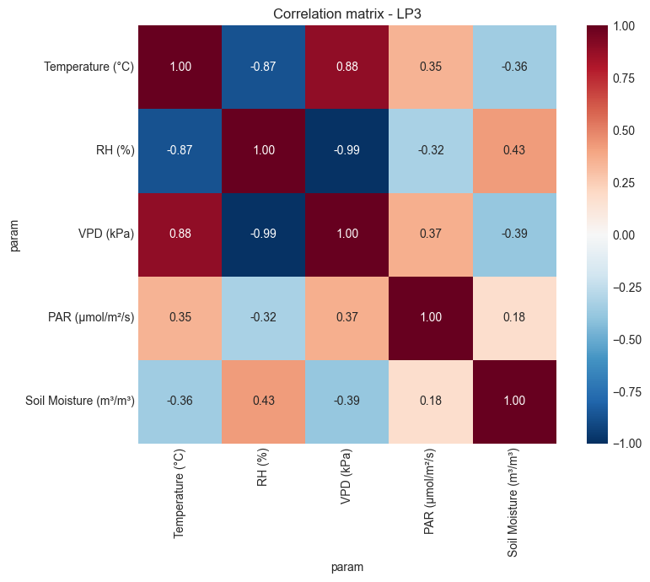
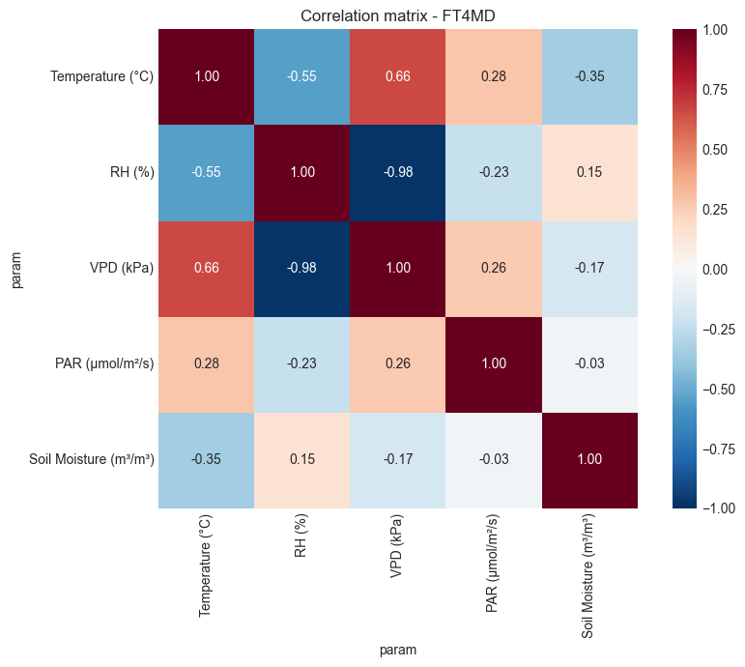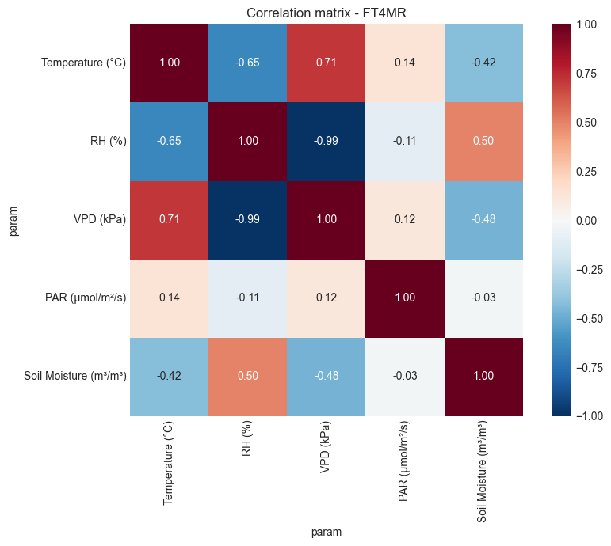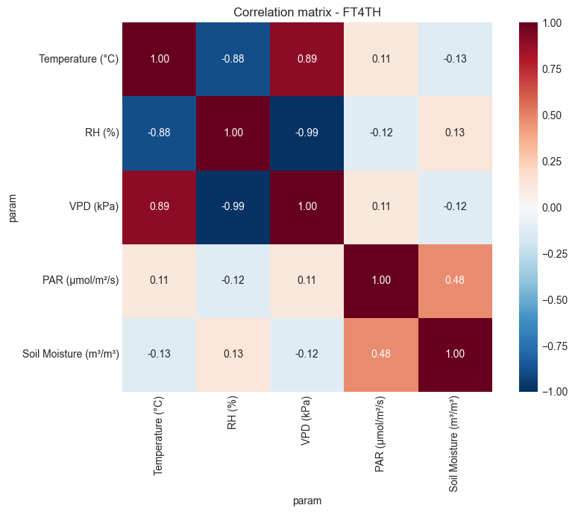
Figure 24: Per-site correlation heatmaps for UP2, US5, CN2, LP3, FT4MD, FT4MR and FT4TH (left to right, top to bottom). LP3 shows the strongest atmospheric–soil moisture coupling; FT4MR shows the weakest.

This site-to-site variation in coupling strength has a direct implication for the modelling approach in Phase 3. A single global model trained on all sites together is likely to underfit both the strongly coupled sites (LP3) and the weakly coupled ones (FT4MR). Forest-type-stratified or site-aware models are expected to perform better, and this will be tested systematically in the leave-one-site-out evaluation.

2.6 Challenges and Limitations
The following issues arose during the first phase of the project and are documented here both for completeness and because several remain relevant to the design of the Phase 3 work.
Data reshaping complexity. Working with a long-format dataset of this size required careful attention to the pivot logic. Matching records from different parameters by timestamp and site is straightforward in principle but produces subtle errors if sensor timestamps are not perfectly aligned — for example, a sensor logging at :00 versus another logging at :30 would produce empty or duplicated rows in the wide-format table if the join is done without appropriate tolerance. This was identified and resolved, but it added time to the early analysis phase.
Anomalous site behaviour. Two sites — US5 and FT4TH — exhibit microclimate characteristics that do not fully match their forest type classifications. US5 (labelled FT1) records temperatures and RH values more consistent with FT2; FT4TH (labelled FT4) receives PAR levels comparable to an FT1 or FT2 site. Based on the data alone, the most plausible explanations are localised canopy cover at US5 and a tree-fall gap or clearing near the FT4TH sensor location. The LiDAR data planned for Phase 3 should allow these hypotheses to be tested objectively. In the interim, both sites are retained in the dataset but flagged for sensitivity analysis during the modelling phase.
Uneven sensor coverage. PAR instruments are absent or have sparse records at certain plots, and soil moisture coverage is lower than the atmospheric variables. Any model that incorporates PAR as an input is therefore restricted to the subset of plots where PAR records are available, which limits the training data for PAR-inclusive analyses.
Absence of rainfall records. The dataset does not include precipitation measurements. Soil moisture drydown can be characterised post-event — identifying when drying begins and quantifying its rate — but predicting when a recharge event will occur requires external rainfall data. Obtaining a complementary precipitation record from the Singapore Meteorological Service is planned for Phase 3 to support the soil moisture prediction model.

Chapter 3 Future Work

3.1 Remote Sensing Data Integration
The most significant development in the second half of the project is the integration of airborne remote sensing data from drone-based mapping surveys of the CCNR. This data provides a structural characterisation of the forest canopy — canopy height, vertical layering, cover fraction and vegetation density — that the ground-level microclimate sensors alone cannot supply. Canopy structure is expected to be a critical explanatory variable in the predictive models because it directly controls how much solar radiation reaches the understory, how wind is intercepted and how soil moisture is regulated through transpiration and litter accumulation. Prior work has demonstrated that LiDAR-derived structural metrics, combined with field survey data, can meaningfully predict the minimum, maximum and mean of near-ground thermal conditions across forest types with differing disturbance histories [2], and that satellite observations of forest structure and topographic variables can be used to estimate near-ground temperatures at landscape scale [3].
The recently received dataset comprises two modalities: LiDAR point clouds and multispectral orthomosaic imagery from missions flown over the Chestnut/Mandai region in March 2026, covering three of the seven monitoring sites (FT4MD, US5 and CN2). A fourth site (LP3) was surveyed separately in December 2024 and its data is already available. For the remaining three sites (FT4MR, FT4TH and UP2), a comparable dataset is available through a Singapore Land Authority (SLA) archive, access to which is being coordinated and is expected to be resolved during Phase 3.
The planned processing workflow for the remote sensing data is as follows:
- Site identification and georeferencing: The March 2026 dataset labels survey zones as "Location 1" through "Location 7" without explicit station names. Matching each zone to its corresponding microclimate station will be done by overlaying the GeoTIFF orthomaps, KML station files and a Google Satellite background layer in QGIS, using GPS coordinates to achieve an unambiguous match.
- Region of interest cropping: Once stations are identified, the orthomaps and LiDAR point clouds will be cropped to 72 × 72 m squares centred on each station location. This window encloses the outer octagon of the sensor deployment area and covers approximately 0.5 ha — the minimum analysis unit specified for this project.
- LiDAR feature extraction: From the point clouds, the following metrics will be derived using standard algorithms: canopy height model (CHM), canopy cover fraction at multiple height thresholds (e.g., >2 m, >5 m, >10 m), point density profiles and vertical stratification index.
- Multispectral feature extraction: From the M3M orthomosaic imagery, vegetation spectral indices will be computed: NDVI, red-edge NDVI (RE-NDVI), green NDVI and normalised difference red-edge index (NDRE). These indices are sensitive to canopy density, chlorophyll content and vegetation water stress.
- Feature integration: The extracted canopy and spectral features will be merged into the microclimate modelling dataset, keyed by plot identifier, for use as predictor variables in the Phase 3 models.

One particular benefit of the canopy structure data is that it provides an objective basis for investigating the anomalous sites discussed in Section 2.6. If FT4TH shows significantly lower canopy closure in the LiDAR data compared to FT4MD or FT4MR, that would provide direct structural evidence for the canopy gap hypothesis. Similarly, higher canopy cover at US5 relative to UP2 would help explain its unexpectedly temperate microclimate for an FT1 classification.

3.2 Predictive Modelling
Building and validating predictive models for the five microclimate variables is the primary technical objective of Phase 3. The EDA and correlation analysis from Phase 2 have established the targets and identified the most informative predictor variables; the remote sensing integration described above will add canopy structural features as a new predictor class. The modelling approach will proceed through the following stages.
Baseline models. Linear regression and gradient-boosted tree models will be trained on temporal features (hour of day, day of year, lagged values of the target variable), site-level categorical features and the canopy structural metrics from the remote sensing data. These baselines establish the performance floor against which more complex models are compared.
Feature engineering. Cross-parameter lagged features will be explored — for example, yesterday's VPD as a predictor of today's soil moisture, or rolling 7-day mean RH as an input to the temperature model. Canopy structural metrics (CHM, cover fraction, NDVI) will be incorporated at the site level.
Sequence models. For temperature and relative humidity, where autocorrelation is strong and diel patterns are clear, a Long Short-Term Memory (LSTM) or temporal convolutional network will be evaluated against the gradient-boosted baseline. The decision to invest in a sequence model will depend on whether the baseline achieves acceptable accuracy first.
Rainfall augmentation. Precipitation records from the Singapore Meteorological Service will be obtained and added as an exogenous input to the soil moisture model. Rainfall timing is the most important missing predictor for soil moisture recharge events.
All models will be evaluated using leave-one-site-out cross-validation: the model is trained on six sites and evaluated on the seventh, cycling through all seven. This is the most appropriate evaluation framework given the small number of sites and directly tests the generalisability required for the reforestation application. Primary metric: mean absolute error (MAE) on held-out sites. Secondary metric: R² on held-out sites.

3.3 Final Report and Validation
The full FYP report will be written in parallel with the Phase 3 modelling work. It will incorporate a literature review chapter — covering prior work on tropical forest microclimate, machine learning approaches to environmental prediction and remote sensing for forest characterisation — that was deferred during Phase 1 and 2 to focus on analysis. All code, trained models and key outputs will be version-controlled and documented to a level that allows reproduction of the results. The findings from Phase 2 will be interpreted in light of the broader ecological literature, and any assumptions embedded in the modelling will be stated explicitly.

Chapter 4 Conclusion
The first half of this project has established a solid analytical foundation for the work ahead, and this interim report documents that foundation in enough detail to evaluate it independently.
The core finding from the exploratory analysis is that the microclimate gradient across Singapore's CCNR forest types is real, consistent and quantitatively substantial. Moving from open FT1 habitat to mature primary forest (FT4), mean VPD drops by a factor of 2.7 and mean PAR by a factor of 37. Temperature differences in absolute terms are more modest — roughly 1–2°C between the extreme sites — but the differences in daily variability and in the frequency of high-stress events are much larger. These are not marginal variations; they represent meaningfully different growing environments that directly constrain which plant species can establish and how quickly ecological recovery can proceed.
The soil moisture drydown analysis produced the most unexpected result of the semester. LP3 (late secondary forest, FT3) dries faster than any other site in the network — faster even than the open FT1 sites — despite having a higher mean moisture level. This result is consistent across 28 independently detected drydown events and is not a modelling artefact. The most plausible mechanistic explanation is that LP3's denser vegetation drives higher transpiration-mediated water loss relative to the more open sites, where drying is dominated by surface evaporation. The LiDAR and multispectral data from the March 2026 survey will allow this hypothesis to be tested structurally.
Two sites — US5 and FT4TH — show microclimate characteristics that do not fully match their forest type classifications, and both remain open questions. Whether these reflect genuine ecological complexity at those locations or are artefacts of sensor placement is not determinable from the microclimate data alone; the remote sensing data should help resolve this.
The correlation analysis confirms that atmospheric variables and soil moisture are moderately coupled across the network, with the strength of coupling varying meaningfully across sites. LP3 shows the tightest coupling; the primary forest site FT4MR shows the weakest. This heterogeneity in coupling strength is directly relevant to the modelling approach — it suggests that site-stratified or forest-type-aware models will outperform a single global model, a hypothesis that the leave-one-site-out evaluation in Phase 3 will test formally.
Looking ahead, Phase 3 has two primary deliverables: a set of validated predictive models for the five microclimate variables, and a processed canopy structural dataset from the remote sensing missions. Together, these will form the basis for the final model suite and the reforestation assessment application. The analytical groundwork laid in Phase 1 and 2 has produced clear targets, identified the key predictors and flagged the main uncertainties. The aim now is to resolve those uncertainties through modelling.

References
[1] C. D. Marsh, R. A. Hill, M. G. Nowak, E. Hankinson, A. Abdullah, P. Gillingham, and A. H. Korstjens, “Measuring and modelling microclimatic air temperature in a historically degraded tropical forest,” Agricultural and Forest Meteorology, vol. 327, p. 109200, 2022.
[2] B. Blonder, C. Morrow, B. Maitner, D. Harris, C. Lamanna, C. Violle, B. Enquist, and A. Kerkhoff, “New approaches for delineating n-dimensional hypervolumes,” Methods in Ecology and Evolution, vol. 9, no. 7, pp. 1–14, 2018.
[3] A. Ismaeel, M. Jonard, and Q. Ponette, “Satellite observations of forest structure and topographic variables to estimate near-ground air temperatures within forests,” Remote Sensing of Environment, 2024.

Abbreviations
Term | Definition
CCNR | Central Catchment Nature Reserve — Singapore's largest protected forest area
CHM | Canopy Height Model — a raster surface derived from LiDAR point clouds representing the elevation of the top of the canopy above ground
FT1–FT4 | Forest Types 1 through 4, representing a successional gradient from open edge and grassland (FT1) to mature primary dipterocarp forest (FT4)
LiDAR | Light Detection and Ranging — an active remote sensing method producing georeferenced 3D point clouds of vegetation structure
LSTM | Long Short-Term Memory — a type of recurrent neural network architecture suited to sequential time-series data
MCAR | Missing Completely At Random — a pattern of data missingness with no systematic relationship to measured or unmeasured variables
NDVI | Normalised Difference Vegetation Index — a spectral index of vegetation greenness derived from near-infrared and red reflectance
PAR | Photosynthetically Active Radiation — photon flux density in the 400–700 nm waveband (μmol/m²/s)
RH | Relative Humidity — the ratio of actual to saturation water vapour pressure, expressed as a percentage
SM | Soil Moisture — volumetric water content of the soil (m³/m³)
VPD | Vapour Pressure Deficit — the difference between saturation and actual vapour pressure (kPa); a direct index of atmospheric evaporative demand

