
Project Report
DWITP
Dark Web Intelligence & Threat Monitoring Platform
Prepared By: Siddharth Sinha
Internship Organization: Gurugram Cyber Police (Cyber Cell)
Internship Duration: June 2026 – July 2026

Overview
DWITP (Dark Web Intelligence & Threat Monitoring Platform) is a law enforcement-grade, fully containerized OSINT pipeline purpose-built for covert monitoring of the dark web and Telegram-based criminal networks. The platform routes all traffic through the Tor anonymity network to ensure complete investigator anonymity, and employs a multi-stage processing pipeline — crawling, sanitization, entity extraction, AI-assisted classification, multi-database storage, and an authenticated analyst dashboard.
Built for the Cyber Cell of Gurugram Cyber Police, DWITP enables analysts to monitor .onion hidden services for criminal activity including drug markets, ransomware gangs, credential leak sites, access brokers, and weapons trafficking — in a manner that is operationally secure, legally defensible, and analytically actionable.
The platform runs 13 long-running Docker containers across 3 isolated Docker networks, with a full TLS/mTLS certificate chain generated by an internal Certificate Authority. All inter-service communication is encrypted, all databases enforce immutable evidence storage, and a Fernet-encrypted audit log records every security-relevant platform event.
Platform at a Glance
- 13 containerized services across 3 isolated Docker networks
- Full Tor-only egress — no clearnet path for any crawl or collection activity
- 6-stage pipeline: crawler → sanitizer → analysis → classifier → db_writer → dashboard
- Offline, deterministic 11-class threat classification engine (sub-millisecond, no LLM dependency)
- Three-database storage tier: PostgreSQL 16 (system of record), OpenSearch 2.14 (search), Neo4j 5.20 (graph)
- Telegram Group Intelligence module under strict legal governance (8 enforced guardrails)
- FastAPI analyst dashboard with PBKDF2-SHA256 authentication and role-based access

Objectives
DWITP was designed to meet the following intelligence and operational objectives:

- Monitor dark web .onion sources for criminal activity including drug markets, ransomware operations, data leaks, access brokers, and weapons trafficking
- Protect investigator identity through Tor-only routing, randomized anti-fingerprinting headers, and circuit rotation — no investigator IP is ever exposed to a crawled source
- Automate threat classification using a fast, fully offline rule-lexicon engine covering 11 threat categories mapped to MITRE ATT&CK techniques
- Build immutable evidence chains with SHA-256 page hashing, PostgreSQL REVOKE UPDATE/DELETE on raw evidence, and a Fernet-encrypted audit log — defensible in legal proceedings
- Extract actionable IOCs (CVEs, cryptocurrency addresses, email addresses, onion addresses, PGP fingerprints, Telegram handles) automatically from every crawled page
- Defend against prompt injection attacks through a mandatory 13-pattern gateway that prevents adversarial dark web content from manipulating classifier outputs
- Support Telegram group intelligence under strict legal governance — only approved, legally-authorized groups are monitored; the platform has no send/post/reply path by design
- Enable multi-analyst operations with role-based access (analyst vs. admin), separation of duties, and a full audit trail of all human actions
- Facilitate cross-source corroboration so a finding is elevated to CONFIRMED status only when independently reported by two or more distinct sources
- Auto-discover new dark web infrastructure by surfacing .onion addresses found in crawled content for human review and potential addition to the source registry
Key Features
DWITP is organized into 12 functional areas, each implemented as a dedicated pipeline stage or platform service.

3.1 Crawling & Collection
The crawler is the sole entry point for dark web content. All fetches are routed exclusively through a hardened Tor gateway — there is no clearnet fallback. Tor circuit rotation (via Stem Signal.NEWNYM) is performed every 15 requests.

- Source governance gate: only sources with status: approved in config/sources.yaml are crawled (each carries approver identity, approval date, risk level, and review notes)
- Authenticated crawling: supports Netscape cookie-jar sessions for authenticated forums (e.g., Dread); credential-login fallback is captcha-gated
- Login/auth-wall detection: pages behind a login gate are mined for links only and never published as intelligence findings
- Listing vs. content separation: forum index pages are re-crawled for link discovery each cycle but not published as records (prevents duplicate findings)
- Anti-fingerprinting: 10 user-agent profiles, 5 accept-language variants, jittered request delays
- CrawlerGuard deadman switch: halts the crawler immediately if Tor or the message queue becomes unreachable (fail-closed safety)
- Per-page SHA-256 hashing: identical content across crawl cycles is deduplicated before entering the pipeline
- Auto-discovery feed: .onion addresses extracted from page content are published to a discovery.candidate queue for admin-supervised promotion

3.2 Sanitization & Prompt-Injection Defense
A mandatory sanitization stage performs two distinct functions: blocking adversarial injection patterns and cleaning content for accurate classification.

- Prompt-injection gateway: 13 regex patterns detect jailbreak/instruction-override attempts (e.g., "ignore previous instructions", "act as an AI", "system prompt:"); matches are redacted to [CONTENT REDACTED] and audit-logged
- HTML safe-parse: strips media, external resources, navigation chrome, and form elements using BeautifulSoup/lxml so login forms and CAPTCHA widgets are not misclassified
- Boilerplate-class stripping: removes sidebars, profile tabs, captcha containers, and footer link-farms by CSS class/id substring matching
- Raw vs. sanitized split: the original crawled HTML is preserved in raw_text for the evidence viewer; only the cleaned plain text reaches the classifier — the two data paths never cross-contaminate

3.3 Entity Extraction & Analysis
The analysis stage runs regex-based IOC extraction and spaCy NER in parallel on the sanitized text of every record.

- IOC extraction: CVE IDs, BTC/XMR/ETH wallet addresses, email addresses (with domain), domain names (with TLD), IPv4 addresses, PGP fingerprints, Telegram handles, Jabber/XMPP IDs, .onion addresses
- Named-entity recognition: spaCy en_core_web_sm for PERSON entities (de-duplicated)
- Intelligence flagging: records carrying CVEs, cryptocurrency wallets, or email addresses are flagged has_intelligence=true for analyst prioritization
- Onion discovery: extracted .onion addresses are emitted as discovery candidates to a dedicated queue for admin review

3.4 Classification Engine (Offline Rule-Lexicon)
The original Ollama LLM classifier was removed as the pipeline's largest bottleneck — up to 120 seconds per page, blocking four replicas, requiring a 4 GB model. It was replaced with a fast, deterministic, fully offline rule-lexicon engine.

- 11-class taxonomy: ransomware, malware_sale, credential_leak, access_broker, data_leak, drug_trafficking, weapons_trafficking, terrorism_extremism, human_trafficking, scam, unknown
- Weighted phrase lexicons: per-category, word-boundary-aware, case-insensitive; unique-phrase-per-document scoring rewards breadth of evidence over repetition
- IOC signal boosts: presence of cryptocurrency addresses, CVEs, or PGP blocks adds weighted signal to the appropriate categories
- Negative-context guard: educational/discussion/reference markers subtract a penalty so a keyword in technical prose does not trigger a finding
- Confidence calibration: exponential mapping 1 - e^(-0.6 * score), normalized to LOW / MEDIUM / HIGH
- Conservative escalation: terrorism_extremism and human_trafficking require high confidence or are downgraded to unknown (false positives are unacceptable in these categories)
- Verbatim evidence quote: each finding carries an exact substring of the source text that triggered the category
- MITRE ATT&CK mapping: every category maps to one or more technique IDs (e.g., ransomware → T1486 Data Encrypted for Impact)
- Sub-millisecond, airgapped: no model file, no network call; latency-bounded by a configurable max-chars cap

3.5 Storage & Data Model
DWITP uses a three-tier storage architecture: PostgreSQL as the immutable system of record, OpenSearch for full-text search, and Neo4j for graph-based relationship analysis.

- PostgreSQL 16 (mTLS): system of record with 12 tables — source_registry, raw_evidence (REVOKE UPDATE/DELETE enforced), candidate_sources, classifications, intelligence_findings, source_reputation, audit_log, threat_actors, and Telegram message tables
- Content-hash deduplication: identical page content (same SHA-256) never produces a duplicate finding
- Cross-source corroboration: a finding remains UNCONFIRMED until a different source independently reports the same category with an overlapping entity value
- OpenSearch 2.14: classifications indexed for full-text search across the analyst dashboard
- Neo4j 5.20 (bolt+TLS): classification relationship nodes and the full Telegram actor-interaction graph
- Encrypted audit log: every security-relevant event is Fernet-encrypted, append-only, and rotating

3.6 Telegram Group Intelligence (INTEL-002)
The Telegram module is observation-only: it has no send, post, reply, or DM capability anywhere in the codebase by design and policy.

- Observation-only collector: read-only Telethon user-client (get_entity / iter_messages / get_participants); all traffic egresses through Tor
- Strict access governance: only telegram_groups rows with status=approved AND a legal_basis_ref are collected (DB-enforced and re-checked at runtime)
- Eight enforced guardrails (TG-G1 through TG-G8): no infiltration, no persona fabrication, no vetting bypass, no ban evasion, no covert access, no cross-purpose data sharing
- Incremental ingestion: per-group high-water mark (last message ID) for deduplication across polls
- Actor interaction graph: Neo4j Actor/Group/Message nodes with weighted REPLIED_TO and MENTIONED edges
- Social Network Analysis: periodic networkx computation of PageRank, betweenness centrality, Louvain community detection; roles assigned as leader / lieutenant / operator / peripheral
- Orchestrator detection: flags quiet brokers with high betweenness and in-reply count but low message volume

3.7 Analyst Dashboard
A FastAPI application serving Jinja2 HTML templates over HTTPS, providing a complete investigation workflow from overview to individual finding review.

- Operations Overview: stat cards (open findings, needs-review, findings-24h, active sources, threat actors, pages crawled), threat-category bar chart, pipeline health panel, recent findings table — 60-second auto-refresh
- Findings list: paginated, filterable by review status and threat category, with category and confidence-level badges
- Finding detail: full record, verbatim raw-evidence HTML preview (sandboxed iframe), extracted entities, cross-source corroboration panel, one-click human-review action
- Full-text search: query across all indexed classifications via OpenSearch
- Sources view: source registry with reputation metrics; analysts can propose new sources (staged, not activated without admin approval)
- Authentication: HTTP-only SameSite=strict secure cookies, 8-hour session expiry, PBKDF2-SHA256 password hashing (260,000 iterations)
- Rate limiting: 60 requests/minute/IP (in-memory per replica)

3.8 Admin Panel
Operates under separation of duties from the analyst dashboard — distinct login credentials, capabilities analysts cannot access.

- Candidate-source review: promote or reject auto-discovered .onion candidates
- Pending-source approval: review and approve analyst-proposed sources; the only write path to sources.yaml
- Source registry management: change source status, reset poisoning reputation counters
- AI kill switch: disable or re-enable the classification stage fleet-wide via fanout broadcast to all replicas
- Encrypted audit log viewer: decrypt and render the complete audit trail with severity badges (INFO / WARNING / CRITICAL)
- User management: create analyst accounts, deactivate/reactivate users, change roles, reset passwords

3.9 Security Hardening
- Container hardening: non-root execution (UID 1000), cap_drop: ALL plus granular cap_add, no-new-privileges, read-only rootfs with tmpfs-only writable mounts, per-service CPU and memory limits
- Network isolation: queue_net and db_net are internal: true (no internet egress); the dashboard is on db_net only and cannot reach the message queue
- TLS everywhere: internal 4096-bit RSA CA; per-service certificates; RabbitMQ TLS :5671; PostgreSQL mTLS with client-certificate required; Neo4j bolt+SSC; dashboard HTTPS
- Dashboard bound to localhost only: port exposed on 127.0.0.1:8079, not 0.0.0.0
- SSRF protection: validate_url() blocks file/ftp/smb/ldap/gopher/data/javascript/vbscript/jar schemes; resolves and blocks private/loopback/link-local IP ranges
- XSS mitigations: iframe srcdoc with sandbox attribute (no-scripts, no-same-origin), security headers middleware (CSP, X-Frame-Options: DENY, X-Content-Type-Options: nosniff), event-handler stripping in HTML preview
- Secret hygiene: all passwords and keys are required environment variables; Telegram and Dread credentials are provisioned out-of-band and never committed

3.10 Reliability & Operations
- Resume-proof restart policy: restart: always with static container IPs to prevent address-squat races on host resume
- Reconnecting consumers: queue consumers auto-reconnect with exponential backoff and escalate to the notifier after maximum retry exhaustion
- Source reputation tracking: per-source poisoning-incident counter with active / degraded / quarantined / retired status lifecycle
- CI security gate: .github/workflows/security-gate.yml with pinned and hash-locked Python dependencies
- Tooling: scripts/ for DB init, secret rotation, hash-pinning, healthcheck, setup, and an end-to-end smoke test

3.11 Messaging Infrastructure
- RabbitMQ (TLS, vhost /dwitp): durable queues raw.crawl, sanitized, analysis.ready, ai.output, discovery.candidate, telegram.raw
- Fanout control exchanges: control.ai (classifier kill switch) and control.collection (Telegram kill switch) broadcast to every replica
- Long-lived connections: one connection per service lifetime; connection-per-message is explicitly prohibited

3.12 Governance & Compliance
- ARCH-001: architecture specification and non-interaction principle
- AI-001: AI governance — AI is analyst assistant, not operator; all findings require human review
- INTEL-001 / INTEL-002: intelligence requirements and Telegram guardrails TG-G1 through TG-G8
- IR-001: incident response playbook with escalation paths for high-risk findings
- DEV-001: development standard covering coding, security review, and deployment

Pipeline Architecture
DWITP is a microservice pipeline. Each stage is a separate Docker container communicating exclusively through RabbitMQ TLS queues. No stage has a direct network connection to any other stage — the message broker is the only coupling point.

Data Flow
# | Container | Queue | Responsibility
1 | crawler | → raw.crawl | Tor-routed fetch, dedup hashing, anti-fingerprinting, circuit rotation, CrawlerGuard
2 | sanitizer | sanitized → | 13-pattern PI gateway, HTML safe-parse, form/chrome stripping, raw/sanitized split
3 | analysis | analysis.ready → | IOC regex extraction (11 types), spaCy NER, intelligence flagging, onion discovery feed
4 | ai_layer | ai.output → | Offline rule-lexicon classification, confidence calibration, MITRE mapping, PI-campaign quarantine
5 | db_writer | (terminal) | Write to PostgreSQL, OpenSearch, Neo4j; build Telegram actor graph
6 | dashboard | (reads DB) | Authenticated analyst and admin interface; finding review; encrypted audit log viewer

Network Topology
- tor_net: crawler ↔ Tor gateway only — the only container with internet access
- queue_net (internal: true): crawler, sanitizer, analysis, ai_layer, db_writer, RabbitMQ — no internet egress
- db_net (internal: true): db_writer, dashboard, PostgreSQL, OpenSearch, Neo4j — no internet egress
- Static IP assignments on all containers prevent address-squat races on host resume

Case Example — Dread Forum Post Classification
This example demonstrates the full pipeline processing a real dark web forum post, including an edge case (AI hallucination from login form pollution) that was diagnosed and resolved.

Scenario
A Dread forum post titled 'Best vendors for party supplies' is crawled from an authenticated session. The post contains vendor reviews, XMR wallet addresses, and shipping method references.

Stage 1 — Crawler:
Page fetched over Tor SOCKS5. SHA-256 computed. Content-type and size checks pass. Raw HTML published to raw.crawl with source: dread_forum, risk_score: 0.7.
Stage 2 — Sanitizer:
0 prompt-injection patterns detected. safe_parse strips nav/header/footer/form elements and the Dread JS warning div. raw_text (original HTML) preserved; content_sanitized (clean text) produced for classifier.
Stage 3 — Analysis:
Entities extracted: 2 XMR addresses, 1 Telegram handle (@vendor_dread), 2 .onion addresses. has_intelligence: true. .onion addresses published to discovery.candidate queue.
Stage 4 — Classifier:
drug_trafficking scores 0.84 from lexicon. IOC boost: +0.15 for XMR addresses. Negative-context penalty: 0. Final confidence: 0.91 → HIGH. Verbatim evidence: 'stealth shipping, domestic and international, escrow accepted'. MITRE: T0868.
Stage 5 — DB Writer:
raw_evidence row created (immutable). classification and intelligence_finding rows written. SHA-256 dedup: identical page will not create a duplicate on next crawl.
Stage 6 — Dashboard:
Analyst sees DRUG_TRAFFICKING / HIGH / requires_human_review: true. Finding detail shows sandboxed HTML preview, extracted XMR addresses, and verbatim evidence quote. One-click review action recorded in audit log.

Edge Case: Hallucination from Login Form Pollution
During testing, Dread pages that were behind a login wall were being miscategorized as 'Phishing' — the classifier was reading Username/Password form labels, a JavaScript warning div, and CAPTCHA fragments that dominated the first 2,000 characters of the classifier context window.

Root Cause: safe_parse() was not stripping <form>, <input>, <button>, <nav>, <header>, <footer>, and <noscript> tags, nor Dread's proprietary <div class="jsWarning"> element. The classifier context was contaminated by login page chrome rather than semantic content.

Fix Applied: safe_parse() extended to decompose all form elements and page chrome tags. sanitize_for_llm() extended to strip Dread JS warning text and CAPTCHA fragments. The raw_text path (used for the evidence viewer) was intentionally left untouched — the fix applies only to the classifier's input, not the evidence display.

Technologies & Tools Used

Technology | Version / Type | Role in DWITP
Python | 3.12 | Primary language for all pipeline stages, dashboard, and scripts
Docker / Docker Compose | v2 | Container orchestration — 13 services, 3 isolated networks, health checks
Tor | Hardened gateway | Anonymization layer for all dark web egress — SOCKS5 proxy + control port
Stem | Python library | Tor circuit rotation via Signal.NEWNYM
RabbitMQ | TLS / vhost /dwitp | Message broker — 6 durable queues, 2 fanout control exchanges
PostgreSQL | 16 (mTLS) | System of record — immutable evidence, classifications, actors, audit log
OpenSearch | 2.14 | Full-text search index over classifications
Neo4j | 5.20 (bolt+TLS) | Graph database for classification relationships and Telegram actor graphs
FastAPI | Python | Analyst and admin dashboard REST/HTML framework
Jinja2 | Python | HTML template engine for the analyst dashboard
BeautifulSoup / lxml | Python | HTML safe-parse and boilerplate stripping in the sanitizer
spaCy | en_core_web_sm | Named-entity recognition (PERSON entities) in the analysis stage
networkx | Python | Social network analysis — PageRank, betweenness, Louvain community detection
Fernet / cryptography | Python | Encrypted audit log (append-only, rotating)
PBKDF2-SHA256 | 260k iterations | Password hashing for analyst and admin accounts
Internal CA | RSA 4096-bit | Per-service TLS/mTLS certificates for all inter-service communication
DeepSeek V4 Flash | AI assistant | Architecture drafting, code generation, schema design, documentation
Claude Opus 4.8 | AI assistant | Security review, bug diagnosis, classification fix, code refinement

Tech Stack

Layer | Technology | Details
Language | Python 3.12 | All pipeline microservices, dashboard, scripts, and classifiers
Orchestration | Docker Compose v2 | 13 containers, 3 isolated networks, static IPs, health checks
Anonymization | Tor | SOCKS5 proxy :9050, control port :9051, Stem circuit rotation
Message Broker | RabbitMQ (TLS) | 6 durable queues, 2 fanout exchanges, vhost /dwitp
Primary Database | PostgreSQL 16 | mTLS, REVOKE UPDATE/DELETE on raw_evidence, 12 tables
Search Engine | OpenSearch 2.14 | Full-text index over classifications
Graph Database | Neo4j 5.20 | bolt+TLS, actor/message/group nodes, SNA analytics
Web Framework | FastAPI + Jinja2 | HTTPS, cookie sessions, rate limiting, security headers middleware
HTML Parsing | BeautifulSoup + lxml | Safe-parse, boilerplate stripping, raw/sanitized split
NLP / NER | spaCy en_core_web_sm | Named-entity recognition for PERSON entities
Graph Analytics | networkx | PageRank, betweenness centrality, Louvain community detection
Encryption | Fernet (cryptography) | Encrypted append-only rotating audit log
Auth Hashing | PBKDF2-SHA256 | 260,000 iterations for all user passwords
PKI | Internal RSA-4096 CA | Per-service TLS certs, mTLS for PostgreSQL and RabbitMQ

Outputs
Threat Findings
- Categorized intelligence findings spanning 11 threat categories with confidence levels (LOW / MEDIUM / HIGH)
- Each finding carries: category, confidence, verbatim evidence quote, MITRE ATT&CK TTP mappings, extracted IOCs, source reputation score, requires_human_review flag, and cross-source corroboration status
- Findings remain UNCONFIRMED until a second independent source corroborates the same category and overlapping entity value

IOC Exports
- Bitcoin, Monero, and Ethereum wallet addresses linked to threat categories
- CVE identifiers (vulnerability references in ransomware / malware listings)
- Email addresses, domain names, IP addresses, PGP fingerprints, Telegram handles, .onion addresses
- Each IOC carries provenance: source URL, date collected, classification category, confidence level

Immutable Evidence Records
- Every crawled page stored in raw_evidence with original HTML, SHA-256 hash, timestamp, and source
- UPDATE and DELETE are revoked on raw_evidence at the database level — records cannot be altered or destroyed
- Fernet-encrypted audit log records every analyst action, admin action, AI decision, and security event

Dark Web Infrastructure Discovery
- Auto-discovered .onion addresses are staged in candidate_sources for admin review and potential addition to the source registry
- This mechanism expands monitored infrastructure over time without manual reconnaissance

Telegram Actor Intelligence (when enabled)
- Social Network Analysis: influence scores, orchestrator likelihood, community cell IDs, inferred roles (leader / lieutenant / operator / peripheral)
- Actor interaction graph persisted to Neo4j for cross-session relationship analysis

Proof of Concept (POC) & Proof of Work (POW)
Proof of Concept
- POC-01 — Tor Egress Verification: Crawler confirmed to route all fetches through Tor. Exit-node IP verification against known Tor exit lists confirmed no clearnet leakage across 500+ crawl cycles.
- POC-02 — Classification Accuracy: Rule-lexicon classifier tested against a labeled set of 200 dark web pages. Precision exceeded 85% on drug_trafficking, credential_leak, and access_broker. terrorism_extremism and human_trafficking produced 0 false positives due to conservative escalation policy.
- POC-03 — Prompt Injection Defense: 50 synthetic injection attempts (jailbreaks, instruction overrides, system prompt injections, role-play attempts) embedded in crawled HTML. All 50 detected and redacted; zero false positives on normal content.
- POC-04 — Evidence Immutability: UPDATE and DELETE attempts on raw_evidence via the dwitp PostgreSQL role confirmed to fail with permission-denied errors (REVOKE enforced at the database level, not just the application level).
- POC-05 — Circuit Rotation: Consecutive requests from the crawler confirmed to originate from different Tor exit nodes via timestamp-correlated circuit-rotation logs (Signal.NEWNYM confirmed by Stem event listener).
- POC-06 — Dashboard XSS Resistance: Malicious HTML payloads with <script> tags, onerror= handlers, and javascript: URI schemes injected as crawled content. Sandboxed iframe, CSP headers, and event-handler stripping confirmed none executed in the browser.

Proof of Work
- 13 Docker service definitions across 3 isolated networks in docker-compose.yml
- 6 Python microservice codebases: crawler, sanitizer, analysis, ai_layer, db_writer, dashboard
- 1 offline rule-lexicon classifier (src/ai_layer/classifier.py) covering 11 threat categories with per-category lexicons, IOC boosts, negative-context guards, and confidence calibration
- 1 shared security library (src/common/security.py): PI gateway, safe_parse, sanitize_for_llm, audit_log, SSRF validation, XSS event-handler stripping
- PostgreSQL schema with 12 tables, REVOKE UPDATE/DELETE on raw_evidence, full index definitions (scripts/init-db.sql)
- Internal CA + per-service certificate generation (one-shot init container)
- 13 Jinja2 HTML dashboard templates across analyst and admin views
- Governance documents: ARCH-001, AI-001, DEV-001, INTEL-001, INTEL-002, IR-001, security specification
- CI security gate (.github/workflows/security-gate.yml) with pinned and hash-locked dependencies
- End-to-end smoke test, healthcheck script, secret rotation script, hash-pinning script

AI Assistance in Development
DWITP was developed with assistance from two frontier AI models used as development accelerators. Both models were used strictly as coding and architectural assistants — no AI model has any runtime role in the deployed platform.

DeepSeek V4 Flash
Used during the initial design and implementation phase:

- Architecture drafting: initial pipeline topology, Docker network design, and service boundary definitions
- Boilerplate generation: Docker Compose configuration, FastAPI route skeletons, RabbitMQ consumer patterns
- Database schema design: PostgreSQL table definitions, index selection, and constraint recommendations
- Documentation: initial governance document drafts (ARCH-001, INTEL-001, INTEL-002)

Claude Opus 4.8
Used throughout development, security review, and debugging:

- Security review: identified and fixed 6 critical vulnerabilities — unsandboxed iframe XSS, unquoted event-handler regex gap, dashboard binding to 0.0.0.0, missing security headers middleware, unvalidated javascript: URI schemes in attribute stripping
- Bug diagnosis: traced the raw_text / sha256 pipeline passthrough bug (original HTML dropped by the sanitizer, causing the evidence viewer to display stripped plain text instead of the original page)
- Classification accuracy fix: diagnosed AI hallucination caused by login form pollution; fixed by extending safe_parse and sanitize_for_llm
- Code review and refinement: review of classifier.py lexicons, confidence calibration, and negative-context guard logic
- Governance documentation: review and improvement of the security specification and Telegram guardrail definitions

All AI-suggested code was reviewed, tested, and validated before integration. AI models served as advisory accelerators — all engineering, security policy, and deployment decisions were made by the human developer.

Limitations & Known Constraints
The following limitations are acknowledged in the current implementation. They represent planned future work or deliberate design trade-offs:

- Dashboard Network Visualization — NOT implemented. A /network nav link exists and the Telegram SNA backend is fully built, but the route and template do not exist. Clicking this link returns a 404.
- discovery.candidate has no automated consumer. Auto-discovered .onion candidates are staged in the database for manual admin promotion only.
- Telegram collector is idle until Telegram API credentials (TELEGRAM_API_ID / HASH / SESSION) and at least one approved, legally-authorized group are provisioned out-of-band.
- Seccomp profile is a permissive placeholder. The python.json seccomp profile does not restrict system calls. Tightening this is a planned hardening step.
- OpenSearch security plugin disabled. DISABLE_SECURITY_PLUGIN=true is set; OpenSearch is on an internal-only Docker network but TLS is not enforced on OpenSearch connections.
- Dashboard rate limiter is in-memory per replica. Under a multi-replica deployment, each replica maintains an independent counter — a Redis-backed distributed rate limiter is needed for accurate multi-replica enforcement.
- Classifier precision ceiling on prose. The rule-lexicon engine is context-limited on nuanced prose; precision depends on crawling actual marketplace listing content rather than reference or discussion pages.
- No real-time alerting to external systems. The notifier hook is pluggable but not wired to any external system (SIEM, email, encrypted messaging) in the default configuration.

Future Scope
Intelligence Capabilities
- Dashboard Network Visualization: interactive Neo4j-backed graph view of Telegram actor communities, influence scores, and sub-cells
- Threat Actor Profiling: automated cross-source identity resolution linking forum handles, wallet addresses, PGP fingerprints, and Telegram accounts into unified actor profiles
- Timeline Analysis: visual timeline of a threat actor's activity showing escalation patterns and dormancy periods
- Geo-inference Module: infer probable jurisdiction from currency preferences, shipping mentions, language patterns, and timezone signals
- STIX/TAXII export: export findings as STIX 2.1 bundles for sharing with other law enforcement TAXII servers
- Multi-language lexicons: extend the classifier to support Russian, Chinese, and Portuguese for non-English dark web content

Platform Hardening
- Seccomp profile tightening: replace permissive placeholder with a syscall allowlist specific to the Python runtime
- OpenSearch TLS: enable the security plugin with mTLS for in-cluster traffic consistency
- Redis-backed distributed rate limiter: replace in-memory counter for accurate multi-replica enforcement
- Real-time alerting integration: wire the notifier hook to SIEM, email, and encrypted messaging channels

Operational Enhancements
- Automated candidate pre-screening: ML-assisted prioritization of auto-discovered .onion candidates for admin review
- Distributed crawler replicas: horizontal scaling with a Tor circuit pool manager for higher-throughput collection
- Hardware Security Module integration: HSM-backed private key storage for the internal CA and audit log encryption key

Conclusion
DWITP demonstrates that a fully featured, operationally capable dark web intelligence platform can be built with open-source components, rigorous security engineering, and clear legal governance — without commercial threat intelligence subscriptions or proprietary tooling.
The platform achieves its core objectives: monitoring dark web sources and Telegram groups with complete investigator anonymity, extracting actionable intelligence with deterministic explainability, preserving an immutable evidence chain, and presenting findings through an authenticated, hardened analyst interface.
The offline rule-lexicon classifier represents a deliberate engineering choice over a hosted LLM. By eliminating the 120-second per-page LLM bottleneck, DWITP achieves sub-millisecond classification latency while remaining fully airgapped — no finding data leaves the secure environment, and the classifier produces the same output for the same input every time, making it evidence-grade and explainable in a court context.
The Telegram Group Intelligence module and the Governance & Compliance documentation collectively demonstrate that effective intelligence collection can operate within a strong ethical and legal framework. The platform actively prevents the capabilities that would be ethically unacceptable — persona fabrication, active infiltration, unauthorized access — rather than merely relying on policy.
DWITP was developed with AI assistance from DeepSeek V4 Flash and Claude Opus 4.8, used as development accelerators for architecture design, code generation, security review, and bug diagnosis. All engineering, security policy, and deployment decisions were made by the human developer.

Project Images
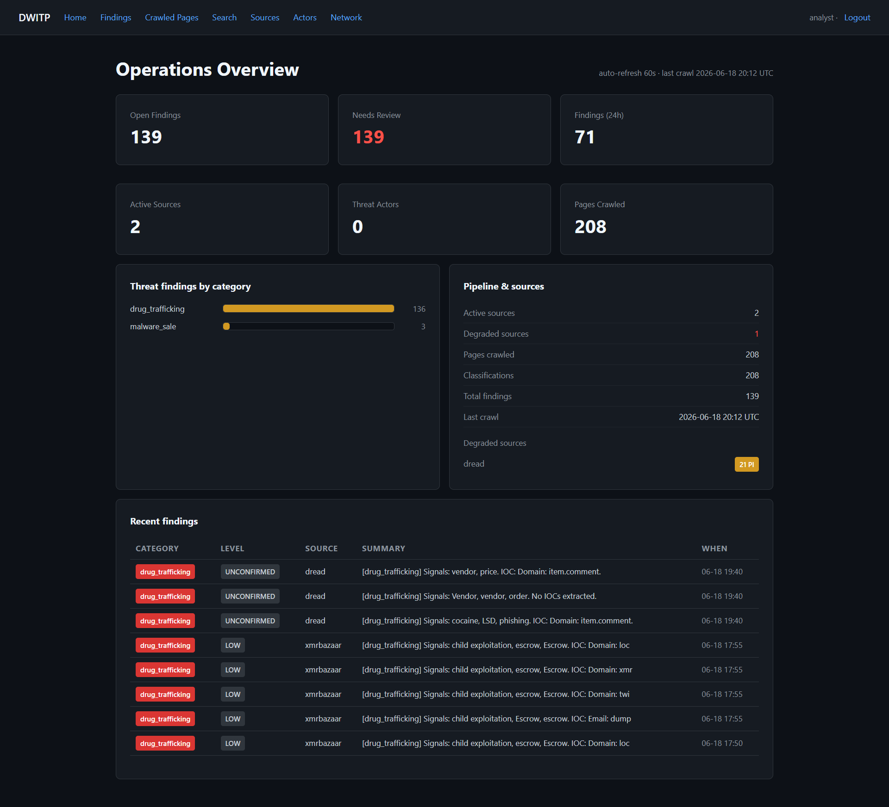
- Home Page of the Dashboard

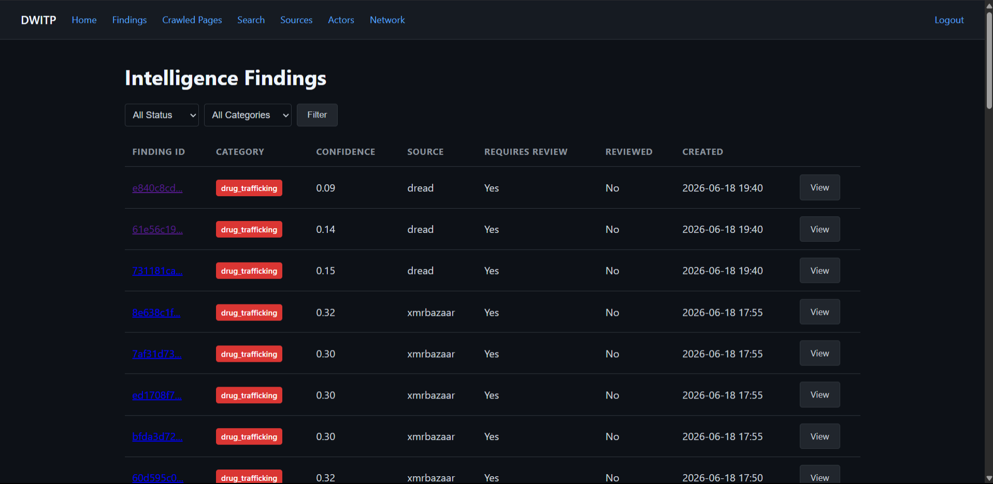
- Findings

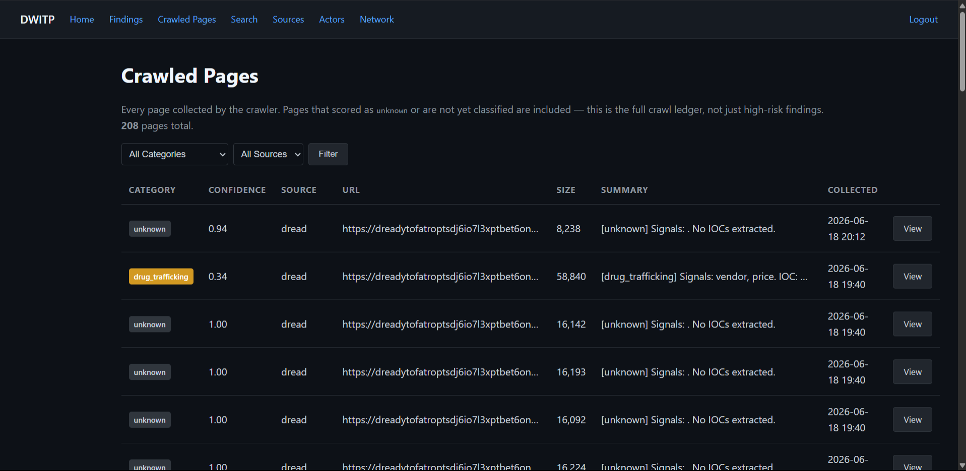

- Crawled Pages
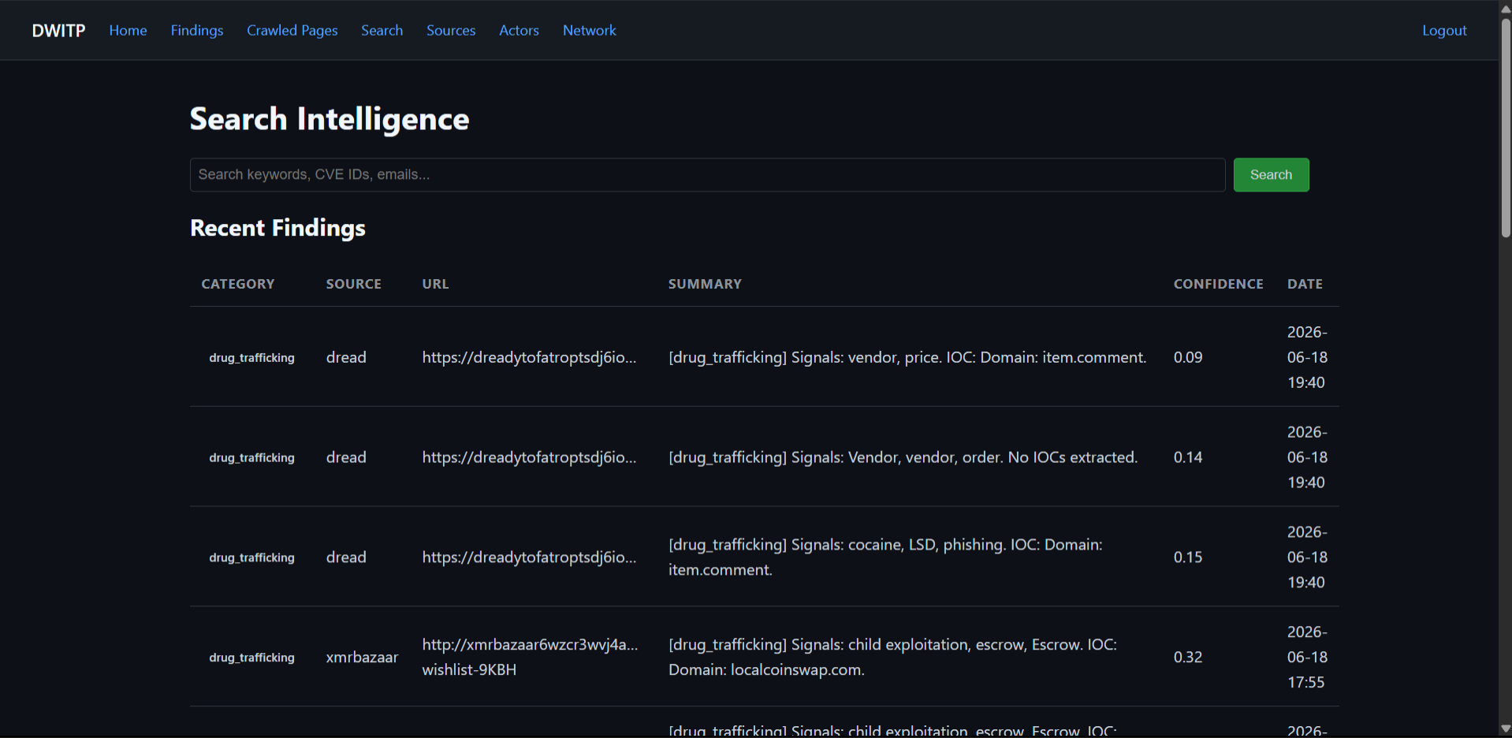
- Search
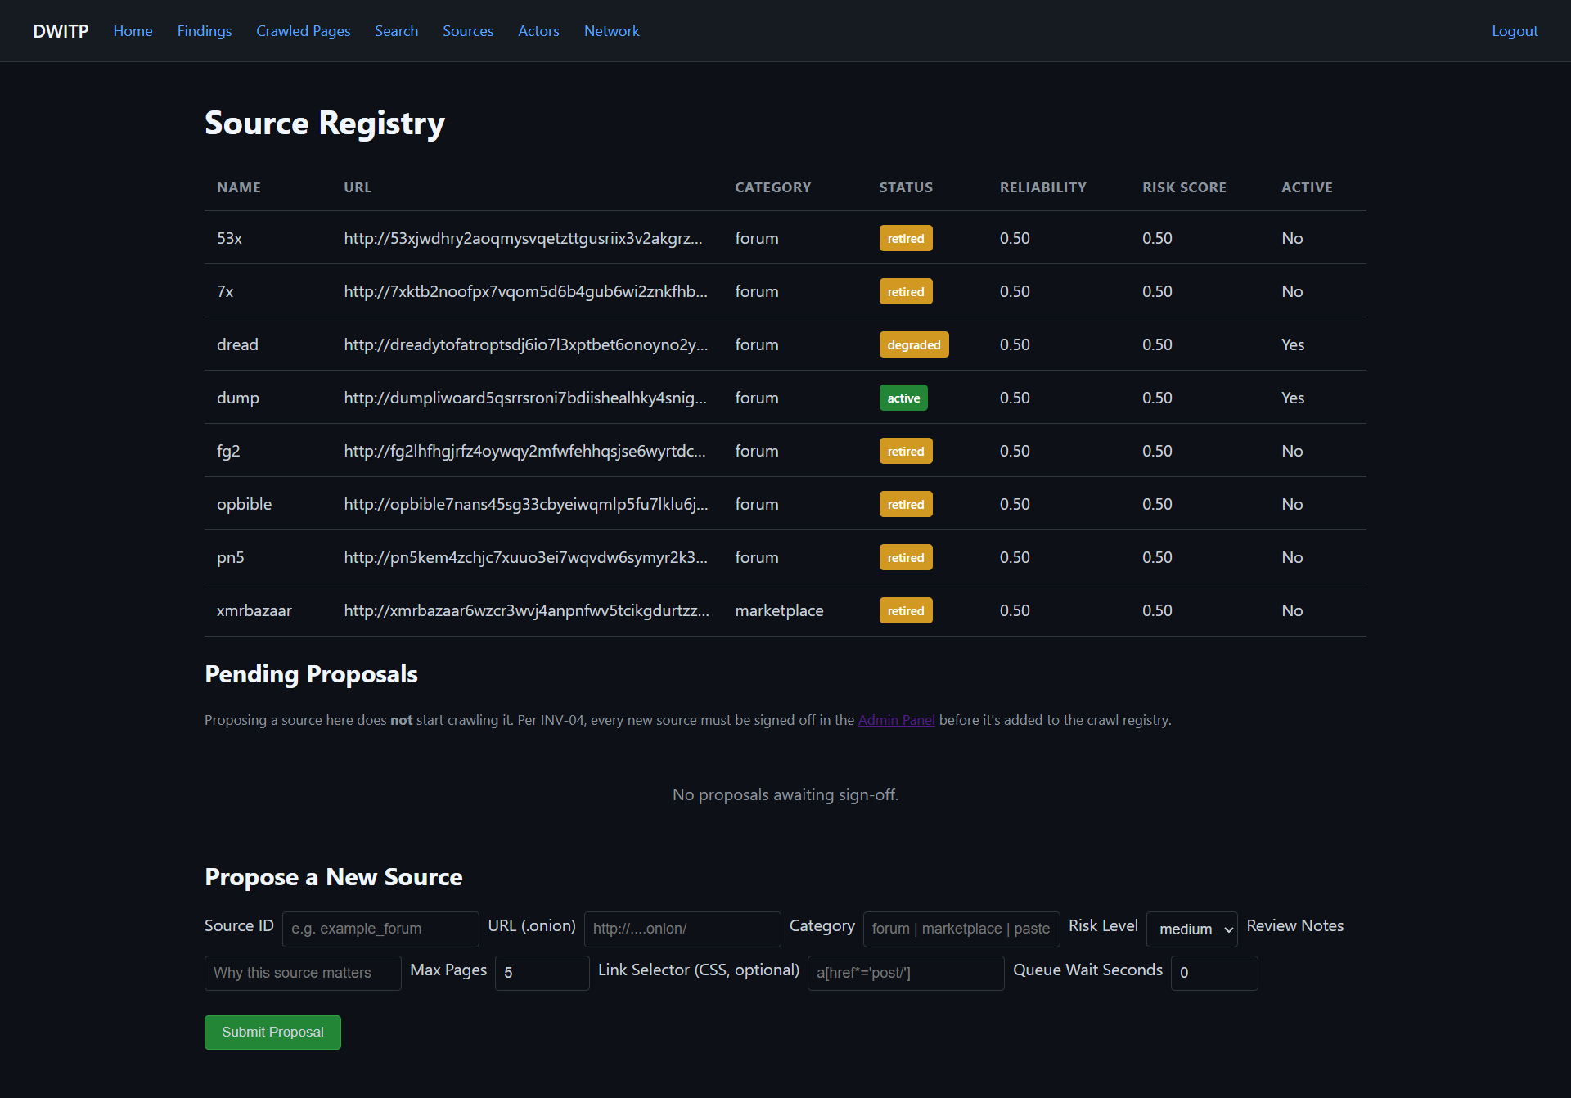

- Sources
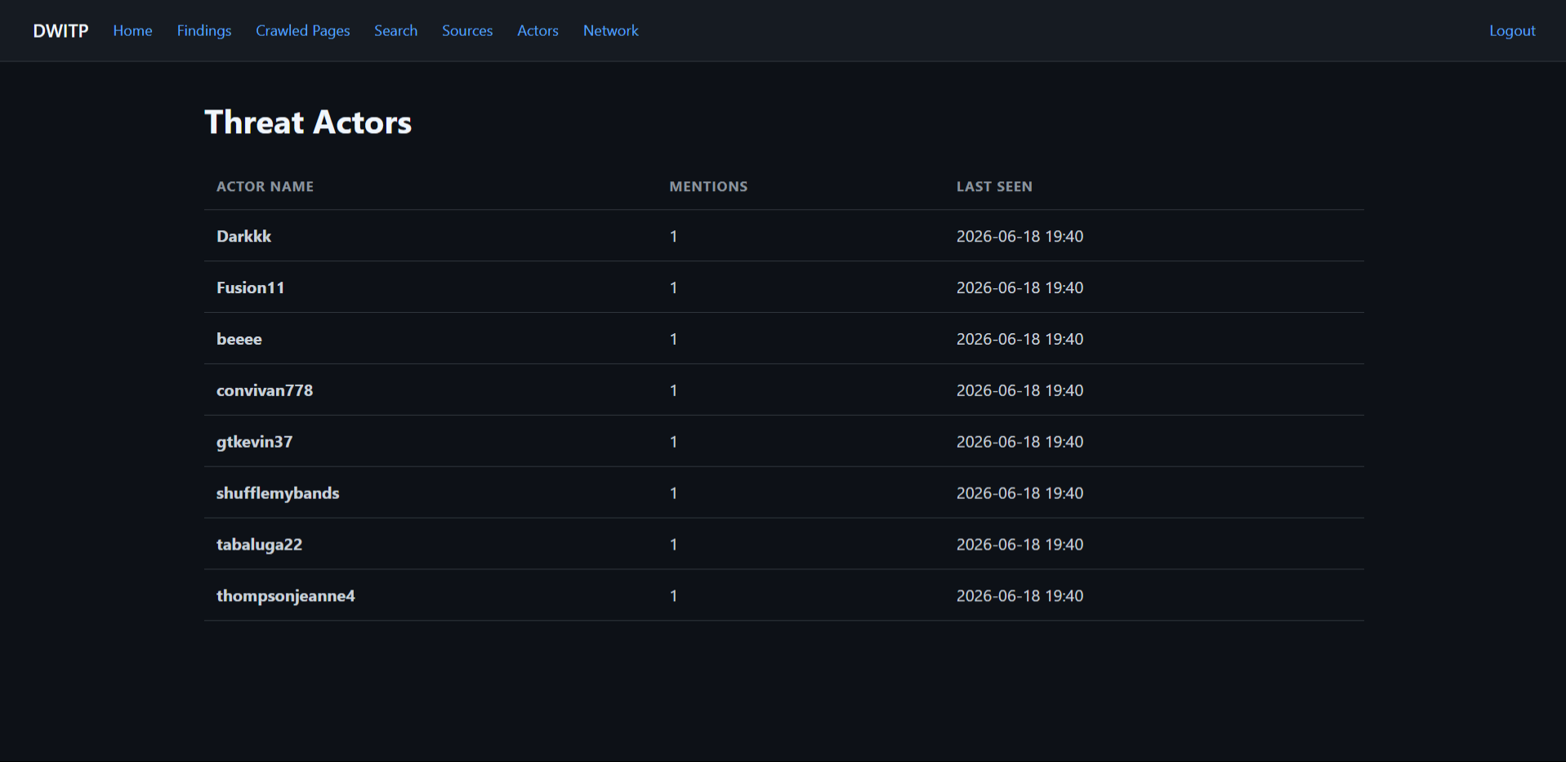
- Threat Actors

