
Project Report
CDR/IPDR Investigation Visualizer
Telecom Intelligence & Forensics Module (TIFM)

Prepared By: Siddharth Sinha
Internship Organization: Gurugram Cyber Police (Cyber Cell)
Internship Duration: June 2026 – July 2026

Overview
The CDR/IPDR Investigation Visualizer — internally designated as the Telecom Intelligence & Forensics Module (TIFM) — is a full-stack, web-based investigation platform developed for use by Law Enforcement Agencies (LEAs). It enables investigators to ingest, visualize, and analyze Call Detail Records (CDR) and IP Detail Records (IPDR) sourced from telecom providers, and transforms this raw data into actionable intelligence about subjects of interest.
The system integrates interactive geospatial mapping, network graph analysis, AI-driven insights, forensic session reconstruction, and a 60+ provider service attribution engine into a unified, secure browser-based interface. Unlike conventional spreadsheet-based CDR analysis, TIFM provides real-time pattern detection, meeting identification, identity resolution, and AI-generated investigation reports — delivered within a session-authenticated, role-controlled environment built for law enforcement operational use.

Objectives
- Enable LEAs to upload CDR and IPDR CSV files and instantly visualize subject activity across geographic, temporal, and network dimensions.
- Identify high-risk communication patterns including co-location events, SIM swaps, device changes, night-dominant activity, and activity spikes.
- Provide AI-driven investigation reports with explainable confidence scores, ranked investigation leads, and data-grounded hypotheses.
- Reconstruct IPDR sessions and attribute them to known services (WhatsApp, Telegram, Google, Zoom, etc.) using a unified 60+ provider knowledge base with 83 CIDR ranges.
- Support multi-case investigation management with secure session-based authentication and role-based access control.
- Generate downloadable forensic evidence reports with EVID-XXXXXXXX session integrity hashes for court-admissible documentation.
- Provide a fine-tunable AI backbone (TIFM/Qwen2.5) for domain-specific investigator Q&A without reliance on external cloud LLM services.

Key Features

1. Authentication & Security
- Session-based login with HttpOnly cookies and 48-byte cryptographically random URL-safe session tokens.
- PBKDF2-SHA256 password hashing with 210,000 iterations and a random 16-byte salt — matching NIST/OWASP current recommendations.
- AFK auto-logout after 10 minutes of inactivity with a 3-stage visual indicator: Active (green, 0–2 min), Idle (yellow, 2–9 min), Expiring Soon (pulsing red, 9–10 min).
- Multi-session tracking: view and individually revoke any active session; logout-everywhere support.
- Health-check ping every 5 minutes: if the session is revoked server-side, auto-logout fires immediately.
- Admin bootstrapping from environment variables on first startup; no manual database seeding required.

2. Data Ingestion
- CSV upload for CDR, IPDR, and Tower records with a client-side preview modal showing the first 20 rows before confirmation.
- Replace-on-upload strategy for CDR/IPDR; upsert (merge-by-tower-ID) semantics for tower records.
- Case-aware upload: all records tagged to the active case ID, enabling true multi-investigation isolation.
- Sample data generator: 60 towers, 1,200 CDR records, and 1,800 IPDR records across 10 Indian cities with realistic IMSI/IMEI, call types, protocols, and APNs.
- Triangulation seed script: 4 towers in the Mumbai corridor (LTE/NR/UMTS) and 21 IPDR records for controlled triangulation testing.

3. Dashboard
- 10 KPI summary cards: Total Records (CDR/IPDR breakdown), Reconstructed Sessions, Top Contact, Most Active Tower, Unique Contacts, Unique Subjects, Geo-fenced Records (when geofence active), and Activity Spikes.
- Case Summary: 11 metrics including observation period, total sessions, meetings, SIM swaps, and device changes.
- Data Quality Score Card (0–100%) with per-category penalty breakdown: missing tower (−5), missing coordinates (−8), missing duration (−10), invalid timestamps (−15), unknown protocols (−3).
- Period Comparison: dual date-range selector to detect volume changes, new/lost contacts, and service usage deltas between two time windows.
- Mini D3 force-directed network graph (200-record sample), service doughnut chart, daily activity bar chart, and top contacts horizontal bar chart — each rendered in an isolated error boundary.

4. Network Graph
- Full-page interactive D3.js v7 force-directed graph showing entity relationships with zoom (0.2×–8×), pan, node drag, and search/highlight (dims non-matching nodes to 10% opacity).
- Link deduplication: multiple connections between the same entity pair are merged into a single weighted edge.
- Backend NetworkX computation: degree centrality, betweenness centrality, greedy modularity community detection, and bridge edge identification.
- Subject filter dropdown; graph capped at 500 links for a specific subject or 150 links for all subjects to prevent visual clutter.

5. Tower Map (6 Modes)
- Movement Path: polyline trace of tower sequence in chronological order, with distance calculation (km) and a time-playback slider that auto-advances every second.
- Activity Heatmap: Leaflet.heat gradient overlay (green → yellow → red) showing geographic concentration of activity.
- Operational Zones: radius circles around towers sized proportionally to visit count (radius = 10 + √count × 4), with activity percentage breakdown in sidebar.
- Co-location: identifies towers where multiple subjects appear together; highlights towers shared with the selected subject.
- Meeting Detection: detects probable in-person meetings using temporal proximity, encounter frequency, and LCS-based movement similarity (Longest Common Subsequence of tower sequences). Confidence tiers: High (<5 min gap), Medium (<15 min), Low (<60 min).
- Triangulation: tech-aware coverage circles (5G/NR = 1 km, 4G/LTE = 3 km, 3G/UMTS = 5 km, 2G/GPRS = 15 km) with Turf.js polygon intersection for overlap zone estimation.
- Geofencing: draw a custom polygon on the map; dashboard shows geo-fenced record count and percentage.

6. Entity Timeline
- Entity-grouped collapsible cards with 50-bucket activity density strips providing a bird’s-eye view of when each entity was active.
- Gantt-style session bars with hover tooltip showing service, times, duration, confidence %, and evidence categorized into Infrastructure / Ports / Behavior / Signals.
- Session evidence overlay with EVID-XXXXXXXX integrity hash for forensic chain-of-custody documentation.
- Side-by-side entity comparison mode: two-column grid layout for parallel timeline analysis.
- Type filter (All / CDR / IPDR), name search, and session count display per entity.

7. Charts (12 Types)
- Service Usage Doughnut, Hourly Activity Bar (24 hours), Top Contacts Horizontal Bar, Service Timeline Line (14 days, 6 services), Contact Direction Stacked Bar (MO/MT), Contact Duration, Day of Week, Duration Distribution Histogram, Protocol Distribution Doughnut, Top Ports, Data Volume, and Tower Activity.
- All charts use Chart.js 4.4.7 with theme-aware color updates when switching between dark and light mode; safe chart destruction prevents stale reference errors.

8. Records Table
- 24-column data table: Time, Type, Subject, Counterpart, Duration, Detail, Direction/APN, Service, SrcPort, DstPort, Port Service, App Attribution, Tower, Cell, LAC, IMSI, IMEI, MSISDN, Technology/RAT, Upload/Download bytes, Lat, Lng, Case.
- Record annotations (star/flag) persisted server-side per user across sessions.
- Filters: record type, service, real-time text search across 9 fields, and infinite scroll pagination (60 records/page load).
- App Attribution column shows all matching service signatures from the 60+ provider knowledge base for each IPDR record.

9. Subject Profile
- Modal overlay with 15 metric cards: Contacts, Total Records, Sessions, Towers, Top Service, Avg Records/Day, Peak Hour, Day/Night Classification, Detected Meetings, First/Last Seen, Dormant Periods, Activity Spikes, Longest Dormant Gap, and Observation Period.
- Identity timeline: chronological IMSI/IMEI state transitions with SIM swap, device change, combined change, and partial-change detection.
- Tower analytics: top 5 towers by activity, night tower (23:00–05:00 dominant), and weekend tower (Sat/Sun dominant).
- Hourly activity bars, attributed services with confidence %, detected co-locations with meeting scores, clickable contact chips for recursive entity navigation, and recent activity list.

10. AI Insights (4 Subtabs)
- Overview: case summary, 8 stat cards (subjects, records, sessions, meetings, SIM swaps, device changes, observation period, high-risk findings), and per-subject assessment cards sorted by meeting count and night activity.
- Findings & Leads: auto-generated findings with explainable confidence breakdowns (base + same tower + time window + encounter frequency + movement similarity components), investigation leads ranked 0–100, and a hypothesis engine generating investigative questions from real data patterns.
- Deep Investigate: day-grouped timeline narrative with event compression (×N block merging), 5-type report generator (Executive Summary, Subject Report, Communication Analysis, Location Analysis, Full Investigation), and an 8-module full investigation command center (Findings, Identity, Anomalies, Sessions, Network, Location, Calls, Temporal).
- AI Chat: 7 context chip types (Subject, Timeline, Meetings, Service Attribution, Graph, Tower Data, Raw Records), 5 preset context buttons, and investigator notes Q&A with 3 mode options (TIFM Backend, Fine-tuned TIFM, Legacy Ollama).

11. Identity Resolution
- Tracks full chronological A→B→A re-appearance sequences, capturing SIM swaps, device changes, combined changes, partial-IMEI and partial-IMSI transitions.
- Each transition timestamped and confidence-labelled (High / Medium).
- Validated by 38 assertions across 12 test scenarios including complex A→B→C→A re-appearance and sequential SIM-then-device change.

12. Session Reconstruction & Service Classification
- Concurrent activity track model: IPDR records bucketed by (counterpart IP, activity family) so simultaneous flows form coherent parallel sessions instead of fragmenting.
- Family-adaptive idle gaps: DNS 60 s, Web 300 s, RTC/VoIP 1,200 s, VPN/Remote/P2P 1,800 s, Transfer 600 s.
- Two-phase service attribution: Phase 1 matches provider IP ranges (60+ providers, 83 CIDR ranges, longest-prefix match); Phase 2 falls back to port-only matching (250+ ports, 12 ranges).
- 14+ behavioral traffic categories: VPN/Encrypted Tunnel, RDP, File Transfer, Video Call, Voice Call, Streaming, Conference, Media Upload, Messaging, Browsing, and more.
- Unified attribution_data.json: single source of truth consumed by both backend and frontend, eliminating drift between classification engines.

13. Services Tab
- Per-service evidence scorecards with 6 criteria: IP match, port/protocol alignment, distinctive indicators, session pattern, multi-subject presence, and attribution clarity.
- Service cards listing associated subjects, towers, contacts, and recent session Gantt bars with evidence trees.
- Burst detection: per-subject daily activity spikes exceeding 3× average (minimum 10 records) with date and comparison.
- Name search filter and minimum confidence threshold selector (0–95%).

14. Correlation Tab
- Cross-subject weighted correlation score: contact overlap (5 pts), service overlap (2 pts), tower overlap (1 pt), session overlap (4 pts).
- Meeting detection for selected A/B pairs, common towers, contacts, services, and overlapping time window analysis.

15–21. Backend Services, API, Case Management & Administration
- FastAPI backend with 40+ REST endpoints across 10 domains: authentication, data upload, records, geo-spatial, investigation, graph analysis, timeline, statistics, annotations, cases, AI/TIFM, and admin user management.
- Full case management CRUD: create, rename, delete (with cascade to all associated records); active case selector in the top navigation bar.
- Admin tab: list, create, update, reset password, and delete users; visible only to role=admin users.
- PostgreSQL primary database with automatic SQLite fallback on connection failure; Pydantic Settings for environment-based configuration with LRU-cached singleton.
- TIFM multi-agent AI backend: 5 specialized agents (Service Attribution, Identity, Movement, Network, Report) orchestrated by TelecomIntelligenceOrchestrator.
- PoliceInvestigator: 12 analysis modules including SocialNetworkAnalyzer (k-core, triads, bridges, PageRank, clustering), IdentityDeepAnalyzer, AnomalyDetector, GapAnalyzer, and CallDetailAnalyzer.
- QLoRA fine-tuning pipeline: 3,218 training examples across 15 question types for Qwen2.5-3B-Instruct with 4-bit LoRA adapters (PyTorch, HuggingFace PEFT, TRL SFTTrainer).

AI Assistance in Development
The development of the CDR/IPDR Investigation Visualizer leveraged two frontier AI models as development assistants throughout the project lifecycle. Their use significantly accelerated the implementation of complex algorithms while all analytical logic, scoring algorithms, and investigation outputs remain fully deterministic and investigator-controlled.

AI Model | Role in Development
DeepSeek V4 Flash | Used for rapid code generation, backend Python service implementation, and algorithm design. Key contributions: session reconstruction engine, attribution data pipeline design, PoliceInvestigator module scaffolding, synthetic dataset generator, and API endpoint structure.
Claude Opus 4.8 | Used for architectural review, complex frontend JavaScript logic, multi-agent orchestration design, QLoRA fine-tuning pipeline scaffolding, and edge-case handling in identity resolution and meeting detection. Also assisted with documentation and validation test design.
Note: No LLM inference occurs in the core analysis pipeline without explicit investigator initiation. All findings, scores, and session classifications are produced by deterministic, rule-based, or statistical algorithms.

Case Example
The following illustrates a sample investigation session using the platform against a synthetic 5-subject criminal network dataset:

- Dataset: 5 subjects, ~800 CDR/IPDR records interleaved with normal family/business traffic (criminal_network_noise scenario).
- Subjects Detected: 10.1.0.1 (primary), 10.1.0.2 through 10.1.0.5 (network members).
- Meetings Detected: 7 probable in-person meetings across 3 towers, scored High (gap <5 min) with movement similarity 0.72–0.91 via LCS analysis.
- Identity Events: 2 SIM swaps (subject 10.1.0.3: IMSI transition on Day 4), 1 device change (subject 10.1.0.1: IMEI transition on Day 7).
- Top Services: WhatsApp (UDP 3478–3480, Meta IPs, confidence 91%), Telegram (confidence 84%), Signal (confidence 79%), ProtonVPN (UDP 1194, confidence 73%).
- Night Activity: Subject 10.1.0.1 — 74% of records between 23:00–05:00. Classified: Night-Dominant.
- Investigation Finding (AI): High severity — “Subjects 10.1.0.1 and 10.1.0.2 show repeated co-location (7 encounters) at TRI_TWR_A with <5 min temporal gap and 0.88 movement similarity. Evidence: same tower, 7 encounters, LCS overlap score 0.88.”
- Report Generated: Full Investigation Report exported as formatted markdown with session integrity hash EVID-4F2A91C7.

Tech Stack

Layer | Technology
Backend Language | Python 3.11+
Web Framework | FastAPI with Uvicorn (ASGI)
Database (Primary) | PostgreSQL via SQLAlchemy ORM
Database (Fallback) | SQLite 3 with automatic failover
Frontend | Vanilla JavaScript (ES6+), HTML5, CSS3 with CSS Custom Properties
Geospatial Mapping | Leaflet.js 1.9.4, Turf.js, Leaflet.heat, Leaflet.draw
Network Graph | D3.js v7 (force simulation)
Charts | Chart.js 4.4.7 (12 chart types)
Graph Analysis | NetworkX (Python)
AI/ML Framework | HuggingFace Transformers, PEFT, BitsAndBytes, TRL SFTTrainer
TIFM Model | Qwen2.5-3B-Instruct with 4-bit QLoRA adapters
Data Processing | Pandas, NumPy, hashlib, ipaddress
Authentication | HttpOnly cookies, PBKDF2-SHA256, secrets module
Configuration | Pydantic Settings, .env file, lru_cache singleton
Version Control | GitHub (private repository)
Deployment Environment | Linux / Windows (Docker-compatible)

APIs & Libraries Used

Source / Library | Use Case
OpenStreetMap (via Leaflet tiles) | Base map tiles for the interactive tower map
Turf.js | Geospatial polygon intersection for triangulation and geofence record filtering
Leaflet.heat | Heatmap gradient rendering for activity concentration visualization
Leaflet.draw | Interactive polygon drawing for geofence definition
NetworkX (Python) | Graph construction, centrality metrics, community detection, and bridge identification
D3.js v7 | Force-directed network graph with zoom, pan, drag, and search
Chart.js 4.4.7 | 12 chart types across the dashboard, charts tab, and subject profile modal
Pandas | CSV ingestion, column normalization, and bulk data operations
SQLAlchemy | ORM for PostgreSQL/SQLite, query filtering, bulk inserts, and transactions
HuggingFace Transformers | QLoRA fine-tuning and inference for Qwen2.5-3B-Instruct TIFM model
PEFT / BitsAndBytes | 4-bit quantization and LoRA adapter management for on-device inference
Pydantic Settings | Environment variable validation and application configuration
ipaddress (stdlib) | CIDR range matching for IP-based service attribution (longest-prefix)
hashlib (stdlib) | PBKDF2-SHA256 password hashing and session evidence integrity hashing

Note: All mapping, charting, and graph libraries are free and open-source. No paid third-party telecom intelligence APIs are used. All data ingestion is via standard CSV uploads provided by authorized telecom intercept channels.

Outputs
- Downloadable .txt forensic investigation report with subject profiles, reconstructed sessions, meeting evidence, raw CDR/IPDR records (up to 200 each), and tower listings — timestamped for evidentiary use.
- AI-generated reports in 5 formats (Executive Summary, Subject Report, Communication Analysis, Location Analysis, Full Investigation) rendered as formatted HTML from markdown.
- Session evidence overlays with EVID-XXXXXXXX djb2 integrity hashes providing forensic chain-of-custody documentation for individual sessions.
- Exportable AI findings feedback as JSON (false-positive tracking keyed by finding content hash — persists across page refreshes).
- 8-module full investigation output: Findings, Identity, Anomalies, Sessions, Network (role distribution), Location (hotspots, entropy), Calls (signal calls, odd-hour calls, calling circles), and Temporal analysis.
- Fine-tuning dataset export: 3,218 Q&A pairs across 15 question types for Qwen2.5-3B-Instruct model training.
- Synthetic case data in 5 criminal scenario types: criminal network, drug trafficking, scam, human trafficking, and financial fraud.

Proof of Concept (POC) and Proof of Work (POW)

POC:
- End-to-end workflow validated on a deterministic synthetic dataset (seed 42): 60 towers, 1,200 CDR records, 1,800 IPDR records across 10 Indian cities.
- Meeting detection stress-tested on 8 curated scenarios: normal_user (88 records), call_center (326 records, single tower — false-positive benchmark), shared_transport (10 commuters on same train), criminal_network_noise (800 records with signal embedded in noise), and large_dataset (50 subjects, ~119k records — performance test).
- Service attribution validated with 17 hand-verified labeled fixtures achieving ≥95% accuracy across content / hosting / access_network / VPN / anonymization / internal categories.
- Identity resolution validated with 38 assertions across 12 scenarios including A→B→A re-appearance, sequential SIM-then-device change, and MSISDN accumulation.
- LCS benchmark: meeting detection for 50 subjects at 5,000 observations each (worst-case 5-shared-tower scenario) completes within acceptable thresholds.

POW:
- Full web application — FastAPI backend + Vanilla JS single-page frontend — deployable on standard Linux/Windows with Python 3.11+ and a PostgreSQL or SQLite database.
- Modular backend: 12+ service modules (investigation, session reconstruction, attribution, graph, towers, stats, timeline, cases, auth, AI agents, investigator, fine-tune pipeline).
- TIFM multi-agent AI backend: 5 specialized agents orchestrated by TelecomIntelligenceOrchestrator with a 17-entry knowledge base.
- PoliceInvestigator: ~1,300 lines implementing 12 analysis modules and 8 investigation output sections via POST /ai/investigate.
- QLoRA fine-tuning pipeline: Model Fine-tuned locally using own system resources and single-pass inference via /ai/chat.
- Comprehensive validation suite: 38 identity resolution assertions, 17 service attribution fixtures, 13 AI test classes (541 lines), and a 19-item pre-demo checklist.

Security & Ethics
- All CDR and IPDR data is uploaded by authorized LEA personnel from official telecom intercept sources; no data is scraped from public networks or third-party services.
- Tool designed exclusively for legal, authorized use by Law Enforcement Agencies under applicable national telecom interception and cybercrime investigation laws.
- Session security: HttpOnly cookies, 48-byte random tokens, PBKDF2-SHA256 (210,000 iterations), AFK auto-logout, multi-session revocation, and client IP/user-agent capture per session.
- All DOM-rendered user data passes through an HTML-escaping utility (esc() function) preventing XSS injection attacks.
- No investigation data leaves the deployment server to external third parties; all analysis is performed on-premises.
- AI-generated findings are clearly labeled as AI-assisted and require investigator verification before any operational action.
- Burner/risk labels in subject assessments use descriptive behavioral language rather than conclusory crime labels, preserving investigator judgment.

Limitations
- CDR and IPDR data must be supplied in a specific CSV column schema; automatic detection has limited flexibility for non-standard telecom provider formats.
- The TIFM fine-tuned model (Qwen2.5-3B-Instruct) requires a GPU for efficient inference; CPU-only deployments fall back to the rule-based backend analysis engine.
- IP-based service attribution cannot identify services delivered exclusively over shared CDN infrastructure without a subject-specific IP footprint (common for many Indian e-commerce, streaming, and fintech apps).
- Meeting detection uses temporal and spatial co-location as a proxy for physical meetings; results are probabilistic and require corroboration from other evidence.
- No real-time CDR/IPDR streaming ingestion support; current implementation relies on batch CSV uploads.
- Blockchain, social media, and dark-web data sources are out of scope; the platform is limited to telecom CDR and IPDR record analysis.
- The false-positive rate target of <20% for meeting detection may be exceeded in scenarios with dense shared-tower activity (e.g., urban commercial areas).

Future Scope
- Real-time CDR/IPDR streaming ingestion via lawful intercept API integration (CALEA/LI interface compatibility).
- Encrypted SNI-based and DNS-over-HTTPS traffic identification for improved attribution of privacy-focused services.
- Multi-agency collaboration mode: case sharing across departments with audit trail logging and role-scoped data access.
- Mobile companion app (Android/iOS) for field investigators to access subject profiles, maps, and alerts on-device.
- Integration with national threat databases and known criminal entity registries for automated entity flagging.
- Train TIFM models on real (de-identified) CDR/IPDR datasets for improved inference accuracy and domain specificity.
- Tower dump record support: bulk-location analysis from tower dump data for crowd-filtering and suspect identification.
- CCTV metadata correlation and social media OSINT cross-referencing for multi-source intelligence fusion.
- Automated evidence package generation in court-ready PDF format with investigator signature and chain-of-custody log.

Conclusion
The CDR/IPDR Investigation Visualizer (TIFM) is a comprehensive, AI-augmented telecom forensics platform purpose-built for the operational needs of Law Enforcement Agencies. It transforms raw CDR and IPDR records into actionable investigative intelligence through geospatial mapping, network graph analysis, forensic session reconstruction, and a multi-agent AI investigation backend — all delivered within a secure, role-controlled, web-based environment.
By combining a 60+ provider service attribution engine, statistical anomaly and spike detection, LCS-based meeting scoring, explainable confidence breakdowns, and a fine-tuned forensics language model, the platform substantially reduces the time required to extract meaningful intelligence from large telecom datasets. Its modular architecture, comprehensive validation suite (38 identity assertions, 17 attribution fixtures, 13 AI test classes), and open-source technology stack make it a practical and deployable asset for cybercrime investigation units operating within resource-constrained environments.
Development was significantly accelerated through the use of DeepSeek V4 Flash and Claude Opus 4.8 as AI coding and architecture assistants, demonstrating how frontier AI models can responsibly support the development of public safety tools while maintaining full investigator control over all analytical outputs.

Project Images

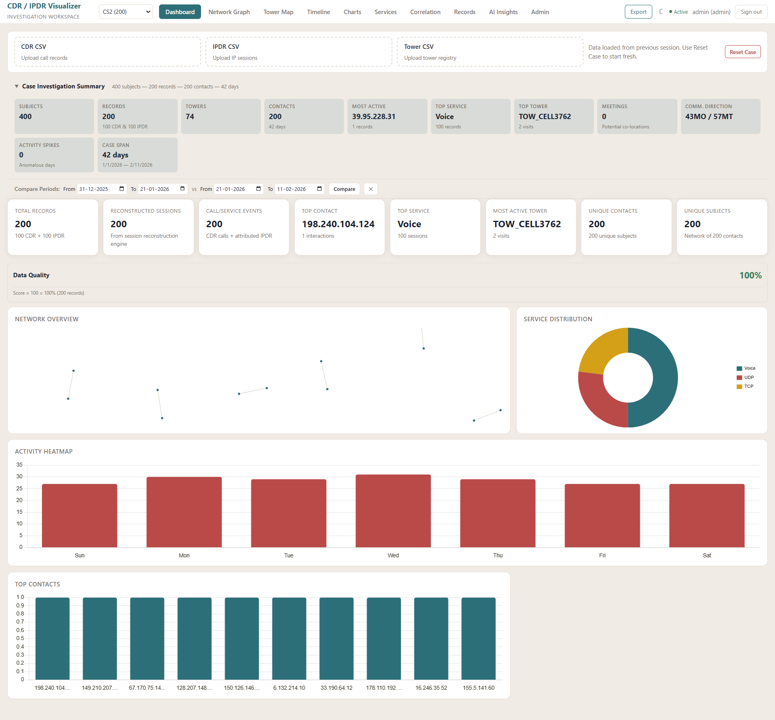

Home Page of the Dashboard

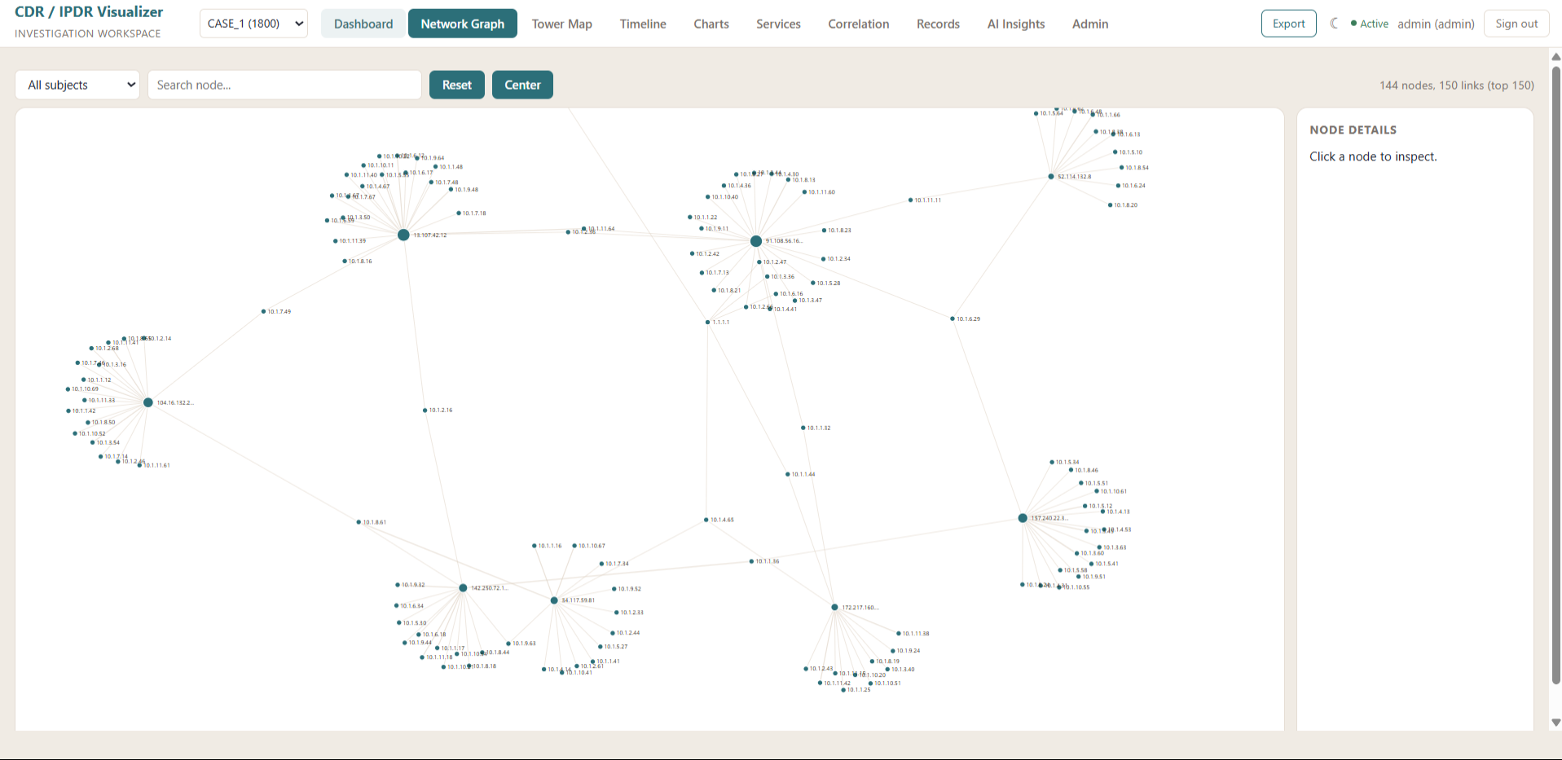

Network Graph

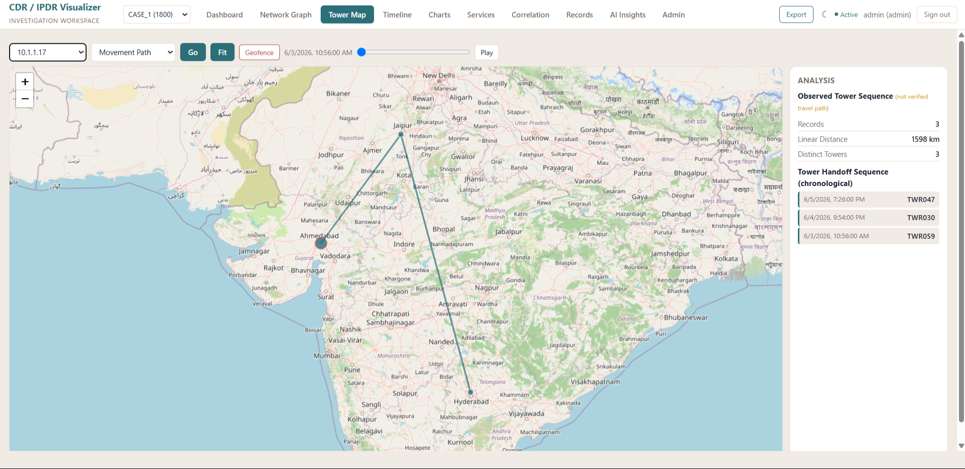

Maps

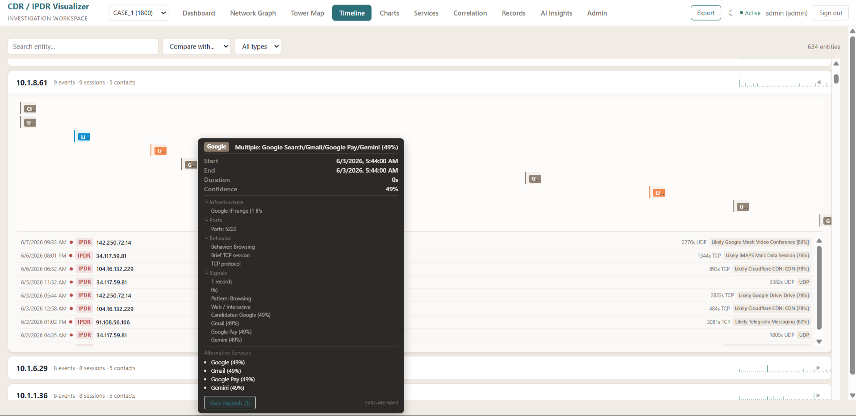

Timeline Reconstruction

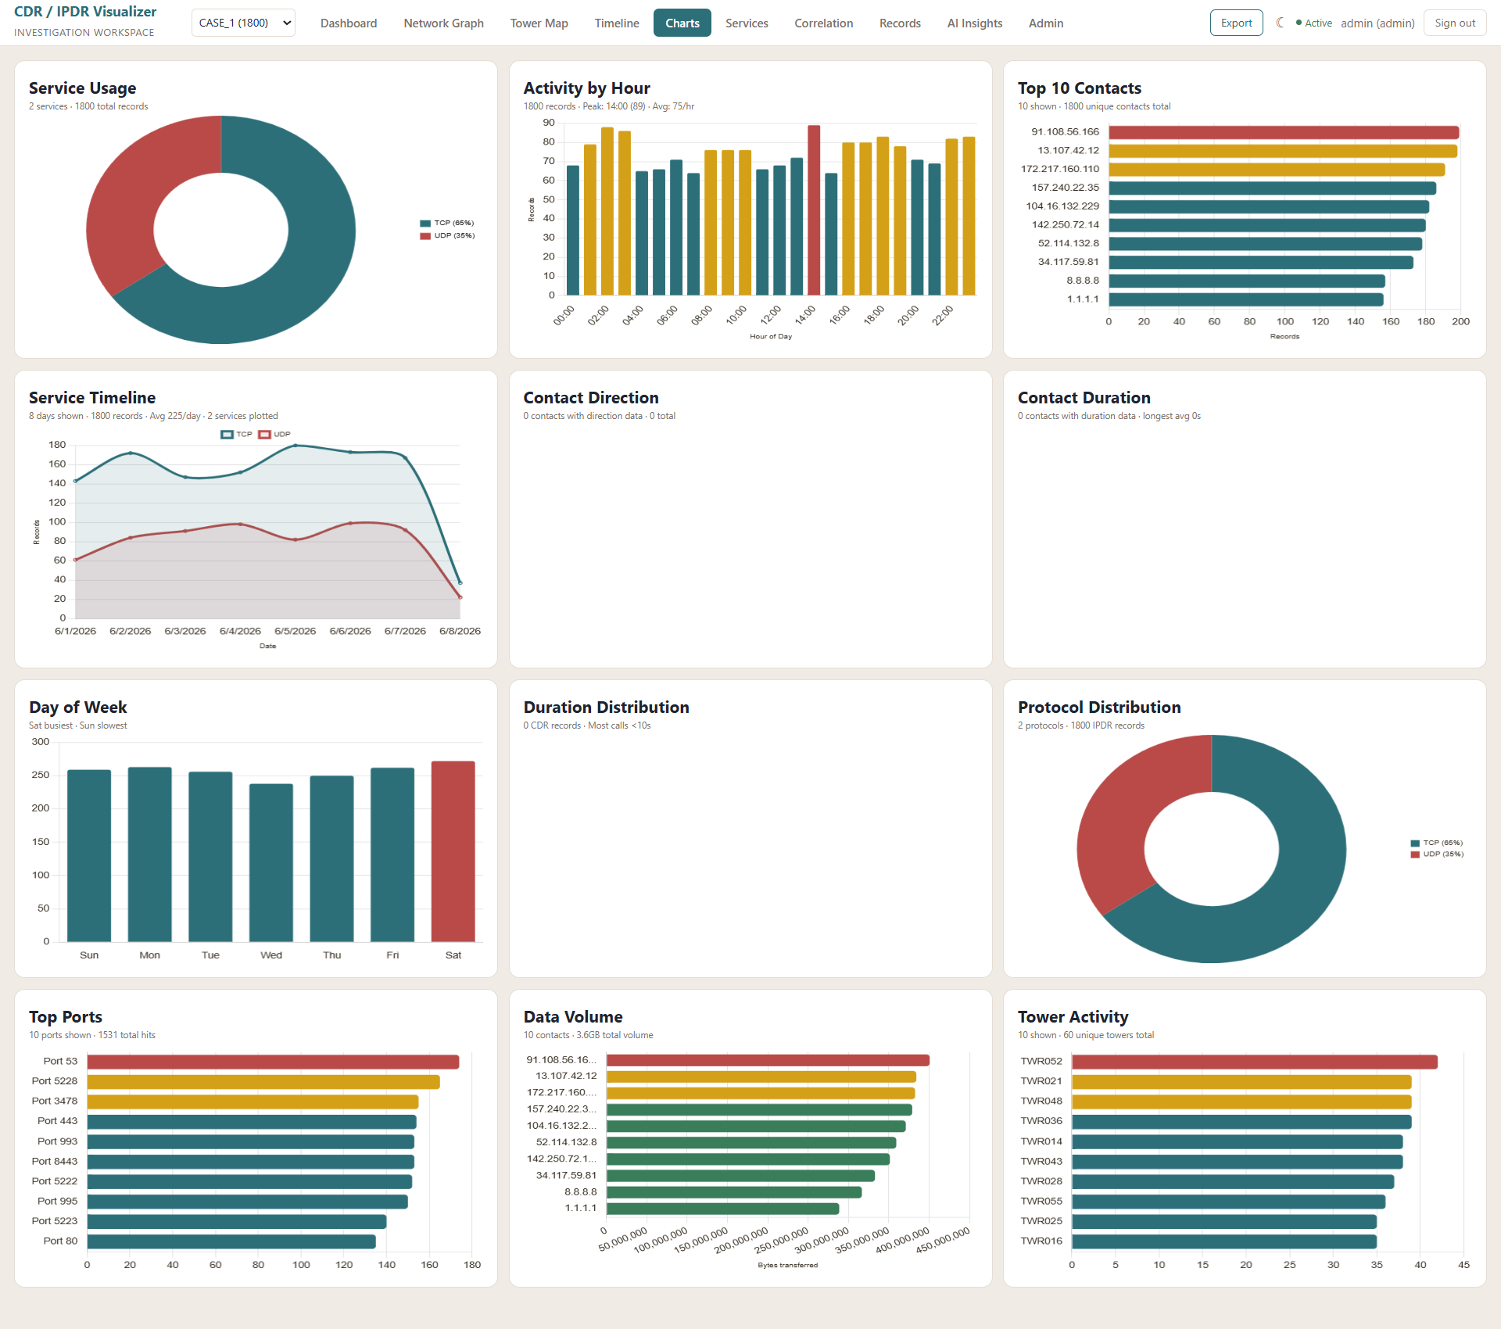

Charts

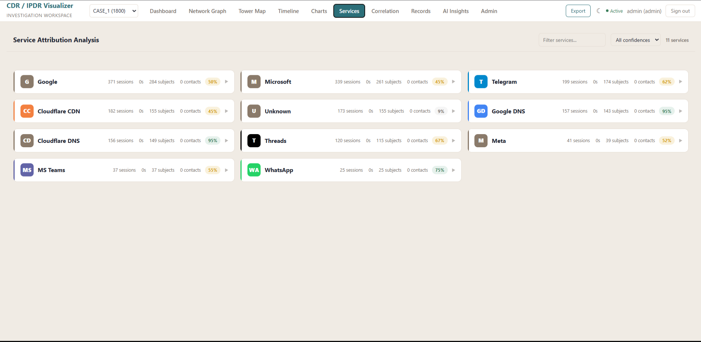

Service/App Attribution

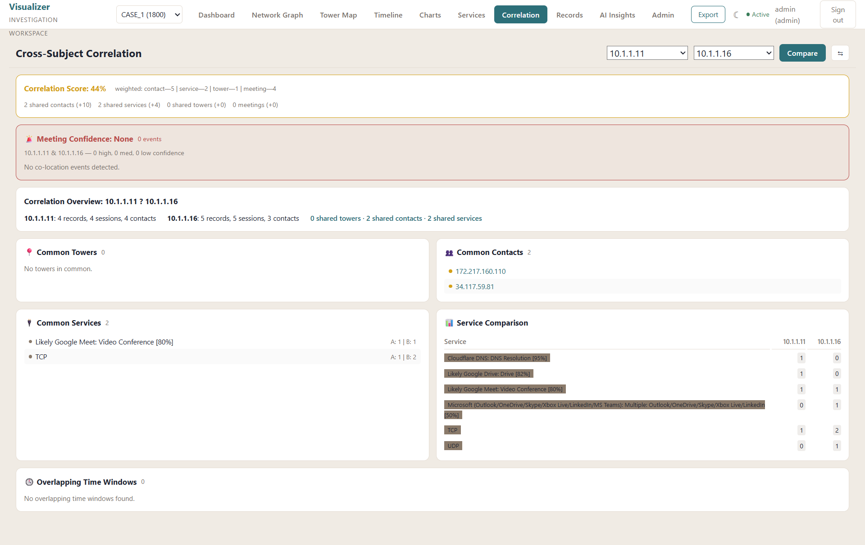

Subject Correlation

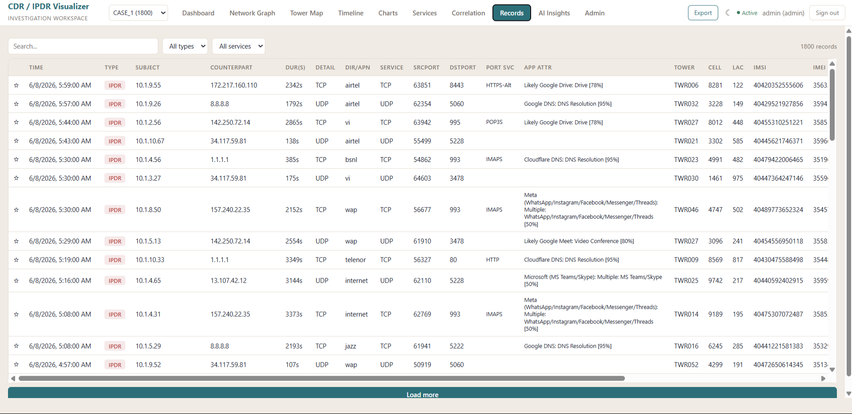

Raw Records Viewer

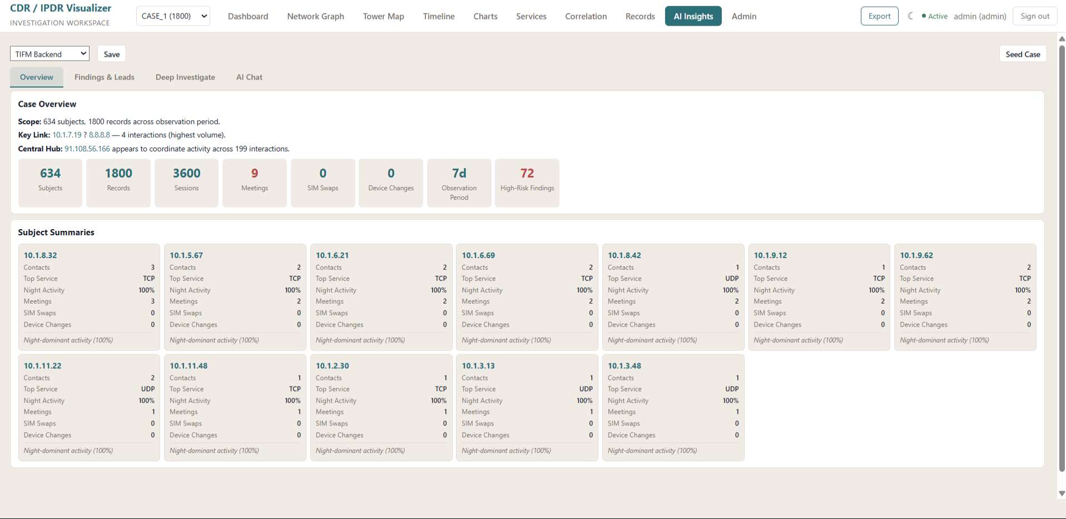

AI Insights

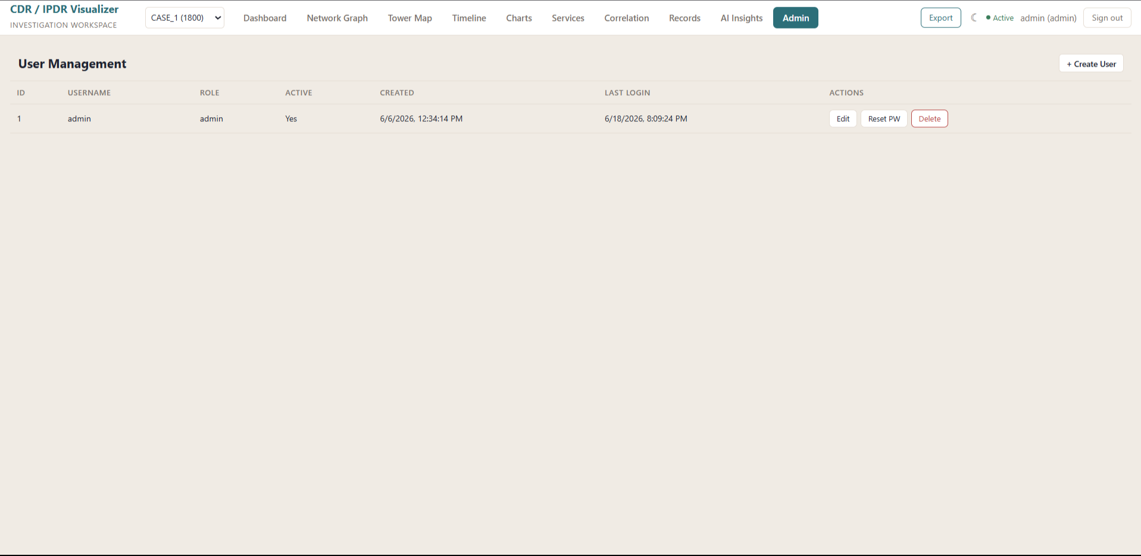

User Management

