Analysis of Weichselberger MIMO Channel Model

Abstract
The Weichselberger channel model provides a flexible framework for modeling spatial correlation in MIMO systems. This report investigates four coupling scenarios and evaluates their impact on effective rank, coherence, pilot overhead, and NMSE using Singular Value Thresholding (SVT)-based matrix completion.

Introduction
Accurate channel estimation is critical in massive MIMO systems. The Weichselberger model captures joint transmit–receive correlations through a coupling matrix, enabling realistic representation of channel statistics.

Methodology
Transmit and receive correlation matrices are generated using exponential correlation. Eigenvalue decomposition is performed to obtain spatial eigenmodes. A coupling matrix is designed for each scenario and used to generate the channel matrix. Matrix completion is then applied and the minimum pilot ratio achieving NMSE ≤ -15 dB is determined through binary search.

Simulation Parameters
Nr=16, Nt=8, Number of Simulations=10, Target NMSE=-15 dB, rho_t=0.7, rho_r=0.6.

Results Summary
Scenario | Effective Rank | Coherence | Pilot Ratio | Observations | NMSE(dB)
1 | 7.2984 | 1.5524 | 0.97848 | 126 | -16.37
2 | 6.6151 | 1.5645 | 0.96141 | 124 | -16.241
3 | 7.2816 | 1.5745 | 0.97922 | 126 | -16.256
4 | 6.9386 | 1.5729 | 0.97031 | 125 | -15.59

Case 1: Exponential Diagonal Decay
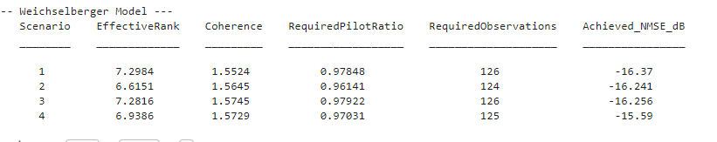
Analysis and discussion of the coupling structure, rank behavior, coherence characteristics, pilot requirements, and reconstruction performance.

Case 2: Block/Clustered Energy Distribution
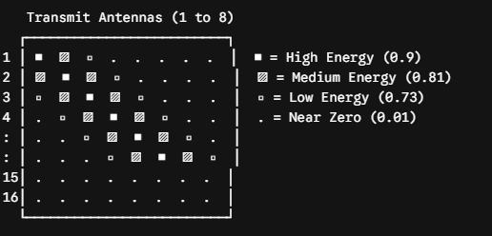

Case 3: Exponential Cross-Diagonal Decay
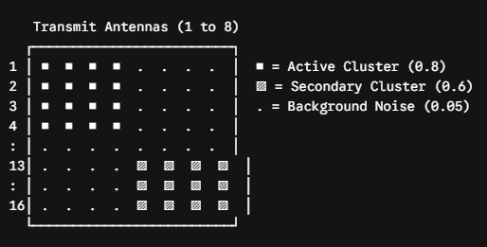

Case 4: Banded Diagonal Coupling
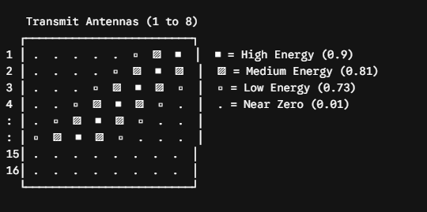

Discussion
Case 2 achieved the lowest effective rank and minimum pilot requirement, indicating the strongest low-rank structure. Cases 1 and 3 exhibited higher ranks due to broader energy dispersion. Case 4 provided a balanced behavior between sparsity and richness.

Conclusion
The results confirm that the coupling structure significantly influences matrix completion performance. All scenarios achieved NMSE better than -15 dB, validating the effectiveness of SVT-based reconstruction.

