Project Report: Scientific Calculator
Submitted by: Siddhesh Sandeep Mahajan
Roll Number: MT2025122
Date: March 7, 2026

1. Introduction: What and Why of DevOps?
What is DevOps?
DevOps is a set of practices that combines Software Development (Dev) and IT Operations (Ops). It aims to shorten the systems development life cycle and provide continuous delivery with high software quality.
Why DevOps?
Speed: Automates testing and deployment to deliver features faster.
Reliability: Ensures consistent environments from development to production.
Collaboration: Breaks down silos between developers and system administrators.

2. Tools Used
Version Control: Git & GitHub
Automation Server: Jenkins
Containerization: Docker & Docker Hub
Configuration Management: Ansible
JUnit4 : Unit testing framework

3. Project Steps & Implementation

Step 1: Source Control Management (GitHub)
Brief: We used Git for version control and GitHub to host our remote repository.
Setup: Created a new repository named SPE_PRO.
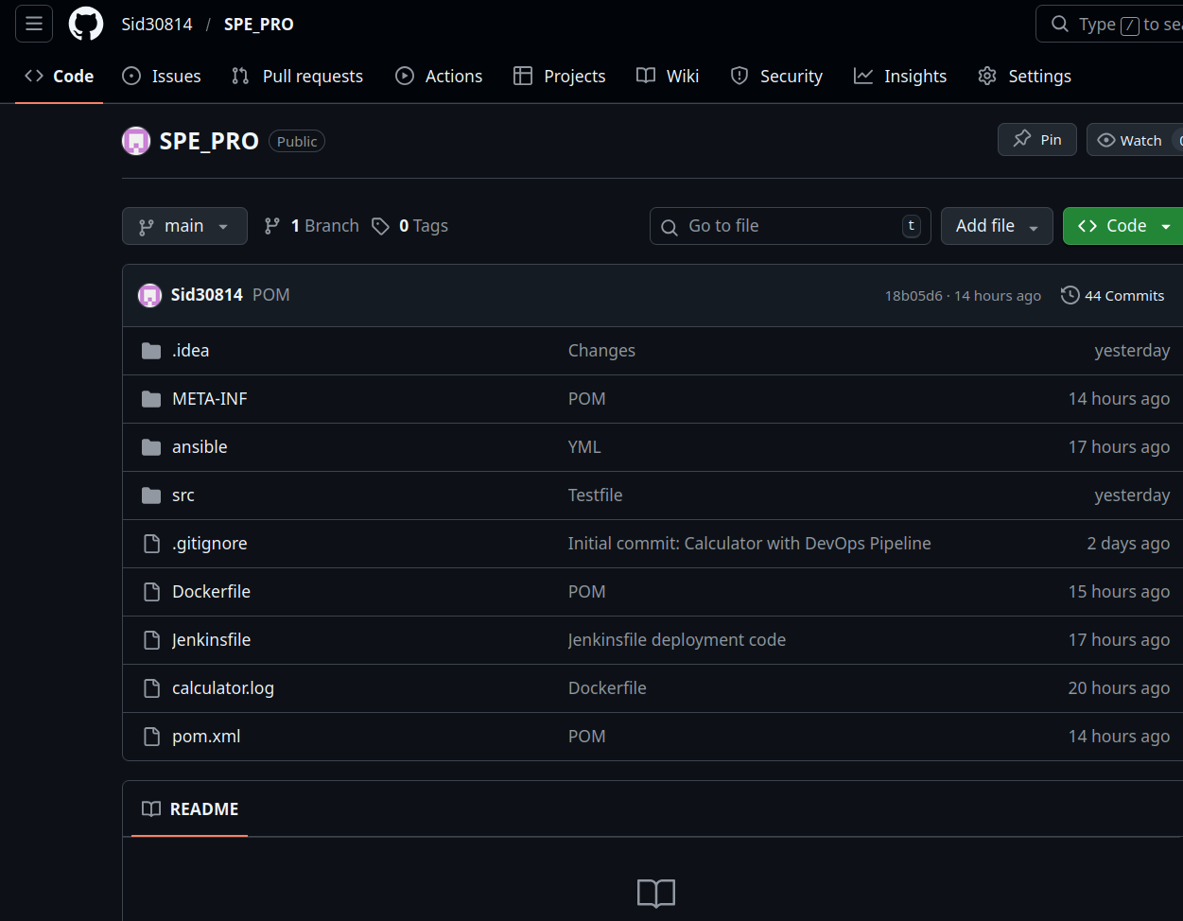

Step 2: Containerization (Docker)
Brief: Docker allows us to package the application and its dependencies into an immutable image.
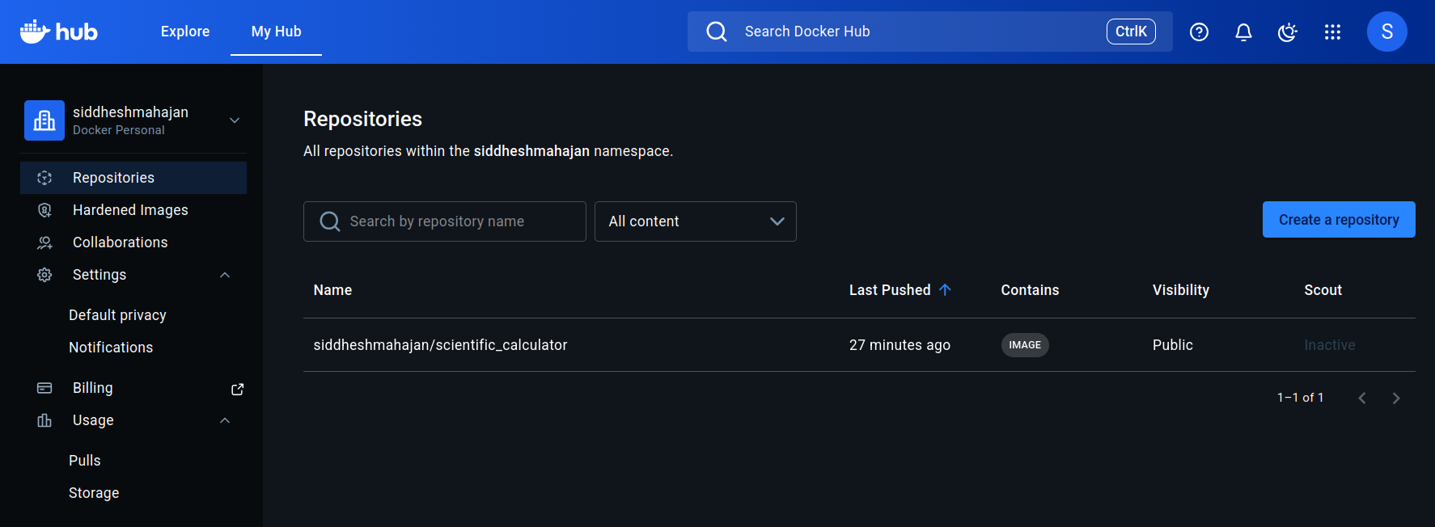

Step 3: CI/CD Pipeline (Jenkins)
Brief: Jenkins serves as the orchestration layer to automate the entire process.
Setup: Configured a Pipeline job and added Docker Hub credentials in Jenkins Manage Credentials.

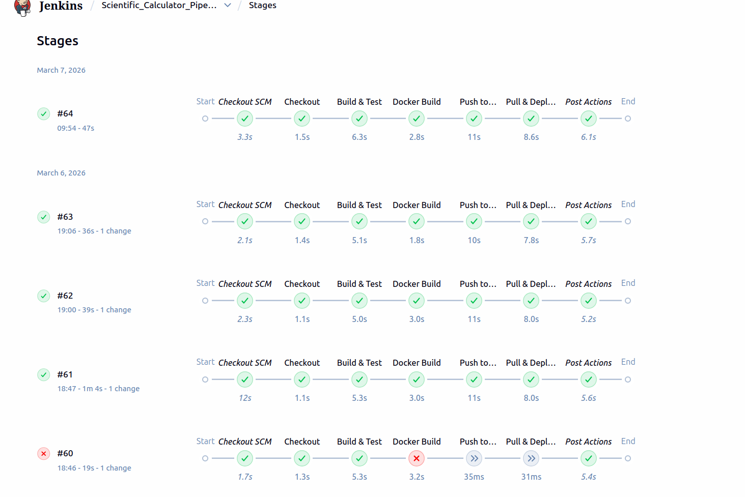

Step 4: Deployment Automation (Ansible)
Brief: Ansible automates server configuration and container deployment without needing manual SSH commands.
sh 'ansible-playbook -i ansible/inventory.ini ansible/playbook_pull.yml'

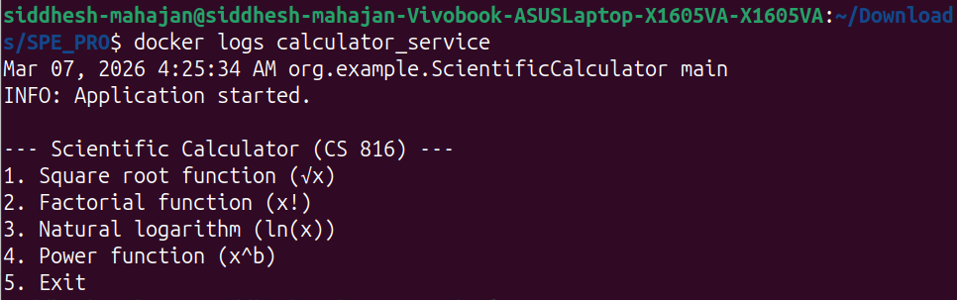

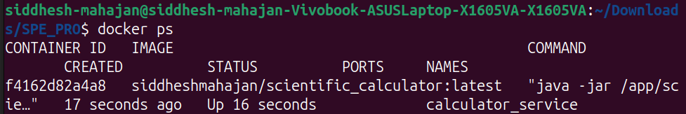
Step 5. Final Verification
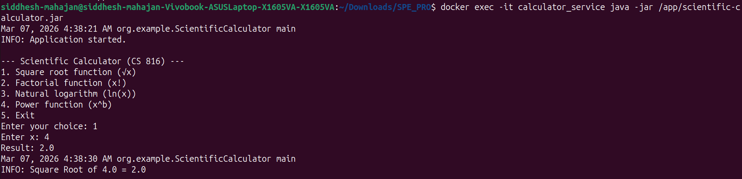

Project Phases
Phase 1: Preparation and Structuring
The project begins by organizing the source code into a standardized layout. We ensure the main class is correctly placed within the project’s directory tree, allowing automated tools to identify the application's entry point.
Jenkins Stage: Checkout
This step establishes a connection to the GitHub repository and clones the main branch.
stage('Checkout') { steps { git branch: 'main', url: 'https://github.com/Sid30814/SPE_PRO.git' } }

Phase 2: Building and Packaging
We transform the raw code into a ready-to-run package by compiling the files and resolving dependencies. We configure build instructions to specify the starting class, ensuring the Java engine knows exactly which program to launch.
Jenkins Stage: Build & Test
This stage cleans the environment, compiles source code, and runs the JUnit test suite.
stage('Build & Test') { steps { sh 'mvn clean package' } }
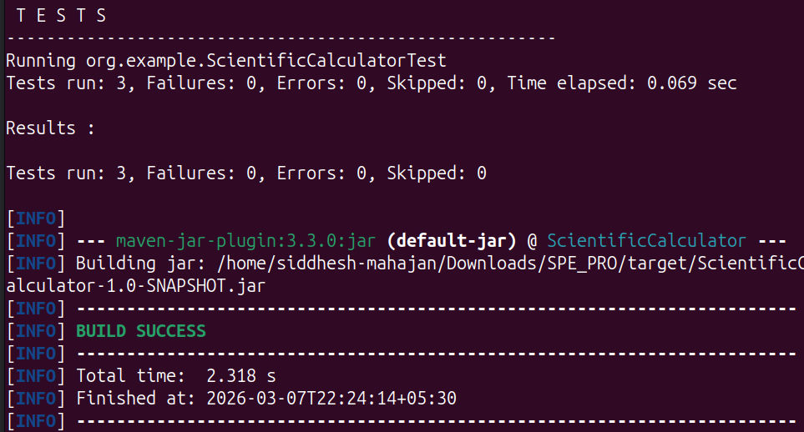

Phase 3: Containerization
We create a blueprint for a small, isolated environment containing only the software needed to run the calculator application. This portable image ensures the application works identically on any machine.
Jenkins Stages: Docker Build & Push
These stages construct the Docker image based on the Dockerfile and securely push it to the Docker Hub registry.
stage('Docker Build') { steps { sh "docker build -t ${DOCKER_HUB_USER}/${IMAGE_NAME}:latest ." } }
stage('Push to Docker Hub') { steps { withCredentials(...) { sh "docker push ${DOCKER_HUB_USER}/${IMAGE_NAME}:latest" } } }

Phase 4: Automation and Deployment
An orchestration tool is used to instruct the server to fetch the latest application image from the Docker Hub registry. The system identifies the existing container, gracefully stops it to free the network port, and launches the updated version of the application.
Jenkins Stage: Pull & Deploy
This stage executes the Ansible playbook, which manages server-side deployment and restarts the application container.
stage('Pull & Deploy') { steps { sh 'ansible-playbook -i ansible/inventory.ini ansible/playbook_pull.yml' } }

WHY Ngrok used
In this project, ngrok serves as the vital link between our private development environment and the public internet. Since your local Jenkins server resides behind a firewall and lacks a public IP address, external services like GitHub cannot "see" it to send automated notifications. By initiating a secure tunnel, ngrok provides a temporary public URL that forwards traffic directly to your local machine. This allows GitHub Webhooks to instantly trigger your pipeline the moment code is pushed, transforming a manual build process into a truly automated, event-driven CI/CD workflow.

4. Project Links
GitHub Repository: [https://github.com/Sid30814/SPE_PRO.git]
Docker Hub Repository: [https://hub.docker.com/r/siddheshmahajan/scientific_calculator/tags]

