Volume Controller Fuzzy System

A fuzzy system is a system that uses linguistics to manage the system where instead of using crisp numbers as boundaries, we use fuzzy terms that can be interpreted differently by the user. Our system has to be able to respond the best it can given any user. There was an article a while ago that explained why televisions (TVs) get louder during commercials or advertisements. Someone may simply assume this occurs because the TV producers, or those that paid for the advertisements, want to get our attention in order to get us to by something or by into an idea. This may be true, but what allows this to happen is a rule the Federal Communications Commission (FCC) has placed on TV stations that allows the advertisement to be as loud as the highest decibel (dB) reading during the last segment after the previous advertisement. So if there is a loud explosion or a high pitched sound at any point, the volume can be raised to that level. Our fuzzy system will assist in controlling your TV volume to a bearable level during commercials. We will have two inputs, time elapsed (T) during the current segment and decibel level (D), with one output (V) for new volume level. See Figure 1 below for an illustration of our volume controller fuzzy system.

|  |  |
| --- | --- |
| Figure . Fuzzy decision maker layout | Figure . Common Decibel and Noise Exposure Levels |

Time elapsed (T) has a universe of discourse (UOD) or range from 3 minutes to 5 minutes equal to 180 seconds to 300 seconds while decibel level (D) has a UOD or range from 0 to 90 dB. For a relative comparison of what sounds are heard at a certain dB level, refer to Figure 2 above. Since 80 dB is two times as loud as the arbitrary base of comparison for a radio or TV-audio at 70 dB, we will limit the maximum dB at 81 as a multiple of 9. The output, new volume level (V), will have a UOD or range of an average TV volume level between 0 (off) to 100 (max). Some TVs may have a lower maximum volume; however, for the purposes of our fuzzy system, we will simplify keep this range between 0 and 100.

These three variables can be described individually with the fuzzy terms high, medium, and low or long, medium, and short in accordance with their identity: Time as TL for a long period of time, TM for a medium period of time, and TS for a short period of time; Decibel as DH for a high dB level, DM for a medium dB level, and DL for a low dB level; and Volume as VH for a high tv volume level, VM for a medium tv volume level, and VL for a low tv volume level. Depending on the user, these fuzzy terms can mean different things, so we set up a number of ranges of Nonfuzzy sets for each variable and then an expert assigns a relative membership percentage between 0 and 1 to each Nonfuzzy set’s variable fuzzy set. For example, The nonfuzzy set for Time less than 180 seconds (3 minutes) has a membership of 0.0 for TL, a membership of 0.1 for TM, and a membership of 1.0 for TS. Refer to Table 1 below for the complete fuzzy sets and nonfuzzy sets for inputs and outputs.

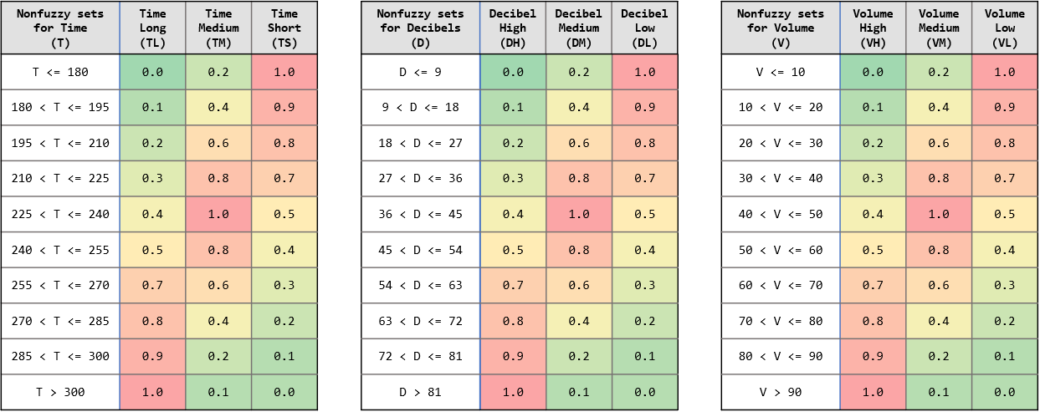

Table 1. Fuzzy Sets and Nonfuzzy Sets

The decision Rules are developed linguistically to increase or decrease the TV volume level and are implemented as a set of fuzzy conditional statements in the form: IF statement of variable 1 AND statement of variable 2 THEN action on variable 3. In this system, variable 1 is elapsed Time (T) input, variable 2 is decibel (dB) level (D) input, and variable 3 is the new volume level output (V). Refer to Table 2 below for the canonical relationship between both input variable fuzzy sets to determine the related output fuzzy set.

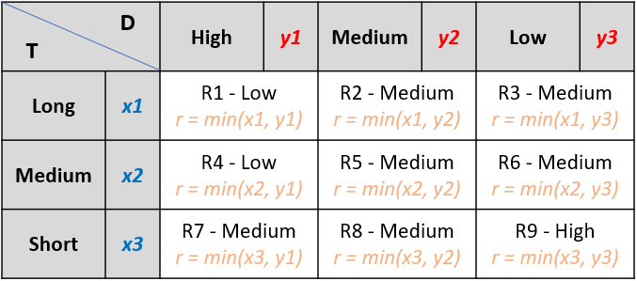

Table 2. Fuzzy Set Variable Relationships

For example, as shown in Table 2: **IF** *long T (TL)* **AND** *high D (DH)* **THEN** *medium V (VM)*. In other words, when the time is long (statement of variable 1) and the decibels are high (statement of variable 2), then the volume of the TV is medium (action on variable 3). These rules were derived from experience of the designers.

In the five steps to calculate the crisp value for volume, Step 1 involves finding the degree membership for each given input to the related fuzzy sets using Table 1. These values will be transferred to Table 2 in the *x1*, *x2*, and *x3* values of time and *y1*, *y2*, and *y3* values of decibels for the degree membership of their related fuzzy sets, respectively. In Step 2, we calculate the degree of freedom (DOF) from the fulfillment of the IF part of all rules and transferred to Table 2 with each *r-*value, respectively. In Step 3, we calculate the Volume action vector for each rule using Table 2 *r-values* and the Table 1 *VH*, *VM*, or *VL* vector values depending on which “THEN” action is described. In Step 4, we compute the net selection volume (NSV) vector by comparing all vector values in the previous step for each rule. Finally, in Step 5, we calculate the scalar volume action based on the previous NSV vector and the weight against the interval value. This final value is what is easily understood and thus given to the user as the output value, or in this case, used by the TV as the value the volume should be set to.

By implementing this volume control fuzzy set expert system, loud commercials will be dampened to keep the relative decibel level at about the same level as the rest of the programming. Additionally, if the volume is too low, then it will increase the TV volume. When the audio gets too loud again, it will adjust back to a reasonable level again. Thus, the user will not need to use the remote.

Running this program, written in Java language, with time intervals of 5 seconds and decibel intervals of 5 dB, we get the following results for the calculated TV volume as shown in Table 3.

|  |  |  |  |  |  |  |  |  |  |  |  |  |  |  |  |  |  |  |  |
| --- | --- | --- | --- | --- | --- | --- | --- | --- | --- | --- | --- | --- | --- | --- | --- | --- | --- | --- | --- |
| T \ D | **0** | **5** | **10** | **15** | **20** | **25** | **30** | **35** | **40** | **45** | **50** | **55** | **60** | **65** | **70** | **75** | **80** | **85** | **90** |
| **180** | **57** | **65** | **61** | **61** | **57** | **57** | **55** | **55** | **51** | **51** | **50** | **48** | **48** | **47** | **47** | **46** | **46** | **45** | **45** |
| **185** | **55** | **61** | **61** | **61** | **57** | **57** | **54** | **54** | **50** | **50** | **48** | **47** | **47** | **45** | **45** | **44** | **44** | **44** | **44** |
| **190** | **55** | **61** | **61** | **61** | **57** | **57** | **54** | **54** | **50** | **50** | **48** | **47** | **47** | **45** | **45** | **44** | **44** | **44** | **44** |
| **195** | **55** | **61** | **61** | **61** | **57** | **57** | **54** | **54** | **50** | **50** | **48** | **47** | **47** | **45** | **45** | **44** | **44** | **44** | **44** |
| **200** | **52** | **57** | **57** | **57** | **57** | **57** | **54** | **54** | **50** | **50** | **47** | **44** | **44** | **42** | **42** | **41** | **41** | **41** | **41** |
| **205** | **52** | **57** | **57** | **57** | **57** | **57** | **54** | **54** | **50** | **50** | **47** | **44** | **44** | **42** | **42** | **41** | **41** | **41** | **41** |
| **210** | **52** | **57** | **57** | **57** | **57** | **57** | **54** | **54** | **50** | **50** | **47** | **44** | **44** | **42** | **42** | **41** | **41** | **41** | **41** |
| **215** | **48** | **55** | **55** | **55** | **55** | **55** | **54** | **54** | **50** | **50** | **47** | **42** | **42** | **39** | **39** | **38** | **38** | **38** | **38** |
| **220** | **48** | **55** | **55** | **55** | **55** | **55** | **54** | **54** | **50** | **50** | **47** | **42** | **42** | **39** | **39** | **38** | **38** | **38** | **38** |
| **225** | **48** | **55** | **55** | **55** | **55** | **55** | **54** | **54** | **50** | **50** | **47** | **42** | **42** | **39** | **39** | **38** | **38** | **38** | **38** |
| **230** | **43** | **51** | **51** | **51** | **52** | **52** | **51** | **51** | **50** | **50** | **47** | **42** | **42** | **38** | **38** | **36** | **36** | **36** | **36** |
| **235** | **43** | **51** | **51** | **51** | **52** | **52** | **51** | **51** | **50** | **50** | **47** | **42** | **42** | **38** | **38** | **36** | **36** | **36** | **36** |
| **240** | **43** | **51** | **51** | **51** | **52** | **52** | **51** | **51** | **50** | **50** | **47** | **42** | **42** | **38** | **38** | **36** | **36** | **36** | **36** |
| **245** | **43** | **50** | **50** | **50** | **50** | **50** | **49** | **49** | **48** | **48** | **47** | **42** | **42** | **37** | **37** | **36** | **36** | **36** | **36** |
| **250** | **43** | **50** | **50** | **50** | **50** | **50** | **49** | **49** | **48** | **48** | **47** | **42** | **42** | **37** | **37** | **36** | **36** | **36** | **36** |
| **255** | **43** | **50** | **50** | **50** | **50** | **50** | **49** | **49** | **48** | **48** | **47** | **42** | **42** | **37** | **37** | **36** | **36** | **36** | **36** |
| **260** | **42** | **48** | **48** | **48** | **48** | **48** | **48** | **48** | **47** | **47** | **45** | **42** | **42** | **39** | **39** | **36** | **36** | **36** | **36** |
| **265** | **42** | **48** | **48** | **48** | **48** | **48** | **48** | **48** | **47** | **47** | **45** | **42** | **42** | **39** | **39** | **36** | **36** | **36** | **36** |
| **270** | **42** | **48** | **48** | **48** | **48** | **48** | **48** | **48** | **47** | **47** | **45** | **42** | **42** | **39** | **39** | **36** | **36** | **36** | **36** |
| **275** | **40** | **47** | **47** | **47** | **47** | **47** | **46** | **46** | **45** | **45** | **44** | **40** | **40** | **37** | **37** | **34** | **34** | **34** | **34** |
| **280** | **40** | **47** | **47** | **47** | **47** | **47** | **46** | **46** | **45** | **45** | **44** | **40** | **40** | **37** | **37** | **34** | **34** | **34** | **34** |
| **285** | **40** | **47** | **47** | **47** | **47** | **47** | **46** | **46** | **45** | **45** | **44** | **40** | **40** | **37** | **37** | **34** | **34** | **34** | **34** |
| **290** | **38** | **46** | **46** | **46** | **46** | **46** | **45** | **45** | **44** | **44** | **43** | **39** | **39** | **36** | **36** | **33** | **33** | **32** | **32** |
| **295** | **38** | **46** | **46** | **46** | **46** | **46** | **45** | **45** | **44** | **44** | **43** | **39** | **39** | **36** | **36** | **33** | **33** | **32** | **32** |
| **300** | **38** | **46** | **46** | **46** | **46** | **46** | **45** | **45** | **44** | **44** | **43** | **39** | **39** | **36** | **36** | **33** | **33** | **32** | **32** |

Table 3. TV Volume Results

# References

BoomSpeaker. (2019, September). *Noise Level Chart: Decibel Levels of Common Sounds with Examples*. Retrieved on April 18, 2020 from https://boomspeaker.com/noise-level-chart-db-level-chart/.

Federal Communications Commission (FCC). (2019, December). *Loud Commercials on TV*. Retrieved on April 18, 2020 from https://www.fcc.gov/consumers/guides/loud-commercials-tv.

Purdue University. (2000, February). *Noise Sources and Their Effects.* Retrieved on April 18, 2020 from https://www.chem.purdue.edu/chemsafety/Training/PPETrain/dblevels.htm.