The solenoid used was the JF-0826B.
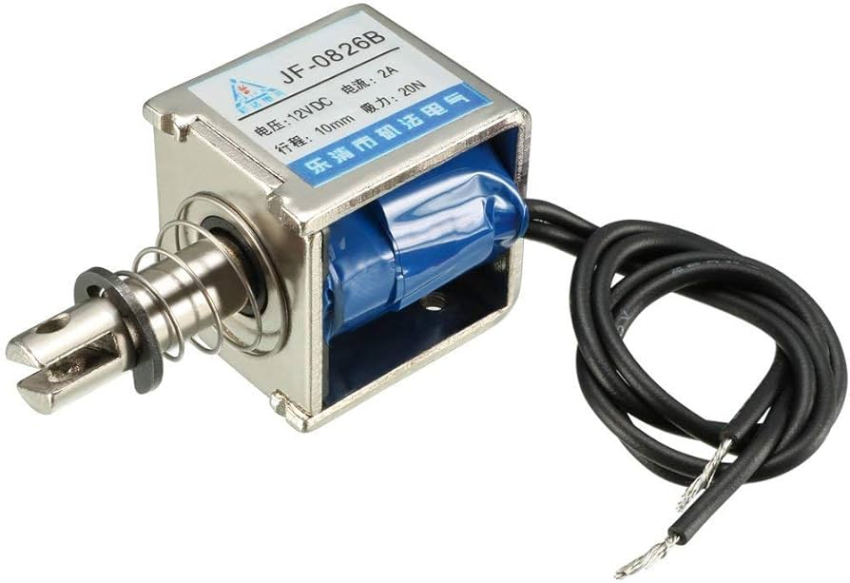
During testing, the solenoid was powered using a separate power source instead of the main TurtleBot power rail. The solenoid operates at approximately 12 V.
Batteries used:-
- DC-168 (12.6V, 1800 mAh)- Used to power SOLENOID ONLY
- 3S 11.V Lipo Battery ( IDP provided battery)- powers everything else

Components | Voltage (V) | Current(A) | Max Current (A) | Power (W) | Max Power (W)
Solenoid (normal runtime) | 12 | 1.786 A | 2A | 21.432 | 24
Turtlebot (boot) | 11.1 | 0.889 | No Surge | 9.8679 | 9.8679
Turtlebot (standby) | 11.1 | 0.544 | No Surge | 6.0384 | 6.0384
Turtlebot (teleop) | 11.1 | 0.65 | 0.742 | 7.215 | 8.2362

Note:
- If solenoid is kept ON continuously, the current slowly increases and eventually reaches the lab power supply current limit of 2 A after approximately 15 seconds (However, the solenoid is never intended to stay ON for this long during the mission because it heats up significantly. It is only fired in short pulses.)
- This separate power architecture was used to isolate the high-current solenoid load from the Raspberry Pi and OpenCR. Since the solenoid draws relatively high current during firing, powering it from the main robot battery could cause voltage sag, brownout, or unstable behaviour in the control electronics.

Turtlebot Battery power ~ | 19 Wh
How long it can last (Standby Power)(h) ~ | 2.5hr
Max teleop power (h) | 1.5 hr

Solenoid Battery Testing:
From lab power supply testing:
Supply voltage ≈ 12 V
Typical running current after transient = 1.786 A
Current during short firing intervals fluctuates between approximately 1 A and 1.786 A
If kept ON continuously, the current slowly increases and reaches the lab power supply current cap of 2 A after around 15 seconds.
However, the solenoid is not designed to remain ON continuously during the mission. It is only fired in short pulses because continuous operation causes significant heating.
Solenoid Power Calculation
Power = Voltage × Current
Lower short-pulse estimate (during transient state) :
P = 12.6 × 1.4
P = 17.64 W
Typical measured running power:
P = 12.6 × 1.786
P = 22.50 W
Worst-case capped current:
P = 12.6 × 2
P = 25.2 W
Therefore, the solenoid power draw is approximately 17.64 W to 22.5 W during short activations, with a worst-case continuous estimate of 25.2 W.
Runtime of Separate Solenoid Battery:
DC-168 Battery rating given:
12.6 V, 1800 mAh
Energy in watt-hours:
Energy = Voltage × Capacity
So:
Energy = 12.6 V × 1.8 Ah = 22.68 Wh
Using the full-charge battery energy:
Battery energy = 22.68 Wh
At 1 A short-pulse current:
Runtime = 22.68 / 12.6
Runtime = 1.8 h
Runtime = 108 min
At typical measured current of 1.786 A:
Runtime = 22.68 / 22.50
Runtime = 1.01 h
Runtime ≈ 60 min
At worst-case capped current of 2 A:
Runtime = 22.68 / 25.2
Runtime = 0.9 h
Runtime = 54 min
In reality, the solenoid fires only in short pulses. Therefore, the average current draw is much lower than the continuous current draw, and the actual usable runtime is much longer than the continuous ON estimate.
Since the mission runtime is only 25 minutes, the separate 12.6 V, 1800 mAh battery provides enough energy for solenoid operation, assuming the solenoid is only pulsed briefly during firing events.
Final Design Decision
The final design used a separate battery/power source for the JF-0826B solenoid actuator.
This was a major improvement (from PDR where we used only the turtlebot battery) because it isolated the high-current switching load from the TurtleBot power rail, reducing the risk of voltage sag or brownout affecting the Raspberry Pi and OpenCR.
With the separate solenoid power source, the robot was able to successfully complete the mission at both stations.

Assumptions made for estimation:
- Power consumption is assumed constant within each operating mode (boot / standby / teleop).
- Boot-up power is treated as a short transient and neglected in endurance.
- Teleop runtime is estimated using the measured max teleop power (worst-case continuous draw).
- Solenoid is assumed and intended to not be activated (or their duty cycle is negligible) during the navigation of turtlebot.
- Battery voltage and capacity are assumed constant and equal to rated values
- Power conversion losses and internal resistance/voltage sag are neglected for first-order estimation.
- Temperature, battery ageing, and state-of-charge effects are neglected.

