**MongoDB Assignment**

1. Create a Database with the name College using MongoDB command – **use College**

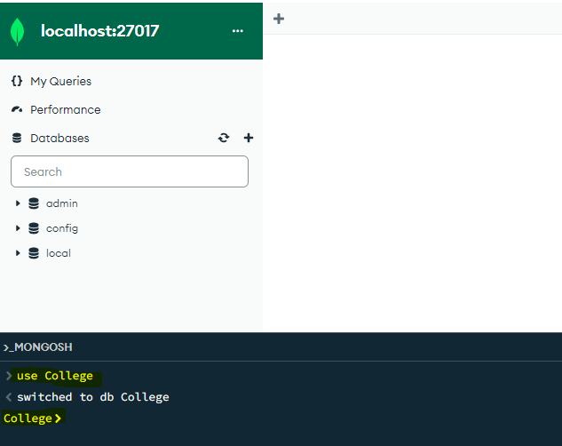

1. Create MongoDB Collection employee and department under College database

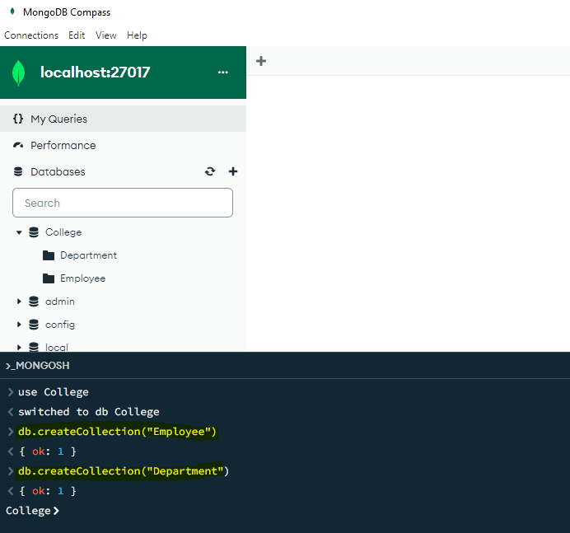

1. Insert Records into **Employee** Collection

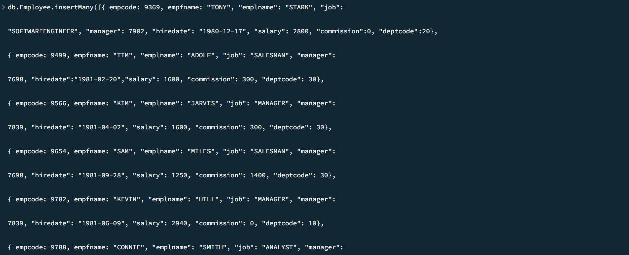

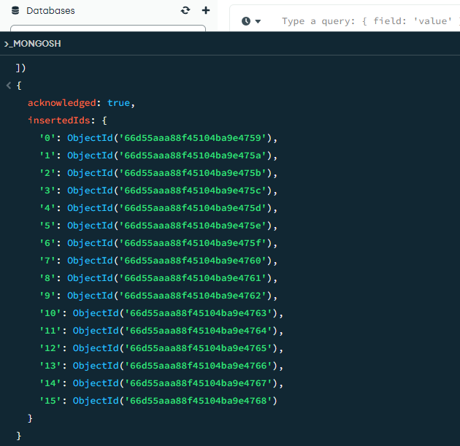

1. Insert Records into **Department** Collection

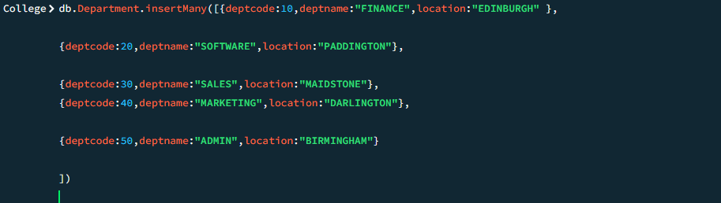

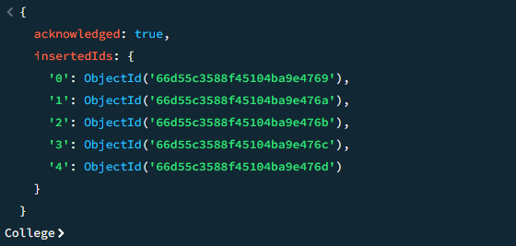

1. List all the documents inside a collection’s employee and department both.

**Employee**

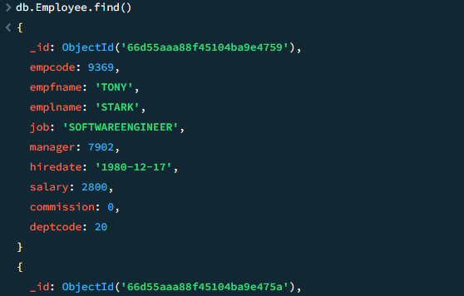

**Department**

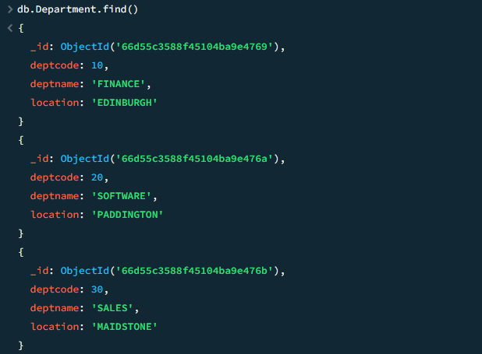

1. **List all the documents of employee collection WHERE job in (“SALESMAN”, “MANAGER”):**

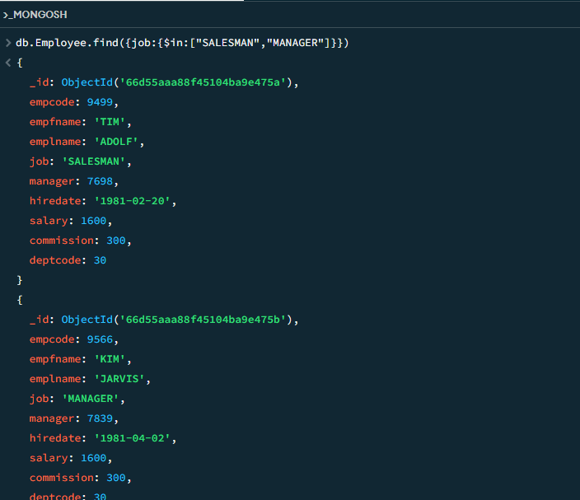

1. **List all the documents of employee collection WHERE job = “ANALYST” AND SALARY <**

**15000**

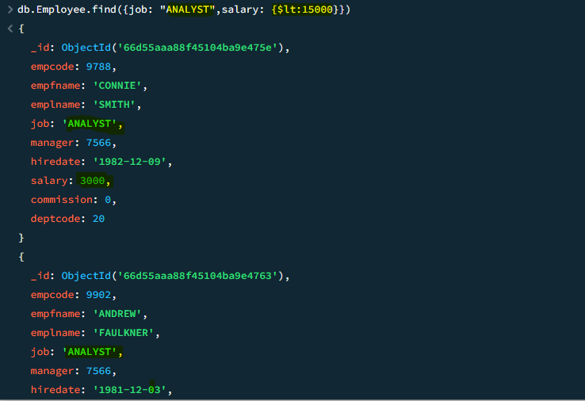

1. **List all the documents of employee collection WHERE job = “ANALYST” or SALARY<**

**1500**

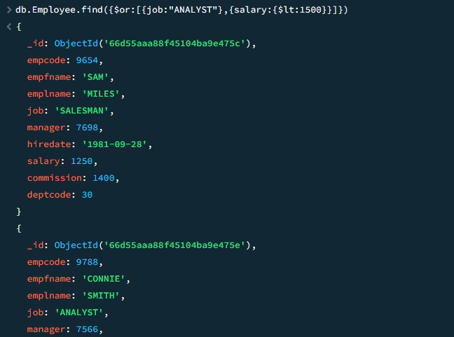

1. **List all the documents of employee collection WHERE job =” ANALYST” AND (SALARY < 15000 OR empfname LIKE ”T%”)**

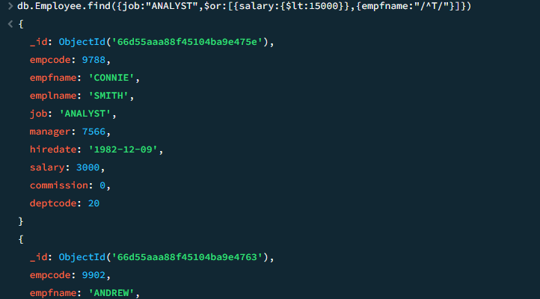

1. **List all the documents of employee collection in ascending order of job**

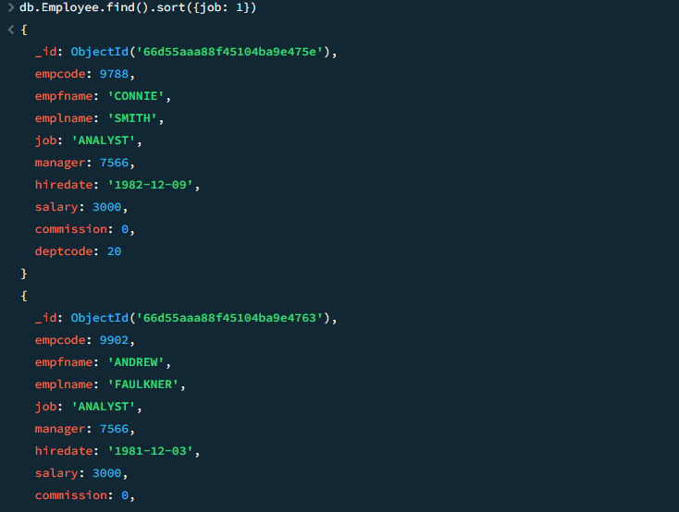

1. **Create index on the empcode field of employee collection. Code.**

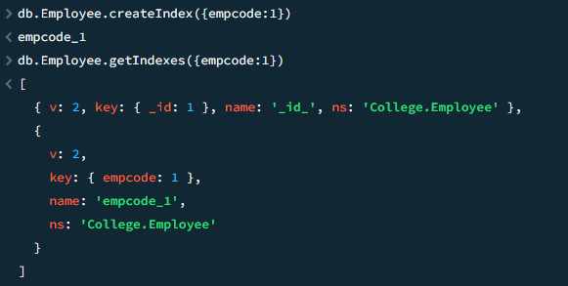

1. **Create multiple indexes on empcode and hiredate fields of employee collection. Code.**

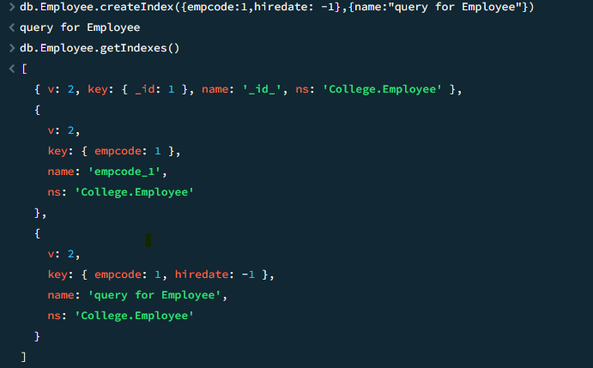

1. **Delete first record of employee collection where job is SALESMAN.**

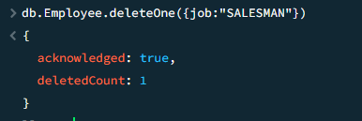

1. **Delete all the records of employee collection where the job is SALESMAN.**

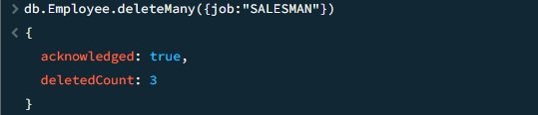

1. **Delete all the records of employee collection.**

