

**Big Data for Managers & Analytics**

**Submitted To:**

Prof. Amarnath Mitra

**Report on** **Project on** **Database Management using MySQL**

**Topic:** Loan Application System

**Submitted by:**

**Siddhant Banyal (064050)**

**Database**

This database schema is designed to manage a loan application system. It includes key tables:

* **Customer**: Stores personal information of customers, including names, contact details, and unique identifiers like Aadhar and PAN numbers.
* **Application**: Tracks loan applications linked to customers, detailing loan amounts, types, statuses, and dates.
* **Loan**: Records specific loan details associated with each application, including the amount and type.
* **Property**: Manages information about properties owned by customers, including their values.
* **Employment**: Records employment details for each customer.
* **Income**: Captures income details for customers.
* **Credit**: Stores credit scores for customers.

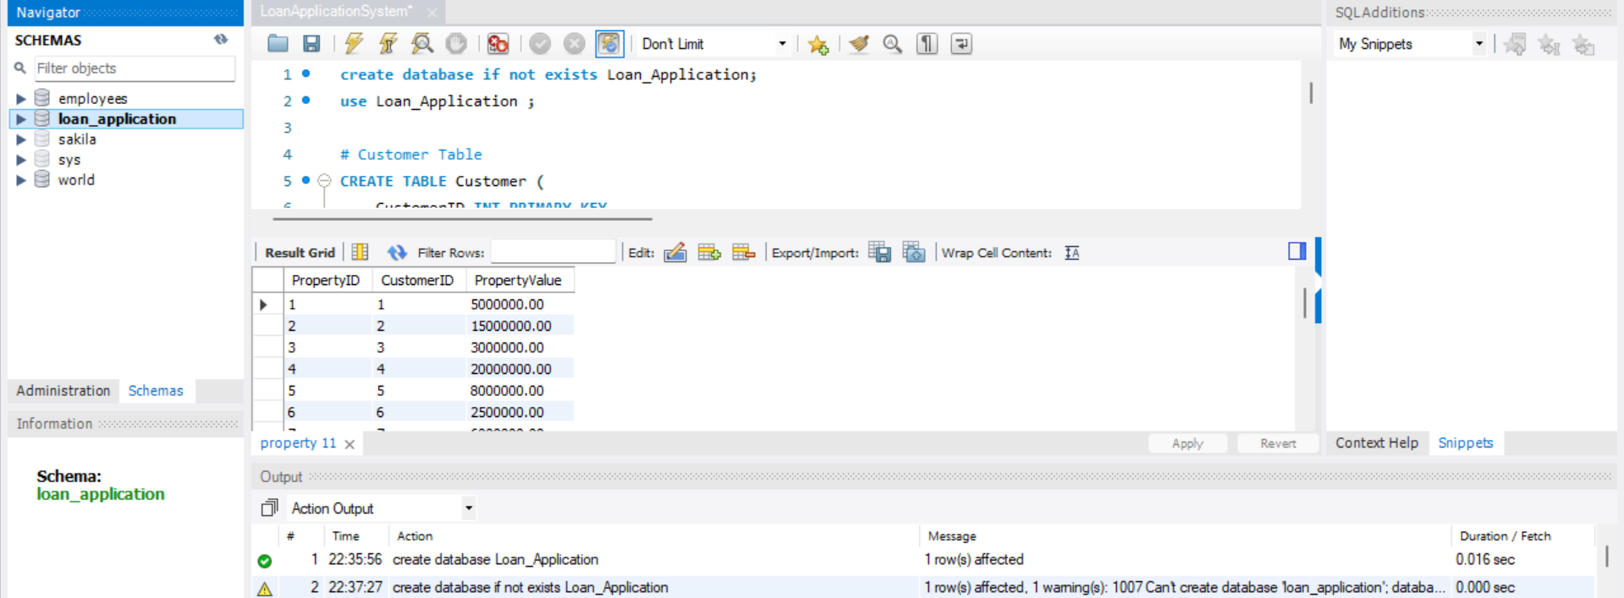

**Tables**

The database consists of seven tables, each serving a specific role and these tables are interconnected, with **Customer** being the central entity, linking to **Application, Property, Employment, Income, and Credit.** This structure ensures comprehensive management of customer data and loan processing.

1. **Customer Table:** Contains personal details of customers, including names, contact information, and unique identifiers such as Aadhar and PAN numbers.

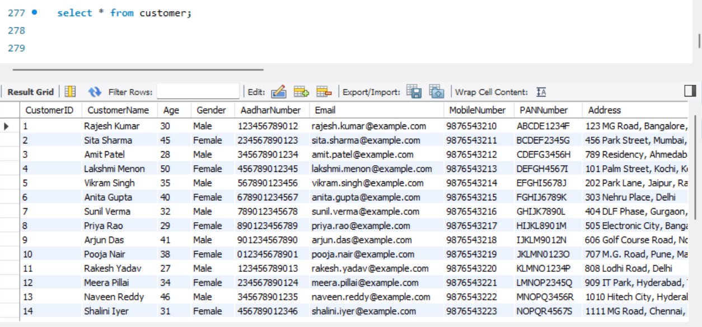

1. **Application Table**: Records each loan application, detailing the amount requested, type of loan, status, and the date it was submitted.

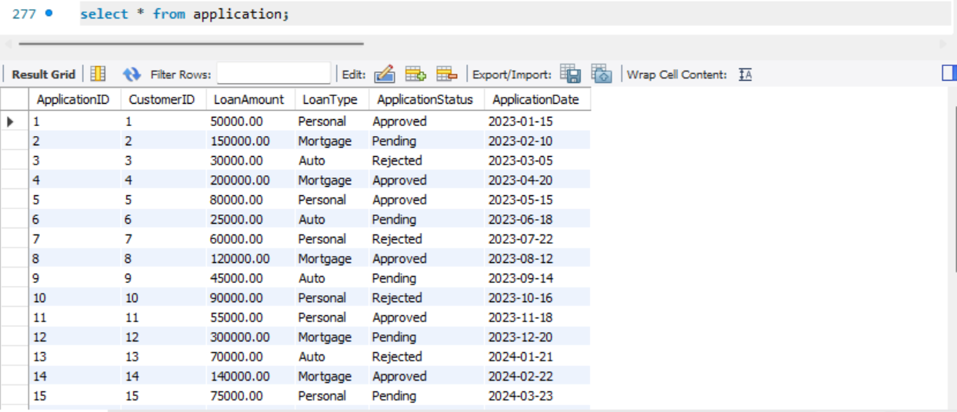

1. **Loan Table**: Stores information about the loan associated with each application, including the amount and type of loan.

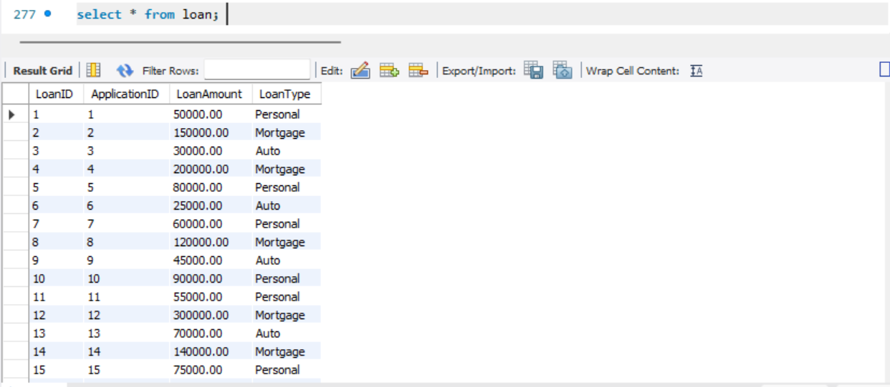

1. **Property**: Lists properties owned by customers, including the value of each property.

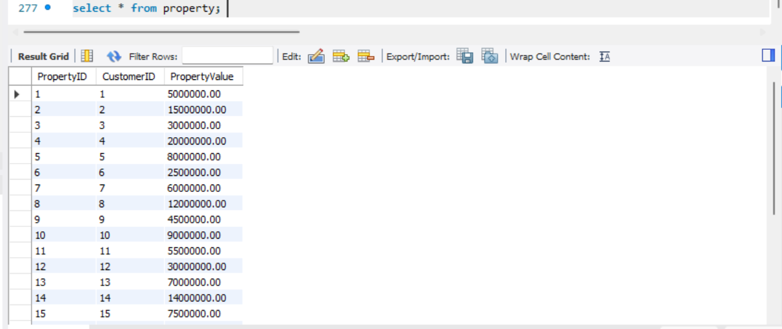

1. **Employment**: Provides details about the customer’s employment status.

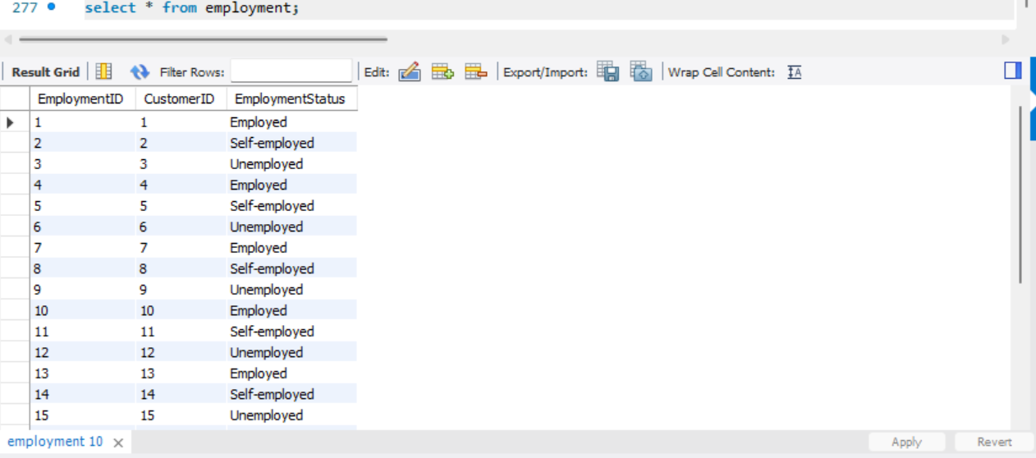

1. **Income**: Records the income information for each customer.

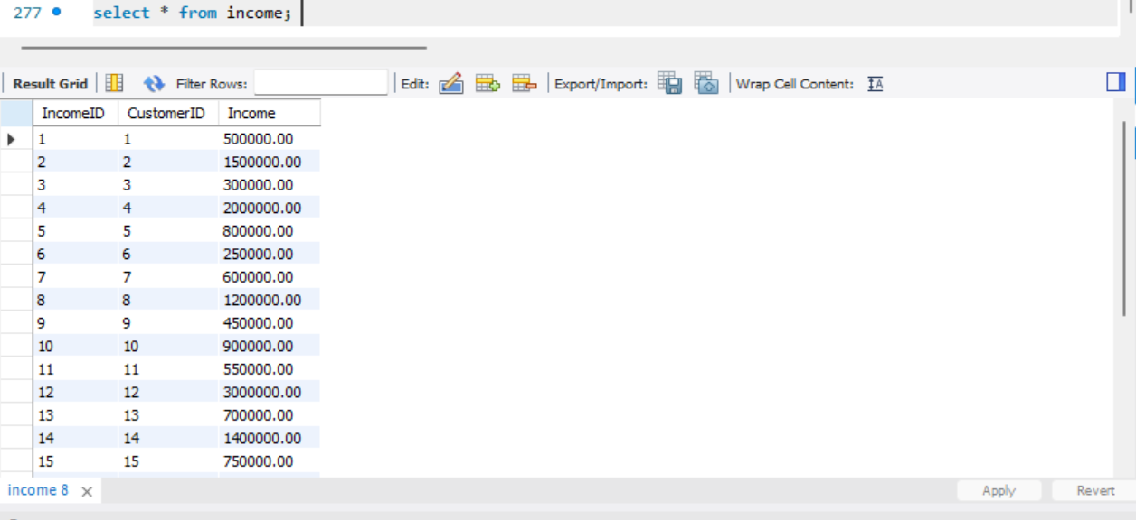

1. **Credit**: Contains credit scores for customers.

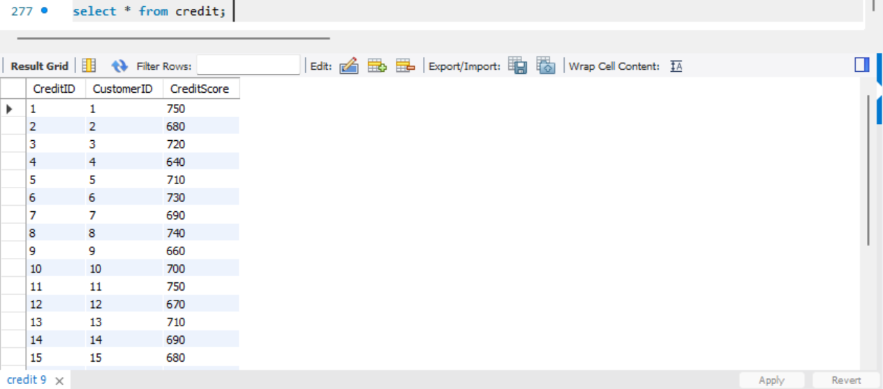

**Stress Testing**

Stress testing of database using the CRUD operations:

• **Create:** Used to insert new records.

• **Read:** Used to retrieve and view data.

• **Update:** Used to modify existing data.

• **Delete:** Used to remove data.

**Create Operation:**

**Inserting into Customer Table:**

INSERT INTO Customer (CustomerID, CustomerName, Age, Gender, AadharNumber, Email, MobileNumber, PANNumber, Address)

VALUES

(1, 'Rajesh Kumar', 35, 'Male', '123456789012', 'rajesh.kumar@example.com', '9876543210', 'ABCDE1234F', '123 Main Street, Delhi');

**Inserting into Application Table:**

INSERT INTO Application (ApplicationID, CustomerID, LoanAmount, LoanType, ApplicationStatus, ApplicationDate)

VALUES

(26, 26, 500000, 'Home Loan', 'Pending', '2024-08-01');

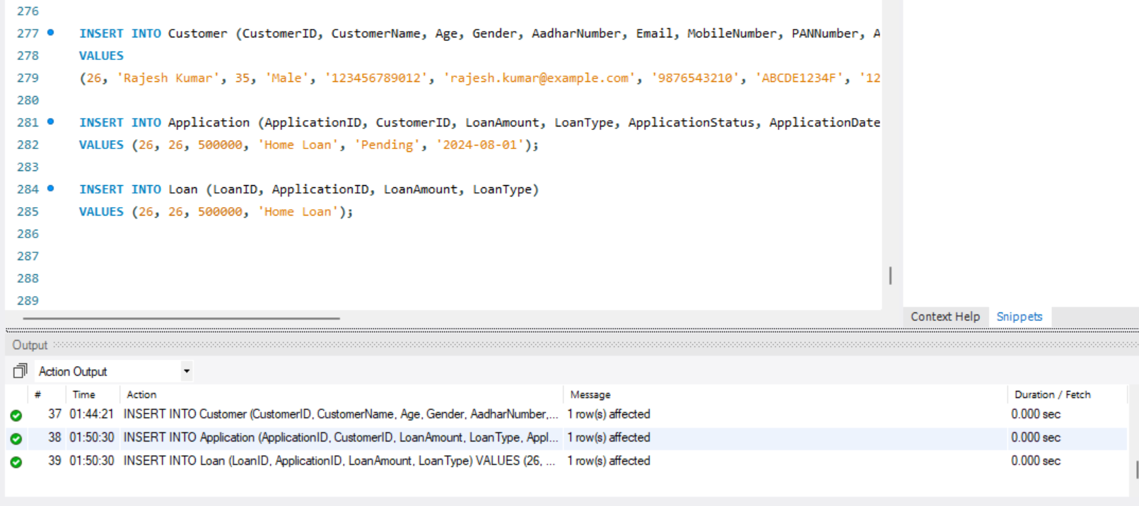

**Read (Select) Operation: -**

**Retrieving from Customer Table where gender is Male:**

SELECT * FROM Customer WHERE gender = "Male";

**Retrieving from Application where gender is Male:**

SELECT * FROM application where loanAmount >= 50000 And loantype = "Personal”;

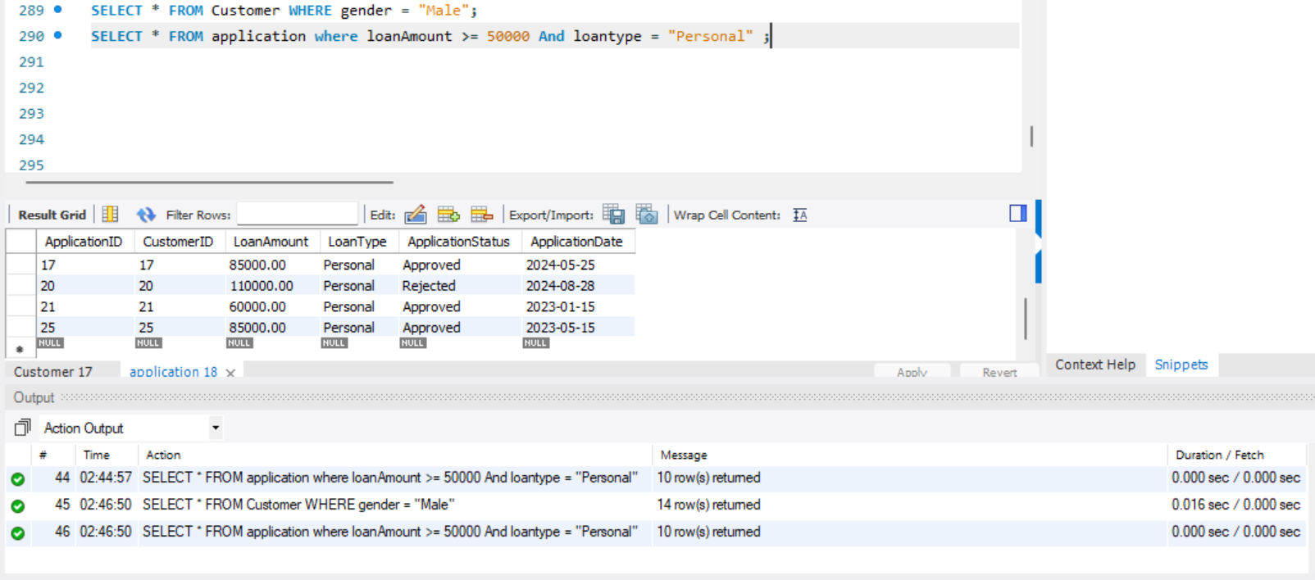

**Update Operation:**

**Updating From Customers Table:**

UPDATE Customer

SET Email = 'rajesh.newemail@example.com', MobileNumber = '9123456780'

WHERE CustomerID = 26;

**Updating From Application Table:**

UPDATE Application

SET LoanType = "Auto"

Where applicationid = "10"

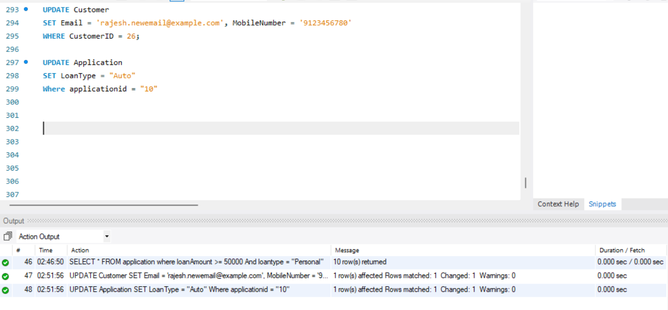

**Delete Operation:**

**Deleting from Loan Table:**

Delete from Loan where LoanId = 1;

**Deleting From Application Table:**

Delete from Application where Applicationid = 1;

