**SCIRT**

The Stronger Christchurch Infrastructure Rebuild Team(SCIRT) was a multi-billion-dollar initiative funded by the government of New Zealand and the Christchurch city council to rebuild the city of Christchurch damaged by the 2011 earthquake.

Rated as the second worst disaster in New Zealand the SCIRT initiative was formed as a conglomerate of five major construction companies: Fletchers, McConnell Dowell, Downers, City care and Futon Hogan. Each company was tasked to carry out specific works on the designated issue. The alliance had split the approach into two halves, as the Integrated services team(IST) that comprised of 300+ engineers, 70 consultancies and various project managers and technical designers and the delivery team which consisted of the above stated companies.

The scope of the damage was huge and realized. Due to the size of the re-building and repair program the code of conduct, of “Best Practices” had to be modified specifically for the Christchurch earthquakes. This was related to the health and safety, environmental protection, whilst achieving the recommended quality stated via industrial agreements all of which are important factors. The budget set aside by the government bodies also included the price of the tools and equipment required. New Zealand Transport Association(NZTA), Canterbury Earthquake Recovery Authority (CERA) and the local council were also responsible for the technical evaluation/assessment of the damage through visual, technological and software aids.

There were various management plans initiated by SCIRT to guide organizations. These plans contributed towards the delivery of high quality and timely deliverables during the rebuilding, repairing and replacing stage. The SCIRT plans consisted of Cost management, prioritization of infrastructure repairs, project deadlines, environmental assistance, communication, delivery systems, social impact and procurement plans.

One of the objectives to prioritize the infrastructure, was “doing the right thing at the right time”. This gave fast tracked the prioritization section by analyzing the risk associated with the infrastructure that had been damaged. For instance, if the road leading to a hospital was blocked it would cut off access to the hospital for citizens causing major issues in terms of healthcare. This lead to a design method called the “MESHT”. The MESHT objects, were the Medical and Emergency, Schools, Hospitals and transport and the structure and infrastructure leading towards these highly important infrastructural objects were prioritized.

Contacting suppliers and contractors which brought in more arms to work sped up the process employing highly skilled and professional workers. Another aspect that was important was community outreach and community involvement conducted using Canterbury maps to highlight regions which required attention.

**Tools**:The tools are the equipment required to conduct the assessment/survey of the damage. The tools are also equipment’s used in the restoring and construction of the infrastructure. The tool name attribute specifies whether the tool is a heavy equipment tool or a software tool. The description is the information of the tool in terms of the cost, specifications, environmental emission norms and the make. The attribute application area highlights the region in which it can be used.

**Damage assessment:** The damage assessment is the byproduct of a survey conducted by using the tools to evaluate the degree of damage. The attribute damage assessment name is the name or type of damage sustained. Be it directly earth quake related or a result of some other factor. The structure attribute points out, the identity of the structure that is to be analyzed. The structure could be a bridge, road, canal, footpath, etc.

**Tools usage:** The tools usage entity demonstrates the ability of the tool and how it is to be used to deliver to a certain problem. As different tools have various maneuvers A tool used for excavating can also be used for towing or destroying using the bucket. The used in attribute explains what the tool will be doing. The description attribute gives the overall performance of the various methods that the tool uses and can be used in.

**Priority:** The priority entity highlights the importance of the infrastructure which needs to be looked at and repaired first. This a by product after the damage assessment has been carried out along with the design system(MESHT) in place by the alliance’s. The priority name attribute highlights whether the it is of high importance, medium importance or low importance.

**Project:** The project entity considers the theory and the cure for the damage. The project looks at the physiological requirements in terms of the cost and deadlines to fix the damage.

**Data storage:** The data storage entity is where all the data is stored. The data type attribute distinguishes the type of data, whether financial, geospatial, project managerial or raw data from sensors and equipment on the field. The data can also be used for future reference.

**Management:** The management entity is the headquarter of the entire diagram. All the data is relayed to the management where the decision-making processes take place.All management plans, procurement, financial, human resources etc. are handled under the management.The attribute Management name draws to attention the type of management with context to the relevant problem. Social initiatives, environmental initiatives, economic are subject under the management. The description attribute explains the goal and scope of the management and briefly outlines the entire project.

**Contractor:** The contractor carries out the work. Contractor info is the description of the work it does.

**The assumptions and limitations**

The data that was given as a reference point contained just one paragraph. The information given by RAMM was not sufficient and extensive research had to be done to find out what contributing factors were supporting the topological requirements.

Lack of data providing a clear outline about the management was restricted and hence, a more generalized approach was taken to highlight management rather than individual components.

The GIS software information was not available in details hence had to assume that the information provided was good for the surface level structure.

There was no information in context to the environment, society and future initiatives. Hence sustainability could be considered. The description of tools was too generalized, and no specific tools were listed, other than CCTV’s, which had to be considered worthy in the assessment of roads. The type of heavy equipment was not mentioned.

It had to be considered that all the work on SCIRT was complete by the time the information in the sample sheet came through.

Surface level objects contribute to an array of objects, from roads to buildings, to trees all of which can be deemed as surface level, however, the word surface level does not necessarily mean surface level and hence does not give a clear insight into surface level, bridges are over the surface and so are retaining walls. Taking that into considering all the surface objects were considered and hence not a lot of attributes could be formed due to lack of information.

The subject is now an old concept and is currently being sought to be replaced by a newer system. This has restricted the amount of information available online. Although there is a substantial amount of data online in terms of data model it does not quite explain the in-depth view of the SCIRT program.

It had to be assumed that the model constructed by SCIRT was efficient. The ERD diagram does not provide a comprehensive overview of the entire management structure as it would have been too large to accommodate all the management plans along with the project the environment social and other causes.

The making of an ER diagram in this case scenario can have no limits, increasing the size of the ER diagrams and the information that would go through with it. Hence due to a lack of information the damage assessments for all types of surface structures as instructed in the assignment had to be considered common.

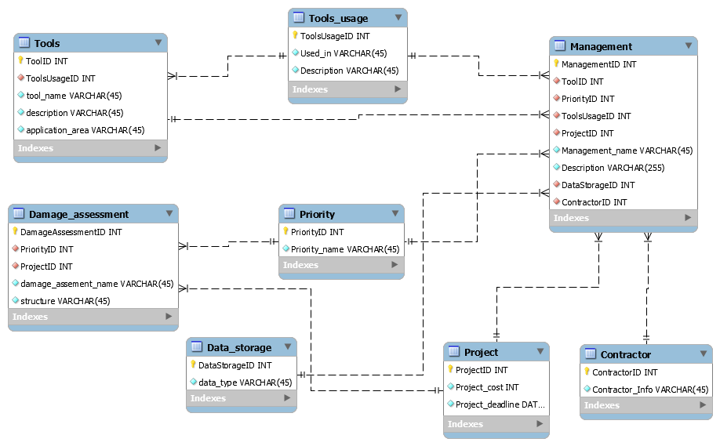

Figure . ERD SCIRT

-- MySQL Workbench Forward Engineering

SET @OLD_UNIQUE_CHECKS=@@UNIQUE_CHECKS, UNIQUE_CHECKS=0;

SET @OLD_FOREIGN_KEY_CHECKS=@@FOREIGN_KEY_CHECKS, FOREIGN_KEY_CHECKS=0;

SET @OLD_SQL_MODE=@@SQL_MODE, SQL_MODE='TRADITIONAL,ALLOW_INVALID_DATES';

-- -----------------------------------------------------

-- Schema mydb

-- -----------------------------------------------------

-- -----------------------------------------------------

-- Schema mydb

-- -----------------------------------------------------

CREATE SCHEMA IF NOT EXISTS `mydb` DEFAULT CHARACTER SET utf8 ;

USE `mydb` ;

-- -----------------------------------------------------

-- Table `mydb`.`Project`

-- -----------------------------------------------------

CREATE TABLE IF NOT EXISTS `mydb`.`Project` (

`ProjectID` INT NOT NULL,

`Project_cost` INT NOT NULL,

`Project_deadline` DATETIME NOT NULL,

PRIMARY KEY (`ProjectID`))

ENGINE = InnoDB;

-- -----------------------------------------------------

-- Table `mydb`.`Tools_usage`

-- -----------------------------------------------------

CREATE TABLE IF NOT EXISTS `mydb`.`Tools_usage` (

`ToolsUsageID` INT NOT NULL,

`Used_in` VARCHAR(45) NOT NULL,

`Description` VARCHAR(45) NOT NULL,

PRIMARY KEY (`ToolsUsageID`))

ENGINE = InnoDB;

-- -----------------------------------------------------

-- Table `mydb`.`Tools`

-- -----------------------------------------------------

CREATE TABLE IF NOT EXISTS `mydb`.`Tools` (

`ToolID` INT NOT NULL,

`ToolsUsageID` INT NOT NULL,

`tool_name` VARCHAR(45) NOT NULL,

`description` VARCHAR(45) NOT NULL,

`application_area` VARCHAR(45) NOT NULL,

PRIMARY KEY (`ToolID`),

INDEX `ToolsUsageID_idx` (`ToolsUsageID` ASC),

CONSTRAINT `ToolsUsageID`

FOREIGN KEY (`ToolsUsageID`)

REFERENCES `mydb`.`Tools_usage` (`ToolsUsageID`)

ON DELETE NO ACTION

ON UPDATE NO ACTION)

ENGINE = InnoDB;

-- -----------------------------------------------------

-- Table `mydb`.`Priority`

-- -----------------------------------------------------

CREATE TABLE IF NOT EXISTS `mydb`.`Priority` (

`PriorityID` INT NOT NULL,

`Priority_name` VARCHAR(45) NOT NULL,

PRIMARY KEY (`PriorityID`))

ENGINE = InnoDB;

-- -----------------------------------------------------

-- Table `mydb`.`Damage_assessment`

-- -----------------------------------------------------

CREATE TABLE IF NOT EXISTS `mydb`.`Damage_assessment` (

`DamageAssessmentID` INT NOT NULL,

`PriorityID` INT NOT NULL,

`ProjectID` INT NOT NULL,

`damage_assement_name` VARCHAR(45) NOT NULL,

`structure` VARCHAR(45) NOT NULL,

PRIMARY KEY (`DamageAssessmentID`),

INDEX `PriorityID_idx` (`PriorityID` ASC),

INDEX `ProjectID_idx` (`ProjectID` ASC),

CONSTRAINT `PriorityID`

FOREIGN KEY (`PriorityID`)

REFERENCES `mydb`.`Priority` (`PriorityID`)

ON DELETE NO ACTION

ON UPDATE NO ACTION,

CONSTRAINT `ProjectID`

FOREIGN KEY (`ProjectID`)

REFERENCES `mydb`.`Project` (`ProjectID`)

ON DELETE NO ACTION

ON UPDATE NO ACTION)

ENGINE = InnoDB;

-- -----------------------------------------------------

-- Table `mydb`.`Data_storage`

-- -----------------------------------------------------

CREATE TABLE IF NOT EXISTS `mydb`.`Data_storage` (

`DataStorageID` INT NOT NULL,

`data_type` VARCHAR(45) NOT NULL,

PRIMARY KEY (`DataStorageID`))

ENGINE = InnoDB;

-- -----------------------------------------------------

-- Table `mydb`.`Contractor`

-- -----------------------------------------------------

CREATE TABLE IF NOT EXISTS `mydb`.`Contractor` (

`ContractorID` INT NOT NULL,

`Contractor_Info` VARCHAR(45) NOT NULL,

PRIMARY KEY (`ContractorID`))

ENGINE = InnoDB;

-- -----------------------------------------------------

-- Table `mydb`.`Management`

-- -----------------------------------------------------

CREATE TABLE IF NOT EXISTS `mydb`.`Management` (

`ManagementID` INT NOT NULL,

`ToolID` INT NOT NULL,

`PriorityID` INT NOT NULL,

`ToolsUsageID` INT NOT NULL,

`ProjectID` INT NOT NULL,

`Management_name` VARCHAR(45) NOT NULL,

`Description` VARCHAR(255) NOT NULL,

`DataStorageID` INT NOT NULL,

`ContractorID` INT NOT NULL,

PRIMARY KEY (`ManagementID`),

INDEX `ToolsUsageID_idx` (`ToolsUsageID` ASC),

INDEX `PriorityID_idx` (`PriorityID` ASC),

INDEX `ToolID_idx` (`ToolID` ASC),

INDEX `ProjectID_idx` (`ProjectID` ASC),

INDEX `DataStorageID_idx` (`DataStorageID` ASC),

INDEX `ContractorID_idx` (`ContractorID` ASC),

CONSTRAINT `ToolsUsageID`

FOREIGN KEY (`ToolsUsageID`)

REFERENCES `mydb`.`Tools_usage` (`ToolsUsageID`)

ON DELETE NO ACTION

ON UPDATE NO ACTION,

CONSTRAINT `PriorityID`

FOREIGN KEY (`PriorityID`)

REFERENCES `mydb`.`Priority` (`PriorityID`)

ON DELETE NO ACTION

ON UPDATE NO ACTION,

CONSTRAINT `ToolID`

FOREIGN KEY (`ToolID`)

REFERENCES `mydb`.`Tools` (`ToolID`)

ON DELETE NO ACTION

ON UPDATE NO ACTION,

CONSTRAINT `ProjectID`

FOREIGN KEY (`ProjectID`)

REFERENCES `mydb`.`Project` (`ProjectID`)

ON DELETE NO ACTION

ON UPDATE NO ACTION,

CONSTRAINT `DataStorageID`

FOREIGN KEY (`DataStorageID`)

REFERENCES `mydb`.`Data_storage` (`DataStorageID`)

ON DELETE NO ACTION

ON UPDATE NO ACTION,

CONSTRAINT `ContractorID`

FOREIGN KEY (`ContractorID`)

REFERENCES `mydb`.`Contractor` (`ContractorID`)

ON DELETE NO ACTION

ON UPDATE NO ACTION)

ENGINE = InnoDB;

SET SQL_MODE=@OLD_SQL_MODE;

SET FOREIGN_KEY_CHECKS=@OLD_FOREIGN_KEY_CHECKS;

SET UNIQUE_CHECKS=@OLD_UNIQUE_CHECKS;