Works on Command line interface, it is case sensitive

GIT Commands:

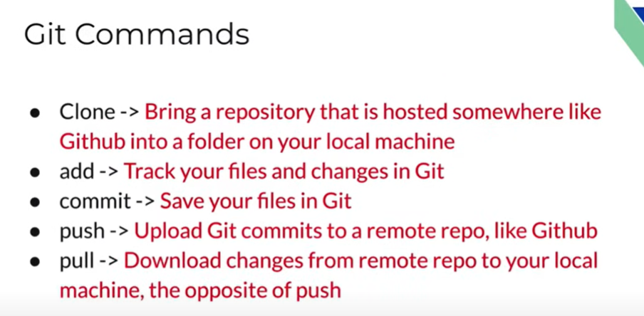

Readme.md - file that contains all the necessary info of the project/repository. Usually a text file

Each commit has a unique address mentioned

While importing to our code editor, use the HTTPS link not the SSH one. Unless we have an SSH key setup we cannot use SSH.

LS - short for la-ls. It is used to list the folders and files within the folders including hidden files.

git status - command used to show history and shows the files that have yet to be committed.

When you get an untracked file, it shows that the particular file hasn’t been updated in git

To commit an untracked file, you need to need to use "git add . " this will track both the untracked files in the repository and update the files that have been updated in the mean time.

If we want to commit a particular file then use git add <File name>

Connecting our machine to GITHUB is done through SSH keys

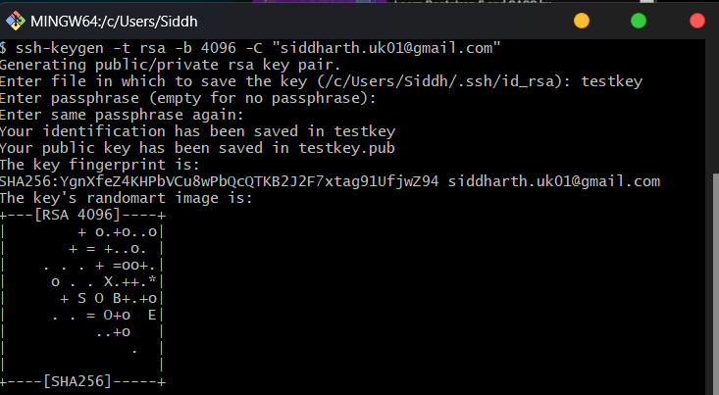

This can be run on cmd prompt, GIT and on VSCode.

The public key given by <testkey>.pub is a proof that this public key exists because of private key

To copy anything to our clipboard, we use pbcopy < ~/testkey.

Just use ~ to copy previous text to clipboard

Use git push origin main to save file to repository in GITHUB. It requires authentication then you can upload

**To save file into the repository in GITHUB we do**

1. **git add .**
2. **git status**
3. **git commit -m "<Title>" -m "<Description>"**
4. **git push origin main**
5. **Refresh GITHUB to access the files**

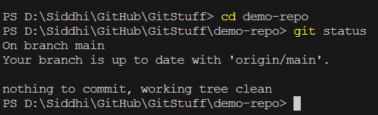

Cd demo-repo gives changes the directory or leads to git to the repository demo-repo

Git status is used to check if the repository we're in is upto date or any files are pending that require pushing and committing.

Git remote is used to access a repository that is not on this computer, but access it locally through the command