Demo Plan

TODO: Run through grammerly
This demo document will take you through a tour of the various features implemented in this project.

CORE REQUIREMENTS:
You can compile the program by running the make command as such:
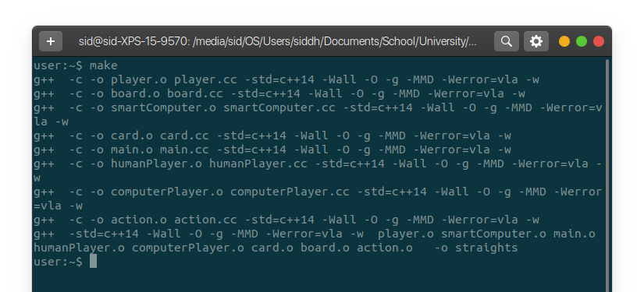
At this stage, the executable “straights” will be built in the current directory. This executable is fully compliant with the program specification in straights.pdf, and implements all required features completely.
To run the program without a specified seed, a constant internal seed will we used and the program can be called as such:
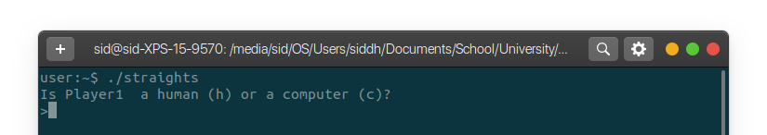

To run straights with a specified seed, simply enter a positive numeric seed as the first command line option. For example:
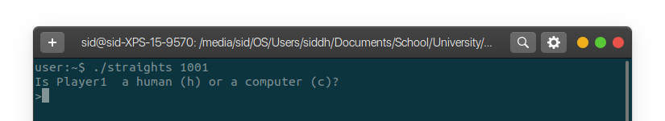
For now, we will use the seed 246. Initialize all player to be human:
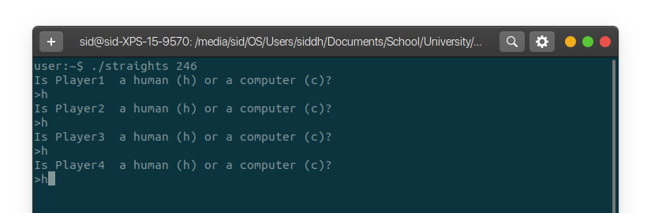
You will notice it will start the game with Player4 since they have the 7 of spades:
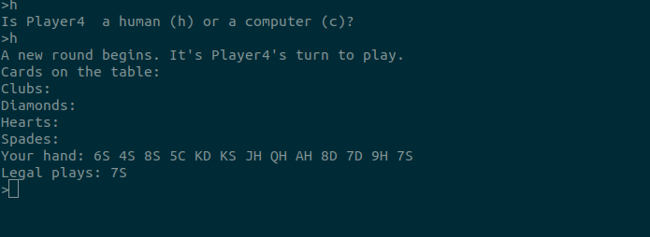
You will notice that the only legal play is 7S since it is the first play of the round (even though there exists another usually valid card: 7D in the user’s hand).
Note the following cases in which the user inputs invalid moves and the program’s response:
“discard 6S” invalid since there is a legal play:
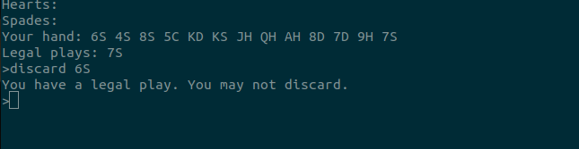
“play 7D” invalid since the user must play the 7S on the first play of the round:
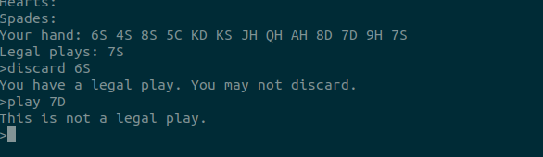
“play 7SS” invalid since 7SS does not represent a valid card:
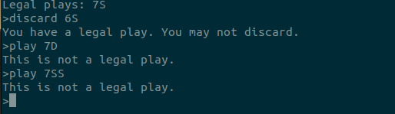
“random” invalid since it is not a supported command:
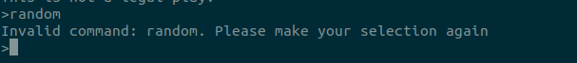

Also note the deck command reliably produces the state of the shuffled deck:
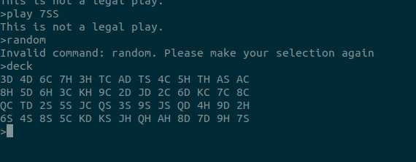
Since the cards are dealt to the players 13 at a time, the bottom row corresponds to the cards dealt to player 4 (as can be seen in the “Your hand: ...” line printed above).

Continuing with the game, we will play the 7S:
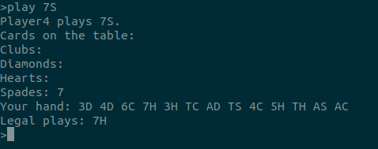

The game continues to Player1. Notice, the spades line for cards on the table lists the 7S played by Player4 on the previous turn. Let’s have Player1 ragequit using the “ragequit” command:
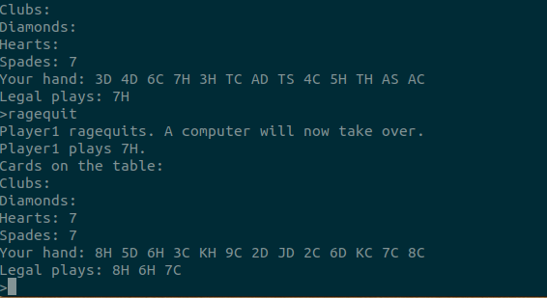
Notice program notifies the user of the replacement of Player1 with a computer. Then, the computer plays the only legal play (as seen in the printed line: “Legal plays: ...”): 7H.
On Player2’s turn, play 8H:
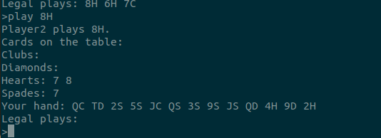
On Player3’s turn, it can be seen that the “Hearts: ...” line is correctly populated with 7 and 8. Additionally Player3 is forced to discard as they don’t have any legal card.
Consider the following invalid move cases and program reponses during a discard move:
“play QC” invalid since there are no legal plays:
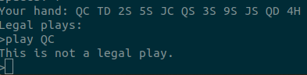

“discard 5H” invalid since the player does not own that card:
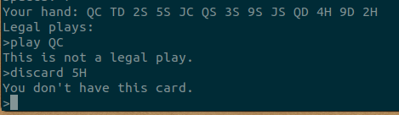

“discard QJ” invalid since such a card does not exist:
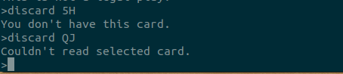

Now, we will ragequit Players3 and 4 to speed up the gameplay:
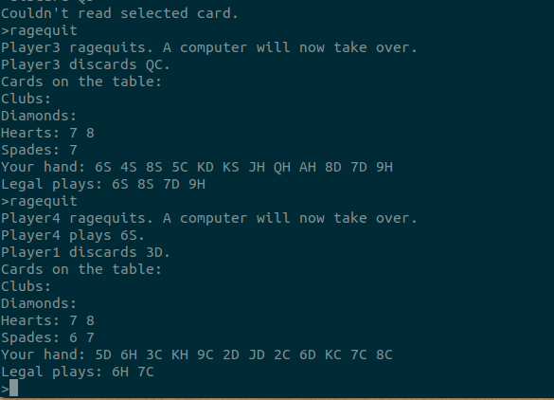
Note, Player3 discarded the first card as per the specification, and Player4 played the first legal card as per the specification. Also note the order of the “Legal plays: ...” list is sorted by the cards’ appearance in the players’ hand.
As Player2, will will make the following moves:
play 6H
play 7C
play 8C
play 3C
play 9C
play 2C
play 6D
play 5D
discard KH
discard 2D
play JD
Now, this is the state of the game after “play JD”:
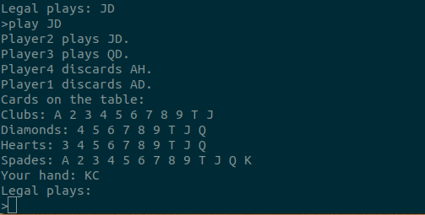

Note, as the gameplay progresses the “Cards on the table” grows as seen above. Since there is only one card left in the player’s hand, this constitues the last move of the round. We will “discard KC” with the following output:
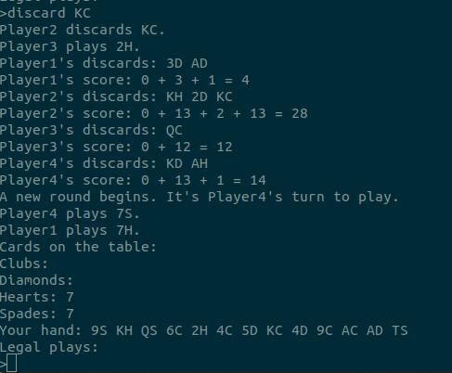
At the end of the round, the program lists each player’s discards and their associated score. Note, the initial “0 + ...” in the calculation respresent the prior rounds’ score sum, which is 0 on the first round.
In this new round, run the “deck” command to see the state of the shuffled deck:
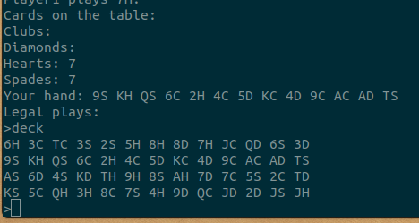

Notice, this deck is shuffled from the original deck command. This is repeatable and deterministic when using the same seed. We will ragequit Player2 in order to speed up the game and let the computer players do the “slow” work of playing the rest of the game.
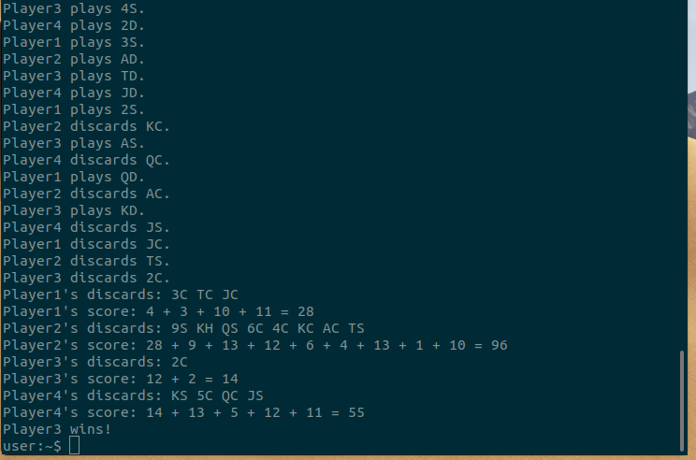
In the screenshot above, we can see the sum of this round’s discards with the prior rounds’ scores. In this round, player2’s reaches 96, and it crosses the 80 threshold, ending the game. Since Player3 has the lowest score (14), they win. If multiple players have the same lowest score, the “Player<x> wins!” statement will be printed for each of them.
To demonstrate the “quit” functionality, start a new game with seed 246 and fill it with humans:
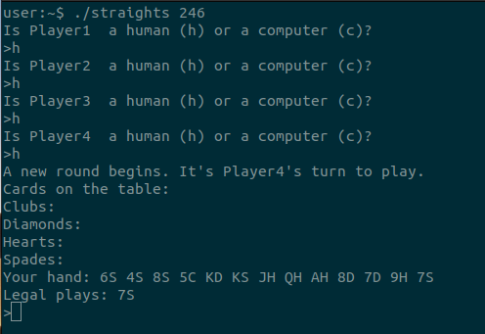

Now, use the “quit” command to end the game:
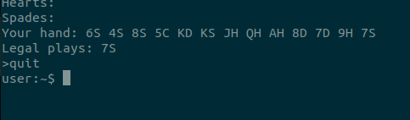

This is also enabled to read the GNU/Linux-style <Ctrl-D> end-of-file signal and interpret it as a “quit” message. This process does not lead to any leaked memory.
BONUS FEATURES:
To enable bonus features, use the “--enablebonus” flag either after the seed or alone as such:
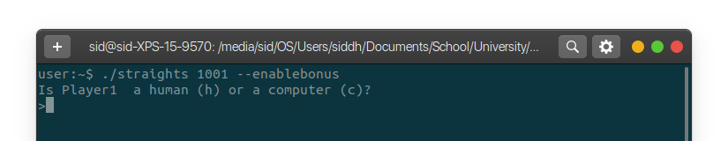
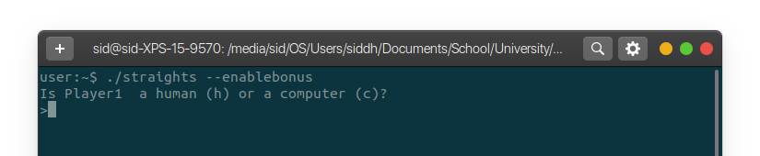
The following bonus feature are implemented:
- Project completed without explicitly managing memory and no memory leaks
- Smarter computer player algorithms
- Clearer player turns (UX)
- A new “imtired” command which allows ending the game early

In the bonus version of the program, the computer players use a new strategy when choosing how to play:
- If there exists a legal play, play the card with the highest rank as to dispose of the high risk of having to discard it
- If there does not exist a legal play, discard the card with the lowest ranks as to add the lowest value to the discard sum, and "live to fight another day" and potentially play the high-rank cards later in the round
This simple change makes the computer opponents more difficult to win against. In the demo ahead, keep an eye out for computer players generally playing higher than usual cards, and generally discarding lower than usual cards.
For the purposes of this demo, use the command “./straights 246 --enablebonus” to run the program and set all players to be human and “play 7S” for player4:
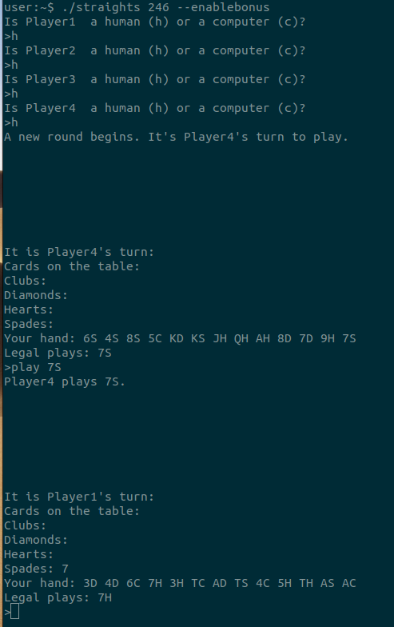

Notice, there is now spacing between player turns, alongside a header with the player whos turn it is. In my experience playing this game it sometimes got confusing what was going on. Some spacing and headers greatly improve the user experience. This makes it easier for Player1 to differentiate between player4 and player1’s respective information.

Quit the running game using the “quit” command.
Finally, another bonus implementation is the “imtired” command which allows players to end the game on the current round. Start a new game with the same command (./straights 246 –enablebonus). Initialize Players 1, 2, and 3 to be human and Player 4 to be a computer:
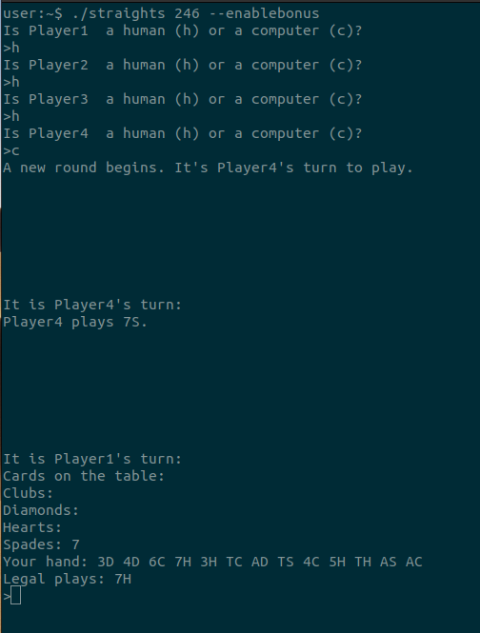

Suppose Player1 is getting tired of the game, but does not want to ragequit and rather end the game early, then Player1 can issue the command “imtired” to initiate a poll asking all other players if they want to end the game this round. Take a look by issuing the command “imtired”:
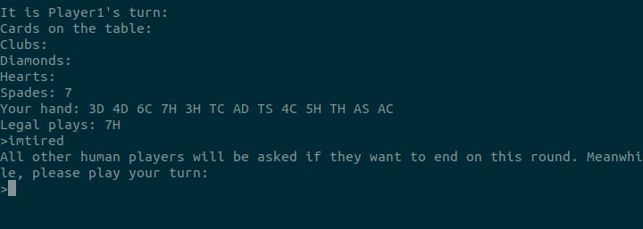

Now, player1 will play their turn as usual by playing “play 7H”:
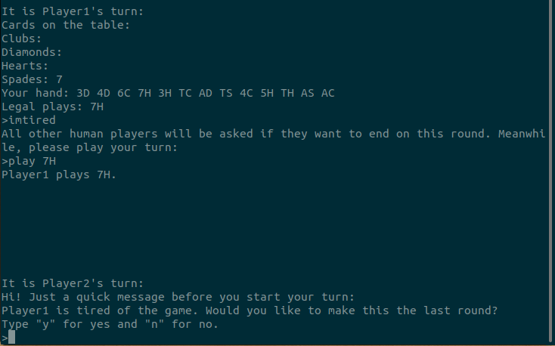
Right before Player2’s turn, they are notified of Player1’s intentions and can contribute to the poll. For now, let Player2 type “y” for yes and “play 8H” on their turn:
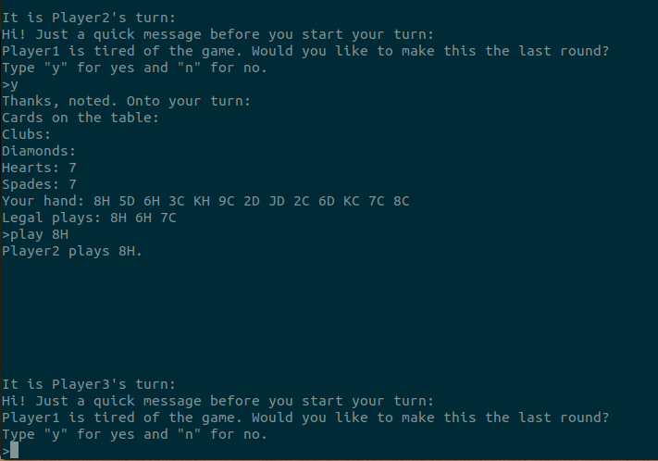

Likewise, Player3 is notified. Let Player 3 also type “y” for yes, and then “discard QC”:
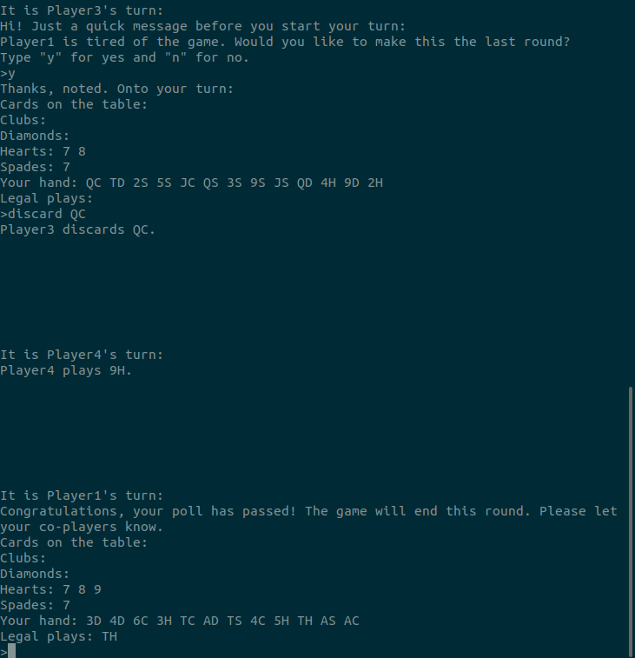

Player 1 is notified of the passing of the poll and that the game will end this round. To quickly wrap up, have all players ragequit, and note the end of round/game message:
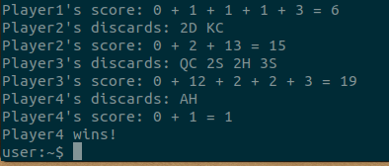

Even though no player crossed the 80 point threshold for ending the game, it finished in only one round where Player4 won.
Other potential cases and program handling for “imtired” command:
Typo in response:
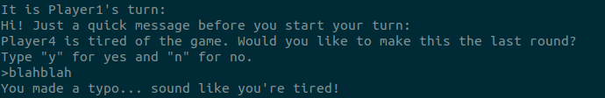
The program treats typos as a “y” vote primarily for humour purposes.
Someone does not want to end the game:
Notifies the player who began the poll of the status.
Someone runs the command “imtired” during a running poll:
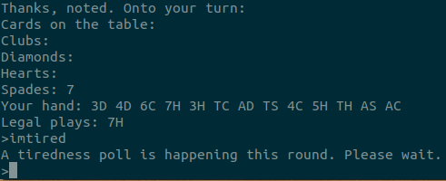

Notifies the player of the status and asks them to wait for later in the game.
Attempting the command without the “--enablebonus” command line program flag:
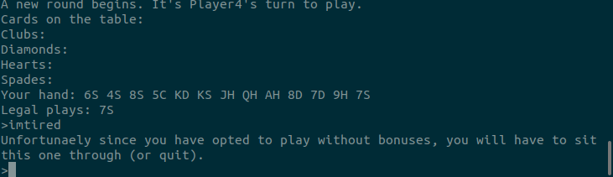
Notifies the player of the bonus-state and some alternate options.

