JBL Tour Pro 2



https://www.gamereactor.eu/jbl-tour-pro-2-1273433/

JBL's Tour Pro series offers an in-ear set with good tech features such as silicone passive noise suppression, adaptive noise reduction, customizable software and spatial sound. However, the price tag of £250 and lack of AptX support may limit the sound quality for some. The case with a screen is bulky and the plastic pieces must be removed for use.

0.2

JBL Bar 1000 review - A high-end soundbar with great Dolby Atmos + 3D Sound

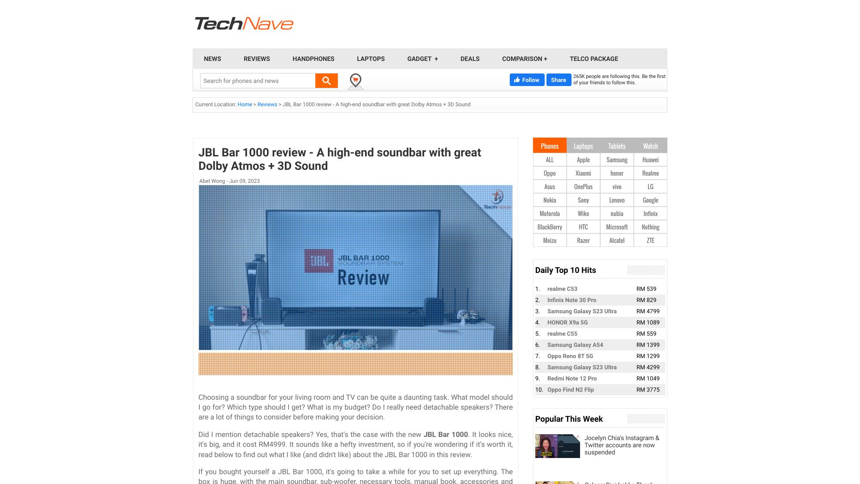

https://technave.com/gadget/JBL-Bar-1000-review-A-high-end-soundbar-with-great-Dolby-Atmos-3D-Sound-34692.html

The JBL Bar 1000 is an expensive soundbar with detachable rear speakers, offering top-class Dolby Atmos sound along with MultiBeam, Dolby Atmos, and DTS:X technologies for improved sound quality. There is some overlap of bass and vocals, but it can be worth the effort for sound and experience. It is ideal for those just starting their living room sound theatre setup.

0.4

JBL बूमबॉक्स 2 को टक्कर देने आ गया नया म्यूजिक प्लेयर, कीमत के मामले में है 7 गुना सस्ता

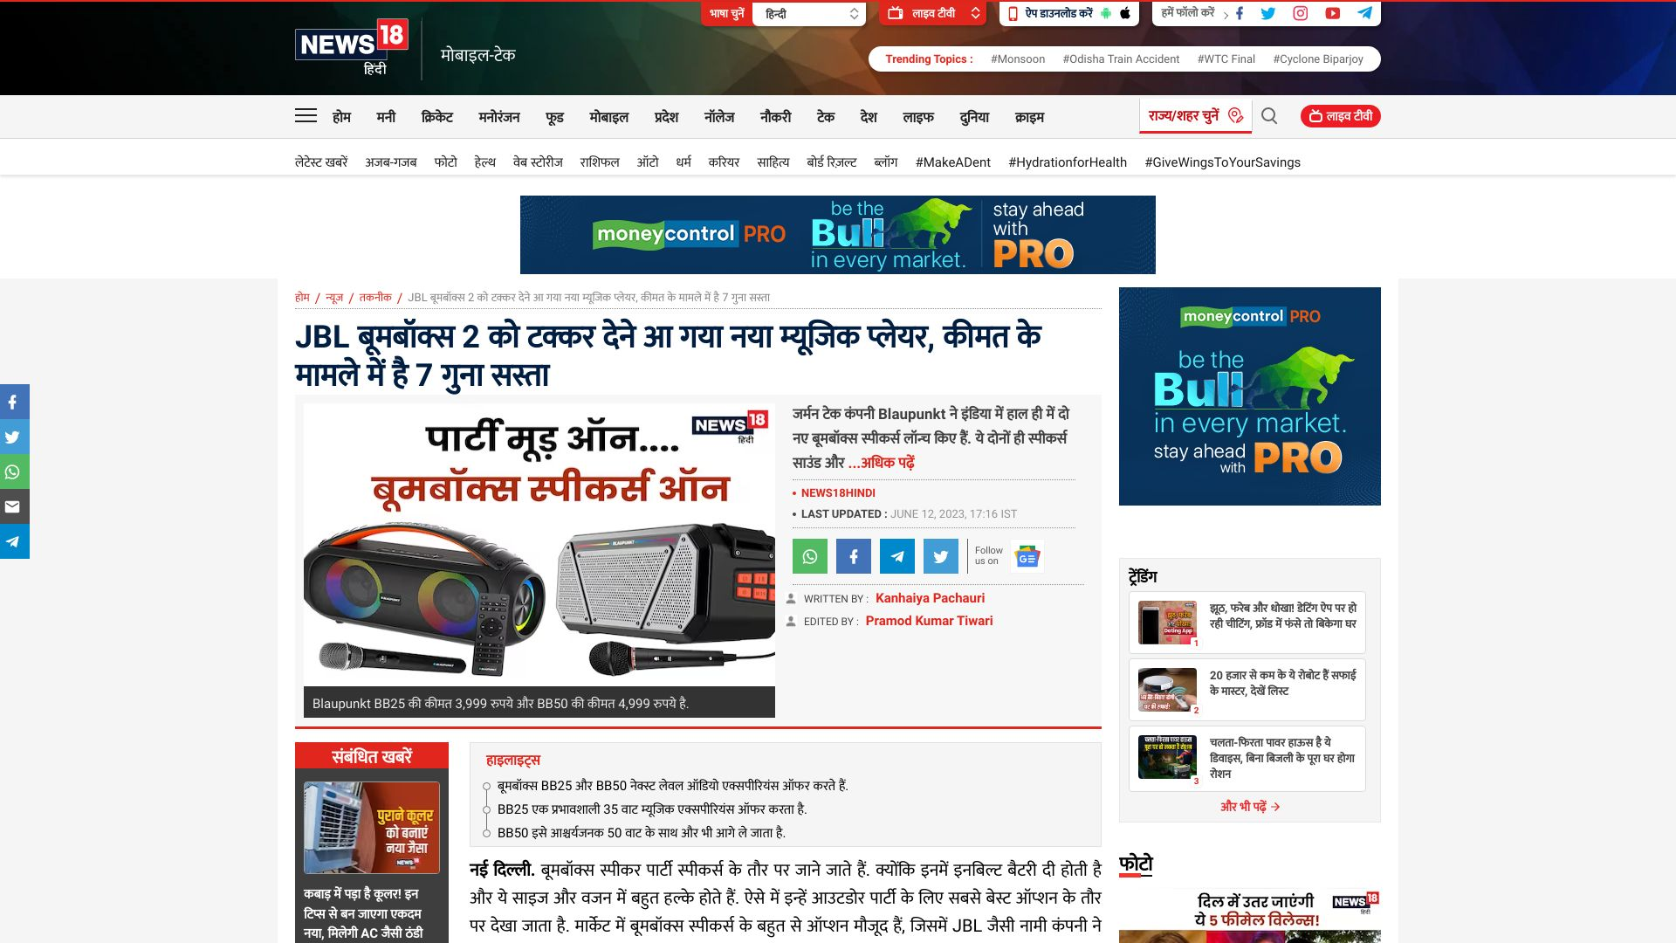

https://hindi.news18.com/news/tech/diy-blaupunkt-boombox-come-to-compete-with-jbl-boombox-2-it-5-times-cheaper-in-terms-of-price-6493413.html

Blaupunkt's बूमबॉक्स BB25 and BB50 NexLevel audio experience have been released in a low-cost package, providing high quality audio for nighttime parties and more.

0.8

