TEST CASES

Siddhesh Mehta 111903105

Sanmeet Wakchaure 111903087

Test Case 1 : Login SignUp

Before correction : Test case failed

Here when some fields were left blank before signing up errors were noticed. This was due to some bugs in the code. Validating the fields should be done before their submission.

Solution :

Before accessing the fields we must take them from the user and if not entered by user we must assume some value to it.

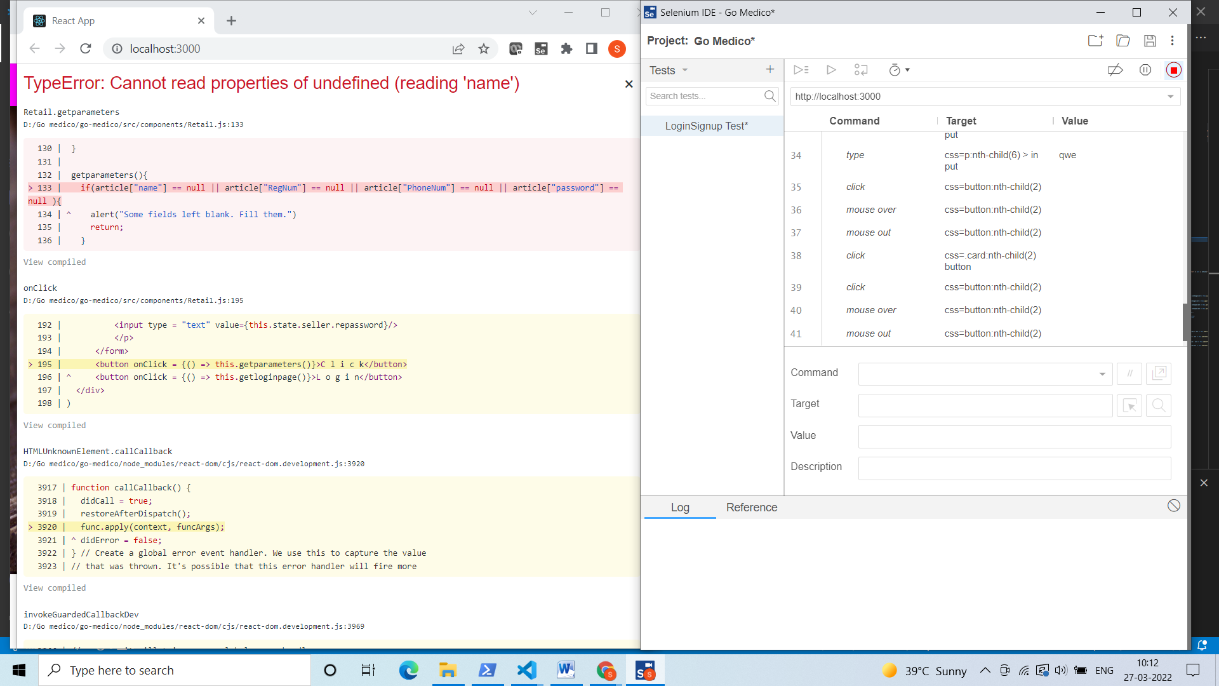

After correcting errors: Test case 1 passed

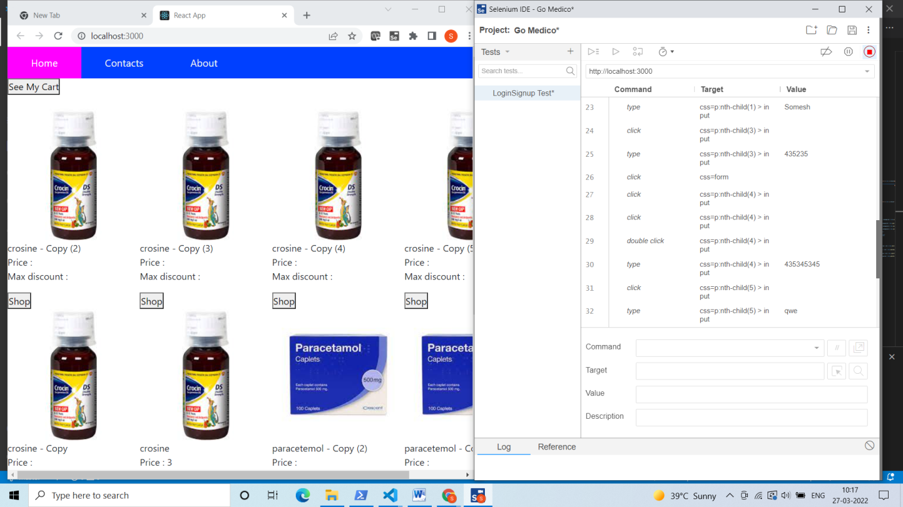

Test case 2: Cart Test Case 1

In this test case we add items to cart and then see our cart. Then we remove some items from cart and then again see our cart. Here we are able to see the changes in the cart. So The test case is passed.

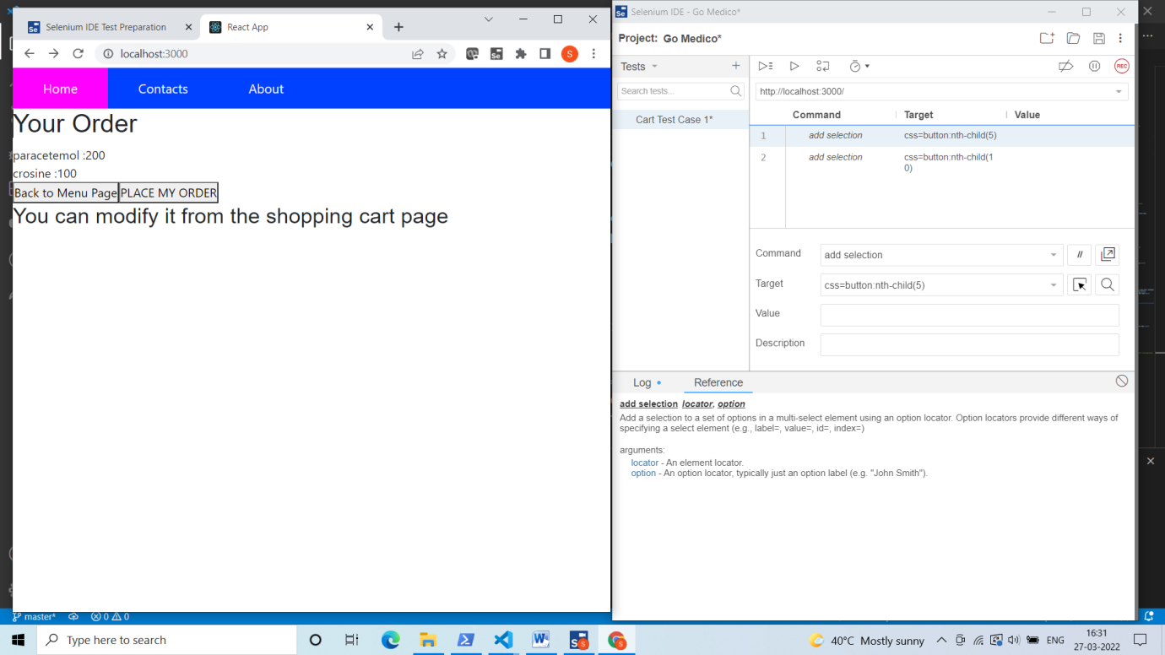

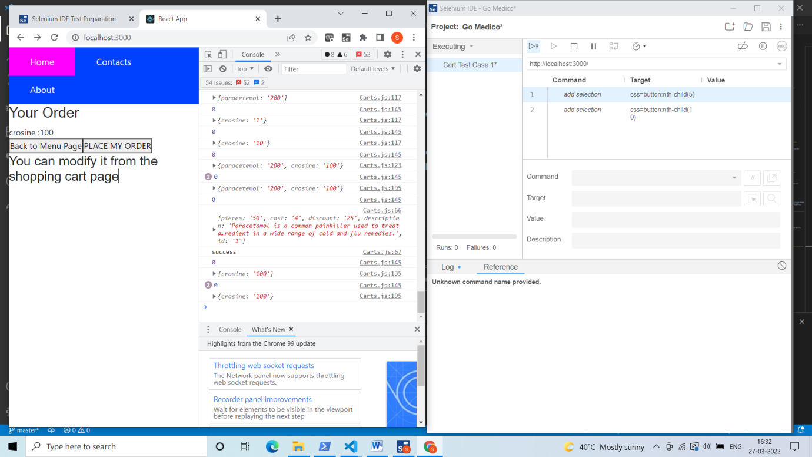

Test Case 3 : Cart Test Case 2

If we do not have any information about a any particular item then we should not get any error while selecting the item. Here we selected an item whore information is not present in database. Technically we should no be able to go to the next page. So we have achieved it.

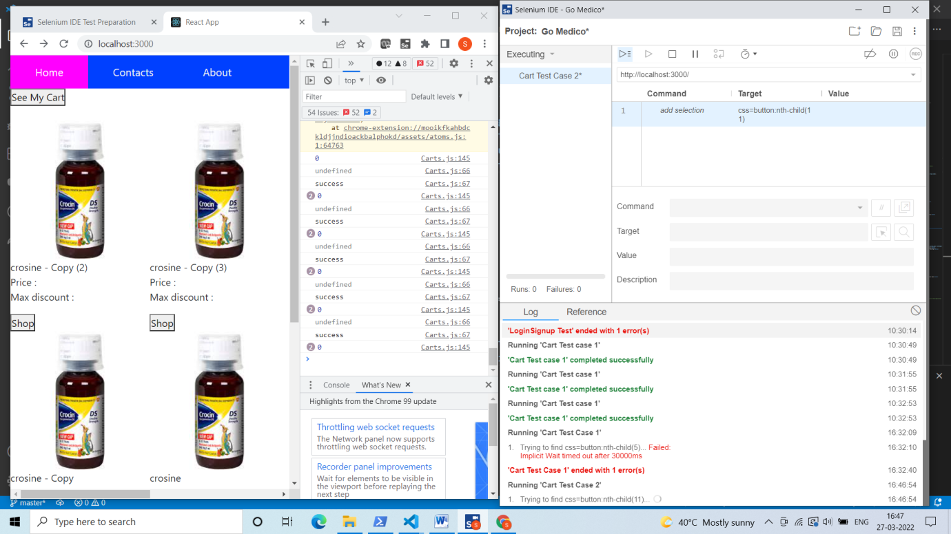

Test Case 4: Prescription Management Test case 1

Here we are uploading a .txt file and trying to see whether the file reached the folder at a particular path. Here as we see we are able to see the file in our folder being uploaded. So the test case passed

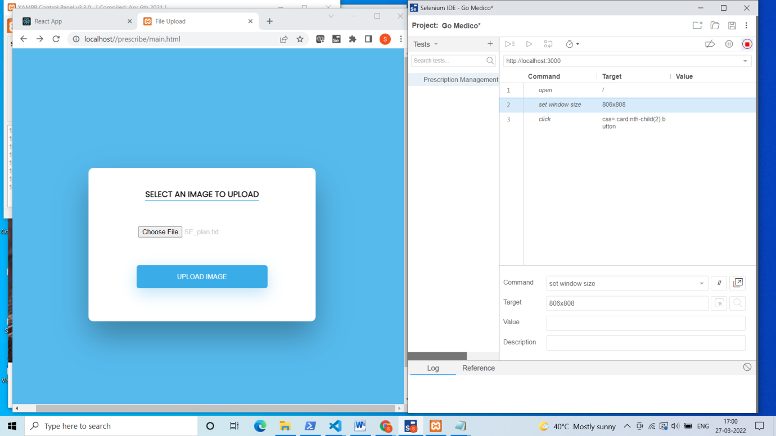

We are uploading a file named “SE_plan.txt”. We are able to see the same file in our folder in the following image.

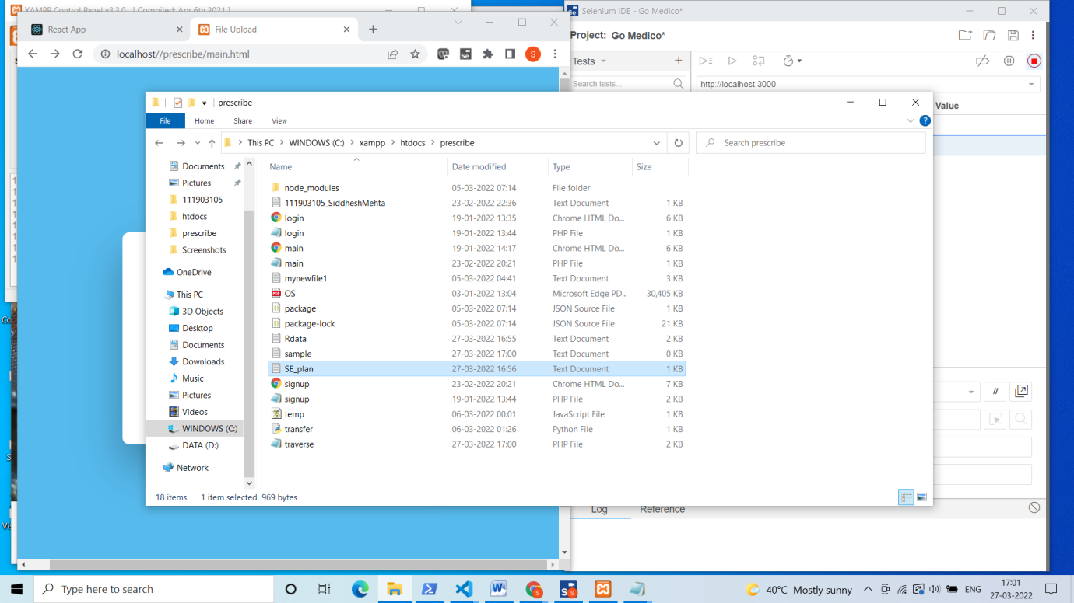

Test Case 5: Prescription Management Test case 2

Here we uploaded Prescription and we are now selecting items from the prescription. Selected items should be written into a text file. The file will be read by python code via inter-process communication and then send to express server via HTTP request. We see than the data is entered into the file.

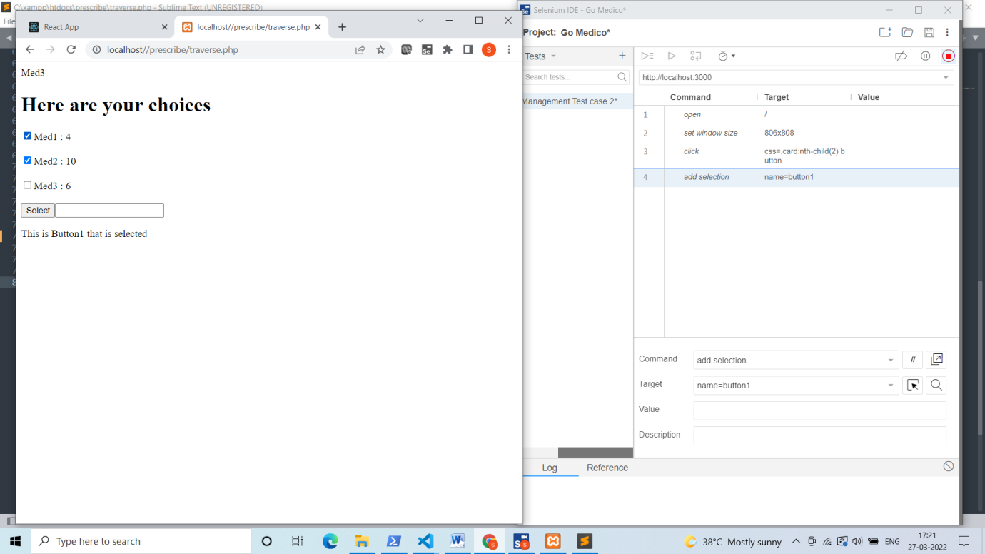

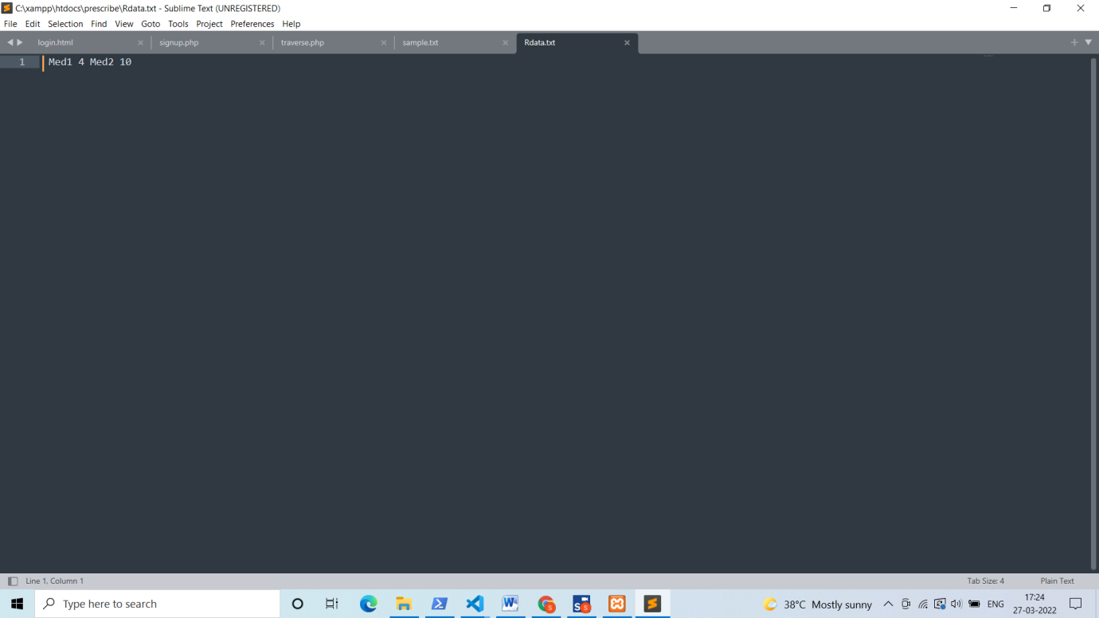

So

Test case 1 : Passed

Test case 2 : Passed

Test case 3 : Passed

Test case 4 : Passed

Test case 5 : Passed