Southern Cross University
Unit: ISY10221 (Computing Project 1)
Assignment task 3: Systems Analysis Specification



Project Supervisor: Paul Woods
Project Client: Jo Mason
Project Name: SMP (Student Mentoring Program)
Group Members: Shouqiang Li, Saeid Moradi & Babaljeet Kaur

Executive Summary

Table of Contents

Contents
- Schema Diagrams

- Schema Analysis of smp
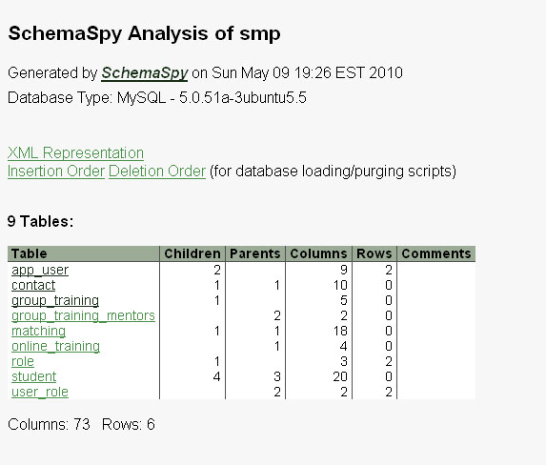

- 9 Tables
- app_user
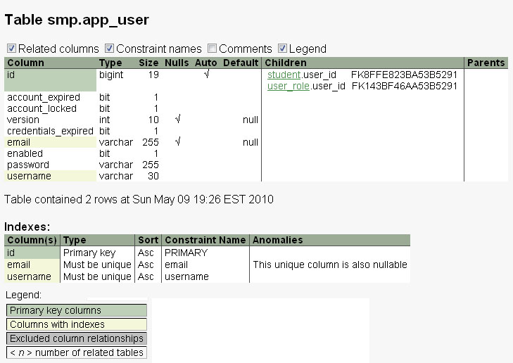

- contact
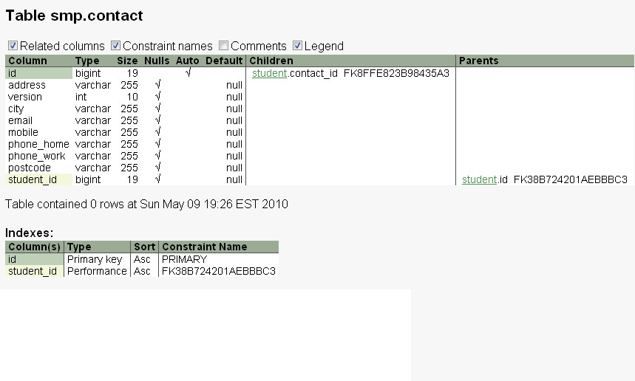
- group_training
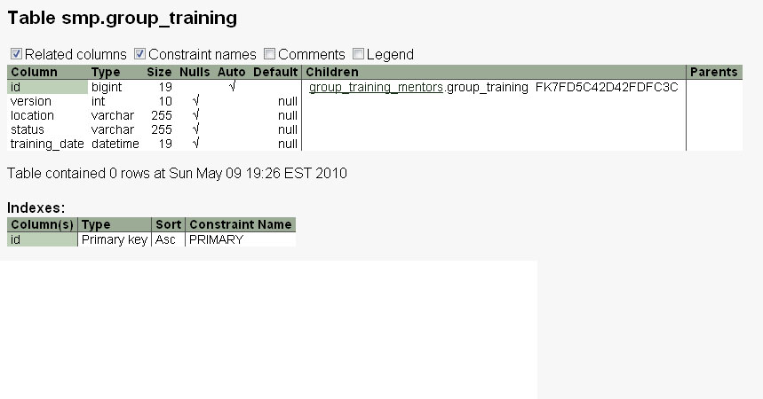

- group_training_mentors

- matching
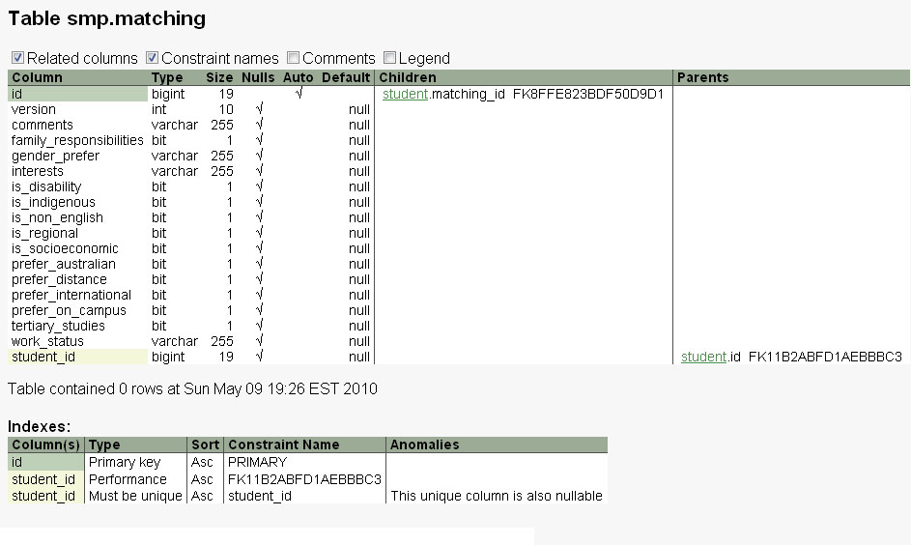
- online_training
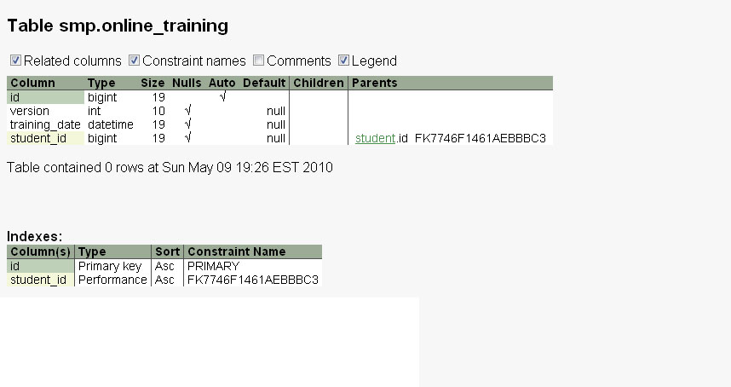

- role
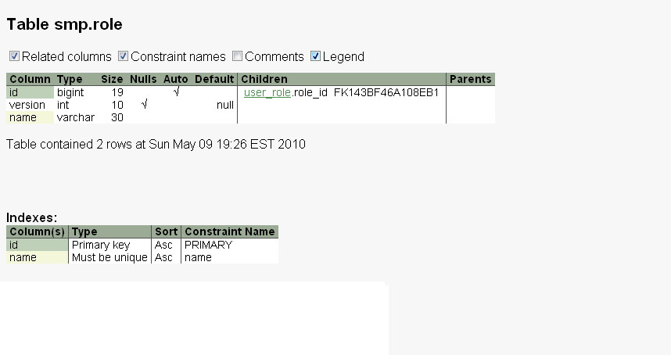

- student
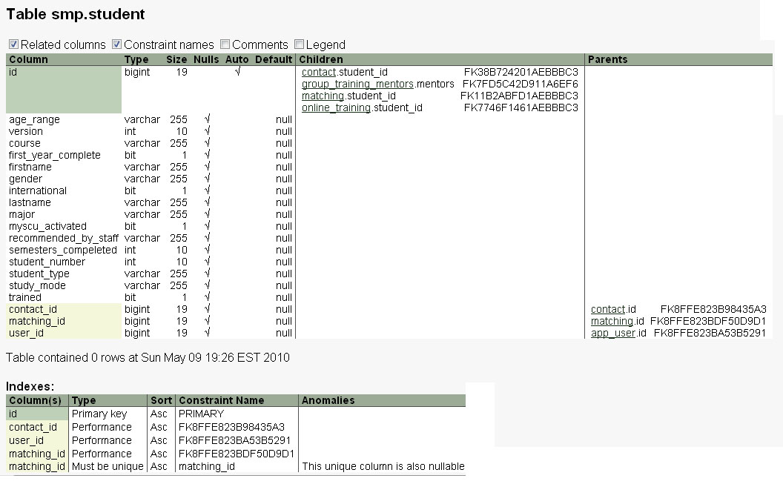
- user_role
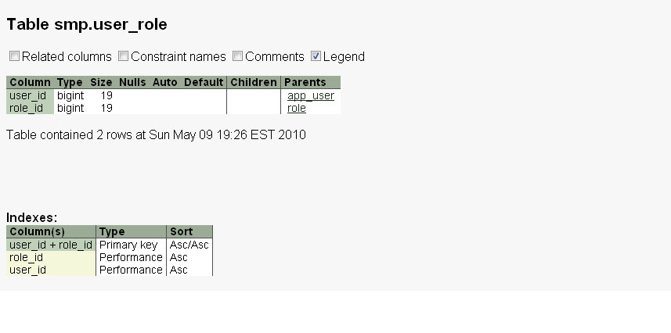

- Relationships
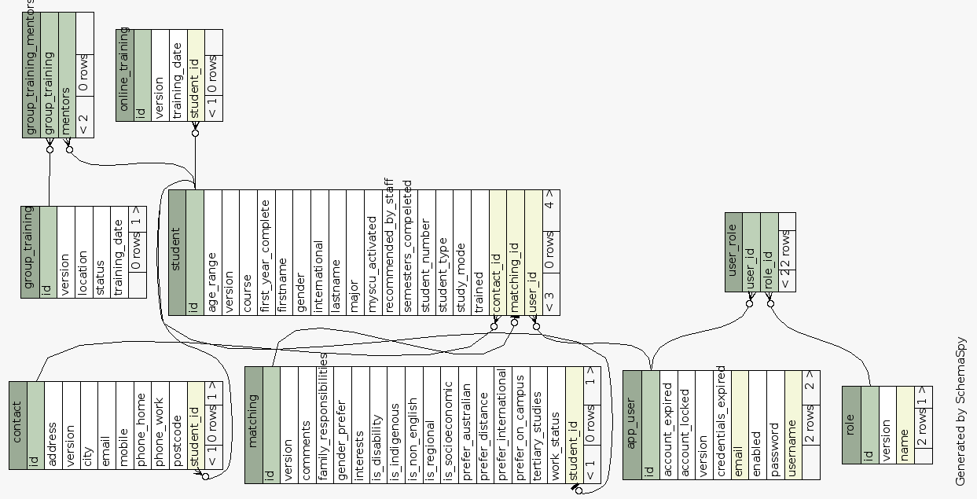

- Constraints
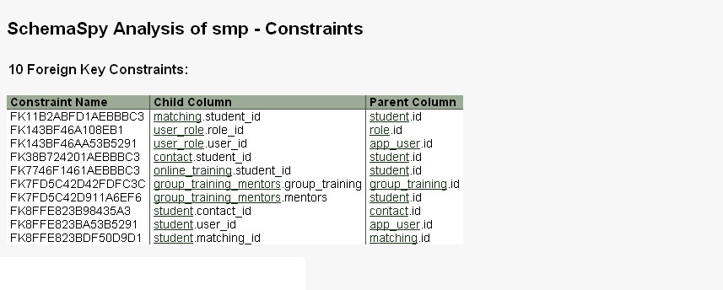

- Process Descriptions

2.1 Became a Mentor

2.1.1 Submit
Date: | 28/04/2010 | Analyst: | Saeid Moradi
Process: | 1.1 SUBMIT | System: | MENTORING

Inputs: | STUDENT DETAILS
Outputs: | STUDENT-INFORMATION,CONTACT-INFORMATION, MATCHING-INFORMATION

Structured English:

Input STUDENT DETAILS
If all student information is valid then
Write STUDENT-INFOMATION to STUDENTS
Write MATCHING-INFORMATION to STUDENTS
Write CONTACT-INFORMATION to STUDENTS
Display successful message to user.
Notify Coordinator about new registration.
Else
Display error message to user.
EndIf

2.1.2 Information Downloads into database
Date: | 28/04/2010 | Analyst: | Jiya
Process: | 1.2 INFORMATION DOWNLOADS INTO DATABASE | System: | MENTORING

Inputs: | STUDENT NUMBER
Outputs: | STUDENT-INFORMATION,CONTACT-INFORMATION

Structured English:
Get Student Number from STUDENT
If StudentNumber IsValid
Then
{
Extract Student Information from University Database.
Get Other information from the Student (which is not available in University Database)
Enter the Information from the Database to SMP Database
}
Else
{
Deny Information entry to the database
Display message
}

2.1.3 Acknowledgment
Date: | 28/04/2010 | Analyst: | Jiya
Process: | 1.3 ACKNOWLEDGMENT | System: | MENTORING

Inputs: | ACKNOWLEDGMENT STATEMENT
Outputs: | ACKNOWLEDGMENT STATEMENT,TRAINING OPTION SELECTION

Structured English:
If STUDENT FORM ACCEPTED
{
Send automatically generated email of Acknowledgement
}
Else
{
Do nothing
}

2.2 Became a Mentee

2.2.1 Fill the forms and submit

Date: | 28/04/2010 | Analyst: | Saeid Moradi
Process: | 2.1 FILL THE FORMS AND SUBMIT | System: | MENTORING

Inputs: | STUDENT DETAILS
Outputs: | STUDENT-INFORMATION,CONTACT-INFORMATION, MATCHING-INFORMATION

Structured English:

Input STUDENT DETAILS
If all student information is valid then
Write STUDENT-INFOMATION to STUDENTS
Write MATCHING-INFORMATION to STUDENTS
Write CONTACT-INFORMATION to STUDENTS
Display successful message to user.
Notify Coordinator about new registration.
Else
Display error message to user.
EndIf

2.1.2 Information Downloads into database

Date: | 28/04/2010 | Analyst: | Jiya
Process: | 1.2 INFORMATION DOWNLOADS INTO DATABASE | System: | MENTORING

Inputs: | STUDENT NUMBER
Outputs: | STUDENT-INFORMATION,CONTACT-INFORMATION

Get Student Number from STUDENT
If StudentNumber IsValid
Then
{
Extract Student Information from University Database:
Get Other information from the Student(which is not available in University Database)
Enter the Information from the Student(which is not available in University Database)
Enter the Information from the Database to SMP Database
}
Else
{
Deny Information entry to the database
Display messages
}

2.1.3 Acknowledgment
Date: | 28/04/2010 | Analyst: | Jiya
Process: | 1.3 ACKNOWLEDGMENT | System: | MENTORING

Inputs: | ACKNOWLEDGMENT STATEMENT
Outputs: | DONE MESSAGE

Structured English:
Structured English
If STUDENT form accepted
{
Send automatically Generated email of Acknowledgement
}
Else
{
Do Nothing
}

2.3 Training

2.3.1 Schedule Timetable
Date: | 28/04/2010 | Analyst: | Jiya
Process: | 3.1 SCHEDULE TIMETABLE | System: | MENTORING

Inputs: | Training Date, Location and other
Outputs: | Name of the STUDENTS attending the training

Date for a training session is set by the coordinator
If STUDENT sign up for the session
{
Name of the STUDENT is added to the list
}
Else
{
Do nothing
}

2.3.2 Book a Training
Date: | 28/04/2010 | Analyst: | Jiya
Process: | 3.2 BOOK A TRAINING | System: | MENTORING

Inputs: | Student Details, Date suitable for the
Outputs: | List of students who booked the training

Structured English:
STUDENT books a date
If the date is suitable for the coordinator
{
Email confirming the booking
}
Else
{
Email denying the request
}

2.3.3 Group training
Date: | 28/04/2010 | Analyst: | Jiya
Process: | 3.3 GROUP TRAINING | System: | MENTORING

Inputs: | Training Date, Location and other details
Outputs: | Name of the students attending the training

Date for a training session is set by the coordinator
If STUDENT sign up for the session
{
Name of the STUDENT is added to the list
}
Else
{
Do nothing
}

2.3.4 Online training

Date: | 28/04/2010 | Analyst: | Bruce
Process: | 3.4 ONLINE TRAINING | System: | MENTORING

Inputs: | Training date
Outputs: | TRAINING RECORD

Structured English:
GENERATE TRAINING DATE LIST
CASE TRAINING DATE SELECTED
CASE 1-N:
GENERATE TRAINING REPORT
BREAK;
OUTPUT TRAINING REPORT

2.3.5 Contact
Date: | 28/04/210 | Analyst: | Bruce
Process: | 3.5 CONTACT | System: | MENTORING

Inputs: | TRAINING REPORT
Outputs: | EMAIL DRAFT

Structured English: INPUT STUDENT ID AND TRAINING REPORT
GET DATA FROM MENTOR DATABASE
GENERATE AUTO EMAIL DRAFT BY EXISTING FORMAT

2.3.6 Record
Date: | 28/04/2010 | Analyst: | Bruce
Process: | 3.6 RECORD | System: | MENTORING

Inputs: | MENTOR WHO FINISHED THEIR TRAINING
Outputs: | TRAINING FINISHED RECORD

Structured English:
STORE TRAINING TYPE & TRAINING FINISHED INFORMATION TO THE DATABASE

2.3.7 Transfer
Date: | 28/04/2010 | Analyst: | Bruce
Process: | 3.7 TRANSFER | System: | MENTORING

Inputs: | Not sure
Outputs: | Not sure

Structured English: not sure

2.4 Adding student to MySCU

2.4.1 Sending list of students
Date: | 28/04/2010 | Analyst: | Saeid Moradi
Process: | 5.1 Sending list of students | System: | MENTORING

Inputs: | SELECTED STUDENTS
Outputs: | SELECTED STUDENTS, ACCESS

Structured English:
Show list of students that are valid for selection
Coordinator select group of students
List of selected students will goes to process 5.2 and 5.3

2.4.2 Email list of students

Date: | 28/04/2010 | Analyst: | Saeid Moradi
Process: | 5.2 EMAIL LIST OF STUDENTS | System: | MENTORING

Inputs: | SELECTED STUDENTS
Outputs: | EMAILED STUDENTS FOR GETTING ACCESS

Structured English:
Input SELECTED STUDENTS.
If mail server is running then
send email to MYSCU
Else
show error message .
End If

2.4.3 Sending SMS

Date: | 28/04/2010 | Analyst: | Saeid Moradi
Process: | 5.3 SENDING SMS | System: | MENTORING

Inputs: | SELECTED STUDENTS
Outputs: | SMSED STUDENTS FOR GEETING ACCESS

Structured English:
Input SELECTED STUDENTS
If SMS server is running then
send SMS to students
Else
show error message .
End If

2.5 Matching process

2.5.1 Establishing matching list
Date: | 28/04/2010 | Analyst: | Bruce
Process: | 5.1 ESTABLISH MATCHING LIST | System: | MENTORING

Inputs: | PARAMETER
Outputs: | PROMPT

Structured English:
ENTER PARAMETER(LOOK FOR MENOR FOR METEE OR LOOK FOR MENTEE FOR MENTOR)
PROMPT TO IMPUT MENTOR OR MENTEE ID

2.5.2 Search for mentors
Date: | 28/04/2010 | Analyst: | Bruce
Process: | 5.2 SEARCH FOR MENTORS | System: | MENTORING

Inputs: | MENTEE ID
Outputs: | MENTORS LIST

Structured English:
ENTER MENTEE ID
FOR (i=0;i<10;i++)
(MAX)(MENTOR&MENTEE)S’ SIMILARITY
PUT MENTOR IN THE LIST
END LOOP

2.5.3 Search for mentees

Date: | 28/04/2010 | Analyst: | Bruce
Process: | 5.3 SEARCH FOR MENTEES | System: | MENTORING

Inputs: | MENTOR ID
Outputs: | MENTEES LIST

Structured English:
ENTER MENTOR ID
FOR (i=0;i<10;i++)
(MAX)(MENTOR&MENTEE)S’ SIMILARITY
PUT MENTEE IN THE LIST
END LOOP

2.5.4 Generate matching report

Date: | 28/04/2010 | Analyst: | Bruce
Process: | 5.4 GENERATE MATCHING REPORT | System: | MENTORING

Inputs: | MATCHED MENTOR ID & MENTEE ID
Outputs: | REPORT

Structured English:
GO TO MENTOR/MENTEE DATABASE
GET MATCHED MENTOR & MENTEE INFORMATION (ID, NAME, GENDER, RELIGION, EMAIL, TELPHONE NUMBER, AGE, HOBBY)
GENERATE MATCHED REPORT

2.5.5 Generate email draft to the pair

Date: | 28/04/2010 | Analyst: | Bruce
Process: | 5.5 GENERATE EMAIL DRAFT TO THE PAIR | System: | MENTORING

Inputs: | MATCHED PAIR REPORT
Outputs: | EMAIL DRAFT

Structured English:
COPY MATCHED PAIR REPORT
MODIFY IT TO A EMAIL DRAFT

2.5.6 Send out email to mentor/mentee

Date: | 28/04/2010 | Analyst: | Bruce
Process: | 5.6 SEND OUT EMAIL TO MENTOR/MENTEE | System: | MENTORING

Inputs: | EMAIL DRAFT
Outputs: | EMAIL

Structured English:
DISPLAY DRAFT EMAIL TO COORDINATOR
PROMPT TO MODIFY
(COORDINATOR CLICK COMFIRM)
(COORDINATOR CLICK SEND OUT)

2.6 Report Generator Process

2.6.1 Customize Setting
Date: | 28/04/2010 | Analyst: | Saeid Moradi
Process: | 6.1 CUSTOMIZE SETTING | System: | MENTORING

Inputs: | REPORT PARAMTER
Outputs: | REPORT PARAMTER

Structured English:

Input report parameters
If parameters are valid with current user then
Output parameters
Else
show error message
EndIf

2.6.2 Report Generator Process

Date: | 28/04/2010 | Analyst: | Saeid Moradi
Process: | 6.2 REPORT GENERATOR | System: | MENTORING

Inputs: | REPORT-PARAMTER, STUDENT-INFORMATION, MATCHING-INFORMATION
Outputs: | GENERATED LIST

Structured English:

Input report parameters from customize setting processing
Read student information from STUDENTS
Read matching information from STUDENTS
Case
export format is PDF
Display report in PDF format
export format is DOC
Display report in Word format
export format is EXL
Display report in Excel format
EndCase

- Data dictionary/Data Descriptions

3.1 Data Stores

3.1.1 Students (Mentor/Mentee)
DATA DICTIONARY - DATA STORE
Name: | STUDENTS
Alias(es)
Description: | This is the Student Master file , which holds all student information
Composition: | STUDENT-INFORMATION  + CONTACT-INFORMATION  + MATCHING-INFORMATION
Average volume: | 300 records | Peak volume: | 500 records
Growth Rate:: | 50% per year
Added by: | Saeid Moradi | Modified by:
Date added: | 28/04/2010 | Date Modified :

3.1.2 Training Timetable
DATA DICTIONARY - DATA STORE
Name: | TRAINING
Alias(es)
Description: | This is the Training Master file, which holds all available training timetables.
Composition: | TRAINING-INFORMATION
Average volume: | 50 records | Peak volume: | 100 records
Growth Rate:: | 50% per year
Added by: | Saeid Moradi | Modified by:
Date added: | 28/04/2010 | Date Modified :

3.2 Data Flows

3.2.1 Student details
DATA DICTIONARY - DATA FLOW
Name: | STUDENT-DETAILS
Alias(es)
Description: | This contains all the details required for student information.
Composition: | STUDENT-INFORMATION  + CONTACT-INFORMATION  + MATCHING-INFORMATION
Added by: | Saeid Moradi | Modified by:
Date added: | 28/04/2010 | Date Modified :

3.3 Matching details
DATA DICTIONARY - DATA FLOW
Name: | MATCHING-DETAILS
Alias(es)
Description: | This contains all the details required for a student matching.
Composition: | STUDENT-INFORMATION  + MATCHING-INFORMATION
Added by: | Saeid Moradi | Modified by:
Date added: | 28/04/2010 | Date Modified :

3.4 New training
DATA DICTIONARY - DATA FLOW
Name: | NEW TRAINNG
Alias(es)
Description: | This contains new training session for students.
Composition: | TRAINING-INFORMATION
Added by: | Saeid Moradi | Modified by:
Date added: | 28/04/2010 | Date Modified :

3.2.4 Booked training
DATA DICTIONARY - DATA FLOW
Name: | BOOKED TRAINNG
Alias(es)
Description: | This contains booked training session for an student.
Composition: | TRAINING-INFORMATION
Added by: | Saeid Moradi | Modified by:
Date added: | 28/04/2010 | Date Modified :

3.2.5 Access
DATA DICTIONARY - DATA FLOW
Name: | ACCESS
Alias(es) | access, permission
Description: | This contains all the details required for give a access to students.
Composition: | STUDENT-INFORMATION
Added by: | Saeid Moradi | Modified by:
Date added: | 28/04/2010 | Date Modified :

3.2.6 Report Parameter
DATA DICTIONARY - DATA FLOW
Name: | REPORT PARAMETER
Alias(es) | reportParameter
Description: | This contains all the details required for a Report.
Composition: | DATE-FROM  + DATE-TO  + EXPORT-FORMAT  + {CRITERIA}
Added by: | Saeid Moradi | Modified by:
Date added: | 28/04/2010 | Date Modified :

3.2.7 Generated Report
DATA DICTIONARY - DATA FLOW
Name: | GENERATED REPORT
Alias(es) | generatedReport
Description: | This contains all the details required for a generated report.
Composition: | REPORT-PARAMETER  + COORDINATOR-PERMISSION
Added by: | Saeid Moradi | Modified by:
Date added: | 28/04/2010 | Date Modified :

3.2.8 Email
DATA DICTIONARY - DATA FLOW
Name: | EMAIL
Alias(es) | email
Description: | This contains all the details required for a sending email.
Composition: | SUBJECT  + BODY  + RECEVIER  + SENDER  + ATTACHMENT
Added by: | Saeid Moradi | Modified by:
Date added: | 28/04/2010 | Date Modified :

3.2.9 Matching list
DATA DICTIONARY - DATA FLOW
Name: | MATCHING LIST
Alias(es) | matchingList
Description: | This contains all students for matching.
Composition: | STUDENT-INFORMATION  + MATCHING-INFORMATION
Added by: | Saeid Moradi | Modified by:
Date added: | 28/04/2010 | Date Modified :

3.3 Data Structure

3.3.1 Contact Information
DATA DICTIONARY - DATA STRUCTURE
Name: | CONTACT-INFORMATION
Alias(es)
Description: | Student Contact Information
Composition: | STUDENT-ID  + ADDRESS  + CITY  + POSTCODE  + (PHONE-HOME)  + (PHONE-WORK)  + (MOBILE)  + EMAIL
Added by: | Saeid Moradi | Modified by:
Date added: | 28/04/2010 | Date Modified :

3.3.2 Student Information
DATA DICTIONARY - DATA STRUCTURE
Name: | STUDENT-INFORMATION
Alias(es)
Description: | Student Information
Composition: | USER-ID  + FIRSTNAME  + LASTNAME  + GENDER  + AGE_RANGE  + STUDENT_NUMBER  + STUDENT_TYPE  + STUDY_MODE  + COURSE  + MAJOR  + FIRST_YEAR_COMPELETE  + (RECOMMENDED_BY_STAFF)  + SEMESTERS_COMPELETED  + INTERNATIONAL  + TRAINED  + MYSCU_ACTIVATED
Added by: | Saeid Moradi | Modified by:
Date added: | 28/04/2010 | Date Modified :

3.3.3 Matching Information
DATA DICTIONARY - DATA STRUCTURE
Name: | MATCHING-INFORMATION
Alias(es)
Description: | Student Matching Information
Composition: | STUDENT-ID  + GENDER_PREFER  + WORK_STATUS  + FAMILY_RESPONSIBILITY  + TERTIARY_STUDIES  + (INTERESTS)  + (COMMENTS)  + PREFER_ONCAMPUS  + PREFER_DISTANCE  + PREFER_ASUTRALIAN  + PREFER_INTERNATIONAL  + IS_REGIONAL  + IS_DISABILITY  + IS_SOCIOECONOMIC  + IS_NON_ENGLISH  + IS_INDIGENOUS
Added by: | Saeid Moradi | Modified by:
Date added: | 28/04/2010 | Date Modified :

3.3.3 Training Information
DATA DICTIONARY - DATA STRUCTURE
Name: | TRAINING
Alias(es)
Description: | Training Information
Composition: | TRAINING_DATE  + LOCATION  + STATUS
Added by: | Saeid Moradi | Modified by:
Date added: | 28/04/2010 | Date Modified :

3.4 Data Elements

3.4.1 First Name
DATA DICTIONARY - DATA ELEMENT
Name: | FIRSTNAME
Alias(es)
Description: | Student First Name is compulsory.
For Editing Use: | Valid Values/Codes  Any alphabet |  | Meaning  Acceptable
Used in: | Data Flow(s)  STUDENT-INFORMATION |  | Data Store(s)  STUDENTS
Size: | 2–50 characters | Picture clause:
Added by: | Saeid Moradi | Modified by:
Date added: | 28/04/2010 | Date Modified :

3.4.2 Last Name
DATA DICTIONARY - DATA ELEMENT
Name: | LASTNAME
Alias(es)
Description: | Student Last Name is compulsory.
For Editing Use: | Valid Values/Codes  Any alphabet |  | Meaning  Acceptable
Used in: | Data Flow(s)  STUDENT-INFORMATION |  | Data Store(s)  STUDENTS
Size: | 2–50 characters | Picture clause:
Added by: | Saeid Moradi | Modified by:
Date added: | 28/04/2010 | Date Modified :

3.4.3 Gender
DATA DICTIONARY - DATA ELEMENT
Name: | GENDER
Alias(es) | gender
Description: | Student Gender
For Editing Use: | Valid Values/Codes  Male or Female |  | Meaning  Valid
Used in: | Data Flow(s)  STUDENT-INFORMATION |  | Data Store(s)  STUDENTS
Size: | 4-6 characters | Picture clause:
Added by: | Saeid Moradi | Modified by:
Date added: | 28/04/2010 | Date Modified :

3.4.4 Student Number
DATA DICTIONARY - DATA ELEMENT
Name: | STUDENT-NUMBER
Alias(es) | studentNumber
Description: | Student Number is provided by Southern Cross University and is compulsory.
For Editing Use: | Valid Values/Codes  2ddddddd |  | Meaning  Valid (d = digit number)
Used in: | Data Flow(s)  STUDENT-INFORMATION |  | Data Store(s)  STUDENTS
Size: | 8 characters | Picture clause:
Added by: | Saeid Moradi | Modified by:
Date added: | 28/04/2010 | Date Modified :

3.4.5 Student Type
DATA DICTIONARY - DATA ELEMENT
Name: | STUDENT_TYPE
Alias(es) | studentType
Description: | Student Type
For Editing Use: | Valid Values/Codes  Mentor or Mentee |  | Meaning  Valid
Used in: | Data Flow(s)  STUDNET-INFORMATION |  | Data Store(s)  STUDENTS
Size: | 6 characters | Picture clause:
Added by: | Saeid Moradi | Modified by:
Date added: | 28/04/2010 | Date Modified :

3.4.6 Study Mode
DATA DICTIONARY - DATA ELEMENT
Name: | STUDY-MODE
Alias(es) | studyMode
Description: | Student Study Mode is compulsory.
For Editing Use: | Valid Values/Codes  On-campus – Lismore /  On-campus – Coffs Harbour /  On-campus – Tweed /  On-campus – Port /  Distance |  | Meaning  Valid  Valid  Valid  Valid  Valid
Used in: | Data Flow(s)  STUDENT-INFORMATION |  | Data Store(s)  STUDENTS
Size: | 8-30 characters | Picture clause:
Added by: | Saeid Moradi | Modified by:
Date added: | 28/04/2010 | Date Modified :

3.4.7 Course
DATA DICTIONARY - DATA ELEMENT
Name: | COURSE
Alias(es) | course
Description: | Student Study Course
For Editing Use: | Valid Values/Codes  Any alphabet |  | Meaning  Valid
Used in: | Data Flow(s)  STUDNET-INFORMATION |  | Data Store(s)  STUDENTS
Size: | 3-50 characters | Picture clause:
Added by: | Saeid Moradi | Modified by:
Date added: | 28/04/2010 | Date Modified :

3.4.8 Major
DATA DICTIONARY - DATA ELEMENT
Name: | MAJOR
Alias(es) | Major
Description: | Student Study Major
For Editing Use: | Valid Values/Codes  Any alphabet |  | Meaning  Valid
Used in: | Data Flow(s)  STUDNET-INFORMATION |  | Data Store(s)  STUDENTS
Size: | 3-50 characters | Picture clause:
Added by: | Saeid Moradi | Modified by:
Date added: | 28/04/2010 | Date Modified :

3.4.9 First Year Complete
DATA DICTIONARY - DATA ELEMENT
Name: | FIRST_YEAR_COMPLETE
Alias(es) | firstYearComplete
Description: | It show student is valid for being mentor.
For Editing Use: | Valid Values/Codes  Yes or No |  | Meaning  Valid
Used in: | Data Flow(s)  STUDENT-INFORMATION |  | Data Store(s)  STUDENTS
Size: | 2-3 characters | Picture clause:
Added by: | Saeid Moradi | Modified by:
Date added: | 28/04/2010 | Date Modified :

3.4.10 Recommended By Staff
DATA DICTIONARY - DATA ELEMENT
Name: | RECOMMENDED_BY_STAFF
Alias(es) | recommendedByStaff
Description: | Staff name
For Editing Use: | Valid Values/Codes  Any alphabet |  | Meaning  Valid
Used in: | Data Flow(s)  STUDENT-INFORMATION |  | Data Store(s)  STUDENTS
Size: | 2-50 characters | Picture clause:
Added by: | Saeid Moradi | Modified by:
Date added: | 28/04/2010 | Date Modified :

3.4.11 Semesters Completed
DATA DICTIONARY - DATA ELEMENT
Name: | SEMESTERS_COMPLETED
Alias(es) | semestersCompleted
Description: | Semesters completed by Southern Cross University.
For Editing Use: | Valid Values/Codes  dd |  | Meaning  Valid (d = digit number)
Used in: | Data Flow(s)  STUDENT-INFORMATION |  | Data Store(s)  STUDENTS
Size: | 1-2 characters | Picture clause:
Added by: | Saeid Moradi | Modified by:
Date added: | 28/04/2010 | Date Modified :

3.4.12 International
DATA DICTIONARY - DATA ELEMENT
Name: | INTERNATIONAL
Alias(es) | isInternational
Description: | Yes if the student is International
For Editing Use: | Valid Values/Codes  Yes or No |  | Meaning  Valid
Used in: | Data Flow(s)  STUDENT-INFORMATION |  | Data Store(s)  STUDENTS
Size: | 2-3 characters | Picture clause:
Added by: | Saeid Moradi | Modified by:
Date added: | 28/04/2010 | Date Modified :

3.4.13 Trained
DATA DICTIONARY - DATA ELEMENT
Name: | TRAINED
Alias(es) | isTrained
Description: | Yes if the student is Trained
For Editing Use: | Valid Values/Codes  Yes or No |  | Meaning  Valid
Used in: | Data Flow(s)  STUDENT-INFORMATION |  | Data Store(s)  STUDENTS
Size: | 2-3 characters | Picture clause:
Added by: | Saeid Moradi | Modified by:
Date added: | 28/04/2010 | Date Modified :

3.4.14 MySCU activated
DATA DICTIONARY - DATA ELEMENT
Name: | MYSCU_ACTIVATED
Alias(es) | isMyscuActivated
Description: | Yes if the student is Trained
For Editing Use: | Valid Values/Codes  Yes or No |  | Meaning  Valid
Used in: | Data Flow(s)  STUDENT-INFORMATION |  | Data Store(s)  STUDENTS
Size: | 2-3 characters | Picture clause:
Added by: | Saeid Moradi | Modified by:
Date added: | 28/04/2010 | Date Modified :

3.4.15 Address
DATA DICTIONARY - DATA ELEMENT
Name: | ADDRESS
Alias(es) | address
Description: | Address
For Editing Use: | Valid Values/Codes  Any alphabet |  | Meaning  Valid
Used in: | Data Flow(s)  CONTACT-INFORMATION |  | Data Store(s)  STUDENTS
Size: | 5-150 characters | Picture clause:
Added by: | Saeid Moradi | Modified by:
Date added: | 28/04/2010 | Date Modified :

3.4.16 City
DATA DICTIONARY - DATA ELEMENT
Name: | CITY
Alias(es) | city
Description: | City
For Editing Use: | Valid Values/Codes  Any alphabet |  | Meaning  Valid
Used in: | Data Flow(s)  CONTACT-INFORMATION |  | Data Store(s)  STUDENTS
Size: | 2-50 characters | Picture clause:
Added by: | Saeid Moradi | Modified by:
Date added: | 28/04/2010 | Date Modified :

3.4.17 Post Code
DATA DICTIONARY - DATA ELEMENT
Name: | POSTCODE
Alias(es) | postcode
Description: | Postcode is a digit code which identifies the geographical region in which a student lives. Because of Distance study we did not add constraint for this element but it is compulsory.
For Editing Use: | Valid Values/Codes  Any digital number |  | Meaning  Valid
Used in: | Data Flow(s)  CONTACT-INFORMATION |  | Data Store(s)  STUDENTS
Size: | 4-10 characters | Picture clause:
Added by: | Saeid Moradi | Modified by:
Date added: | 28/04/2010 | Date Modified :

3.4.18 Phone Home
DATA DICTIONARY - DATA ELEMENT
Name: | PHONE_HOME
Alias(es) | phoneHome
Description: | Home Phone Number is not compulsory.
For Editing Use: | Valid Values/Codes  Any ten digit number |  | Meaning  Acceptable
Used in: | Data Flow(s)  CONTACT-INFORMATION |  | Data Store(s)  STUDENTS
Size: | 10 characters | Picture clause:
Added by: | Saeid Moradi | Modified by:
Date added: | 28/04/2010 | Date Modified :

3.4.19 Phone Work
DATA DICTIONARY - DATA ELEMENT
Name: | PHONE_WORK
Alias(es) | phoneWork
Description: | Work Phone Number is not compulsory.
For Editing Use: | Valid Values/Codes  Any ten digit number |  | Meaning  Acceptable
Used in: | Data Flow(s)  CONTACT-INFORMATION |  | Data Store(s)  STUDENTS
Size: | 10 characters | Picture clause:
Added by: | Saeid Moradi | Modified by:
Date added: | 28/04/2010 | Date Modified :

3.4.20 Mobile
DATA DICTIONARY - DATA ELEMENT
Name: | MOBILE
Alias(es) | mobile
Description: | Mobile number is not compulsory.
For Editing Use: | Valid Values/Codes  Any ten digit number |  | Meaning  Acceptable
Used in: | Data Flow(s)  CONTACT-INFORMATION |  | Data Store(s)  STUDENTS
Size: | 10 characters | Picture clause:
Added by: | Saeid Moradi | Modified by:
Date added: | 28/04/2010 | Date Modified :

3.4.21 Email
DATA DICTIONARY - DATA ELEMENT
Name: | EMAIL
Alias(es) | Email
Description: | Email Address
For Editing Use: | Valid Values/Codes  foo@scu.edu.au  foo@notSCUEmailAddress.com |  | Meaning  Valid  InValid
Used in: | Data Flow(s)  CONTACT-INFORMATION |  | Data Store(s)  STUDENTS
Size: | 7-50 characters | Picture clause:
Added by: | Saeid Moradi | Modified by:
Date added: | 28/04/2010 | Date Modified :

3.4.22 Age range
DATA DICTIONARY - DATA ELEMENT
Name: | AGE_RANGE
Alias(es) | ageRange
Description: | Student Age Range is compulsory.
For Editing Use: | Valid Values/Codes  Under 25 /  25-30/  30-40/  Over 40 |  | Meaning  Valid  Valid  Valid  Valid
Used in: | Data Flow(s)  STUDENT-INFORMATION |  | Data Store(s)  STUDENTS
Size: | 5-20 characters | Picture clause:
Added by: | Saeid Moradi | Modified by:
Date added: | 28/04/2010 | Date Modified :

3.4.23 Gender prefer
DATA DICTIONARY - DATA ELEMENT
Name: | GENDER
Alias(es) | Gender
Description: | Student Gender
For Editing Use: | Valid Values/Codes  Yes/ No/ Do not care |  | Meaning  Valid
Used in: | Data Flow(s)  MATCHING-INFORMATION |  | Data Store(s)  STUDENTS
Size: | 2-15 characters | Picture clause:
Added by: | Saeid Moradi | Modified by:
Date added: | 28/04/2010 | Date Modified :

3.4.24 Work Status
DATA DICTIONARY - DATA ELEMENT
Name: | WORK-STATUS
Alias(es) | workStatus
Description: | Student Work Status
For Editing Use: | Valid Values/Codes  Full-time / Part-time / Casual / do not work |  | Meaning  Valid
Used in: | Data Flow(s)  MATCHING-INFORMATION |  | Data Store(s)  MATCHING
Size: | 5-15 characters | Picture clause:
Added by: | Saeid Moradi | Modified by:
Date added: | 28/04/2010 | Date Modified :

3.4.25 Family Responsibility
DATA DICTIONARY - DATA ELEMENT
Name: | FAMILY_RESPONSIBILITY
Alias(es) | familyResponsibility
Description: | Parental/family responsibilities
For Editing Use: | Valid Values/Codes  Yes/ No |  | Meaning  Valid
Used in: | Data Flow(s)  MATCHING-INFORMATION |  | Data Store(s)  STUDENTS
Size: | 2-3 characters | Picture clause:
Added by: | Saeid Moradi | Modified by:
Date added: | 28/04/2010 | Date Modified :

3.4.26 Tertiary Studies
DATA DICTIONARY - DATA ELEMENT
Name: | TERTIARY_STUDIES
Alias(es) | tertiaryStudies
Description: | Have you done any previous tertiary studies?
For Editing Use: | Valid Values/Codes  Yes/ No |  | Meaning  Valid
Used in: | Data Flow(s)  MATCHING-INFORMATION |  | Data Store(s)  STUDENTS
Size: | 2-3 characters | Picture clause:
Added by: | Saeid Moradi | Modified by:
Date added: | 28/04/2010 | Date Modified :

3.4.27 Interests
DATA DICTIONARY - DATA ELEMENT
Name: | INTERESTS
Alias(es) | Interests
Description: | Interests, hobbies, etc.
For Editing Use: | Valid Values/Codes  Any alphabet |  | Meaning  Valid
Used in: | Data Flow(s)  MATCHING-INFORMATION |  | Data Store(s)  STUDENTS
Size: | 2-150 characters | Picture clause:
Added by: | Saeid Moradi | Modified by:
Date added: | 28/04/2010 | Date Modified :

3.4.28 Comments
DATA DICTIONARY - DATA ELEMENT
Name: | COMMENTS
Alias(es) | Comments
Description: | Comments, Others.
For Editing Use: | Valid Values/Codes  Any alphabet |  | Meaning  Valid
Used in: | Data Flow(s)  MATCHING-INFORMATION |  | Data Store(s)  STUDENTS
Size: | 2-150 characters | Picture clause:
Added by: | Saeid Moradi | Modified by:
Date added: | 28/04/2010 | Date Modified :

3.4.29 Prefer On Campus
DATA DICTIONARY - DATA ELEMENT
Name: | PREFER_ONCAMPUS
Alias(es) | preferOnCampus
Description: | Prefer to be match with students on campus
For Editing Use: | Valid Values/Codes  Yes/ No |  | Meaning  Valid
Used in: | Data Flow(s)  MATCHING-INFORMATION |  | Data Store(s)  STUDENTS
Size: | 2-3 characters | Picture clause:
Added by: | Saeid Moradi | Modified by:
Date added: | 28/04/2010 | Date Modified :

3.4.30 Prefer Distance
DATA DICTIONARY - DATA ELEMENT
Name: | PREFER_DISTANCE
Alias(es) | preferDistance
Description: | Prefer to be match with distance students .
For Editing Use: | Valid Values/Codes  Yes/ No |  | Meaning  Valid
Used in: | Data Flow(s)  MATCHING-INFORMATION |  | Data Store(s)  STUDENTS
Size: | 2-3 characters | Picture clause:
Added by: | Saeid Moradi | Modified by:
Date added: | 28/04/2010 | Date Modified :

3.4.31 Prefer Australian
DATA DICTIONARY - DATA ELEMENT
Name: | PREFER_AUSTRALIAN
Alias(es) | preferAustralian
Description: | Prefer to be match with Australian students.
For Editing Use: | Valid Values/Codes  Yes/ No |  | Meaning  Valid
Used in: | Data Flow(s)  MATCHING-INFORMATION |  | Data Store(s)  STUDENTS
Size: | 2-3 characters | Picture clause:
Added by: | Saeid Moradi | Modified by:
Date added: | 28/04/2010 | Date Modified :

3.4.32 Prefer International
DATA DICTIONARY - DATA ELEMENT
Name: | PREFER_AUSTRALIAN
Alias(es) | preferInternational
Description: | Prefer to be match with international students.
For Editing Use: | Valid Values/Codes  Yes/ No |  | Meaning  Valid
Used in: | Data Flow(s)  MATCHING-INFORMATION |  | Data Store(s)  STUDENTS
Size: | 2-3 characters | Picture clause:
Added by: | Saeid Moradi | Modified by:
Date added: | 28/04/2010 | Date Modified :

3.4.33 Regional
DATA DICTIONARY - DATA ELEMENT
Name: | IS_REGIONAL
Alias(es) | isRegional
Description: | Student from regional or remote area.
For Editing Use: | Valid Values/Codes  Yes/ No |  | Meaning  Valid
Used in: | Data Flow(s)  MATCHING-INFORMATION |  | Data Store(s)  STUDENTS
Size: | 2-3 characters | Picture clause:
Added by: | Saeid Moradi | Modified by:
Date added: | 28/04/2010 | Date Modified :

3.4.34 Disability
DATA DICTIONARY - DATA ELEMENT
Name: | IS_DISABILITY
Alias(es) | isDisability
Description: | Student with a disability.
For Editing Use: | Valid Values/Codes  Yes/ No |  | Meaning  Valid
Used in: | Data Flow(s)  MATCHING-INFORMATION |  | Data Store(s)  STUDENTS
Size: | 2-3 characters | Picture clause:
Added by: | Saeid Moradi | Modified by:
Date added: | 28/04/2010 | Date Modified :

3.4.35 Socioeconomic
DATA DICTIONARY - DATA ELEMENT
Name: | IS_SOCIOECONOMIC
Alias(es) | isSocioeconomic
Description: | Student from low socioeconomic background (eg; in receipt of Centrelink assistance)
For Editing Use: | Valid Values/Codes  Yes/ No |  | Meaning  Valid
Used in: | Data Flow(s)  MATCHING-INFORMATION |  | Data Store(s)  STUDENTS
Size: | 2-3 characters | Picture clause:
Added by: | Saeid Moradi | Modified by:
Date added: | 28/04/2010 | Date Modified :

3.4.36 Non-English
DATA DICTIONARY - DATA ELEMENT
Name: | IS_NON_ENGLISH
Alias(es) | isNonEnglish
Description: | student from non-English speaking background.
For Editing Use: | Valid Values/Codes  Yes/ No |  | Meaning  Valid
Used in: | Data Flow(s)  MATCHING-INFORMATION |  | Data Store(s)  STUDENTS
Size: | 2-3 characters | Picture clause:
Added by: | Saeid Moradi | Modified by:
Date added: | 28/04/2010 | Date Modified :

3.4.37 Indigenous
DATA DICTIONARY - DATA ELEMENT
Name: | IS_INDIGENOUS
Alias(es) | isIndigenous
Description: | Indigenous Australian student.
For Editing Use: | Valid Values/Codes  Yes/ No |  | Meaning  Valid
Used in: | Data Flow(s)  MATCHING-INFORMATION |  | Data Store(s)  STUDENTS
Size: | 2-3 characters | Picture clause:
Added by: | Saeid Moradi | Modified by:
Date added: | 28/04/2010 | Date Modified :

3.4.38 Training Date
DATA DICTIONARY - DATA ELEMENT
Name: | TRAINING_DATE
Alias(es) | trainingDate
Description: | Training date for group session.
For Editing Use: | Valid Values/Codes  Date pattern (eg. dd/MM/yy) |  | Meaning  Valid
Used in: | Data Flow(s)  TRAINING-INFORMATION |  | Data Store(s)  TRAINING
Size: | 8-12 characters | Picture clause:
Added by: | Saeid Moradi | Modified by:
Date added: | 28/04/2010 | Date Modified :

3.4.39 Location
DATA DICTIONARY - DATA ELEMENT
Name: | LOCATION
Alias(es) | Location
Description: | Location for training session.
For Editing Use: | Valid Values/Codes  Any alphabet |  | Meaning  Valid
Used in: | Data Flow(s)  TRAINING-INFORMATION |  | Data Store(s)  TRAINING
Size: | 2-20 characters | Picture clause:
Added by: | Saeid Moradi | Modified by:
Date added: | 28/04/2010 | Date Modified :

3.4.40 Status
DATA DICTIONARY - DATA ELEMENT
Name: | STATUS
Alias(es) | Status
Description: | Training status for each session.
For Editing Use: | Valid Values/Codes  ACTIVE/ LOCKED/ EXPIRED |  | Meaning  Valid
Used in: | Data Flow(s)  TRAINING-INFORMATION |  | Data Store(s)  TRAINING
Size: | 2-20 characters | Picture clause:
Added by: | Saeid Moradi | Modified by:
Date added: | 28/04/2010 | Date Modified :

- Technical Specifications:

Technical constraints specification refers to all the technical limitations involved in developing, testing, installing and operating the system. Operating new system has three main constraints base on our client's conditions. The client (Southern Cross University) has a strong policy for deploying new application. New system should be compatible with existing applications without creating any issue or security risks. Next there is no dedicated server available for this project, therefore new system is deployable through RedHat Linux servers (with LAMP architecture) or Microsoft servers (with .Net framework. Last the IT department of university is planning to integrate this new system with current systems, consequently our constraints can get even more narrow by IT department.
Moreover in developing new system we may face some technical difficulties. For example team members may not be familiar or skilled with selected programming language by IT department. Therefore more time will be required for development phase. Another issue can be having exact same settings in both development and production. Developer will need to run and test the code in their personal computers with similar settings to production for preventing unexpected errors.

- Report Designs:
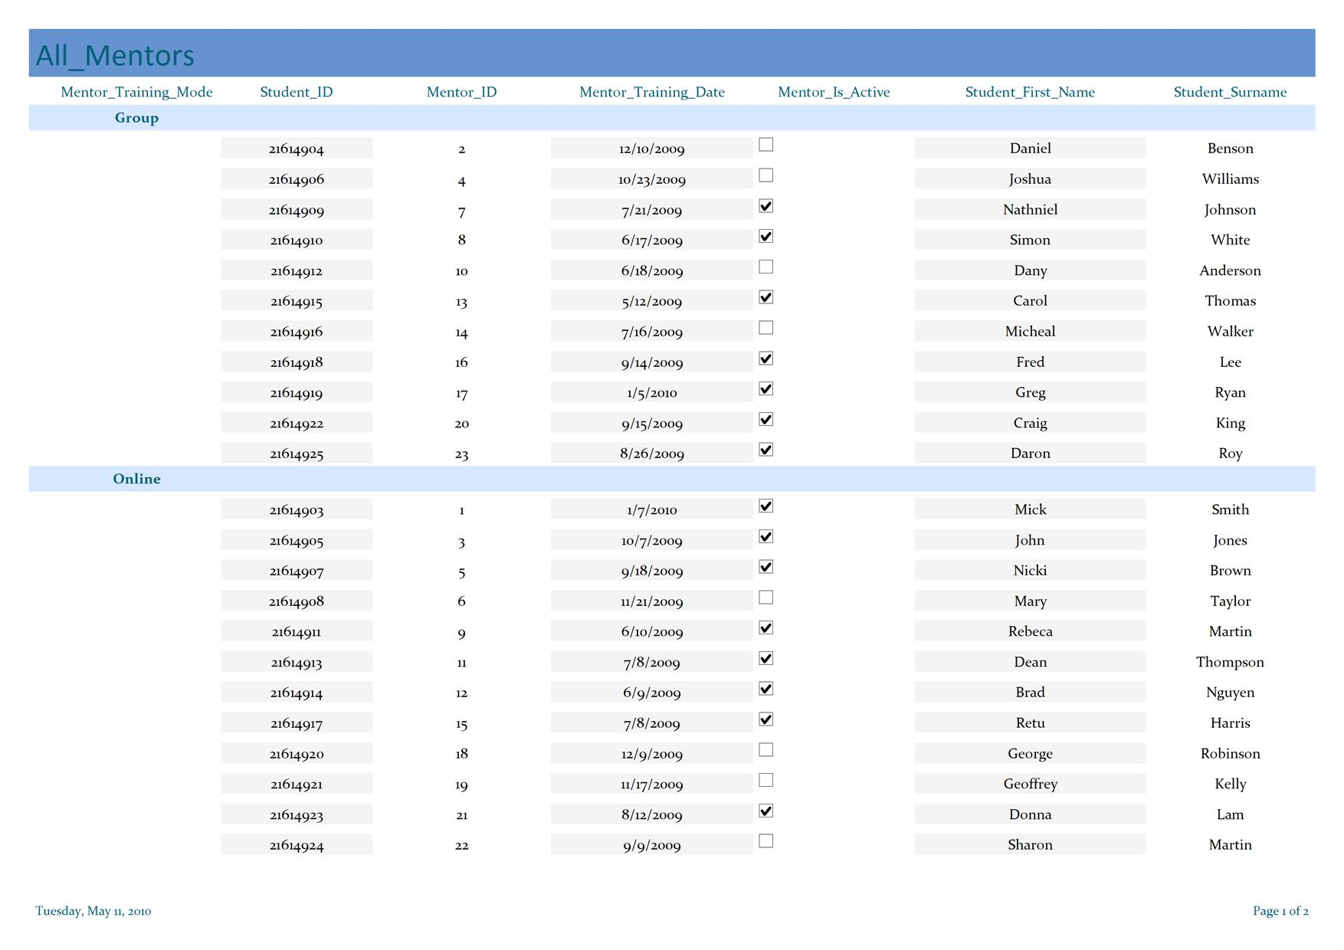

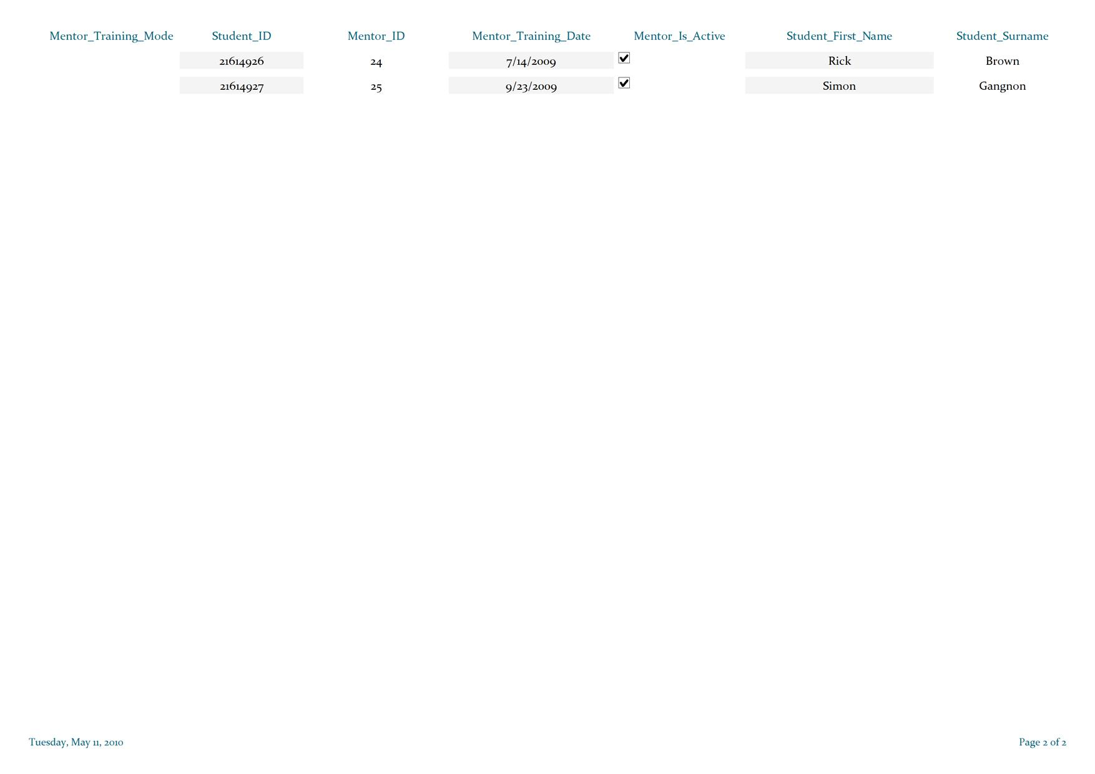

- Screen Design & Menu Design
  - Admin_menu
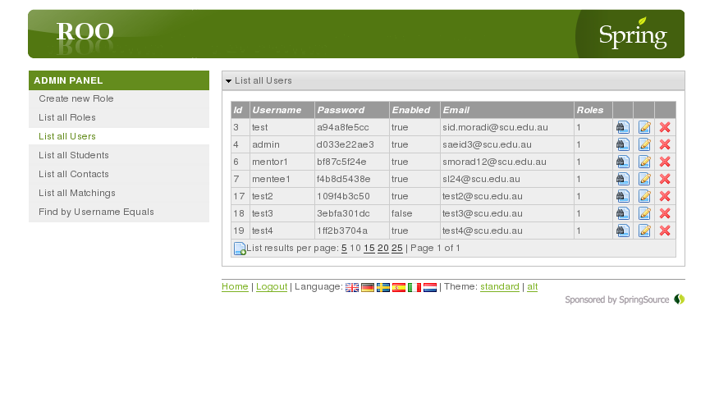

  - Coordinator_menu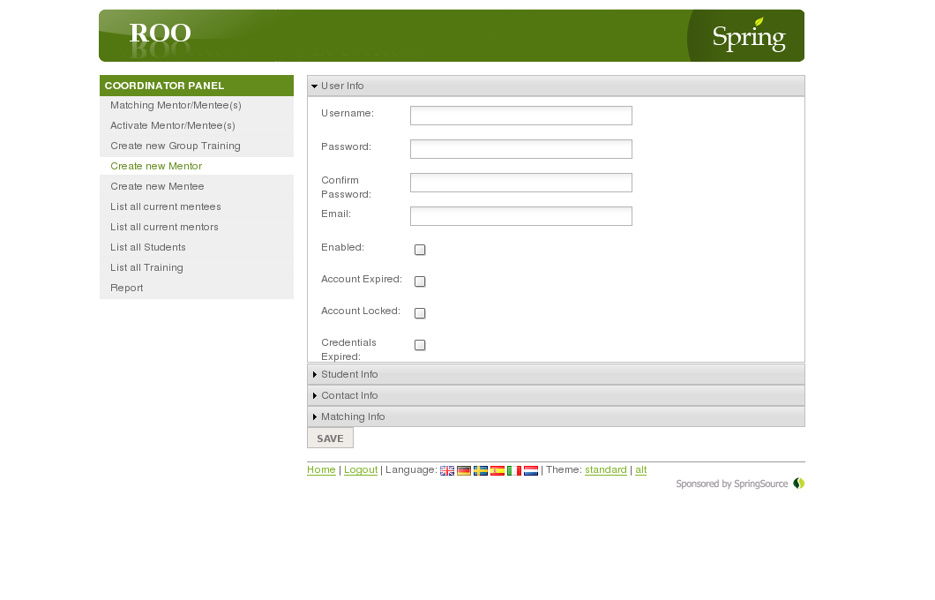
  - Mentee_menu
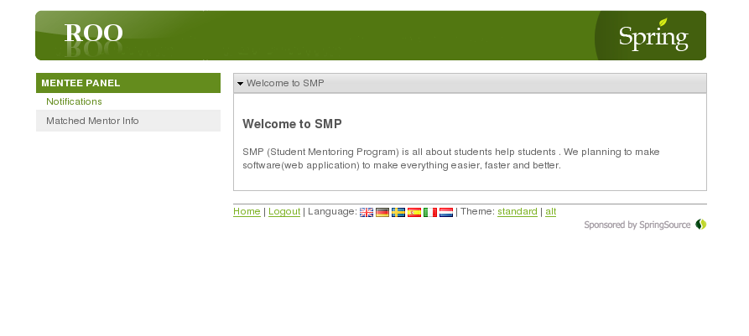

  - Mentor_menu
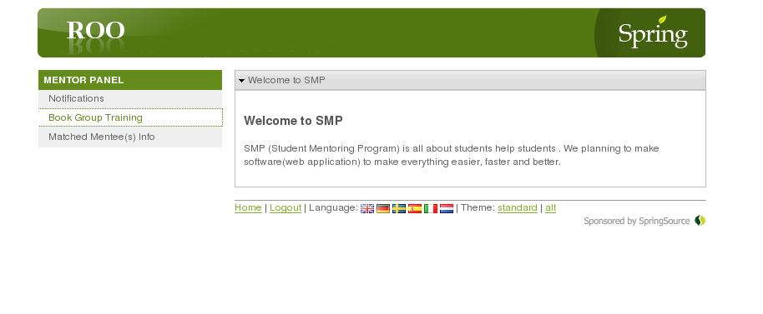

  - Login
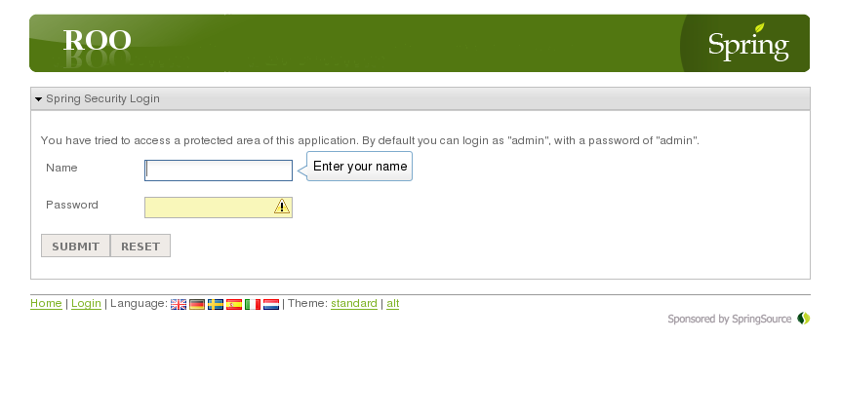

- System Hierarchy chart
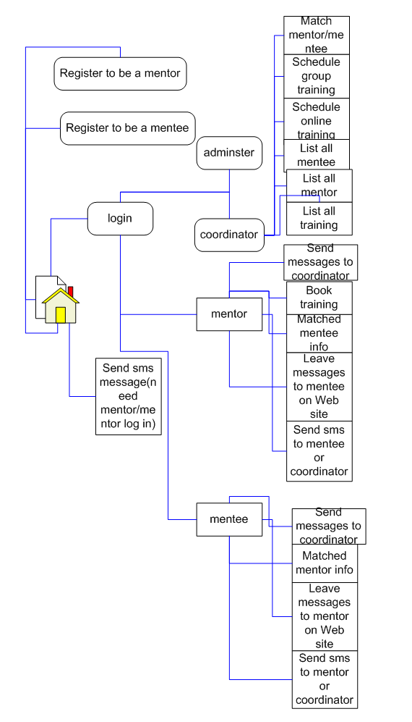

Project Management Charts

Recommendation

Appendix

References List

