Southern Cross University
Unit: ISY10221 (Computing Project 1)
Assignment task 3: Systems Analysis Specification



Project Supervisor: Paul Woods
Project Client: Jo Mason
Project Name: SMP (Student Mentoring Program)
Group Members: Shouqiang Li, Saeid Moradi & Babaljeet Kaur

Executive Summary

Table of Contents

Contents
- Schema Diagrams
- Schema Analysis of smp
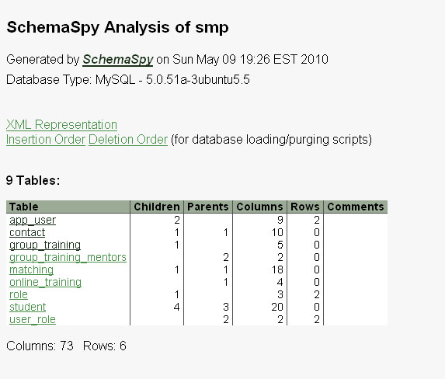
- 9 Tables
- app_user
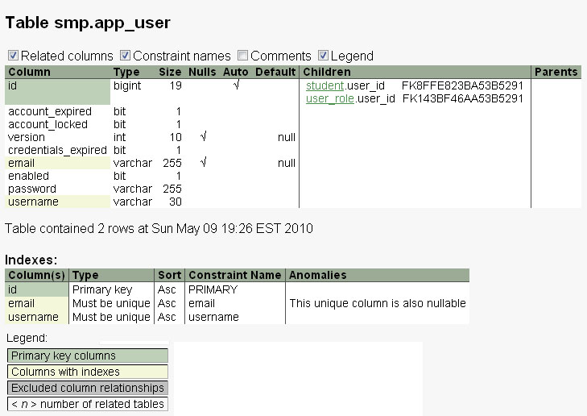
- contact
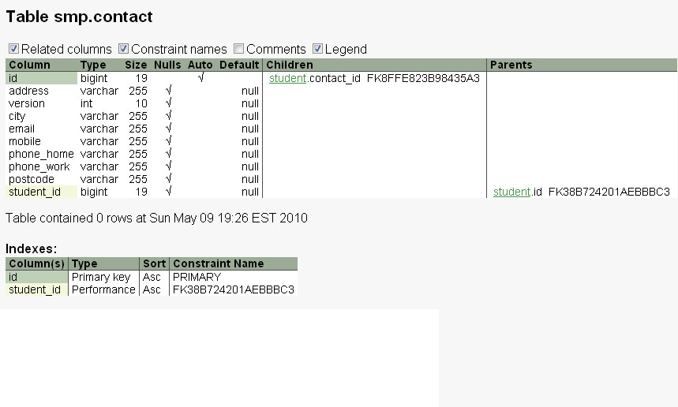
- group_training
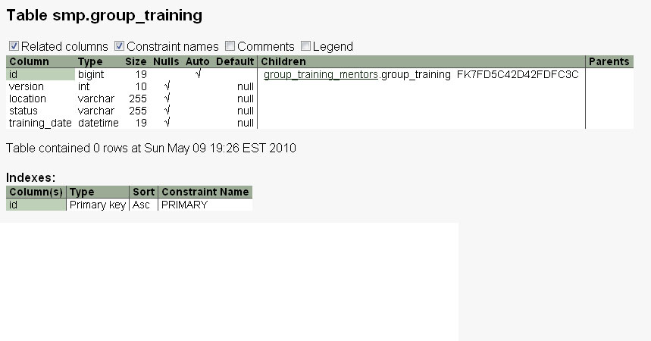
- group_training_mentors
- matching
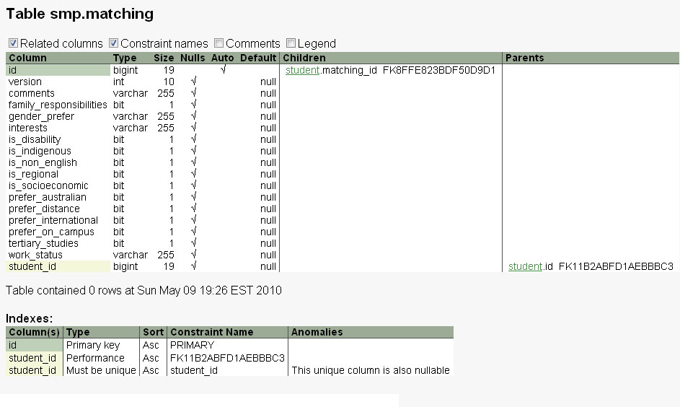
- online_training
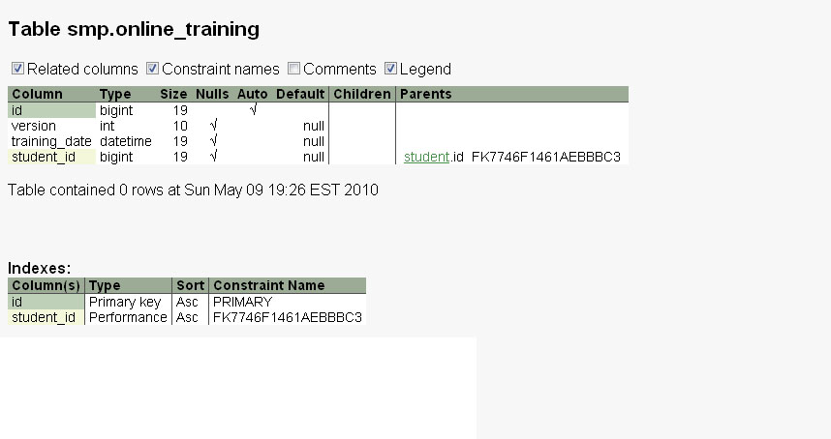
- role
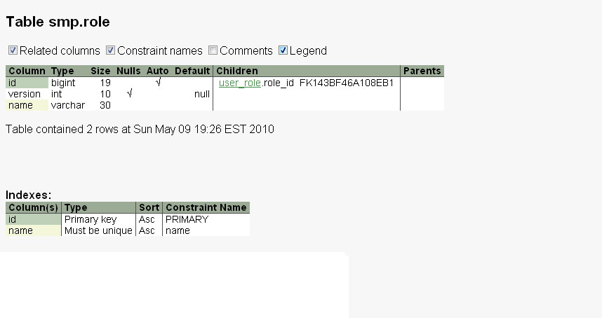
- student
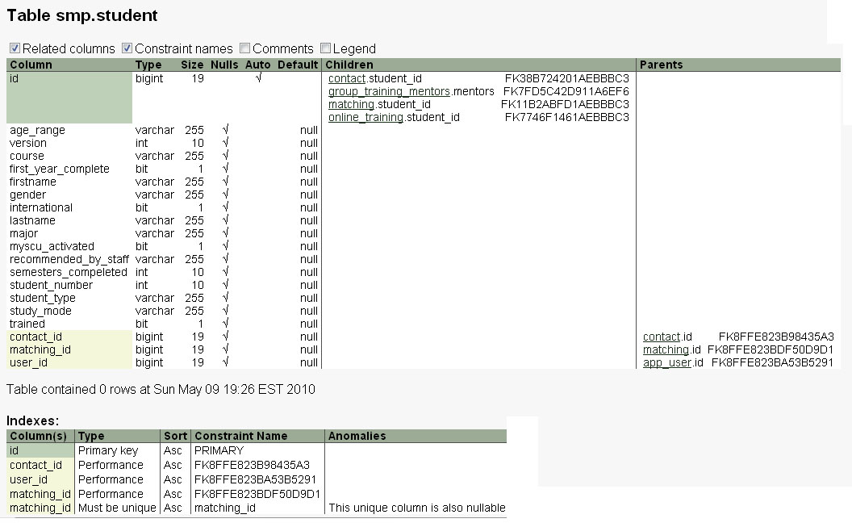
- user_role
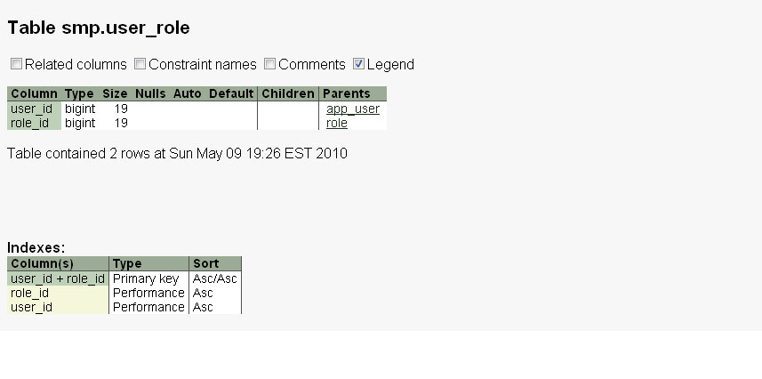
- Relationships
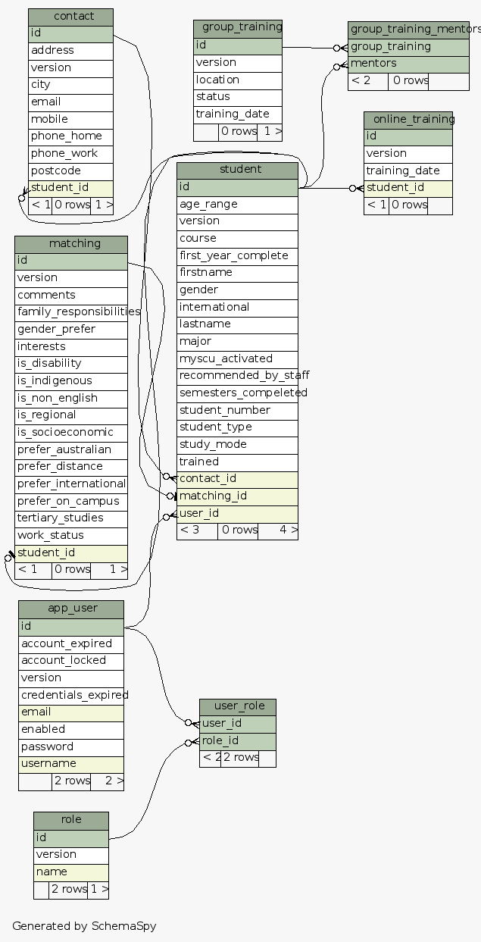
- Constraints
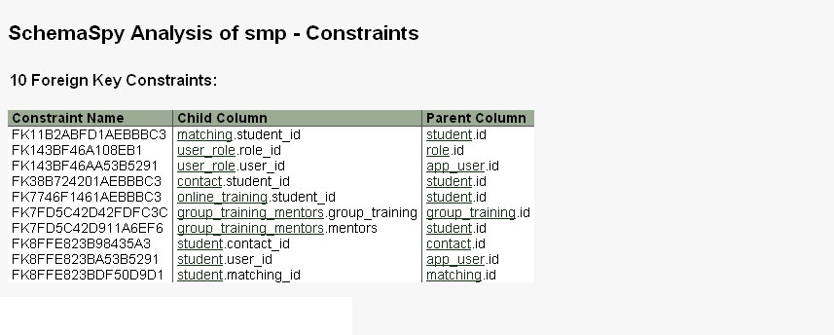
- Process Descriptions
- Data dictionary/Data Discriptions
- Technical Specifications
- Report Designs
- Screen Design & Menu Design
  - Admin_menu
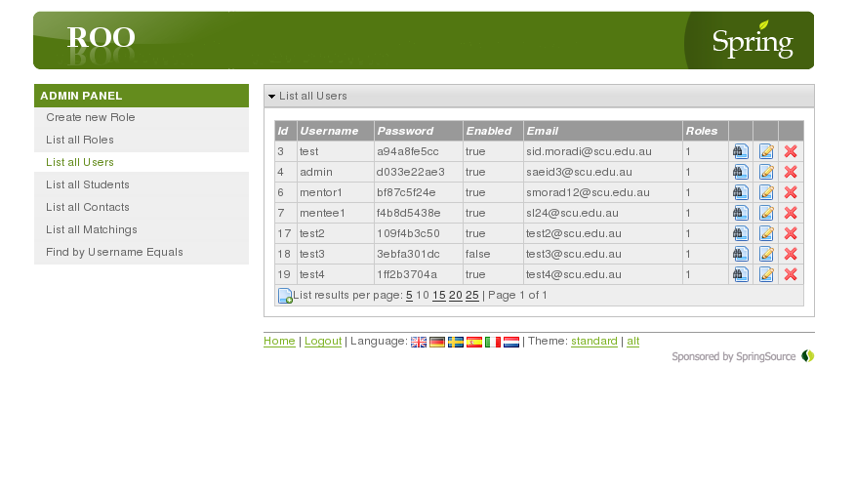
  - Coordinator_menu
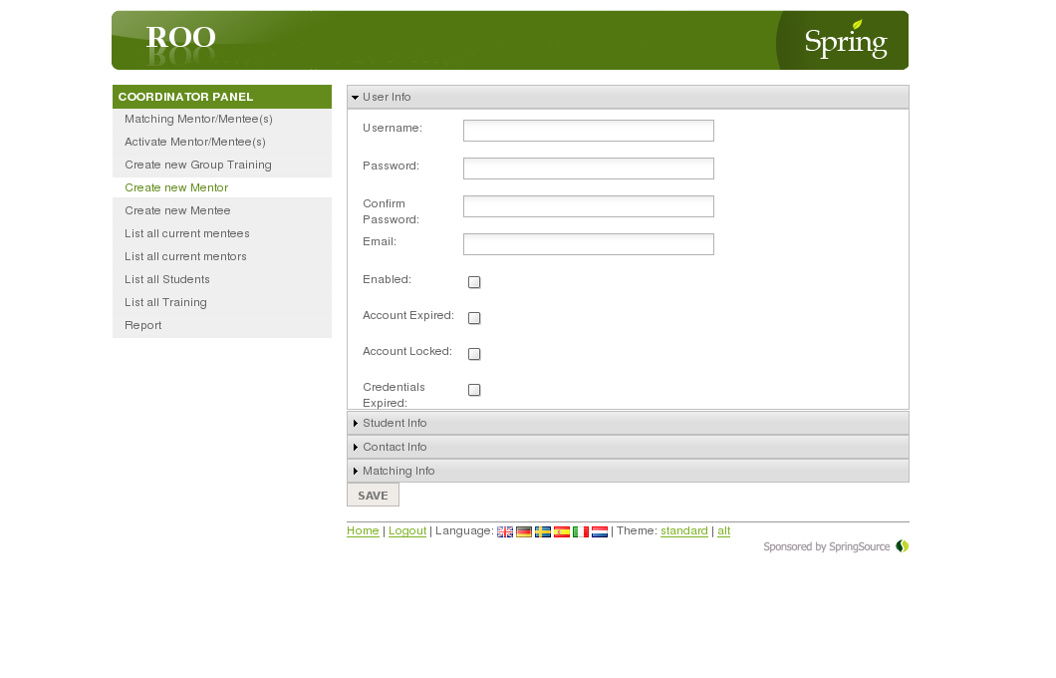
  - Mentee_menu
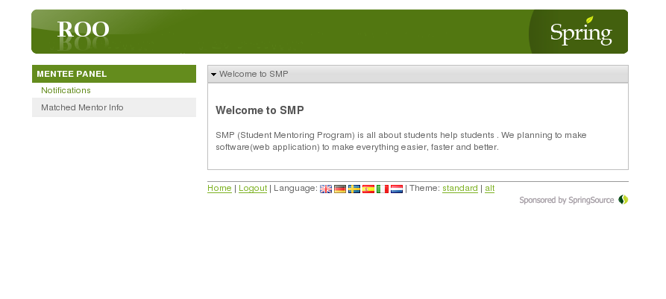
  - Mentor_menu
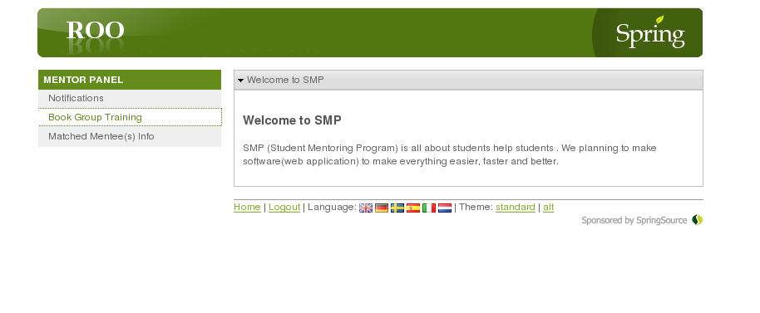
  - Login
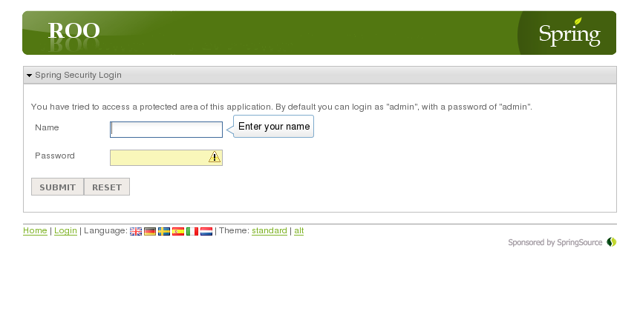
- System Hierarchy chart

Project Management Charts

Recommendation

Appendix

Reference List

