Southern Cross University
Unit: ISY10221 (Computing Project 1)
Assignment Task 1: Preliminary Project Description



Project Supervisor: Paul Woods
Project Client: Jo Mason
Project Name: SMP (Student Mentoring Program) Project
Group Members: Shouqiang Li, Saeid Moradi & Babaljeet Kaur

Table of Content
1. Project Overview: 3
• Expected deliverables: 3
2. Description of Project Team 4
• Team member skill relative to the project being undertaken: 4
2.1 Shouqiang Li 4
2.2 Saeid Moradi 4
2.3 Babaljeet Kaur 4
3. Description of Client and Organisation: 5
• Contact Details 5
• Staff Information 5
• Organisational Chart 5
4. Preliminary Feasibility Assessment 6
4.1 Operational Feasibility 6
4.2 Skill Feasibility 6
4.3 Time/ Economic Feasibility 6
4.4 Schedule Feasibility 6
5. Development Environment: 8
6. Technical Considerations 9
7. Reference List 10

STUDENT MENTORING PROGRAM

Project Overview
The Aim of the Project is to develop a website for ‘Student Mentoring Program’. This program comes under ‘Higher Education Sector’ business type and is managed by Equity and Diversity Office (Southern Cross University). It is about senior students (who are further along in their courses) helping new coming students (in the same course), to settle into University life more quickly. It has been observed that the number of students joining this program has increased gradually. As a result the staff needs a better way to handle student information. The overall goal of the project is to develop a website that will help the staff to do so.
The website will provide useful information to the students who want to be a mentor or seek a mentor. SMP project aims at providing a platform, which can be used by ‘Student Mentoring Program’ staff members and students. It also aims at providing a way by which the staff is able to manage mentor and mentee data. A stated objective of the project is to create a web application that people can easily reach through the Internet and which provides access to information related to the mentoring program.

Expected deliverables

Expected deliverables for the SMP project would be web-based software which can be used by the staff and the students related to the mentoring program. The project is trying to deliver a website, in which pages are light weigh, take less time to load and are easy to navigate. Moreover, it will be designed in a way that will help make the job of the organisation staff easier. It will also aim at providing a better way for the people related to the program to communicate more effectively and efficiently. The website will be designed in such a way that it is modular and easy to expand in the future.

Description of Project Team
The SMP project is being undertaken by a group of three University students – Shouqiang Li, Saeid Moradi and Babaljeet Kaur. All the team members are International students, studying internally in Coffs Harbour. Shouqiang, Saeid and Babaljeet are students from China, Iran & India respectively.
- Team member skill relative to the project being undertaken:
  - Shouqiang Li: Presently doing ‘Bachelor of Information Technology’
Languages known are Java, CSS, JavaScript, PHP, XHTML, XML etc.
Other IT related Skills: Basic photoshop, Adobe Flash, systems analysis and design, academic writing skills & database management.
0434 089 934
sli24@scu.edu.au
  - Saeid Moradi: Presently doing ‘BachInfoTech’ Software Development Major.
- Development J2EE applications by MVC Architecture using
  - Spring
  - JSP (and JSF)
  - Hibernate
- Development with GWT (Google Web Tools)
- Web Standards: HTML and CSS
- PHP Development
- Worked with Apache Maven and ANT
- Worked on Unix based OS (RedHat Linux, Ubuntu)

0421 782 194
s.moradi.12@scu.edu.au
  - Babaljeet Kaur: Presently doing ‘Associate Degree of Information Technology’,
Languages Known are XML, XHTML, C++, PHP, JavaScript, CSS etc.
Other IT related Skills: System Analysis and Design skills & Database management skills.
0434 265 226
b.kaur.10@scu.edu.au

Description of Client and Organisation:
The client for SMP project is Jo Mason, who is a coordinator for Coffs Harbour Campus Mentoring Program. She maintains information about the students who have signed-up for being a mentor or a mentee. Moreover, she also trains the mentors to help them assist their mentees.
- Contact Details:
Location: O.1.25, O Block, Coffs Harbour Campus
+02 6659 3643
jo.mason@scu.edu.au
- Staff Information:
Equity and Services department includes Rachel, the manger; two coordinators Rob Cumimgs (Tweed & Lismore) and Jo Mason (Coffs & Distance Students) and two Blackboard Administrators Kim McDonogh and Kaylen Abraham.
- Organisational Chart:
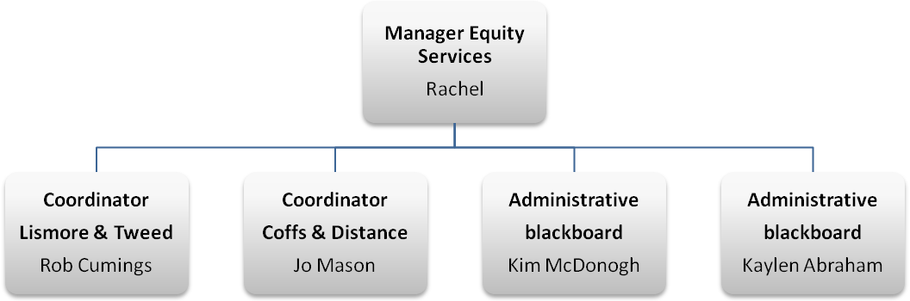

Preliminary Feasibility Assessment

Operational Feasibility
Jo Mason, shows much interest in the Project, and this Project will meet the needs of mentor program because of increasing number of the mentor and mentee. In the same time, there are some policies for creating new system in Southern Cross University, which may stop project for being practically testing and operating.

Skill Feasibility
Our group member skills and technical programming environment have been described in Description of Project team on page 4. They are highly relevant to the needs of developing this project and technical considerations. Also the team is very eager to learn new things to meet the speeding development of technology.

Time/ Economic Feasibility
Learning new skills and technology for the needs of project will cost a quantity of time. Every group member in our group are willing to spend more than 10 hours every week to try our best to do this project, in the same time getting priceless experience. (Preliminary Feasibility Timetable attached).
The group has decided to work free of charge for this project. The hardware and software provided by SCU will also be very useful resources.

Schedule Feasibility
Timetable in the study guide is a good but basic schedule for our group. The team will speed up our project if it is possible.

In conclusion, this project will take us about 300 hours across two semesters. The team is willing to spend more time if necessary. Furthermore, we need some valuable advises from Paul who is our project supervisor (see figure below).

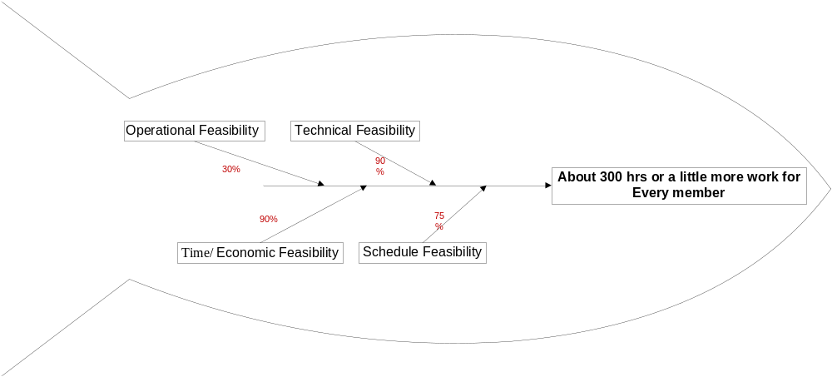

Development Environment

The new system will be a web application with Client/Server architecture. Java is preferred programming language for implementing this system. “Java technology's versatility, efficiency, platform portability, and security make it the ideal technology for network computing”. Moreover, it can be run on any operating system. Linux-based operating systems are our preferred choice of OS.
One of required software to deploy our application is a Java web server. For example Apache Tomcat is an open source Java web server that implements Java Servlet and JavaServer Pages technologies. Furthermore, JavaServer Pages (version 2.1) is our preferred technology for UI (User Interface) layer. For Data layer we plan to use Hibernate as our ORM (Object Relational Mapping). “Hibernate is a powerful, high performance object/relational persistence and query service.” With hibernate we can use different range of databases, for example MS-SQL server, MySQL, Oracle or DB2, etc. For SMP project, MySQL with Innodb Dialect will be preferred. For business layer the plan to use Spring framework. The team found Spring as a great framework to integrate needed libraries together. For example “Spring Roo is a next-generation rapid application development tool for Java developers. With Roo you can easily build full Java applications in minutes.”
Another possibility that the group have is deploying application by Spring-roo and Cloud Foundry Add-on. “SpringSource Cloud Foundry is the first self-service, pay-as-you-go, public cloud deployment platform for full-feature Java web applications that unifies the entire build, run, and manage application lifecycle for Java.” We should mention that Could Foundry is in Beta version and free to use at the time of writing this document.
The last tool that we want to work with is SVN (Subversion). Subversion is a version-control system. We found SVN quit similar to CVS. Plus with SVN we can use Google code project-hosting utility which is web-base and free of charge!
After setup repository by SVN at Google then we only need to have a client to connect to the server and do the update or commit actions.

Technical Considerations

There are some issues that we may face in future. One of main issues can occur in deployment phase. For example version of tomcat in production can be different from development which may create some strange issues. Noteless we plan to use tomcat 6.x version.
Another seen problem in production is build process itself. In development we will build project by Maven2 and the result is a war file which will be deploy to tomcat web server automatically. But in production we may don’t have permission to run Maven commands. Therefore we have to make the war file manually and upload the binary to the server. Upload the binary is not safe to transfer especially if the file is getting bigger and while we need multiple update every time. Best possible solution is update source code with SVN and build project by Maven at server.
Could Foundry is an alternative method to deploy our web application in production. In this scenario deployment is simpler. There is a command by Spring-roo’s add-ons which enable us to deploy the application on the fly. Could Foundry have a free signup because of being in Beta version. It means they may charge us after moving from Beta version to upper version. But hopefully team can use this service before their upgrade. The project team also considered other ‘could computing’ companies. For example Google App Engine will offer free limited resources. And in case if project needs more than limited resources then it will have to pay. But, the prices are very reasonable. For example for bandwidth usage, current price is $0.12 per GB transferred out.
Could Foundry use Amazon Web Services infrastructure which give us better support in Java libraries than Google App Engine.

Reference List
Apache Tomcat, Viewed 26 February 2010, <http://tomcat.apache.org/>
Apache Maven, Viewed 26 February 2010, <http://maven.apache.org/>
Could Computing, Viewed 27 February 2010, <http://en.wikipedia.org/wiki/Cloud_computing>
Could Foundry, Viewed 26 February 2010, <http://www.cloudfoundry.com/>
Google App Engine, Viewed 27 February 2010, <http://code.google.com/appengine/>
Google App Engine FAQ, Viewed 27 February 2010, <http://code.google.com/appengine/kb/billing.html#rounding>
Google Code project-hosting, Viewed 26 February 2010, <http://code.google.com/projecthosting/>
Hibernate, Viewed 26 February 2010, <https://www.hibernate.org/>
Java Technology, Viewed 26 February 2010, <http://www.java.com/en/about/>
Java Servlet, Viewed 26 February 2010, <http://java.sun.com/products/servlet/index.jsp>
JavaServer Pages, Viewed 26 February 2010, <http://java.sun.com/products/jsp/>
Spring framework, Viewed 26 February 2010, <http://www.springsource.org/about>
Spring-roo, Viewed 26 February 2010, <http://www.springsource.org/roo>
Spring-roo Could-Foundry addon, Viewed 26 February 2010, <http://forum.springsource.org/showthread.php?p=267357>
Subversion, Viewed 26 February 2010, <http://subversion.tigris.org/>

