Southern Cross University
Unit: ISY10222 (Computing Project II)
Assignment Task 1: Prototype


Project Supervisor: Paul Woods
Project Client: Jo Mason, Rob Cumings
Project Name: SMP (Student Mentoring Program) Project
Group Members: Saeid Moradi, Babaljeet Kaur & Shouqiang Li

Table of Contents
Introduction 3
Prototype 4
Brief Description 5
Story Board 7
Timeline 14

Introduction

This document provides the prototype links of the SMP project. It also gives a brief description of this website, which is focus on the functions of this website, what it will be, what it will do, as well as who will use it. This document also includes storyboards. The screenshot of work timeline of the team is added at the end of this document.

Prototype
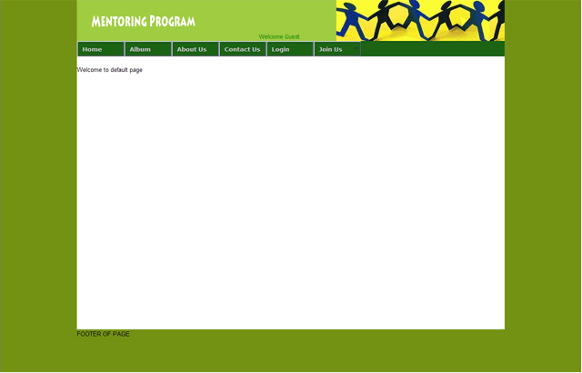
The prototype can be viewed by visiting the URL list next:
http://infotech.scu.edu.au/~smp &
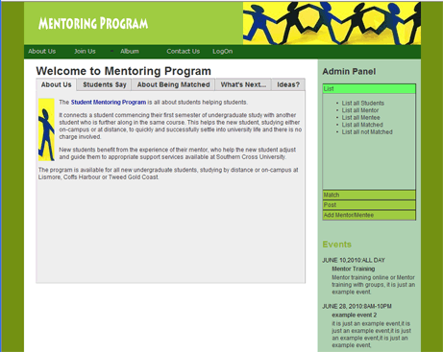
http://infotech.scu.edu.au/~smp/html/index_admin.html

Brief Description
This website is developed to reduce the work load of the mentoring project.
The southern cross university students can register to become a mentor or mentee on the web site as long as they reach the requirements, which are, a mentor should have at least a year university experience, and a mentee should be a freshman. The registered students information will be stored in the database.
The coordinator can log on to the coordinator account on the website to
The functions after users login are listed below:
1. The coordinators:
- list
- List all students,
- list all mentors,
- list all mentees,
- list all matched mentors and mentees,
- list all not matched mentors and mentees.
- Match. The coordinator can match a mentor for a mentee and vice versa.
- Post events. The coordinator can post a group training online training on the website, they also can post a event to the website as well (optional).
- Add mentor and mentee to the database. Modify or update mentor/mentee information in the database.

2. The Administrator can maintain or update the website.
3. The Managers can access similar functions as coordinator but they have more power. They can manage all campus students.
4. The students can log in as mentor or mentee access discussion board, get some mentoring event notice, join a study group, eg. IT, hospitality, nursing, etc. The mentor and mentee also can link to the facebook. New mentors can book a training.
In addition, after a semester, mentee status will be updated.
There also other optional functions to develop or not depending on the time issue. For example:
- Displaying different “Hello Message” on the website every time any user log on.
- Album
- Message to the mobile phone to the mentor/mentee online.
- Automatic email format reply generator, which will generator the formatted email for coordinator by getting the information from database and then it will be modified by the coordinator and then send out.
- Add hobbies choices to the register form, for the sake of easier matches.

Story Board
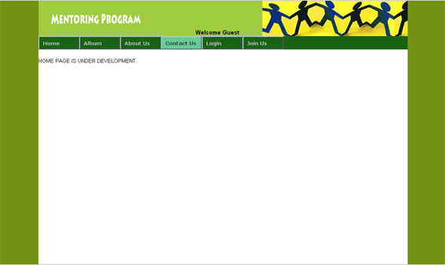
Title: Home page Frame ID: 1
Media Used:
Buttons: Horizontal JavaScript Query Multi Level CSS Menu
Welcome to the mentoring website
Background Colour: #739112,
Background Image: mentoring.jpg
Logo Image: mentoring_logo.png
Description (purpose / objectives): This is the home page of the mentoring website, it will display some welcome message and the users (Manager, Administrator, Coordinator, Students) can have accesses to more funcions after they log on.
User Interactions Required: The main user interactions required are
- clicking on the join us link to register,
- registered user can log on the website
Navigation / Links:
Join Us>register Interface | Log in>log in Interface
Login as Coordinator> manage mentor/mentee | Login as Manager > Manage all campus mentor/mentee
Login as Administrator>Manage the website | Login as mentor/mentee>some functions

Title: Join Us Frame ID: 2
Media Used:
Buttons: Horizontal JavaScript Query Multi Level CSS Menu
Please Fill you form and become a mentor (Mentee)
Name:

Background Colour: #739112,
etc:

Submit
Background Image: mentoring.jpg
Logo Image: mentoring_logo.png
Description (purpose / objectives): On this page, the users can register to become mentor or mentee as long as they reach the requirements, which are, a mentor should have at least a year university experience, and a mentee should be a freshman. The registered students information will be stored in the database.
User Interactions Required: The main user interactions required are
- fill the mentor/mentee registration form and submit the form,
Navigation / Links:
Home >go to Home Page | Log in>log in Interface
Login as Coordinator> manage mentor/mentee | Login as Manager > Manage all campus mentor/mentee
Login as Administrator>Manage the website | Login as mentor/mentee>some functions

Title: Login Frame ID: 3
Media Used:
Buttons: Horizontal JavaScript Query Multi Level CSS Menu
Please enter you username and password
Username:
mentor
Background Colour: #739112,
Password:
***********
Submit
Background Image: mentoring.jpg
Logo Image: mentoring_logo.png
Description (purpose / objectives): On this page, the users can Log in as coordinator, manager, Administrator, mentor or mentee.
User Interactions Required: The main user interactions required are
- fill the user name and password and then submit it.
Navigation / Links:
Home >go to Home Page | Join Us>register interface
Login as Coordinator> manage mentor/mentee | Login as Manager > Manage all campus mentor/mentee
Login as Administrator>Manage the website | Login as mentor/mentee>some functions

Title: Login As Coordinator Frame ID: 4
Media Used:
Buttons: Horizontal JavaScript Query Multi Level CSS Menu
Match for a Mentor
Match for a Mentee

List all Students
List all Mentor
List all Mentee
List all Matched
List all not Matched

Coffs Harbour Campus

Add a Mentor
Add a Mentee
Edit a Mentor
Edit a Mentee
Delete a Mentor
Delete a Mentee
Background Colour: #739112
Post an Event

Background Image: mentoring.jpg
Logo Image: mentoring_logo.png
Description (purpose / objectives): On this page, the coordinate can use this website to list students, match mentor and mentee, post events, and add mentor and mentee to the database.
In details, the coordinator can list all students, list all mentors, list all mentees, list all matched mentors and mentees, list all not matched mentors and mentees.
The coordinator can match a mentor for a mentee and vice versa.
The coordinator can post a group training online training on the website, they also can post a event to the website as well (optional).
Navigation / Links:
Home >go to Home Page | Join Us>register interface
Login > Login Interface | Login as Manager > Manage all campus mentor/mentee
Login as Administrator>Manage the website | Login as mentor/mentee>some fun functions

Title: Login As Administrator Frame ID: 5
Media Used:
Buttons: Horizontal JavaScript Query Multi Level CSS Menu
Has root access to the database
Details will be discussed in more clients meetings
Background Colour: #739112

Background Image: mentoring.jpg
Logo Image: mentoring_logo.png
Description (purpose / objectives): On this page, the Administrator can maintain the web site.
Navigation / Links:
Home >go to Home Page | Join Us>register interface
Login > Login Interface | Login as Manager > Manage all campus mentor/mentee
Login as Coordinator>manage the students | Login as mentor/mentee>some functions
Title: Login As Manager Frame ID: 6
Media Used:
Buttons: Horizontal JavaScript Query Multi Level CSS Menu
Has more power than coordinators,
Details will be discussed in more clients meetings

Background Colour: #739112

Background Image: mentoring.jpg
Logo Image: mentoring_logo.png
Description (purpose / objectives): On this page, the Managers can access similar functions as coordinator but they have more power. They can manage all campus students.
Navigation / Links:
Home >go to Home Page | Join Us>register interface
Login > Login Interface | Login as Administrator > Maintain the website
Login as Coordinator>manage the students | Login as mentor/mentee>some functions
Title: Login As Mentor/Mentee Frame ID: 7, 8
Media Used:
Buttons: Horizontal JavaScript Query Multi Level CSS Menu
Leave messages to your Mentor/ Mentee online

Join a study group
- IT
- Nursing
- Education

Link to facebook

- Join a social sport Event
- Basketball
- Soccer
- Badminton
Background Colour: #739112

Background Image: mentoring.jpg
Logo Image: mentoring_logo.png
Description (purpose / objectives): On this page, the students can access discussion board, get some mentoring event notice, join a study group, eg. IT, hospitality, nursing, etc. The mentor and mentee also can link to the facebook. New mentors can book a training.
Navigation / Links:
Home >go to Home Page | Join Us>register interface
Login > Login Interface | Login as Administrator > Maintain the website
Login as Coordinator>manage the students | Login as Manager> manage the students

Timeline

