CSEL Focus Areas

School Programs
Princeton Community Middle School, Princeton Community School District
Summer Bridge Program

During June of 2024 and 2025, CSEL facilitators conducted SEL classes each year for 100+ 6th graders in the Summer Bridge Program, which prepared students in all subjects for the entry to the middle school.
Princeton Community Middle School, Princeton Community School District
SEL Classes / Peer Mediation Training

Over the past two years (five semesters), CSEL facilitators conducted SEL classes for thirteen 8th grade and eighteen 6th grade classes, totaling over 700 students. In addition, CSEL trained 96 6th, 7th and 8th graders as peer mediators using a nationally recognized peer mediation program entitled, People Against Violent Environments (PAVE), and received two ‘Ohio Best Practices Awards’ for its successful work.
Evanston Academy / Evanston Middle School, Cincinnati Public Schools
CSEL facilitators conducted SEL classes for grades K-6 during the 2023-24 and 2024-25 school years. Evanston Academy then transitioned to a middle school for the 2025-26 school year where CSEL is providing SEL classes for six 7th and 8th grade classes this semester.
Chase Elementary School, Cincinnati Public Schools
CSEL facilitators are conducted 41 SEL classes over the past two years and is currently working with six K-6 classes.
South Avondale Middle School, Cincinnati Public Schools
CSEL facilitators conducted 12 SEL classes and nearly 300 students during the Fall Semester, including 4 classes each of 6th, 7th, and 8th grades. We will also be training peer mediation teams for each grade level in January and facilitating ten additional SEL classes in the second semester. This is South Avondale’s first year as a middle school.

Community Affiliations
Greater Cincinnati Foundation, Cincinnati, OH
The Center for Social-Emotional Learning (CSEL) is a recipient of a Greater Cincinnati Foundation (www.gcfdn.org) Educational Success Grant for $30,000 per year for two years, announced in May 2023. As the region’s leading community foundation, Greater Cincinnati Foundation connects people with purpose in an eight-county region in Ohio, Kentucky, and Indiana. GCF is leading the charge toward a more vibrant Greater Cincinnati – now, and for generations to come.
The title of the Greater Cincinnati Foundation Educational Success Grant is Developing Peer Mediation & Social-Emotional Learning Skills at Princeton Middle School and St. Monica’s Center in Lincoln Heights. This was the second GCF Educational Success Grant awarded to CSEL.
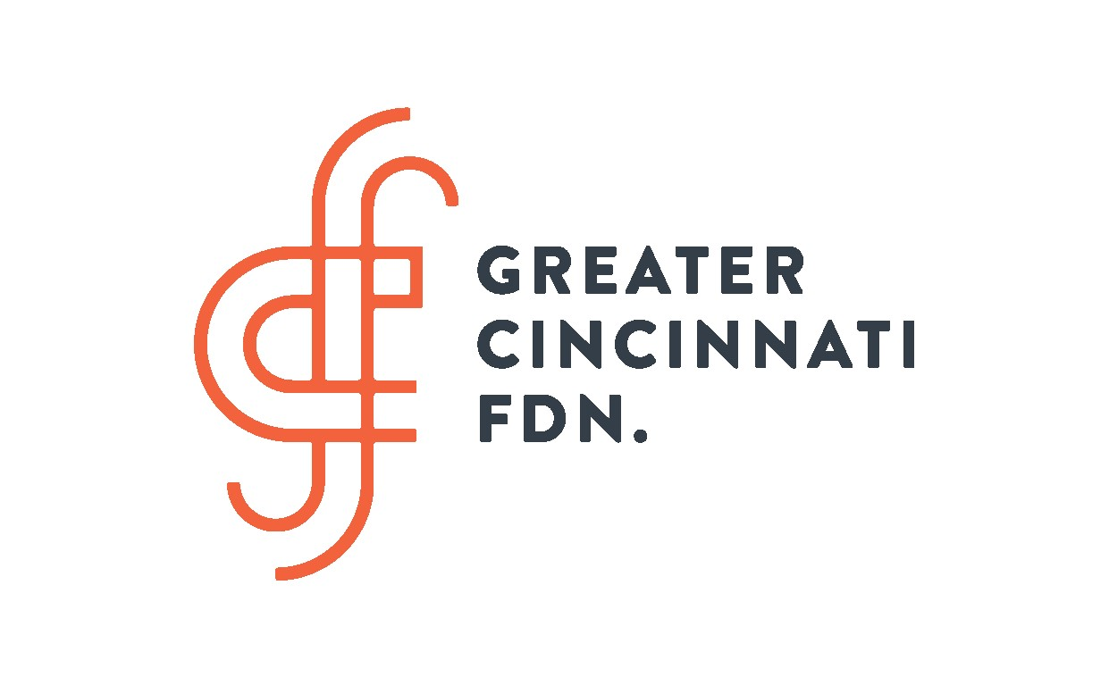

(Add link here to access grant information)

Talbert House, Cincinnati, OH
CSEL has been a Prevention Agency of Talbert House for ten years and a licensed agency of the Ohio Mental Health and Addiction Services since 2023. We received OMHAS Prevention funding that flows through Talbert House.
St. Monica Center, Lincoln Heights, OH
CSEL’s relationship began in July 2022, when we trained 33 students in grades 5-8 as peer mediators. St. Monica’s Center is staffed by a dynamic and inspirational Director, Michael Pearl, and a dedicated staff. In addition, SMC is supported by the ACTS Episcopal churches—Ascension & Holy Trinity, St. Simon of Cyrene and Christ Church Glendale—whose financial support and members are visible in every activity at SMC. CSEL provided two follow-up activities each year, mediation training in July 2023 (21 adults and 20 students) and July 2024 (8 adults and 18 students) funded by a Greater Cincinnati Foundation Educational Success Grant, written by CSEL Executive Director Robert Kelly.
Cincinnati Public Library, Cincinnati, OH
CSEL contracted with the Cincinnati Public Library System in 2023 in order to support the staff development goal of the Youth Librarians to focus on Social-Emotional Learning and purchasing books that support those skills. To that end, Executive Director Bob Kelly conducted a workshop for the Youth Librarians covering the SEL skills and facilitating two activities, including taking responsibility and conflict resolution. In addition, CSEL staff facilitated SEL workshops for preschoolers and their parents at seven library branches.
Research / Results
Over the past nine years, more than 85% of students and 96% of school staff have indicated that students have learned things that will be helpful in school, at home and with friends. Students also responded in a positive way to four other survey statements, and school staff indicated moderate to significant improvement in eight positive characteristics, including social interaction, positive attitudes, cooperation with others, ability to manage anger, problem-solving skills, and reduction of problem behaviors. In addition, pre and post test data has produced significant positive results for all SEL groups receiving the entire curriculum for their grade level. 98% Students who participated in Peer Mediation training responded that they learned things that will be helpful in school, at home and with friends. Both students and adult table leaders in peer mediation training responded over 95% positively to all statements on post-training surveys. Data from 2-year Greater Cincinnati Foundation Educational Success Grant implementation of Social-Emotional Learning classes and peer mediation training at St. Monica Center in Lincoln Heights and Princeton Community Middle School.
- 78-100% Students in 23 SEL classes (10 sixth grade and 13 eighth grade) and 100% of students in peer mediation training at St. Monica Center (SMC) and Princeton Community Middle School (PCMS) responded positively to six statements about what they learned.
- 100% of staff at SMC and PCMS respond that students demonstrated moderate to significant improvement in Peer Interaction and Cooperation as a result of SEL classes and peer mediation.
- Over the past two years of SEL and Mediation training, SMC has seen a 21% and PCMS has seen a 17% reduction in suspensions.
Success Stories
Our CSEL programs have filled a crucial mental health need in Greater Cincinnati, teaching social-emotional skills, including communication, cooperation, affirmation of self and others, appreciation of differences, goal-setting, peaceful conflict resolution, and peer mediation. These were important elements of our predecessor organizations, the Center for Peace Education (1979-2009) and Bridges for a Just Community (2009-2013).
Our peer mediation training program, developed by Robert E. Kelly and his key staff in 1996, has won two Ohio BEST Practices Awards, the Ohio School Conflict Management Award, and the Nestle' Foundation's "Very Best in Teaching" Award for the United States.

Testimonials
Insert link to access David’s Mackzum’s Letter (Princeton Community Middle School)

We are so grateful for Mr. Kelly and his team from the Center of Social-Emotional Learning for partnering with us to teach the very important skill of conflict resolution to our young people. Our young people face many challenges, but we are in the trenches with them, attempting, to the best of our ability, to provide them the tools they need to be successful. The Bible says, "Blessed (happy) are the peacemakers..." (Matt. 5:9)! Happiness is the blessing that comes when we find peaceful resolutions to conflict. This skill, especially used the way we plan to use it, will help better the culture and behavior here at St. Monica's. And beyond St. Monica's, the skill of peer mediation can even save lives!

Michael Pearl, Director, St. Monica Center, June 2024

“This year I witnessed how powerful it is to community support for a fledgling program to change the culture and practice of a large public school around conflict and discipline. Then, in January, Rev. Mike Pearl and his team at St. Monica’s Recreation Center personally invited several middle school students to attend a Saturday workshop to practice skills the school had not yet called on. All of these young people come from a small Black community and must find their way in a big, multiracial school with many students from wealthier, predominantly white areas. Pastor Mike started the day telling the students they were chosen because of their leadership potential. They rose to the challenge, practicing conflict resolution with role plays. It was lovely to see their interactions with each other and St. Monica’s adult staff: clearly these youth know how much they are loved and valued here.”

Ariel Miller, ACTS Group Leader

Current News & Events
CSEL Staff Development (August, 2025)
CSEL facilitators participate in at least one staff development session each year, in addition to staff development in schools where they facilitate. Staff development includes CASEL Competencies, evidence-based practices, trauma-informed practices, sharing of successful lessons, and the integration of art, music, movement, and mindfulness. The Executive Director and CSEL staff also meet to review student and school staff survey responses in order to adjust instructional strategies for upcoming classes.

Greater Cincinnati Foundation Educational Success Grant (2025)
CSEL received a $60,000 grant that responds to St. Monica’s Center (SMC) and Princeton Community Middle School’s (PCMS) goals of increasing conflict-resolution skills and reducing disciplinary actions, especially out-of-school/program suspension that result in a students’ removal from class/activities. In addition, SMC and PCMS desire further development of the social-emotional learning skills of communication, cooperation, bias awareness/appreciation of differences, and conflict management, and, ultimately, to improve student achievement. These goals are supported by the extensive research documenting the relationship between social-emotional learning, decreases in conduct problems, reduction in violence, increases in positive social behavior and an 11% increase in academic performance (Collaborative for Academic, Social and Emotional Learning).
International SEL Exchange – Chicago, Illinois (Annual)
The annual exchange involved over 100 sessions involving Social-Emotional Learning research and practices, in addition to organizations who are focused on preventing conflict and violence. Over 1800 participants from 49 states and 30 countries attended the three-day conference in November 2024 at McCormick Place in Chicago. The 2025 Exchange will be held remotely and spread over a longer period in order to encourage more participation and eliminate the cost of travel, as occurred during the Covid years.
Resources
Links
Add the following link to access – Social and Emotional Learning, Ohio – sel4oh.org
Add the following link to access – Social and Emotional Learning, United States – sel4us.org
Add the following link to access – BLOG #1 (written by Bob Kelly)
Add the following link to access – BLOG #2 (written by Bob Kelly)
Videos
- Why Building Emotional Intelligence in Classrooms Might Be the Key to Better Grades
- Social and Emotional Learning: A Schoolwide Approach
- 5 Easy Ways To Integrate Social-Emotional Learning (SEL) Into Academic Content Lessons
- Cooperation | Social and Emotional Learning Relationship Skills | [Interactive Video]
- 3 ways to resolve a conflict | Dorothy Walker | TED Institute
Articles

