**Cryptography and Network Security  
Lab Assignment - IV**

**Program 1: RSA Key Generation**

**Code:**

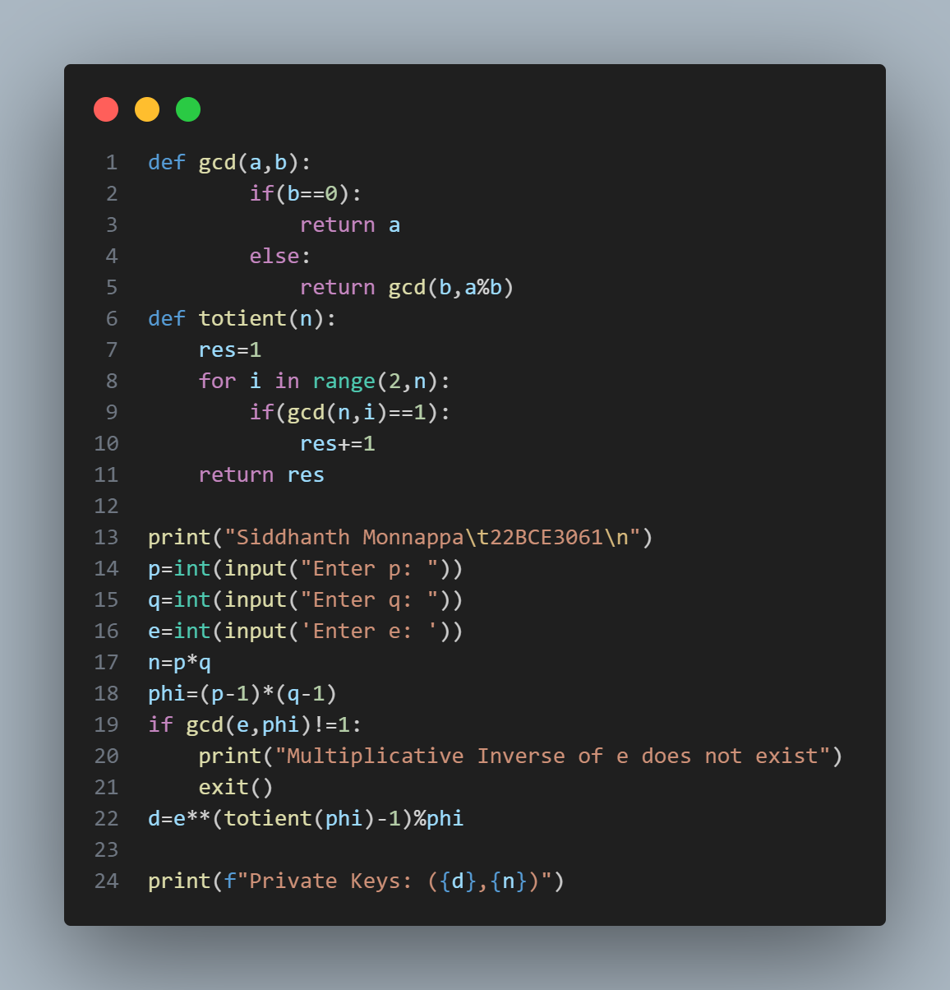

**Input/Output:**

**Program 2: RSA Key Generation & Encryption/Decryption**

**Code:**

**Input/Output:**

**Program 3: Elgamal Key Generation & Encryption/Decryption**

**Code:**

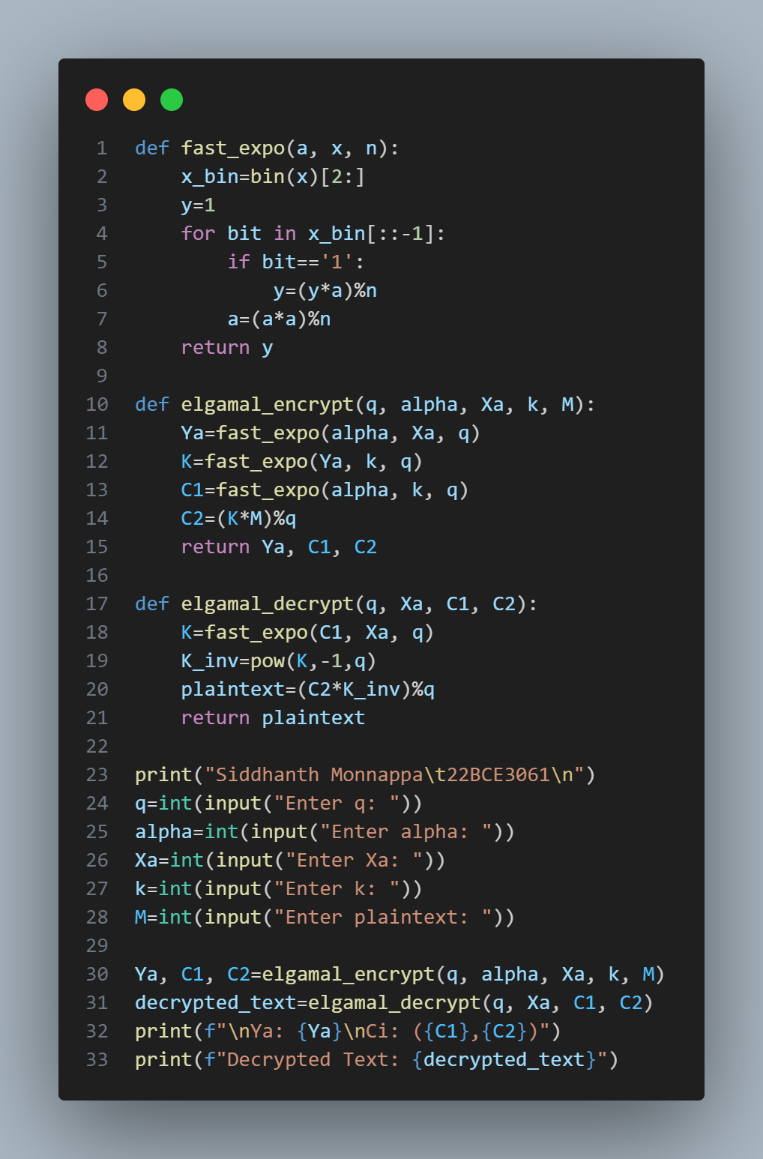

**Input/Output:**

**Program 4: Diffie Hellman Key Exchange**

**Code:**

**Input/Output:**

**Program 5: Diffie Hellman Man-In-The-Middle Attack with Key Exchange**

**Code:**

**Input/Output:**

