PathFold WSL and GUI User Guide
  - For Windows with WSL 2 and the PathFold CPU edition
For future use Windows PC with WSL2, keep the ZIP itself on Windows, but install/run PathFold from the Linux filesystem. The sequence is:
wsl -d Ubuntu
Then in Ubuntu:
mkdir -p ~/PathFold
cd ~/PathFold

unzip "/mnt/d/PathFold-Complete-0.2.4-Linux-x86_64-Compact-CPU.zip"

cd PathFold-0.2.4-Linux-x86_64-Compact-CPU
Install the CPU edition:
./Setup-CPU.sh
Check the base Workbench:
./Doctor.sh
Check the CPU engine:
./Doctor-CPU.sh
Then launch:
./Start-PathFold.sh

One important distinction: this is a complete portable Linux x86-64/WSL CPU package, not a native Windows .exe. The ZIP itself is stored and visible normally in Windows, while PathFold is extracted and executed inside WSL2.

Contents
1 Reopen the working installation 3
2 Activate WSL on a new Windows computer 5
3 Assemble and validate a fresh portable package 7
4 Complete the first GUI analysis 9
5 GUI controls and analysis parameters 11
6 Read and interpret the numerical results 20
7 Research declarations and paired results 23
8 Run PathFold with the CPU engine 26
9 Optional atom tools and AF3 workflows 33
10 Manage files and troubleshoot 37
11 Your screenshots as a page reference 42
12 Sources and verification record 45
Use the Contents links or Word’s Navigation pane to jump to a chapter. For routine use, start with Chapter 1. For a first analysis, follow Chapter 4. For model proposals, follow Chapter 8.
Task | Chapters
Launch an installed GUI | 1
Set up another Windows computer | 2 and 3
Analyze and export structures | 4 through 6
Declare paired research inputs | 7
Run CPU inference or optional tools | 8 and 9
Find troubleshooting and references | 10 through 12

1 Reopen the working installation

1 1 Enter Ubuntu from Windows
Open Windows Terminal and choose a PowerShell tab. Ordinary launches do not need administrator privileges. Check the installed distribution, then enter the account used in your log. [W3]
Windows PowerShell
wsl --list --verbose
wsl --distribution Ubuntu --user XXXXXX
The listing should show Ubuntu with VERSION 2.
The prompt changes to a Linux prompt such as xxxxxx@XXXXXX:~$. You are now in Ubuntu. If PowerShell opens Ubuntu at /mnt/c/WINDOWS/system32, run cd ~ before working.

1 2 Start PathFold from Ubuntu
PathFold should be installed in the WSL Linux filesystem rather than run directly from the ZIP on the Windows drive. Microsoft recommends keeping Linux workloads under the Linux filesystem, such as /home/<user>/..., for better Linux-side performance.
After installation, set a short variable for the PathFold directory. PF_ROOT is only a shell convenience variable; it does not modify the installation or your home directory.
Ubuntu terminal
PF_ROOT="$HOME/PathFold/PathFold-0.2.4-Linux-x86_64-Compact-CPU"

cd "$PF_ROOT"

./Start-PathFold.sh
Expected result. PathFold Workbench 0.2.4 opens as a Linux GUI application through WSL2/WSLg. The Ubuntu terminal may remain attached to the launcher or may return to the shell prompt, depending on how the launcher starts the GUI. Either behavior can be normal. During the first launch, keeping the terminal open is useful because startup diagnostics or errors may be printed there.
Close PathFold normally from the GUI when finished.

For a changed installation or a suspected failure, close the GUI and run the consumer checks before relaunching:
Ubuntu terminal
cd "$PF_ROOT"
./Verify-Package.sh
./Doctor.sh
./Doctor-CPU.sh
Verify-Package.sh checks the delivered package files. Doctor.sh checks the desktop runtime. Doctor-CPU.sh checks the separately installed inference runtime. These checks do not generate model proposals.

1 3 Understand the successful diagnostics
Observation in your log | Meaning and action
GUI doctor reports status: completed, frozen: true and a passed multiprocessing probe | The bundled desktop runtime started and its child process responded. Continue with GUI analysis.
GUI doctor reports torch: null and engine_​available: false | Expected for the analysis-only desktop. The CPU engine is a separate executable selected explicitly for inference.
CPU doctor reports Torch 2.8.0+cpu and package integrity valid: true | The separate CPU runtime is installed. Your log records verification of 3,674 payload files.
CPU device state is available_​unqualified | Operator diagnostics passed. This label does not establish full-model numerical or scientific qualification on this particular WSL host.
wsl --status warns that WSL1 is unsupported | Check the installed distribution's VERSION column. Your observed WSL2 run does not require WSL1.

Checkpoint. Confirm a visible GUI window, a functioning Prepare page, and no startup error. Do not repeat assembly inside the existing installation to reopen it.

First-time installation from the ZIP
If PathFold has not yet been installed on that Windows PC, keep the distribution ZIP on the Windows filesystem and extract it into the WSL Linux filesystem.
For example, if the ZIP is stored at:
D:\PathFold-Complete-0.2.4-Linux-x86_64-Compact-CPU.zip
start Ubuntu from PowerShell:
wsl -d Ubuntu
Then run:
ZIP_WIN="/mnt/d/PathFold-Complete-0.2.4-Linux-x86_64-Compact-CPU.zip"
PF_HOME="$HOME/PathFold"
PF_ROOT="$PF_HOME/PathFold-0.2.4-Linux-x86_64-Compact-CPU"

mkdir -p "$PF_HOME"
cd "$PF_HOME"

unzip "$ZIP_WIN"
cd "$PF_ROOT"
Install the bundled CPU inference edition:
./Setup-CPU.sh
Run the desktop-runtime diagnostic:
./Doctor.sh
Run the CPU inference-runtime diagnostic:
./Doctor-CPU.sh
Then launch PathFold:
./Start-PathFold.sh
Setup-CPU.sh normally only needs to be run once after a fresh extraction. It expands and installs the bundled CPU edition into the local PathFold directory.

2 Activate WSL on a new Windows computer
This chapter is for another computer or a machine that does not yet have a working WSL installation. Skip it on the computer shown in your screenshots.

2 1 Check Windows and the architecture
Press Windows+R, type winver, and inspect the Windows version. WSLg GUI integration requires Windows 11 or Windows 10 build 19044 or later. The delivered binary targets x86_64 or AMD64; ARM64 operation is not qualified by this release. [W2]
Open PowerShell as Administrator and inspect what already exists:
Windows PowerShell
wsl --status
wsl --version
wsl --list --verbose
wsl --list --online
If a working Ubuntu distribution already appears as VERSION 2, retain it and use its exact distribution name. The name Ubuntu does not by itself guarantee Ubuntu 24.04. Your supplied log uses resolute repositories and glibc 2.43; it does not establish Ubuntu 24.04.

2 2 Install a listed Ubuntu distribution
For a new machine, install a distribution listed by the online command. The following example uses the generic catalog entry: [W1]
Windows PowerShell
wsl --install -d Ubuntu
If Ubuntu-24.04 appears in the online list and you want an environment closer to the Ubuntu 24.04 release build host, use wsl --install -d Ubuntu-24.04 instead. Run one installation command for the distribution you chose. Restart Windows if prompted, open that distribution, and create a Linux username and password. Linux password entry shows no characters while typing.
Recheck the installed distribution in PowerShell:
Windows PowerShell
wsl --list --verbose
If it is VERSION 1, back up important files, stop its jobs, and convert that exact distribution to version 2. For the distribution named Ubuntu, the command is wsl --set-version Ubuntu 2. WSLg needs WSL2. [W1, W2]

2 3 Update WSLg when needed
Save projects and finish or safely cancel all Linux jobs first. In PowerShell as Administrator, run:
Windows PowerShell
wsl --update
wsl --shutdown
Then reopen Ubuntu. Shutdown stops every running WSL distribution. WSLg provides individual Linux application windows on the Windows desktop. Install current Windows graphics drivers if display support needs attention. [W2, W3]
If a first-time install fails with a Virtual Machine Platform or virtualization error, check firmware virtualization and the Windows feature using Microsoft's troubleshooting guidance [W6]. For a missing Virtual Machine Platform feature, an administrator can enable it with:
Windows PowerShell
dism.exe /online /enable-feature /featurename:VirtualMachinePlatform /all /norestart
Restart Windows after enabling the feature. Keep the installed distribution and its files while diagnosing the platform; follow the official manual-install procedure [W8] if your Windows configuration requires that route.
Checkpoint. wsl --list --verbose shows the chosen distribution as VERSION 2, and its Linux shell opens successfully.

3 Assemble and validate a fresh portable package
Use a new assembly directory for a new installation. Your existing package is already assembled. The Complete Portable edition includes the GUI AppImage, CPU archive, registered model histories 1, 3 and 6, example data, optional tool archives, example exports, source and instructions.

3 1 Prepare Ubuntu and obtain all three parts
In the Ubuntu terminal, install the ZIP extraction tool and inspect the environment:
Ubuntu terminal
sudo apt update
sudo apt install -y unzip
cd ~
uname -m
cat /etc/os-release
ldd --version
df -h ~
Expect x86_64; record the actual Ubuntu and glibc versions. Allow at least 10 GB free for download parts, assembly, CPU extraction and temporary GUI extraction. This is practical headroom from the package guide, not a universal measured requirement. Large runs need additional space. Check Windows host free space as well as the Linux report.
Download these three original ZIPs into Windows Downloads:
File names or paths
PathFold-Complete-Portable-0.2.4-Linux-x86_64-Part-01.zip
PathFold-Complete-Portable-0.2.4-Linux-x86_64-Part-02.zip
PathFold-Complete-Portable-0.2.4-Linux-x86_64-Part-03.zip
OR
PathFold-Complete-0.2.4-Linux-x86_64-Compact-CPU.zip
For Linux workloads, assemble under the Linux home filesystem. Your Windows Downloads folder is accessible as /mnt/c/Users/xxxxxx/Downloads. [W4]

3 2 Extract the transport ZIPs into one new folder
The example below deliberately refuses an existing assembly folder. Choose a different new name if PF024_New_Assembly already exists.
Ubuntu terminal
(
set -e
mkdir -p "$HOME/PathFold-install"
mkdir "$HOME/PathFold-install/PF024_New_Assembly"
cd "$HOME/PathFold-install/PF024_New_Assembly"
WIN_DOWNLOADS='/mnt/c/Users/xxxxxx/Downloads'
PART_BASE="$WIN_DOWNLOADS/PathFold-Complete-Portable-0.2.4-Linux-x86_64"
unzip -o "${PART_BASE}-Part-01.zip"
unzip -o "${PART_BASE}-Part-02.zip"
unzip -o "${PART_BASE}-Part-03.zip"
ls -lh
sh Assemble-Portable.sh
)
Use the actual filenames if a browser appended a suffix such as (1). Before assembly, confirm all three .tar.partNN pieces, Assemble-Portable.sh, MULTIPART.json and READ_FIRST.txt are present. The assembler checks each piece, the joined archive and the extracted package inventory. If any check fails, retain the message and obtain the correct original file.
The original joined TAR has SHA-256 aacd4059199314c8c30db73057d15c1de11a25f5d355d2028cfb87e030f97f7f. The supplied assembler performs this check; manual joining is unnecessary.

3 3 Set up the separate CPU edition and launch
In Ubuntu, enter the resulting package directory:
Ubuntu terminal
ASSEMBLY_ROOT="$HOME/PathFold-install/PF024_New_Assembly"
PF_ROOT="$ASSEMBLY_ROOT/PathFold-Complete-Portable-0.2.4-Linux-x86_64"
cd "$PF_ROOT"
./Verify-Package.sh
./Setup-CPU.sh
./Doctor.sh
./Doctor-CPU.sh
./Start-PathFold.sh
Setup-CPU.sh installs and verifies the bundled CPU edition. It prints its root folder. It does not start inference or automatically select the GUI's engine. Read Chapter 8 to connect that executable and its model checkpoint directory.
The complete GUI launcher uses AppImage extract-and-run, so mounted FUSE is unnecessary. If using the separate standalone AppImage instead, the following Ubuntu commands launch its analysis GUI:
Ubuntu terminal
chmod u+x PathFoldWorkbench-0.2.4-x86_64.AppImage
./PathFoldWorkbench-0.2.4-x86_64.AppImage --appimage-extract-and-run gui
The standalone GUI file does not include the complete CPU inference edition. Use the Complete Portable package for the combined workflow described in this guide.
Checkpoint. The assembly and package hashes pass, both doctors complete, and a visible PathFold window opens. Preserve immutable runtimes and keep new outputs in writable user folders.

4 Complete the first GUI analysis

4 1 Understand the six pages
Page | What you do
Prepare | Choose a work mode, ordered structures, a separate reference and a new destination. Preview and validate the actual inputs.
Configure | Select analysis settings. In Run PathFold mode, also select model history, candidate budget, seed and execution settings.
Run | Start the worker and inspect its acknowledged status, progress and log.
Explore | Inspect a completed snapshot, actual frames, metrics, matrices, residue selection and figure styling.
Compare | Analyze explicitly mapped trajectories and optionally declare a paired research comparison.
Export | Save and verify a result bundle, numerical arrays, selected figures and permitted source structures.

Use the sidebar to move among pages. Moving to a page does not start work. A draft is the editable setup; a completed snapshot contains the results of a particular run.

4 2 Run the demonstration shown in your screenshots
1. Click Demo at the top right. This fills the demonstration folder, a separate reference and demo-specific chain mapping. It prepares a draft; it does not compute results.
2. In Prepare, choose Explore existing results. Confirm the ordered structures and reference fields are filled. Click Preview ordered frames to inspect the actual loaded frames.
3. Scroll down if necessary and click Validate inputs. Read the validation summary, including frame count, residue mapping, coverage and any warnings.
4. In Configure, keep the demonstration settings: contact cutoff 14 Å, minimum sequence separation 3, strict coverage, chain mapping {"X":"A"} and display smoothing window 1. Leave advanced JSON, Isomap and DSSP off for this first run.
5. Click Continue to Run, then click Start. This is the step missing in your screenshot of the Run page.
6. Wait for an acknowledged completed result. The snapshot opens in Explore after background loading. A busy worker or loading message requires waiting for completion.
7. In Explore, move the frame slider, inspect an available metric and select a residue or matrix pair. Read the Inspector for raw values and provenance.
8. Click Save project and choose a durable .pfproject file under your own projects folder. Then use Export to create a new result bundle and verify it.
Why your Explore and Export pages are empty. The supplied screenshots show no completed snapshot. This is consistent with a draft that has not run. Start the analysis, use Open for a saved .pfproject, or use Open result bundle on Export for a saved bundle.
Demo file paths. The AppImage can expose its internal demo under a temporary /tmp/appimage_extracted_… directory. That path can change on another launch. Use Demo again to populate the current installation's demo, or choose durable example files from the complete package. Do not copy a temporary path from a screenshot into a future run.

4 3 Open the supplied complete example
For a durable precomputed example, click Open and select examples/demonstration_project/portable-project.pfproject inside the Complete Portable root. Alternatively use Open result bundle on Export and select examples/result.bundle. Read the restored input paths and snapshot provenance before changing anything. The bundle carries actual numerical results and can be verified independently.
From Ubuntu, the shipped bundle can be checked with:
Ubuntu terminal
cd "$PF_ROOT"
./PathFold.sh validate-bundle examples/result.bundle
If this shell has not yet defined PF_ROOT, repeat its assignment in Chapter 1 using your installed folder. A variable set in one terminal is not automatically set in a different terminal.
Checkpoint. Explore contains actual frames and available analyses, the provenance line identifies a completed snapshot, and a saved project or verified bundle can be reopened.

5 GUI controls and analysis parameters

5 1 The six pages and common controls
Prepare chooses the work mode, source files and output. Configure sets analysis and, when requested, inference. Run launches work and displays actual worker stages. Explore opens completed snapshots. Compare analyzes a second trajectory or explicit research declarations. Export creates a verified result bundle.
Open (Ctrl+O) opens a .pfproject file, not an arbitrary PDB, snapshot JSON or result directory. Save project (Ctrl+S) saves the current draft, viewer state and a checksummed copy of a completed snapshot if one is open. Demo (Ctrl+D) loads demonstration inputs. Ctrl+1 through Ctrl+6 select Prepare through Export. Clicking Continue to Configure or Continue to Run changes pages only. Scroll inside a page to reveal fields below the current view; use the splitters to resize molecular and chart panels.
Only one worker job runs at a time. Wait for a snapshot to finish opening before starting another job. Draft changes do not rewrite completed snapshots. The application also autosaves its draft under its writable user-data directory, but an intentional saved project is the useful portable working record.

5 2 Prepare step by step
1. Select a Work mode. Explore existing results analyzes local ordered structures and needs no Torch engine. Run PathFold creates an AF2-conditioned Cα path using a separate compatible engine, trusted checkpoints and matching AF2 features. Import AF3 results imports independent prediction samples. Configured AF3 execution uses an explicitly installed and authorized local or HTTPS provider; it is not a bundled live AF3 installation.
2. For local analysis, use Add files to select .pdb, .cif, .mmcif, .npz, .npy or a trajectory manifest JSON. Use Add folder for a trajectory directory. Explicit file lists retain displayed order. A recognized numeric directory layout is ordered by frame number; a directory with trajectory_manifest.json uses its declared order. Ambiguous names, duplicate indices or undeclared gaps require an explicit list or manifest.
3. Select list entries and use Move up, Move down or drag within the list to arrange them. Remove deletes the selected entries from this draft, not their files. Dropped local files are added in their displayed order. Inspect the effective order rather than assuming an operating-system file dialog sorted frames correctly.
4. Set Source direction to forward to preserve that order or reverse to analyze it in reverse. This is a source-order choice, not a physical-time or molecular-direction claim. Reorder or reverse only once. Preview becomes stale after changing the input list or direction.
5. Choose an optional Reference in its separate field. Never insert a target reference into the ordered frames merely to enable target comparisons. Without an explicit reference, the first frame is the geometric alignment target, and reference-contact/RMSD metrics remain unavailable.
6. Choose Result destination. Analysis and AF3 import write a new snapshot JSON file; leaving this field empty creates a unique file in user-data/snapshots. PathFold inference and configured AF3 execution need new result directories. Completed output is preserved; choose a different name for a new run.
7. Click Preview ordered frames or Validate inputs. In analysis mode both run read-only input validation and show actual Cα previews plus a mapping table. The table previews up to 200 mapped residues; thumbnails preview up to 128 complete frames within a 2 MiB message limit. These display limits do not remove frames or residues from the actual analysis. Read the total counts and all reported omissions.
8. Resolve coverage, sequence, ordering or checksum errors before proceeding. In Run PathFold mode, Validate inputs performs inference preflight, which checks compatibility and availability rather than proving scientific qualification.
Prepare control | Default or choices | Meaning and how to use
Work mode | Explore existing results initially; four modes above | Controls which input fields and settings appear. Outputs and advanced JSON drafts are kept separately by mode.
Use exact frames and reference from the open snapshot | Off; available after a snapshot opens | Reanalyzes retained exact records without original source paths. Disables the ordered-input box and resets direction to forward when enabled. Cannot work if the bundle omitted source structures.
Override the stored reference with the selected file | Off; enabled only with snapshot input | Check only when deliberately replacing the saved reference. Otherwise the stored reference is used and the file field is disabled.
Ordered structures | Empty on a fresh draft | An ordered file list, a recognized directory, a multi-model structure or a trajectory manifest. Check actual frame IDs in the preview.
Source direction | forward or reverse; forward initially | Changes effective frame order while retaining source order metadata.
Reference (separate role) | Empty unless loaded or restored | Optional for analysis; required by PathFold inference. Its Cα identities must map to the input.
AF2 feature bundle | Shown in Run PathFold | Select the matching AF2 single/pair feature bundle; AF3 embeddings cannot substitute for it.
Feature provenance JSON | Leave empty in 0.2.4 | This visible field passes a path string where the feature loader expects a metadata object. Use a sibling .json sidecar (features.npz → features.json) or an advanced feature_​metadata object instead; see the inference reference.
AF3 result directory / ZIP | Shown in Import AF3 results | Existing result source. Import validates structures, identities, confidence and hashes. Samples remain independent predictions.
AF3 input JSON and Authorized provider config | Shown in Configured AF3 execution | Explicit job input and authorized provider configuration; validation does not establish runtime reachability.
Original chain ID | AF3 import; for example A | After import, select an actual AF3 sample in Explore, enter its original protein chain ID, then Extract selected sample chain. Save a separate exact NPZ endpoint; full-complex context remains linked.

5 3 Configure the analysis
These controls affect a new analysis. To change an already completed result’s scientific settings, reanalyze the source or retained snapshot. Figure styling in Explore is a separate display recipe.
Control or key | Default or choices | Meaning and how to use
Contact cutoff / cutoff | 14.0 Å; GUI 0.1–100 Å | A Cα pair is a contact when distance is less than or equal to this cutoff and the pair is eligible. Increasing it usually increases contact counts. Keep the same value across comparisons and report it.
Minimum sequence separation / min_​separation | 3; GUI integer 0–100 | Same-chain eligible pairs have positional separation at least this number; the diagonal is always excluded. Interchain pairs remain eligible. This uses positions, not differences between author residue numbers.
Residue coverage policy / mapping_​policy | strict or intersection; strict initially | strict requires identical Cα-present canonical coverage. intersection retains only the shared Cα-present residues and records excluded coverage. Use intersection deliberately; it changes the analysis population. Neither mode fixes sequence mismatches.
Chain mapping / chain_​mapping | Empty field means {}; demo uses {"X":"A"} | JSON source-chain to canonical-chain aliases, with string keys and values. Map equivalent identifiers only. It does not align sequences or renumber residues. Alias collisions producing duplicate canonical residues are rejected.
Display smoothing window / smoothing_​window | 1; GUI integer 1–101 | 1 preserves plotted values. Larger windows apply a centered finite mean to line plots. Raw values stay separate; a missing central value remains missing. This is display smoothing, not generated-coordinate smoothing.
Descriptive nonlinear embedding / nonlinear_​embedding | Off | Enables Isomap when PCA is enabled and at least three frames form a connected graph. It describes coordinate geometry, not a reaction coordinate, free energy or kinetics.
Optional DSSP backbone annotation / dssp | Off | Check only with eligible supplied/reconstructed N/CA/C/O backbone and a separately configured hash-verified DSSP executable. Raw Cα frames cannot supply DSSP annotations. Choose the DSSP backend config JSON exposed by the checkbox.
Inspect actual hardware | Action | Runs diagnostics in the GUI worker, even if a separate engine executable is entered. The base GUI can therefore report Torch unavailable while its separately installed CPU engine works. Use Doctor-CPU.sh or inference preflight for that engine; availability still does not qualify the model.
Advanced analysis configuration JSON | Off; editor {} | Enter a JSON object of supported overrides. It merges last, so an override can replace the value shown above. Inspect the read-only effective JSON before validation or Start.
Effective configuration | Read-only | Shows the current requested merged configuration. The saved result records full defaults and method settings after validation. Red error text requires correction.

The Analysis choices group holds the scientific settings. Its checkbox is labeled Descriptive nonlinear embedding (Isomap; not a reaction coordinate). The general advanced group is labeled Advanced configuration JSON (merged with displayed settings). In Run PathFold mode, the PathFold execution group appears with Preset, Trained history, Candidates per generated step, Maximum generated steps, Seed, Independent seeds, Stopping similarity, Checkpoint directory, Optional engine executable, Execution device and Candidate microbatch. Their exact meaning and settings are described in the inference section. The advanced editor then merges into inference configuration; it does not become an advanced analysis editor in that mode.

5 4 Advanced analysis JSON reference
Use JSON booleans true/false, quoted keys and strings, and no comments or trailing commas. Unknown keys are rejected. GUI limits and advanced service limits can differ. direction is the GUI/worker source-loading key; the service records it as source_direction, which the worker sets from direction. Use direction, not a competing source_direction override, when controlling GUI order.
Key | Default and accepted values | Meaning and how to use
persistence | 2; integer 1–100000 | Consecutive source frames required to confirm contact formation or dissolution. Event step marks the start and confirmation_​step its later confirmation. Not a time duration.
cutoff_​sweep | [10.0,12.0,14.0,16.0]; 1–32 distinct finite positive Å values | Produces separate contact-sensitivity results; does not replace the primary cutoff.
contact_​separation_​policy | legacy_​mapped_​positions_​v1 or source_​axis_​positions_​v2 | Default legacy uses positions after common mapping. Source-axis mode preserves listed anchor positions before missing-Cα/intersection filtering: explicit reference if present, otherwise first input. Unlisted residues are not invented.
memory_​budget_​mb | 512; integer 16–16384 | Working-set estimate limit in MiB. Raising it permits larger work but does not supply more physical RAM. Reduce inputs explicitly if needed.
compute_​pca | true; boolean | Enables complete aligned-coordinate SVD/PCA. Disabling it also prevents this analysis path from computing Isomap.
pca_​scale | false; boolean | true standardizes centered coordinate columns by sample standard deviation; changes PCA and Isomap feature geometry and units.
isomap_​neighbors | 5; integer 1–1000 | Explicit graph neighbor count, capped at frames−1. Increase deliberately if graph is disconnected. Isomap is bounded to 2000 frames.
seed | 0; integer 0–4294967295 | Analysis/bootstrap seed. Distinct from the PathFold inference seed. Current Isomap uses deterministic ties and no randomness.
domains | []; at most 32 selections | Each object needs a unique name and nonempty unique residue_​ids. Use canonical IDs from mapping, not row numbers; all selected IDs must be in common coverage.
ensemble_​cluster_​threshold_​angstrom | 2.0; finite positive Å | Endpoint aligned-RMSD threshold for ordered complete-link grouping of separate runs. Descriptive grouping, not a transition probability.
role_​filter | ["generated"]; nonempty list | Controls role-summary statistics only; does not remove frames from primary plots. Accepted roles: initial_​condition, generated, reference, reconstructed, unknown_​boundary, imported. Imported-only work may need ["imported"] or ["unknown_​boundary"] for the intended summary.
compute_​sasa | false; boolean | Enables supplied observed-heavy-atom surface estimation for eligible all_​atom records. Not available from raw Cα; missing atoms prevent a complete-molecule claim.
sasa_​probe_​radius | 1.4; finite positive Å | Probe radius added to declared element radii for the surface estimate. Report it with SASA results.
sasa_​points | 100; integer 20–2000 | Fibonacci-sphere points per atom. More points increase precision and workload; bounded atom/point budgets still apply.
experimental_​distances | []; at most 10000 observations | Explicit Cα-pair distance observations with provenance and compatible forward model. This is not direct FRET or SAXS fitting.
gap_​open and gap_​extend | −0.2 and −0.01; finite nonpositive scores | Compare global affine gap scoring: one opening plus length−1 extensions per gap run. Alignment consumes both sequences and changes comparison indices only.
fast_​threshold and slow_​threshold | 0.2 and 0.01; finite 0 ≤ slow ≤ fast | Thresholds on adjacent reference-Dice changes for descriptive penalties. They are not rates or speeds.
penalty_​policy | independent_​v1; also legacy_​exclusive_​v1 | Default lets slow and backward components coexist. Choose legacy only for an explicitly declared compatibility comparison.
run_​audit_​path | null or path string | Optional recorded candidate audit JSON, checked within a 64 MiB limit and hashed. Use the matching run audit, not an unrelated candidate file.
dssp | null or validated backend object | Same DSSP setup as the checkbox/config-file workflow. See optional-backend instructions.
direction | "forward" or "reverse" | GUI/worker-only loading option. Usually use the Prepare dropdown instead of an advanced override.

Example for an existing trajectory with deliberately increased memory and persistent-contact analysis:
Configuration JSON
{
"memory_budget_mb": 1024,
"persistence": 3,
"cutoff_sweep": [10.0, 12.0, 14.0, 16.0],
"contact_separation_policy": "source_axis_positions_v2",
"compute_pca": true,
"pca_scale": false
}
A domain object can be {"name":"DomainA","residue_ids":["A:10","A:11","A:12"]}; obtain the exact identifiers from your mapping table. The identifier combines chain, a colon, residue number and any insertion code; for example A:10 or A:10A. Three or more noncollinear residues are needed for an eligible orientation, although smaller selections can still have centroid/RMSD descriptors. An experimental distance needs id, residue_a, residue_b, value_angstrom, uncertainty_angstrom (positive or null), source and forward_model:"ca_pair_distance_v1". Use real documented observations; unavailable pairs remain missing.

5 5 Run and recovery
Check the mode, first input and destination summary, then press Start. A separate local process performs work. Progress is based on worker events; an indeterminate bar means no meaningful fraction has been supplied. Read the stage, elapsed seconds and worker log. Completion and snapshot loading are distinct; wait until Explore shows actual frame counts before inspecting or exporting.
Pause at checkpoint is available for a running PathFold inference only and requests an acknowledged safe boundary. It does not pause playback or make a resume checkpoint for analysis/import/export/AF3 execution. Resume checkpoint uses the saved original inference configuration when recovery state is paused, failed or cancelled; the engine still validates its checkpoint. Cancel requests cooperative cancellation and waits for acknowledgment. Force stop asks permission to kill the owned worker and can lose work since the last safe checkpoint; retain partial outputs for inspection. Closing the window during active work offers cancellation and keeps it open until the worker acknowledges.
Reconnect AF3 appears only in configured AF3 mode and reconnects an existing HTTPS job with explicit input, provider and output paths. Local AF3 processes do not resume as PathFold checkpoints. Explore separate derivative appears after successful reconstruction or minimization; it analyzes the derivative separately rather than changing its parent snapshot.

5 6 Explore actual results
Use the Frame slider or Frames filmstrip to select real records. The initial counter 0 / 0 means no frames are open. With data, the counter is displayed from 1, while raw step/residue indices and comparison metadata commonly start at 0. Click Play to loop existing ordered frames; fps is 1–30, default 5, and controls presentation only. Imported independent AF3 samples use a Sample selector and disable playback.
In Software view, drag to rotate, use the wheel to zoom, click a Cα residue to select it, and press R with the molecular view focused to reset the camera. This is an offline orthographic view of actual supplied coordinates. Optional Mol* 3D loads bundled assets and requires a working normal-user WebEngine/WebGL environment; if unavailable, Software view remains usable.
Choose an available analysis in the figure dropdown. Line/scatter points with a unique frame or step select that frame; aggregate or residue/contact points report their data without inventing a frame. Select a cell in the actual contact matrix to highlight mapped residues. A heatmap replacing that matrix may have other axes; its cells are not automatically residue pairs. Keyboard arrows navigate focused plots/matrices.
The Residues / sequence tab lists source residue identities and observed_ca. Select a row to highlight it. Inspector shows coordinates, role, representation, source hash and original atom confidence where supplied. No confidence is inferred for generated frames or copied from reference atoms. Raw / displayed data shows independent raw_ and displayed_ columns with missing values retained as missing.
In Figure styling, edit Figure title, Y label / units and Display smoothing (raw values retained), then Apply display recipe. Smoothing 1–101 is enabled for ordered line figures only; it changes displayed values and later export recipes, not source coordinates or raw analysis. Editing a unit label does not convert numerical units. Save project to preserve recipes. Export records a derived analysis identity when display recipes change.
Optional all-atom reconstruction creates a separate geometric heavy-atom derivative with a configured PULCHRA executable and its expected SHA-256; the dialog also requires a new Result directory, Time budget (1–3600 seconds; default 120) and optional geometric H-bond optimization (off; explicit -q). Optional restrained energy minimization requires complete supported heavy atoms and a hash-checked OpenMM backend config plus a new derivative directory. Disabled buttons have eligibility explanations in their tooltips. Raw Cα normally needs reconstruction first. Neither derivative is physical dynamics or proof of structural accuracy.

5 7 Compare a second trajectory
Prepare Trajectory A and its separate reference/configuration first. Enter an existing Trajectory B / manifest field with a directory or paste its trajectory_manifest.json path; Browse chooses a directory in this control. Choose Trajectory B direction independently, then Analyze comparison. The shared coverage, chain aliases, cutoff, smoothing and reference come from Prepare/Configure. Wait for completion, then use the pairwise matrix or aligned-position dropdown to inspect actual A/B frame pairs. A gap can leave one side empty. Alignment changes the comparison view, not either source collection or its original order. Comparison metadata records common coverage, direction, gaps and methods.
Enable Research declarations and paired results (advanced) for a separate declaration audit or paired numerical comparison. Chapter 7 covers every field, bootstrap setting and required input schema. These reports do not independently establish rights, training independence or scientific improvement.

5 8 Export and reopen
A completed snapshot must be open. Enter a new bundle directory, select the desired available figures, choose formats, retain structures and exact arrays when you need complete reuse, and click Export and verify bundle. The job returns to Run, and a successful acknowledgment says Verified bundle in Export. A destination already containing completed output is not a place for a new export.
Export control | Default or choices | Meaning and how to use
Figure selection and Select all / Select none | All current figures selected | Select actual data-bound analyses; unavailable measurements are not added by choosing a format.
SVG PDF PNG TIFF | SVG on initially; others off | SVG/PDF preserve vector analysis figures; PNG/TIFF are raster outputs. Choose PDF for a printable figure set and SVG for editing.
Compose selected analyses into multi-panel SVG / PDF | On | Combines selected figures for the selected vector formats. The renderer supports at most 48 panels per composition; select a smaller set if exceeded.
Outline SVG glyphs (default: editable text) | Off | Default text remains editable. Checking converts SVG glyphs to paths; useful for font portability but text becomes harder to edit/search.
Include permitted source structures | On | Retains exact structure records and masks for molecular reuse/reanalysis, subject to supplied sharing declarations. Off records omissions and is not a guarantee of anonymization.
Include exact numerical analysis arrays (including SVD) | On | Keeps numerical arrays including complete SVD data. Off retains table-based figures but prevents full array recovery. Independent from structure inclusion.
Exact numerical arrays | npz or zarr; npz initially | NPZ is one array archive; Zarr is a directory-based array store. Preserve the entire bundle either way.
Include viewer/camera state and actual-atom snapshot | On | Records presentation state and eligible actual-atom rendering when structures are included; not reconstructed atoms.
Actual-frame animation (playback frames; not physical time) | Off | Exports actual supplied playback frames, using Explore fps. Requires structure inclusion; frame rate is not physical time.
Capability preview | Read-only | Lists selected figure IDs, columns, units, formats, eligibility, omissions and minimum numeric bytes. The byte count is only a lower bound; text/vector figures can be much larger.
Open result bundle | Action | Validates and imports an existing export directory into a new snapshot, allowing inspection according to its retained capabilities.
Replot an exported bundle | Action | Choose an existing bundle and a new figure output directory. Regenerates from exported tables/recipes without original source paths.

Keep manifest.json, COMPLETE.json, result.json, figure folders, arrays and permitted source records together. Changing, deleting or adding files inside a verified bundle can invalidate its strict inventory. A project is different: move the .pfproject and its adjacent .pfproject.assets directory together. Saved projects retain snapshots but external inference checkpoints, feature files, provider installations and credentials remain external. A snapshot is the immutable exact analysis record, not a complete engine installation.

6 Read and interpret the numerical results
Step index is the position in the selected source order. Reversing a trajectory reverses that order once; playback speed changes presentation. Neither operation supplies physical time. Coordinates and coordinate distances use ångströms. A blank cell or JSON null means unavailable or mathematically undefined, rather than zero. Inspect the raw table, mapping coverage and eligibility reason before interpreting a plot.
The explicit reference is separate from the ordered frames. Without one, the first frame is an alignment target for coordinate decomposition and displacement, but reference RMSD and reference contact scores remain unavailable. Chain mapping and residue coverage determine the common Cα atoms being compared. Use the same mapping, reference, contact cutoff and separation policy for comparisons intended to be comparable.
Result | Definition and practical interpretation
Mapped RMSD to reference | Root mean square of Cα coordinate differences after a proper Kabsch rotation and translation, with equal Cα weights. Lower means closer in this mapped geometry. It requires an explicit reference and does not prove atomistic accuracy.
Radius of gyration Rg | Square root of the mean squared Cα distance from the Cα centroid. Lower usually indicates greater compactness for the same residue selection; it is not a mass weighted whole molecule value.
Adjacent frame structural jump | Separately aligned Cα RMSD between the current frame and its preceding frame. The first value is missing. Large jumps identify changes in the supplied sequence, not an inferred transition rate.
Residue displacement | Distance from each globally aligned Cα to the same residue in the explicit reference, or first frame if no reference exists. This is a per residue view of motion within the chosen common mapping.
End to end distance | Distance between the first and last mapped Cα for a single canonical chain. Multiple chain selections are ineligible.
Contact count | Number of unique unordered eligible Cα pairs with distance less than or equal to the cutoff. Same chain pairs must meet the positional separation threshold; interchain pairs remain eligible. Self pairs are excluded.
Native contacts and nonreference contacts | Here native means contacts present in the selected reference. Native contacts are the current/reference intersection; nonreference contacts are current contacts outside that intersection. They are reference dependent labels.
Precision and recall | Precision is intersection/current contacts. Recall is intersection/reference contacts, a fraction sometimes called native contact Q in other tools. PathFold labels this recall; it does not provide a separate independently defined Q score. A zero denominator gives a missing value.
Dice and Jaccard | Dice = 2 × intersection/(current + reference counts). Jaccard = intersection/union. Both range from 0 to 1 when defined. If both contact sets are empty within a nonempty eligible universe, both equal 1; this means agreement of empty sets, not successful folding. With no eligible pairs they are missing.
Target progress | Change in reference contact Dice from the preceding selected frame. Positive means greater reference contact agreement; negative means less. It is not physical progress or elapsed time.
Contact persistence and events | Persistence fraction is the proportion of source frames containing a pair. Formation/dissolution requires the configured number of consecutive frames in the new state. The event step begins the run; confirmation step is when the persistence requirement is met. Initially present contacts are left censored because their earlier history is unknown.
Contact formation proxy | For each residue, formed reference contacts divided by its eligible reference contacts. A zero denominator is missing. This geometrical fraction is not experimental mutational Φ.
Coarse geometry | Adjacent Cα distances below 1.5 Å or above 6.0 Å are flagged. Coarse overlap pairs are eligible nonlocal Cα pairs closer than 1.5 Å. These screens do not replace all atom stereochemistry or a topology assessment.
Domain results | Each named domain is fitted independently to the same target. Internal RMSD describes its deformation; centroid distances and relative rotations describe domain relationships. Rotation needs at least three noncollinear selected Cα atoms in both structures; otherwise the orientation result is missing.
PCA and SVD | PCA decomposes globally aligned Cα xyz features after centering. Scores locate frames along components; loadings describe coordinate directions; singular values and explained variance describe sample spread. All SVD components are retained. Scaling, if enabled, uses sample standard deviations, so units become standardized features. Component signs are arbitrary. This is descriptive geometry, not a reaction coordinate or free energy landscape.
Isomap | Optional graph geodesic embedding of the same centered/scaled aligned features. It needs 3–2000 frames and a connected explicit neighbor graph. A disconnected graph is reported ineligible; increase neighbors deliberately or select an appropriate subset. Seed is recorded, but this implementation is deterministic.
Ensemble diversity and clusters | Endpoint pairwise aligned RMSD measures spread across ordered runs. A run joins the first existing cluster only if its endpoint is within the threshold of every member. Representatives minimize summed within cluster endpoint RMSD, with run index ties resolved consistently. Cluster membership can depend on supplied run order; diversity does not measure calibrated confidence.

Fast, slow and backward penalties use changes Δ in reference Dice. With the default independent policy, fast = max(Δ − fast threshold, 0), slow = max(slow threshold − abs(Δ), 0), and backward = max(−Δ, 0). Slow and backward can coexist. The legacy exclusive policy chooses one component according to its rule. These are declared descriptive penalties, not a validated physical rate model.
Imported pLDDT and PAE retain their source meanings and source atom/token axes. Original B factors are separately named and are not automatically confidence. Generated frames do not inherit these values. Backbone torsions require supplied connected N/Cα/C atoms. SASA describes supplied heavy atoms only. DSSP requires eligible supplied backbone atoms and the explicitly configured backend. Missing atom data cannot be inferred from Cα coordinates. TICA, kinetic rates, equilibrium probabilities and free energy calculations are not implemented GUI analyses in this release.
Completed snapshots retain their original analysis configuration. Changing Configure changes the draft. Run a new analysis to obtain new scientific tables; figure smoothing and styling affect presentation. Exported raw and plotted tables distinguish those effects.

7 Research declarations and paired results
This optional Compare section audits declared provenance and evaluates supplied numerical rows. It does not train a model, run candidate methods or verify rights, homology assignments, training independence or scientific improvement. It produces a separate report without replacing the open trajectory snapshot.
1. Open Compare and enable Research declarations and paired results advanced.
2. Select Dataset declarations JSON and enter a new report JSON destination. Use a Linux path inside your writable workspace. Existing reports are never overwritten.
3. For a declaration audit, choose Audit requested use and click Audit declarations.
4. For comparison, also select Paired results JSON, choose bootstrap settings, and click Compare paired results. The comparison validates manifest permissions according to each dataset split; the Audit requested use selector applies to the audit action.
5. Wait for the completed report path and report identity. A failure displays its reason and does not publish a successful report. Retain both original inputs alongside the report because exact input hashes are stored, but original input bytes are not embedded.
GUI field | Default or limit | Use
Dataset declarations JSON | Required; 8 MiB maximum input | Declares each protein identity, split, source, sequence and permitted use.
Paired results JSON (comparison only) | Required only for comparison; 8 MiB maximum | Provides measured or explicitly synthetic method rows; not structure files.
New report JSON | Required; destination must be new | Separate audit or comparison output. Use a different filename for each run.
Audit requested use | analysis; choices analysis, validation, training | Every record must declare permission for the chosen audit use.
Bootstrap seed | 0; 0–2147483647 in GUI | Reproduces the protein resampling draws. It is independent of inference seeds.
Bootstrap samples (protein draws) | 5000; 100–100000 | Number of resampling replicates. The workload is capped at 50 million protein draws.

Buttons are disabled until the required paths are present, or while a worker or snapshot loader is active. Comparison needs both methods for every selected protein/seed pair; rows are not silently dropped to repair a mismatch.

7 1 Dataset JSON fields
Field | Required format and use
schema_​version and records | Top level schema_​version is "1.0"; records is a nonempty list.
protein_​id | Unique nonblank identifier; no surrounding whitespace. Match this identifier in paired rows.
source_​id and source_​sha256 | Nonblank source label and its actual lowercase 64 character SHA256 digest. Source hashes may not cross declared splits.
domain | Nonblank dataset domain or provenance category, such as an explicitly identified synthetic fixture.
split | train, validation or test. Without an explicit audit use, train requires training permission; validation/test require validation permission.
homology_​group | Nonblank declared group identifier. A group may not cross splits. Selected test proteins in paired comparison must have distinct declared groups. The application does not compute these assignments.
permitted_​uses and terms_​evidence | Nonempty unique list of analysis/training/validation plus nonblank evidence describing the relevant terms. The application checks declarations, not independent legal entitlement.
sequence | Optional for audit, required for each comparison protein. Actual uppercase one letter protein sequence without gaps/spaces; accepted letters are ACDEFGHIKLMNPQRSTVWYBXZJUO. Exact sequence aliases cannot cross splits.
sequence_​sha256 | Optional lowercase SHA256 of the supplied sequence; must match. A hash without the sequence is rejected.

7 2 Paired results JSON fields
Field | Required format and use
schema_​version | "1.0".
baseline and candidate | Distinct nonblank method names; corresponding method labels in the rows.
metric and metric_​unit | Metric names the finite numeric field in each selected row. Declare one consistent unit; state externally whether lower or higher is desirable.
compute_​budget_​unit | One consistent nonblank unit for the declared compute budgets.
data_​origin | synthetic_​fixture or user_​supplied_​results. Keep numerical practice fixtures explicitly synthetic.
rows | Nonempty list; each selected row requires protein_​id, method, nonnegative integer seed, positive integer proposal_​budget, positive finite compute_​budget and the named metric value. Optional row units must agree with declared units.

Selected proteins must be in the dataset test split, supply actual sequences, and have distinct source hashes, sequence hashes and declared homology groups. At least two proteins are required. Each protein/seed needs exactly one baseline and one candidate with equal proposal and compute budgets. Additional method names are counted as excluded; they do not contribute to the comparison.
The report computes candidate minus baseline per seed, averages those differences within each protein, then gives each protein equal weight and bootstraps proteins. The 95 percent percentile interval describes these supplied paired rows. For RMSD, a negative difference is usually desirable; for contact agreement, a positive difference is usually desirable. Neither a sign nor an interval establishes independent experimental success.
For a safe practice run, use the two files data/research_demo/dataset.json and data/research_demo/results.json from the extracted source developer kit. Set Bootstrap seed to 37, Bootstrap samples to 200, and choose a fresh destination such as research-practice.json. The supplied synthetic example produces mean delta 3 fixture_units and interval [2, 4]. It has no biological performance interpretation.

8 Run PathFold with the CPU engine
The portable desktop performs trajectory analysis without Torch. Pathway generation uses the separate CPU edition. It requires an ordered initial history, a separate target reference, compatible AF2 single and pair features, and the registered checkpoint for that history. A generated step is a selected Cα structure; its internal 1,000 diffusion indices are neither 1,000 saved pathway frames nor elapsed physical time.

8 1 Connect the installed CPU edition
Run these commands in Ubuntu. The package root below matches your successful installation. PF_ROOT names the complete portable folder, and CPU_ROOT names its installed CPU edition.
Ubuntu terminal
ASSEMBLY_ROOT="$HOME/PathFold-install/PF024_Fresh_Assembly"
PF_ROOT="$ASSEMBLY_ROOT/PathFold-Complete-Portable-0.2.4-Linux-x86_64"
cd "$PF_ROOT"
./Setup-CPU.sh
./Doctor-CPU.sh
CPU_ROOT="$PF_ROOT/cpu/PathFold-CPU-Edition-0.2.4-Linux-x86_64"
printf '%s\n' "$CPU_ROOT/engine/PathFoldEngine"
printf '%s\n' "$CPU_ROOT/checkpoints"
The final two lines print paths to copy into Configure → Optional engine executable and Checkpoint directory, respectively. Use the native engine/PathFoldEngine file in the GUI; Start-Engine.sh is the shell wrapper for terminal commands. Keep the installed engine folder intact because its executable depends on bundled neighboring files. No Python virtual environment needs activation.
Doctor-CPU.sh checks the runtime and package. Its available_unqualified device wording describes operator probes; it does not erase the separate release evidence for the specified CPU workload. It also does not qualify your Windows or WSL host scientifically.

8 2 A first real CPU job
1. In Prepare, select Run PathFold. Remove any demonstration input.
2. Add only CPU_ROOT/examples/4INW_A/initial_frames/4INW_A_frame_0492.pdb. Substitute the actual path printed above for CPU_ROOT; the GUI does not expand shell variables.
3. Set Reference to CPU_ROOT/examples/4INW_A/folded_reference.pdb, and AF2 feature bundle to CPU_ROOT/examples/4INW_A/embeddings/4INW_A.npz. Leave Feature provenance JSON blank for this exact bundled example.
4. Choose a new result directory, for example /home/xxxxxx/PathFold-runs/4INW_A_seed25_trial01. Use your actual Linux username on another installation.
5. In Configure, enter the engine and checkpoint paths. Set Chain mapping to {"X":"A"} for this example. Select history 1, Small real workload, CPU · FP32, seed 25, and microbatch 1.
6. For the supplied example configuration rather than the GUI's stricter ordinary step cap, enable advanced JSON and enter {"threads":2,"max_progress_per_step":1.0,"stop_similarity":1.0}. Read the effective JSON; it must show one candidate, one maximum generated step, and diffusion_steps: 1000.
7. Return to Prepare and select Validate inputs. A successful inference preflight checks the checkpoint, features, residue mapping and available device. It does not generate a pathway.
8. Go to Run and select Start. Follow the diffusion progress and worker log. The recorded release-host example took approximately 21 minutes for one proposal; your hardware may differ substantially.
9. Inspect the termination reason before interpreting the result. no_admissible_candidate is a completed screened search with no acceptable proposal, rather than proof of successful folding. If the initial structure already reaches the stopping similarity, the run can finish with zero generated proposals. Open the generated analysis in Explore, then save a project and export the provenance.

8 3 Feature arrays and provenance variables
Custom inputs need genuine compatible AF2 features; renaming another tensor file does not make it compatible. Let L be the exact number of mapped residues in the target. The NPZ contains exactly two floating arrays, single with shape [L,384] and pair with shape [L,L,128]. The first contains 384 features for each residue; the second contains 128 features for each ordered residue pair. Their numerical values must be finite and within FP32 range. Residue order and sequence must match the target exactly; the loader does not crop or reorder mismatched features.
For a custom features.npz, put its provenance in features.json in the same directory and leave the GUI's Feature provenance JSON field blank. In 0.2.4 that GUI field passes a path string to a loader expecting a metadata object, so it does not provide a reliable file-loading route. Alternatively supply the full object as advanced feature_metadata. The exact byte-identified bundled 4INW_A feature is the sole metadata-free exception.
Metadata field | Required value and use
family | Must be af2_​single_​pair_​v1; AF3 features are incompatible even if dimensions match.
producer | Nonblank identity of the feature producer. Record the actual extraction workflow and version in your provenance.
sequence_​sha256 | SHA-256 of the exact concatenated mapped one-letter sequence encoded as UTF-8. Must agree with the selected target.
residue_​ids | Ordered list of canonical IDs matching the target exactly, such as A:1, A:2 and so on. Include actual insertion codes.
source_​sha256 | Optional SHA-256 of the feature NPZ itself; if supplied, it must match its bytes.
Additional provenance | Preserve meaningful attribution or extraction scope, such as provenance_​scope; this does not replace the required fields.

The metadata records what the arrays represent. It does not generate embeddings. The loader bounds feature imports to 512 MiB of declared members and disables pickle loading. Trust the original model and feature files; keep hashes alongside the inputs.

8 4 GUI execution parameters
Parameter | Default or choices | Meaning and use
Preset | Reproducible corrected baseline; Small real workload; Independent seed ensemble | Baseline sets 10 candidates, 30 maximum steps, seed 25 and stopping similarity 0.90. Small workload sets one candidate and one step. Ensemble sets 10 candidates and 30 steps per run; inspect other retained draft values.
Trained history / initial frames / history | 1, 3 or 6; default 1 | Selects distinct trained weights and exactly that many input structures. Order from oldest to newest; the final initial frame is the current starting structure. No padding or variable history is supported.
Candidates per generated step / candidates | 10; integers 1–4096 | Proposal budget for one selection attempt, not the number of accepted frames. Larger values cost more computation and store more raw proposals.
Maximum generated steps / max_​steps | 30; integers 1–10000 | Upper bound on accepted pathway depth. Stopping similarity, exhausted budgets or failed screens can end the run earlier.
Seed | 25; GUI integers 0–2147483647 | Identifies independent random streams. Individual candidate seeds are derived from the run seed, attempt and candidate ID. Record the seed with the effective configuration.
Independent seeds (ensemble preset) | 3; integers 2–16 | Enabled only for the ensemble preset. Runs sequentially with seeds seed, seed+1, etc., in separate seed_​N subfolders; variation is not calibrated confidence.
Stopping similarity / stop_​similarity | 0.90; 0–1 | Stops when target contact Dice similarity reaches this threshold. This is the engine's full symmetric contact matrix score, including diagonal pairs, rather than an analysis F1 score.
Checkpoint directory | Explicit installed checkpoints folder | Root of all registered history weights and architecture configurations. The engine verifies their exact hashes. Keep these files unchanged.
Optional engine executable | Installed engine/​PathFoldEngine | Required for inference from the analysis-only portable desktop. A compatible native engine must expose the worker protocol.
Execution device / device | CPU FP32 recommended | CUDA and XPU require compatible external runtimes and explicit unqualified-device opt-in. The delivered edition is CPU-only. Although MPS appears in the combo box, the 0.2.4 resolver rejects it.
Candidate microbatch / microbatch | 1; integers 1–4096 | Number of candidates evaluated together. Raising it increases memory and can change floating-point results. CPU microbatch 1 is the reproducibility reference; memory retries can reduce a larger request.

History 3 can use frames 0488, 0490, 0492 in that order. History 6 can use 0482, 0484, 0486, 0488, 0490, 0492. Each uses its own registered checkpoint. All inputs must contain the same complete, exactly mapped single protein chain of 3–400 residues. Different history weights or a larger budget do not establish greater biological accuracy.

8 5 Advanced inference settings
Advanced JSON overrides displayed settings. Use a JSON object with double quotes, numbers and lowercase true, false or null; omit comments and trailing commas. The effective configuration is authoritative. Neither save_every nor editable training-architecture fields belong to this interface. Each committed generated step is saved automatically; an interrupted diffusion proposal is replayed from the last compatible committed boundary.
Parameter | Default or allowed values | Meaning and use
schema_​version | "1.0" | Required supported configuration schema.
preset | "corrected_​baseline_​v1"; "archived_​parameter_​defaults_​v1" | Versioned engine defaults. The archived profile uses diagnostic-only geometry rejection behavior; retain the corrected profile for ordinary use. GUI preview and ensemble are draft recipes, not additional engine preset names.
initial_​frames, reference, features, output_​dir | Explicit paths | Ordered history list, separate endpoint, AF2 NPZ and new run directory. Use absolute paths in copied configurations.
checkpoint_​root, checkpoint | Root; optional exact checkpoint path | The explicit checkpoint must still match the selected registry and neighboring architecture hash.
chain_​mapping | null or alias object | Explicit chain identity aliases; {"X":"A"} is specific to the supplied example. Inference always requires strict complete mapping.
feature_​metadata | null or provenance object | Contains family, producer, sequence hash and residue IDs. Blank uses the adjacent same-basename JSON sidecar, or the exact bundled exception.
precision | "float32" or "fp32" | FP32 policy only. Mixed precision is rejected.
threads | 2; integers 1 through detected CPU count | Torch CPU thread count. Use 1 if only one CPU is visible. Changing it changes the recorded reproducibility boundary.
seed | 25; advanced integer 0–9223372036854775807 | The service permits a larger range than the GUI's 0–2147483647 widget. Use the ordinary GUI range unless deliberately supplying a larger seed through JSON.
noise_​scale | 0.8; finite 0–2 | Scales injected diffusion noise. Retain the default unless intentionally studying this parameter.
max_​progress_​per_​step | 0.2; null or (0,1] | Maximum increase in target contact similarity for admissibility. null removes this cap, while positive progress remains required.
selection_​contact_​threshold | 14.0 Å; 0.01–100 Å | Cα distance cutoff for candidate ranking and stopping. Separate from Configure's analysis cutoff and the fixed 10 Å conditioning cutoff.
geometry_​policy | "screen" or "diagnostic" | Screen rejects coarse spacing, overlaps and crossings. Diagnostic records geometry without that rejection; it is not an accuracy improvement.
selection_​policy | "greedy" or "diverse_​beam" | Greedy retains the best admissible candidate. Diverse beam is experimental and requires experimental: true.
beam_​width | 1; integers 1–32 | Maximum retained branches. Greedy requires 1.
diversity_​angstrom | 1.0 Å; 0–1000 Å | Minimum aligned RMSD between retained diverse-beam candidates.
backtrack_​budget | 0; integers 0–100 | Bounded restoration of earlier frontiers; nonzero requires experimental opt-in.
adaptive_​extra | 0; integers 0–4096 | Additional proposals when none is admissible, within the global budget; nonzero requires experimental opt-in.
total_​candidate_​budget | Derived candidates × (maximum steps + backtrack budget); integers 1–10000000 | Global cap on committed proposals. Extra search cannot exceed it.
experimental | false | Required for advanced search and AF3 hybrid experiments; it grants no qualification.
allow_​unqualified_​device | false | Explicit accelerator experiment permission; unavailable runtimes still fail.
resume | false | true reopens a compatible interrupted run with matching source, configuration, inputs and weights. Completed runs are immutable.
diffusion_​steps | 1000; integers 1–1000 | Trained schedule. A lower count requires diagnostic_​only: true; shortened schedules are diagnostic, not equivalent production predictions.
diagnostic_​only | false | Labels short-schedule diagnostics explicitly. It does not accelerate a qualified equivalent run.
control_​poll_​steps | 25; integers 1–1000 | Interval in diffusion indices between progress and control checks; not a saved-frame interval.
max_​length | 400; integers 3–400 | Additional residue-length limit; inputs are rejected rather than cropped.
af3_​hybrid_​endpoint | false | Explicit experimental use of an AF3-derived endpoint with AF2 conditioning. Requires retained AF3 provenance and experimental: true.
af2_​baseline_​endpoint_​sha256 | null; lowercase 64-character hash for hybrid | Identifies the separate AF2 baseline endpoint for that experiment. Not applicable to ordinary jobs.
job_​id | Optional worker bookkeeping | Prefer the GUI's generated job identity; it is not a scientific tuning parameter.

The effective configuration also records derived values that are not tuning controls: conditioning_contact_threshold is fixed at 10 Å, conditioning_contact_universe declares a full symmetric matrix including the diagonal with strict distance less than the cutoff, and selection_metric is selection_full_matrix_dice_v1. differences_from_archived_code lists this corrected engine's recorded changes, including independent seed scheduling, the Frenet cross-product correction, exact Cα records, trusted assets and atomic recovery. Supplied copies of these fields must match the version's derived values; leave them unchanged. The architecture configuration and model weights are immutable registered assets, not GUI tuning options.

8 6 Terminal alternative and recovery
This creates an absolute-path configuration without modifying the bundled example. Run in Ubuntu after defining PF_ROOT and CPU_ROOT above.
Ubuntu terminal
mkdir -p "$HOME/PathFold-runs/configs"
RUN_ROOT="$HOME/PathFold-runs/4INW_A_seed25_trial01"
CONFIG_PATH="$HOME/PathFold-runs/configs/4INW_A_seed25_trial01.json"
cat > "$CONFIG_PATH" <<EOF
{
"schema_version": "1.0",
"preset": "corrected_baseline_v1",
"history": 1,
"initial_frames": ["$CPU_ROOT/examples/4INW_A/initial_frames/4INW_A_frame_0492.pdb"],
"reference": "$CPU_ROOT/examples/4INW_A/folded_reference.pdb",
"features": "$CPU_ROOT/examples/4INW_A/embeddings/4INW_A.npz",
"checkpoint_root": "$CPU_ROOT/checkpoints",
"chain_mapping": {"X": "A"},
"output_dir": "$RUN_ROOT",
"device": "cpu",
"precision": "float32",
"threads": 2,
"seed": 25,
"candidates": 1,
"microbatch": 1,
"max_steps": 1,
"max_progress_per_step": 1.0,
"stop_similarity": 1.0,
"diffusion_steps": 1000,
"geometry_policy": "screen"
}
EOF
"$PF_ROOT/Start-Engine.sh" infer-preflight --config "$CONFIG_PATH"
# Run the next command only when ready to start real inference.
"$PF_ROOT/Start-Engine.sh" infer --config "$CONFIG_PATH"
Choose a new trial name before a separate run; do not reuse this directory for another configuration. Outputs include effective_config.json, input_provenance.json, trajectory_manifest.json, candidate_audit.json, run_state.json, result.json, events, initial/reference records, raw proposals and retained generated structures. Preserve the whole run folder.
For a paused or interrupted GUI run, retain its configuration and inputs and select Resume checkpoint. Save the project to preserve recovery context. Pause at checkpoint acknowledges a safe boundary; it need not finish the in-flight proposal. Force stop may prevent acknowledgement. A terminal resume sets "resume": true in a copy of the identical configuration and uses the same output directory. Do not change seed, budgets, precision, thread count, geometry or selection policy while resuming.

9 Optional atom tools and AF3 workflows
These integrations operate on separate derivatives or annotations. They are unnecessary for ordinary Cα analysis. The complete package stores their archives in packs/archives. Verify the portable package first, then extract each needed archive into a new writable tools folder, preserving its README, configuration, notices and neighboring libraries. Keep the original Cα or observed structure separately.
Ubuntu terminal
(
set -e
TOOLS_ROOT="$HOME/PathFold-tools-0.2.4"
mkdir "$TOOLS_ROOT"
PACKS_ROOT="$PF_ROOT/packs/archives"
tar -xzf "$PACKS_ROOT/PathFold-PULCHRA-Linux-x86_64-glibc239-23a3e4af.tar.gz" -C "$TOOLS_ROOT"
tar -xzf "$PACKS_ROOT/PathFold-DSSP-4.2.2-Linux-x86_64-glibc239.tar.gz" -C "$TOOLS_ROOT"
tar -xzf "$PACKS_ROOT/PathFold-OpenMM-v2-8.3.1-Linux-x86_64.tar.gz" -C "$TOOLS_ROOT"
find "$TOOLS_ROOT" -type f \
\( -name pulchra -o -name mkdssp -o -name PathFoldOpenMM -o -name config.json \)
)
The plain mkdir deliberately refuses an existing folder. Reuse an intact verified tools installation or choose another folder name before extraction; avoid merging releases. Run only the extraction commands for tools you need. These archives preserve executable bits when extracted with Linux tar.

9 1 PULCHRA reconstruction
Select an eligible actual frame in Explore, then Optional all-atom reconstruction. Choose the extracted PathFold-PULCHRA/bin/pulchra, copy its expected executable SHA-256 from the trusted pack manifest, choose a new derivative directory, and select Create derivative. Use sha256sum "/actual/path/bin/pulchra" to compare the installed executable with that expected value.
Parameter | Default or range | Meaning and use
Installed executable and expected SHA-256 | Required; lowercase 64-character hash | Identifies the separately installed native backend; mismatched bytes are refused.
Result directory | New directory | Contains exact parent, reconstructed derivative, provenance, log and manifest.
Time budget | 120 s; GUI 1–3600 s | Wall-clock bound, independent of atom count.
Geometric H-bond optimization | Off | Enables the explicit PULCHRA -q option; not force-field minimization.
JSON max_​output_​bytes and seed | 33554432 bytes; allowed 1024–268435456; fixed seed 1234 | Output bound and pinned seed. The ordinary GUI dialog uses these defaults.

Eligible parents are complete canonical single Cα chains of 4–400 residues, with continuous identities and adjacent Cα spacing 2.5–4.5 Å. Modified residues, missing atoms and chain breaks are refused. Reconstruction preserves the exact parent and uses PDB precision for backend I/O. It adds modeled heavy atoms; it supplies no calibrated confidence. Use Explore separate derivative after completion. Cancel is supported; resumable pause is not.

9 2 DSSP annotation
Extract the DSSP archive; in Configure, enable Optional DSSP backbone annotation and choose the extracted PathFold-DSSP-4.2.2/config.json. The GUI resolves relative executable, library and dictionary paths against that JSON. Use the shipped hashes without rewriting them. Reanalyze a completed snapshot with actual N, Cα, C and O atoms; raw Cα input remains ineligible.
JSON parameter | Default or choices | Meaning and use
executable, expected_​sha256 | Required | Hash-checked mkdssp executable.
dictionary_​path, dictionary_​sha256 | Paired optional settings | Exact CIF dictionary; supplied by the shipped configuration.
library_​directory, library_​sha256 | Paired optional settings | Dependency folder and complete basename-to-hash map; inventory changes are refused.
timeout_​seconds | 120 s; (0,3600] | Annotation time budget.
max_​output_​bytes | 33554432; 1024–268435456 bytes | Bounded backend output.

DSSP classes, backbone torsions, accessibility and directional hydrogen-bond assignments describe the supplied or reconstructed protein atoms. Blank class becomes coil C; raw values remain available. Hydrogen-bond energy below −0.5 kcal/mol is DSSP's modeled assignment criterion, not measured binding energy. Cα contact plots remain separate from backbone torsions and DSSP assignments.

9 3 OpenMM restrained minimization
Select a complete observed or reconstructed heavy-atom frame, then Optional restrained energy minimization. Choose an explicit backend config JSON and a new derivative directory. Select Validate and minimize. The frozen v2 OpenMM archive supplies a separate native PathFoldOpenMM runner; use its actual path and expected hash from the pack records. Do not select the PathFold inference executable for this field.
JSON parameter | Default or range | Meaning and use
executable, expected_​sha256 | Required | Native OpenMM runner and its expected hash.
runner, expected_​runner_​sha256 | Optional paired source fallback | Only for an explicitly installed isolated Python environment; frozen native use omits them.
max_​iterations | 50; integers 1–1000 | Bound on minimizer iterations; reaching it does not certify convergence.
timeout_​seconds, max_​output_​bytes | 120 s; (0,600]; 33554432 bytes; 1024–67108864 | Independent time and output bounds.
seed | 1234; integers 0–4294967295 | Reproducible modeled hydrogen preparation within the tested protocol.
ph | 7.0; 0–14 | Protonation setting for modeled hydrogens. It does not establish actual solution protonation.
tolerance_​kj_​mol_​nm | 10.0; 0.001–1000 | Force tolerance in kJ/mol/nm.
restraint_​kj_​mol_​nm2 | 1000.0; 0–10000 | Harmonic restraint constant on original heavy atoms in kJ/mol/nm².
threads | Exactly 1 | Required single-thread v2 CPU preparation and minimization protocol.

This profile accepts canonical single protein chains of 4–200 residues with all required unique heavy atoms, terminal OXT, continuous residues and peptide C–N distances 0.9–2.0 Å. It excludes ligands, solvent and unresolved alternate conformations. Missing heavy atoms are not filled automatically. Outputs retain original, hydrogen-prepared and minimized structures, energies, system XML and provenance. AMBER14 with OBC2 implicit solvent and restraints defines this objective; energy decrease is not biological validation or molecular dynamics.

9 4 AF3 import and authorized execution
Import AF3 results accepts an existing result directory or ZIP. Select the source and a new snapshot destination, validate, then Start. Confidence uses its original atom or token axes; independent AF3 samples are not an ordered folding pathway. In the AF3 protein-chain endpoint derivative group, to extract a protein-chain endpoint, select an actual imported sample in Explore, enter its original chain ID in Prepare, then Extract selected sample chain. Keep the full complex parent and provenance. AF3 embeddings cannot replace the AF2 features required by the shipped PathFold checkpoints.
Configured AF3 execution requires a separately installed lawful local runtime or a compatible HTTPS service. No AF3 parameters, subscription or credential are bundled. Choose the AF3 input JSON, explicit provider config, and new output directory. Validation accepts provider schema only; it does not establish reachability, authorization or successful live inference. Reconnect AF3 resumes observation of an existing HTTPS job with matching identity, not a new submission or local AF3 model checkpoint.
Provider setting | Default or choices | Meaning and use
provider_​id, kind | "user-configured"; "local" or "https" | Provider identity uses 1–80 letters, digits, underscore, period or hyphen.
command | Local argument array | Must include {input} and {output} placeholders; {seed} is optional. It is not a shell command string.
base_​url, allowed_​hosts | HTTPS endpoint; optional host list | Exact worker origin and allowed download hosts; no embedded credentials, query parameters or fragments in the base URL.
credential_​env | null or environment variable name | Reads an existing secret from the launch environment; keep secret values out of JSON and projects.
timeout_​seconds, poll_​seconds | 86400 s, 0.25 s | Positive bounds: timeout ≤30 days, polling ≤60 s.
max_​output_​bytes, max_​response_​bytes | 10737418240, 8388608 bytes | Positive integer bounds: output ≤1 TiB, JSON response ≤128 MiB.
contract_​version, capabilities | "pathfold-worker-v1"; submit, poll, cancel, download | Service must implement this specific contract; an ordinary prediction-server URL is insufficient.
installation_​authorized | false | Must explicitly be true for an authorized local runtime.
data_​transfer_​authorized, cost_​acknowledged | false | Both must explicitly be true before remote submission, after understanding provider terms, data transfer and costs.
terms_​notice | Empty text | Records the applicable provider or installation terms.

These fields enable the adapter; tested fixtures do not qualify a live provider. Preserve the worker's state, source hashes, logs and result metadata. Local process control cannot reconstruct a lost model checkpoint.

10 Manage files and troubleshoot

10 1 Keep scientific inputs and outputs organized
Create your own writable workspace in Ubuntu. Keep original inputs unchanged, use a new output folder for each run, and preserve the configuration used to create it. This example creates folders without deleting existing work:
Ubuntu terminal
mkdir -p "$HOME/PathFold-work/inputs"
mkdir -p "$HOME/PathFold-work/configs"
mkdir -p "$HOME/PathFold-work/projects"
mkdir -p "$HOME/PathFold-work/exports"
mkdir -p "$HOME/PathFold-work/runs"
File or folder | Preserve and use
Input structures and trajectory manifests | Original coordinates, identity, frame order and sharing/provenance declarations. A filename alone does not establish order or physical time.
Feature NPZ and matching provenance JSON | Preserve the exact matching AF2 features, sequence, axes, extractor identity and hashes. Model features are separate from the analysis-only GUI.
Inference configuration and run directory | Preserve the exact seed, history, model hashes, original proposals, audit, trajectory and recovery state. Resume from this original state rather than creating a new run with changed settings.
.pfproject and adjacent .pfproject.assets | Move together. The project preserves the draft and, when present, its completed snapshot assets and display recipes. External engines and feature/checkpoint files are not installed by opening it.
Verified result bundle directory | Keep its manifest, completion record, arrays, tables, recipes, figures and included structures together. Open it with the GUI's bundle action; do not edit its inventory in place.
Installed GUI and CPU runtime | Keep the qualified package files unchanged. Put writable data outside the immutable runtime and install future releases into new folders.

To open a Linux result folder in Windows File Explorer, run explorer.exe . in Ubuntu from that folder. For your current package, the Explorer address is \\wsl$\Ubuntu\home\xxxxxx\PathFold-install\PF024_Fresh_Assembly\PathFold-Complete-Portable-0.2.4-Linux-x86_64. Access Linux files through this supported share rather than editing WSL's internal VHD storage. [W4]

10 2 Environment variables and optional WSL resource settings
Variable or setting | Meaning and how to use
PF_​ROOT | Convenience Bash variable in this guide. Set it to the actual complete package directory in each terminal before using $PF_​ROOT. It is not an application parameter.
CPU_​ROOT | Convenience variable used in the inference instructions. It identifies the complete extracted CPU edition, not its parent installation folder.
PATHFOLD_​PORTABLE_​DATA | Application environment variable for a writable GUI state directory. The complete launcher defaults to package user-data/​. Set before launching if you deliberately want another state location.
PATHFOLD_​CPU_​HOME | Launcher environment variable for the parent CPU installation directory; the edition folder is created beneath it. An alternate location requires using the root printed by Setup in the GUI. Preserve a refused incomplete or unowned destination and choose a fresh parent folder.
QT_​QPA_​PLATFORM | Qt display selection. An inherited value offscreen prevents a visible window. For normal WSLg launch, remove that override in the current shell with unset QT_​QPA_​PLATFORM.
DISPLAY, WAYLAND_​DISPLAY, XDG_​RUNTIME_​DIR | WSLg normally sets the display/socket environment. Inspect them when diagnosing display failures. Use WSLg's own environment rather than legacy hard-coded Windows IP overrides.

An alternate GUI state directory can be chosen for one Ubuntu launch:
Ubuntu terminal
PATHFOLD_PORTABLE_DATA="$HOME/PathFold-work/gui-state" \
"$PF_ROOT/Start-PathFold.sh"
Leave WSL resource defaults unchanged when normal use succeeds. Inspect free -h and nproc before choosing limits for a large workload. Microsoft's current guidance recommends the Windows WSL Settings application. If using .wslconfig, it belongs in the Windows profile, here C:\Users\xxxxxx\.wslconfig, and affects all WSL2 distributions. Preserve unrelated existing settings. [W7]
Windows configuration file
[wsl2]
memory=8GB
processors=6
swap=4GB
guiApplications=true
These values are examples for a computer with sufficient resources. memory caps VM RAM; processors limits logical processors; swap supplies slower disk-backed overflow; guiApplications enables WSLg. They are not model parameters or measured PathFold performance targets. Save and stop WSL work before wsl --shutdown; restart the distribution to apply changes. [W7]

10 3 Diagnose startup and package problems
Symptom | Next action
wsl: command not found inside Ubuntu | You are already in Linux. Use exit to return to PowerShell, or call wsl.exe from Ubuntu when Windows interoperability is enabled. Package scripts belong in Ubuntu. [W3]
Linux password appears blank | Password characters are hidden. Type the password and press Enter. Use the Linux account password for sudo.
cd cannot find the package | Run pwd, whoami and ls -lh "$HOME/​PathFold-install". Check case, the assembly folder name and which Linux account owns the installation.
Missing ZIP or assembly piece | Locate all three original part ZIPs. Check for browser-renamed duplicates and use their actual names. Assemble into a new directory.
Assembler refuses an existing target | Reopen the completed package or choose a fresh assembly directory. Preserve the existing installation.
Hash or strict payload inventory fails | Stop and retain the failing file name and log. Obtain the correct original bytes or perform a fresh verified extraction. Do not edit hash inventories or exclude the failing file.
Launcher reports permission denied | Inspect the specific script with ls -l. Correct Linux extraction should preserve executable bits. If only the documented launcher lost its bit, chmod u+x ./​Start-PathFold.sh restores it; rerun checks. Do not recursively change runtime permissions.
AppImage FUSE failure | Use the complete launcher or standalone --appimage-extract-and-run gui route. That route is used by the delivered portable package.
No visible window after launch | Inspect QT_​QPA_​PLATFORM. Unset an inherited offscreen override, check WSL2/WSLg and preserve terminal errors.
CPU engine unavailable in Configure | Select Run PathFold, set the external engine executable and checkpoint directory to the installed CPU edition, then validate inputs. The desktop's own Torch absence is expected.
CPU setup refuses an existing installation | Preserve the destination and error. Choose a new PATHFOLD_​CPU_​HOME parent, rerun setup and use its printed CPU root. Do not remove ownership/checksum protections.
Disk full | Check both df -h ~ and Windows free space. Export to a new location with adequate space. Keep originals, partial-run evidence and completed results while deciding what to archive.

Read-only WSLg checks in Ubuntu:
Ubuntu terminal
printf 'DISPLAY=%s\n' "$DISPLAY"
printf 'WAYLAND_DISPLAY=%s\n' "$WAYLAND_DISPLAY"
printf 'XDG_RUNTIME_DIR=%s\n' "$XDG_RUNTIME_DIR"
printf 'QT_QPA_PLATFORM=%s\n' "$QT_QPA_PLATFORM"
ls -ld /mnt/wslg /tmp/.X11-Unix
ls -l /tmp/.X11-Unix/
cat /mnt/wslg/versions.txt
When the display fails, retain this output and the relevant /mnt/wslg/weston.log messages, then consult Microsoft's WSLg diagnostics [W5]. Save all work before updating and restarting WSL.

10 4 Diagnose scientific and GUI problems
Symptom | Explanation and corrective step
Explore says no completed snapshot | A draft has not produced a result. Run the analysis, open a saved project or import a verified bundle. Wait for snapshot loading to finish.
Export button is disabled | No eligible completed snapshot is open, another worker is busy or loading is incomplete. Read the capability preview and completion state.
Mapping or residue mismatch | Check chain aliases, actual sequences, missing Cα coverage and residue insertion codes. Use strict coverage first. Intersection is a deliberate population change and cannot repair a mismatched sequence.
Reference metrics are absent | Choose an explicit compatible reference separate from the frames, then run a new analysis. A first-frame alignment target does not create reference metrics.
A metric is null or a plot is ineligible | Read the eligibility reason. Missing atoms, undefined denominators, too few frames or unsuitable geometry can make a metric unavailable. Do not substitute zero.
Advanced JSON appears to disagree with widgets | The advanced object merges last and can override visible values. Check the effective configuration; disable or correct overrides before validating.
Feature provenance file triggers an error | In this version, leave the GUI provenance path field blank and use the supported sibling JSON or advanced metadata object described in Chapter 8. Verify sequence and feature identity.
Preview inference seems slow | Small real workload changes candidates and generated steps. It still executes the trained 1,000-index diffusion process. It is not a reduced diffusion model.
No admissible candidate | This is a recorded terminal outcome. Inspect candidate geometry, progress restrictions and audit. Preserve rejected proposals; a smaller budget does not guarantee an accepted step.
Stop or pause seems delayed | Cooperative controls act at safe engine boundaries. Wait for acknowledgment. Force stop can lose uncommitted work and records failure rather than an acknowledged cancellation.
Mol star or WebGL is unavailable | Use Software view. A visible WSLg Qt window does not establish Mol star WebGL or accelerator model qualification.
Reconstruction DSSP or minimization is disabled | Read the tooltip and check required atoms, canonical sequence and configured external backend. Raw Cα frames do not contain a complete backbone or heavy-atom topology.
Newly changed settings do not alter old plots | A completed snapshot preserves its original analysis. Reanalyze to change scientific parameters; display recipes change only presentation.

10 5 Preserve the release scope
The saved release source gate passed 482 tests with one process-identity skip. Its recorded eager FP32 CPU run completed 1,000 diffusion indices and reproduced the source coordinates exactly. Your supplied WSL log and screenshots add startup, integrity and visible Qt observations on your machine. They do not repeat the full numerical run or establish every scientific or platform requirement.
The release records retain 129 scoped passes and 31 unresolved broader requirements. Live AF3 providers, broader scientific acceptance, qualified accelerator inference, ARM64 and a native Windows executable remain outside the delivered qualification. Failed compiler and ONNX experimental candidates are excluded. The CPU reference route uses the preserved eager FP32 engine.
Generated Cα proposals are AF2-conditioned model outputs. Frame order, playback speed, contact progress, reconstruction and energy minimization do not establish physical time, calibrated confidence, kinetics or scientific superiority. Report the actual configuration and provenance with any result you share.

11 Your screenshots as a page reference
These are the six screenshots you supplied. They show the application before an analysis has completed. Use the text instructions and parameter tables for readable field explanations; enlarge these figures in Word when locating a control.
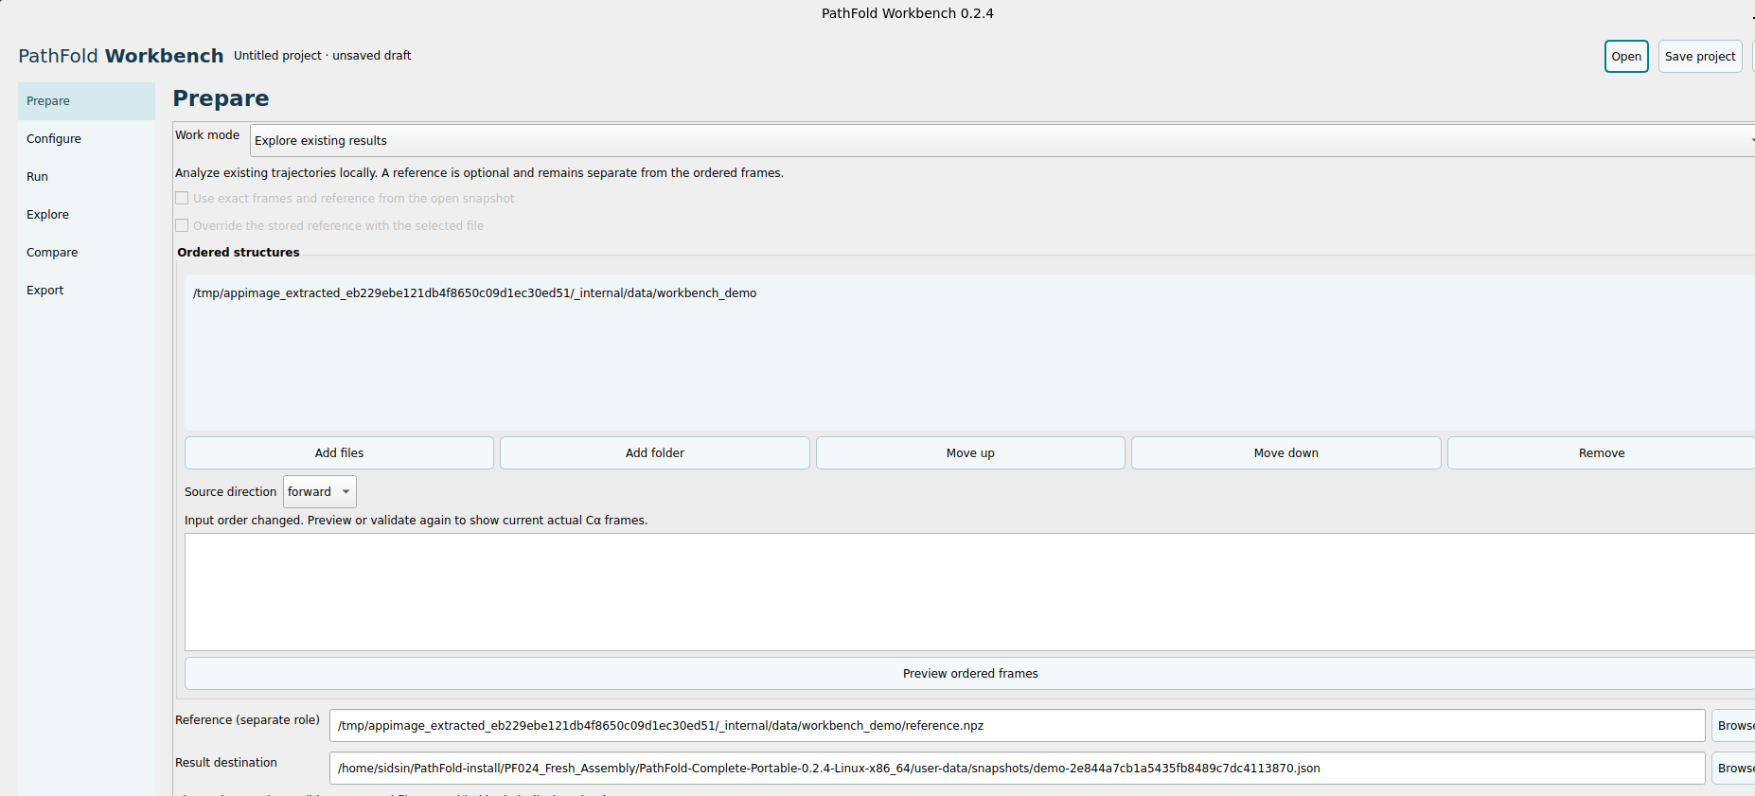
Figure 1 Prepare with demonstration inputs and a separate reference
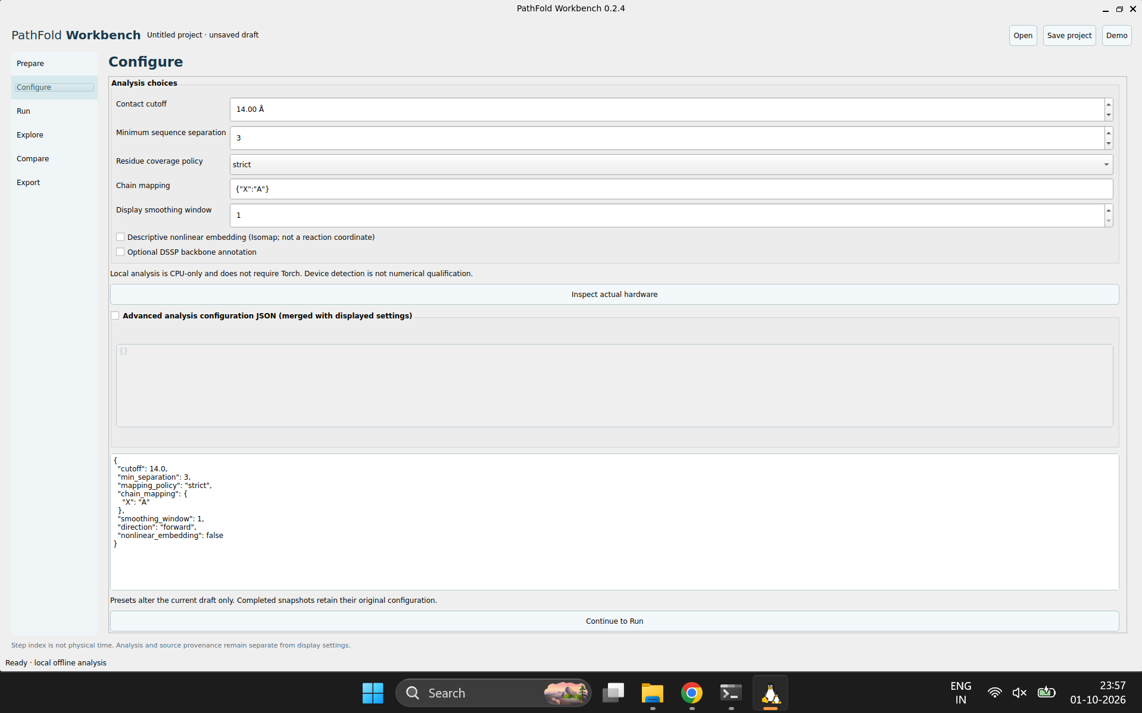
Figure 2 Configure with the demonstrated analysis settings

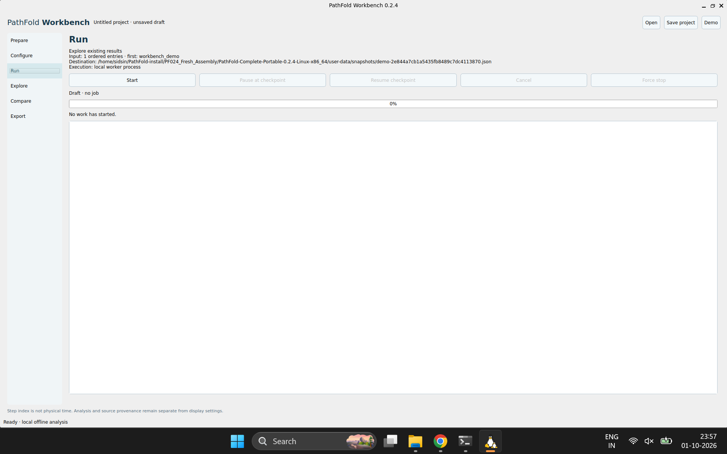
Figure 3 Run shows Draft and no job before Start
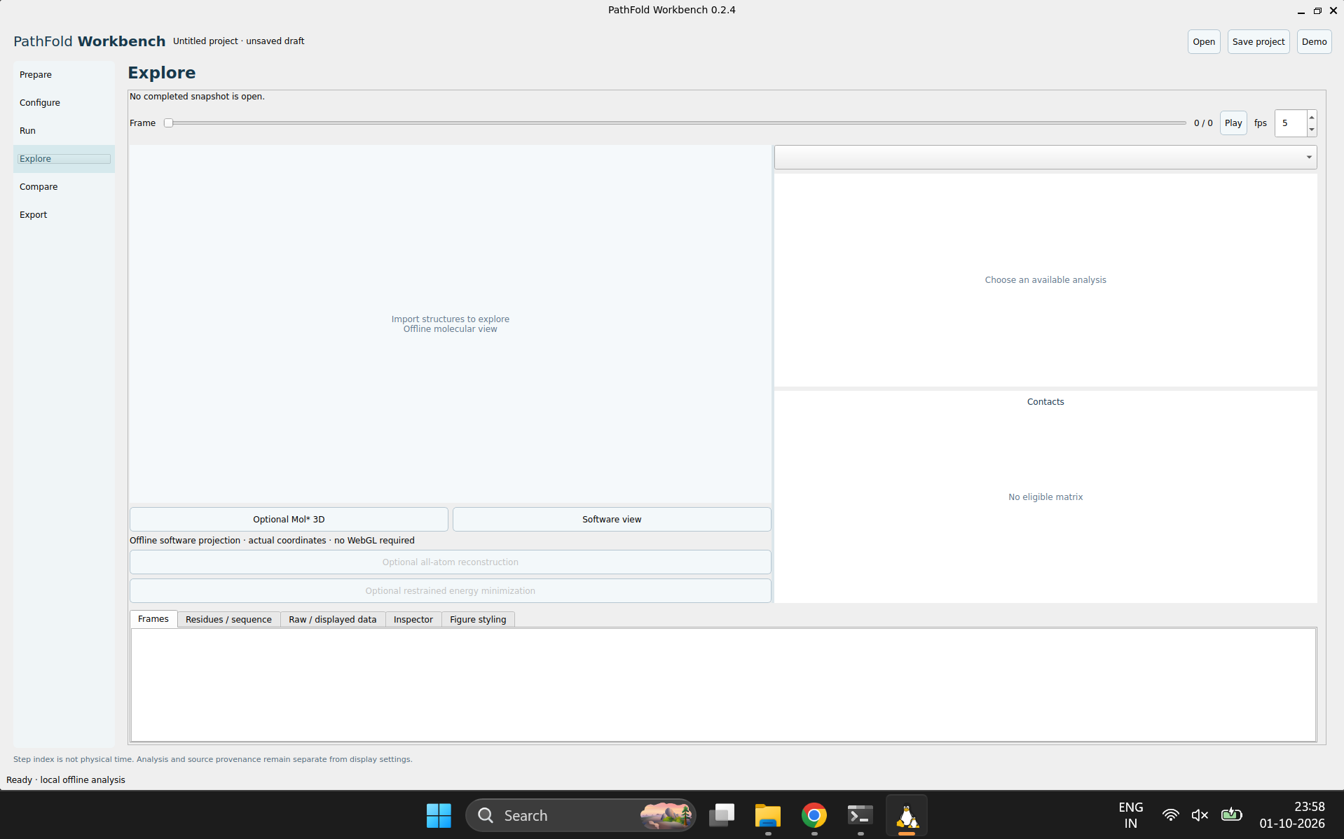
Figure 4 Explore remains empty until a completed snapshot opens

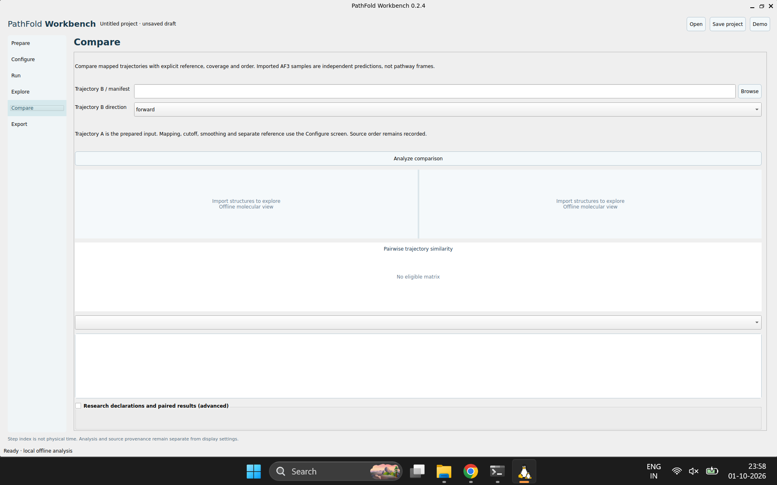
Figure 5 Compare before selecting and analyzing trajectory B
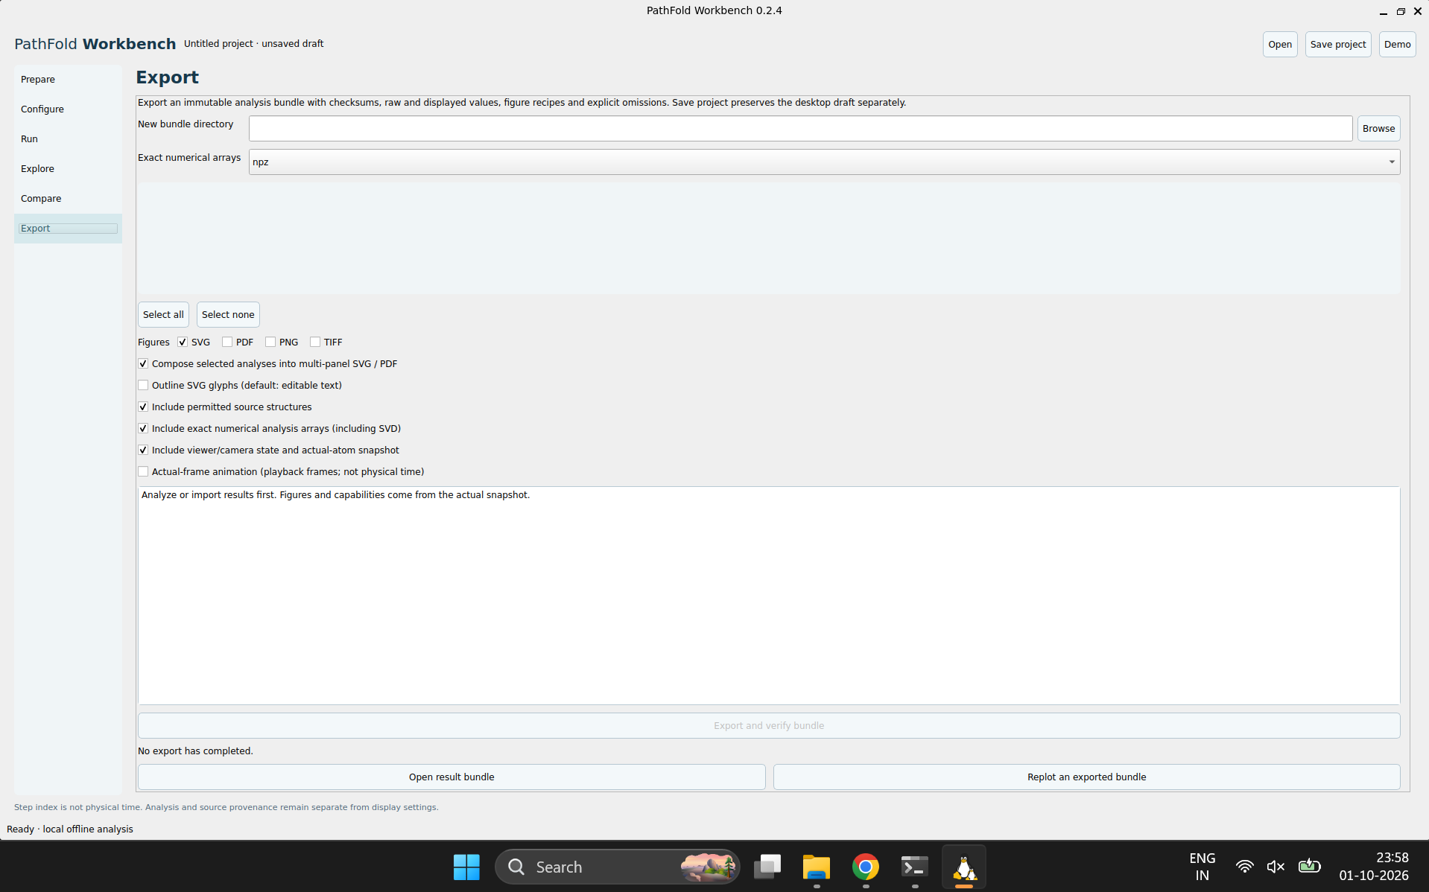
Figure 6 Export remains disabled without a completed snapshot

12 Sources and verification record
This manual was prepared on 2 October 2026 from the delivered source and release records, six local user screenshots and the supplied terminal transcript. The screenshots establish visible startup and draft state. Controls and parameter limits were traced to the delivered source. Bash examples were syntax checked; document layout was rendered and reviewed. Preparing this manual did not install software on your computer or run a new complete PathFold model qualification.

12 1 Official WSL references
- [W1] Microsoft Learn, Install WSL. https://learn.microsoft.com/en-us/windows/wsl/install
- [W2] Microsoft Learn, Run Linux GUI apps with WSL. https://learn.microsoft.com/en-us/windows/wsl/tutorials/gui-apps
- [W3] Microsoft Learn, Basic commands for WSL. https://learn.microsoft.com/en-us/windows/wsl/basic-commands
- [W4] Microsoft Learn, Working across file systems. https://learn.microsoft.com/en-us/windows/wsl/filesystems
- [W5] Microsoft WSLg, Diagnosing cannot open display issues. https://github.com/microsoft/wslg/wiki/Diagnosing-%22cannot-open-display%22-type-issues-with-WSLg
- [W6] Microsoft Learn, Troubleshooting WSL. https://learn.microsoft.com/en-us/windows/wsl/troubleshooting
- [W7] Microsoft Learn, Advanced settings configuration in WSL. https://learn.microsoft.com/en-us/windows/wsl/wsl-config
- [W8] Microsoft Learn, Manual installation steps for older versions of WSL. https://learn.microsoft.com/en-us/windows/wsl/install-manual
Microsoft Learn pages were checked on 2 October 2026. The WSLg wiki is an older diagnostic reference; use current Microsoft Learn for Windows build requirements.

12 2 PathFold version and local sources
Application version: 0.2.4. Distribution revision: final-distribution-1. Target: Linux x86_64 through WSL2 and WSLg for this Windows workflow.
Source commit: 4ee1b14a8052c5eef55d491a8f6d768ac5adef9a.
Source tree: bea98fe0eb17be1a4abe24c3f6a0a620f157ffc7.
Source developer kit SHA-256: 258f71c489d67751dcbc55ad379fc153c90f5dbdb17e3db4aeac910ca9736bef.
Source | Used for
workbench/​gui.py, viewer.py, desktop_​storage.py | Actual page controls, widget ranges, shortcuts, project behavior, rendering and recovery.
workbench/​analysis.py, metrics.py, structures.py, figure_​catalog.py | Analysis defaults, mapping, source order, metrics, mathematical eligibility and display/export settings.
workbench/​contracts.py, engine.py, features.py, devices.py | Inference configuration, feature compatibility, seeds, candidate selection, checkpoint history and device policy.
workbench/​af3.py, remote.py, reconstruction.py, relaxation.py, openmm_​runner.py, atomistic.py | AF3 imports/providers and explicit external atomistic backends.
workbench/​research.py, research_​io.py and bundled research demo | Declared dataset/paired-results schemas, protein bootstrap and the labeled synthetic practice example.
Final Package Guide and Final Delivery Manifest | Complete Portable assembly, component paths, preserved release identities, qualification results and unresolved scope.
Six supplied screenshots and Pasted text transcript | Your actual account names, package location, WSL platform, doctor output and current visible draft.

Full source and notices are included in the supplied developer kit and preserved packages. The source kit's docs/ folder contains the underlying engine, analysis, desktop, feature, AF3, research and optional-backend guides for further technical detail.

