ITSC320 – Software Security

Southern Alberta Institute of Technology

Fall 2025

ASSIGNMENT 3 – Web Application Security

Submission deadline: 11:59pm, Friday, 21st November 2025. Late submissions will not be accepted, and the group members will all receive a 0 grade.

Introduction
Web-based applications are susceptible to a variety of exploits, including the CSRF, XSS and SQL injection exploits we have seen in class. For this assignment you are being given a Java web-based application, called ManageUsersWebApp, and associated MariaDB/MySQL database, called assign3users, to run in the Kali VM for the course. This application is a naively-written Java web application that does not attempt to protect itself against any of the exploits we have discussed. For this assignment you must audit the application and find and produce a detailed write-up for one of each of the following types of exploits that you can use against the application:
- A CSRF exploit
- A XSS exploit
- A SQL injection exploit
For your write-up for each exploit found you must describe both:
- The exploit itself, its effects on the application and its users, and the specific steps needed to reproduce it in the application
- Detailed recommendations for changes you would make to the application to harden it against the exploit so that it is no longer effective

Objectives
By completing this assignment, you will:
- Gain a deeper understanding of the vulnerabilities that can exist in web-based applications
- Understand how to change a web-based application so that it is no longer so vulnerable to these common types of vulnerabilities

Assignment Application Setup
To set up the application so that you can run and interact with it you will need to:
- Copy the provided ManageUsersWebApp folder and all its contents into the Kali VM under /home/user/NetBeansProjects
- Open the project in the ManageUsersWebApp folder in the VM using NetBeans
  - The project has a dependency on a library called mariadb-java-client-3.4.1.jar which is located in the home directory of “user” in the Kali VM (“/home/user”). If you copy the NetBeans project into the location specified above then NetBeans should be able to find the dependency file without any further action being required of you. If it cannot be found then NetBeans will display the message “One or more project resources could not be found…” when you open the project. To fix this perform the following steps in NetBeans:
    - Right-click on the project name in the “Projects” tab on the left-hand side of NetBeans
    - Click on “Properties” at the bottom of the popup menu
    - Click on “Libraries” in the “Categories” list of the dialog box
      - If you see a message under “Compile-time Libraries” saying “Broken reference” then select that message and click on the “Remove” button to the right
    - Click on the “Add JAR/Folder” button
    - Navigate to the “/home/user” folder and select the file in there called “mariadb-java-client-3.4.1.jar” and click on the “Open” button. You should now see the library file listed under “Compile-time libraries”
    - Click on the “OK” button
- Execute the provided assign3users.sql SQL database script file on the MariaDB/MySQL database server in the Kali VM to create the database before you will be able to run and use the ManageUsersWebApp application. You can do this using the MariaDB/MySQL command line program (“mysql”)
- Run the application in NetBeans. You should see a browser window appear with the login page for the application displayed in it

Application Description and Functionality
The ManageUsersWebApp NetBeans-based Java web application consists of the following items:
Web Pages (under “Web Pages” in the NetBeans project):
- index.jsp: the login page for the application.
  - If a parameter called “message” is sent to this page in the URL, e.g. ?message=<a message>, then it will be displayed in the page
- mainpage.jsp: the application’s main page where users can see the details of user login information for application. The exact information shown and the operations available to manipulate user data will vary depending upon the type of user who is logged in (admin, or non-admin).
  - If the user is not logged in (they do not have a session object associated with them with their username stored in it as an attribute), then the user’s browser will be redirected back to the login page of the application
  - This page uses a helper class called MainPageHelper to generate and display the HTML table of users in the system to be shown to the currently logged-in user. You can find the code for that class under “Source Packages/mainpagehelper” in the NetBeans project
  - If a parameter called “message” is sent to this page in the URL, e.g. ?message=<a message>, then it will be displayed in the page

Servlets (under “Source Packages/userservices” in the NetBeans project):
- Validate: this servlet takes username and password, or logout, as parameter values when run. If username and password are provided then it is processing a login attempt, if logout is provided then the user is logging out of the application
- UserServices: this servlet is responsible for handling user management requests (adding or deleting user accounts for the application). If it receives username and password parameters then a new user is being added to the system, whereas if it receives a delete parameter then a user is being deleted from it

Helper Class (under “Source Packages/mainpagehelper” in the NetBeans project):
- The MainPageHelper class is an ordinary Java class which provides a single public method, getUserTable. This method returns as a String a HTML-formatted table containing the user database from the database. The exact contents of the table depend upon the type of user who is logged in, i.e. an admin user will see two columns in the table (Username and Delete), whereas a non-admin user will only see one column (Username). The getUserTable method is called in the mainpage.jsp file at line 35 to insert the HTML for the table into the page that is then sent to the user’s browser to be viewed
The assign3users database:
- This database (called “assign3users” when created in MariaDB/MySQL) contains one table called users. The columns and data in the table are as follows:
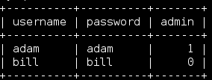
The admin column is a flag describing the type of the user (1 means admin, 0 means non-admin).
Note: Remember, you will need to execute the provided assign3users.sql SQL database script file on the MariaDB/MySQL database server in the Kali VM to create the database before you will be able to run and use the ManageUsersWebApp application.

Sample Application Run 1 (admin user):
- User navigates to the login page of the application:
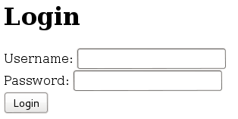

- User logs in as adam (an admin-type user):
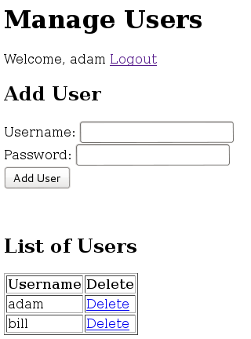

- adam adds a new user to the application:

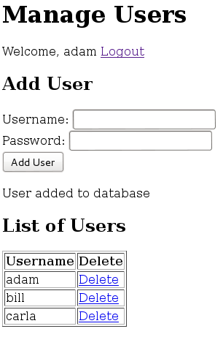
In this example adam has added “carla” to the application. Note the message under the Add User form that is displayed when a new user has been added (“User added to the database”).

- adam deletes carla from the system using the delete hyperlink in her row of the table in the page:
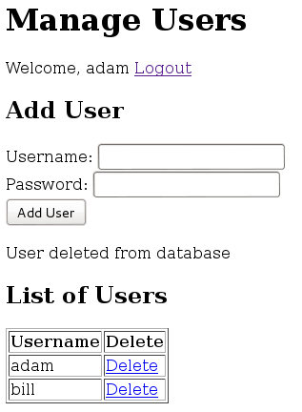
Again, note the message under the Add User form (“User deleted from database”).

- adam logs out of the application using the Logout hyperlink by the welcome message in the page:
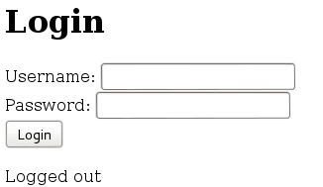
The user is taken back to the login page, and a message is displayed telling them why they are now here (“Logged out”).
Sample Application Run 2 (non-admin user):
- bill (a non-admin user) logs into the application:

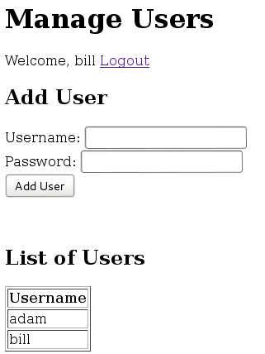

The List of Users table now only shows a list of usernames for the application, but because bill is not an admin he cannot delete users from it (although he can still add them using the form in the page).

Submission Guidelines
- One submission per group, please (not one submission per group member!). Individual submissions will receive a zero. If multiple group members submit for the same assignment only the last/latest submission will be graded
- Submissions must be in the provided assignment3_submission_template.docx file
- Based upon the provided submission template .docx file, you need to discover and document one exploit of each of the three types we have talked about in class. You must also think about what could be done in the application to harden it against the exploits you have found so that it would no longer be vulnerable to them
- You must write up your submission for this assignment using the provided template file
- Submission format must a .docx format file (not PDF or anything else!). Marks will be lost if you do not follow this requirement
- The Contribution Attribution List must be filled out for every member of the group
- The length of the submission for this assignment should be between 5 and 8 pages

Evaluation Criteria
- Demonstrating overall understanding of relevant concepts
- Research Quality: Providing valid and functional examples of each type of exploit requested
- Analytical Skills: Reasonable depth of analysis when describing each exploit and also the proposed change(s) you would make to the application to harden it against the exploits found
- Detail provided in both exploit descriptions and application hardening suggestion: you will lose marks if your submission contains only very brief, vague or muddled descriptions and explanations
- Attribution List information

Why Java-based, and not NextJS? Because NextJS automatically protects us against exploits like XSS (Cross -Site Scripting), whereas many other technologies used to develop web application (like Java) do not. We need you to be able to attack the application each of the three different types of exploits discussed in class.
These are the Java web application equivalent of NextJS API endpoints, they run code when a message is sent to them using their URL but unlike the web pages in the project do not themselves send HTML/CSS to the browser.

