THE GRID: Design of a Node Networking & Surveillance Mesh system

Abstract

* THE GRID is a novel *Low-Power IoT mass surveillance and communications pilot system* by Sidakye Tech, a first of its kind being developed for a large-scale commercial market
* It comprises of a cooperation of IoT hardware, dubbed GRID nodes and a front-end web-based management system which complete the GRID Management system. The concept of the node design centers around a standalone, sustainable & smart IoT communications architecture, relying on renewable energy like solar-power as well as low energy lithium-ion batteries, and can partially be independent of ISP control when the need arises.
* A long-term objective is to allow for integrated support with Sidakye Solutions’ in-house AI suite; nodes will have the functionality to be managed by the Spencer AI program
* The nodes utilize the potential of short-wave technology; relying on point-to-point links between the interconnected nodes which act as repeaters to broadcast connectivity to all endpoints in the entire network within a vicinity. ‘Walkie-Talkie ‘radio frequency is a pivotal communication standard which will be implemented at the pilot stage to gather baseline statistics and feasibility, upon which other communication standards can be considered. The reason being its short
* The system can be designed for several use case scenarios, and can easily be implemented into real estate, business management implementations like supermarkets and malls, traffic monitoring systems and can serve as the substitute for inter-community network connectivity.

Scope of Design

* The following describes the scope of the node network, key areas of focus in the software and hardware development of the network.

|  |  |
| --- | --- |
| Scope | Comments |
| Entire Network |  |
| Hardware |  |
| * IOT Nodes | * Architectural design; Ernest * Composite of the build: Aluminum, Magnesium, or a combination of other materials. * IP Rating for protection against environmental factors: Dust, Rain shower, corrosion of the streetlight structure |
| * Energy Source | * A solar panel component connected to rechargeable lithium-ion batteries.   Considerations here include the power rating of the node devices, broadcast radius of the nodes, |
| * Sensors and components | * + Custom-designed IOT devices, outfitted with required environmental sensors   + The basic array of sensors to be integrated into the physical structure of the node design include Humidity & Temperature, Light Detection and Ranging (LiDAR) |
| * Streetlight structure | * The node system will be integrated into existing streetlight systems in Accra. * Current systems make use of shared electricity poles in some towns, with urban areas adopting modern LED light poles with extensions for attaching other fixtures; see below – ***Current Streetlight Architecture – Madina Adenta Road*** * The pilot phase can be a basis for considering other aspects of the streetlight system, including structural integrity and material degradation |
|  |  |
| Software |  |
| * Web Server |  |
| * Database Server |  |
|  |  |
| Network Layer | There will be an introduction of a private IP addressing schemes for all nodes; DHCP addressing from a single-configured node which will serve as the master in the vicinity. Redundancy and reliability are key here  The Master node connects to the 4G public infrastructure via a 3G/4G module |
| Data Link Layer | A radio frequency (RF) survey to be done to determine deployment options and equipment scope |

Checklist – Components of the Node Build

1. Topology of the GRID network system
   1. Partial Mesh
   2. Technology of choice for the node network: a tabular representation compares the Pros & Cons of a selection of wireless technologies to implement into the Node System

|  |  |  |
| --- | --- | --- |
| Wireless Standard | Advantages | Drawbacks |
| 802.11 (Wi-Fi) | * Support fast data transfer speeds of over 1Gbps * Easy to implement on the TCP/IP stack (Client-server model like a smart streetlight systems) include reference here |  |
| Zigbee () |  |  |
| Family Radio Service (FRS) |  |  |

1. Current Streetlight Architecture

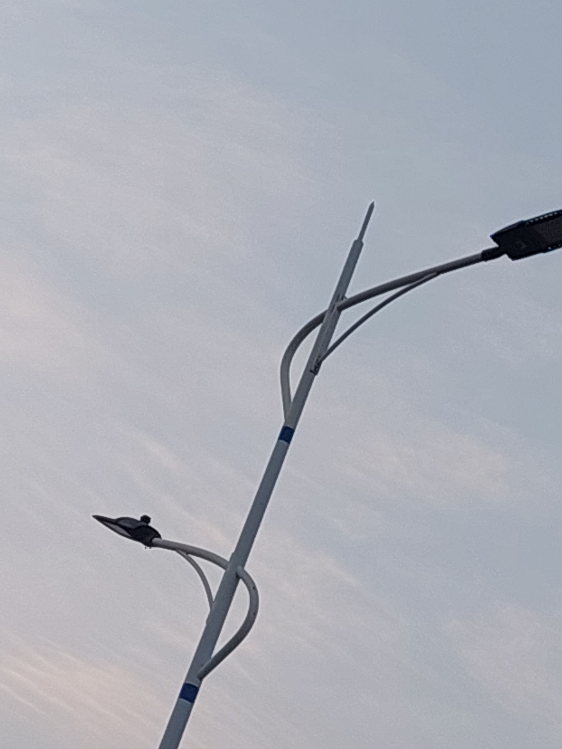

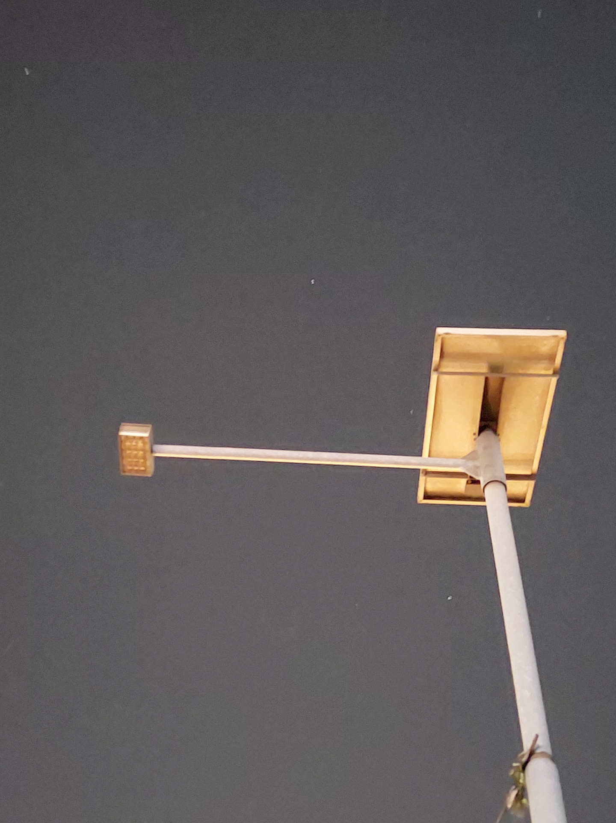

­

*Figure 1. Madina-Adenta Highway – Regular LED Streetlight connected to main power grid*

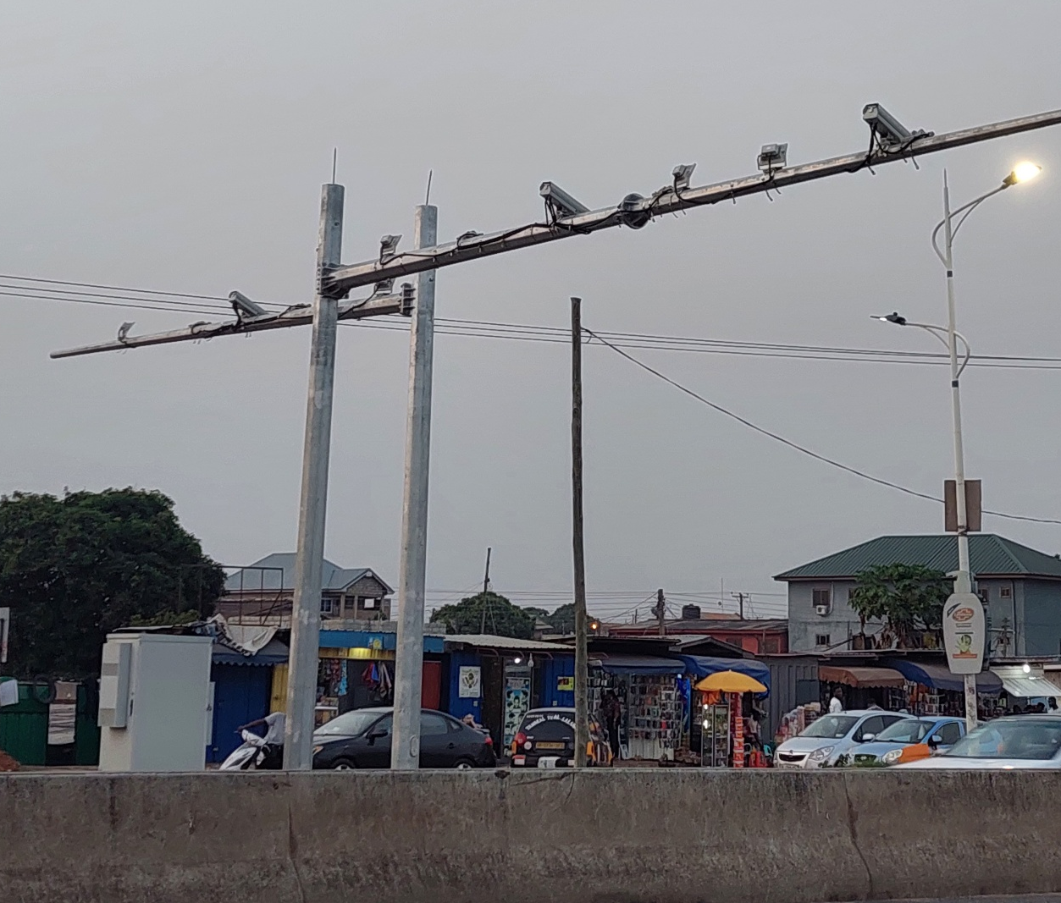

Figure 2. Multipurpose Camera array with control box adjacent

1. Component Design

* ]Insert picture of block diagram of the proposed system (Smart Led)
* The master node can be picked based on the strongest frequency away from the collector
* Short-wave radio tech (look into Walkie-talkie; half duplex)

1. LIDAR sensor specification
   1. Broadcast range – 40 Meters
   2. Application – Traffic and flag point detection
   3. TF02 Pro
2. Cameras
   1. For now, Recycled laptop cameras -Justification: Contributing to E-Waste
3. Humidity/Temperature Sensors – Sensirion,
4. LED Status Indicators for the nodes
5. Power Source Requirements: Solar

|  |  |  |
| --- | --- | --- |
|  |  |  |
|  |  |  |
|  |  |  |
|  |  |  |
|  |  |  |
|  |  |  |

Illustrations & Concept Sketches

Camera

LIDAR

H/T

Solar

H/T