Result Support Management Systems (RSMS)

|  |  |
| --- | --- |
| Developed by | Mentored by |
| Sidapara Vasu | Mr. Niraj Gautam |
| Kalal Bhavin |  |
| Prajapati Yash |  |

1. Introduction

Result Support Management Systems (RSMS) are capable of handling all types of result-report-related tasks, such as scheduling marks entry, generating scores, and generating reports.

A live system is proposed for LJ institute to simplify the result management. Currently, all result work is performed manually by the management committee, requiring a lot of human energy and time. The web-based system provides a comprehensive solution for managing and enhancing the online mark entry process.

The system's primary goal is to provide the staff with an easy method of entering internal marks and forwarding them to the head of the department. Result cells are responsible for verifying these marks and generating reports. In the system, the administrator is responsible for handling the database, providing information about the students in their institute, and supplying course syllabuses. Neither the staff nor the exam cell find the proposed system to be negatively affecting or inconvenient, and the system is very reliable, efficient, and time-saving

* 1. Existing System

The existing system does not contain any automated system for handling the task of examination management, due which the admins as well as faculties finds it difficult to manage all the functionality.

Despite of maintaining all exam related data within the excel file its still difficult to manage as the data grows gradually for each exam that are scheduled for each batch of students. This manual maintaining of all the related data leads to the increase in error rate as all the work is done manually which is not error prone.

* 1. Need for the new system

Currently, the system has several limitations. The proposed system hits the limitations of the current system. In the proposed system, there are several advantages, such as the fact that there is a complete package, so there are no errors in assessing student eligibility and internal marks. Redundancy is also eliminated. Information can be obtained from a single source easily.

Records of the student and institution are brought back without latency. Students' internal marks will be entered by the faculty after the Head of Department allocates the subjects to the faculty. After that, a faculty member can create an excel sheet of the student's marks and upload it to the exam cell portal. Students' average marks will be generated automatically by the system.

* 1. Objective of the new system

Easy to marks entry and maintain data and give support in resulting process.

* 1. Problem Definition

For analysing the marks obtained by students in an educational institution. We are tasked to build up student mark analysing system. This is done to replace the manual entering and processing of marks which are error prone and tedious. This system also maintains information about student. The system will have a Windows based desktop interface to allow the faculty to enter marks obtained by the students, update them and generate various reports. For security reasons, the administrator and faculty only can update the marks and other information.

First the user needs to login to the system for accessing it. The system will retain information on all the students and the institution. The system analyses the marks and generate the result reports. The marks and information about the students are stored in a database and the system works with the database.

The faculty can enter the marks and student information through a visual environment. The updated details are stored in the database. The system generates the overall result by analysing the marks.

One of the most important features of the system is creating reports based on the given criteria.

* 1. Core Component
     + Login
     + Logout
     + Manage institutes
     + Manage courses
     + Manage admins
     + Manage semesters
     + Manage subjects
     + Manage faculties
     + Excel Upload / Download
     + Marks entry
     + Basic Marksheet Creation
     + Exam handling
  2. Project Profile

|  |  |
| --- | --- |
| Project Title | Result Support Management Systems (RSMS) |
| Project Team | Sidapara Vasu  Prajapati Yash  Kalal Bhavin |
| Front-end | HTML  CSS  JAVASCRIPT  BOOTSTRAP |
| Back-end | DJANGO 4.1  PYTHON |
| Database | MySQL |
| Evaluators | Mr. Niraj Gautam  Mr. Himanshu Sharma |

* 1. Assumptions and Constraints

1. Assumptions
   * + - System is developed with assumption that the data required for the calculation will be provided to us by the institute.
       - The system is developed with the need of specific institute named L.J.
2. Constraints
   * + - The system requires data in a particular format (excel sheet).
   1. Advantages and Limitations of Proposed System
3. Advantages
   * Reduce paper work and managing excel sheets.
   * Removal of Duplication of data.
   * Data tracing get easy.
   * Less time consuming.
4. Limitations

* Proposed system does not produce any marksheet.

1. Required Determination & Analysis

2.1) Required Determination

• Marks entry done by subject faculty respectively.

• A file having student marks for making final result.

2.2) Targeted Users

* Super admin
* Admin
* Faculty

1. System Design

3.1) Use Case Diagram

* Super admin
* Admin
* Faculty

3.2) Data Dictionary

3.1) Use Case Diagram

_____________________Super admin___________________

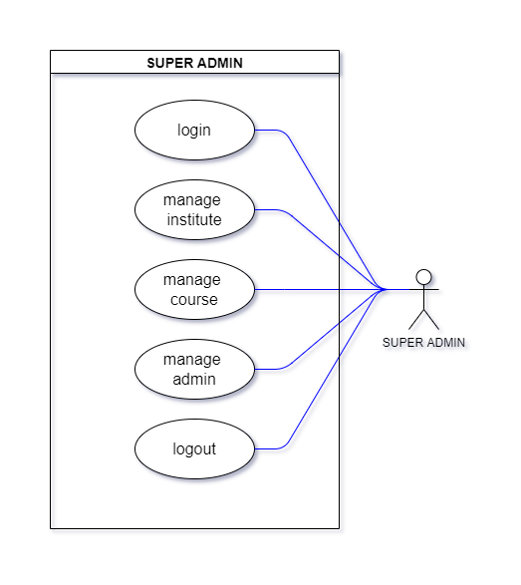

______________________ Admin ____________________

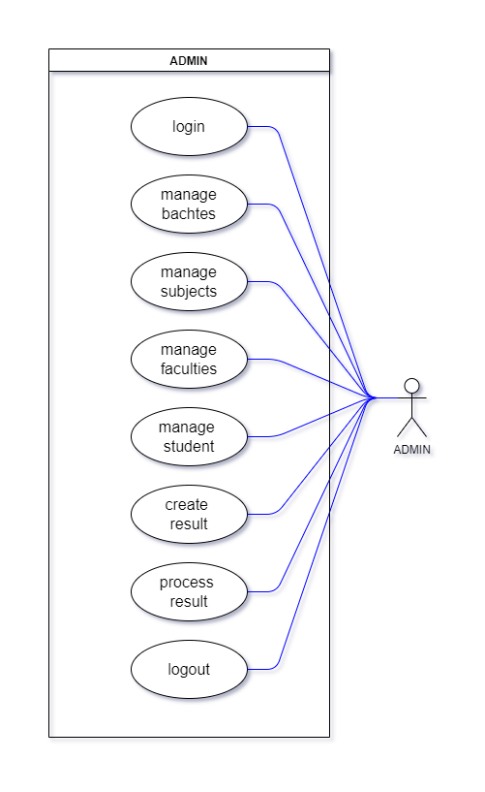

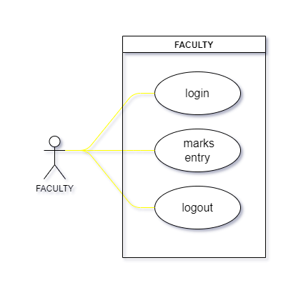______________________ Faculty_____________________

3.2) Data Dictionary

Users

|  |  |  |  |  |
| --- | --- | --- | --- | --- |
| Field name | Data type | Size limits | constraints | Example |
| id | int | - | Primary | 1 |
| username | varchar | 20 | Not null | yash |
| email | varchar | 15 | Not null | y@gmail.com |
| phoneno | varchar | 10 | Not null | 9876541230 |
| password | varchar | 30 |  | bUw12w5 |
| type | varchar | 10 | Default | 3 |

Institute

|  |  |  |  |  |
| --- | --- | --- | --- | --- |
| Field name | Data type | Size limits | constraints | Example |
| id | int | - | Primary | 1 |
| institute | varchar | 40 | Not null | LJ |
| address | varchar | 50 | Not null | sarkhej |

Course

|  |  |  |  |  |
| --- | --- | --- | --- | --- |
| Field name | Data type | Size limits | constraints | Example |
| id | int | - | Primary | 1 |
| course | varchar | 30 | Not null |  |
| Institute  Name | varchar | - | Foreign key | I10001 |

Batch

|  |  |  |  |  |
| --- | --- | --- | --- | --- |
| Field name | Data type | Size limits | constraints | Example |
| id | int | - | Primary | 1 |
| CourseID | int | - | Foreign key | C1001 |
| batch | varchar | 20 | Not null | Winter |

Semester

|  |  |  |  |  |
| --- | --- | --- | --- | --- |
| Field name | Data type | Size limits | constraints | Example |
| id | int | - | Primary | 1 |
| courseID | int | - | Foreign key | C1001 |
| semester | varchar | 3 | Not null | 1st |

Subject

|  |  |  |  |  |
| --- | --- | --- | --- | --- |
| Field name | Data type | Size limits | constraints | Example |
| id | int | - | Primary | 1 |
| name | varchar | 30 | Not null | C++ |
| semester | varchar | - | Foreign key | 1st |
| type | varchar | 10 | Not null | 3 |
| credits | varchar | 3 | Not null | 5 |

Students

|  |  |  |  |  |
| --- | --- | --- | --- | --- |
| Field name | Data type | Size limits | constraints | Example |
| id | int | - | Primary | 1 |
| enrollno | int | 25 | Unique | 2000450021 |
| name | varchar | 30 | Not null | Ram |
| phoneno | varchar | 10 | Unique | 9874563210 |
| gender | varchar | 1 | Not null | Male |
| category | varchar | 12 | Not null | General |
| email | varchar | 30 | Unique | [r@gmail.com](mailto:r@gmail.com) |
| seat no | varchar | 25 | Not null | S2000450021 |
| courseId | int | - | Foreign key | C10001 |
| batchId | int | - | Foreign key | Winter |
| semesterId | int | - | Foreign key | 1st |
| instituteId | int | - | Foreign key | I1001 |
| isActive | boolean | 15 | Not null |  |

1. Development

4.1) Screenshots

Home Page

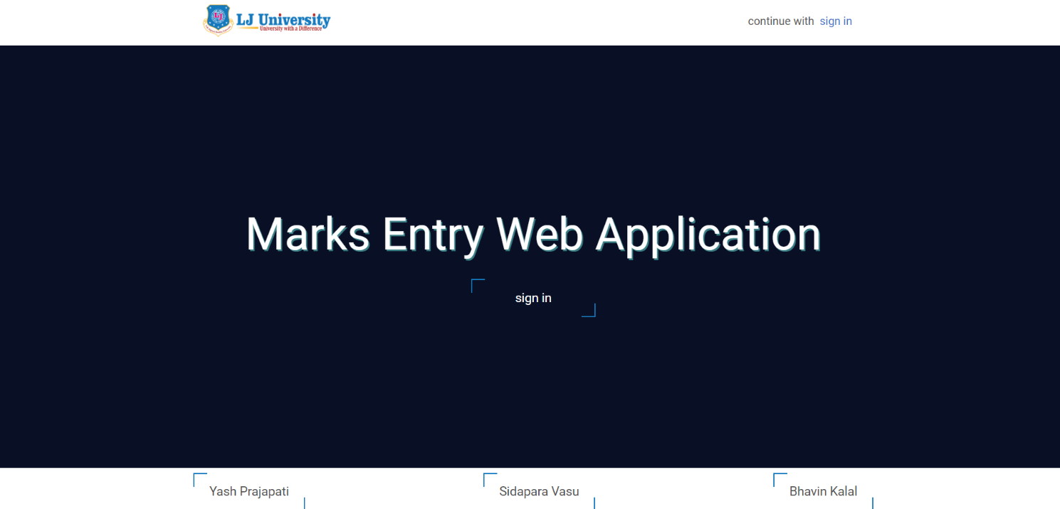

Login Page

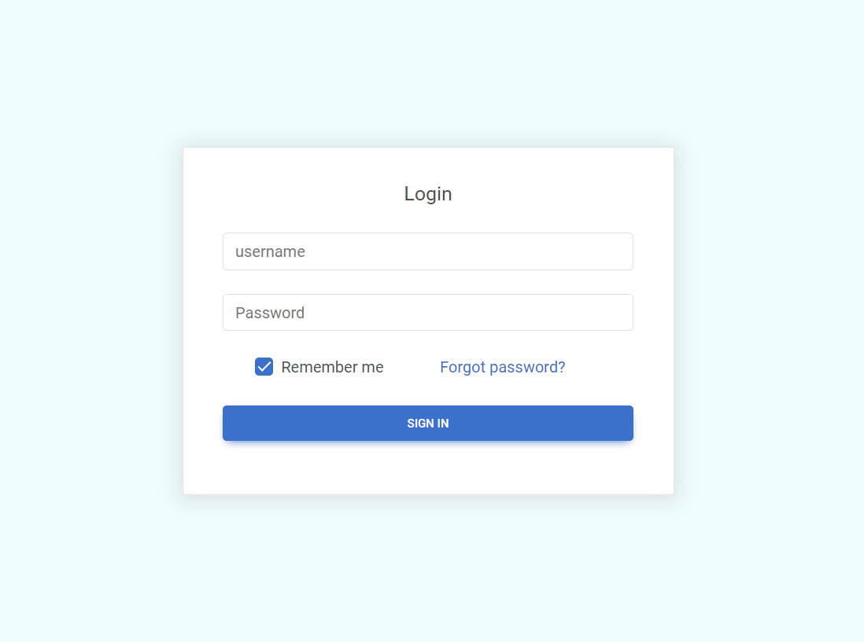

Super admin Dashboard (after login)

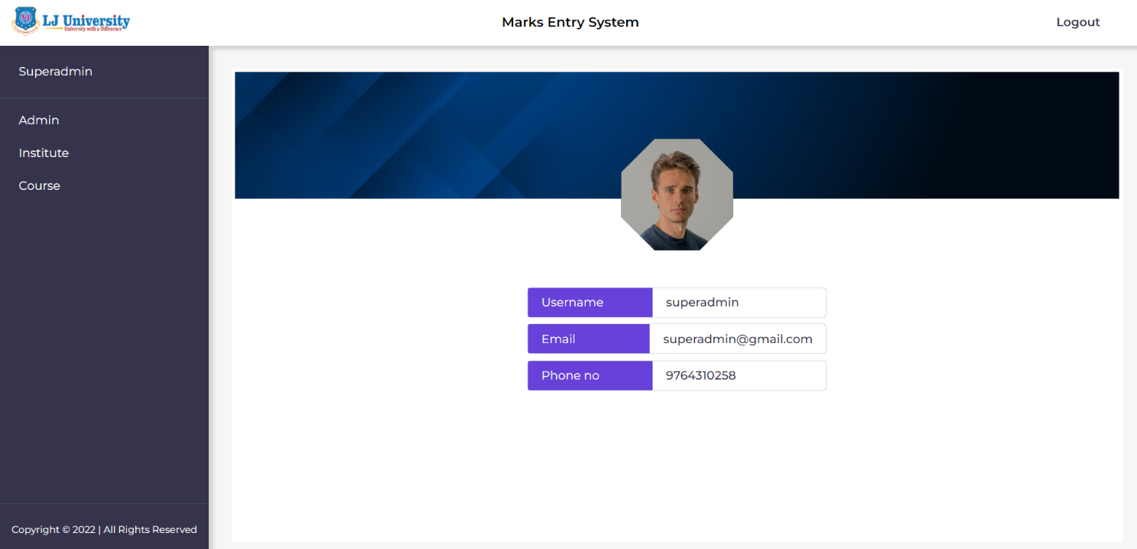

Super admin: Admin Section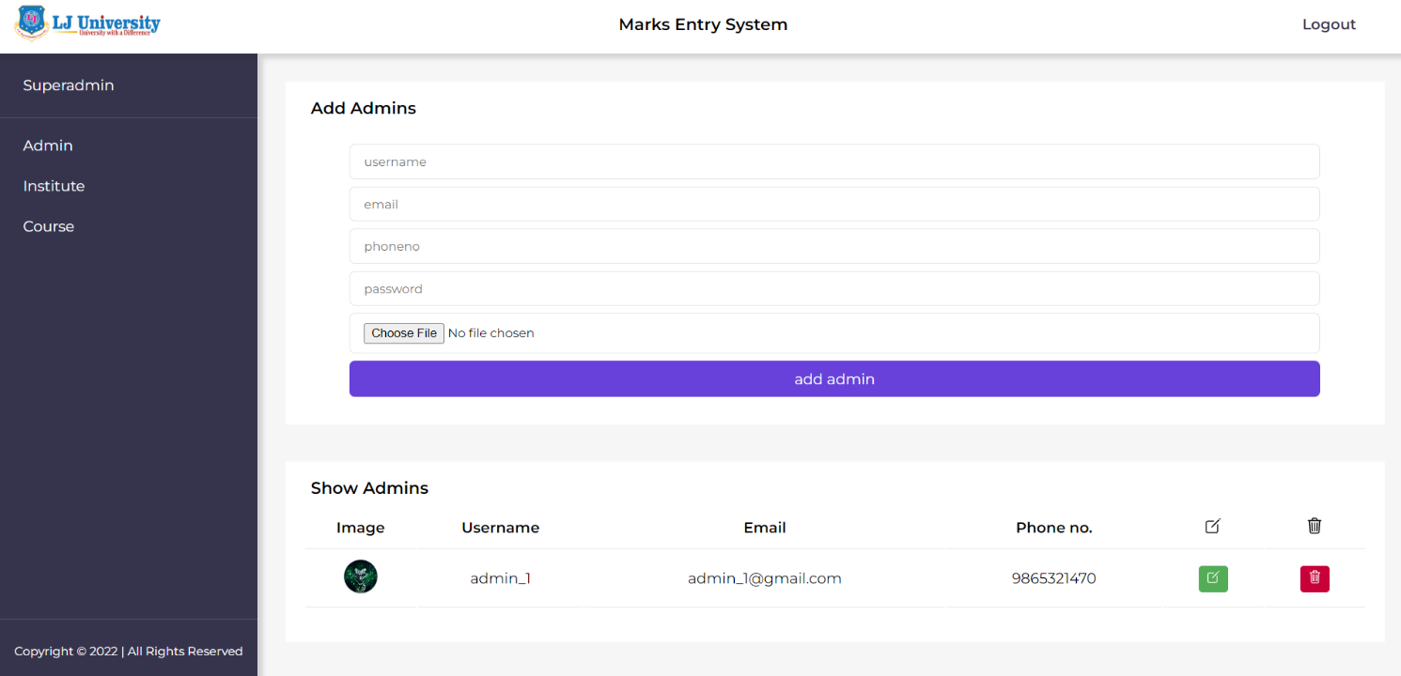

Super Admin: Admin’s Update details

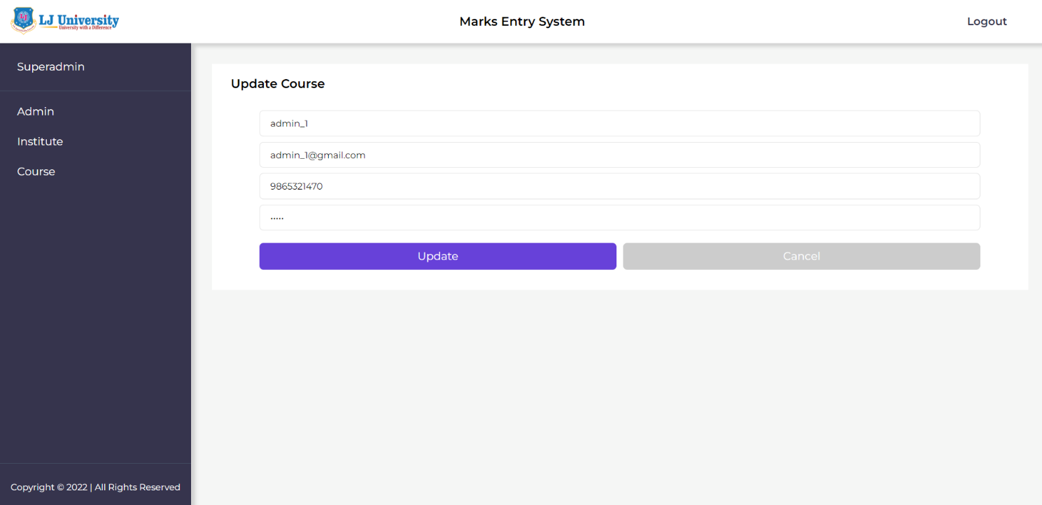

Super Admin: Delete an Admin

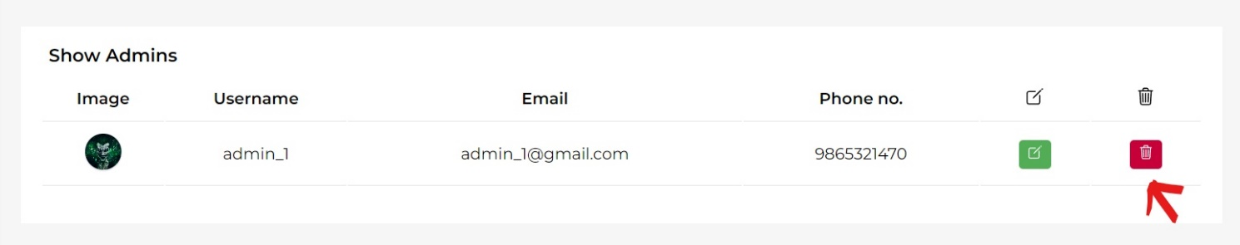

Super admin: Institute Section

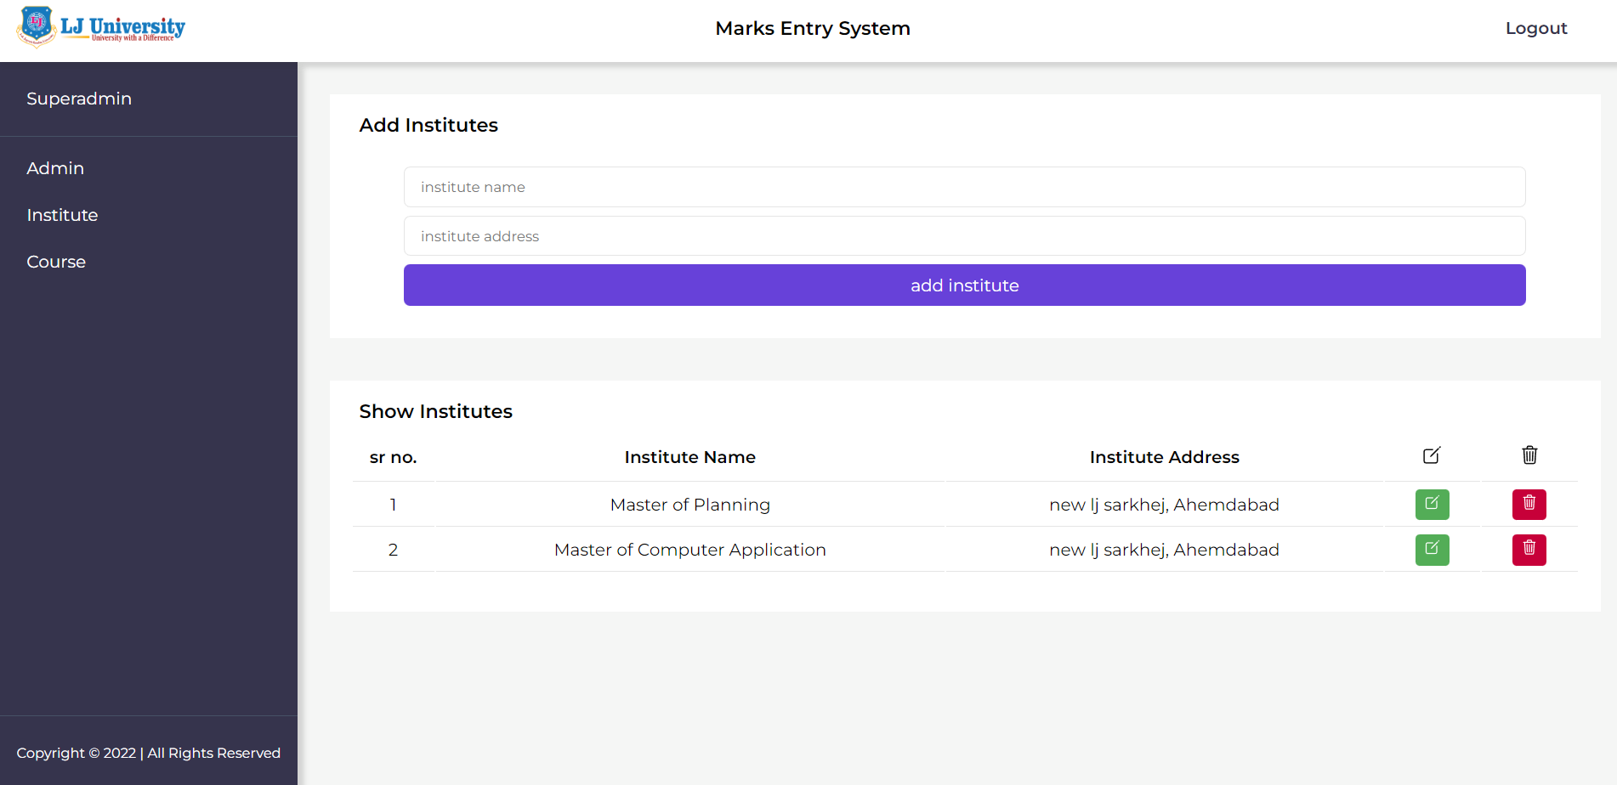

Super Admin: Institute’s Update details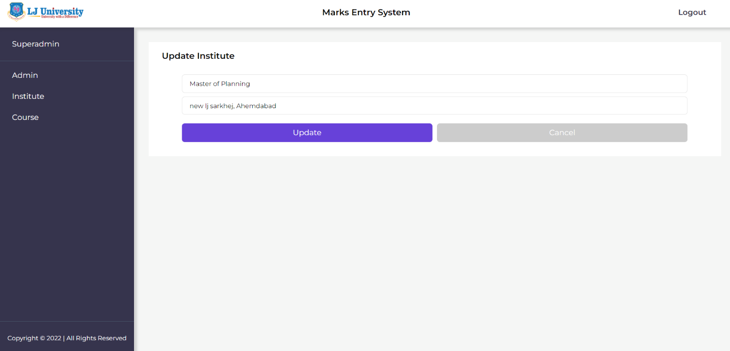

Super Admin: Delete an Institute

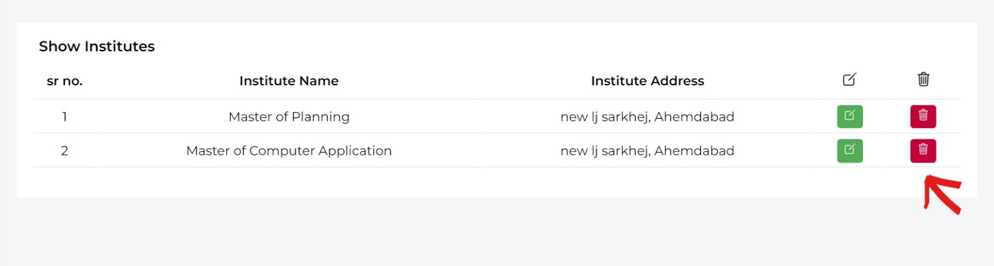

Super admin: Course Section

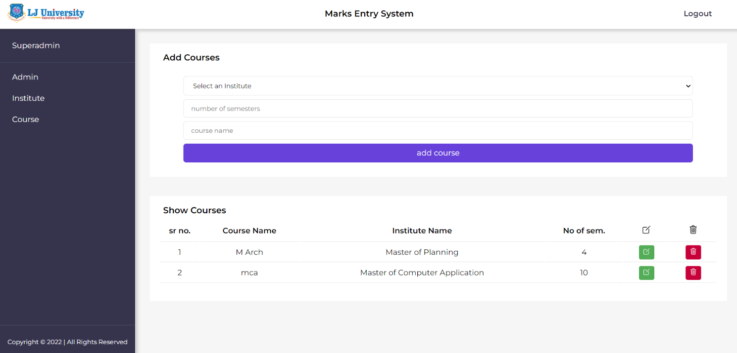

Super Admin: Course Update details

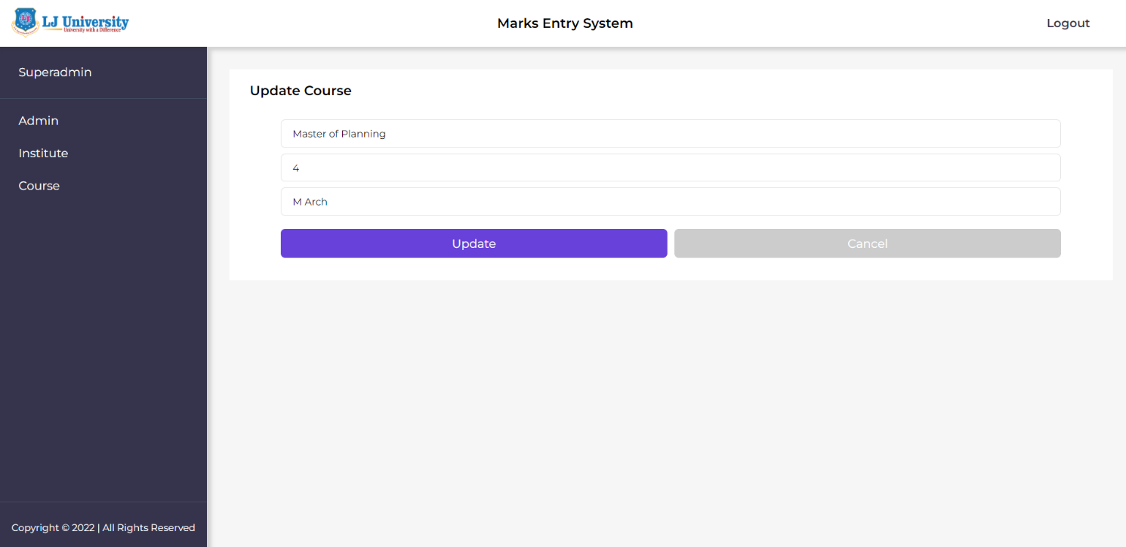

Super Admin: Delete a Course

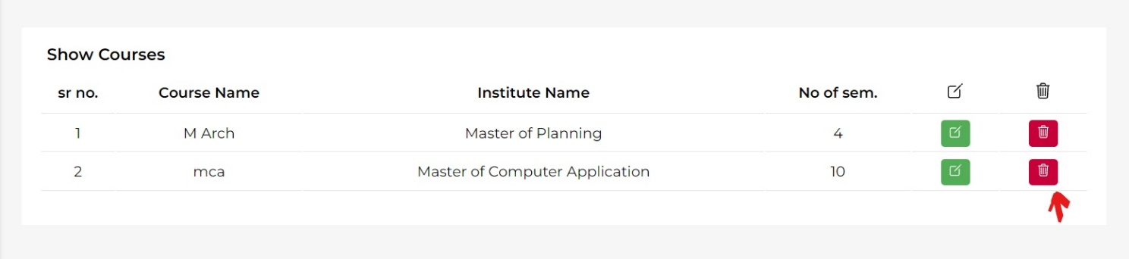

Administrator Dashboard (after login)

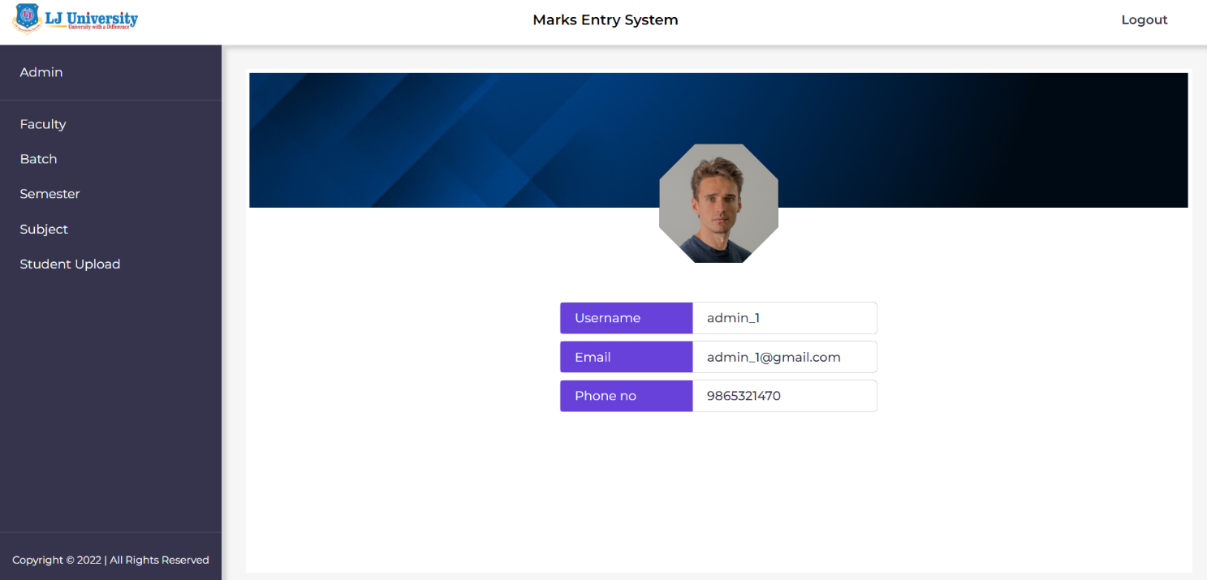

Administrator: Faculty Section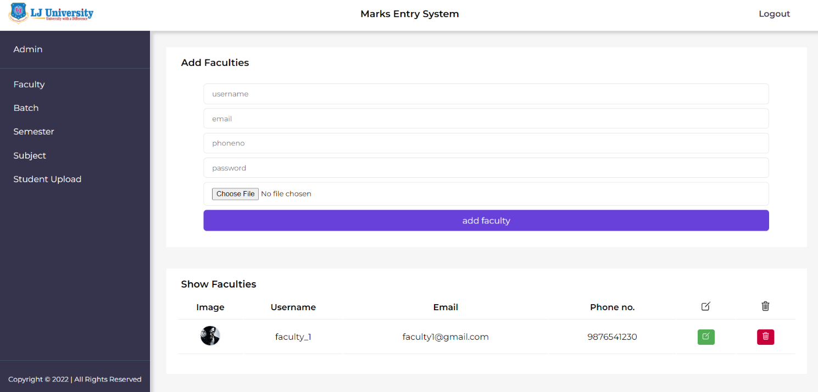

Administrator: Batch Section

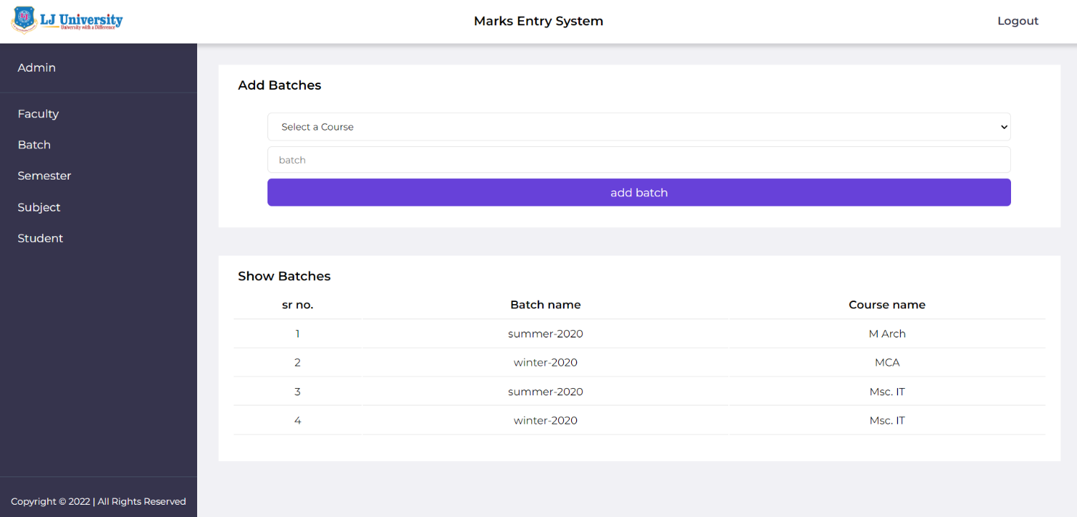

Administrator: Semester Section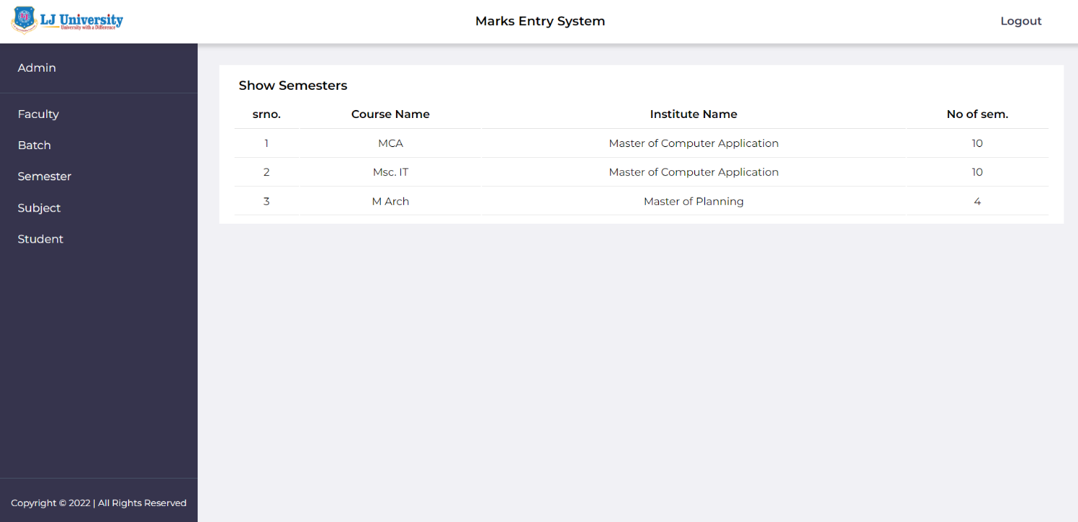

Administrator: Subject Section

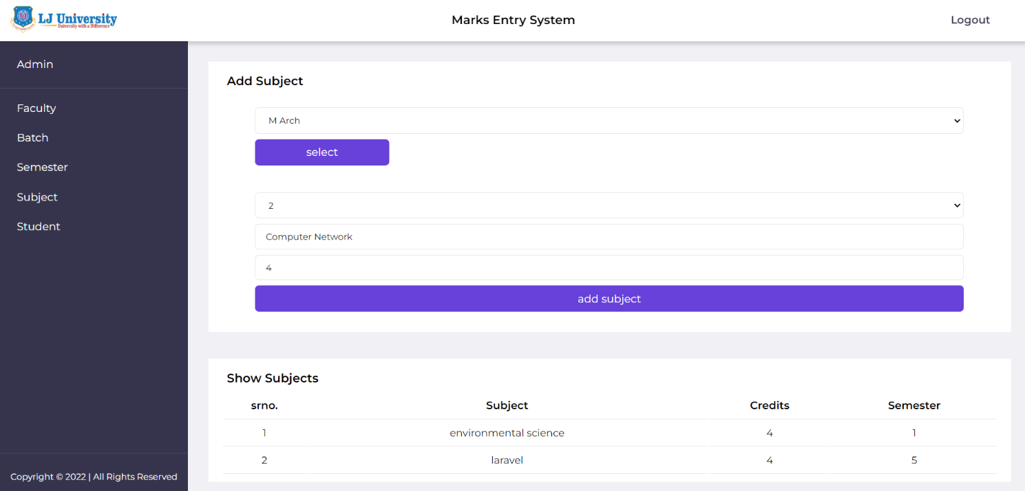Administrator: Student Upload Section

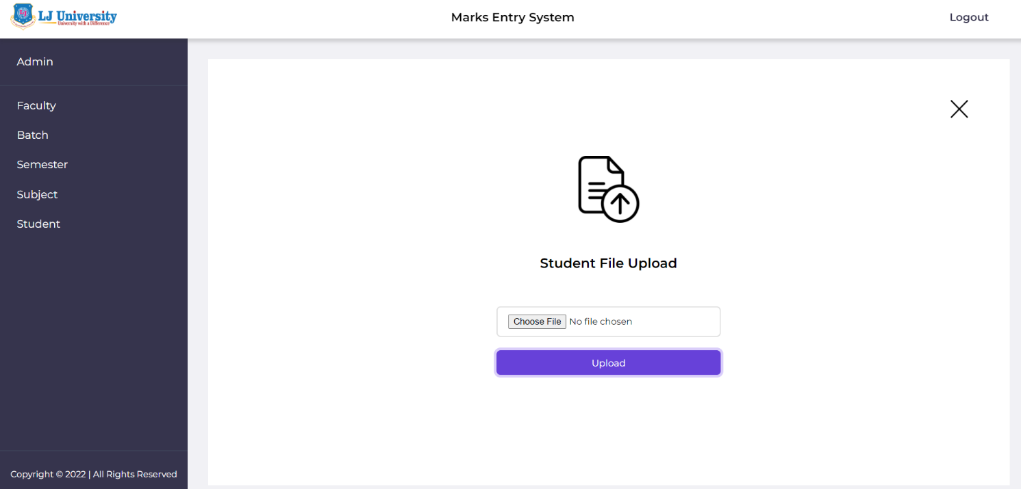

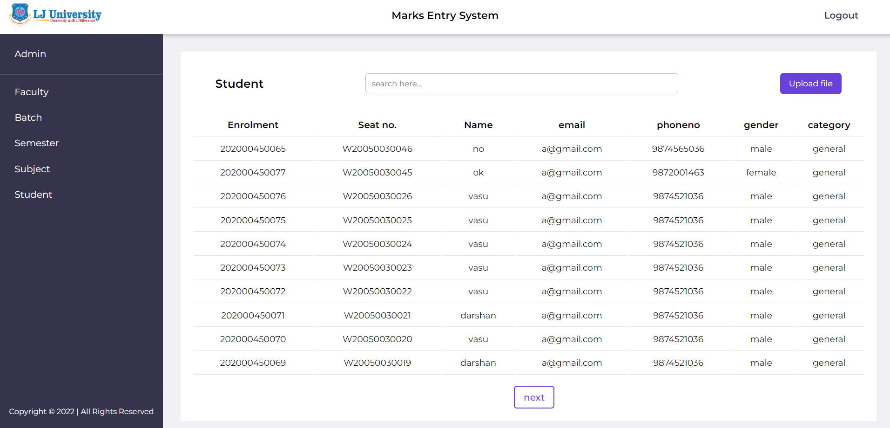

**5.AGILE DOCUMENTATION**

**5.1 Agile Project Charter**

**General Project Information**

|  |  |  |
| --- | --- | --- |
| **PROJECT NAME** | | |
| **Result Support Management System** | | |
| **PROJECT CHAMPION** | **PROJECT SPONSOR** | **PROJECT MANAGER** |
| **Yash Prajapati**  **Vasu Sidapara**  **Bhavin Kalal** | **Prof. Ritisha Parmar** | **Mr. Niraj Gautam** |
| **EXPECTED START DATE** | **EXPECTED DATE OF COMPLETION** | **DATE OF DOCUMENT** |
| **Sep, 3 2022** | **Oct, 17 2022** | **Aug, 30 2022** |

**Project Details**

|  |  |
| --- | --- |
| **VISION** |  |
| **SUCCESS METRICS** | **Reducing paper work by managing marks entry in system**  **Whole data get maintained throughout in database** |
| **RISKS** |  |

6) Conclusion

Marks Entry System is very useful in an institution or in colleges or in universities. There is no paperwork in this proposed system. This project especially minimizes human efforts necessarily. This application is handled by a college so no information leak and data will be secured. Since it is a web-based application anyone can use the system anywhere at any time and it is very easy to get the necessary information without the latency. There will be no headache to the college because the marks are saved in the system, and if the data is entered incorrectly could be corrected by editing option.

7) Bibliography

References:

* + - <https://www.studocu.com/in/document/university-of-mysore/computer-applications/student-result-management-system-project-reportdocx/26775451>
    - <https://www.academia.edu/42162210/Student_result_management_system_project_report>