**5. Docker Basics**

1. List few benefits of docker

* Fast deployment
* Easy to create new instances
* Inside a single host we can place many containers
* Caching a cluster of containers
* Flexible resource sharing
* Fast Migration
* Better security
* Needs fewer software dependencies

1. Install docker
2. 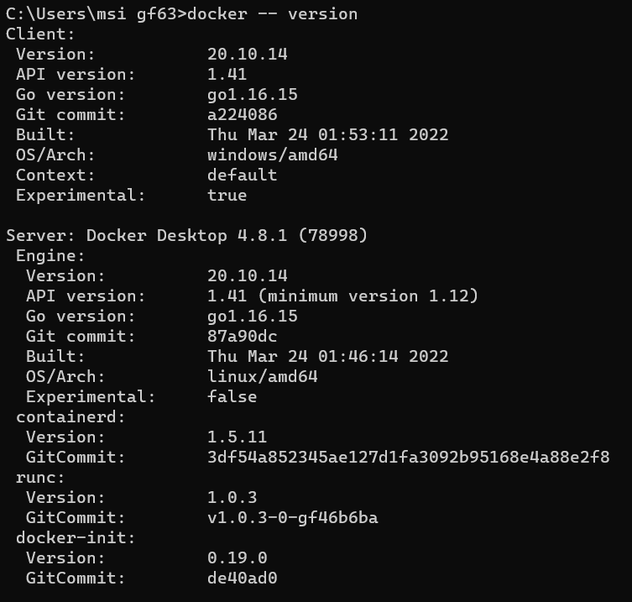Check docker version and copy the output
3. Create a new java project with maven
4. Create a main class and print “Hello docker example”
5. Create a jar file for the project (inside target directory)

* mvn package

1. Run the generated jar file inside target directory with command line

* java -jar sampleDocker-1.0-SNAPSHOT.jar

1. 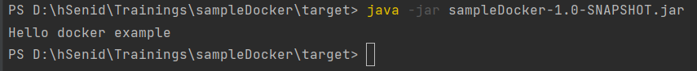Display the output
2. Create a docker image for the java project. What is the command you used?

* docker build -t hellodocker .

1. List all the docker images and show output

* 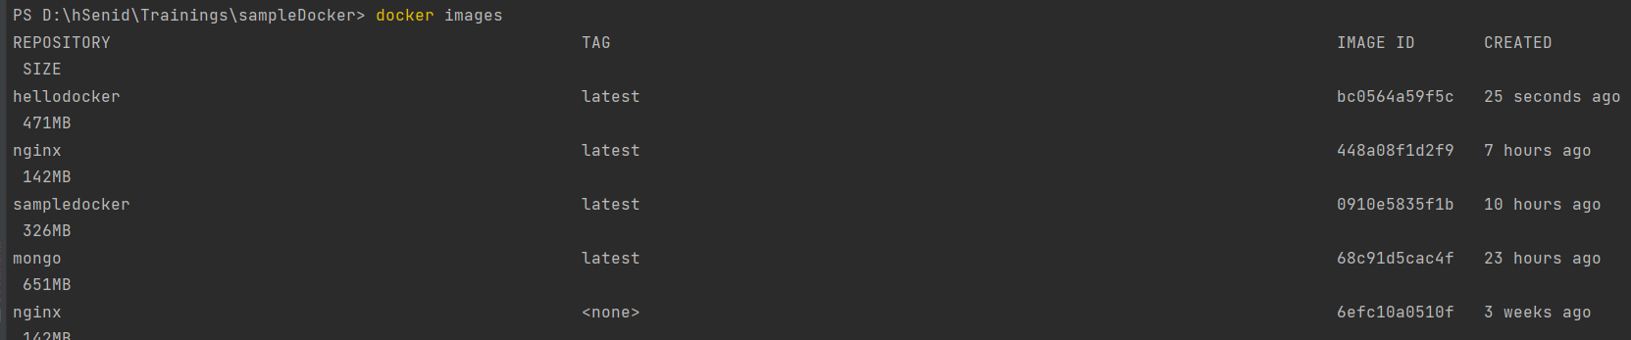docker images

1. Run the created docker image. What is the command you used?

* docker run -p 8080:8080 --name hellodockercon hellodocker

1. List all the docker images and show output
2. Stop the docker container?

* 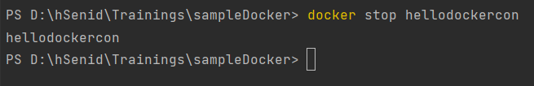docker stop hellodockercon

1. List all the docker containers and show output
2. Remove the docker image. What is the command you used?

* docker rmi bc0564a59f5c --force

1. 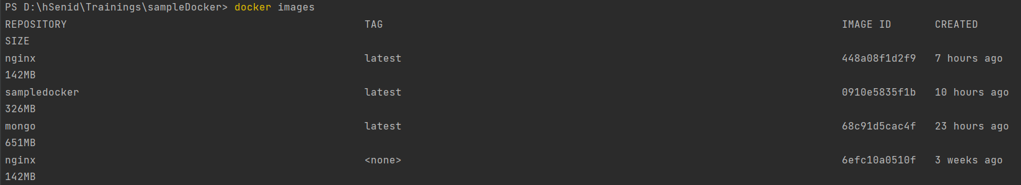List all the docker images and show output
2. What is docker hub?

* a service provided by Docker for finding and sharing container images.

1. Pull hello-world image from docker hub

* docker pull hello-world

1. 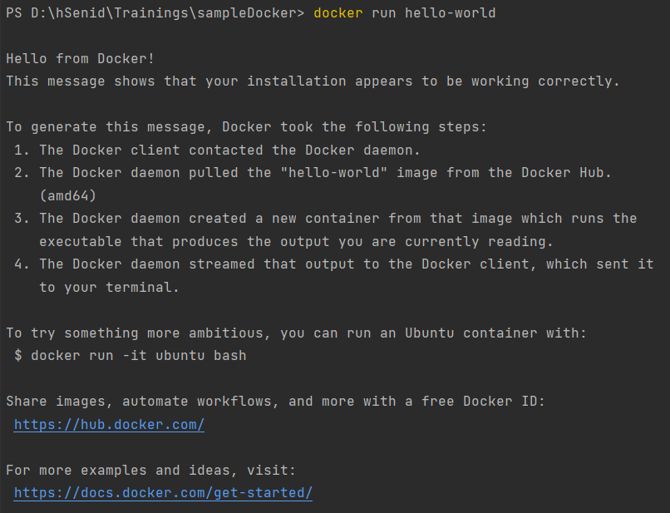Run hello-world image and show output
2. Pull and run mongodb as docker container

* docker pull mongo
* 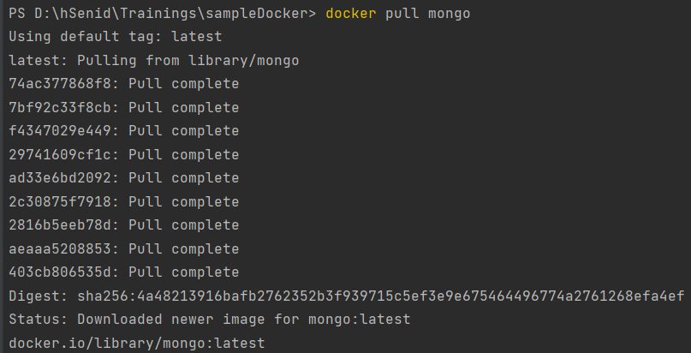docker run -d –-name mongodbex -p 27017:27017 mongo

1. Open mongo shell

* 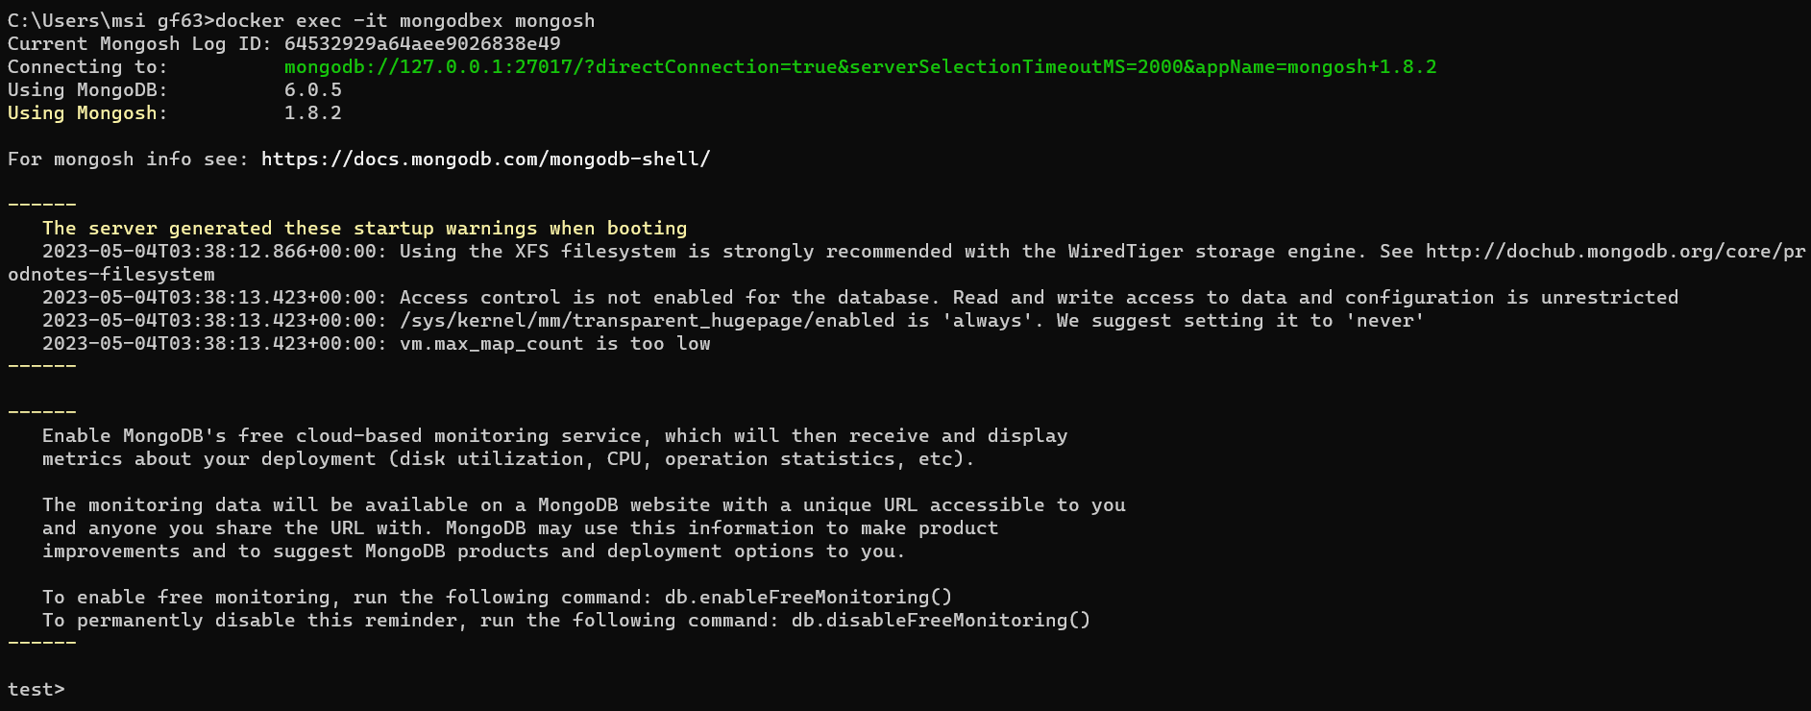docker exec -it mongodbex mongosh

1. 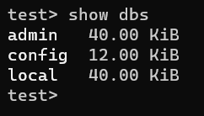List mongodb databases
2. Add your codes and answer sheet to a directory named “docker-basic-training” and push it to your training github repository

