**4. Maven**

1. Why do we need a build tool like maven?

* Build tools used to do the operations needed for the build. It is a program that automates the process of building an executable application from source code. Maven is such a tool which helps to simplify the build process by letting us get package dependencies easily, build project and documentation.

1. Install maven
2. 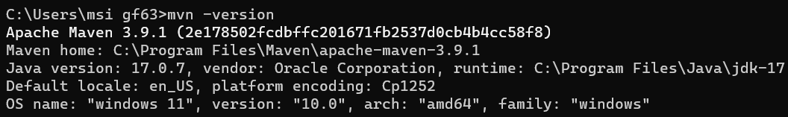Display output of maven version
3. What is the pom.xml file?

* Project Object Model or POM is file that contains the information about the project and configuration details used by Maven to build the project.

1. Explain these tags found in pom.xml files?

|  |  |
| --- | --- |
| groupId | Specifies the ID for the project group. |
| artifactId | Specifies the ID for the project group. Normally refers to the name of the project |
| version | Specifies the Version the project. |
| packaging | Used to define the packaging type. Such as jar, war or etc. |
| dependencies | Used to define the dependencies for the project. |
| dependency | Used inside the dependencies element to define a dependency. |
| properties | Properties are value placeholders. Their values accessible anywhere with in POM file by using ${X} notation. |

1. Create a method which accept an integer as parameter and returns the square of it
2. Add junit (v5) dependency
3. Add a unit test to test the method
4. Run unit tests with maven. What is the command you used?

* mvn test

1. Create a Student class with following attributes and add getters/setters

* id: int
* name: String
* age: int
* subjects: List<String>

1. In your main method create and student object and set these values

id: 1

name: “john”

age: 20

subjects: [“Maths”, “English”, “History”]

1. Then print these student values using getters (e.g: s.getName())
2. Add lombok dependency and remove getter/setter methods from Student class
3. Explain the usage of these commands

|  |  |
| --- | --- |
| mvn clean | Cleans the Maven project by deleting the target directory |
| mvn install | Builds the Maven project and install the project files to the local repository. |
| mvn package | Builds the project and packages the resulting JAR file into the target directory. |

1. Explain 3 types of maven repositories

* Local repository – Created by Maven in our local repository when we run any maven command. We can change the location of the Maven local repository by changing the settings.xml file.
* Central repository – Central repository has been created by Apache Maven community itself and it located on Web. The path of central repository is <http://repo1.maven.org/maven2/>.
* Remote repository – This also located in Web. Since most of libraries can be missing from the central repository, we need to define remote repository in pom.xml file.

1. Add your codes and answer sheet to a directory named “maven-basic-training” and push it to your training github repository.