# Informatica Settings to Transfer Chinese Characters

Screenshots correspond to Bluescope test environment. Apart from the environment specific information like URLs and credentials, procedure should be workable for any other environment with same toolset and corresponding major versions.

It must be stated that the source system (Compass system in Bluescope) and target (Datawarehouse) must have the same characterset: AL32UTF8. Informatica manual mentions that it is enough that they both are UTF8 but although UTF8 by definition handles the multi-byte character set, Chinese characters are not effectively stored unless characterset is found to be AL32UTF8

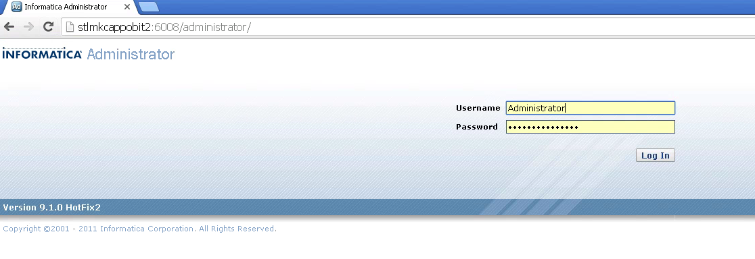

Step 1: Login to Informatica administrator

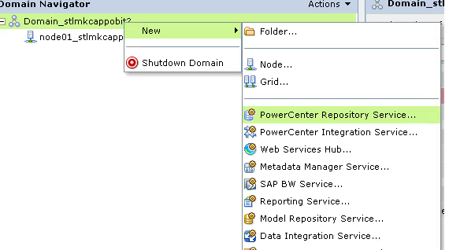

Step 2: Create a new repository service. The repository service schema must be created in a database instance where NLS_CHARACTERSET must be AL32UTF8

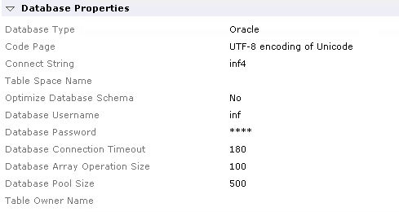

Step 3: Database properties of new repository service should be like above

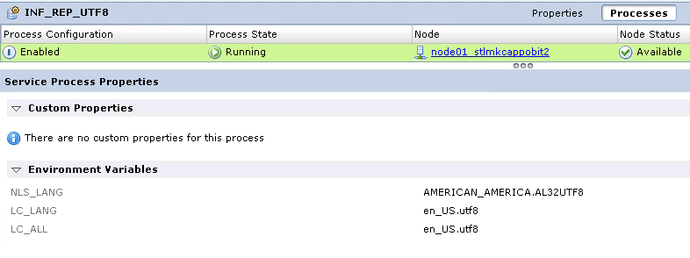

Step 4: Define the required three environment variables for the new repository service after copying the content from old repository service and bringing the service in normal mode (not shown in screenshot as the steps can be easily found in Informatica manuals)

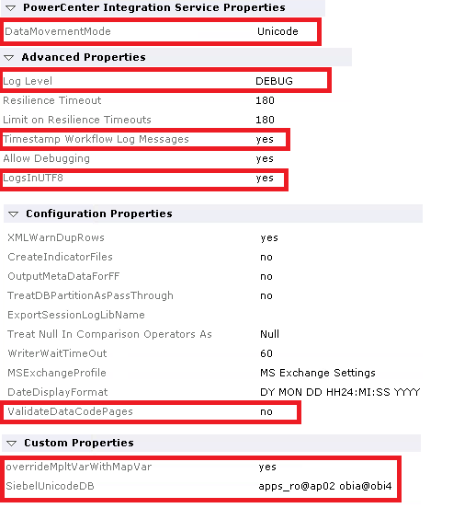

Step 5: Properties as highlighted above should be set for **new integration service**. Property SiebelUnicodeDB has following format: <source user>@<source connection string (mostly the tns names, can be found in Informatica connections) <target db user>@<target connection name (mostly tns names, can be found in Informatica connections)> [<> characters are not needed, note the space between two strings and “@” characters]

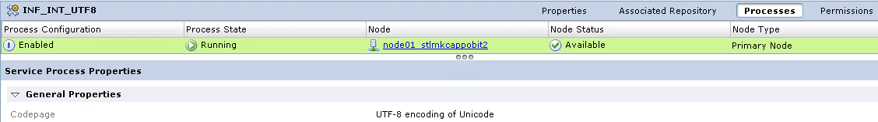

Step 6: Code page property for the new integration service must be set to UTF8.

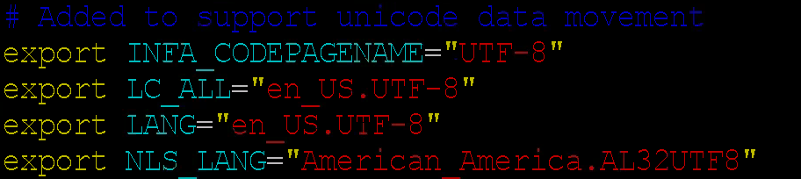

Step 7: The UNIX/Linux server that houses Informatica services should have above lines in it’s profile. It must be made sure that the user that runs Informatica services should have these lines in his/her profile. Here it is added to $HOME/.bashrc as the corresponding user uses bash shell. Corresponding variables must be defined in the Windows environment if the services are running in Windows. Please note that it may be helpful to define these variables in environment where Informatica client tools are installed. But it is not absolutely necessary.

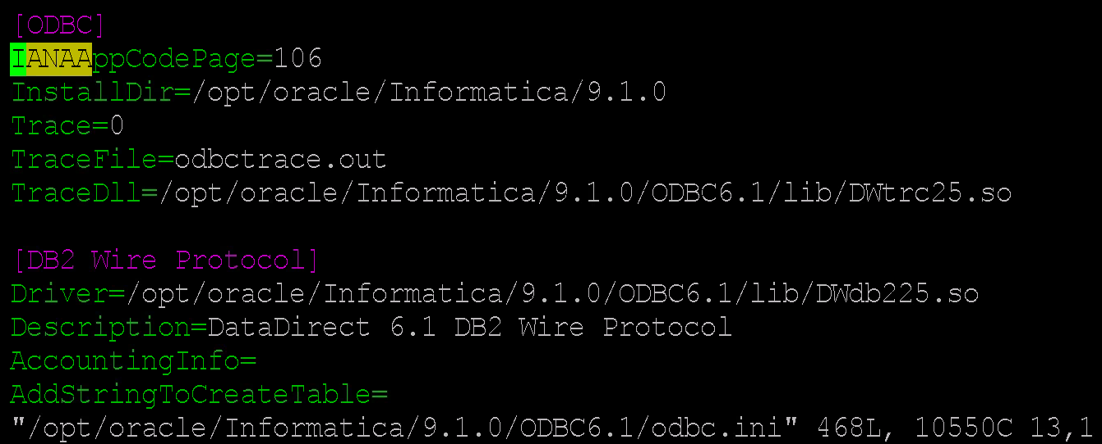

Step 8: Open the odbc.ini file in Informatica environment and change the parameter IANAAppCodePage parameter from 4 (which is Latin) to 106 (which is UTF8). This is necessary if data movement is done via ODBC. For OCI based data movement, this may not be absolutely necessary.

Step 9: Please restart Informatica services using “infaservice.sh [startup|shutdown]” commands. In the current environment the script exists in /opt/oracle/Informatica/9.1.0/tomcat/bin. After that operation, login to Informatica admin console when it comes up and enable the new integration service.

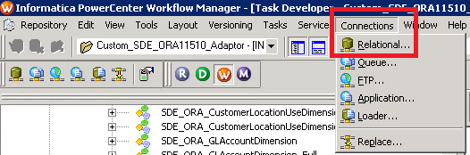

Step 10: Login to Informatica Workflow Manager tool and find relational connections.

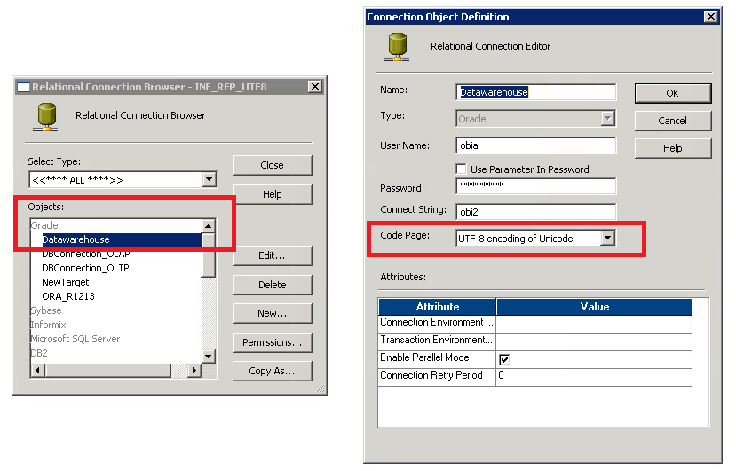

Step 11: For all source and target connections either redefine them with the highlighted code page value or change the code page of the existing connections to UTF-8.

Step 12: Define your target tables in the new target environment and execute the jobs using new repository and integration services.