ShopVerse Daily ETL Pipeline – Apache Airflow Project

Table of Contents
1. Project Overview
2. Folder & Environment Structure
3. Airflow Variables
4. Airflow Connections
5. Database Tables (DDL)
6. DAG Overview
7. Pipeline Workflow
8. How to Place Input Data
9. How to Trigger the DAG
10. Testing Sequence
11. Summary

1. Project Overview
This project implements an end-to-end daily batch data pipeline for the e-commerce company ShopVerse. The pipeline ingests customer, product, and order datasets daily using Apache Airflow, loads them into a PostgreSQL data warehouse, validates data, handles transformations, and applies quality checks.

2. Folder & Environment Structure
The following directory structure is used to organize Airflow DAGs and datasets:
~/airflow/
dags/
shopverse_daily_pipeline.py
data/
landing/
customers/
products/
orders/
anomalies/

3. Airflow Variables
Before running the pipeline, configure these Airflow Variables:
• shopverse_data_base_path = /home/samis/airflow/data
• shopverse_min_order_threshold = 10
• shopverse_alert_email = samisettysiddartha2004@gmail.com
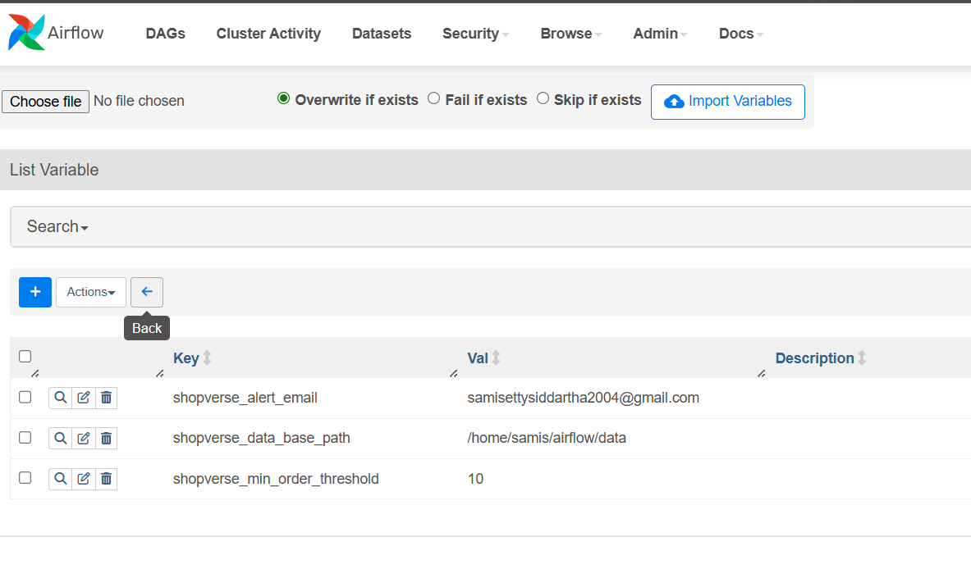

4. Airflow Connections
Create a Postgres connection with the following details:
Connection ID: postgres_dwh
Type: Postgres
Host: localhost
Database: dwh_shopverse
User: airflow_user
Password: root
Port: 5432
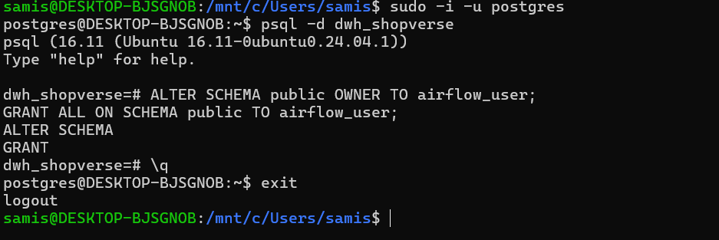

5. Database Tables (DDL)
The following tables must exist before running the pipeline:
Staging: stg_customers, stg_products, stg_orders
Warehouse: dim_customers, dim_products, fact_orders
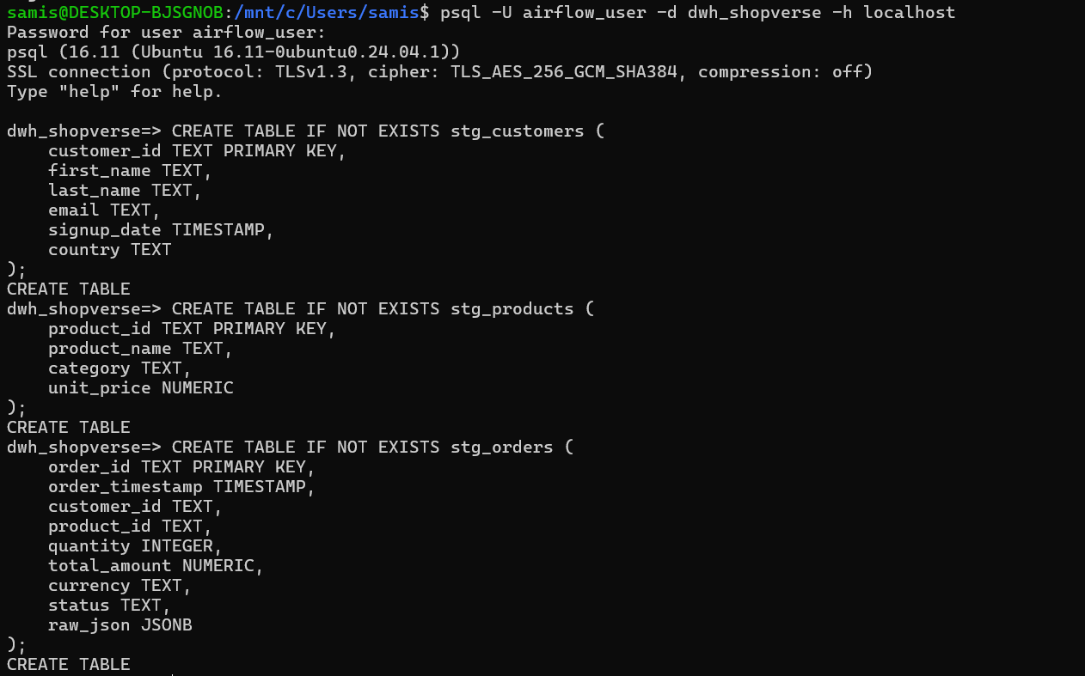
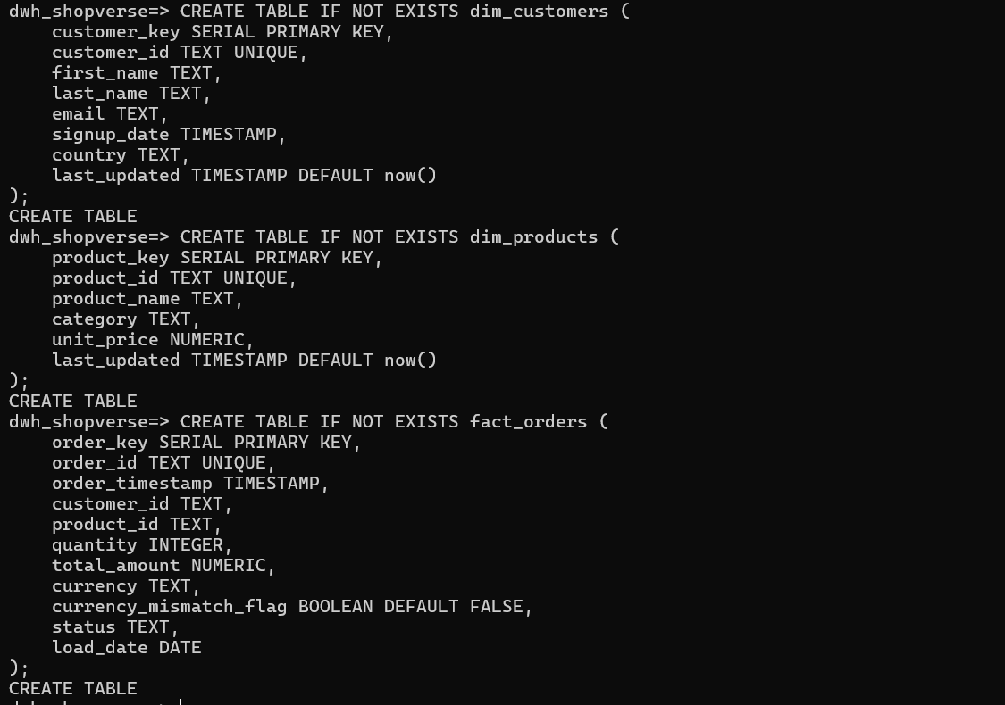

6. DAG Overview
The Airflow DAG 'shopverse_daily_pipeline' runs daily at 01:00 and processes data for the previous day. It uses TaskFlow API, TaskGroups, FileSensors, branching, and data quality checks.

7. Pipeline Workflow
- 1. Wait for files using FileSensor.
- 2. Stage datasets into Postgres (truncate + load).
- 3. Transform and load warehouse tables.
- 4. Apply data quality checks.
- 5. Branch if order volume is below threshold.
- 6. Send alert email if failures occur.
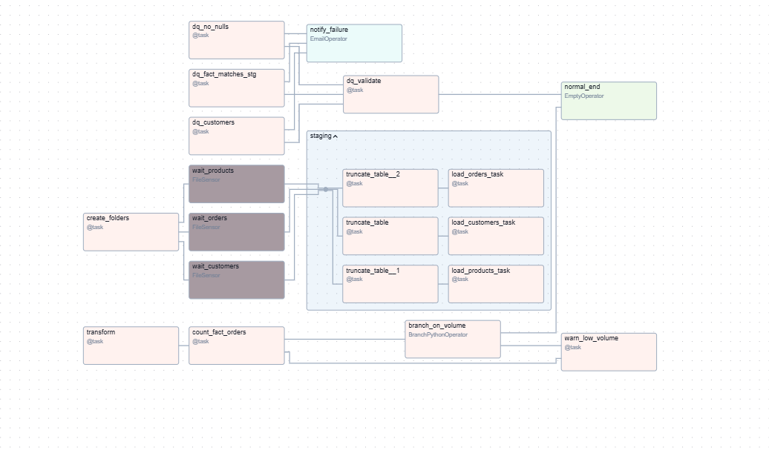

8. How to Place Input Data
Files must follow the naming pattern customers_YYYYMMDD.csv, products_YYYYMMDD.csv, and orders_YYYYMMDD.json in the following directories:
/home/samis/airflow/data/landing/customers/
/home/samis/airflow/data/landing/products/
/home/samis/airflow/data/landing/orders/
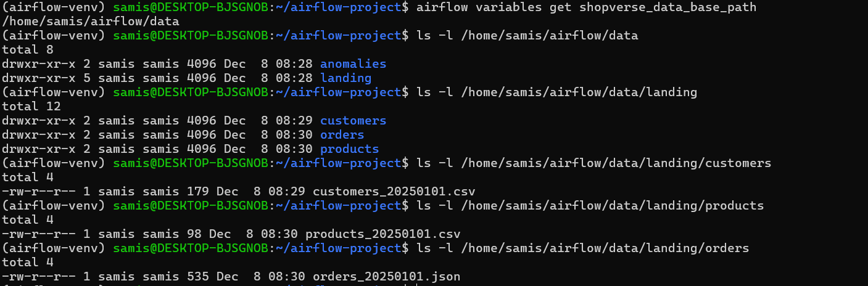

9. How to Trigger the DAG
Manual trigger:
airflow dags trigger shopverse_daily_pipeline --execution-date 2025-01-01
Backfill:
airflow dags backfill shopverse_daily_pipeline -s 2025-01-01 -e 2025-01-05

10. Testing Sequence
- Place test files for a specific date.
- Trigger the DAG and confirm sensors detect files.
- Verify staging tables populate correctly.
- Confirm warehouse tables update.
- Validate that data quality checks pass.
- Test branching behavior with low-volume data.
- Perform a backfill test.

11. Summary
This Airflow project implements a complete daily ETL workflow, including ingestion, staging, transformation, data quality enforcement, anomaly detection, and notifications. The DAG meets all assignment requirements and is built using best practices for modularity and maintainability.

