APRIL 6, 2020

SOCIAL MEDIA ANALYTICS

(FASHION INDUSTRY)

* Siddhartha Shanmuhavel

Contents

Overview 2

System Requirements 2

Strategy 2

Analysis and Visualization 2

Sentimental Analysis: Bar plot 2

Unique location of the user: ggplot 4

Frequency of tweets from the company: Line graph 7

Sentimental Analysis: Word cloud of frequently used hashtags by the company 9

Sentimental Analysis: Word cloud of frequently used words by the company in their tweets 11

Type of company tweets: Pie chart 13

Conclusion 15

Recommendations 15

Overview

The social media effects on our day to day life is quite evident, because it became an integral a part of our lives. The social media marketing has become the fast-growing channel for the promoting any product. The fashion industry is getting benefits from the positive outcomes of social media’s activities. Social media effects in marketing world is kind

of unique from other tools of promotions. Because it has developed and portrayed itself quite distinctly from other traditional marketing methods. It’s offering huge opportunities to the promoters to develop their brand awareness in multiple ways. One thing that has changed dramatically in recent years is that the direct relationship brands now have with their consumers. During this new hierarchy, the patron can amplify or negatively impact on business, through sharing positive or negative responses.

The objective of this task is to detect sentiments of tweets that would help customer identify which is the brand with which they have to collaborate with for their business. We have taken top 3 brands that are popular on social media for consecutive years. After analysing these, we would be recommending the brand to the customer based on which they can collaborate.

Tweets are collected using R and the data is cleaned further removing emoticons, URLs and unwanted data. Sentiment of tweets are predicted using predictive algorithms and the opinion is expressed using graphs like ggplots, Bar graphs, pie chart, word cloud and tables.

System Requirements

* Installation of R Studio
* Twitter developer account set up
* Twitter authentication to access API

Strategy

**Twitter data extraction**

1. Extraction of tweets
2. Cleaning of tweets
3. Loading the data to excel

**Twitter data analysis**

Use of various KPI for the analysis. Using these insights to help the team in choose the right brand for collaboration.

**Tools**

* Twitter Rest API
* R Studio to extract, clean, analyse and visualise the data.
* Tableau for data visualization

Analysis and Visualization

Sentimental Analysis: Bar plot

Twitter Sentiment Analysis is a technique widely used in text mining to analyse the sentiment of the tweet in the form of positive, negative and neutral. Hence, Twitter data is of great

germane as it can be used in various scenarios where companies or brands can utilize a direct connection to almost each of their customer or user and thereby, improve upon their product and position in the market. Using this sentimental analysis, a comparative overview of top three brands which are **CHANEL**, **DIOR** and **ZARA** is given where the client would get an idea of what the end users think about the brand.

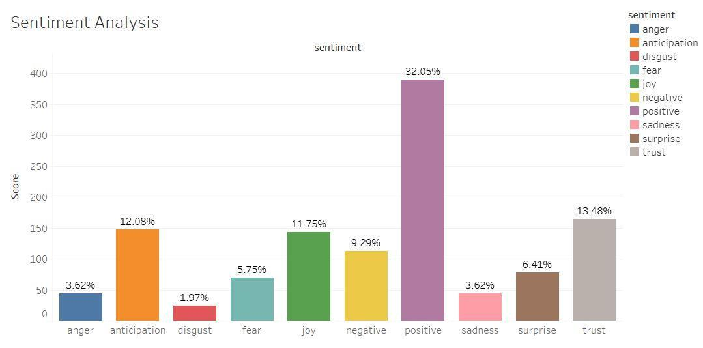

**Fig 1: CHANEL**

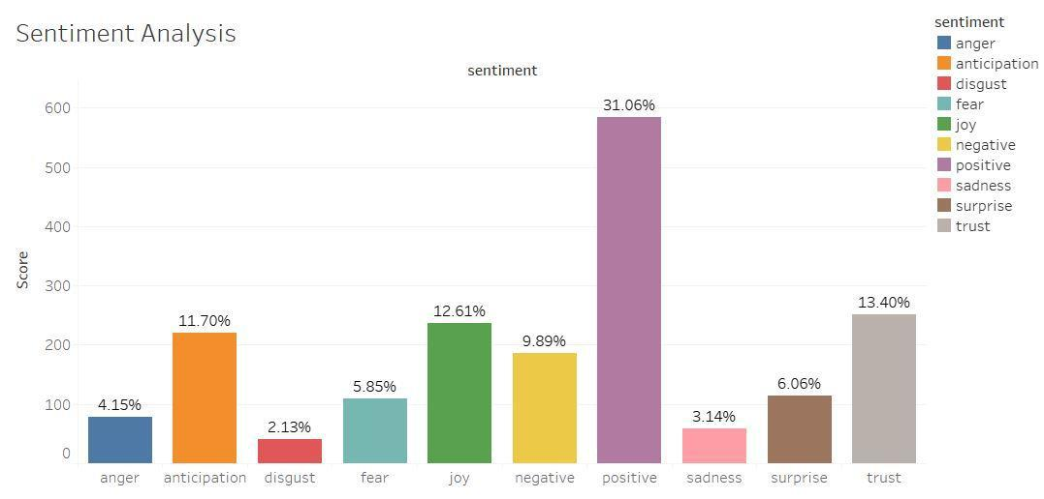

**Fig 2: DIOR**

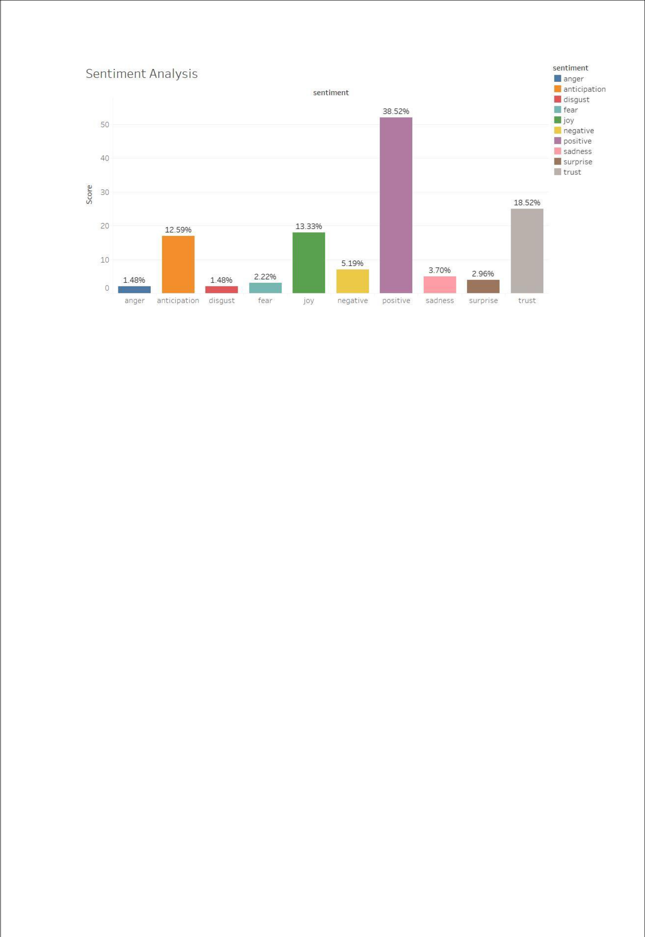

**Fig 3: ZARA**

From the above graphs, an analysis about end user’s sentiments is given below

* Fig 2 shows that the ratio of customers feeling cynical which includes emotions like ***anger(4.15%), disgust(2.13%), fear(5.85), sadness(3.14%)*** and ***negative*** ***(9.89%)*** with*Dior*is more when compared to*CHANEL*(Fig 1).
* Fig 3 shows that ZARA has the the optimistic response which includes ***positive(38.52%), trust(18.52%), anticipation(12.59%), surprise(2.96%)*** and ***joy(13.33%)*** on comparison with*CHANEL*and*Dior*which are luxiorious brands

Unique location of the user: ggplot

The below graphs describes the loaction of the users from where the tweets of the particular brand was tweeted. With this analysis, customer can collaborate with the brand that is doing good in the country from where the customer is based out. In this way they can get market their brand to the end user at a faster pace.

**Fig 4: CHANEL**

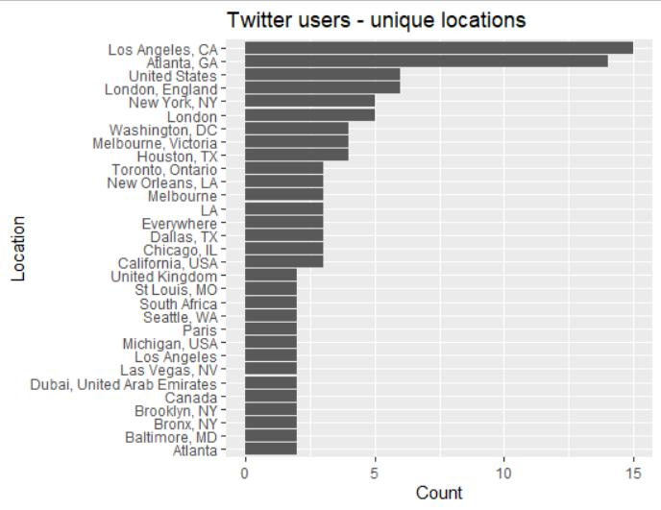

**Fig 5: DIOR**

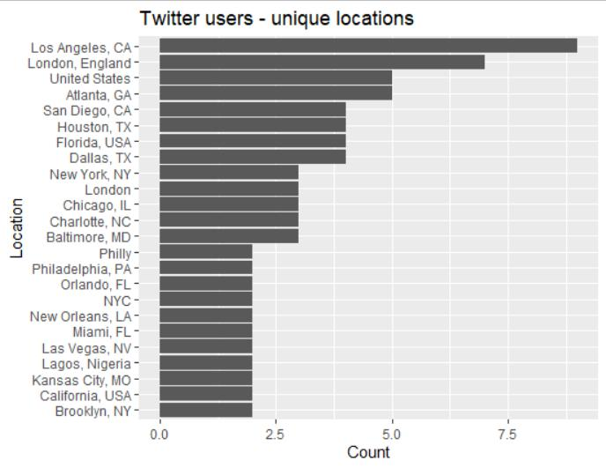

**Fig 6: ZARA**

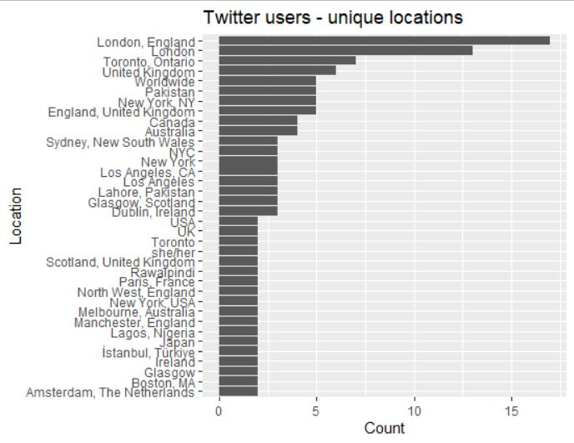

From the above graphs, an analysis about end user’s location is done. The number of tweets analysed are finite i.e. nearly 500 tweets for which below analysis is made:

* From Fig 6, it is noticed that the number of users tweeting about ZARA is highest when compared to the other. Also, it is seen that users tweeting are across the globe which implies that ZARA is ***globally acclaimed*** brand. The number of users tweeted are maximum in United Kingdom.
* From Fig 4 and Fig 5, it is noticed that the number of users of Dior and CHANEL are more from the United States of America. Number of users are seen to be ***less*** ***from other regions of globe.***

Frequency of tweets from the company: Line graph

The below graph shows the frequency of tweets from the company that shows how active it is on social media. This also depicts the growth on social media from 2014 to 2020. This shows how each of the company has increased their social media awareness over a period of time.

Considering the growth of each brand, the company can collaborate with the brand that has been a consistent performer.

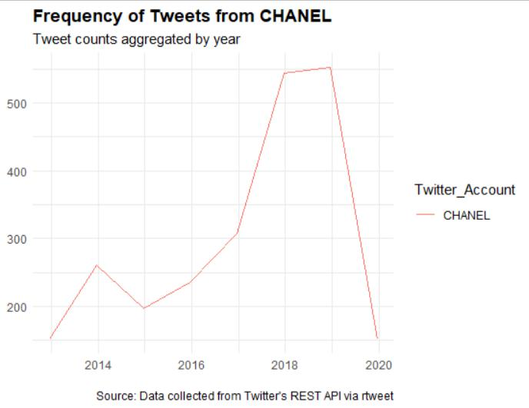

**Fig7**

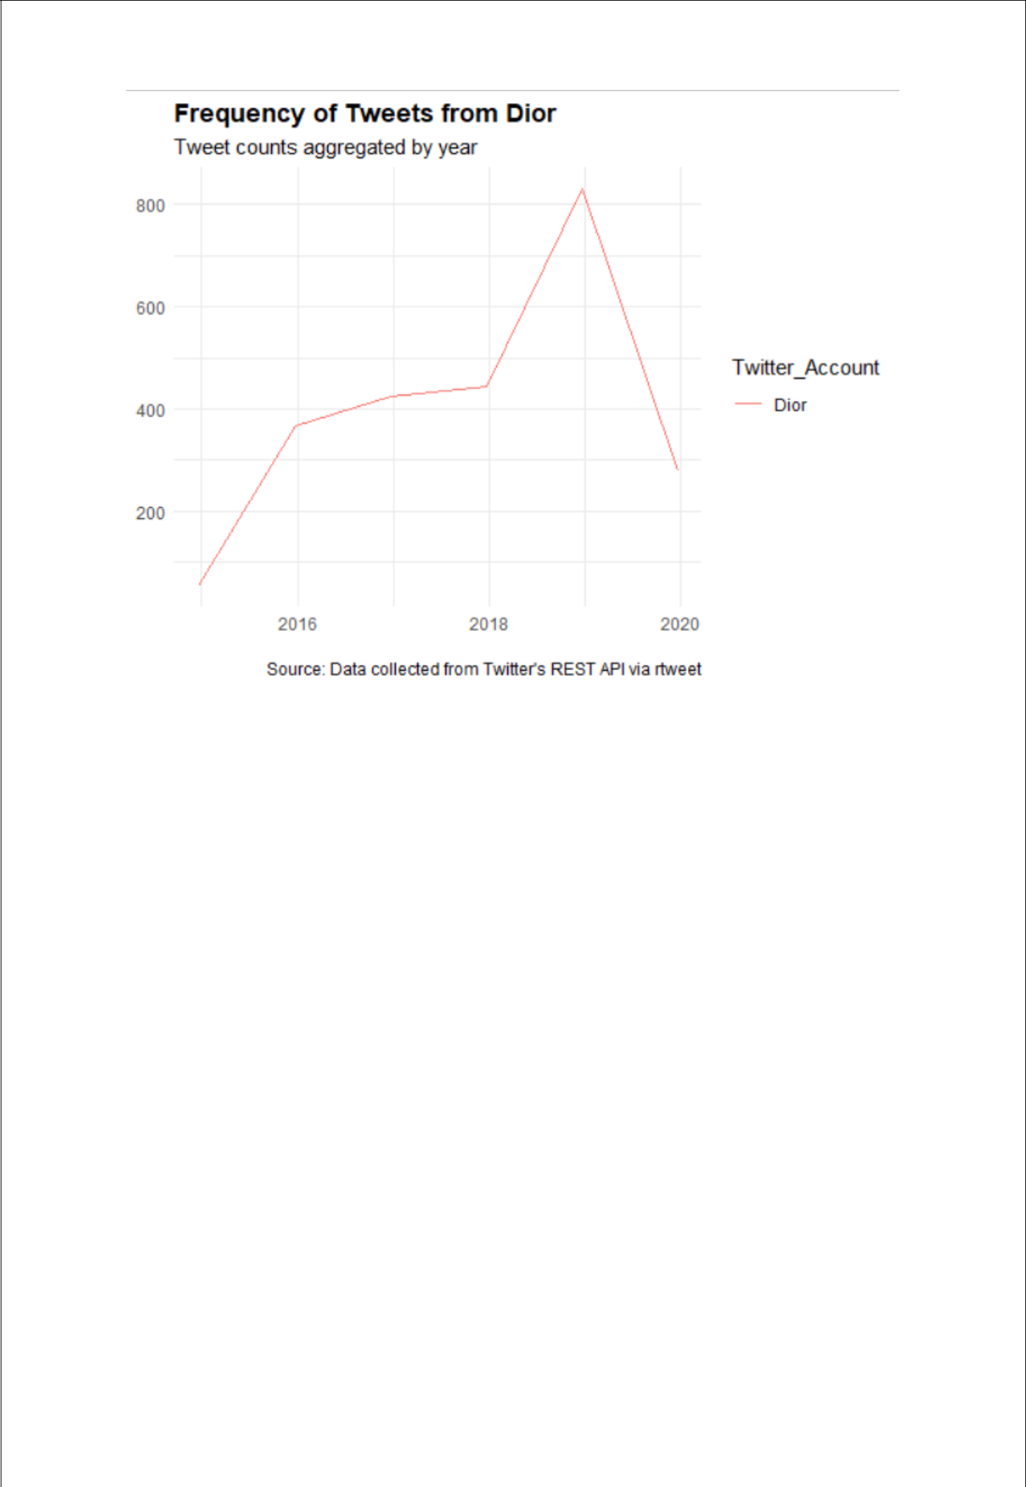

**Fig 8:**

**Fig 9:** 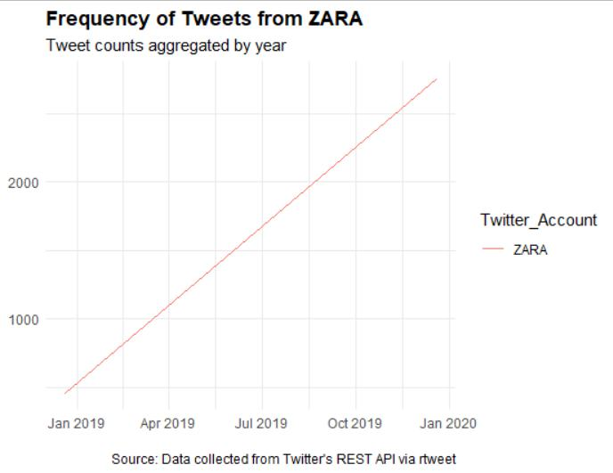

From the above graphs, an analysis about the company’s social media activity log is done. The number of finite tweets(4000) posted by the company is analysed for a duration for which below analysis is made:

* From Fig 9, it is observed that ZARA has been a consistently active on Twitter. Nearly **4000** tweets were analysed that was **aggregated by year**. And *ZARA* is seen to have 4000 tweets from Jan 2019 to Jan 2020. Since it aggregated by year, the number of tweets is seen to be lower to be analysed as the tweets posted by *Zara* is more. Hence, the frequency of tweets by *Zara* has always be***exponential***.This means that, ZARA were always par with the current trend and digital market attracting more consumers.
* From Fig 7 and Fig 8 it is seen that from and average period of 2014 to 2020, *Dior* and *CHANEL* have gradually increased their presence on social media. Sudden **surge** in the frequency is noticed for both the company during the year of2018.There has been a ***growth of 200*** tweets for a period to an average of **700** tweets by 2019. This indicates that company was exploring the social media market during that period.

Sentimental Analysis: Word cloud of frequently used hashtags by the company

Every company has their own strategy to attract customers via social media, market their brand and do the necessary publicity. For all this there are certain hashtags and time during which they do this and it varies from companies to companies.

Word Cloud gives a great prominence to words that appear most frequently in the collected data. It helps to know what the trending topic company is publicizing and useful to drive some insights. We have created a word cloud for all hashtags that each of the company has used for which we have collected nearly 1000 tweets. Below is the analysis from

* In the word cloud of CHANEL, the most used hashtag is ***chanelcmetiersdart***, ***pfw*** and ***chanelincannes*** which are shows which CHANEL would be part of. They also promote their new products with a catchy hashtag.
* In the word cloud of Dior ***starsindior***,***diorcouture*** and ***pfw*** are the most frequent used hashtag. PFW is the common hash tag used by both the companies. Dior also markets their product using hashtags.
* In the case of Zara, there is just one commonly used hashtag i.e ***zaranewin***. This implies that Zara doesn’t believe in online marketing as they are confident with respect to their customer reach. They seem to believe in launching new products using images, but not hastags, which makes them stand different and confident. Despite being part of the competitive digital world, they have reached their target audience without having their own hashtag.

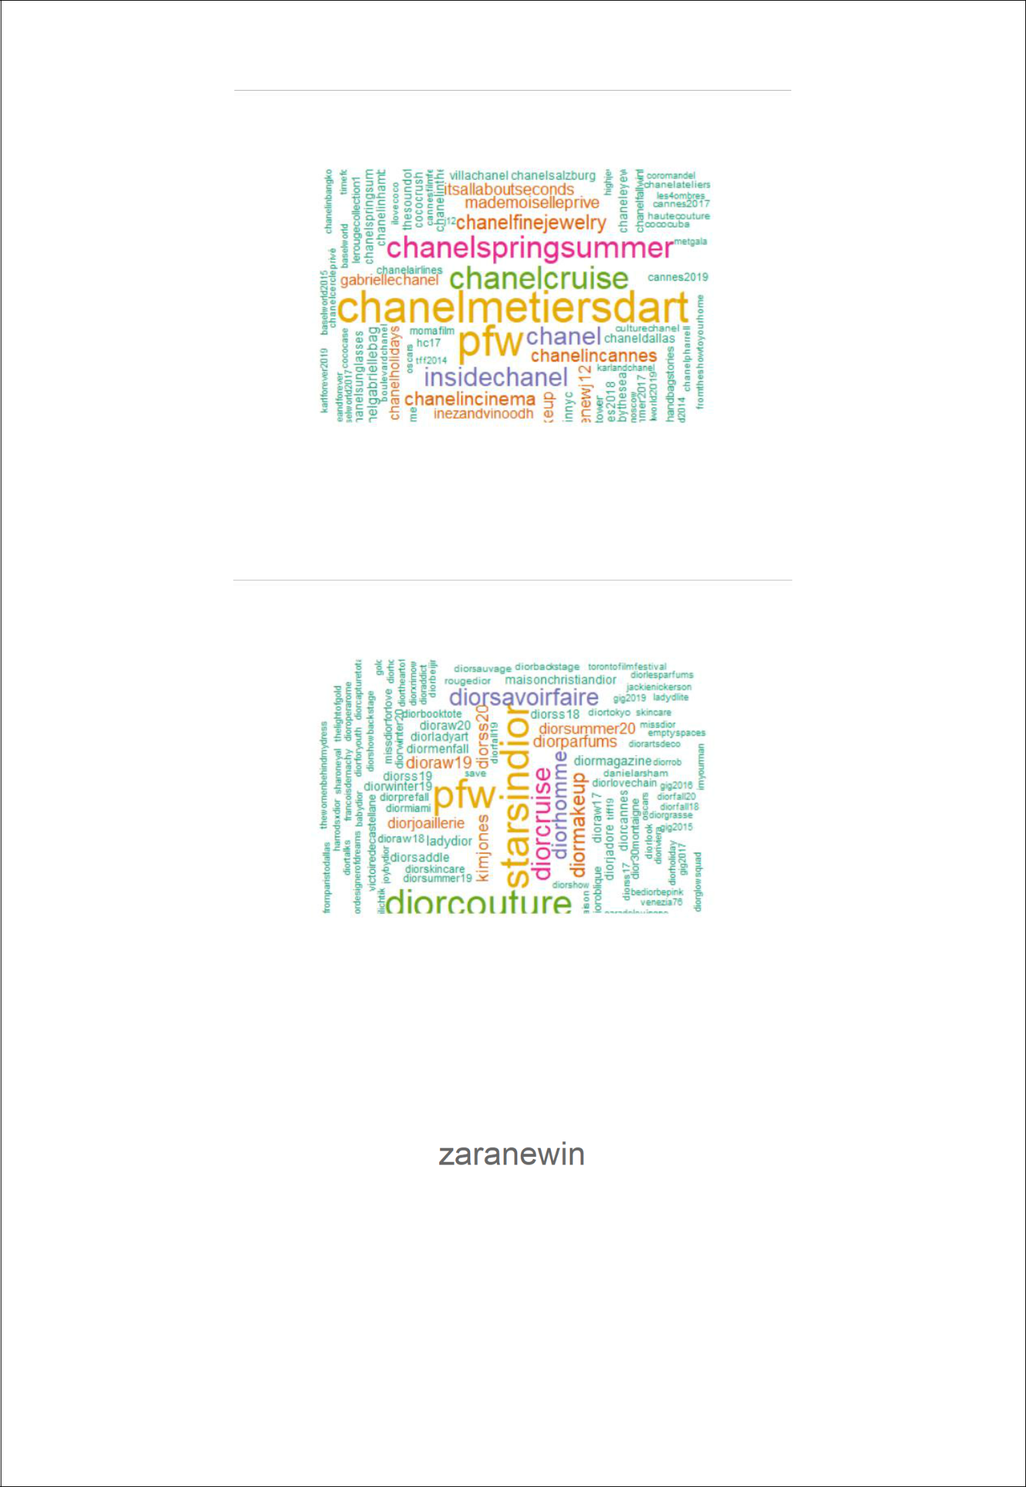

Sentimental Analysis: Word cloud of frequently used words by the company in their tweets

From the below given graphs it is seen that there are few words which are used by each of the company to attract customers and users. These words would help the customer to get an idea about the approach the company is following. So, for this 1000 company tweets are collected, and the below word cloud is plotted using Tableau.

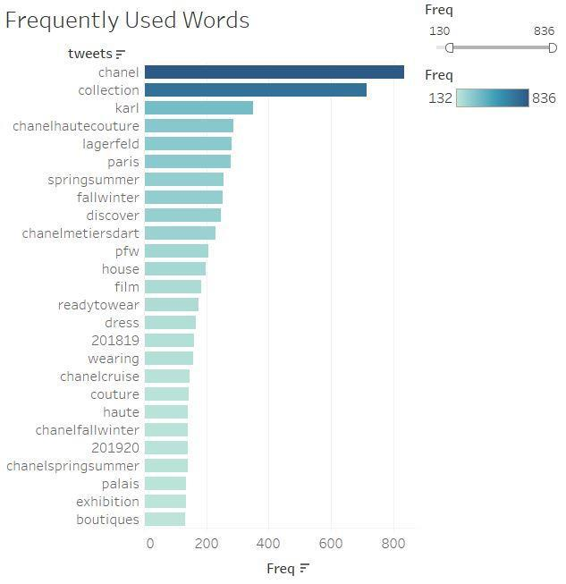

**CHANEL**

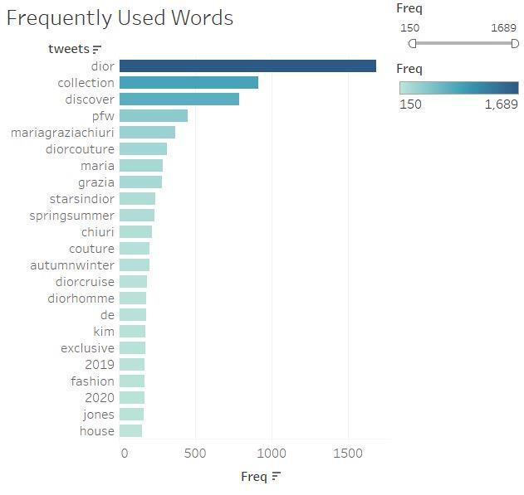

**Dior**

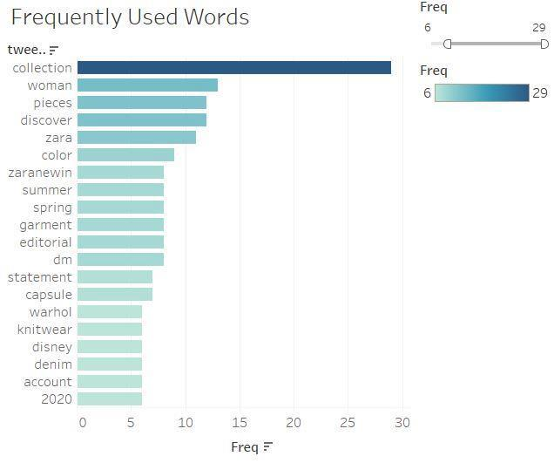

**ZARA**

Type of company tweets: Pie chart

From the below given pie charts it is seen that there are basically three types of tweets that includes Organic(tweets posted by company), Replies( Replies to users) and Retweets(Tweets of the company that are being reposted)

* From fig 10 we can see that, CHANEL has the highest Organic tweets that is around 98.71%, they reply to vvery few of their customers i.e around 1.17% of the crowd and their hashtags are retweeted which is just 0.12%
* From Fig 11, we see that for Dior, there is no replies from their side for customers, and their percentage of retweet is just 2% and maximum tweets are their own hashtags.
* From fig 12, we see that ZARA values customer satisfaction and reaching out to target audience by replying to them they have highest rate of replies that is 96.3 percent and the rest is retweet and organic, This implies that they believe in curtomer relationship management that promotion. They also have a separate page for posting all queries.

**Fig 10: CHANEL**

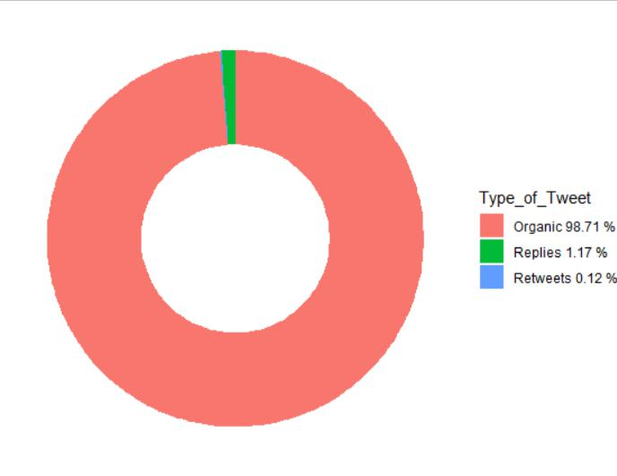

**Fig 11:Dior**

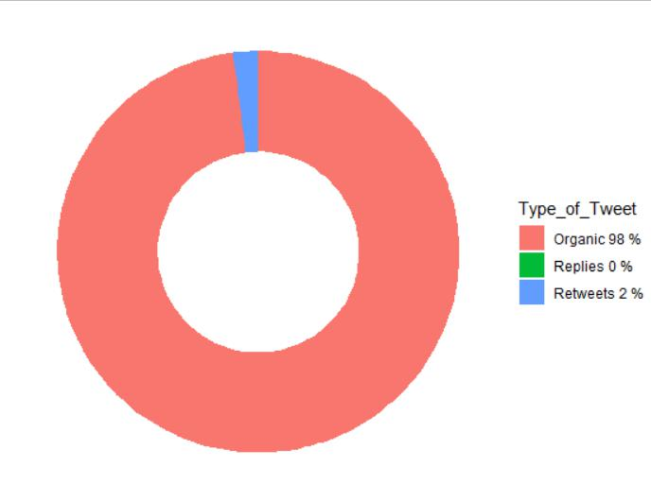

**Fig 12:ZARA**

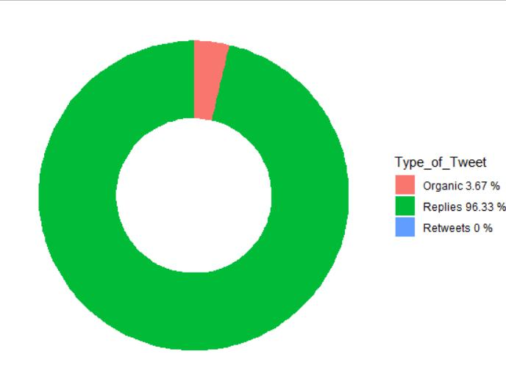

Conclusion

Our analysis has validated the power of social media in the field of fashion industry. We have analysed the top three brands which are *CHANEL*, *Dior* and *Zara*. It helped us understand the real time feedback of their products, customer complaints, customer relationship management is identified, and the popularity of each brands is known. It also states how each of the company are positioning themselves in the digital market.

Based on the analysis made from various graphs, we can conclude that customer can collaborate with **ZARA** for the below reasons:

* ZARA is seen to have more of **positive** responses from the tweets.
* ZARA is **globally** acclaimed brand.
* ZARA is very **popular** on social media and they have a very good customer relationship that they maintained by responding to all the tweets on time.

As a BA/ Consultant, we are able to give customer a better data driven strategies and also a clear insight that would help them decide which brand they can collaborate with for more profit.

Recommendations

1. Analyse image for emotions which would give a better understanding of each user’s feedback or tweet of a product.
2. Detect sarcasm in tweets as all the other emotions which are detected provides a generic emotion
3. Apply machine learning algorithm for capturing health of the hashtag
4. Parallelizing code