CREATE DATABASE evaluation;

USE evaluation;

-- Create the Artists table

CREATE TABLE Artists (

ArtistID INT PRIMARY KEY,

Name VARCHAR(255) NOT NULL,

Biography TEXT,

Nationality VARCHAR(100));

-- Create the Categories table

CREATE TABLE Categories (

CategoryID INT PRIMARY KEY,

Name VARCHAR(100) NOT NULL);

-- Create the Artworks table

CREATE TABLE Artworks (

ArtworkID INT PRIMARY KEY,

Title VARCHAR(255) NOT NULL,

ArtistID INT,

CategoryID INT,

Year INT,

Description TEXT,

ImageURL VARCHAR(255),

FOREIGN KEY (ArtistID) REFERENCES Artists (ArtistID),

FOREIGN KEY (CategoryID) REFERENCES Categories (CategoryID));

-- Create the Exhibitions table

CREATE TABLE Exhibitions (

ExhibitionID INT PRIMARY KEY,

Title VARCHAR(255) NOT NULL,

StartDate DATE,

EndDate DATE,

Description TEXT);

-- Create a table to associate artworks with exhibitions

CREATE TABLE ExhibitionArtworks (

ExhibitionID INT,

ArtworkID INT,

PRIMARY KEY (ExhibitionID, ArtworkID),

FOREIGN KEY (ExhibitionID) REFERENCES Exhibitions (ExhibitionID),

FOREIGN KEY (ArtworkID) REFERENCES Artworks (ArtworkID));

-- Insert sample data into the Artists table

INSERT INTO Artists (ArtistID, Name, Biography, Nationality) VALUES

(1, 'Pablo Picasso', 'Renowned Spanish painter and sculptor.', 'Spanish'),

(2, 'Vincent van Gogh', 'Dutch post-impressionist painter.', 'Dutch'),

(3, 'Leonardo da Vinci', 'Italian polymath of the Renaissance.', 'Italian');

-- Insert sample data into the Categories table

INSERT INTO Categories (CategoryID, Name) VALUES

(1, 'Painting'),

(2, 'Sculpture'),

(3, 'Photography');

-- Insert sample data into the Artworks table

INSERT INTO Artworks (ArtworkID, Title, ArtistID, CategoryID, Year, Description, ImageURL) VALUES

(1, 'Starry Night', 2, 1, 1889, 'A famous painting by Vincent van Gogh.', 'starry_night.jpg'),

(2, 'Mona Lisa', 3, 1, 1503, 'The iconic portrait by Leonardo da Vinci.', 'mona_lisa.jpg'),

(3, 'Guernica', 1, 1, 1937, 'Pablo Picasso\'s powerful anti-war mural.', 'guernica.jpg');

-- Insert sample data into the Exhibitions table

INSERT INTO Exhibitions (ExhibitionID, Title, StartDate, EndDate, Description) VALUES

(1, 'Modern Art Masterpieces', '2023-01-01', '2023-03-01', 'A collection of modern art masterpieces.'),

(2, 'Renaissance Art', '2023-04-01', '2023-06-01', 'A showcase of Renaissance art treasures.');

-- Insert artworks into exhibitions

INSERT INTO ExhibitionArtworks (ExhibitionID, ArtworkID) VALUES

(1, 1),

(1, 2),

(1, 3),

(2, 2);

-- QUERIES

SELECT *FROM Artists;

SELECT *FROM Categories;

SELECT *FROM Artworks;

SELECT *FROM Exhibitions;

SELECT *FROM ExhibitionArtworks;

-- 1. Retrieve the names of all artists along with the number of artworks they have in the gallery, and list them in descending order of the number of artworks.

SELECT a.Name, COUNT(ar.ArtworkID) AS ArtworkCount

FROM Artists a

LEFT JOIN Artworks ar

ON a.ArtistID = ar.ArtistID

GROUP BY a.ArtistID

ORDER BY ArtworkCount DESC;

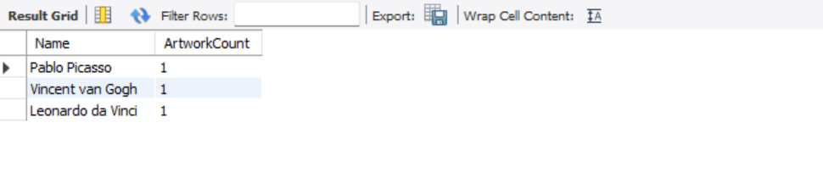

-- 2. List the titles of artworks created by artists from 'Spanish' and 'Dutch' nationalities, and order them by the year in ascending order.

SELECT ar.Title,Year FROM Artworks ar

JOIN Artists a ON ar.ArtistID=a.ArtistID

WHERE a.Nationality IN('Spanish','Dutch')

ORDER BY ar.Year ASC;

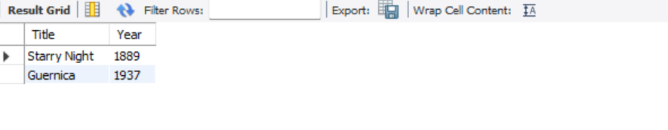

-- 3. Find the names of all artists who have artworks in the 'Painting' category, and the number of artworks they have in this category.

SELECT a.Name, COUNT(ar.ArtworkID) AS ArtworkCount

FROM Artists a

JOIN Artworks ar ON a.ArtistID = ar.ArtistID

JOIN Categories c ON ar.CategoryID = c.CategoryID

WHERE c.Name = 'Painting'

GROUP BY a.ArtistID;

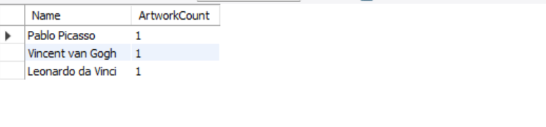

-- 4. List the names of artworks from the 'Modern Art Masterpieces' exhibition, along with their artists and categories.

SELECT ar.Title, a.Name AS Artist, c.Name AS Category

FROM Artworks ar

JOIN ExhibitionArtworks ea ON ar.ArtworkID = ea.ArtworkID

JOIN Exhibitions e ON ea.ExhibitionID = e.ExhibitionID

JOIN Artists a ON ar.ArtistID = a.ArtistID

JOIN Categories c ON ar.CategoryID = c.CategoryID

WHERE e.Title = 'Modern Art Masterpieces';

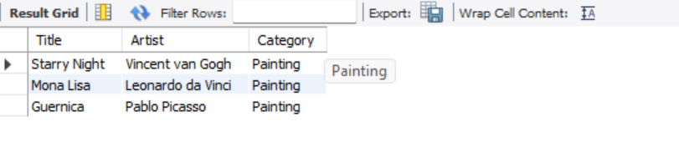

-- 5. Find the artists who have more than two artworks in the gallery.

SELECT a.Name,COUNT(ar.ArtworkID) AS ArtworkCount

FROM Artists a

JOIN Artworks ar ON a.ArtistID = ar.ArtistID

GROUP BY a.ArtistID

HAVING ArtworkCount > 2;

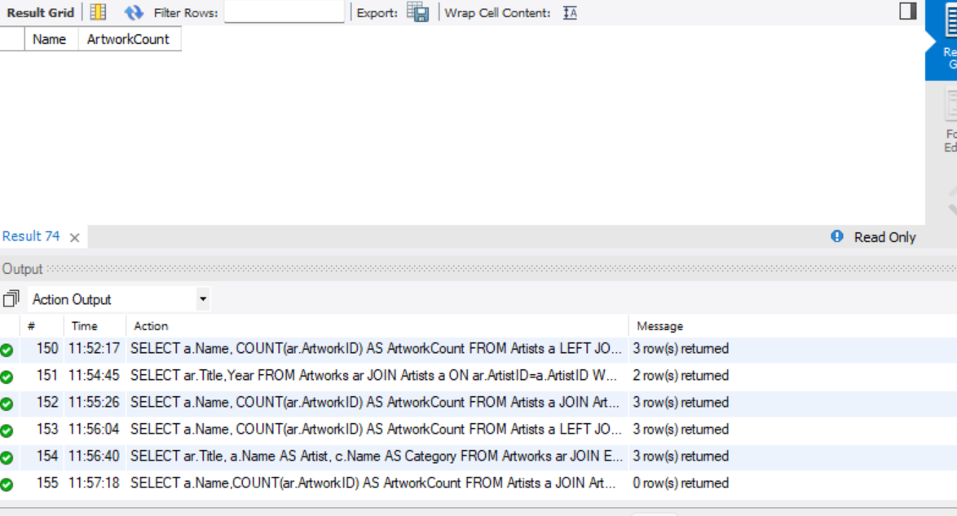

-- 6. Find the titles of artworks that were exhibited in both 'Modern Art Masterpieces' and 'Renaissance Art' exhibitions.

SELECT ar.Title

FROM Artworks ar

JOIN ExhibitionArtworks ea1 ON ar.ArtworkID = ea1.ArtworkID

JOIN Exhibitions e1 ON ea1.ExhibitionID = e1.ExhibitionID

JOIN ExhibitionArtworks ea2 ON ar.ArtworkID = ea2.ArtworkID

JOIN Exhibitions e2 ON ea2.ExhibitionID = e2.ExhibitionID

WHERE e1.Title = 'Modern Art Masterpieces' AND e2.Title = 'Renaissance Art';

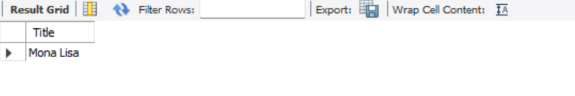

-- 7. Find the total number of artworks in each category.

SELECT c.Name, COUNT(ar.ArtworkID) AS TotalArtworks

FROM Categories c

LEFT JOIN Artworks ar ON c.CategoryID = ar.CategoryID

GROUP BY c.CategoryID;

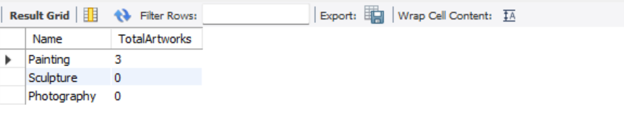

-- 8. List artists who have more than 3 artworks in the gallery.

SELECT a.Name

FROM Artists a

JOIN Artworks ar ON a.ArtistID = ar.ArtistID

GROUP BY a.ArtistID

HAVING COUNT(ar.ArtworkID) > 3;

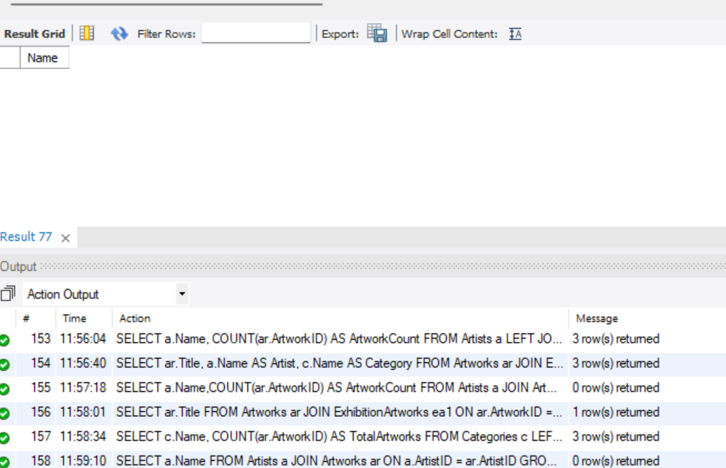

-- 9. Find the artworks created by artists from a specific nationality (e.g., Spanish).

SELECT ar.Title

FROM Artworks ar

JOIN Artists a ON ar.ArtistID = a.ArtistID

WHERE a.Nationality = 'Spanish';

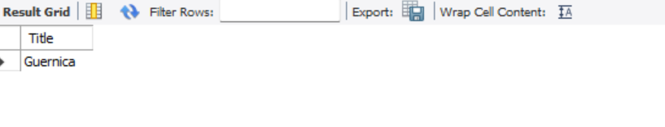

-- 10. List exhibitions that feature artwork by both Vincent van Gogh and Leonardo da Vinci.

SELECT e.Title

FROM Exhibitions e

JOIN ExhibitionArtworks ea ON e.ExhibitionID = ea.ExhibitionID

JOIN Artworks ar ON ea.ArtworkID = ar.ArtworkID

JOIN Artists a ON ar.ArtistID = a.ArtistID

WHERE a.Name IN ('Vincent van Gogh', 'Leonardo da Vinci')

GROUP BY e.ExhibitionID

HAVING COUNT(DISTINCT a.ArtistID) = 2;



-- 11. Find all the artworks that have not been included in any exhibition.(NOT WORKING)

SELECT ar.Title

FROM Artworks ar

LEFT JOIN ExhibitionArtworks ea ON ar.ArtworkID = ea.ArtworkID

WHERE ea.ExhibitionID IS NULL;

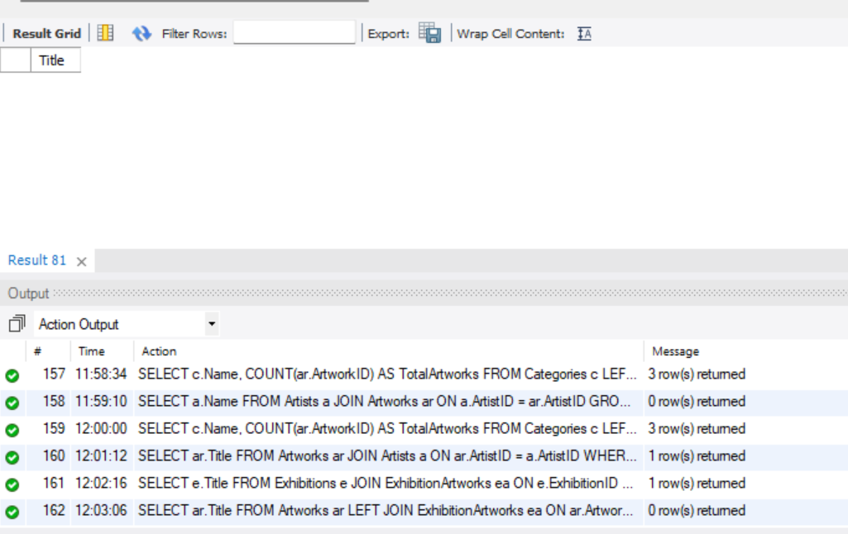

-- 12. List artists who have created artworks in all available categories.---

SELECT a.Name

FROM Artists a

JOIN Artworks ar ON a.ArtistID = ar.ArtistID

JOIN Categories c ON ar.CategoryID = c.CategoryID

GROUP BY a.ArtistID

HAVING COUNT(DISTINCT c.CategoryID);

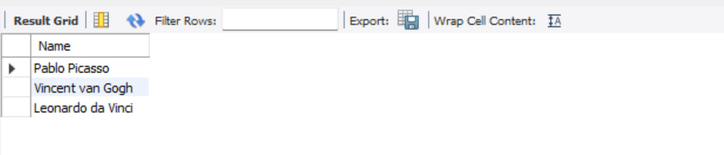

-- 13. List the total number of artworks in each category.

SELECT c.Name, COUNT(ar.ArtworkID) AS TotalArtworks

FROM Categories c

LEFT JOIN Artworks ar ON c.CategoryID = ar.CategoryID

GROUP BY c.CategoryID;

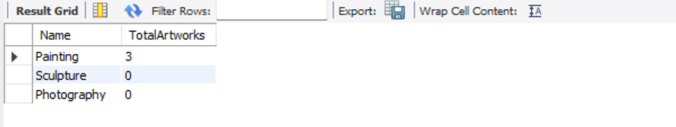

-- 14. Find the artists who have more than 2 artworks in the gallery.

SELECT a.Name,COUNT(ar.ArtworkID) AS ArtworkCount

FROM Artists a

JOIN Artworks ar ON a.ArtistID = ar.ArtistID

GROUP BY a.ArtistID

HAVING ArtworkCount > 2;

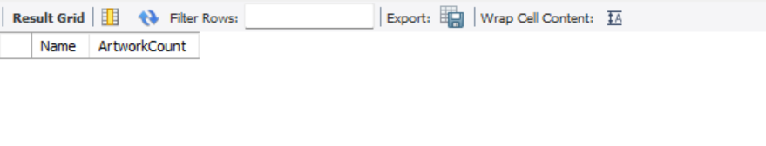

-- 15. List the categories with the average year of artworks they contain, only for categories with more than 1 artwork.

SELECT c.Name, AVG(ar.Year) AS AvgYear

FROM Categories c

JOIN Artworks ar ON c.CategoryID = ar.CategoryID

GROUP BY c.CategoryID

HAVING COUNT(ar.ArtworkID) > 1;

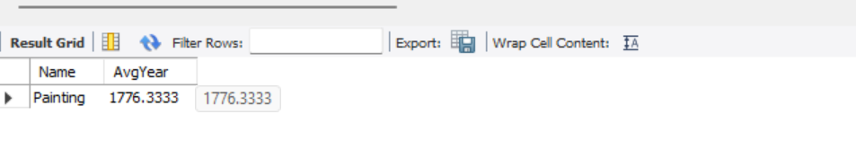

-- 16. Find the artworks that were exhibited in the 'Modern Art Masterpieces' exhibition.

SELECT ar.Title

FROM Artworks ar

JOIN ExhibitionArtworks ea ON ar.ArtworkID = ea.ArtworkID

JOIN Exhibitions e ON ea.ExhibitionID = e.ExhibitionID

WHERE e.Title = 'Modern Art Masterpieces';

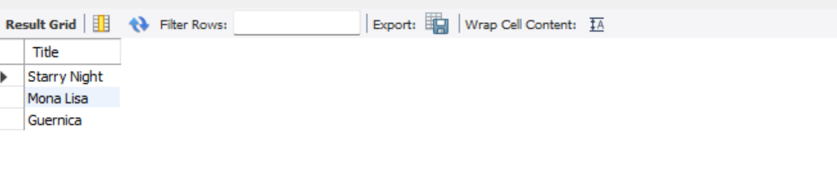

-- 17. Find the categories where the average year of artworks is greater than the average year of all artworks.

SELECT c.Name

FROM Categories c

JOIN Artworks ar ON c.CategoryID = ar.CategoryID

GROUP BY c.CategoryID

HAVING AVG(ar.Year) > (SELECT AVG(Year) FROM Artworks);

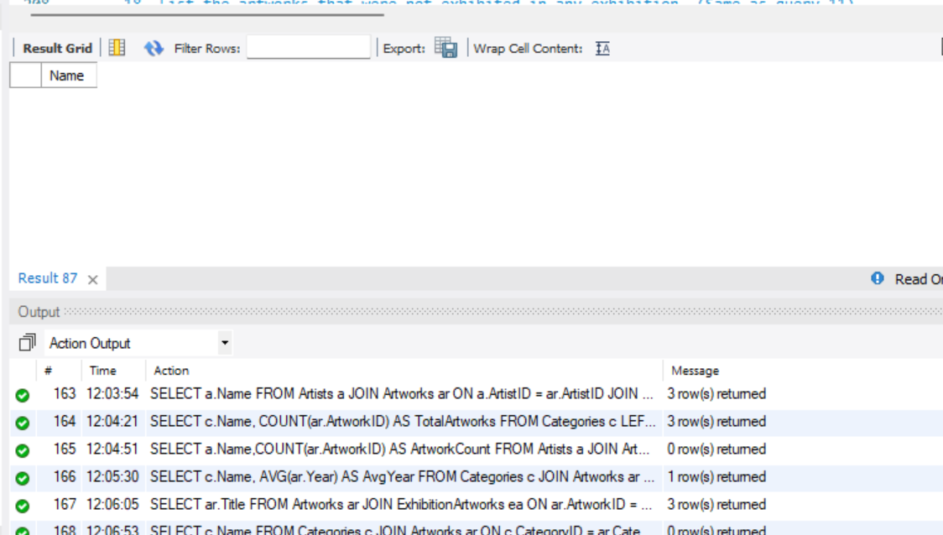

-- 18. List the artworks that were not exhibited in any exhibition. (Same as query 11)

SELECT ar.Title

FROM Artworks ar

LEFT JOIN ExhibitionArtworks ea ON ar.ArtworkID = ea.ArtworkID

WHERE ea.ExhibitionID IS NULL;

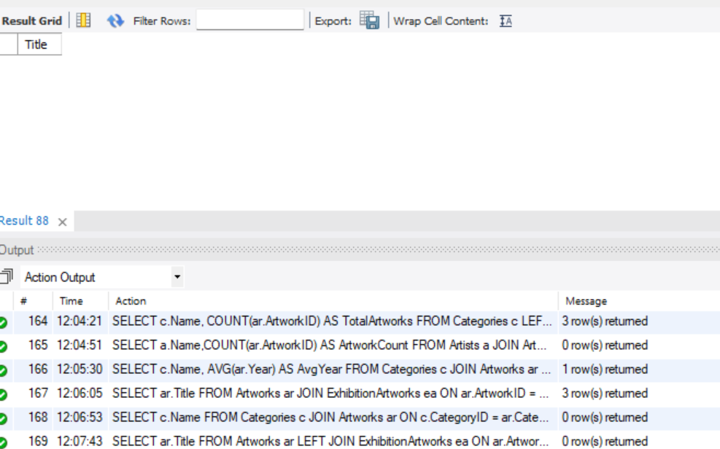

-- 19. Show artists who have artworks in the same category as "Mona Lisa."

SELECT DISTINCT a.Name

FROM Artists a

JOIN Artworks ar ON a.ArtistID = ar.ArtistID

WHERE ar.CategoryID = (SELECT CategoryID FROM Artworks WHERE Title = 'Mona Lisa');

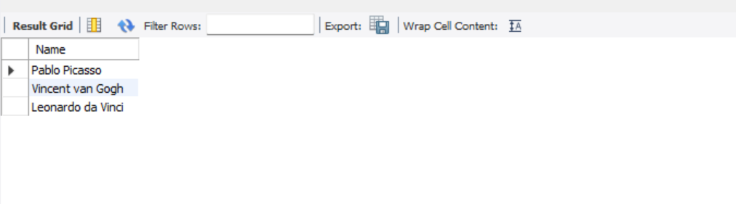

-- 20. List the names of artists and the number of artworks they have in the gallery.(same as 1)

SELECT a.Name, COUNT(ar.ArtworkID) AS ArtworkCount

FROM Artists a

LEFT JOIN Artworks ar

ON a.ArtistID = ar.ArtistID

GROUP BY a.ArtistID

ORDER BY ArtworkCount DESC;

