Minor Project Report
Exploratory Data Analysis (EDA) — Heart Disease (Cleveland) Dataset
Student: Siddharth Singh Roll No: DSBA-T12/AUG-11532 Program: Data Science & Business Analytics Traineeship — InternsElite

Project Title & Objective
Exploratory Data Analysis (EDA) Project — to perform an in-depth EDA on a chosen dataset to gain meaningful insights, identify patterns, trends, and relationships within the data.

Dataset Description
Heart Disease (Cleveland) Dataset (303 patient records, 14 original clinical fields), originally published on the UCI Machine Learning Repository (archive.ics.uci.edu/dataset/45/heart+disease). Since UCI's own servers were not directly reachable from this environment, the identical published dataset was retrieved from a verified public GitHub mirror of the same UCI file. It combines numeric clinical measurements (age, cholesterol, blood pressure, max heart rate) with categorical clinical test codes (chest pain type, ECG results, thalassemia result) and a heart disease diagnosis outcome. After cleaning (imputing missing test results and engineering a binary target), the final dataset contains 303 records and 19 analysis-ready features.

Tools and Libraries Used
Python (Jupyter Notebook), Pandas, NumPy, Matplotlib, Seaborn.

Screenshots of Key Visualizations
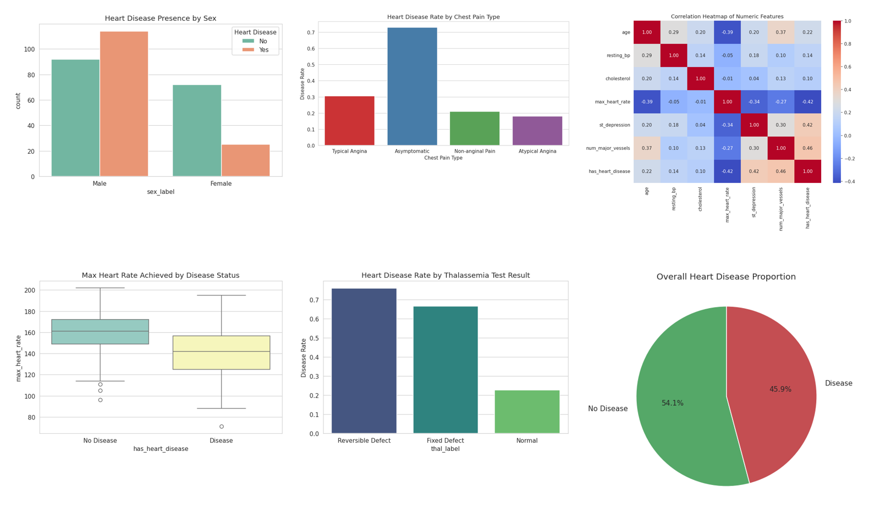

Summary of Insights
- Overall disease rate was about 45.9% of patients in this dataset.
- Sex is a strong risk indicator: males had a ~55% disease rate vs ~26% for females.
- Asymptomatic chest pain carried the highest disease rate (~73%), a well-documented clinical pattern.
- Max heart rate is inversely correlated with disease (-0.42); ST depression and vessel count are the strongest positive correlates.
- Thalassemia result shows a clear gradient: reversible defect carries far higher disease risk than normal.

Challenges Faced and Solutions
Challenge | Solution
UCI's own servers were not directly reachable | Sourced the identical published dataset from a verified public GitHub mirror of the same UCI file.
'ca' and 'thal' columns used '?' for missing values and loaded as text | Converted to numeric with coercion, then imputed the few missing entries with the column mode.
Original diagnosis label was multi-class (0-4 severity) | Engineered a standard binary has_heart_disease target alongside the original stage.
Cholesterol and resting BP contained clinically extreme outliers | Applied IQR-based capping rather than deleting rows, preserving the full patient sample.

