# DishDash: A Discount-Driven Online Ordering Platform for Restaurants

Siddaharth Suman and Ketaki Suhas Kulkarni Informatics, Northeastern University

ITC 6355: Web Application Design and Development Prof. Amin Karimpour

December 14, 2024

# Project Description

DishDash is a dynamic, web-based application developed to bridge the gap between small and medium-scale restaurants and their potential customers. The platform’s primary goal is to offer these restaurants an online presence with minimal setup cost, while incentivizing customers with a $1 discount on every order placed through the platform. The use of this incentive will drive user adoption and promote consistent usage of the service.

For restaurant owners, especially small businesses, gaining visibility on online platforms can be expensive and complex. DishDash solves this problem by providing a simple solution that drives customer traffic and boosts sales volumes. Additionally, the platform offers a streamlined ordering system, encouraging customers to make repeat orders. This ease of access and customer-friendly rewards system will empower small restaurant owners to compete with larger chains and platforms.

# Objectives

1. **Enhance Restaurant Visibility:**DishDash aims to level the playing field by offering small and medium-scale restaurants a platform to gain visibility and connect with a broader customer base. Through this initiative, these businesses can reach customers who may not have otherwise discovered them, enabling greater brand awareness and customer retention.
2. **Promote Higher Order Volumes with Discounts:**By offering a $1 discount on every order, the platform encourages customers to opt for online ordering, increasing the frequency of orders. This discount system is designed to provide immediate value to both the restaurant and the consumer. Additionally, the system will offer volume-based discounts, making it beneficial for customers to order in bulk, further driving sales.
3. **Simplify Online Ordering for Customers:**DishDash aims to eliminate the complexities often associated with online ordering systems. The interface is designed to be user-friendly, with intuitive navigation and features like saved payment information, order history, and easy access to menu updates. The goal is to create a seamless ordering experience from start to finish, ensuring a frictionless user journey.

# Scope of the Project

DishDash is designed with scalability and flexibility in mind. The platform is intended to cater to a wide variety of restaurant types, from fast food to fine dining, and will scale as it grows. The initial phase will onboard local restaurants, focusing on establishing a core group of partners and refining the user experience before expanding to a larger audience.

Key features of the platform include:

* **User Account Management**: A secure registration and login process with personalization options to enhance user experience.
* **Restaurant Listings**: A comprehensive directory of participating restaurants, sortable by criteria such as cuisine type, customer ratings, distance, and more.
* **Order Tracking**: Real-time status updates on the user’s order to keep them informed about the preparation and delivery stages.
* **Discount and Reward System**: A built-in reward system that automatically applies a $1 discount on every order and allows customers to accrue points for further discounts.

# Features

# User Account Management

# Secure Registration and Login: Users can create an account using email or social media logins. The account will securely store order history, payment methods, preferences, and loyalty points.

# Personalized Profiles: Customers can save their favorite restaurants, dishes, and payment methods, enabling quicker orders for future visits.

# Order History and Repeat Orders: Users can view their order history and reorder previously purchased items with a single click.

# Restaurant Listings

# Filterable Listings: Customers can sort and filter participating restaurants by various factors such as cuisine type (Italian, Chinese, etc.), rating, distance, and availability of special promotions.

# Real-time Menu Updates: Restaurants can easily update their menus in real time to reflect availability, specials, or changes in pricing.

# Customer Reviews and Ratings: Users can rate their orders and write reviews, creating an interactive and community-driven atmosphere.

# Ordering and Tracking

# Easy Ordering Process: Users can select their desired items from the menu, customize their orders, and proceed to checkout with minimal steps.

# Real-time Order Tracking: The platform provides real-time updates on the order’s status, such as "Preparing," "Out for Delivery," and "Delivered," along with estimated delivery times.

# Push Notifications: Users will receive notifications about order updates, estimated delivery times, and special promotions available at partner restaurants.

# Discount and Rewards Management

# Automatic $1 Discount: Every order made through the platform receives a $1 discount, incentivizing customers to order frequently.

# Loyalty Points System: Customers earn points with each order, which can be redeemed for discounts or special offers. This encourages repeat usage and builds customer loyalty.

# Volume-based Discounts: Customers can earn additional discounts for bulk orders, perfect for large families or group orders.

# Technology Stack

# To ensure the platform’s scalability and reliability, DishDash will be developed using modern web technologies:

# Frontend: React.js for an interactive, responsive user interface that offers a fast and smooth user experience.

# Backend: Node.js and Express.js for a robust, scalable server-side application that efficiently handles requests and real-time updates.

# Database: MongoDB for storing user data, restaurant details, orders, and transaction history, chosen for its flexibility and scalability.

# Authentication: Firebase Authentication for secure, easy-to-implement user login and management.

# Payment Gateway Integration: Stripe for seamless and secure payment processing.

# Cloud Hosting: AWS for hosting the platform, ensuring scalability and high availability.

# Market Research and Competitive Landscape

# DishDash enters a competitive market filled with established players like GrubHub, DoorDash, and UberEats. However, these platforms often target large, established restaurant chains, leaving small and medium-sized restaurants with limited exposure and high service fees. DishDash differentiates itself by offering a low-cost, high-reward solution specifically tailored for smaller businesses. By focusing on the $1 discount incentive and a simplified user experience, DishDash can carve out a niche market, empowering small businesses and attracting price-conscious customers.

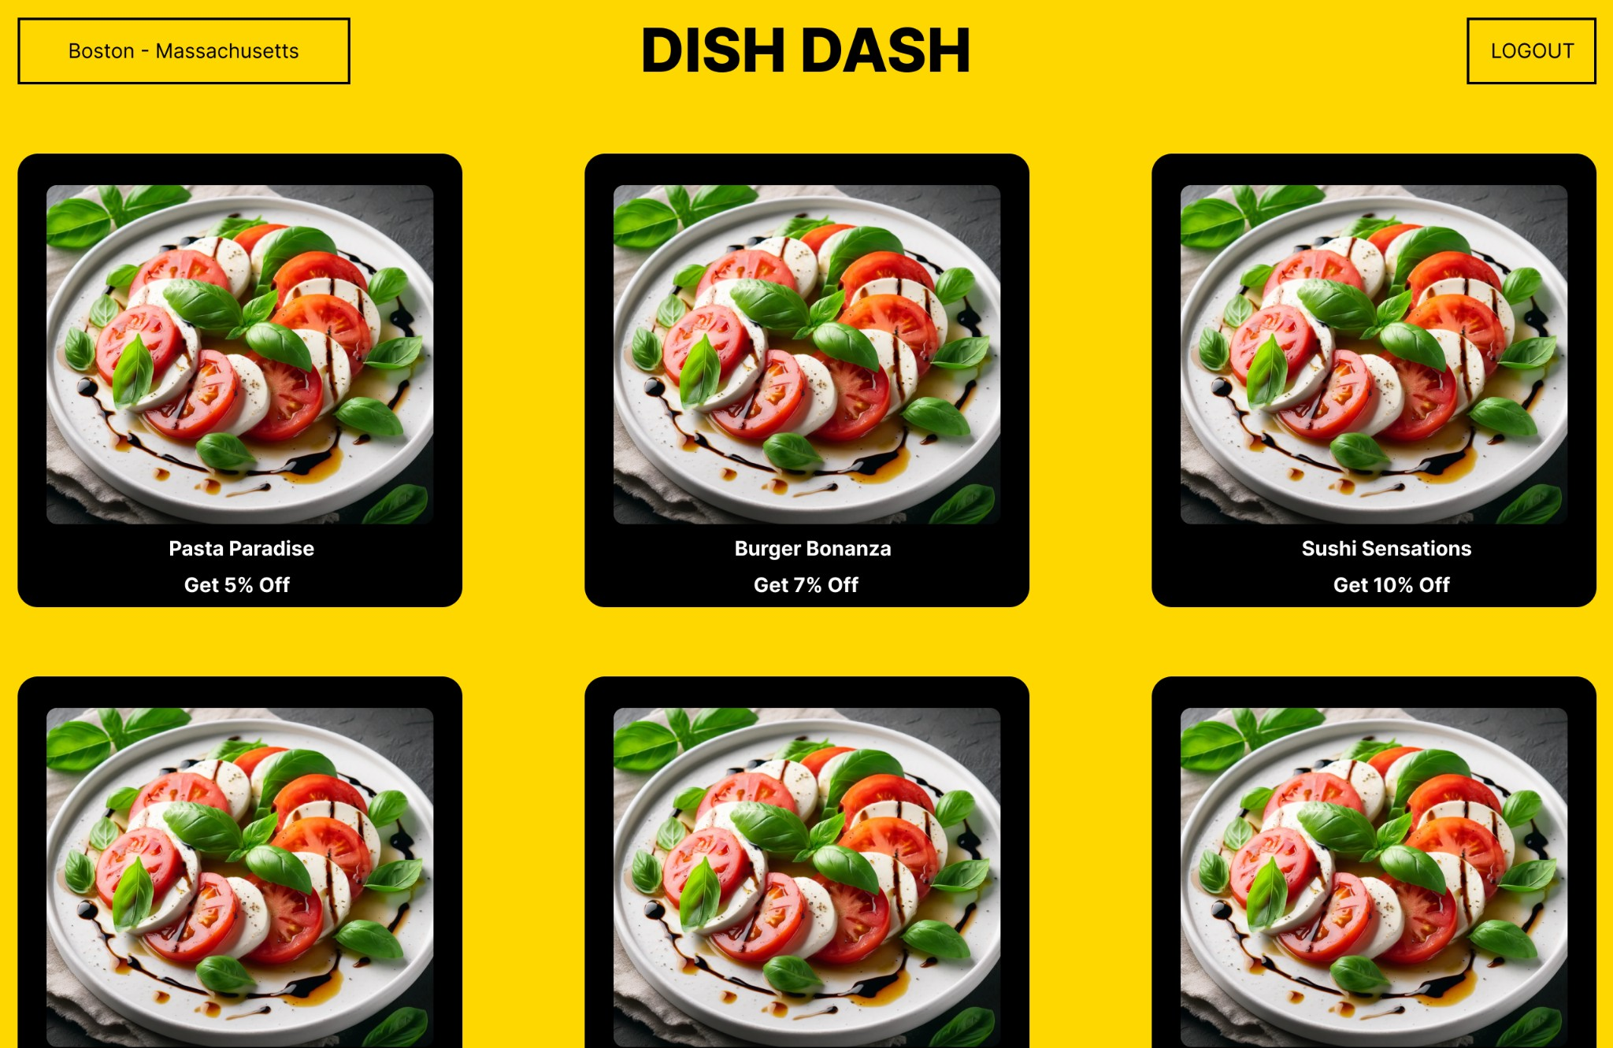**Design:**

