**HALF SUBTRACTOR USING LOGISIM**

**AIM:**

To design and implement the two bit half subtractor using Logisim simulator.

**PROCEDURE:**

1. Pick and place the necessary gates.
2. Insert 2 inputs into the canvas.
3. Connect the inputs to the OR gate, AND gate and NOT gate.
4. Insert 2 outputs into the canvas.
5. Make the connections using the connecting wires.
6. Verify the truth table.

**TRUTH TABLE:**

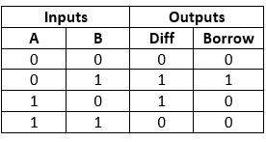

Diff=A'B+AB'  
Borrow = A'B

**OUTPUT**

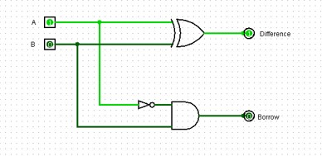

***RESULT:*** *Thus 2-bit half subtractor has been designed and implemented successfully using* Logisim simulator