IndicLearn
Studio
A multilingual study studio for students
Upload notes · read them in the app · ask a tutor in English, తెలుగు, हिन्दी or संस्कृतम् · take quizzes · watch a personal mind map grow

Project guide: what it is, what was wrong with the first version, what technology and models are used, and what happens inside the code.
Author: Siddarth · Domain: NLP for Indic languages (text) · Constraint: no hosted / external API

Contents
1. The project in one page
2. Audit of the first prototype: mistakes, gaps, improvements
3. A tour of the finished application (with screenshots)
4. How the system is built (architecture)
5. Technology stack
6. Models and NLP concepts, explained simply
7. Inside the code, file by file
8. The data: database tables and API
9. How the four languages work
10. Scalability and deployment
11. Testing and quality
12. Honest limitations
13. How to explain this to your sir (likely questions)
14. Future work
Appendix: how to run it

1. The project in one page
IndicLearn Studio is a web application for students. A student uploads a study file (PDF, PowerPoint, Word, Markdown or text) and can immediately:
- Read the file inside the app, with the key terms underlined. Clicking a term shows its definition; selecting any sentence offers “Ask tutor”.
- Ask doubts to a small tutor bot while reading. The bot understands and replies in English, Telugu, Hindi and Sanskrit, answers only from the student’s own notes, quotes the page it used, and refuses to guess when the notes do not contain the answer.
- Take quizzes that the bot (or the Quiz page) generates from the same notes: fill-in-the-blank, “which description fits this term”, and true/false.
- See a mind map. Every document gets a default knowledge map built only from the document itself (topic hierarchy, prerequisite flow, related ideas). On top of it each student gets a personal map that changes colour as they ask questions and answer quizzes, and grows new doubt nodes for questions the notes could not answer.
- Learn from the map: hover a node for a quick definition, click it for details (definition, examples, formulas, what to learn first, what it leads to, a link to the exact page), mark “I understand / still confused”, ask the tutor about it, or follow a guided tour along the learning path.
Hard rules that shaped every decision: no hosted or external API (pretrained models may be used locally); students only; the Indic-language scope must remain (Telugu, Hindi, Sanskrit with English); it must be deployable and scalable, not just a demo.

What is new compared with the first prototype
 | First prototype | IndicLearn Studio
Content | One hard-coded 15-concept Signals & Systems graph | Any uploaded document becomes its own graph (tested on 4 sample notes in 4 languages and on a real 7-page research paper)
Map | A vertical column of nodes with “?” labels | Interactive d3 mind map: Radial / Tree / Flow layouts, hover + click details, search, guided tour
Personalisation | Not connected to the student’s real activity | Mastery computed from questions asked, quiz answers and “I understand” clicks; doubt nodes; recommendations
Tutor | None in the UI | Multilingual (en/te/hi/sa), grounded, cited, makes quizzes
Look | Dark theme | Light, white + gold, serif headings (modelled on your reference site)
Deployability | Heavy mandatory dependencies, no auth, no packaging | Accounts + guest mode, per-user isolation, SQLite/WAL, Docker + compose, env-var config, optional models

2. Audit of the first prototype
You said “nothing is working perfectly”. The audit below lists what was actually wrong, in order of how much it mattered, and what was done about each point. Items marked “brief” were not bugs in old code; they were things your brief required that the prototype did not do at all.
# | Finding | Why it mattered | What was done
1 | The graph was a fixed, hard-coded Signals & Systems graph | Nothing a student uploaded could ever appear on the map | New pipeline: parse → structure → concept mining → graph for any document
2 | Nodes were drawn as a vertical column of “?” with poorly labelled topics | A mind map is only useful if each node says what it is and where it belongs | Real labels, hierarchy (chapter → topic → concept), radial/tree/flow layouts, definitions on hover/click
3 | Brief: no way to upload and read a file | The core student workflow was missing | Library, upload/drag-drop, in-app reader, original-PDF view
4 | Brief: no doubt-asking bot in the interface | Doubts while reading were the main use case | Tutor drawer next to the reader and the map; selection → “Ask tutor”
5 | Brief: no quiz generation from the student’s own material | Quizzes were not tied to the uploaded notes | Quiz generator + quiz cards inside chat + Quiz page
6 | Brief: the map was not personalised from real activity | The “personal” map was not driven by questions and quiz results | Evidence log → mastery model → overlay colours, progress rings, doubt nodes
7 | Brief: default vs personal map not separated | A student’s activity must not rewrite the base structure | Default map = document only; personal map = default + overlay (tested)
8 | Telugu/Hindi text was split wrongly by a normal word regex (`\w` breaks on vowel signs) | Telugu words were cut into pieces; retrieval and concept mining failed on Indic text | Explicit Unicode-range tokenizer for Telugu and Devanagari
9 | Headings of PDFs (IEEE style small-caps) were demoted or lost | Wrong topic hierarchy | Font-size analysis plus text patterns for strong headings
10 | Hard dependencies on `faiss-cpu` and `sentence-transformers` | Needs GBs of downloads before anything runs; fails on a locked-down laptop | Core runs on plain Python libraries; neural models are optional extras
11 | No user accounts or data separation; no limits on upload | Not deployable for more than one student | scrypt-hashed passwords, hashed bearer tokens, guest mode, per-user isolation tests, size/count limits
12 | Dark theme | You asked for a light white-and-gold look | New design system (tokens in `theme.css`), self-hosted fonts incl. Telugu/Devanagari
13 | API docs route collided with the documents route (found while testing the new UI) | The library page broke silently | Swagger UI moved to `/api/swagger`
14 | Short off-topic questions were glued to the currently focused topic (found in screenshots) | The bot answered “who invented pizza” as if it were about Aliasing | Focus fallback only for real follow-ups (“give an example”, “why?”); test added

Mistakes found and fixed during development of the new version
- A heading that followed a table caption was swallowed by the caption-continuation rule (now headings win).
- An index error for concept names whose surface forms all had weight zero.
- A key error when relations referred to concepts that had been filtered out.
- “For z transform” was phonetically matched to “Fourier transform”: windows may no longer start or end on a stop-word and same-length windows are compared word by word.
- Generic-word lists were too aggressive and removed real terms like “unit step”, “time domain”, “Nyquist rate”: they are now edge-only words.
- Sentences such as “This minimum rate is called the Nyquist rate” were stored as the definition: the previous sentence is now added so the definition makes sense on its own.
- Research-paper noise (table numbers, glued tokens like “TheMIMIC”, adverbs, roman numerals) is filtered; some residual noise remains (see limitations).

3. A tour of the finished application

3.1 Sign in or continue as guest
Students can create an account or try the app immediately as a guest. The language selector is available from the first screen. Passwords are hashed with scrypt; the browser keeps only a random token.
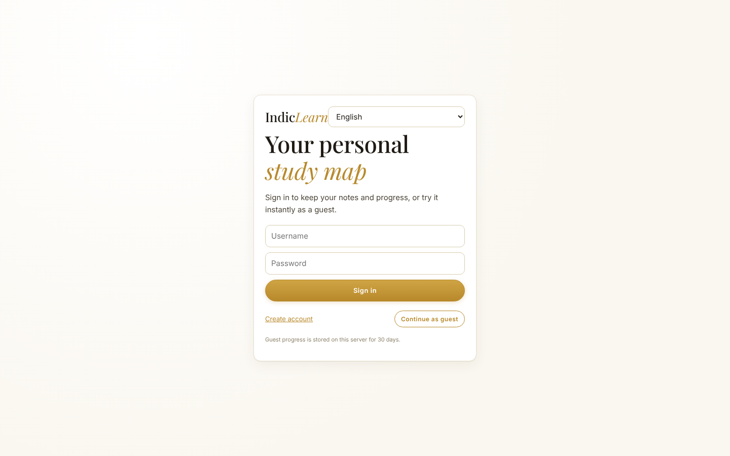
Figure 1 – Sign-in screen in the light/gold theme.

3.2 Library: upload a file
Drag a file into the dashed box or press “Choose file”. PDF, PPTX, DOCX, Markdown and TXT are accepted. The card shows “Reading your notes…” while the background worker parses the file, then shows the detected language, file type, number of concepts and pages. Four sample notes (English, Telugu, Hindi, Sanskrit) are included for a quick demo.
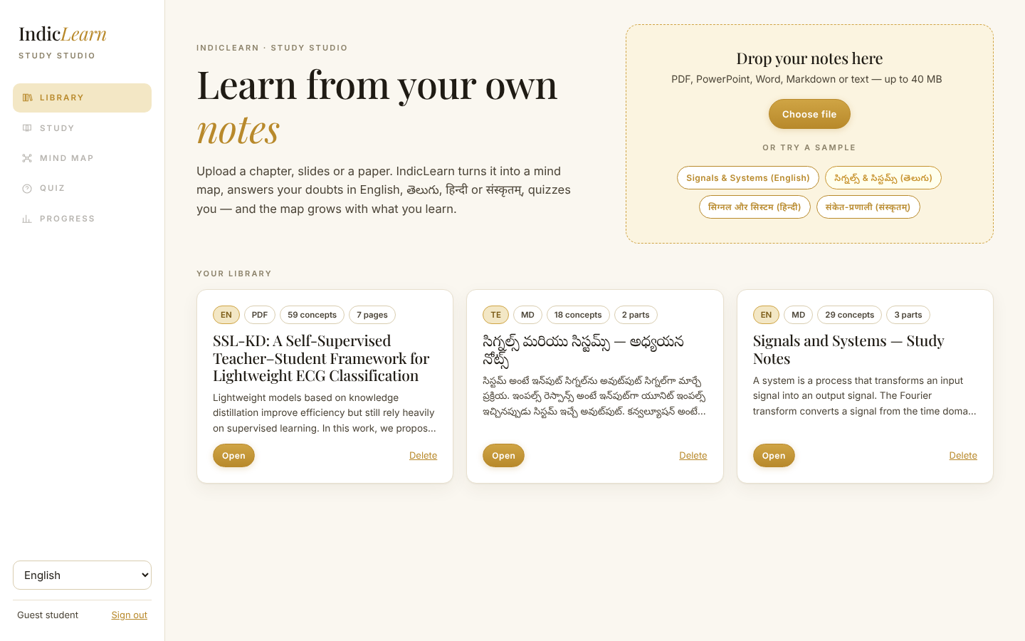
Figure 2 – Library with three documents: a real ECG research paper (PDF), the Telugu sample and the English sample.

3.3 Study: read inside the app
The reader shows the extracted text page by page with a table of contents on the left. Underlined terms are concepts mined from the document; clicking one opens a small card with its definition and two buttons (“Ask tutor”, “Mind map”). For PDFs there is also an “Original PDF” button that shows the untouched file.
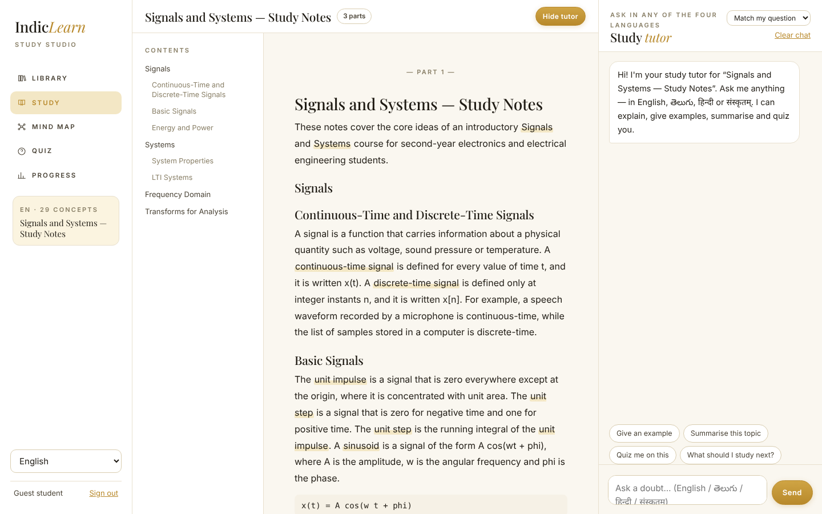
Figure 3 – Reader + tutor drawer.
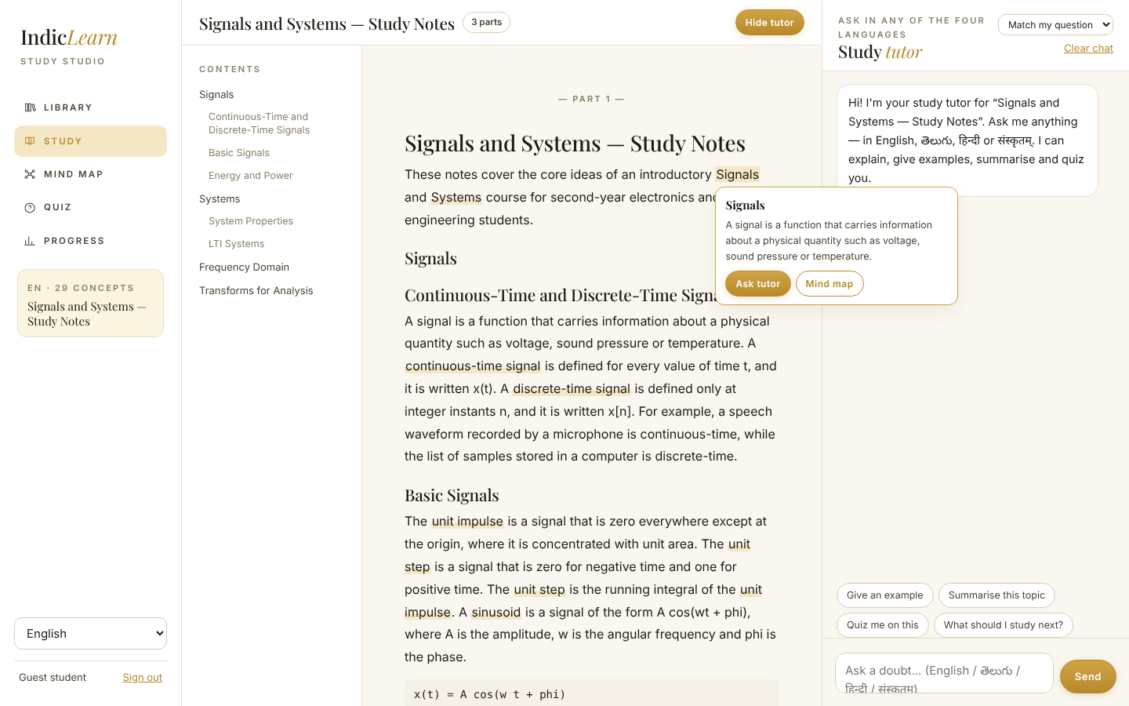
Figure 4 – Clicking an underlined term shows its definition and shortcuts.

3.4 Ask the tutor
Answers are assembled from the student’s notes: a definition (if one exists), the best-matching sentences with the page they came from, formulas, prerequisites (“Review first”), related ideas and what comes next. The small “page 3” chips are citations: clicking one scrolls the reader to the passage and highlights it. “Noted · Aliasing” tells the student that the question has been recorded on the map.
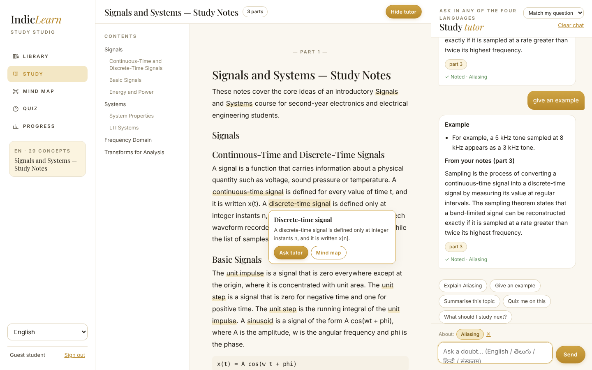
Figure 5 – A grounded answer with citations and a map update note.
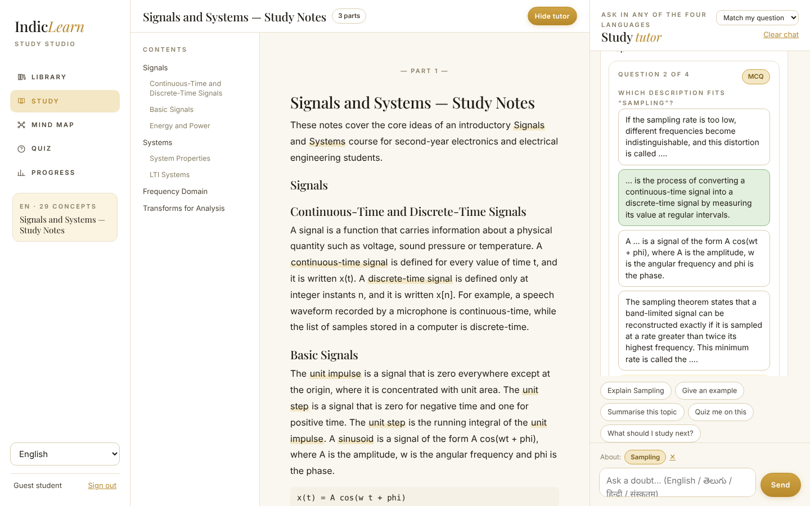
Figure 6 – The bot builds a quiz on request; each answer updates mastery.
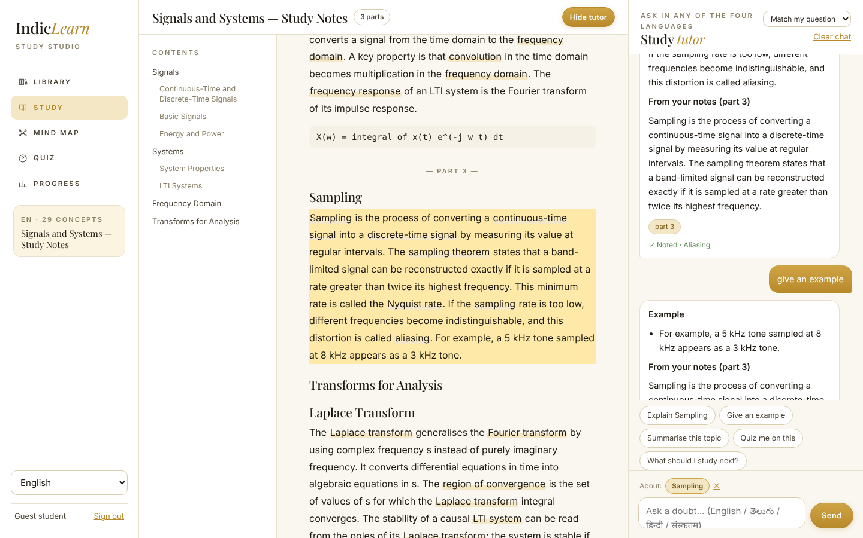
Figure 7 – Clicking a citation jumps to the exact passage in the reader.
Design decision – refuse to guess. If the notes do not contain the answer (relevance below 0.3 and no strong concept link) the bot says so, shows the closest passage it found, and stores the question as a doubt node. This is deliberate: a study tool that invents answers is worse than one that admits a gap.

3.5 The mind map
The map has two modes. Topic map is the default knowledge graph (same for every student). My map is the personal overlay. Three layouts show the same data differently: Mind map (radial, root in the centre), Tree (left-to-right outline) and Flow (columns follow the learning order and prerequisite arrows). Double-click a node to fold or unfold its children; use the search box to find a topic; “Fit” re-centres the view.
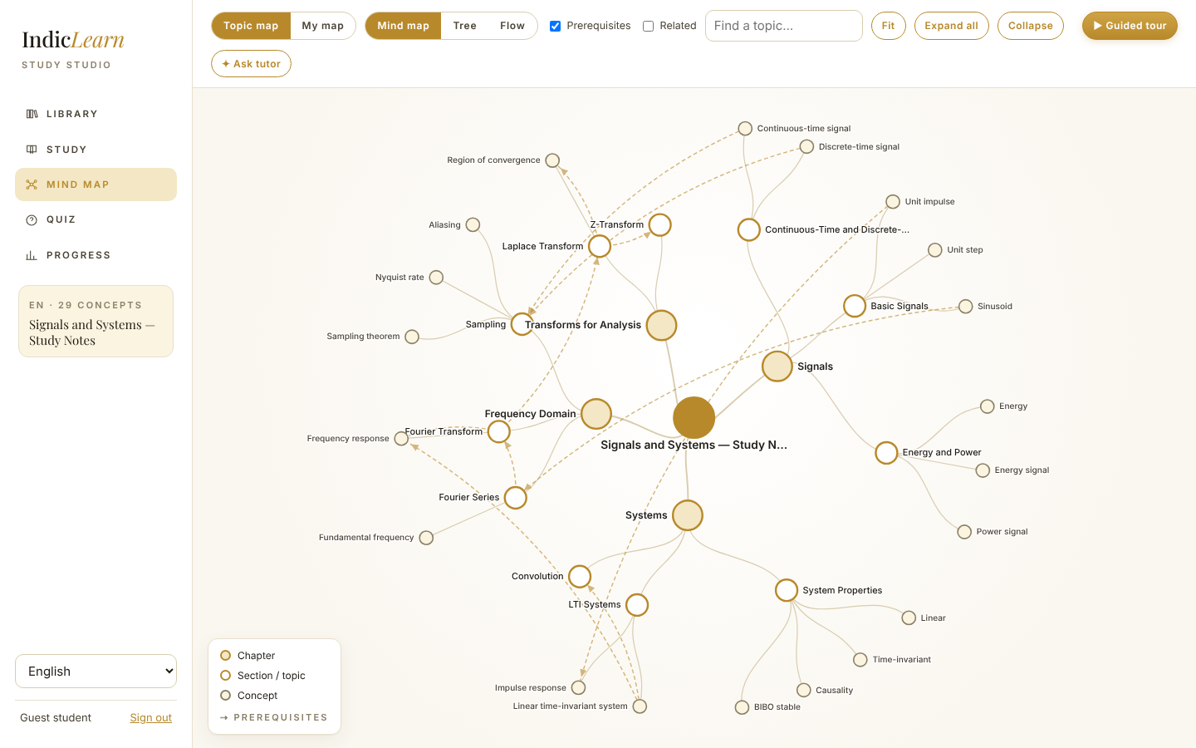
Figure 8 – Default map (radial). Filled gold circles are chapters; hollow gold circles are topics; small grey circles are concepts. Dashed gold arrows mean “learn this first”.
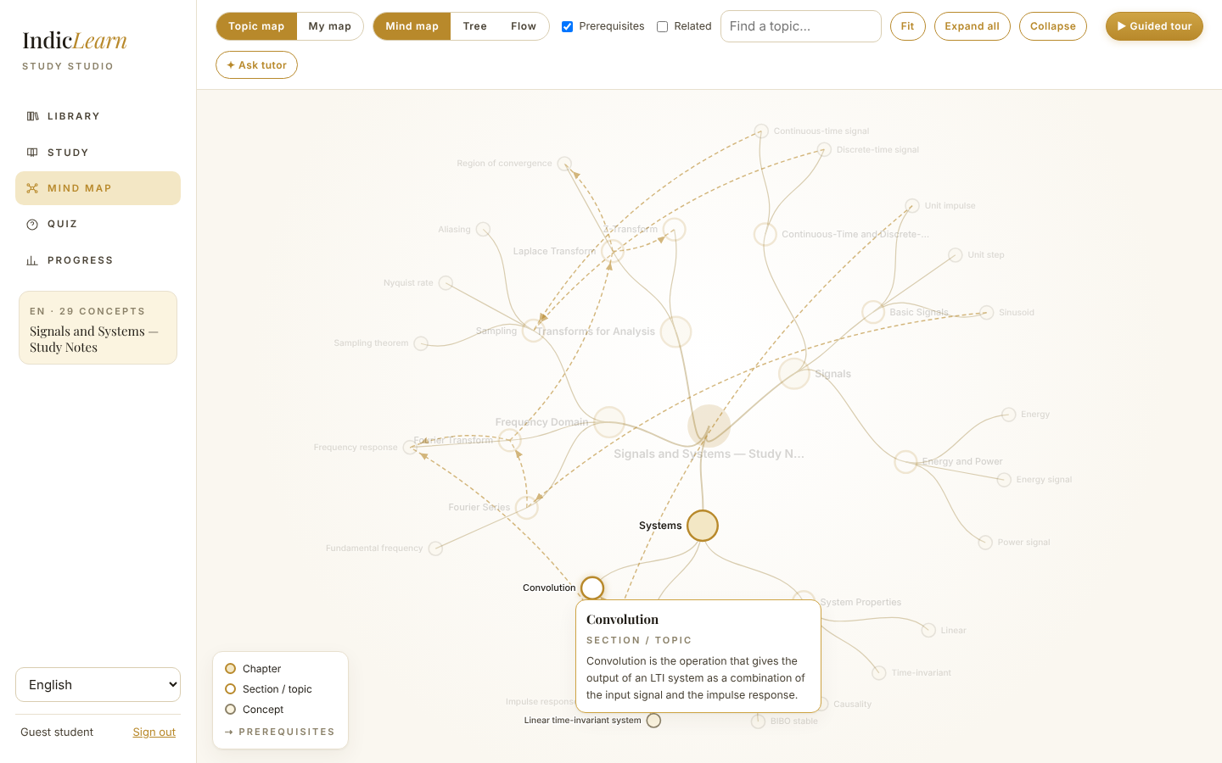
Figure 9 – Hover: a tooltip shows the type and the start of the definition; connected nodes stay bright.
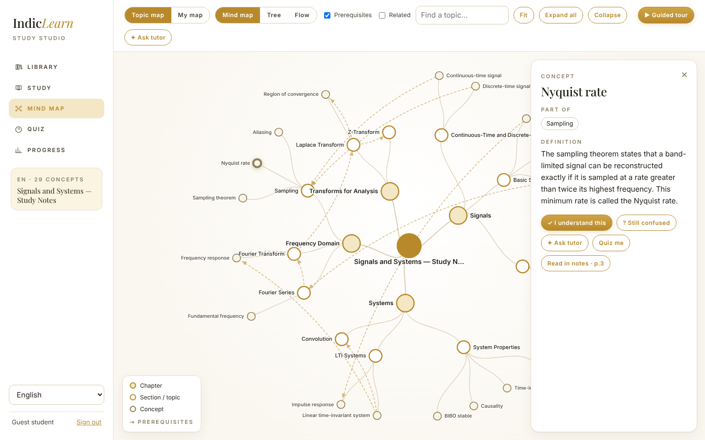
Figure 10 – Click: the detail panel with definition, examples, prerequisites, links and actions.
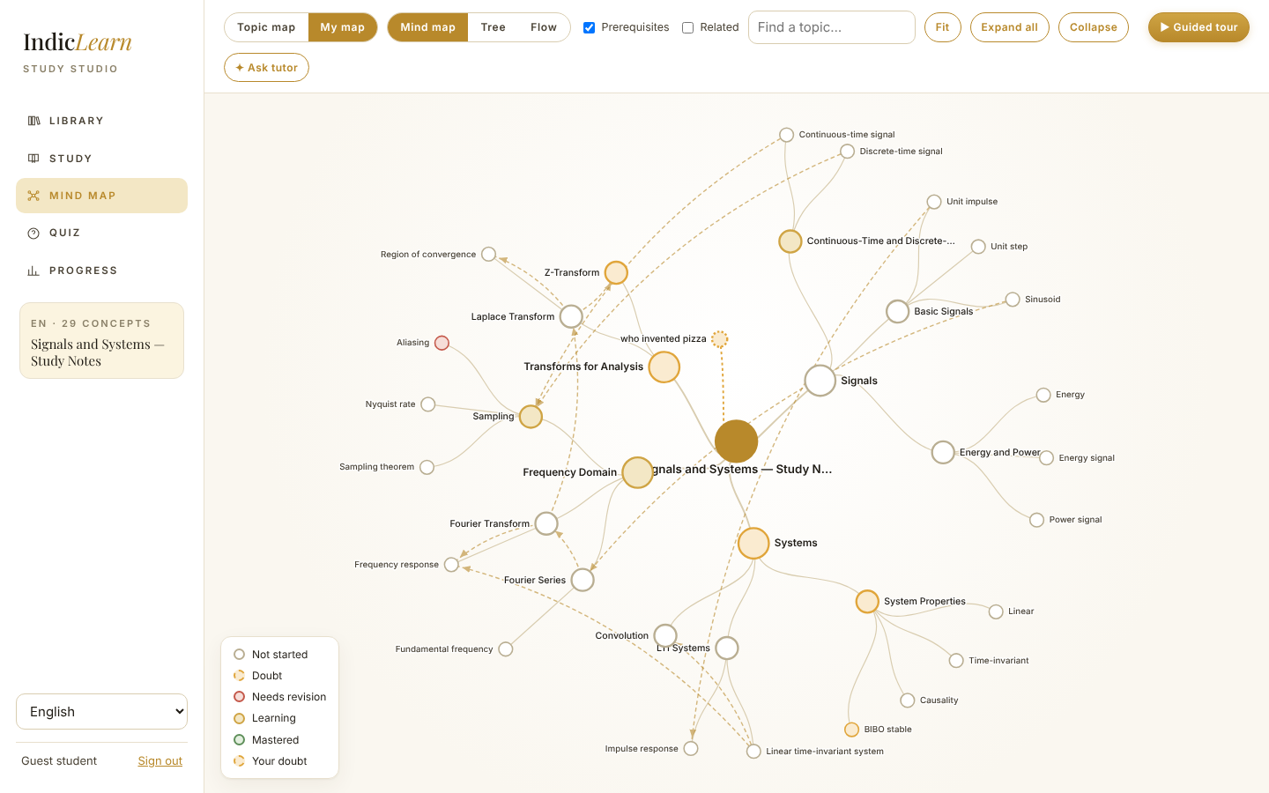
Figure 11 – Personal map. Colours show status: grey = not started, amber = doubt, red = needs revision, gold = learning, green = mastered. Topic nodes get a green progress ring. Dashed amber nodes are doubts.
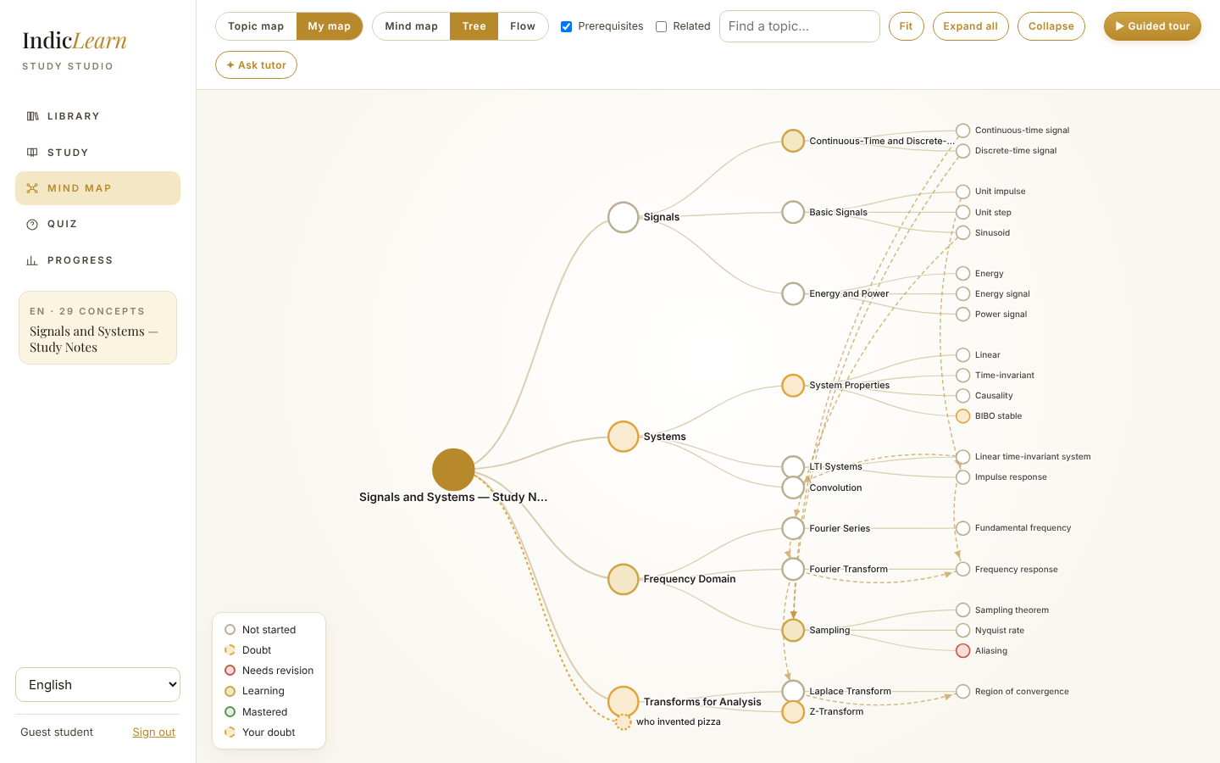
Figure 12 – Tree layout.
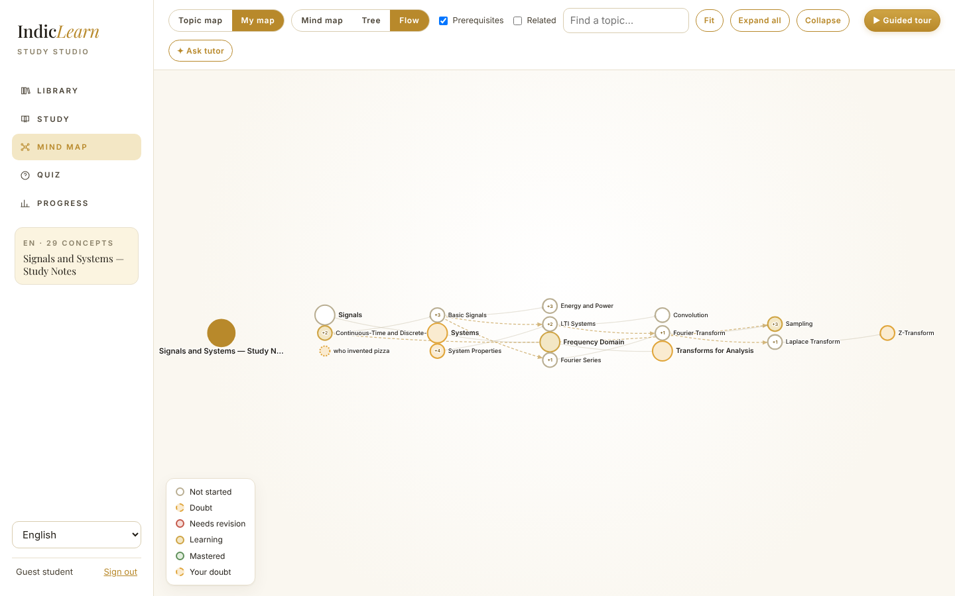
Figure 13 – Flow layout: topics ordered by the learning path and prerequisite links (concepts are folded into their topics).
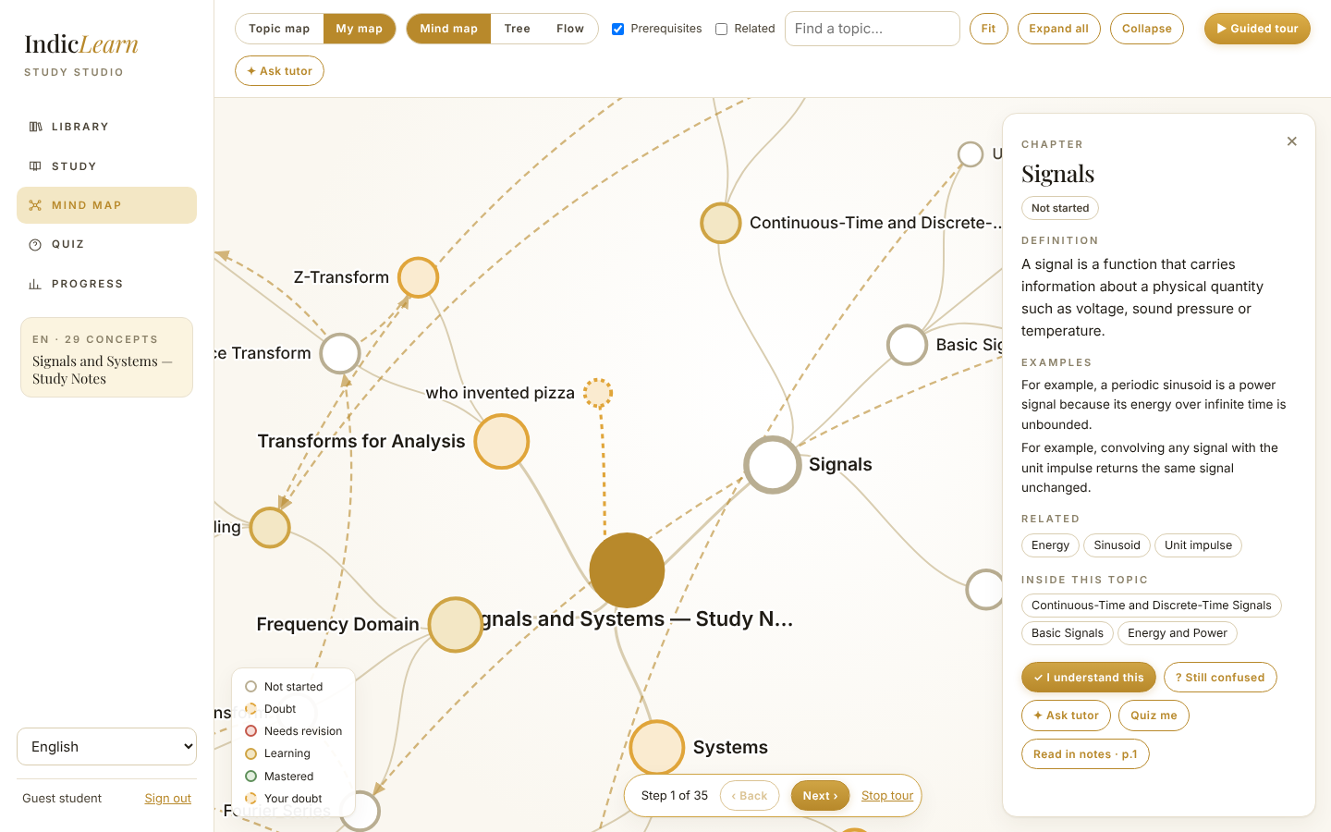
Figure 14 – Guided tour: steps through the learning path one node at a time.

3.6 Quiz and progress
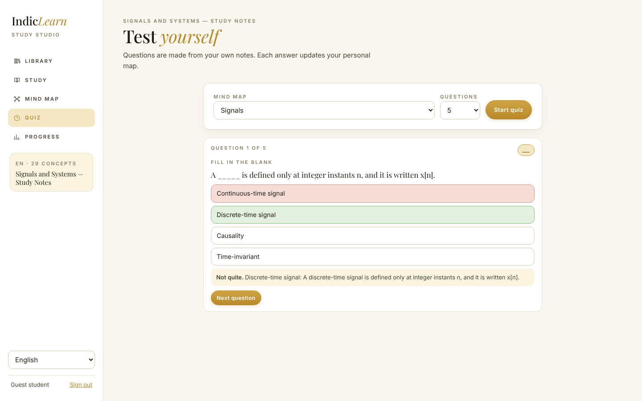
Figure 15 – Quiz page: choose the whole document or one topic, then answer. Wrong answers show the correct one and the definition from the notes.
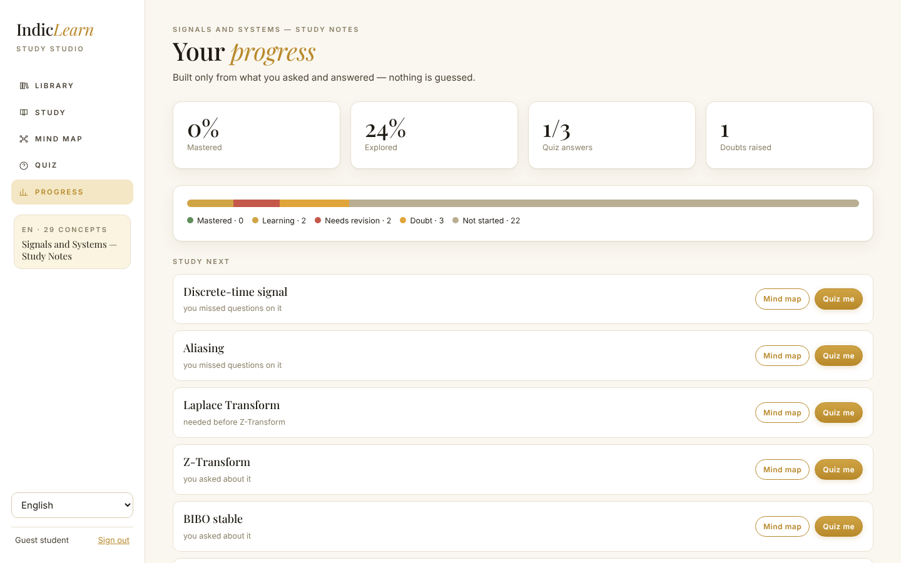
Figure 16 – Progress: counts per status and “Study next” recommendations with the reason for each.

3.7 Telugu, Hindi and Sanskrit
The interface language and the tutor language are independent of the document language. In the screenshots below the Telugu sample is open; the tutor replies in the language the student writes in (or the interface language when the script is ambiguous).
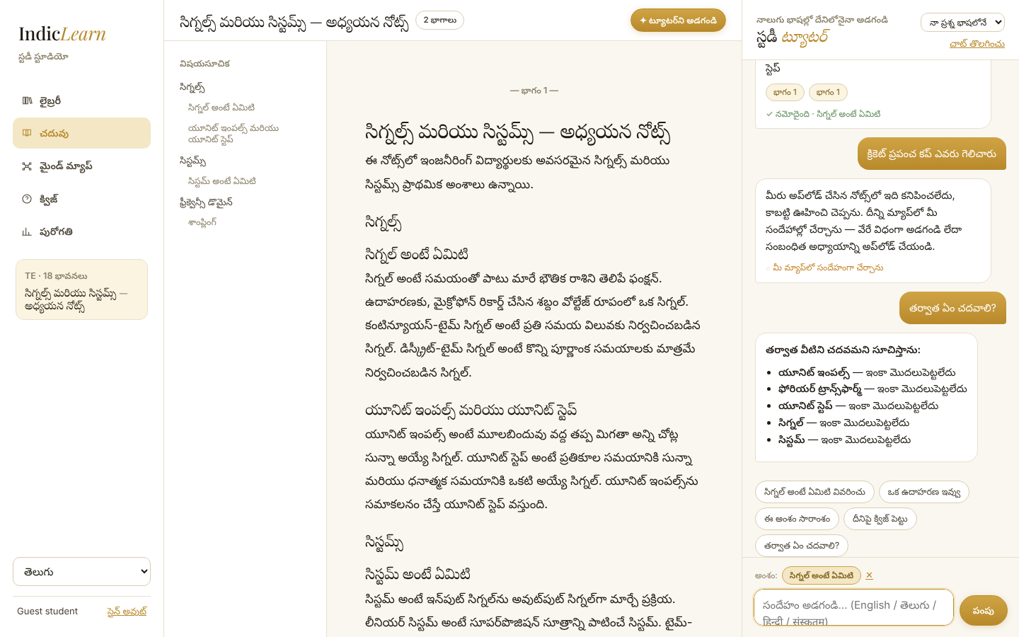
Figure 17 – Telugu interface and Telugu questions (“What is the Nyquist rate?”, “Give an example”, an off-topic question that becomes a doubt, “What should I study next?”).
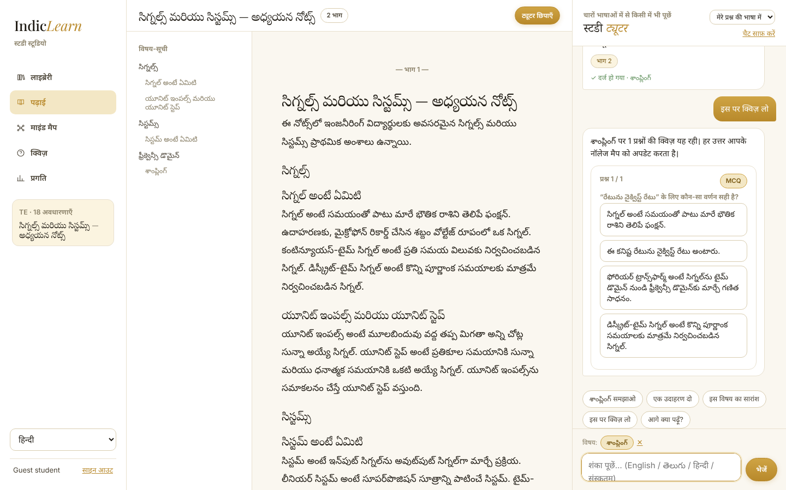
Figure 18 – Hindi interface; “quiz me on this” produces a Hindi-framed quiz.
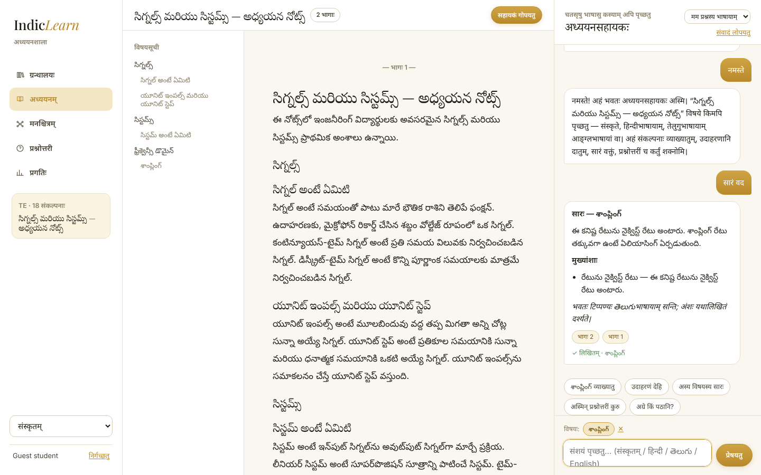
Figure 19 – Sanskrit interface and a Sanskrit request for a summary.
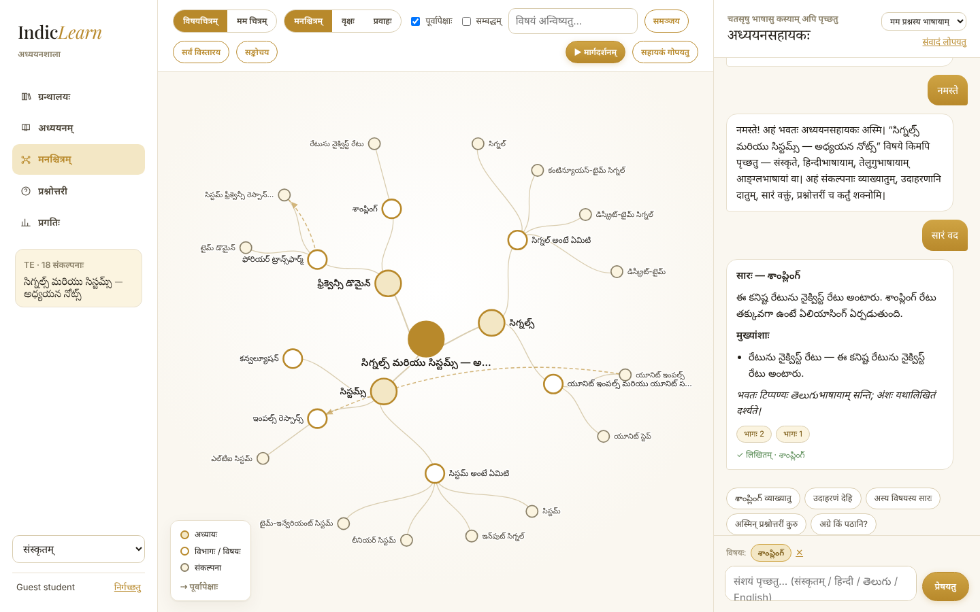
Figure 20 – The map of a Telugu document with the Sanskrit interface.

3.8 A real PDF
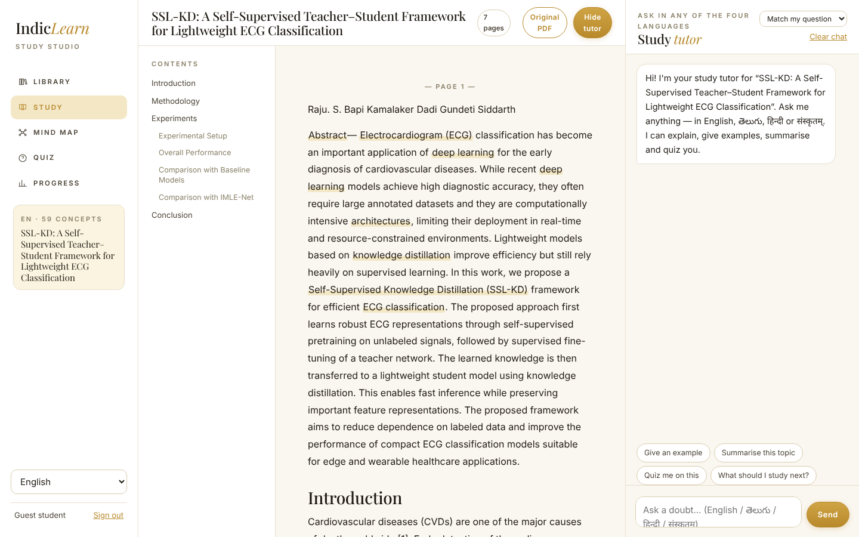
Figure 21 – A real research paper (your SSL-KD ECG paper) parsed into sections: Abstract, Introduction, Methodology, Experiments, Conclusion.
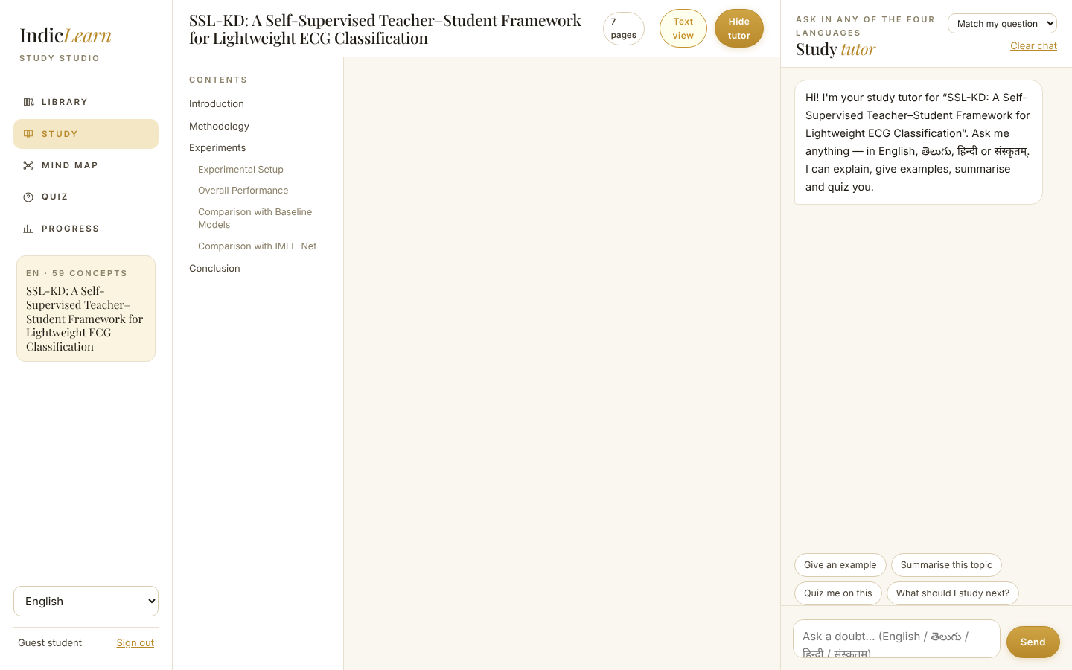
Figure 22 – “Original PDF” shows the untouched file.
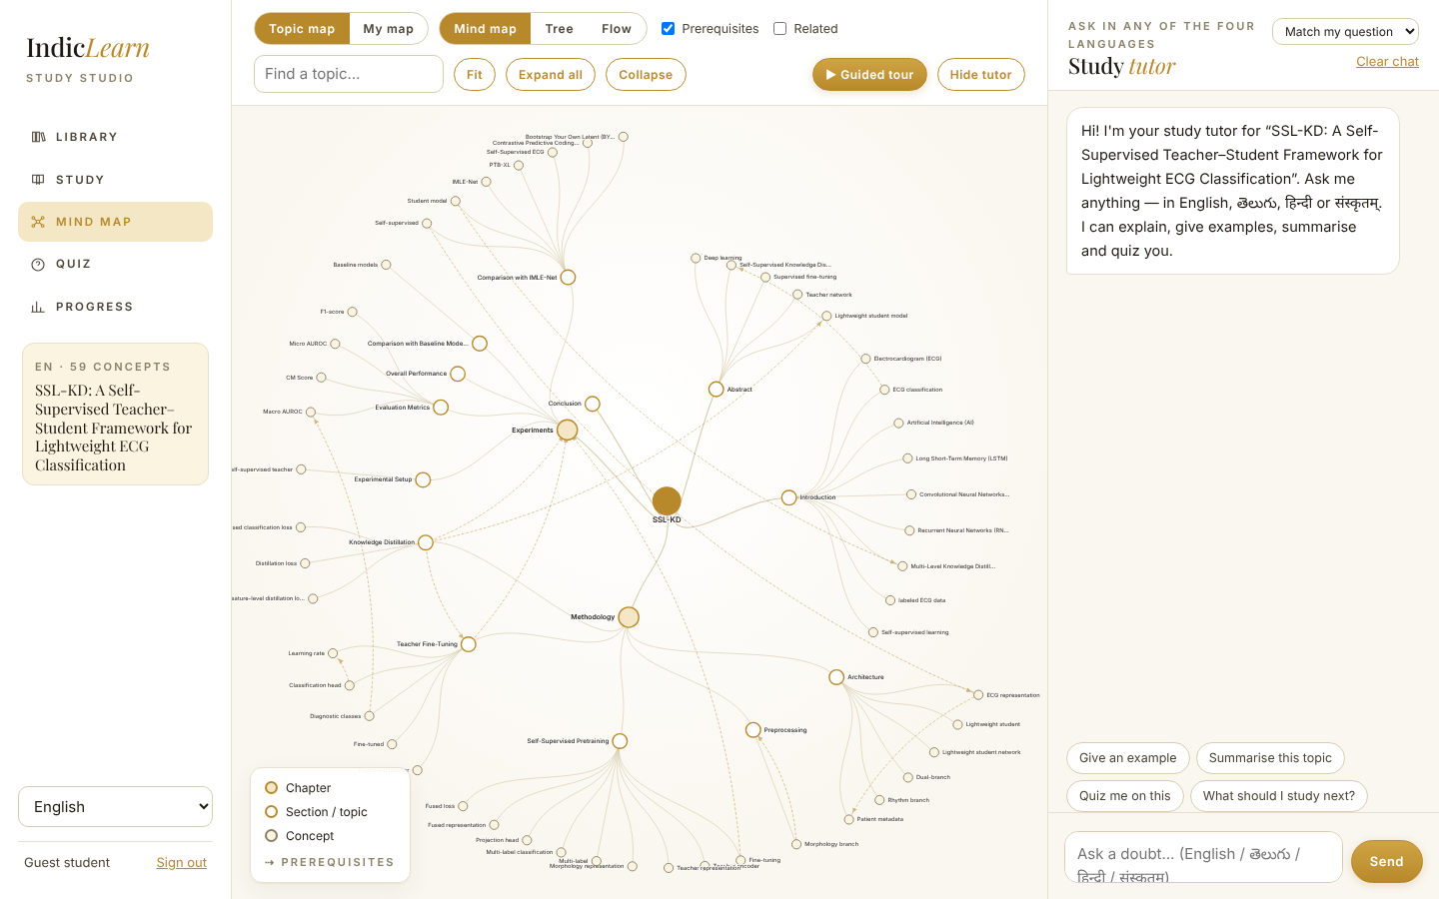
Figure 23 – Default map of the paper (59 concepts). Research papers are noisier than lecture notes; see limitations.

4. How the system is built
There are three layers. The browser shows the interface and talks to the server with JSON. The server (FastAPI) holds the logic. SQLite stores everything. Optional local models plug in at the side; if they are missing, the application silently uses its built-in methods.
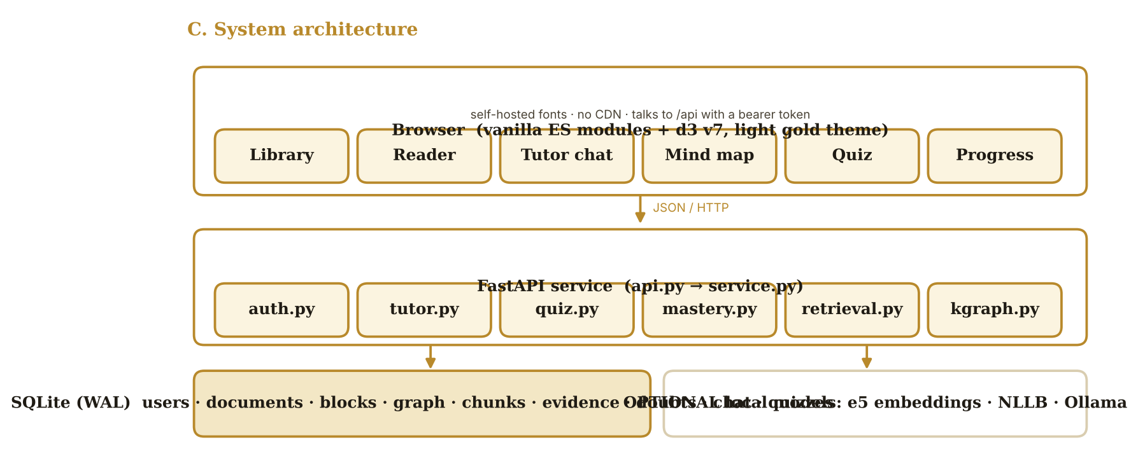
Figure 24 – System architecture.
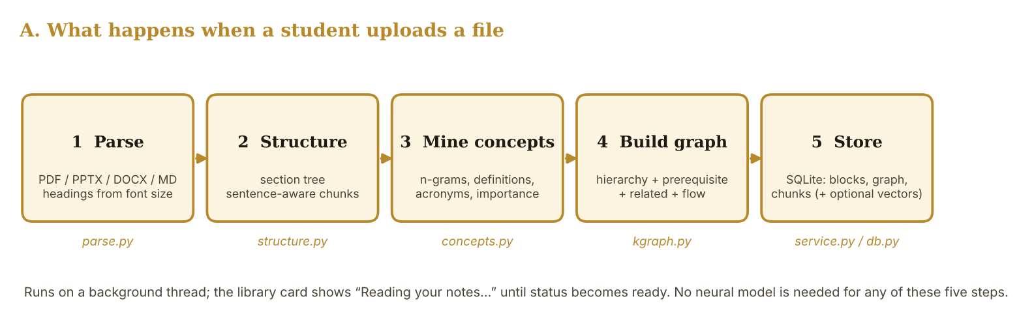
Figure 25 – Ingestion pipeline.
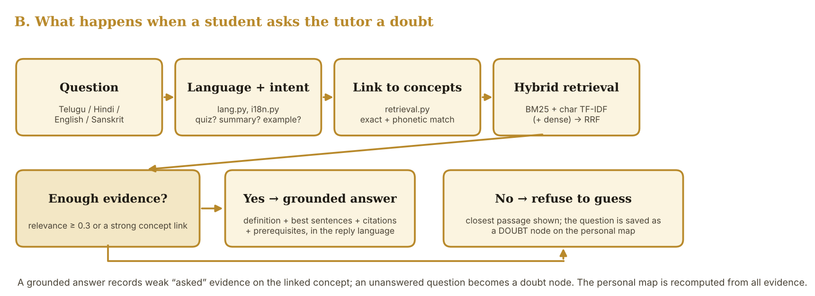
Figure 26 – Question pipeline.

4.1 Why “no neural model required” is a design choice, not a shortcut
- Your sir’s rule is no hosted API. Local models are allowed, but they need large downloads and often a GPU. A student on an ordinary laptop should still get a working tool.
- Study notes are small. For a 10-page document, classical retrieval (BM25 + character n-grams) is fast and very precise, and its behaviour can be explained line by line in a viva.
- Every answer sentence is quoted from the notes. A generative model could rephrase it but could also hallucinate; the extractive default cannot.
- Neural models are still supported as upgrades: dense multilingual embeddings, a local translator and a local LLM (section 6.6).

5. Technology stack
Layer | Technology | Why this choice
Language / runtime | Python 3.10+ (tested on 3.13 here; the project targets 3.10) | Matches your existing project and NLP ecosystem
Web framework | FastAPI + Uvicorn | Typed request validation, automatic OpenAPI, easy to scale with more workers
Database | SQLite in WAL mode (file `indiclearn.sqlite3`) | Zero setup; concurrent readers; the storage layer is isolated in `db.py` so PostgreSQL can replace it later
Document parsing | `pypdf` (PDF), `python-pptx`, `python-docx`, plain Markdown/TXT | Pure-Python, no system packages
Classical ML | scikit-learn `TfidfVectorizer` (character n-grams), NumPy | Lexical + sub-word retrieval that also handles Indic spelling variants
Auth | scrypt password hashing; random bearer tokens stored as SHA-256 hashes; 30-day expiry | No third-party identity service needed
Frontend | Vanilla ES modules (no build step), d3 v7 for the map | Nothing to compile; a student can read every file
Look & feel | CSS variables (tokens), Playfair Display, Inter, Noto Sans/Serif Telugu and Devanagari – all self-hosted in `frontend/vendor` | Works offline; no CDN; Indic scripts render correctly
Packaging | Dockerfile, docker-compose, `.env.example`, `run.bat`, `run.sh` | One command to run anywhere
Tests | pytest (272 total), Playwright for screenshots | Unit tests for NLP, API tests for isolation and flows
Optional local models | multilingual-e5-small (embeddings), NLLB-200-distilled-600M (translation), any Ollama model (rephrasing) | Quality upgrades; never required; never a hosted API

6. Models and NLP concepts, explained simply
Short answer to “what models are used?” By default no neural network at all. The “intelligence” comes from classical, explainable NLP: tokenisation, n-gram statistics, BM25, TF-IDF, rank fusion, a phonetic skeleton for cross-script matching, TextRank-style sentence scoring, and a Bayesian-style mastery estimate. Three optional neural components can be switched on (6.6). These optional paths are implemented with safe fallbacks but could not be run in the build environment (no access to Hugging Face), so they are untested here.

6.1 Reading documents (parse.py, structure.py)
- Font-size headings (PDF). `pypdf` can report the font size of every text fragment. The most common size is “body”; clearly larger or bold text near the top of a line becomes a heading. Strong patterns (“1. Introduction”, “Abstract—”) are accepted even when the font looks small.
- Slides and Word. PPTX slide titles and DOCX heading styles become headings; Markdown `#` headings are used directly.
- Section tree. Headings are turned into a tree (document → chapters → topics). References/Acknowledgements are kept in the reader but excluded from the map.
- Chunks. Each section is cut into passages of about 650 characters at sentence boundaries; every chunk remembers its page and section so answers can cite them.
- No headings? `auto_segment` uses a TextTiling-style method: it compares neighbouring windows of paragraphs with TF-IDF cosine similarity and cuts where similarity is lowest.

6.2 Finding the concepts (concepts.py)
This is the heart of the default knowledge map. It works the same way for English, Telugu, Hindi and Sanskrit because it relies on the language of teaching, not on a dictionary.
- Tokenise and stem. Words are split with a Unicode-aware regular expression (section 9) and reduced to a light stem (plural removal for English; suffix stripping for Telugu/Hindi).
- Candidate terms. Runs of content words become n-grams (1–4 words, “of” allowed inside, e.g. “region of convergence”). Stop-words and very generic words act as boundaries.
- Definition triggers. A candidate that appears in a defining pattern is boosted: English “X is defined as / is called / is the …”, Telugu “X అంటే / అనగా”, Hindi “X कहलाता है / कहते हैं”, Sanskrit “X इति / नाम”.
- Other boosts. Appearing in a heading, being emphasised (bold in Markdown) or being introduced as “Long Form (ABBR)” raise importance. Acronym pairs are merged.
- Scoring. Score ≈ frequency × specificity × length + boosts. Fragments of longer terms are dropped; terms are balanced across sections so every topic gets children.
- Attach details. Each concept gets its best defining sentence, examples (“For example …”), formulas and the pages where it appears.
- Relations. A prerequisite edge A → B is created when A appears in the explanatory part of B’s definition and A was introduced earlier. A related edge is created when two concepts co-occur in at least two short sentences. Section-to-section flow follows document order.
Why this is explainable: for any node you can answer “why is it on the map?” (frequency, definition pattern, heading) and “where did the definition come from?” (page and sentence).

6.3 Cross-language matching without a model (retrieval.py, phonetic.py)
A student may ask in Telugu about a term the notes write in English (“నైక్విస్ట్ రేటు”, “Nyquist rate”). To link them without a translation model, each word is reduced to a consonant skeleton in Latin letters (for example నైక్విస్ట్ → nkvst, Nyquist → nkst, अलियासिंग → lsnk, aliasing → lsnk) and compared with a similarity score. Safeguards prevent false links: a window may not start or end with a stop-word, same-length windows are compared word by word (each ≥ 0.75, mean ≥ 0.88) and different-length windows need ≥ 0.9.

6.4 Retrieval: finding the right passage (retrieval.py)
- BM25 (k1 = 1.4, b = 0.75): the classic keyword ranking function; rewards rare words and penalises very long passages.
- Character n-gram TF-IDF (3–5 characters, cosine similarity): tolerant to spelling variants and Indic word endings.
- Concept boost: passages that mention a concept linked from the question (and especially the one containing its definition) are boosted.
- Dense embeddings (optional): multilingual-e5-small vectors, if enabled.
- Reciprocal Rank Fusion (RRF): each channel ranks the passages; a passage’s fused score is the sum of weight / (60 + rank) over channels. RRF needs no score calibration, which is why it is used.
- Sufficiency score (0–1): coverage of the question’s informative tokens, character-TF-IDF strength, BM25 strength and the concept boost combined. The tutor answers only if this is ≥ 0.3 or a concept was linked strongly.

6.5 The tutor’s answer (tutor.py) and quizzes (quiz.py)
- Language: the reply language follows the script of the question (Telugu script → Telugu, etc.). Devanagari is ambiguous between Hindi and Sanskrit, so the interface language decides.
- Intent detection: multilingual keyword lists in `i18n.py` (including Romanised words such as “saralanga”, “quiz cheyyi”) detect quiz, summary, example, “explain simply”, “what should I study next?” and greetings.
- Composition: definition → best sentences (chosen by overlap with the question) → formula → prerequisites → related → next. Every quoted sentence carries a citation.
- Quizzes: *cloze* blanks the term out of its definition and asks for the term; *which description* shows the term and four definitions (the term is hidden in the options so they cannot be matched by string); *true/false* either keeps a definition or swaps the term for a sibling concept. Distractors come from the same section first and never from names that contain the answer (“Energy” vs “Energy signal”). Weak concepts are prioritised in later quizzes.

6.6 Optional local neural models (llm.py)
Component | Model | Switch | What it adds | Status
Dense retrieval | intfloat/multilingual-e5-small | INDICLEARN_EMBEDDING_BACKEND=sentence_transformers | Semantic matching across languages beyond spelling | Implemented; not run here
Translation | facebook/nllb-200-distilled-600M | INDICLEARN_TRANSLATOR_BACKEND=nllb | Shows quoted passages in the chat language (en/te/hi/sa) | Implemented; not run here
Rephrasing | Any Ollama model (default gemma3:4b) | INDICLEARN_LLM_BACKEND=ollama | Rewrites the grounded answer fluently, only from retrieved text | Implemented; not run here

6.7 Mastery model (mastery.py) – how the personal map is computed
Every action is stored as evidence. A concept’s score is a Beta-style posterior with prior 0.5:
score = (1 + Σ wᵢ·sᵢ·dᵢ) / (2 + Σ wᵢ·dᵢ) confidence = W / (W + 2) dᵢ = 0.5^(age in days / 30)
Evidence | Score sᵢ | Weight wᵢ | Meaning
Quiz answered correctly | 1.0 | 1.00 | strong
Quiz answered wrongly | 0.0 | 1.00 | strong
“I understand this” | 0.9 | 0.50 | medium
“Still confused” | 0.1 | 0.50 | medium
Asked the tutor about it | 0.3 | 0.15 | weak – a doubt signal, not proof of ignorance
Opened / read it | 0.55 | 0.03 | very weak

- Status: *new* (no evidence), *doubt* (only questions so far), *learning*, *revise* (score < 0.45 with some confidence), *mastered* (score ≥ 0.8 with confidence ≥ 0.4). One correct answer is therefore not mastery (a test checks this).
- Recency: evidence halves in weight every 30 days, so old results fade.
- Chapters and topics show an aggregate: importance-weighted score and a green ring for the fraction of mastered children.
- Recommendations: unfinished concepts ranked by (1 − score) × importance, boosted for “revise” and “doubt”, and prerequisites with gaps are surfaced first.
Honesty note. The evidence weights, the 30-day half-life and the status thresholds are a proposed heuristic. They have not been validated with real students; a learning-effectiveness study would be the next research step.

7. Inside the code, file by file
All new application code is in `src/indiclearn/studio/` (about 4,400 lines of Python), `frontend/js/` (about 1,100 lines of JavaScript) and `frontend/css/theme.css`. The earlier research pipeline (`src/indiclearn/rag`, `nlp`, … and 252 tests) is untouched.

7.1 Backend
File | Responsibility | Key ideas
lang.py | Script/language detection, tokenisation, stop-words, stemming, sentence splitting | Explicit Unicode ranges (Telugu U+0C00–0C7F, Devanagari U+0900–097F); Hindi vs Sanskrit cues; Romanised Telugu/Hindi; code-mix flag
parse.py | Files → `ParsedDoc` of blocks (title, heading, para, bullet, math, ref) | PDF font-size visitor; slide titles; DOCX styles; caption/table/emphasis flags
structure.py | Blocks → section tree and chunks | Heading levels; skip References; TextTiling-lite; sentence-aware chunks with page provenance
concepts.py | Concept mining and relation inference | n-grams, definitional triggers, acronyms, importance, prerequisite & related edges, TextRank-lite summary
kgraph.py | Assemble the default graph (nodes, edges, learning path) | Node types root/chapter/section/concept; edge types contains/next/prereq/related; fixes anaphoric definitions
phonetic.py | Cross-script consonant skeleton | Telugu/Devanagari/Latin → common skeleton; similarity score
retrieval.py | Concept linking + hybrid search | BM25, char TF-IDF, optional dense, RRF, sufficiency score
mastery.py | Evidence → mastery → personal overlay → recommendations | Section 6.7
tutor.py / i18n.py | Intent, grounded answer, citations, doubt creation, UI strings for 4 languages | Extractive composer; refuses to guess; graph delta
quiz.py | Question generation | cloze / which-description / true-false; distractor rules
llm.py | Optional embedder, translator, LLM with graceful fallback | Constructing `Models` never raises
service.py | Orchestration: ingest, graph, reader, chat, quiz, progress | Thread-pool ingest; LRU cache of 16 document indexes; ownership checks on every call
auth.py / db.py / config.py | Accounts, SQLite layer, environment settings | scrypt; WAL; 12-factor config
api.py / app.py / __main__.py | HTTP routes, app factory, launcher | `/api/*` routes; static frontend mounted at `/static`

7.2 Frontend
File | Responsibility
index.html, css/theme.css | Shell and the whole design system (colour/font tokens at the top of the CSS)
js/app.js | Boot, sign-in, navigation, library, quiz page, progress page
js/reader.js | Page-by-page reader, term highlighting (one generated regular expression), popovers, selection → “Ask tutor”, citation jumps, original PDF
js/chat.js | Tutor drawer: history, suggestions, citations, delta notes, inline quizzes
js/quizcard.js | Interactive quiz component (used in chat and on the Quiz page)
js/graph.js | The d3 mind map: layouts, collapse/expand, zoom, search, status colours, progress rings
js/mapview.js | Toolbar, tooltip, detail panel, legend, guided tour
js/i18n.js, api.js, state.js, util.js | UI strings (4 languages), fetch wrapper, shared state + event bus, DOM helpers and a safe mini-markdown renderer

7.3 What happens, step by step

Upload
- Browser sends the file to `POST /api/docs`; the server checks extension, size (default ≤ 40 MB) and the per-user limit (25 documents) and stores the file.
- A row with status “processing” is returned at once; a worker thread runs parse → sections → concepts → graph → chunks and writes everything in one transaction, then sets status “ready” (or “error” with a readable message).
- The library polls every 1.4 seconds while any card is processing.

Ask a question
- Browser sends the text, the interface language and the currently focused topic to `POST /api/docs/{id}/chat`.
- The tutor detects the reply language and intent, links the question to concepts, runs hybrid retrieval and checks sufficiency.
- It composes the answer, records “asked” evidence on the linked concepts, or creates a doubt row when the notes cannot answer.
- The reply includes citations, linked nodes and the touched node ids; the map refreshes when it is open.

Answer a quiz question
- `POST /api/quiz/{id}/answer` grades on the server (the answer is never sent to the browser in advance), stores correctness and records strong evidence.
- The response contains the correct option, the explanation (definition + page) and the concept’s new status.

8. The data: database and API

8.1 Tables
Table | Holds
users, tokens | Accounts (scrypt hash + salt) and hashed session tokens with expiry
documents | One row per upload: title, language, script, status, stats, summary
doc_blocks | Parsed blocks in reading order (for the reader)
doc_graph | Default graph as JSON: nodes, edges, learning path
chunks | Retrieval passages with page, section and optional embedding vector
evidence | Every learning event: user, document, node, kind, score, weight, time
doubts | Questions the notes could not answer (become doubt nodes)
chat_messages | Conversation history per user and document
quizzes, quiz_questions | Generated quizzes with the stored answer and grading result

The default graph is stored once per document; the personal map is computed on request from the evidence table. That is why the default map can never be corrupted by a student’s activity.

8.2 API (all under /api)
Route | Purpose
POST /auth/register · /auth/login · /auth/guest · /auth/logout · GET /me | Accounts and sessions
GET /info | Languages, upload limit, samples, which optional models are active
GET /docs · POST /docs · POST /docs/sample/{key} · GET/DELETE /docs/{id} | Library
GET /docs/{id}/reader · /file | Reader content; original file
GET /docs/{id}/graph?mode=default|personal | Knowledge map
GET /docs/{id}/progress · POST /docs/{id}/mark · POST /docs/{id}/reset | Progress, “I understand / confused / viewed”, reset
GET/POST/DELETE /docs/{id}/chat | Tutor
POST /docs/{id}/quiz · POST /quiz/{id}/answer | Quizzes
GET /health · /swagger | Health check; interactive API documentation

9. How the four languages work

Problem 1 – Telugu and Hindi words break standard regular expressions
In Python `\w` does not treat vowel signs (matras) as word characters, so “సిగ్నల్” is cut into pieces. `lang.py` therefore defines words with explicit Unicode ranges and also keeps the zero-width joiners used in Indic conjuncts. This one fix is what made concept mining and retrieval work on Indic text at all.

Problem 2 – which language is this?
Script ratios identify Telugu and Devanagari. Hindi and Sanskrit share a script, so cues (Sanskrit verb endings, vibhakti forms, typical words) are used and, for short questions, the interface language decides. Romanised Telugu/Hindi (“sampling ante enti”) and code-mixed sentences are flagged.

Problem 3 – matching a Telugu question to an English term
Phonetic skeletons (section 6.3). With a translator or embedding model enabled the same question also benefits from semantic matching.

Problem 4 – talking back in the right language
`i18n.py` holds all tutor sentences in four languages as plain data (labels such as Definition / నిర్వచనం / परिभाषा / परिभाषा, “not found” messages, quiz stems and verdicts, recommendation reasons). `frontend/js/i18n.js` does the same for the interface. The content quoted from the notes stays in the notes’ language unless the optional translator is on; the bot says so in a small italic note.
Review needed. The Telugu, Hindi and Sanskrit strings were written for this project and have not been reviewed by a native speaker. Sanskrit is deliberately simple. Having a language expert read `i18n.py` and `frontend/js/i18n.js` is a quick, valuable validation step.

10. Scalability and deployment

What is already scalable
- Stateless web process. All state lives in the database and a rebuildable in-memory cache; run several workers behind a reverse proxy.
- Per-user isolation on every query (tested: another user receives 404 for every document route).
- Background ingest with status polling; the same interface works if the thread pool is replaced by a job queue.
- Bounded resources: upload size, documents per user, 16-document LRU index cache, question length.
- Configuration by environment variables; Docker image runs as a non-root user with a health check and a data volume.
- Storage isolated in one module (`db.py`) so moving from SQLite to PostgreSQL does not touch the logic.
- Optional heavy models are separate extras so the base image stays small.

Scaling path (not yet done)
- SQLite → PostgreSQL; thread pool → Celery/RQ; vectors in the database → pgvector or a vector store.
- HTTPS termination, rate limiting and request logging at a reverse proxy (nginx/Caddy).
- Object storage for uploaded files; scheduled clean-up of expired guest accounts.
- Observability (metrics, structured logs) and an admin view.

Running options
Option | Command
Windows | double-click `run.bat` (creates a virtual environment on first run, then opens the browser)
Linux / macOS | `./run.sh`
Plain Python | `pip install -r requirements.txt` then `PYTHONPATH=src python -m indiclearn.studio` → http://127.0.0.1:8000
Docker | `docker compose up --build` (add `--profile llm` for a local Ollama container)

11. Testing and quality
What | Result
Automated tests | 272 passing: the 252 original research-pipeline tests plus 20 new tests for the studio
New test coverage | language detection, Telugu tokenisation, sentence splitting, phonetic matching, graph structure (no cycles, valid edges), cross-lingual concept linking, grounded vs refused answers, intents in 3 scripts, quiz well-formedness, mastery maths and status transitions, auth, upload validation, the full student flow through the HTTP API, user isolation, Telugu and Hindi documents
Lint | ruff clean on the new package and tests
Browser check | Playwright drove the real UI (all screens above); no JavaScript errors in the console
Document tests | English, Telugu, Hindi and Sanskrit sample notes; a real 7-page research PDF (59 concepts)

Example: what the extractor found in the English sample
15 sections, 29 concepts, 11 prerequisite edges, 8 related edges, 11 chunks. Examples: Aliasing (defined), Nyquist rate (definition completed with the preceding sentence), Z-transform → prerequisite Laplace transform, Convolution → prerequisite Impulse response.

12. Honest limitations
- Optional neural paths were not run. Embeddings, NLLB translation and Ollama are implemented with fallbacks, but the build environment could not download models; they need a first run on your machine (and a note in your results if you evaluate them).
- Heuristic concept mining is imperfect. Clean lecture notes work well. Research papers give a noisier map (generic phrases, some residual table/acronym artefacts). Indic text still shows a few junk multi-word phrases and prerequisite edges are sparse in papers.
- Answers are extractive. The bot quotes and arranges sentences from the notes; it does not explain in its own words unless the optional local LLM is enabled. For an English question on a Telugu document the quoted passage stays Telugu unless the translator is enabled.
- Mastery numbers are a heuristic (section 6.7) and have not been validated with learners.
- Language quality. The Telugu/Hindi/Sanskrit UI and tutor strings need native-speaker review; Sanskrit support is basic (no sandhi splitting or morphological analysis); Telugu/Hindi stemming is suffix-based.
- Speech is not implemented. Your sir’s scope allows “speech or text”; this version is text only. Speech-to-text (for example a local Whisper or IndicWhisper model) would be a natural extension.
- PDF limits. Scanned PDFs (images) are not OCR’d; mathematical formulas in PDFs are extracted as plain text and can be garbled.
- Deployment is single-node. There is no HTTPS, rate limiting, e-mail verification or password reset yet (see 10).
- No user study. Nothing here claims that the tool improves learning; that is a study you would still need to run.

13. How to explain this to your sir
Suggested 60-second summary: “It is a study assistant for engineering students. They upload their own notes; the system mines the concepts and builds a knowledge graph from the document’s structure. A tutor bot answers doubts in English, Telugu, Hindi and Sanskrit using only the notes, and quizzes the student. Questions and quiz results update a personal copy of the graph. It runs fully offline with classical NLP, and can optionally use local multilingual models.”
Likely question | Answer
Where is the Indic-language NLP? | Unicode-aware tokenisation, script and language detection (te/hi/sa + Romanised + code-mix), Indic definition patterns for concept mining, phonetic cross-script linking, multilingual intent detection, multilingual answers and quizzes.
Which pretrained models do you use? | None are required. Optional: multilingual-e5-small (embeddings), NLLB-200 (translation), an Ollama LLM (rephrasing). They are implemented but not yet evaluated.
Why not just use ChatGPT / an API? | Rule: no hosted API. Also, grounding in the student’s own notes with citations avoids hallucination, and everything is explainable.
How do you know an answer is reliable? | It is quoted from the notes with a page citation; below a relevance threshold (0.3) it refuses and records a doubt.
What is the difference between the default and personal graph? | Default = document structure only (hierarchy, prerequisite flow, related). Personal = default + mastery colours, progress rings and doubt nodes computed from the student’s evidence.
How is mastery computed? | A Beta-style posterior from weighted evidence (quiz strong, self-report medium, questions weak) with a 30-day half-life; thresholds map it to statuses.
How is it evaluated? | Functional tests (272). A learning-effect study and a language-expert review are future work; the earlier research pipeline in the repository has its own retrieval experiments (EXP-005A etc.).
Can it scale? | Stateless workers, isolated storage layer, background ingest, Docker; next steps are PostgreSQL and a job queue (section 10).

14. Future work
- Native-speaker review of the Telugu/Hindi/Sanskrit strings; a small gold set of Indic questions for retrieval evaluation.
- Turn on and evaluate the optional models (embeddings, NLLB, Ollama) and report the difference against the default.
- Speech input/output with a local speech model for Indic languages.
- OCR for scanned notes; better mathematics extraction.
- A learning-effectiveness study comparing the personal map and recommendations with plain reading.
- Teacher view (class-level weak topics) – deliberately left out because this version is students-only.
- PostgreSQL, job queue and reverse-proxy hardening for a real multi-user deployment.

Appendix: how to run it
- Open a terminal in the project folder (`D:\Indic_NLP`).
- Windows: double-click `run.bat`. Others: `./run.sh`. (Or `pip install -r requirements.txt`, then `set PYTHONPATH=src` and `python -m indiclearn.studio`.)
- Open http://127.0.0.1:8000, press “Continue as guest”, then try one of the sample notes.
- Run the tests with `pytest` (set `PYTHONPATH=src` if the package is not installed).
- Optional models: `pip install -r requirements-models.txt` and set the variables in `.env.example`.

