CUSTOMER SALES &
CHURN ANALYTICS
Interactive Data Analytics Dashboard with Customer Churn Analysis
Project Report
Student | Siddarth
Program | B.Tech
Institution | Keshav Memorial Engineering College
Submission | AICTE | IBM SkillsBuild Data Analytics with AI Internship 2026

Technology Stack: Python • Pandas • NumPy • Plotly • Streamlit • SciPy • scikit-learn

1. Executive Summary
Customer Sales & Churn Analytics is an end-to-end analytics project that combines data-quality validation, descriptive sales analysis, customer segmentation, churn modelling, and an interactive Streamlit dashboard. The submitted implementation separates dashboard analytics from the scikit-learn model pipeline so the dashboard can run reliably using the exported churn-risk table while the modelling code remains reproducible in the project source.
The dashboard works from the cleaned project dataset and presents five KPI cards, sales visualisations, a customer risk table, churn-model metrics, and business insights. The model pipeline uses RFM features and Logistic Regression with a 75/25 stratified split and `random_state=42`.
Dataset size | 2,000 rows; 12 columns
Total revenue | ₹8.20 Cr
Total profit | ₹1.52 Cr
Orders / quantity | 1,984 orders / 6,904 units
Unique customers | 415
Churn model metrics | Accuracy 61.70% • Precision 75.00% • Recall 15.00%

2. Project Architecture
- `data_cleaning.py` loads `Clean_Data.csv`, validates key fields, flags invalid dates/missing revenue/unknown entities, and produces a data-quality report.
- `analytics.py` provides descriptive aggregations such as revenue by month/category/region/product, product profit, customer-type distribution, and profit/loss/break-even distribution.
- `churn_model.py` builds RFM features, creates a forward-looking churn target, trains Logistic Regression with scaling, evaluates metrics, and creates customer risk levels and actions.
- `app.py` is the Streamlit entry point. It displays the validated business analytics and reads `churn_risk_table.csv` for the customer-risk view rather than retraining scikit-learn on dashboard startup.
- `requirements.txt` and `README.md` document the reproducible environment and operating instructions.

3. Data Preparation & Quality
The project intentionally preserves data-quality issues instead of silently overwriting them. Invalid dates remain flagged, missing revenue values remain missing, and duplicates are reported so that the baseline dataset remains methodologically consistent. The dashboard exposes these findings in an expandable Data Quality Report.
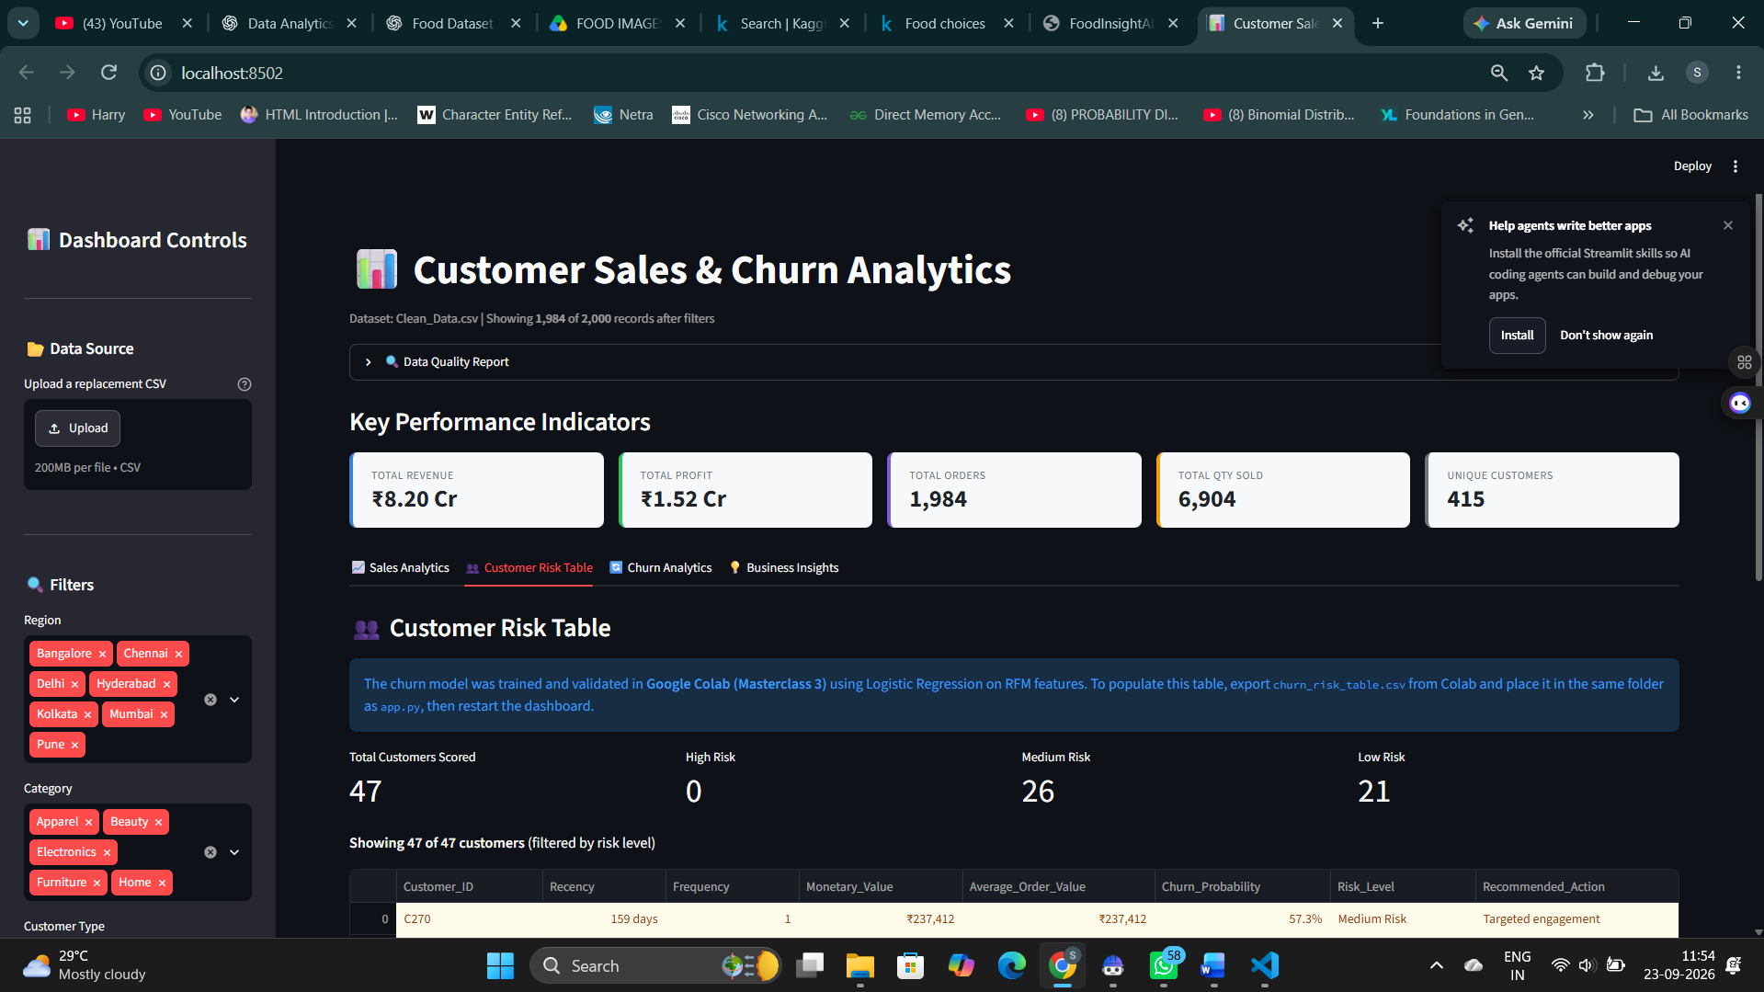
Figure 1. Dashboard Data Quality Report showing 2,000 source rows, invalid dates, missing revenue, duplicates, anomalous values, and churn-model eligible rows.
Quality indicator | Count | Interpretation
Total rows | 2,000 | Source rows retained for analysis
Invalid dates | 1,194 (59.7%) | Limits date-based trend analysis
Missing revenue | 201 (10.0%) | Excluded from revenue calculations
Duplicate rows | 23 | Reported; not removed for baseline consistency
Unknown customer IDs | 26 | Excluded from churn modelling
Unknown products | 7 | Tracked as data-quality gaps
Unknown regions | 16 | Tracked as data-quality gaps
Model-eligible rows | 723 | Valid date + non-missing revenue + known customer

4. Exploratory Sales Analytics
The Sales Analytics tab converts the cleaned dataset into interactive management views. The dashboard supports filtering by region, category, and customer type before calculating the KPI cards and sales visualisations.
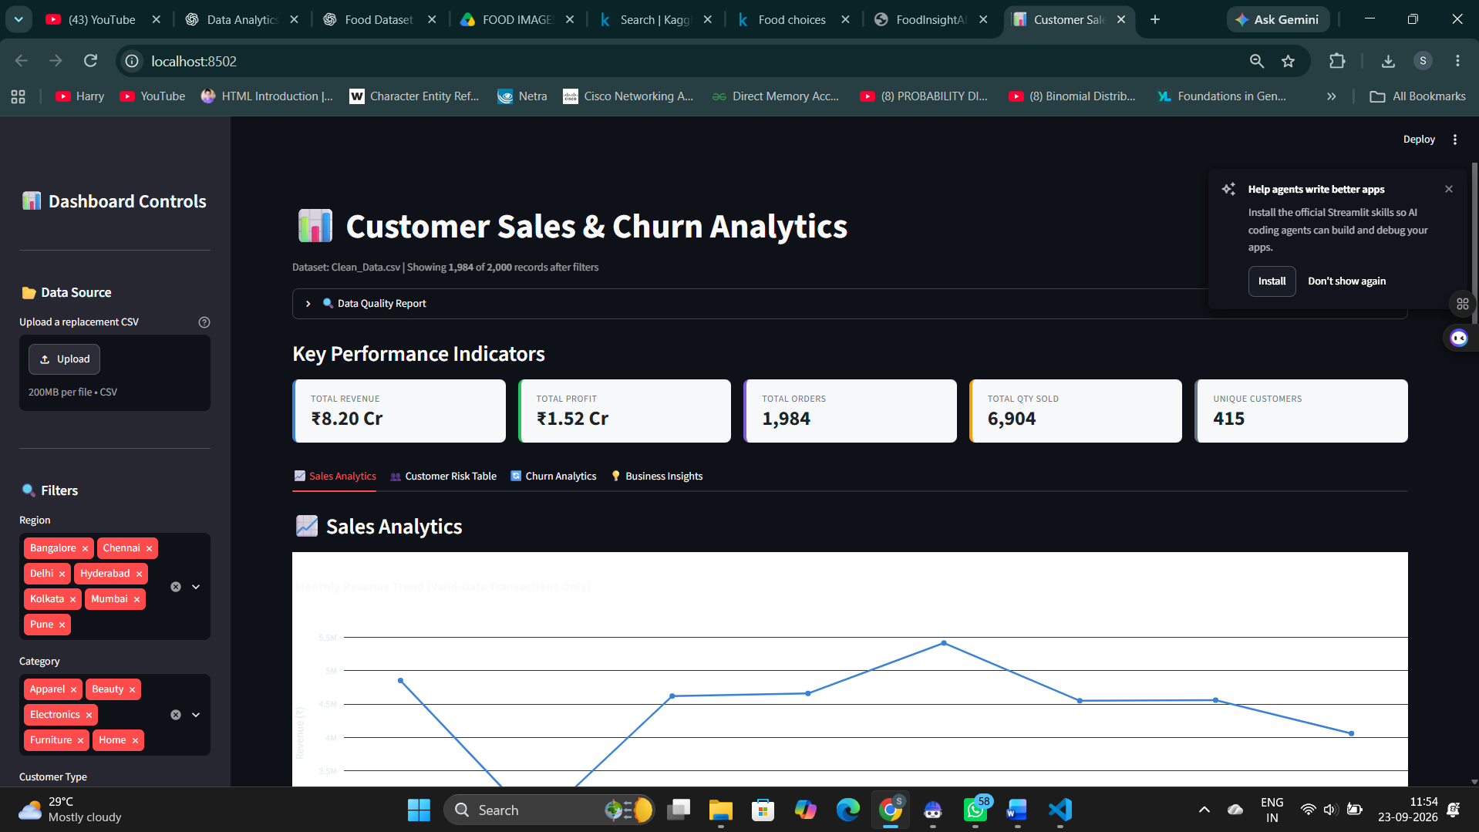
Figure 2. Dashboard overview with KPI cards, interactive filters, and the Sales Analytics section.
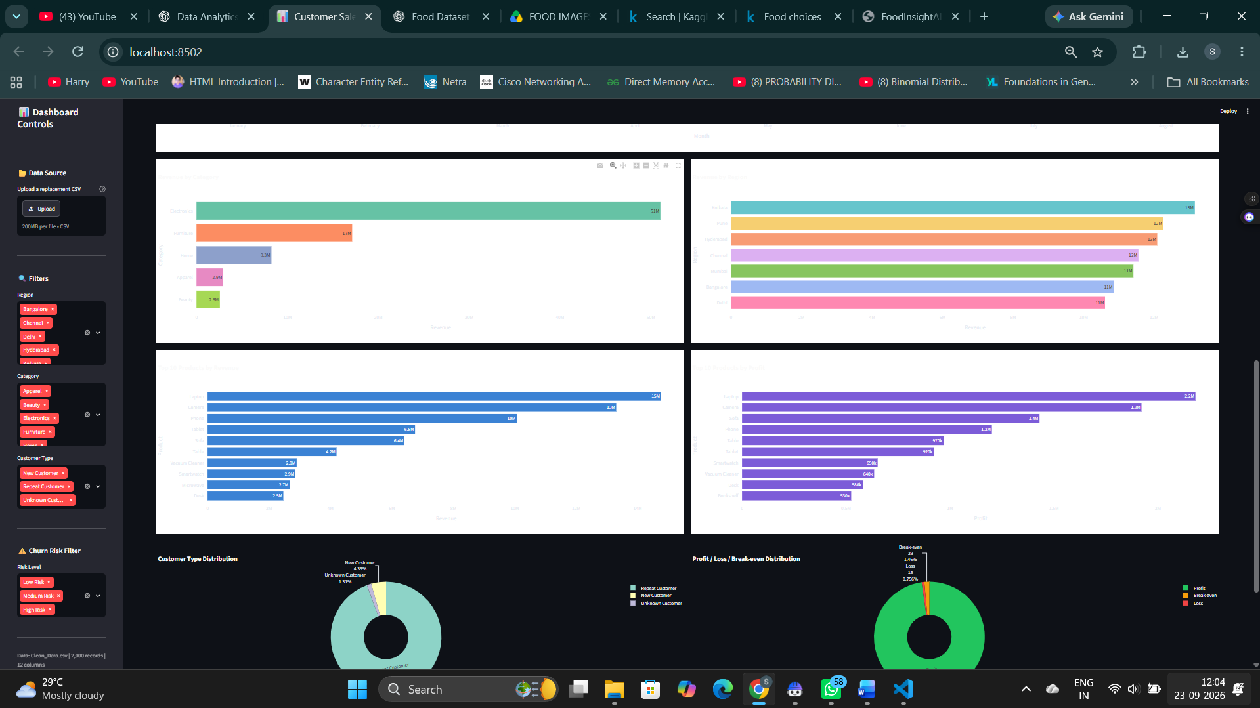
Figure 3. Sales visualisations covering revenue by category/region, top products by revenue/profit, and customer/profit distributions.
Analytical view | Purpose
Monthly revenue trend | Shows revenue over valid-date transactions only.
Revenue by category | Identifies category-level revenue concentration.
Revenue by region | Compares geographic revenue contribution.
Top products by revenue | Highlights products with the largest revenue contribution.
Top products by profit | Shows products contributing most to profit.
Customer / profit distributions | Summarise repeat/new/unknown customer mix and profit status.

5. Customer Churn Methodology
The churn module uses a leakage-safe RFM design. Eligible rows require a valid order date, non-missing revenue, and a known customer identifier. The latest eligible date defines a historical cutoff 180 days earlier. Historical transactions are transformed into customer-level RFM features, while future-window activity defines the churn target.
- Filter the cleaned data to churn-model eligible transactions.
- Determine the latest valid date and the historical cutoff.
- Aggregate historical transactions to customer-level Recency, Frequency, Monetary Value, and Average Order Value.
- Label customers as active or churned based on future-window purchase activity.
- Split the feature matrix 75/25 using stratification and `random_state=42`.
- Scale features with StandardScaler and train Logistic Regression.
- Score customers, assign Low / Medium / High Risk levels, and map each level to a recommended action.
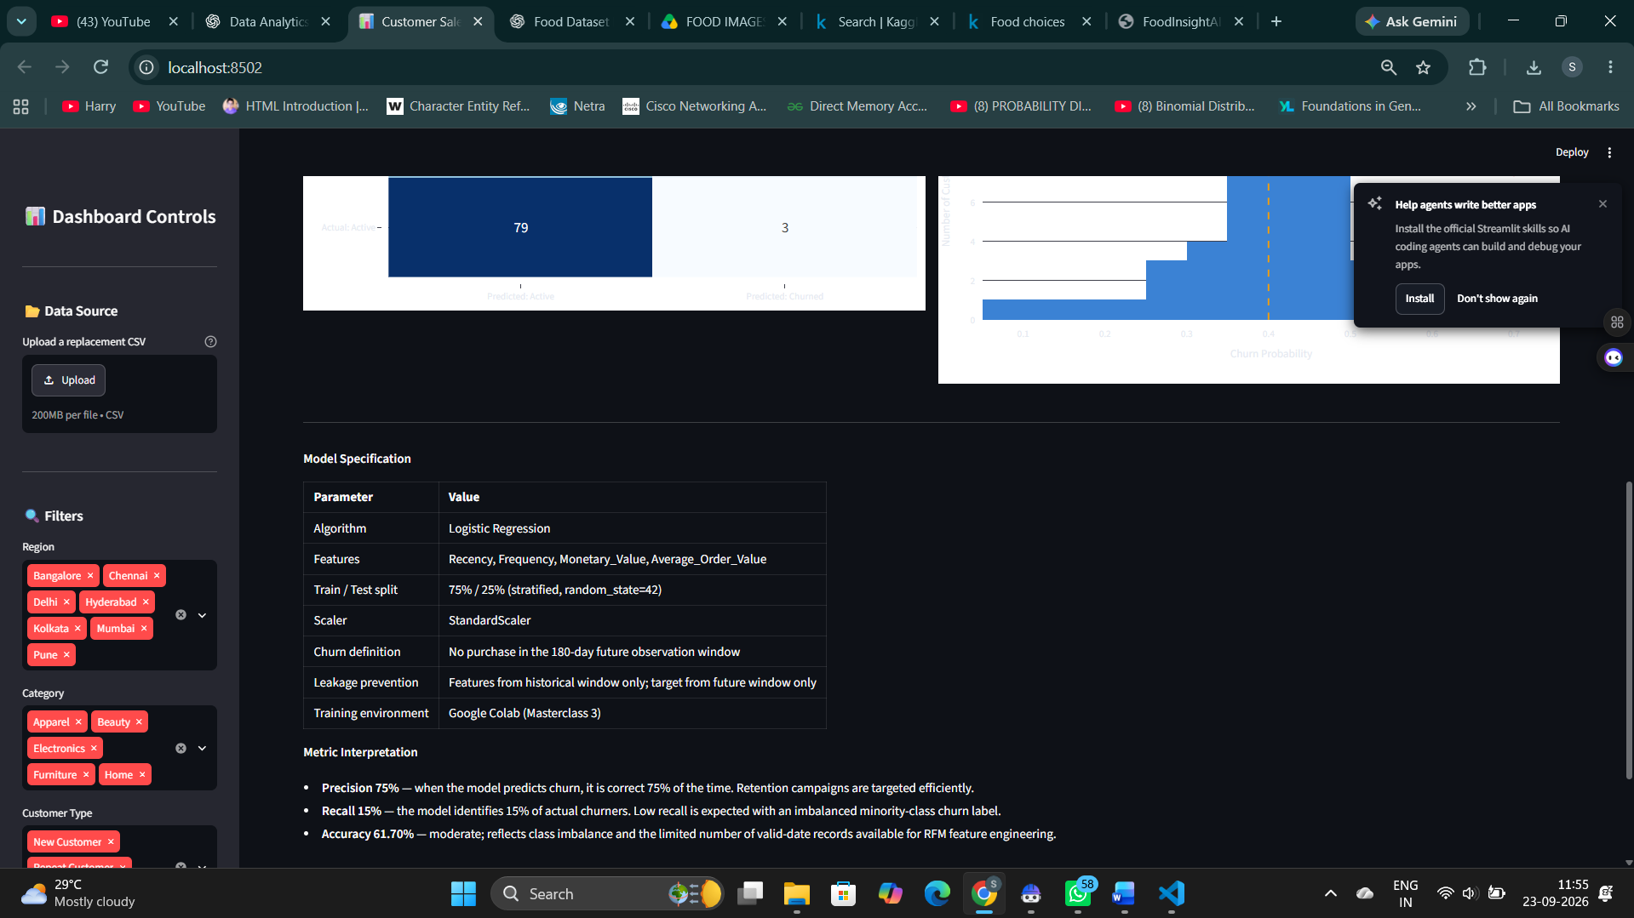
Figure 4. Churn Analytics tab showing validated model metrics and visual diagnostics.

5.1 Model Specification & Interpretation
The model specification shown below mirrors the project implementation and documentation. The dashboard presents the validated results while the reusable training pipeline remains in churn_model.py.
Metric / specification | Value
Algorithm | Logistic Regression
Features | Recency, Frequency, Monetary Value, Average Order Value
Train / test split | 75% / 25%, stratified, random_state=42
Accuracy | 61.70%
Precision | 75.00%
Recall | 15.00%
- Precision of 75% means that, within the validation result, predicted churners were correct three quarters of the time.
- Recall of 15% means the model identifies only a small fraction of actual churners; this is the main modelling limitation highlighted in the project.
- Accuracy of 61.70% should be read alongside the class-imbalance context rather than used as the only evaluation measure.
- The project therefore presents the model as a useful risk-screening component rather than a definitive churn decision system.

6. Customer Risk Scoring
The Customer Risk Table consumes the exported `churn_risk_table.csv` artifact produced from the validated modelling workflow. It exposes customer-level RFM values, churn probability, risk level, and recommended retention action. The dashboard screenshot recorded 47 scored customers in the displayed risk table, split between medium- and low-risk groups.
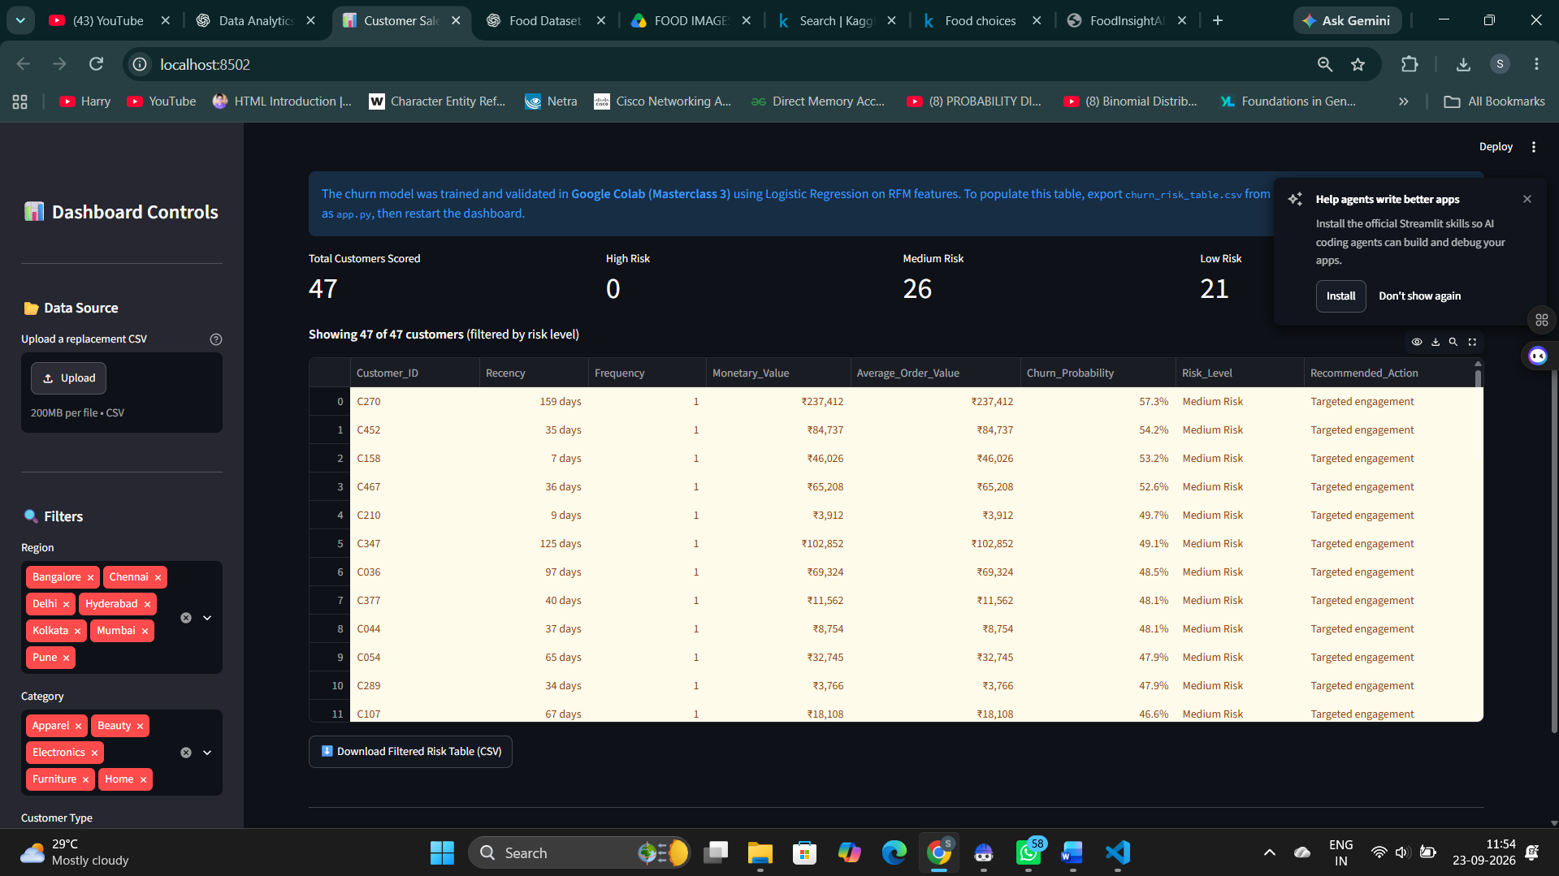
Figure 5. Customer Risk Table with customer-level RFM values, churn probability, risk level, and recommended action.
Risk level | Count | Recommended action
High Risk | 0 | Immediate retention offer required
Medium Risk | 26 | Send re-engagement campaign
Low Risk | 21 | Monitor regularly

7. Business Findings
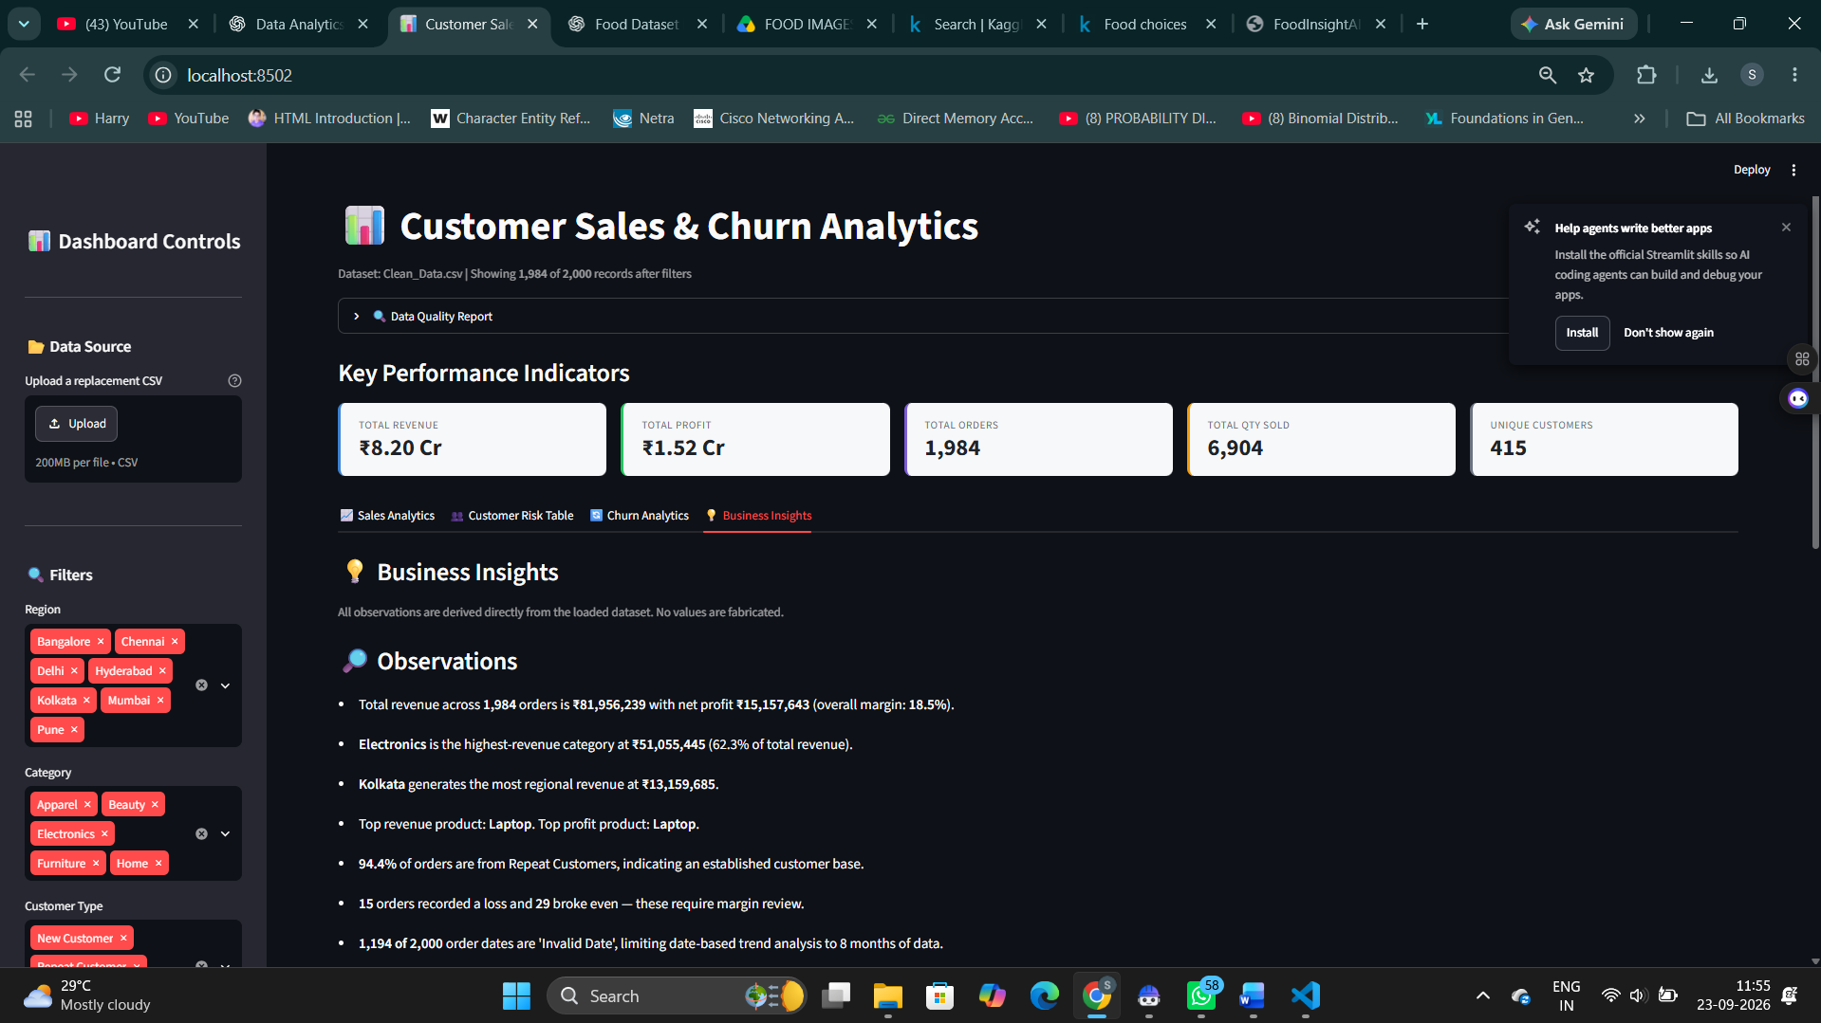
Figure 6. Business Insights section translating dashboard metrics into observations, risks, and practical recommendations.
- Total revenue displayed by the dashboard is approximately ₹8.20 Cr, with total profit of approximately ₹1.52 Cr.
- Electronics is the dominant revenue category in the dashboard insights, creating concentration exposure if demand in that category slows.
- Repeat customers account for the majority of orders in the displayed dataset, indicating an established customer base.
- The dataset contains substantial date-quality limitations, so time-series conclusions should be interpreted cautiously.
- The churn model’s recall is 15%, so the model misses a large portion of actual churners even though precision is 75%; this is explicitly treated as a project limitation rather than hidden.

8. Limitations & Reproducibility Notes
- The Streamlit dashboard is designed to run without importing scikit-learn at startup. It reads the exported churn-risk table for the dashboard view.
- `churn_model.py` contains the full local Logistic Regression pipeline for reproducibility, but a fresh independent local re-run was not treated as a prerequisite for dashboard startup.
- The project documentation specifies Python 3.11 and the pinned dependency set in `requirements.txt`. A fresh environment should be created from that file rather than reusing troubleshooting environments.
- Invalid dates, missing revenue, and unknown entity values reduce the effective modelling sample and constrain trend analysis.
- The project is a single-period snapshot; additional time coverage would improve seasonality and long-term churn analysis.

9. Submission Package
The internship submission form shown during the project setup requests four files plus a GitHub repository link. The final package should contain:
Submission item | Recommended file | Purpose
Code File | Customer_Sales_Churn_Analytics_Submission.ipynb | Complete notebook-format project code and validation sections
Requirements File | requirements.txt | Pinned Python dependencies
Project Report | Customer_Sales_Churn_Analytics_Project_Report.docx | Project methodology, findings, screenshots, limitations
README File | README.md | Overview, setup, run instructions, limitations
GitHub Repository | Public repository URL | Source-code and documentation repository

10. Final Pre-Submission Checklist
- Confirm `Customer_Sales_Churn_Analytics_Submission.ipynb` opens without corruption.
- Confirm `requirements.txt` matches the documented final environment.
- Confirm `README.md` is the final version and contains the correct project structure and run command.
- Confirm `ProjectReport.docx` is the final report and opens correctly.
- Exclude local virtual-environment folders such as `.venv`, `.venv_final`, `.ml_env`, and `.dashboard_env` from the GitHub repository.
- Run the Streamlit application once from the final project folder and verify the dashboard loads.
- Push the final code and documentation to GitHub and paste the public repository URL into the submission form.
Conclusion
The project now has a complete analytical workflow, a functioning interactive dashboard, a reproducible modelling module, documented limitations, and a submission-oriented notebook/report structure. The main remaining task is final packaging and submission verification rather than redesigning the project.

