**ASSIGNMENT-2**

Name : Siddartha Rao Damarla

I’D: 16337125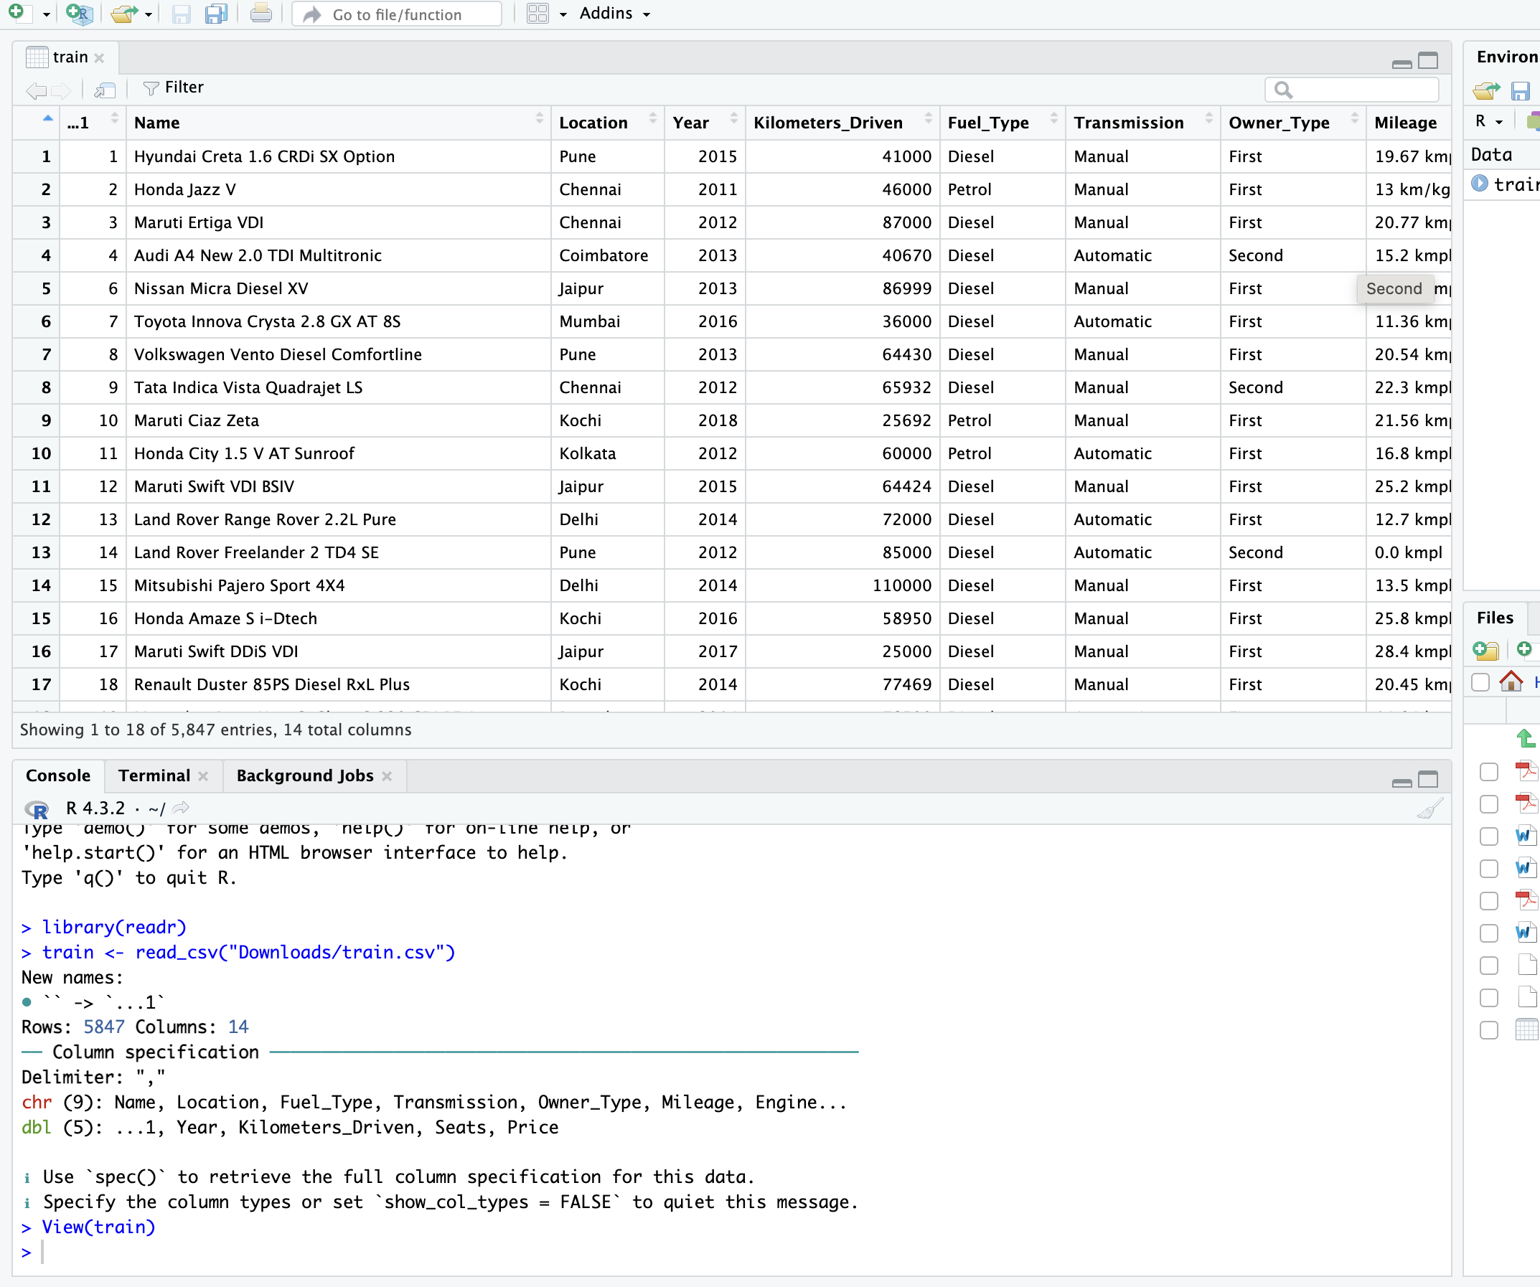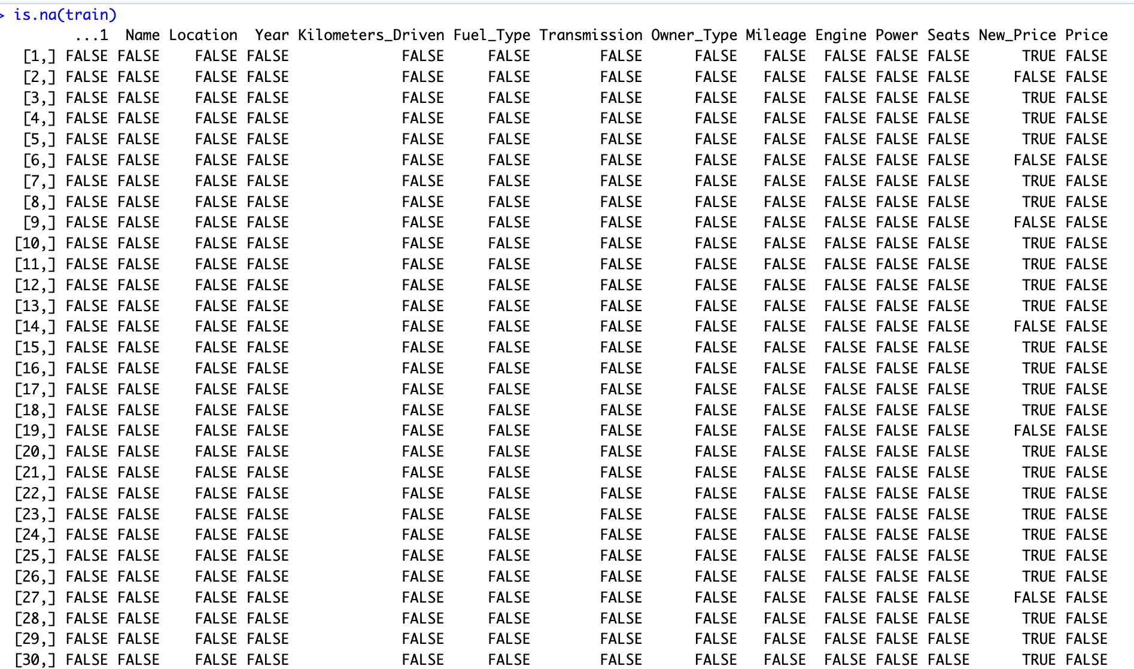

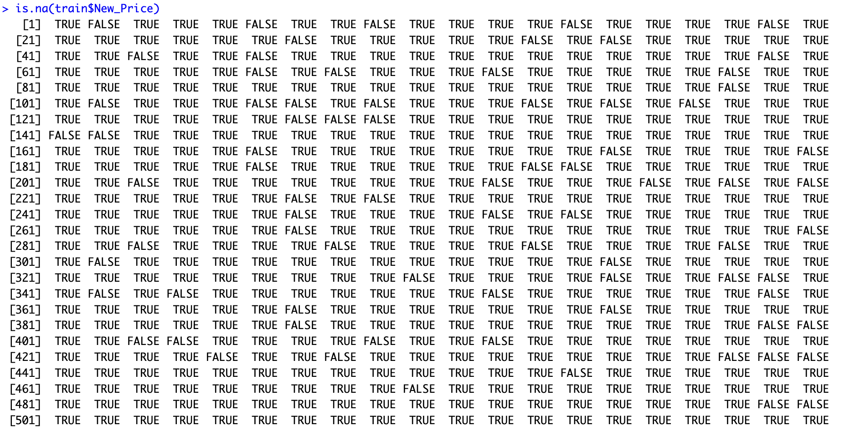

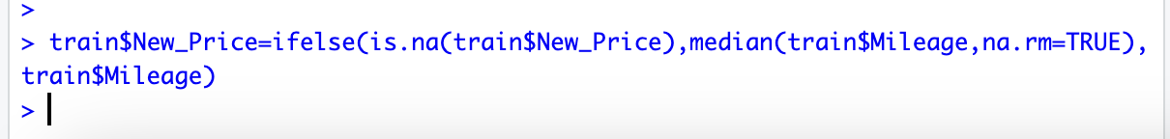

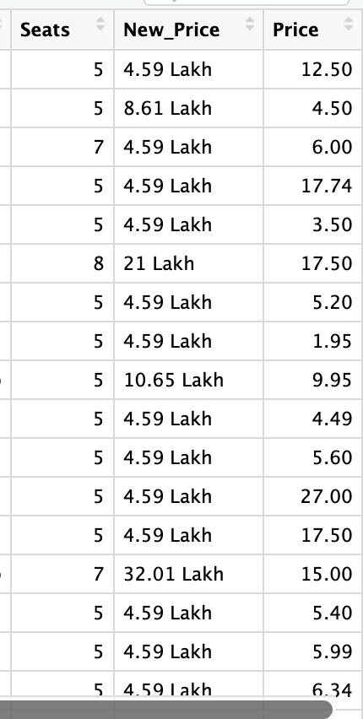

Remove the units from some of the attributes and only keep the numerical for Mileage by removing kmpl, CC from Engine,bhp from power and lakh from New_price.

ImageImage

Change the categorical variables the Fuel_Type and Transmission into numeric values using the hot value encoded.

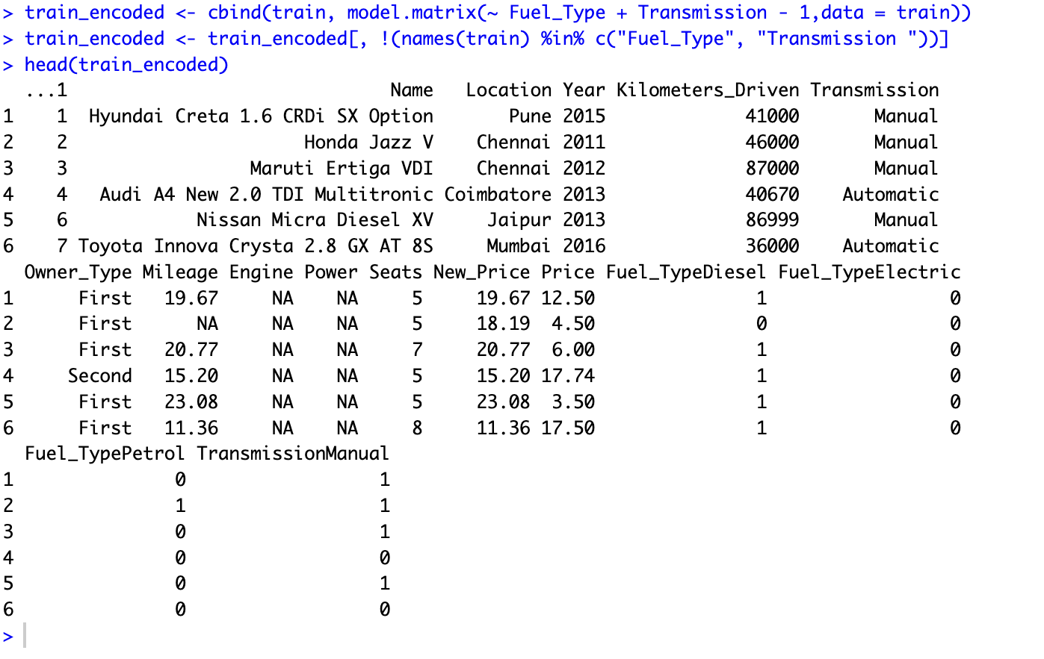

Calculating the current age by subtr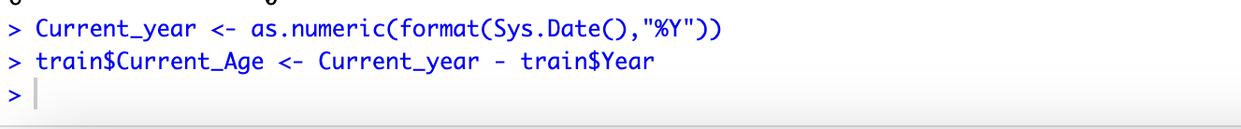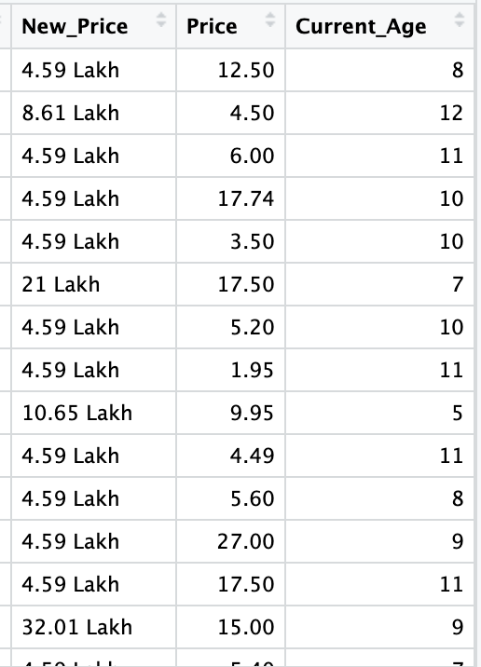acting the year value from current year.