**DAC_Phase 3**

import pandas as pd

FILE_LOCATION = '/content/daily-website-visitors.csv'

whole_dataset = pd.read_csv(FILE_LOCATION,

index_col='Date',

thousands=',')

whole_dataset.index = pd.to_datetime(whole_dataset.index)

whole_dataset

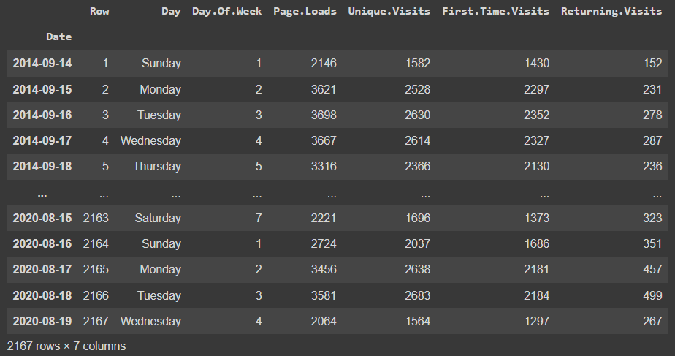

whole_dataset.info()

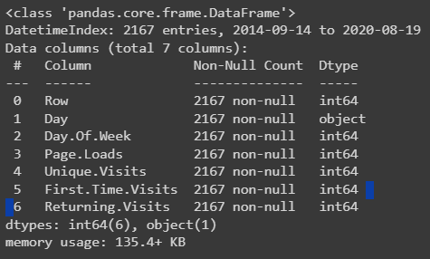

whole_dataset.describe()

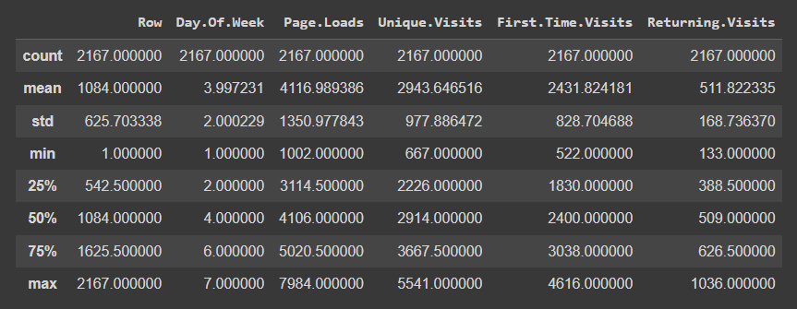

target_column = whole_dataset['Returning.Visits']

target_column

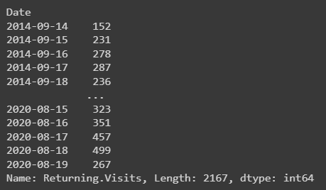

len(target_column)



TEST_DATA_PERCENTAGE = 0.1

TEST_DATA_BOUNDARY_INDEX = int((1 - TEST_DATA_PERCENTAGE) * len(target_column))

print(f"Train data:\tReturning Visits [:{TEST_DATA_BOUNDARY_INDEX}] ({TEST_DATA_BOUNDARY_INDEX + 1})")

print(f"Test data:\tReturning Visits [{TEST_DATA_BOUNDARY_INDEX}:] ({len(target_column) - TEST_DATA_BOUNDARY_INDEX})")

print(f"\nLast target on train data: {target_column[TEST_DATA_BOUNDARY_INDEX]}")

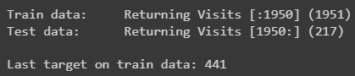

print(f"Train dataset ending values: {target_column[TEST_DATA_BOUNDARY_INDEX - 10: TEST_DATA_BOUNDARY_INDEX].values}")

print(f"Test dataset starting values: {target_column[TEST_DATA_BOUNDARY_INDEX: TEST_DATA_BOUNDARY_INDEX + 10].values}")



y_true = target_column[TEST_DATA_BOUNDARY_INDEX : ]

len(y_true), y_true

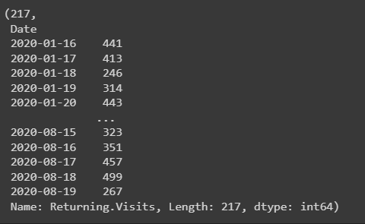

from sklearn.metrics import mean_absolute_error, mean_squared_error, mean_absolute_percentage_error

def evaluate_predictions(y_true, y_preds):

mae = mean_absolute_error(y_true, y_preds)

mse = mean_squared_error(y_true, y_preds)

rmse = np.sqrt(mse)

mape = mean_absolute_percentage_error(y_true, y_preds)

return {

'mae': mae,

'mse': mse,

"rmse": rmse,

"mape": mape

}

evaluate_predictions(y_true, baseline_predictions)

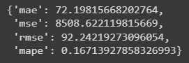

from tensorflow.keras.layers import GRU, Dense, Input, Lambda

from tensorflow.keras import Sequential

tf.random.set_seed(42)

model_1 = Sequential([

Input(shape=(WINDOW_SIZE,)),

Lambda(lambda x: tf.expand_dims(x, axis=1)),

GRU(128, activation="relu"),

Dense(1)

], name='model_1')

model_1.compile(

loss=tf.keras.losses.MeanAbsoluteError(),

optimizer=tf.keras.optimizers.Adam()

)

model_1.summary()

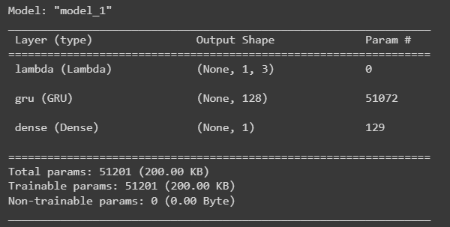

from tensorflow.keras.callbacks import ModelCheckpoint

import os

def create_checkpoint_callback(model):

filepath = os.path.join('models', model.name)

return ModelCheckpoint(filepath, monitor='loss', save_weights_only=True, save_best_only=True)

model_1.fit(train_dataset, epochs=5, callbacks=[ create_checkpoint_callback(model_1) ])

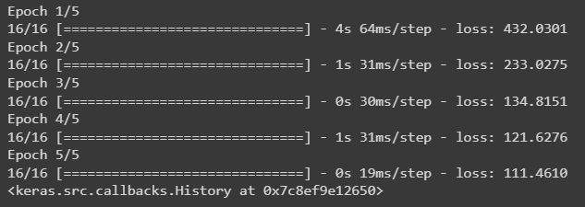

unbatched_train_dataset = whole_dataset[:TEST_DATA_BOUNDARY_INDEX + 1].copy()

unbatched_train_dataset

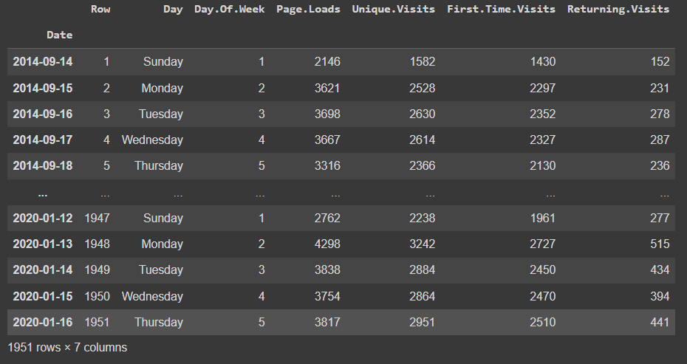

dataset_by_day = unbatched_train_dataset.groupby(by=['Day'])

dataset_by_day['Returning.Visits'].mean()

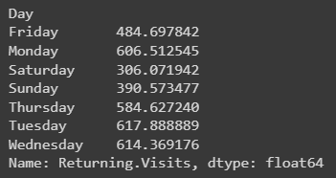

import calendar

train_dataset_with_months = unbatched_train_dataset.copy()

train_dataset_with_months['Month.Name'] = pd.Series(train_dataset_with_months.index,

index=train_dataset_with_months.index)\

.apply(lambda x: calendar.month_name[x.month])

train_dataset_with_months

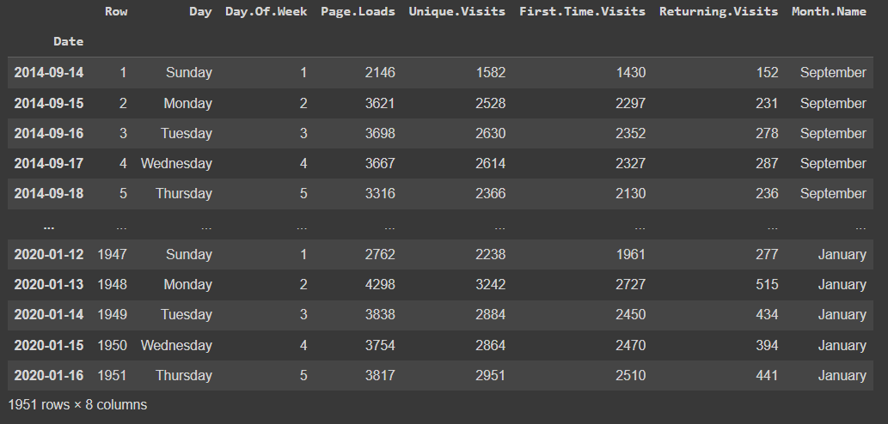

MONTH_NAMES = list(calendar.month_name)[1:]

dataset_group_by_month = train_dataset_with_months.groupby(by='Month.Name')

dataset_group_by_month['Returning.Visits'].mean().loc[MONTH_NAMES]

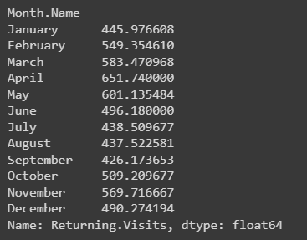

dataset2 = train_dataset_with_months.copy()[['Day', 'Month.Name', 'Returning.Visits']]

dataset2

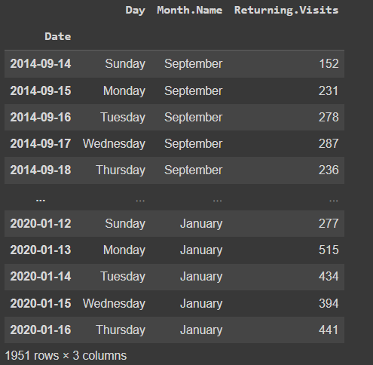

def windowize_dataset(dataset):

for i in range(WINDOW_SIZE):

dataset[f'Returning.Visits[t-{i+1}]'] = dataset['Returning.Visits'].shift(periods=i+1)

return dataset

dataset2 = windowize_dataset(dataset2.copy())

dataset2

