**Google-Play-Store-Analytics**

Training task 1 : "The output of Training 1 is already in that file."

Training task 2: “The output of training 2 is given

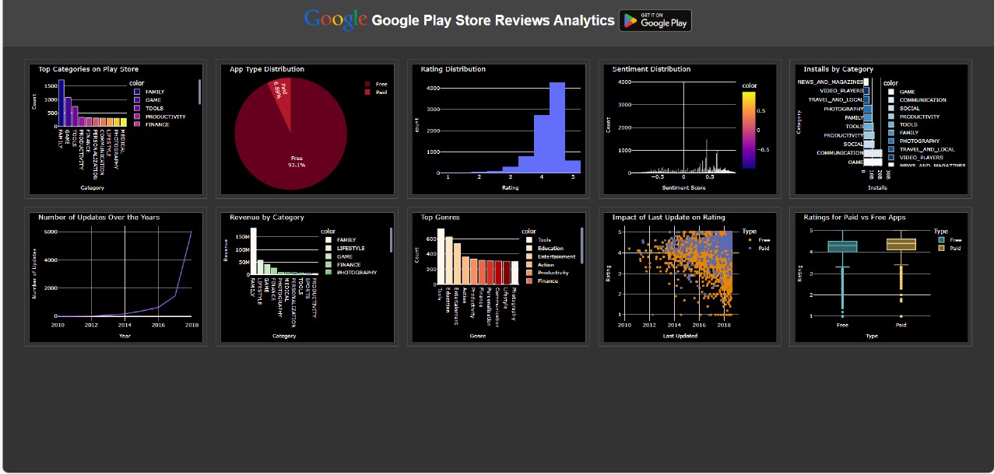

Training task 3: “The output of training 3 is given

