**MAHAVIR STATIONARY**

Arbuda Nivas, Opp. K.B. Comm. Centre,  
Khanpur, Ahmedabad-1. M.NO: 9825042967

Agency Code: 2776988

To, (to)

R.O. No.: (ro_no) DATE: (date)

**PLEASE RELEASE THE ADVERTISEMENT AS PER OUR FOLLOWING INSTRUCTION:**

|  |  |  |  |  |  |
| --- | --- | --- | --- | --- | --- |
| No. | PARTICULARS | DATE | SIZE | RATE | PAGE |
| (no) | (particulars) | (date2) | (size) | (rate) | (page) |

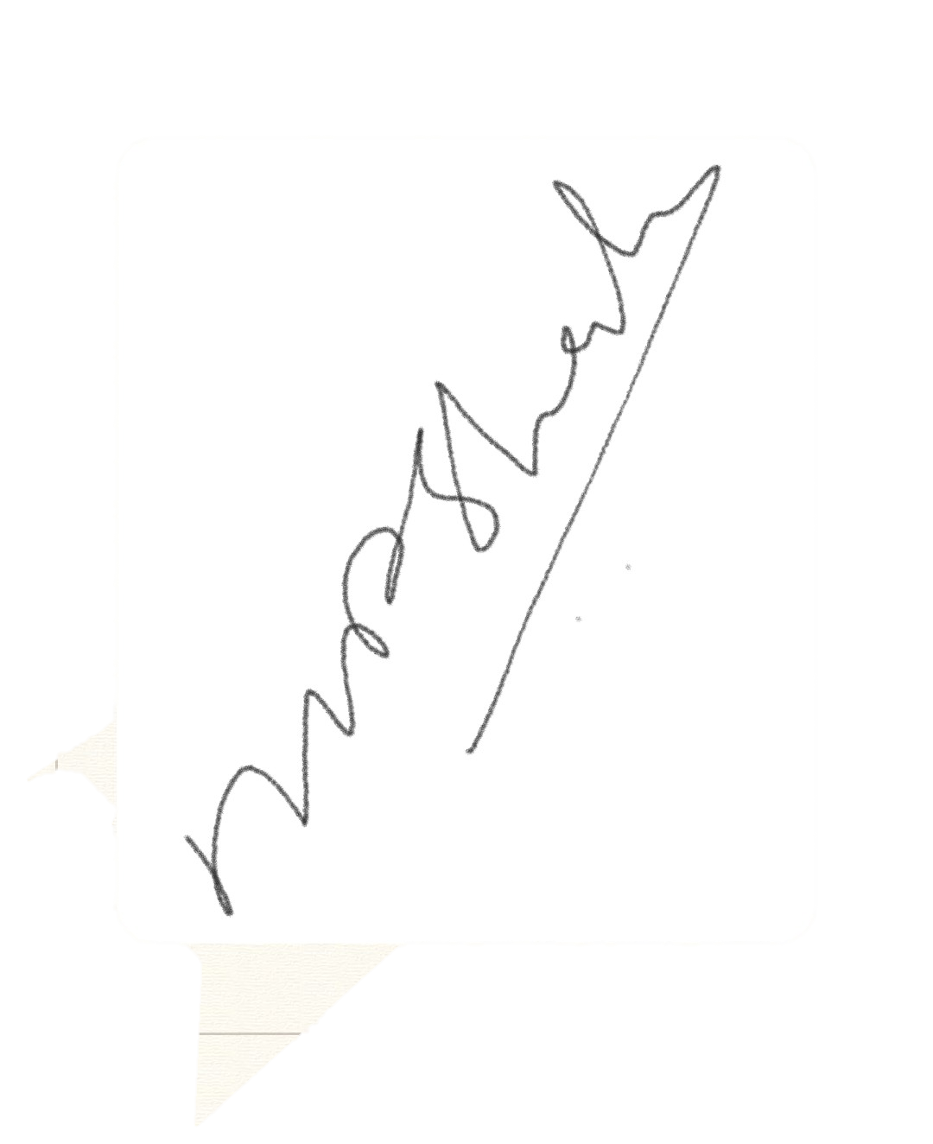  
  
For, MEHUL NEWS AGENCY

