1. **What is the difference between truncate, delete, drop?**

|  |  |  |
| --- | --- | --- |
| **Truncate** | **Delete** | **Drop** |
| Truncate is Data Definition Language Command(DDL) | Delete is Data Manipulation Language Command(DML) | Drop is Data Definaton Language Command(DDL) |
| Deletes All the rows from table but it does not delete structure. | Delete All the records from table in the database. | Drop the Complete Table from database. |
| Cannot use Rollback command to restore deleted rows from table | Can be use rollback command | Cannot use rollback command. |
| Need a table Alter permission to use truncate command | DELETE permission is required to delete the rows of the table. | Need a Alter permission to use Drop command |
| TRUNCATE TABLE table_name; | DELETE permission is required to delete the rows of the table. | DROP TABLE table_name; |

1. What are alias in MySQL?

Alices are used to give temporary name to table or column in table.

Syntax :

Select col_name AS column_name from table_name;

1. How do you display even rows of the any table?

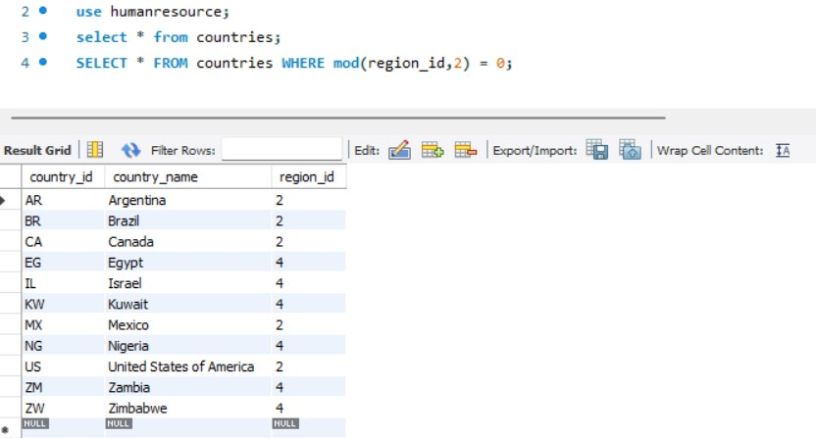

1. How can you remove duplicates from a table(distinct and other way)

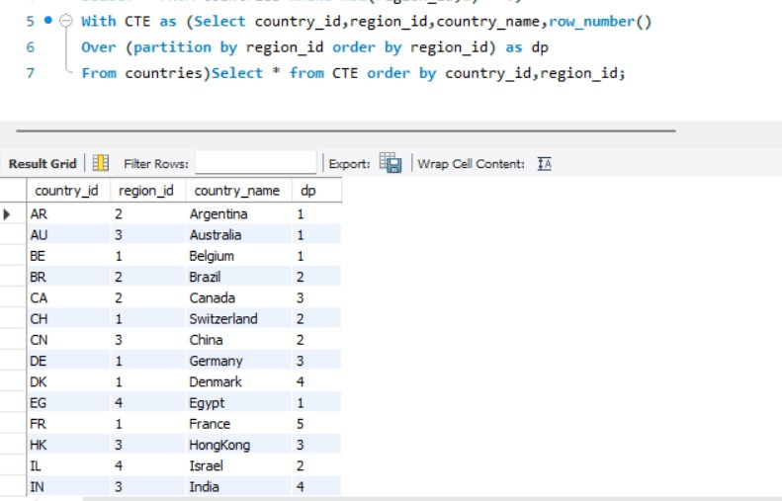

1. How you can find 5th max salary?

