Patient Diabetes Risk Prediction
An End-to-End Health Data Science Project

1. Project Overview
This project applies an end-to-end data science workflow to a clinical/patient records dataset with the goal of predicting whether a patient is at risk of diabetes. The workflow covers data preparation, exploratory data analysis (EDA), predictive modeling, and evaluation, concluding with actionable findings.
Dataset: 2,000 synthetic patient records with 12 clinical and lifestyle features (age, sex, BMI, blood pressure, cholesterol, glucose, smoking status, family history, physical activity, alcohol use, and sleep) plus a binary diabetes diagnosis label. The data includes realistic missing values (3-5% in select columns) to mirror the imperfections of real-world clinical records.

2. Exploratory Data Analysis

2.1 Class Balance
Diabetes prevalence in the dataset is approximately 20%, reflecting a realistic imbalance seen in real clinical screening populations. This imbalance is addressed during modeling using class weighting.
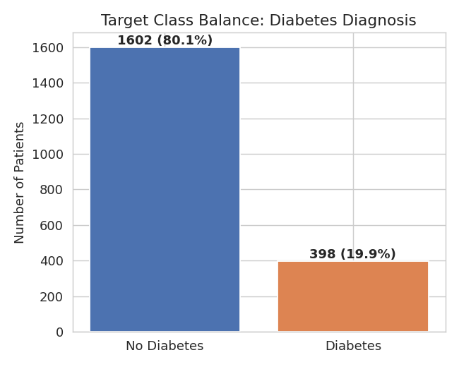
Figure 1. Distribution of diabetes diagnosis across the patient cohort.

2.2 Feature Distributions
Patients diagnosed with diabetes show visibly higher glucose levels, BMI, age, and blood pressure compared to non-diabetic patients, and lower physical activity levels, consistent with established clinical risk factors.
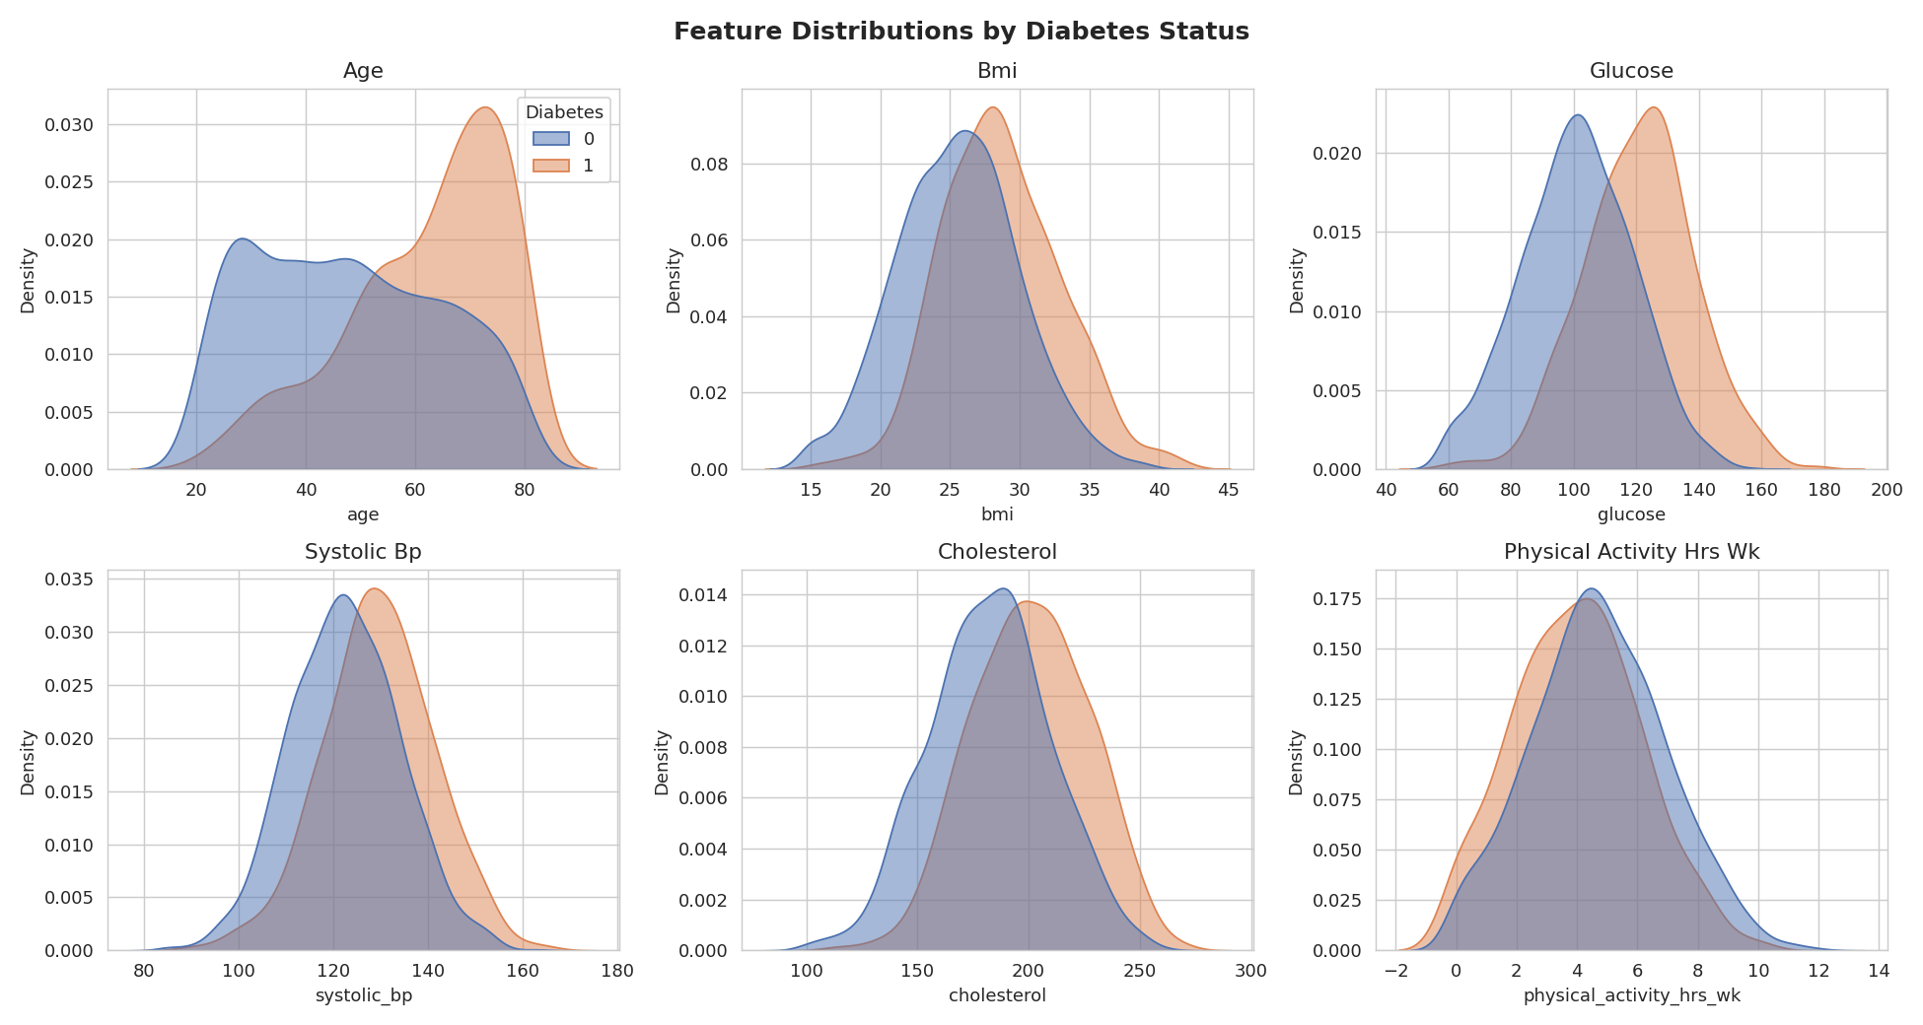
Figure 2. Distribution of key clinical features split by diabetes outcome.

2.3 Correlation Analysis
Glucose level shows the strongest correlation with diabetes diagnosis (r = 0.41), followed by age (r = 0.33), BMI (r = 0.28), and cholesterol (r = 0.26). Physical activity is negatively correlated (r = -0.13), suggesting a protective effect.
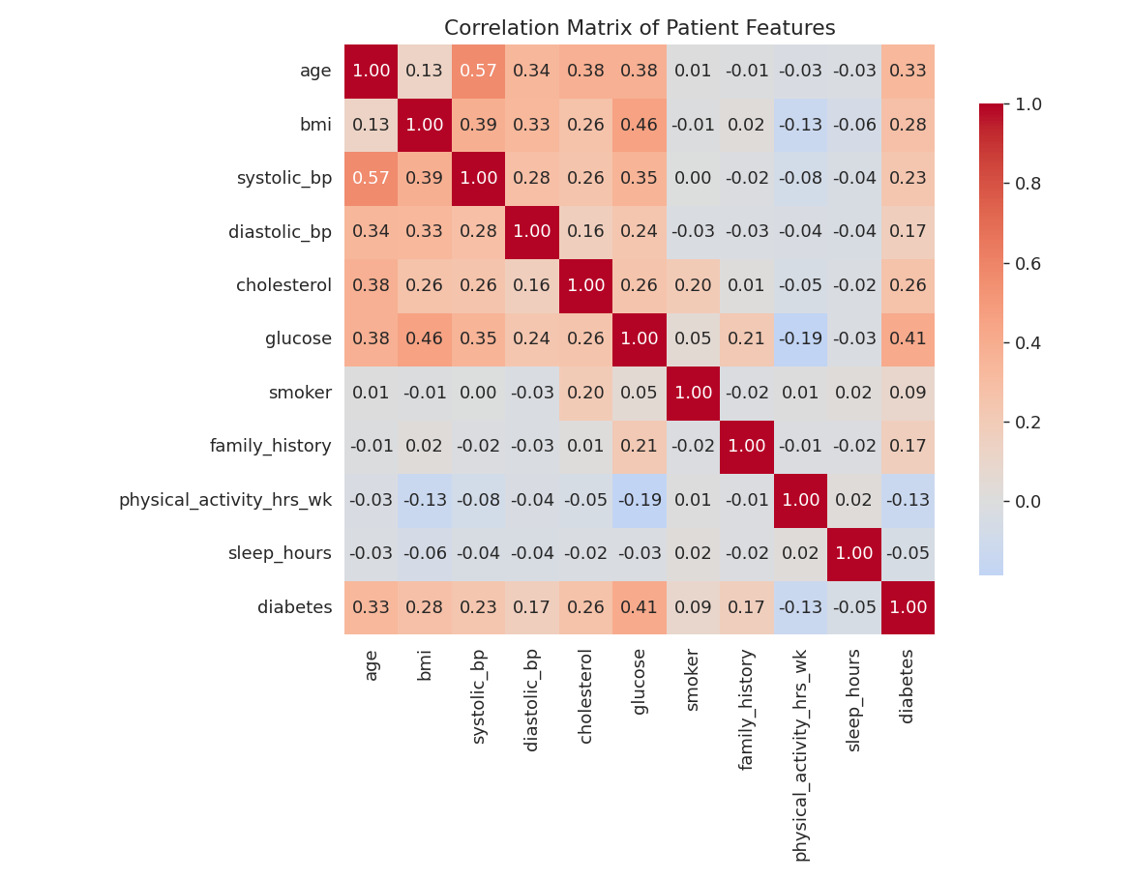
Figure 3. Correlation matrix across all numeric patient features.

2.4 BMI vs. Glucose
Plotting BMI against glucose level shows a clear separation between diabetic and non-diabetic patients, with diabetic cases clustering toward higher values on both axes.
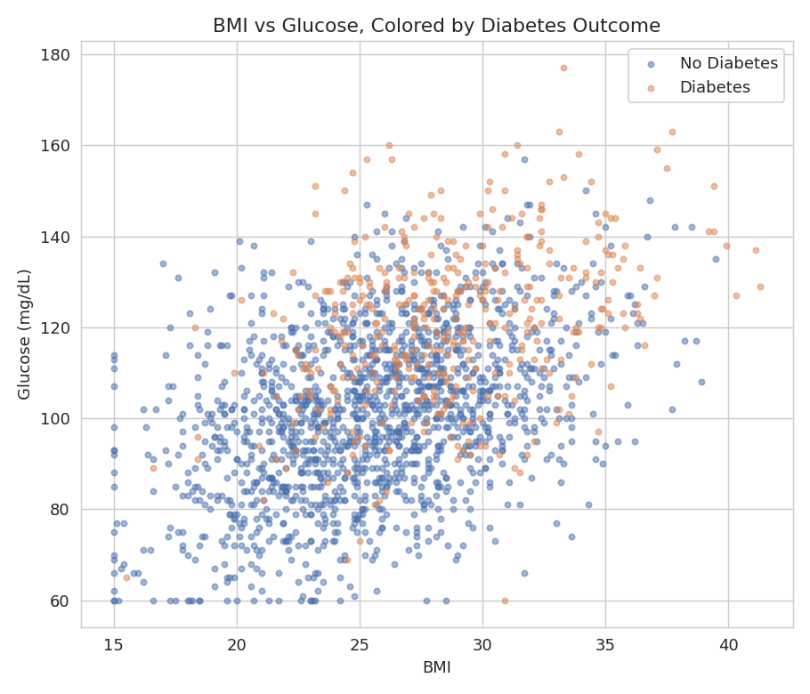
Figure 4. BMI vs glucose, colored by diabetes outcome.

3. Predictive Modeling
Two classification models were trained on a 75/25 train-test split (stratified by outcome), after median-imputing missing numeric values, one-hot encoding categorical variables, and standardizing numeric features:
- Logistic Regression - a linear, highly interpretable baseline model.
- Random Forest - a non-linear ensemble model capable of capturing feature interactions.
Both models used class weighting to compensate for the ~80/20 class imbalance.

3.1 Model Performance
Model | Accuracy | ROC-AUC | F1-score
Logistic Regression | 75.2% | 0.847 | 0.547
Random Forest | 79.0% | 0.819 | 0.571

Logistic Regression achieved the highest ROC-AUC (0.847), indicating strong ability to rank patients by risk, and is the recommended model given its combination of performance and interpretability - an important factor in clinical settings. Random Forest achieved slightly higher raw accuracy (79.0%) and F1-score, driven by better precision, but a lower AUC.

3.2 ROC Curve Comparison
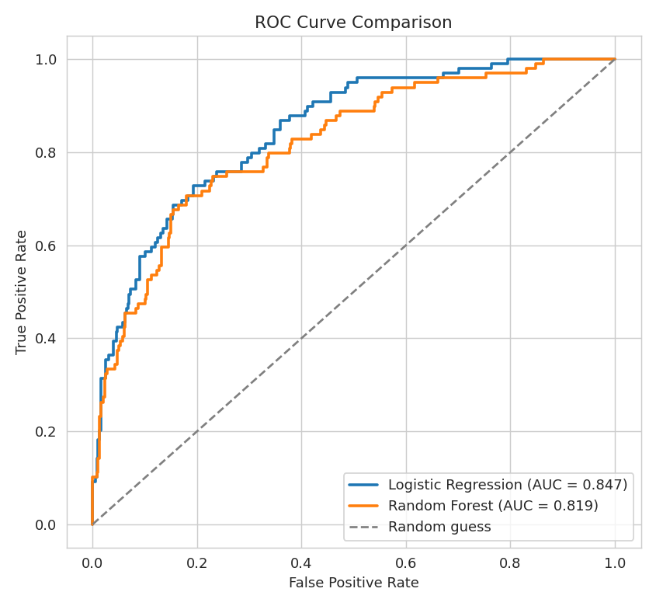
Figure 5. ROC curves for both models on the held-out test set.

3.3 Confusion Matrix
The confusion matrix below shows the Logistic Regression model's predictions on the test set (500 patients). The model was tuned to prioritize recall on the diabetic class, which is generally preferable in a screening context where missing a true case is costlier than a false alarm.
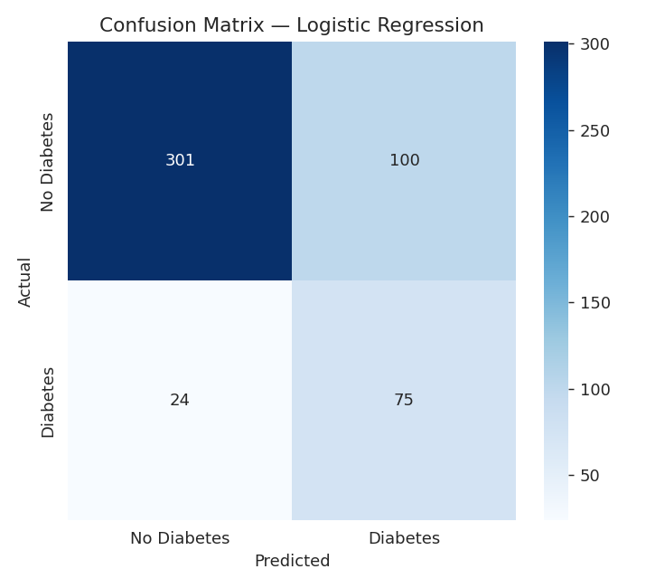
Figure 6. Confusion matrix for the best-performing model.

3.4 Feature Importance
Feature importance from the Random Forest model confirms glucose, age, BMI, cholesterol, and blood pressure as the dominant predictors of diabetes risk.
Rank | Feature | Relative Importance
1 | Glucose level | 28.9%
2 | Age | 18.7%
3 | BMI | 13.5%
4 | Cholesterol | 11.3%
5 | Systolic blood pressure | 8.4%

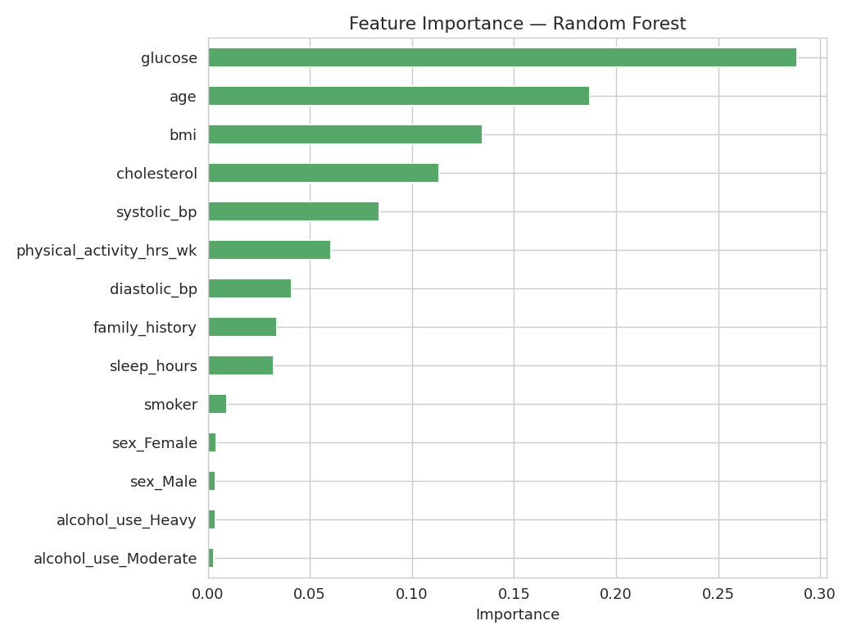
Figure 7. Relative feature importance from the Random Forest classifier.

4. Conclusions & Recommendations
- Glucose level is by far the strongest single predictor of diabetes risk, consistent with clinical understanding, followed by age and BMI.
- The Logistic Regression model reached an ROC-AUC of 0.85, meaning it reliably distinguishes higher-risk from lower-risk patients and would be a reasonable basis for a clinical screening tool, pending validation on real patient data.
- Because missing a true diabetic case is more costly than a false positive in a screening context, the model was tuned toward higher recall (76%) on the diabetic class at some cost to precision - a tradeoff that should be reviewed with clinical stakeholders.
- Physical activity showed a protective association, reinforcing lifestyle intervention as a relevant component of risk management.
- Next steps: validate on real-world clinical data, test additional models (e.g., gradient boosting), calibrate predicted probabilities, and incorporate cost-sensitive thresholds aligned with clinical priorities.
Note: This dataset is synthetically generated for educational purposes and does not represent real patients. Model results are illustrative of the workflow, not clinical guidance.

