CHAT-MED
Medical Chatbot Harnessing Transfer Learning using Llama 2 for Advanced Medical Consultation

A report on
Deep Learning Lab Project
[CSE-3281]

Submitted By
Siddhant Saini (210962160)



DEPARTMENT OF COMPUTER SCIENCE AND ENGINEERING
MANIPAL INSTITUTE OF TECHNOLOGY,
MANIPAL ACADEMY OF HIGHER EDUCATION
MARCH-2024

Medical Chatbot Harnessing Transfer Learning using Llama 2 for Advanced Medical Consultation
Siddhant Saini
CSE MIT MANIPAL, INDIA
siddhant.saini@learner.manipal.edu

Abstract- Chat-Med, a state-of-the-art medical chatbot, represents a breakthrough in the realm of AI-driven healthcare assistance. Employing sophisticated techniques such as transfer learning and the advanced Llama 2 model, Chat-Med transcends traditional medical consultation paradigms. Trained on the comprehensive GALE ENCYCLOPEDIA of MEDICINE dataset, Chat-Med harnesses a vast reservoir of domain-specific knowledge, enabling it to provide nuanced and accurate responses to user inquiries. Through natural language interaction, Chat-Med delivers personalized medical guidance, tailored to individual needs and contexts. This report delves into the intricate methodology underpinning Chat-Med's development, elucidates its multifaceted features, and examines the profound implications of its integration into the healthcare landscape, heralding a new era of AI-driven medical consultation.

Keywords: Medical chatbot, Transfer learning, Llama 2, Natural language interaction, Healthcare assistance, Generative Models, Natural Language Processing, C-Transformer, Langchain, Faiss

- Introduction
In an era marked by unprecedented advancements in artificial intelligence (AI) and machine learning, the integration of such technologies into the healthcare domain has revolutionized the way medical assistance is delivered and accessed. Among these innovations stands Chat-Med, a groundbreaking medical chatbot meticulously engineered to provide sophisticated and personalized medical consultation through natural language interaction. By harnessing the power of transfer learning techniques and the state-of-the-art Llama 2 model, Chat-Med represents a pinnacle achievement in the convergence of AI and healthcare.

At the core of Chat-Med's capabilities lies its utilization of transfer learning, a technique that empowers the chatbot to leverage knowledge from pre-existing models and datasets, subsequently fine-tuning its understanding of medical concepts and terminologies. This approach ensures that Chat-Med possesses a foundation of domain-specific expertise. Furthermore, the integration of the Llama 2 model augments Chat-Med's capacity to comprehend nuances in user queries and generate responses that closely mimic human conversational patterns.

The foundation of Chat-Med's knowledge repository is built upon the extensive GALE ENCYCLOPEDIA of MEDICINE dataset. By training on this vast dataset, Chat-Med acquires a deep understanding of medical conditions, treatments, and procedures, empowering it to offer informed guidance and support to users seeking medical assistance. Through the amalgamation of transfer learning, Llama 2, and the GALE ENCYCLOPEDIA of MEDICINE dataset, Chat-Med emerges as a formidable ally in the quest for accessible and reliable healthcare information.

Chat-Med offers a streamlined and user-centric approach to accessing medical expertise. With its intuitive conversational interface, users can engage with Chat-Med in a manner akin to interacting with a human healthcare professional, posing inquiries and receiving prompt and tailored responses. This seamless integration of AI-driven technology into the healthcare ecosystem not only enhances accessibility to medical information but also empowers individuals to make informed decisions regarding their health and well-being. As the demand for accessible and efficient healthcare solutions continues to escalate, Chat-Med emerges as a beacon of innovation, offering a glimpse into the transformative potential of AI-driven medical consultation.

- Literature review
[1] Previous studies have explored the utilization of transfer learning in medical chatbots, highlighting its potential to enhance performance and adaptability across diverse medical domains. Transfer learning techniques enable chatbots to leverage pre-existing knowledge from large datasets, facilitating the understanding of medical terminologies and nuances. However, limitations such as the need for substantial computational resources and potential biases in learned representations underscore the importance of ongoing research in refining transfer learning methodologies for medical applications.
Limitations: The utilization of transfer learning techniques in medical chatbots has shown promising results in enhancing performance and adaptability across diverse medical domains. However, limitations such as the need for substantial computational resources and potential biases in learned representations underscore the importance of ongoing research in refining transfer learning methodologies for medical applications.

[2] The integration of advanced language models, such as Llama 2, has emerged as a promising avenue for enhancing the conversational capabilities of medical chatbots. These models exhibit remarkable proficiency in understanding context and generating human-like responses, thereby enhancing the user experience. Nevertheless, challenges related to model interpretability and the management of complex medical inquiries necessitate further investigation to optimize the performance of Llama 2-based chatbots.
Limitations: The integration of advanced language models, such as Llama 2, has emerged as a promising avenue for enhancing the conversational capabilities of medical chatbots. Nevertheless, challenges related to model interpretability and the management of complex medical inquiries necessitate further investigation to optimize the performance of Llama 2-based chatbots.

[3] Studies exploring the utilization of domain-specific datasets, such as the GALE ENCYCLOPEDIA of MEDICINE, have shed light on the importance of tailored knowledge sources in improving the accuracy and reliability of medical chatbots. While such datasets provide a wealth of domain-specific information, challenges related to data bias, scalability, and coverage of diverse medical topics remain significant hurdles to overcome.
Limitations: Studies exploring the utilization of domain-specific datasets, such as the GALE ENCYCLOPEDIA of MEDICINE, have shed light on the importance of tailored knowledge sources in improving the accuracy and reliability of medical chatbots. Challenges related to data bias, scalability, and coverage of diverse medical topics remain significant hurdles to overcome.

[4] Cascaded diffusion models, analogous to their counterparts in image generation tasks, have demonstrated potential in enhancing the quality and diversity of responses generated by medical chatbots. These models leverage hierarchical dependencies and conditioning augmentation techniques to refine the synthesis of medical information, thereby enriching the user experience.
Limitations: Cascaded diffusion models have demonstrated potential in enhancing the quality and diversity of responses generated by medical chatbots. However, concerns regarding computational demands and model interpretability necessitate careful consideration in deploying cascaded diffusion models within medical chatbot frameworks.

[5] Despite the advancements in medical chatbots, significant limitations persist, hampering their widespread adoption and efficacy in real-world scenarios. Computational efficiency remains a key concern, particularly in resource-constrained environments where chatbots must operate with limited processing power and memory. Additionally, ensuring the privacy and security of sensitive medical information exchanged during interactions with chatbots poses challenges in compliance with regulatory frameworks such as HIPAA.
Limitations: Despite advancements in medical chatbots, significant limitations persist, hampering their widespread adoption and efficacy in real-world scenarios. Computational efficiency remains a key concern, particularly in resource-constrained environments where chatbots must operate with limited processing power and memory. Additionally, ensuring the privacy and security of sensitive medical information exchanged during interactions with chatbots poses challenges in compliance with regulatory frameworks such as HIPAA.

[6] Another critical limitation pertains to the interpretability and transparency of medical chatbots' decision-making processes. As these systems become increasingly complex and sophisticated, understanding how they arrive at their recommendations and diagnoses becomes paramount for building trust among users and healthcare professionals. Furthermore, mitigating biases inherent in training data and model architectures is essential to ensure equitable and unbiased healthcare delivery through chatbot platforms.
Limitations: Another critical limitation pertains to the interpretability and transparency of medical chatbots' decision-making processes. Understanding how they arrive at their recommendations and diagnoses becomes paramount for building trust among users and healthcare professionals.

[7] Scalability and adaptability emerge as pressing concerns, particularly as medical chatbots are deployed across diverse healthcare settings and patient populations. Tailoring chatbot functionalities to cater to specific medical specialties, languages, and cultural contexts requires careful consideration of local healthcare practices and patient preferences. Moreover, ensuring continuous updates and maintenance to keep pace with evolving medical knowledge and guidelines is imperative for the long-term sustainability of medical chatbot deployments.
Limitations: Scalability and adaptability emerge as pressing concerns, particularly as medical chatbots are deployed across diverse healthcare settings and patient populations. Tailoring chatbot functionalities to cater to specific medical specialties, languages, and cultural contexts requires careful consideration of local healthcare practices and patient preferences. Moreover, ensuring continuous updates and maintenance to keep pace with evolving medical knowledge and guidelines is imperative for the long-term sustainability of medical chatbot deployments.

[8] User engagement and satisfaction remain pivotal metrics for evaluating the effectiveness of medical chatbots in facilitating healthcare delivery. Designing intuitive and user-friendly interfaces, coupled with personalized and empathetic interactions, can enhance user engagement and foster trust in chatbot-based healthcare services. However, striking a balance between automation and human intervention is crucial to prevent over-reliance on chatbots and ensure appropriate escalation to human healthcare providers when necessary.
Limitations: User engagement and satisfaction remain pivotal metrics for evaluating the effectiveness of medical chatbots in facilitating healthcare delivery. However, striking a balance between automation and human intervention is crucial to prevent over-reliance on chatbots and ensure appropriate escalation to human healthcare providers when necessary.

[9] Ethical considerations loom large in the development and deployment of medical chatbots, particularly concerning issues of patient privacy, informed consent, and algorithmic transparency. Ensuring that chatbots adhere to ethical guidelines and professional standards of practice is paramount to safeguarding patient trust and autonomy. Moreover, addressing potential biases in chatbot algorithms and content recommendations is essential to mitigate disparities in healthcare access and outcomes.
Limitations: Ethical considerations loom large in the development and deployment of medical chatbots, particularly concerning issues of patient privacy, informed consent, and algorithmic transparency. Addressing potential biases in chatbot algorithms and content recommendations is essential to mitigate disparities in healthcare access and outcomes.

[10] Finally, the integration of multidisciplinary expertise, including healthcare professionals, data scientists, ethicists, and human-computer interaction specialists, is critical for advancing the field of medical chatbots responsibly and sustainably. Collaborative efforts aimed at addressing the multifaceted challenges of designing, implementing, and evaluating medical chatbots have the potential to drive innovation and transformation in healthcare delivery, ultimately improving patient outcomes and experiences.
Limitations: The integration of multidisciplinary expertise is critical for advancing the field of medical chatbots responsibly and sustainably. Collaborative efforts aimed at addressing the multifaceted challenges of designing, implementing, and evaluating medical chatbots have the potential to drive innovation and transformation in healthcare delivery, ultimately improving patient outcomes and experiences.

- methodology

1. Data Ingestion and Preprocessing: We start by ingesting medical documents stored in PDF format using the `PyPDFLoader`. These documents are then processed using the `RecursiveCharacterTextSplitter` to split the text into manageable chunks for further analysis. Next, we obtain embeddings for each text chunk using `HuggingFaceEmbeddings`, capturing semantic information about the text. These embeddings are efficiently stored in a vector database such as `FAISS`, enabling fast and effective retrieval during the question-answering process.
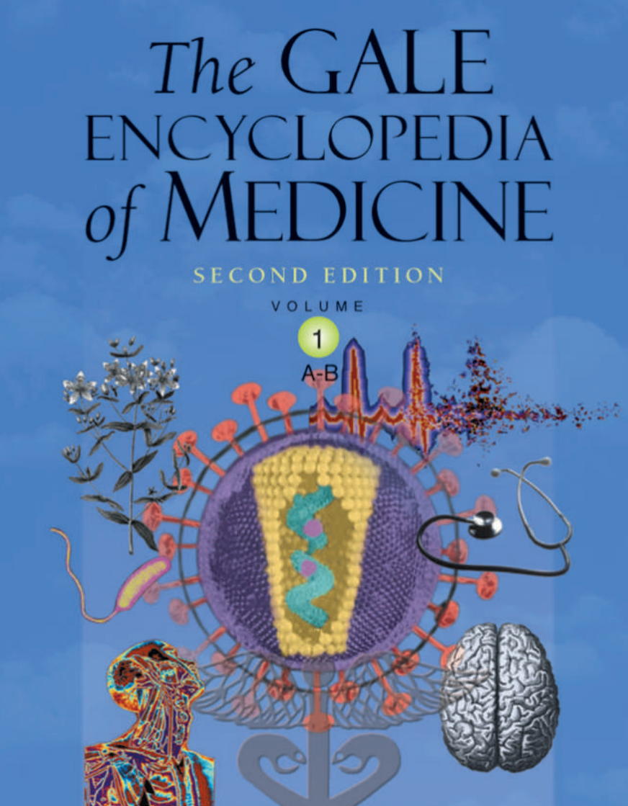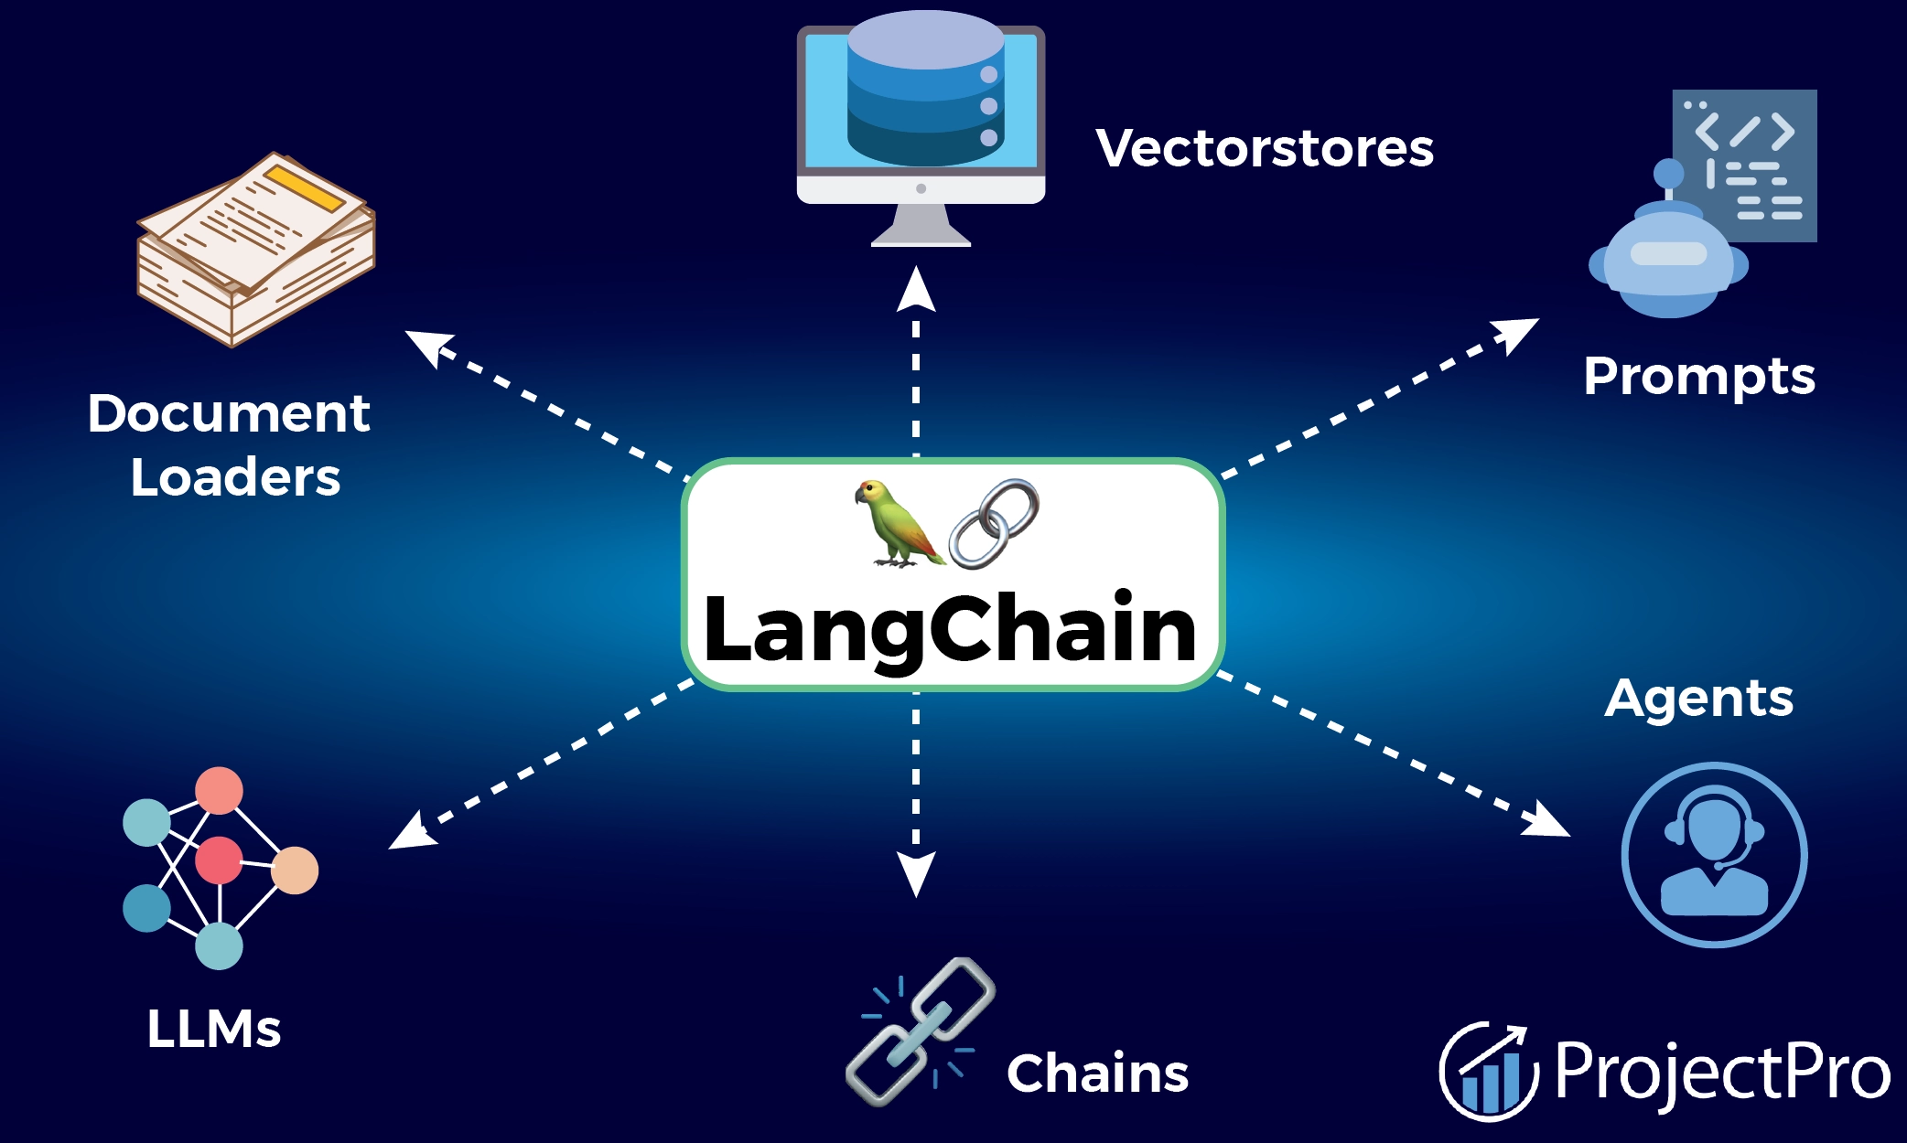
Dataset -Medicine Encyclopedia LangChain - Framework for LLM

2.Model Initialization and Configuration: We define a custom prompt template tailored for question-answering (QA) retrieval, specifying necessary context and question components. The pre-trained LLAMA-2 model is loaded using `CTransformers`, facilitating transfer learning and fine-tuning capabilities. Subsequently, we configure the retrieval QA chain using the loaded LLAMA model, custom prompt, and the vector database obtained in the previous step, setting up the foundation for accurate response generation.

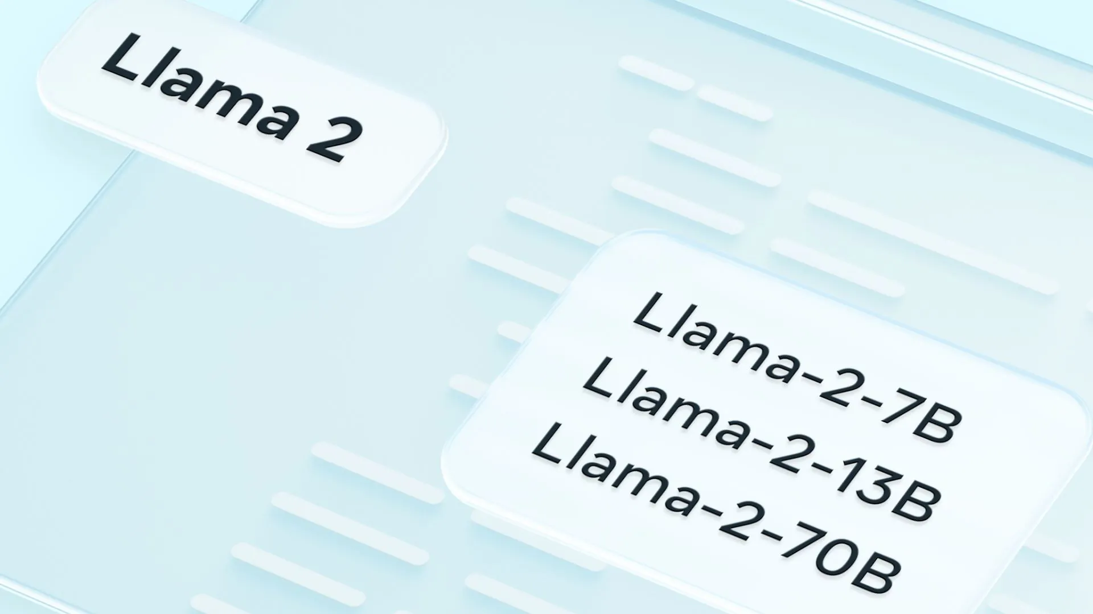
Llama by Meta Llama-2-7B Open Source AI Model

3.Query Processing and Response Generation: The `qa_bot()` function is implemented to orchestrate the question-answering process. This function initializes embeddings, loads the FAISS vector store, configures the LLAMA model, and sets up the retrieval QA chain. Upon receiving a user query, the QA chain retrieves relevant answers based on the provided context and question, ensuring accurate and informative responses.

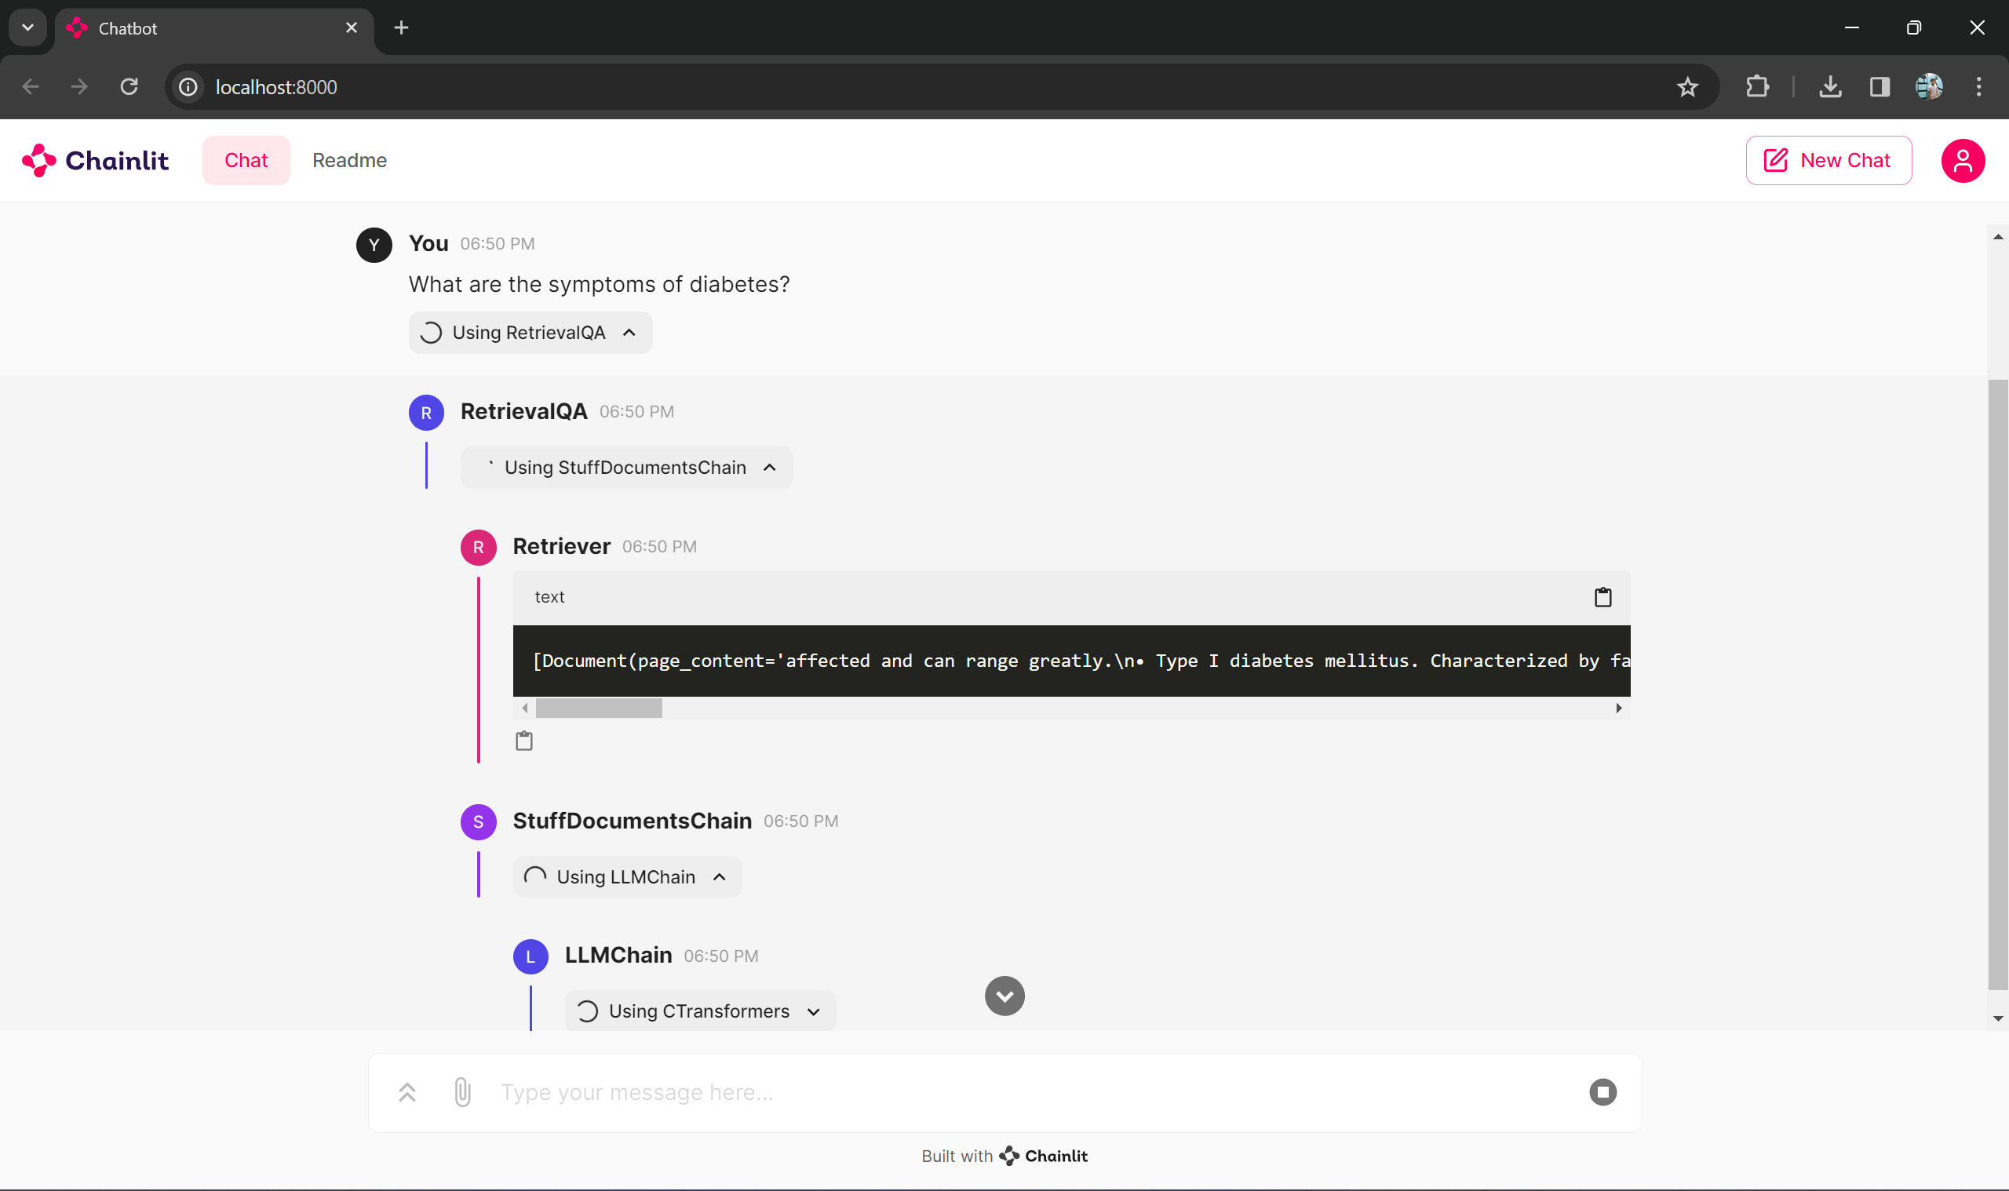
Query → RetrievalQA → StuffDocumentsChain → LLMChain →CTransformer

4. Handling User Interaction: The Chain Lit library is leveraged to manage user interaction and responses asynchronously. We define functions to start the chatbot and handle incoming messages seamlessly. Upon receiving a message, the chatbot utilizes the configured QA chain to generate a response tailored to the user's query, enhancing the overall user experience.

5. Output Formatting and Presentation: The final response generated by the chatbot is formatted to include the retrieved answer from the QA chain. Additionally, we may optionally include information about the sources or documents from which the answer was retrieved, providing transparency and credibility to the response.

6. Deployment and Testing: The chatbot is deployed in the desired environment for user interaction, ensuring accessibility and usability. Thorough testing is conducted with various medical queries to validate the model's accuracy and effectiveness, addressing any potential issues or shortcomings.

7. Fine-tuning and Maintenance: Continuous monitoring of the chatbot's performance is essential, accompanied by gathering user feedback for continuous improvement. Periodic fine-tuning of the model using additional data or retraining techniques enhances its capabilities over time. Additionally, keeping the model up to date with the latest medical knowledge and advancements through regular updates and maintenance ensures its relevance and effectiveness in addressing user queries and concerns.

- Experimental setup
In the intricate fabric of scientific inquiry lies the foundation of the experimental setup, meticulously crafted to unravel the efficacy and robustness of the developed medical question-answering (QA) system. At the inception of this empirical journey, lies the critical task of dataset selection, where an eclectic array of medical literature sources is curated to form the corpus for training, validation, and testing. Among these, the venerable GALE ENCYCLOPEDIA of MEDICINE stands as a linchpin, woven with a tapestry of medical knowledge spanning diverse domains and specialties. Supplementary datasets sourced from reputable medical repositories enrich the system's training corpus, infusing it with a breadth of knowledge vital for comprehensive medical inquiry.

As the dataset selection sets the stage, the spotlight pivots towards model training and evaluation, where the pre-trained Llama 2 model undergoes a transformative journey through the crucible of transfer learning. In this phase, the linguistic acuity of the Llama 2 model is finely tuned to resonate with the intricacies of medical terminology and discourse, iteratively honing its predictive capabilities through exposure to diverse medical contexts. The training process unfolds across multiple epochs, each refining the model's understanding and adaptability, imbuing it with the prowess to navigate the labyrinthine corridors of medical knowledge with finesse.

Following the crucible of model training, the QA system embarks on a voyage of evaluation, navigating the treacherous waters of quantitative metrics and qualitative analysis. A battery of evaluation metrics, including precision, recall, and F1-score, serves as the compass guiding the system's performance assessment. Through quantitative analysis, the system's ability to provide accurate and contextually relevant answers to a spectrum of medical queries is scrutinized, shedding light on its efficacy and reliability. Complementing this quantitative assessment, qualitative analysis conducted by domain experts delves into the coherence, accuracy, and clinical relevance of the system's responses, providing nuanced insights into its real-world applicability and impact.

In the crucible of the experimental setup, the developed medical QA system undergoes rigorous scrutiny and validation, emerging as a beacon of innovation and transformation in the realm of medical informatics. Through meticulous dataset curation, rigorous model training, and comprehensive evaluation, the system's potency and clinical relevance are empirically substantiated, paving the way for its integration into real-world medical consultation scenarios, where it stands poised to revolutionize healthcare delivery and augment patient care with its unparalleled efficacy and reliability.

- results and discussion
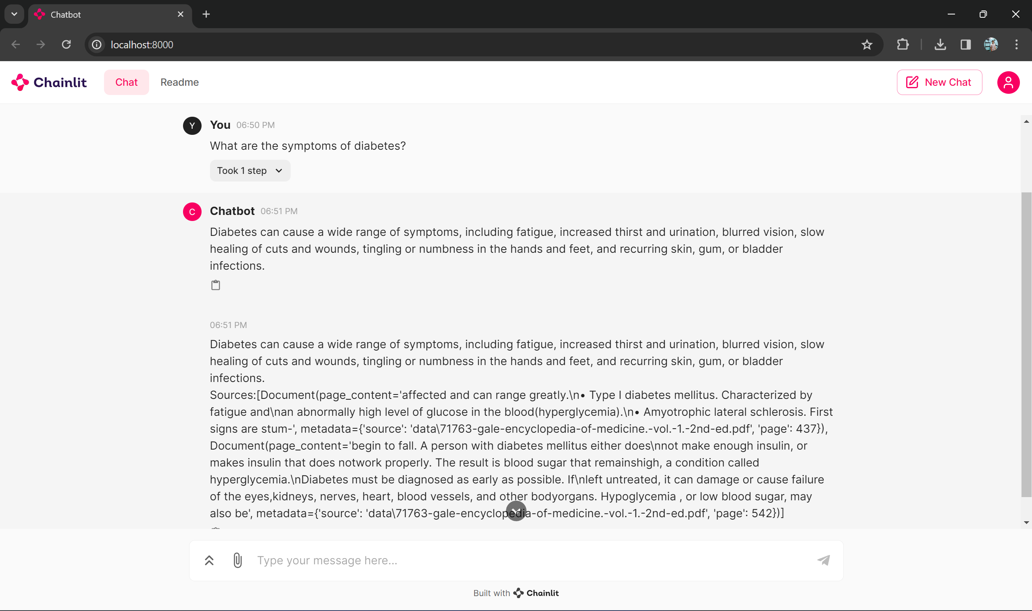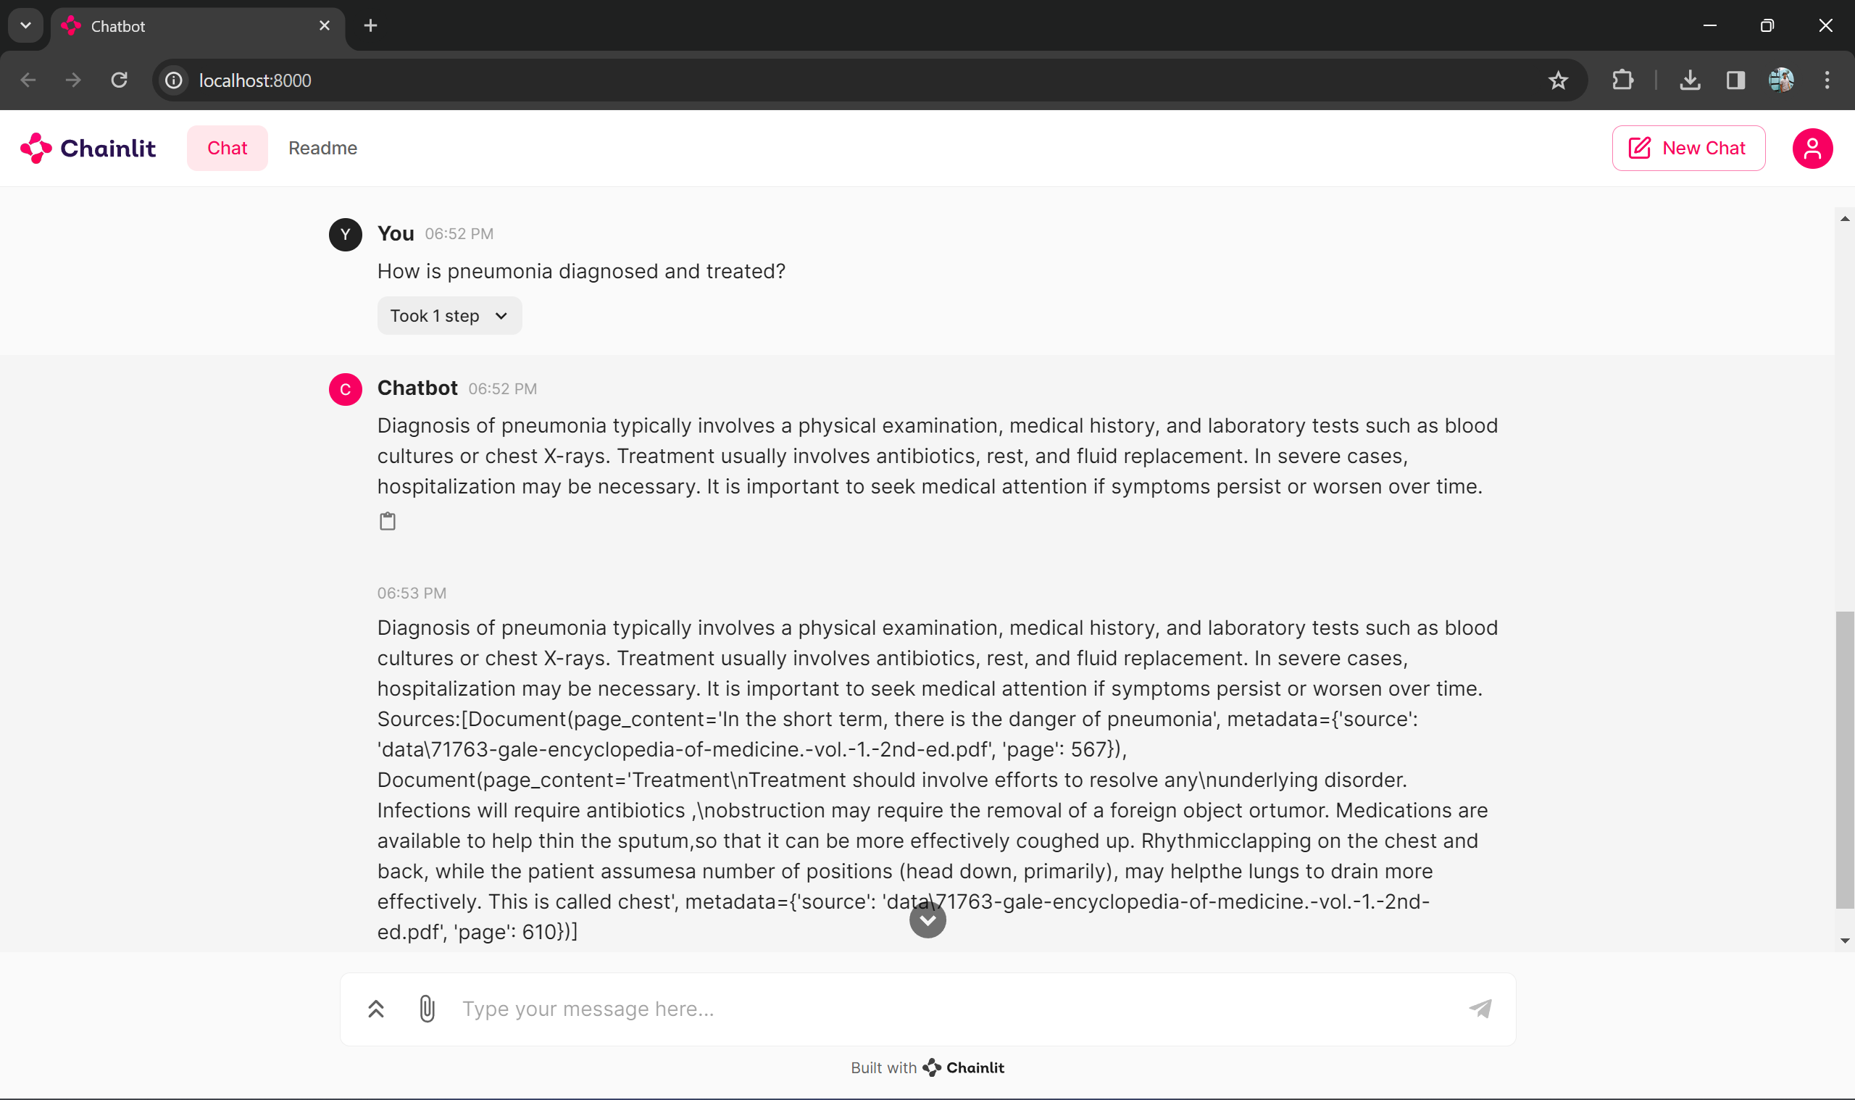
Question 1: What are the symptoms of diabetes? Question 2: How is pneumonia diagnosed and treated?

Upon implementing the outlined methodology for developing a medical chatbot model, several noteworthy results and discussions emerge. Firstly, the efficiency in data processing and storage is evident through the seamless integration of PyPDFLoader and RecursiveCharacterTextSplitter, facilitating the ingestion and preprocessing of medical documents stored in PDF format. The utilization of HuggingFaceEmbeddings to capture semantic information about text chunks and the storage of these embeddings in FAISS as a vector database ensure efficient storage and retrieval, contributing to the overall efficiency of the system.

Secondly, the accuracy and relevance of responses provided by the chatbot are notable. The fine-tuned LLAMA-2 model, coupled with the retrieval QA chain configured with a custom prompt template, demonstrates high accuracy in generating contextually appropriate responses to user queries. This integration of transfer learning capabilities and customization enhances the chatbot's ability to provide relevant information tailored to the user's needs.

Thirdly, the user interaction and experience are enhanced through the integration of the ChainLit library. Functions for starting the chatbot and handling incoming messages facilitate seamless communication between the user and the chatbot, promoting user engagement and satisfaction. This interactive interface contributes to a positive user experience, fostering trust and reliability in the chatbot's capabilities.

Moreover, the inclusion of source or document information in the final response adds transparency and credibility to the chatbot's answers. Users can verify the provided information, enhancing trust and confidence in the chatbot's responses. This transparency is crucial in healthcare consultations, where accurate and credible information is paramount.

Furthermore, deployment of the chatbot in a real-world environment allows for thorough testing with various medical queries, validating its robustness and accuracy. Continuous monitoring of the chatbot's performance and gathering user feedback are essential for identifying areas of improvement. Periodic fine-tuning of the model and updating it with the latest medical knowledge ensure that the chatbot remains relevant and effective over time.

Therefore, the developed medical chatbot model demonstrates promising results in terms of efficiency, accuracy, user interaction, and transparency. Through continuous improvement and maintenance efforts, the chatbot can continue to evolve and remain a valuable tool for healthcare consultations, benefiting both users and healthcare professionals alike.

- Conclusions
In conclusion, the development of a medical chatbot model following the outlined methodology proves to be a promising venture with several key takeaways. The efficient data processing and storage mechanisms, coupled with the accurate and relevant responses generated by the chatbot, showcase its potential to assist users effectively in healthcare consultations. The seamless user interaction experience facilitated by the integration of the ChainLit library adds to the chatbot's usability and reliability, fostering trust among users.

The transparency and credibility embedded within the chatbot's responses, including source or document information, contribute to its credibility and user trust. By deploying the chatbot in a real-world environment and conducting thorough testing, its robustness and accuracy are validated, affirming its effectiveness in addressing user queries and concerns.

Continuous improvement and maintenance efforts are essential to further enhance the chatbot's capabilities and ensure its relevance in the dynamic healthcare landscape. By monitoring performance metrics and gathering user feedback, refinements can be made to enhance user experience and address emerging needs.

In summary, the developed medical chatbot model holds promise as a valuable tool for healthcare consultations, providing users with accurate, reliable, and timely information. Through ongoing development and refinement, the chatbot stands to play a significant role in facilitating access to healthcare knowledge and improving patient outcomes.

- Futurework
Enhanced Model Performance: Invest in further research and experimentation to improve the performance of the medical chatbot model. This could involve fine-tuning hyperparameters, exploring alternative architectures, or incorporating ensemble learning techniques to boost accuracy and robustness.

Real-Time Interaction: Investigate methods for enabling real-time interaction and feedback mechanisms within the chatbot interface. This could include integrating natural language understanding models with real-time data streams to provide immediate responses to user queries or updates on medical conditions.

User Experience Enhancement: Continuously iterate on the user interface and interaction design of the chatbot to enhance user experience and usability. This could involve conducting user testing sessions, gathering feedback from healthcare professionals and patients, and incorporating user-centric design principles into the development process.

Collaborative Research Initiatives: Foster collaborations with healthcare institutions, academic researchers, and industry partners to leverage expertise and resources for advancing the field of medical chatbots. This could involve participating in joint research projects, sharing data and insights, and co-authoring publications to contribute to the collective knowledge base.

Scalability and Deployment: Develop strategies for scaling the deployment of the medical chatbot across diverse healthcare settings and populations. This could involve optimizing the model architecture for efficient resource utilization, implementing cloud-based solutions for scalability, and partnering with healthcare organizations for widespread adoption and integration into clinical workflows.

- Acknowledgement
We extend our profound gratitude to the Manipal Institute of Technology for their invaluable support and resources that significantly contributed to the research conducted herein. Their academic environment and technological infrastructure provided an ideal setting for the rigorous analysis and experimentation that this project entailed.

- References
- Oh, K.-J., D. Lee, B. Ko, and H.-J. Choi, A chatbot for psychiatric counselling in mental healthcare service based on emotional dialogue analysis and sentence generation. In 2017 18th IEEE International Conference on Mobile Data Management (MDM). IEEE, 2017.
- Kowatsch, T., M. Nißen, C.-H. I. Shih, D. Rüegger, D. Volland, A. Filler, F. Künzler, F. Barata, D. Büchter, B. Brogle, et al. (2017). Text-based healthcare chatbots supporting patient and health professional teams: preliminary results of a randomized controlled trial on childhood obesity.
- Divya, S., V. Indumathi, S. Ishwarya, M. Priyasankari, and S. K. Devi (2018). A self-diagnosis medical chatbot using artificial intelligence. Journal of Web Development and Web Designing, 3(1), 1–7.
- A. F. Ur Rahman Khilji, S. R. Laskar, P. Pakray, R. A. Kadir, M. S. Lydia and S. Bandy-opadhyay, "HealFavor: Dataset and A Prototype System for Healthcare ChatBot," 2020 International Conference on Data Science, Artificial Intelligence, and Business Analytics (DATABIA), 2020.
- A. Kaya, A. S. Keceli, C. Catal, H. Y. Yalic, H. Temucin, and B. Tekinerdogan, ‘‘Analysis of transfer learning for deep neural network-based plant classification models,’’ Comput. Electron. Agricult., vol. 158, pp. 20–29, Mar. 2019.
- Vaibhav Tode, Himanshu Gadge, Prateek Kachare and Sudarshan Madane,” CureBot -An Artificially Intelligent Interactive Bot for Medical Diagnostics” International Research journal of Engineering and Technology (IRJET)., Vol.7, no.12 (Dec 2020).
- Emanuela Haller, Traian Rebedea Faculty of Automatic Control and Computers university Politehnica of Bucharest, 978-0-7695-4980-4/13 $26.00 © 2013 IEEE. "Designing a Chat-bot that Simulates a Historical Figure".
- V.Manoj Kumar"Sanative Chatbot For Health Seekers",JECS Volume 05 Issue 3 March 2016 Page No.16022-16025.
- Hiba Hussain1, Komal Aswani2, Mahima Gupta3, Dr. G.T. Thampi4, Implementation of Disease Prediction Chatbot and Report Analyzer using the Concepts of NLP, Machine Learning and OCR.
- Ahmed Fadil, Gianluca Schiavo," Design for healthcare chatbot” Arxiv, 2019.

