Connecting To EC2

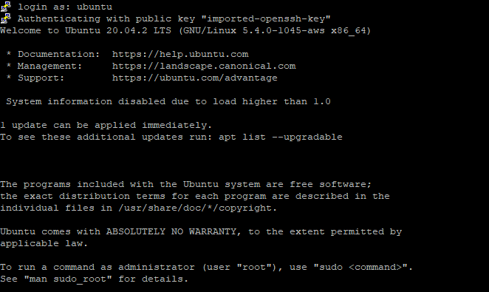

Updating the ubuntu system



Installing MySql Client



Connecting To Our RDS (MySQL Server)

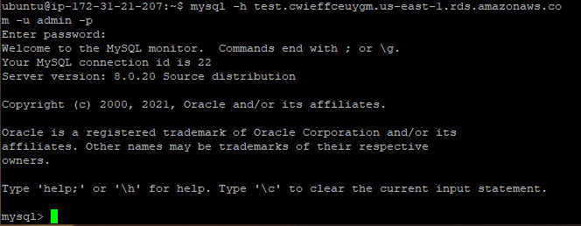

Creating primary database

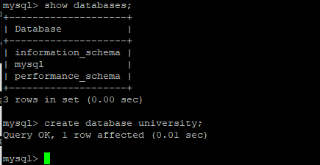

Using the newly created database and creating Professor Table

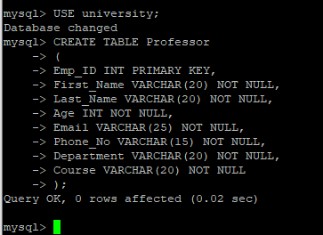

Creating Student Table

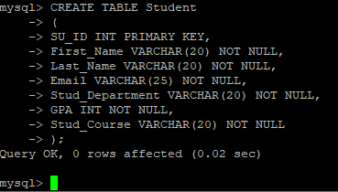

Showing Tables In The Database

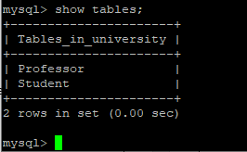

Inserting Values In Professor Table and Displaying

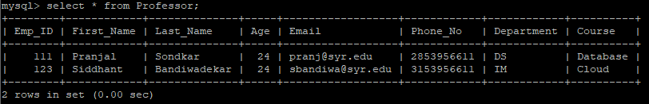

Inserting Values In Student Table and Displaying

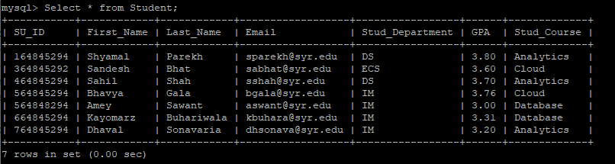

Displaying and Verifying Matching Students Using Inner Join for Courses in Both Tables

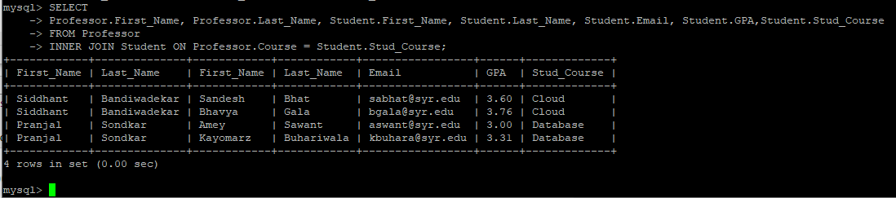

Exporting .csv Files



Creating IAM Role With Administrative Access

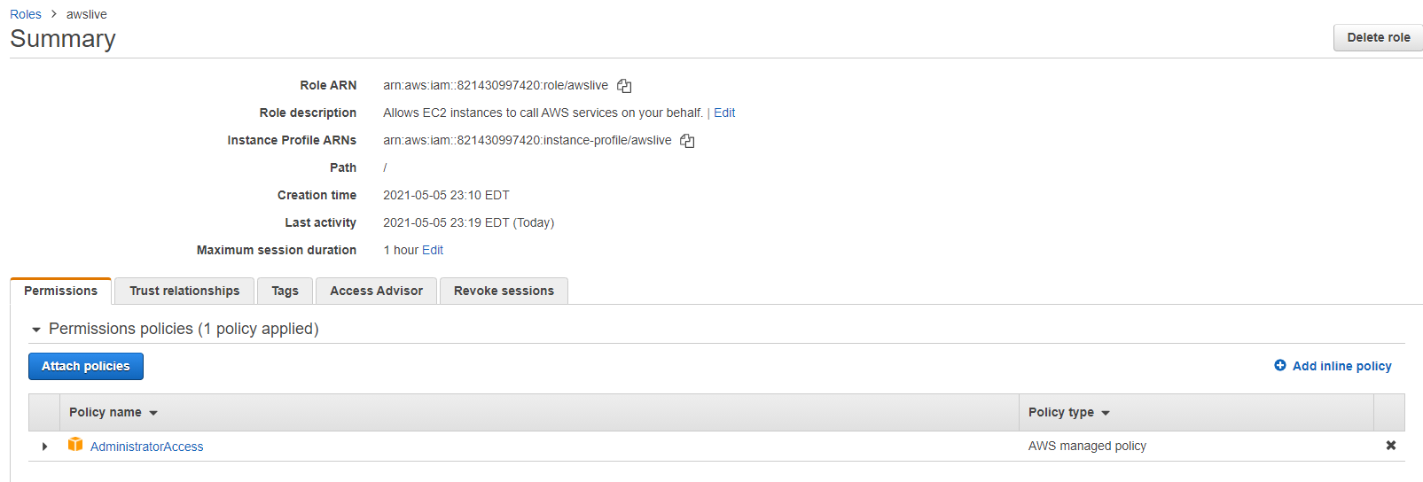

Installing awscli For S3



Uploading Files on S3

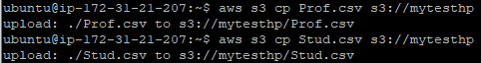

Installing Pandas



Installing pip



Installing Fuzzymatcher (Python)



Installing Apache Server For Hosting Website



Allowing Access To /var/www/html folder



Installing Php-Mysql



Moving The Webpages From S3 To /var/www/html For Hosting



Restarting and Checking The Status Of Apache Server

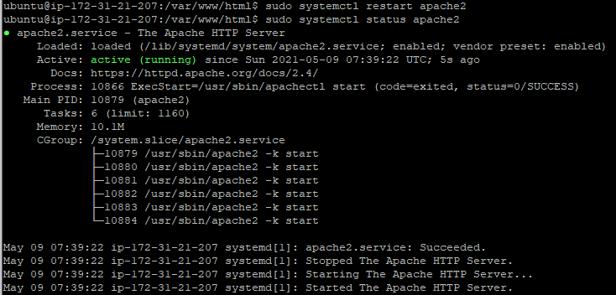

Establishing Connection With The RDS Server With The Webpage: -

$connect = mysqli_connect('test.cwieffceuygm.us-east-1.rds.amazonaws.comm', 'admin', 'password','university');

**Professor Webpage**

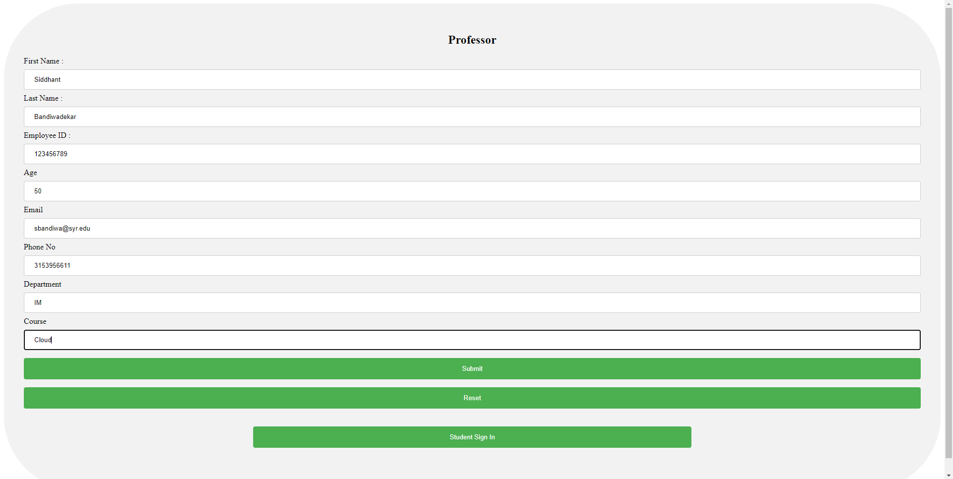

Success Message

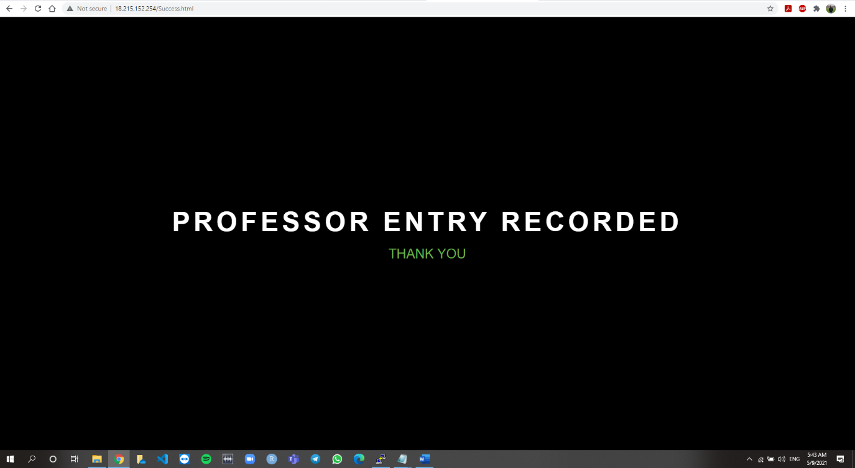

Database Update (Table Name – Professor)

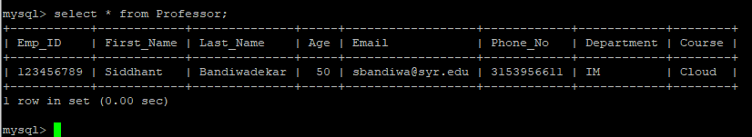

**Student Webpage**

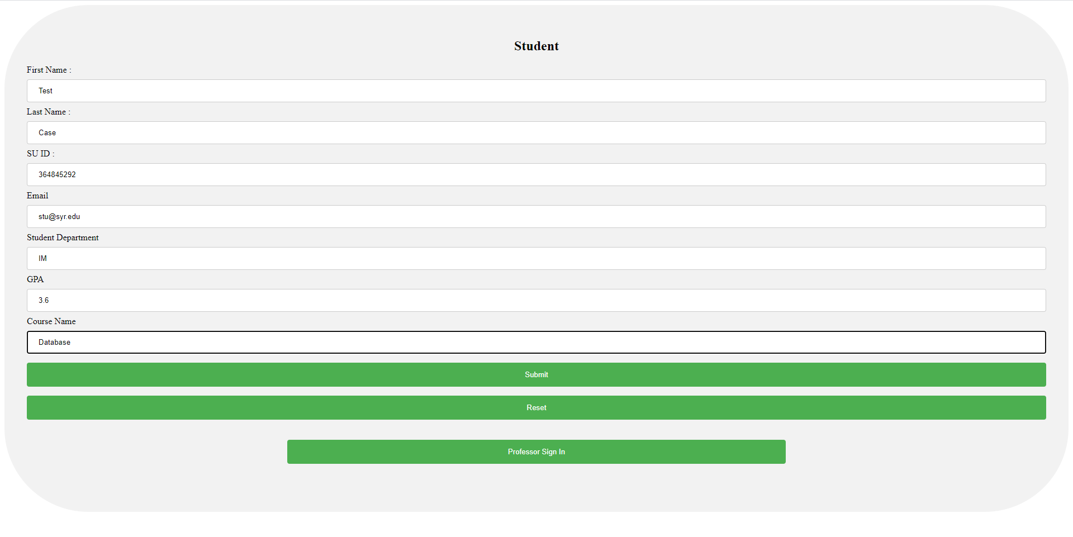

Success Message

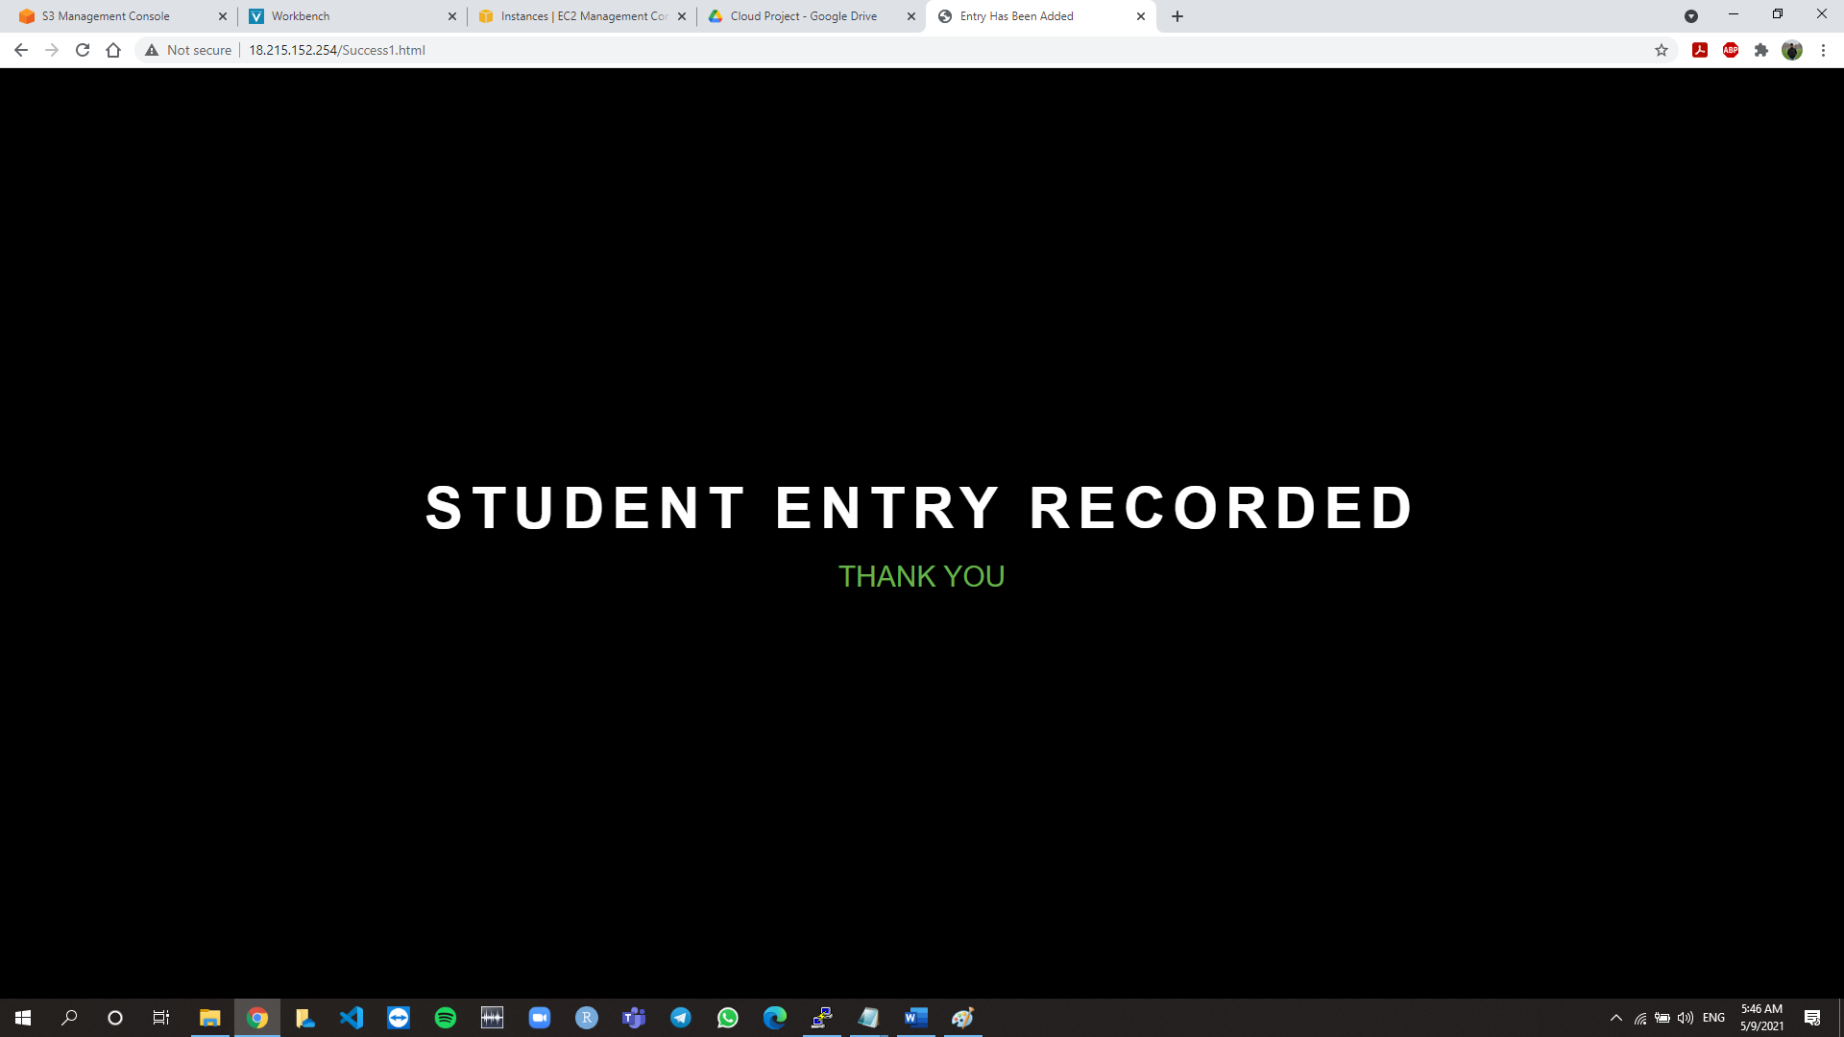

Database Update (Table Name – Student)

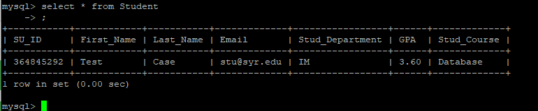

Professor Private Access

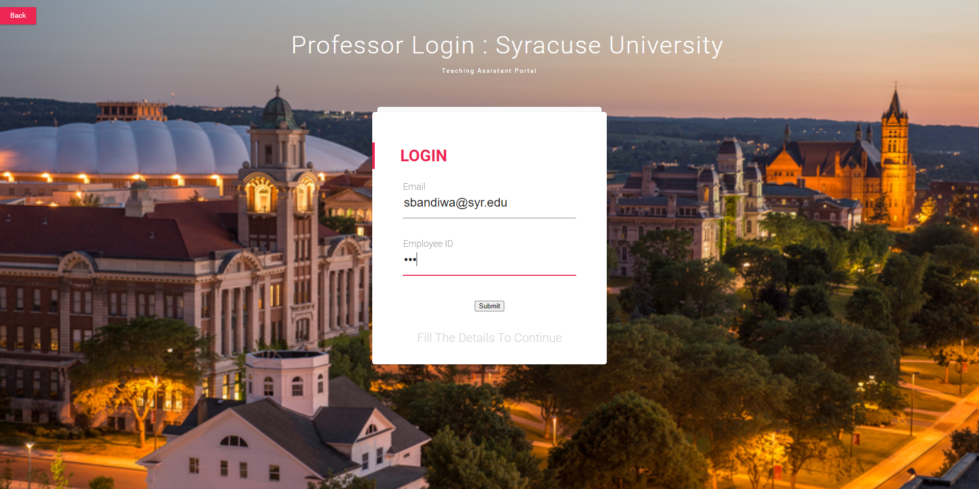

Matching Records

