Is NBA Clutch Performance Real? 26 Seasons of Data Say Yes

Introduction
Some franchises win because of talent. The 2024-25 and 2025-26 New York Knicks won because of something harder to measure.
They went down 20 to the Boston Celtics twice in the same series and won both games. In Game 1 of the 2025-26 Eastern Conference Finals against Cleveland, they trailed by 20 with eight minutes left. They won. Against the San Antonio Spurs, they were down double digits in every single game they won across the series, including one where they trailed by 29 points in the third quarter, a deficit no playoff team has recovered from in NBA history, until that night.
Three comebacks. Multiple opponents. A two-year stretch that looked, from the outside, like fortune. It wasn't.
For most of basketball history, clutch was treated as part of a player's makeup, something in the blood before the season started, not a skill that could be coached or measured. Jordan had it. Reggie Miller had it. Kobe Bryant built an entire career on it. The analytics era spent years pushing back, arguing that late-game heroics were mostly sample size, that the clutch performer was whoever happened to be holding the ball when the deficit closed. The data tells a more specific story.
We pulled 26 seasons of cWPA (clutch Win Probability Added) across every qualifying NBA player to measure how real, how repeatable, and how predictable clutch performance actually is. The Knicks are the right starting point, because they just gave us two years of unusually clear evidence.

The Data
The clutch metric throughout this analysis is cWPA, clutch Win Probability Added, sourced from inpredictable.com. It captures a player's net impact on win probability during clutch situations, accounting for shots, turnovers, free throws, rebounds, assists, steals, and blocks. Positive cWPA means the player moved the needle in the right direction. The methodology is inpredictable.com's own, and while we can describe the inputs, the underlying win probability model isn't publicly auditable.
The dataset covers 26 seasons (2000-01 through 2025-26) in three variants: regular season, playoffs, and combined. Minimum 62 games for regular-season analysis, minimum 10 for playoffs. Those thresholds filter out late-season call-ups, injury-shortened seasons, and first-round sweep victims without meaningful sample sizes. After filtering: roughly 5,500 qualifying regular-season player-seasons and 1,800 playoff entries.
For the predictive model, we paired cWPA with standard Basketball-Reference box-score stats. The model asks what a player's regular-season numbers would predict about their clutch production in the same season. Descriptive, not a forecast.

What the Leaderboards Look Like
Clutch WPA is right-skewed. Most qualifying players sit around 0.2 per season, and genuinely high-impact clutch performers form a thin tail. The median qualifying regular-season cWPA is 0.21. The all-time single-season record is 5.84 — DeMar DeRozan, 2021-22.
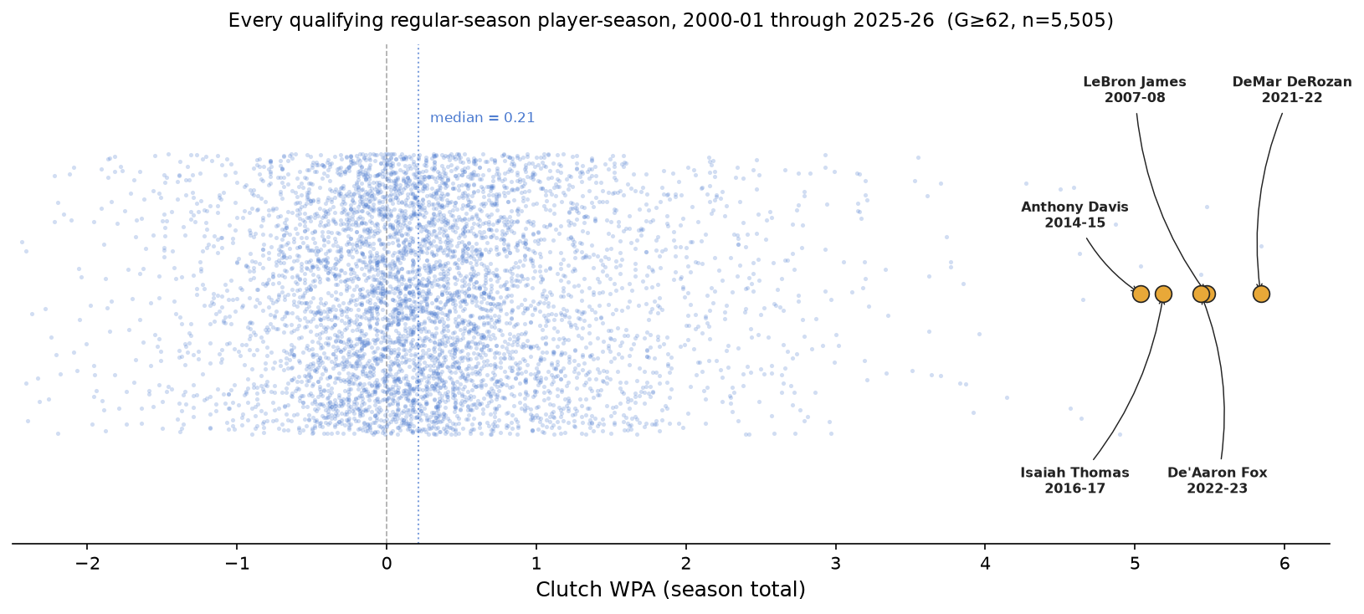
Every qualifying regular-season player-season (G≥62, n=5,505). Top 5 seasons highlighted. The five greatest are clustered between 5.04 and 5.84.
The next four: LeBron James in 2007-08 (5.48), De'Aaron Fox 2022-23 (5.44), Isaiah Thomas 2016-17 (5.19), and Anthony Davis 2014-15 (5.04). These are generational-pace seasons — note how far right of the main cloud they sit.
All-time career leaders in regular-season clutch WPA across 26 seasons (top 30):
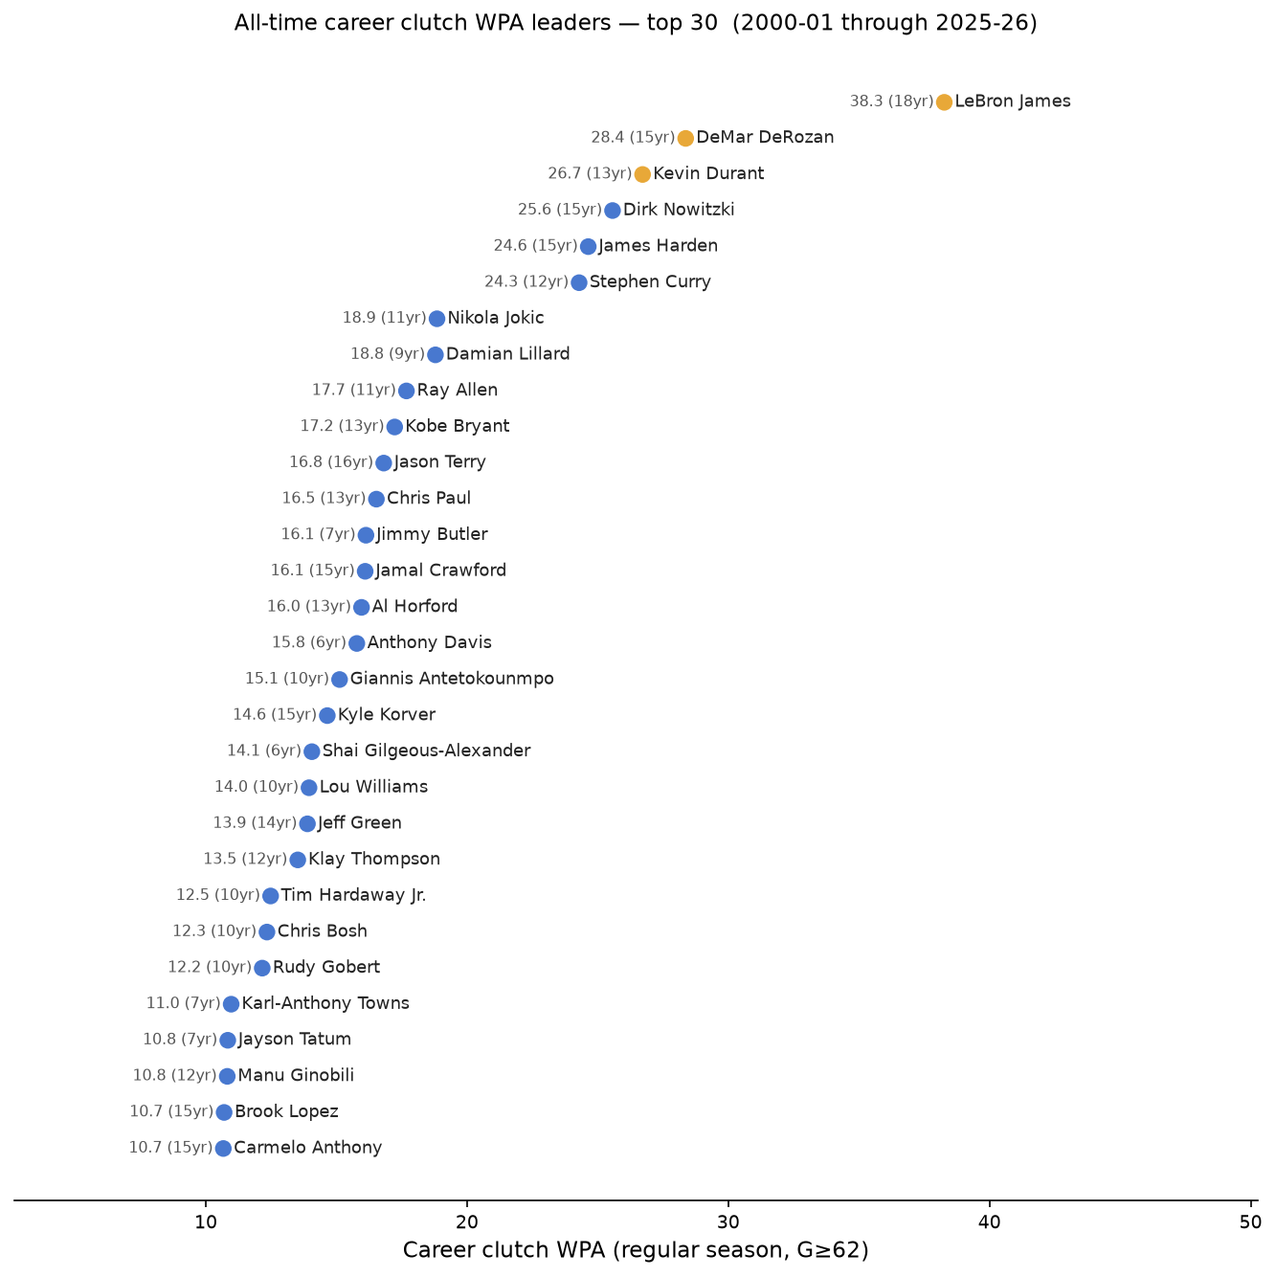
Career cWPA total (regular season, G≥62). Number in parentheses = qualifying seasons. Gold = top 3.
LeBron leads through a combination of sustained excellence and longevity. Durant and DeRozan follow — both positive in nearly every qualifying year, which is harder to sustain than any single high season.
Last 5 years (2021-22 through 2025-26) — regular season leaders (top 30):
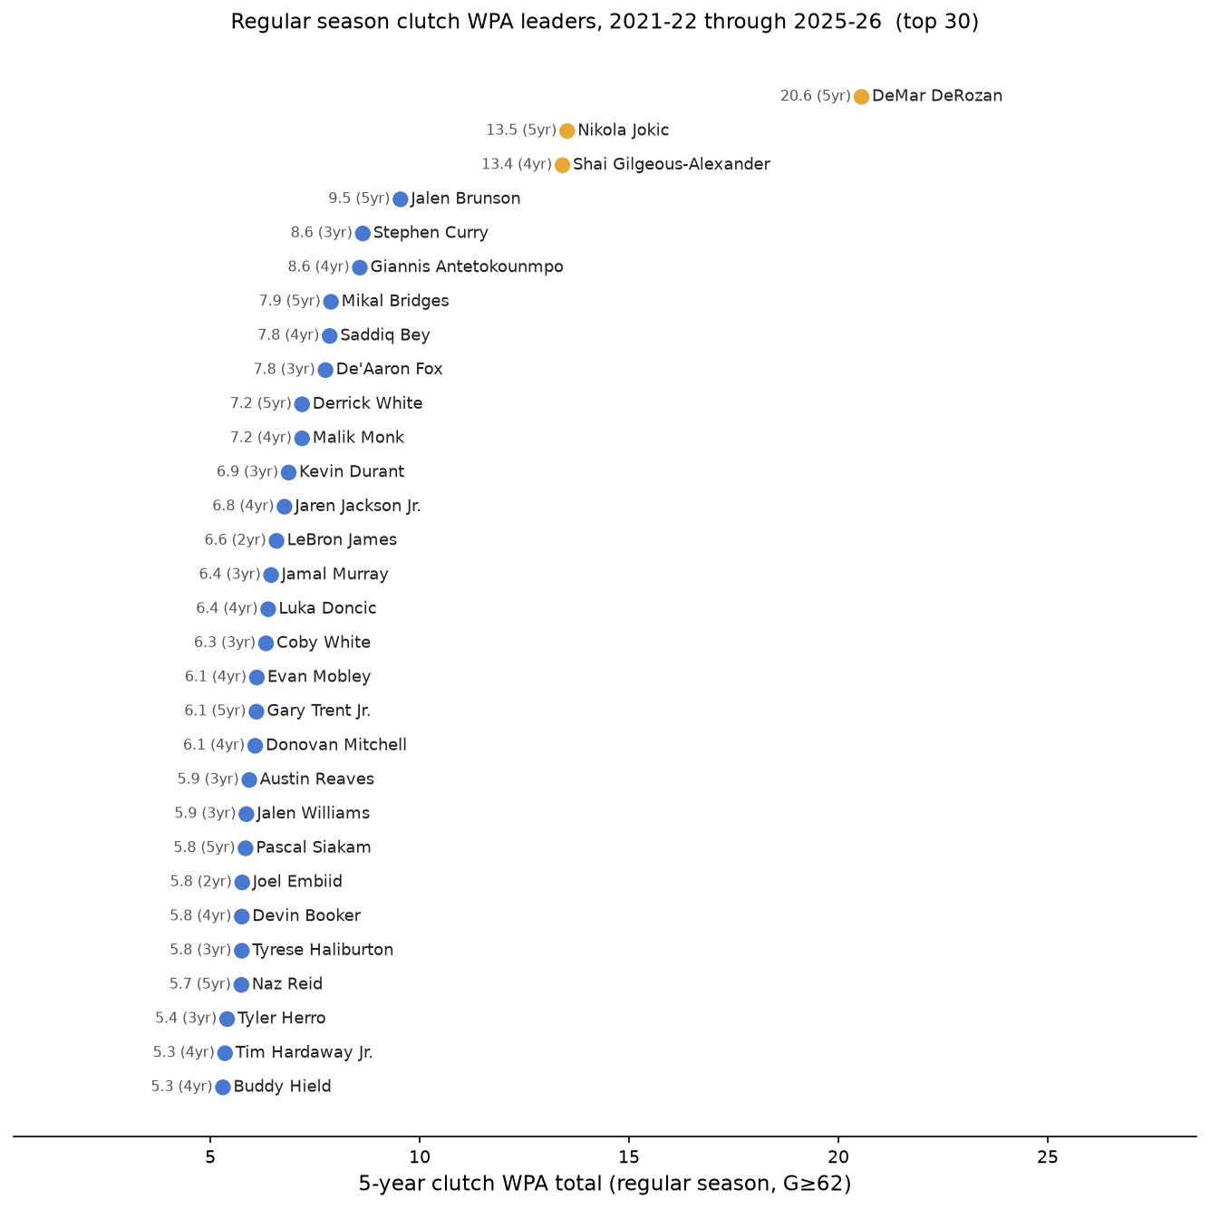
5-year cumulative cWPA, 2021-22 through 2025-26 (regular season, G≥62 each season). Number in parentheses = qualifying seasons in this window. Gold = top 3.
DeRozan's 20.55 over five seasons is a significant gap from the field — Jokic and SGA both cleared 13, but nobody else came close.
Playoffs (G≥10), last 5 years:

Player | 5yr cWPA | Qualifying runs
Jalen Brunson | 2.37 | 5
Tyrese Haliburton | 2.24 | 2
Derrick White | 2.14 | 3 (2021-23)
Jimmy Butler | 2.11 | 2 (2021, 2022)
OG Anunoby | 1.73 | 2

The best single playoff clutch season in the 26-year dataset: Haliburton, 2024-25, at 2.63. Dirk Nowitzki's 2010-11 run (2.15) held that record for over a decade.
Note that Haliburton's 5-year cumulative (2.24) is lower than his own single season (2.63) — a poor 2023-24 run (-0.39) offsets the record. Brunson's 2.37 lead comes from five straight positive appearances: no single peak, just consistent above-average clutch production every year he was in the playoffs.

Do Players Repeat Their Clutch Production?
Three correlation analyses: regular season year-over-year, regular season to same-season playoffs, and combined year-over-year. Each scatter plot below shows R² in the top-left corner — the share of variance explained.

Regular Season, Year Over Year (R² = 0.26)
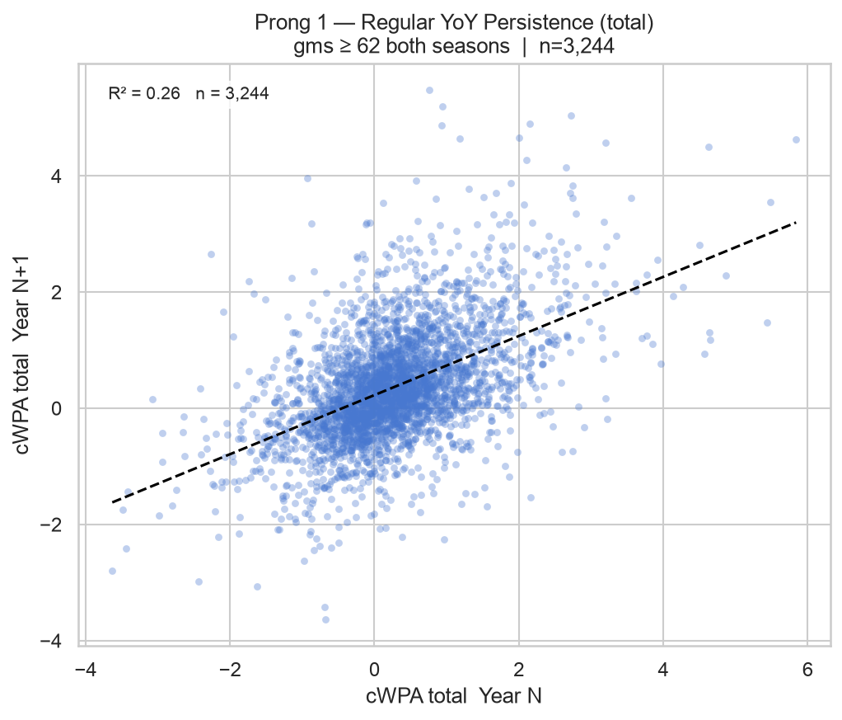
Across 3,244 consecutive season pairs: knowing last year's cWPA explains 26% of this year's variance. The signal is real and holds across every era in the data. Chris Paul finished positive in all 13 of his qualifying regular seasons. Kevin Durant, the same. That kind of consistency is not luck.
The caveat: 74% unexplained. The ordering is directionally right, but this is not a precise ranking tool.

Regular Season to Same-Season Playoffs (R² = 0.15)
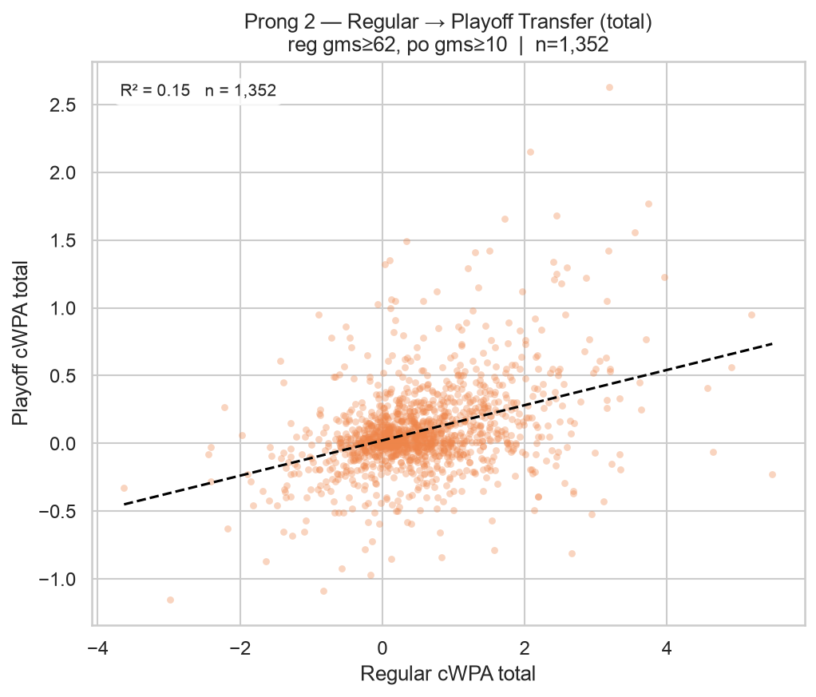
Across 1,352 player-seasons qualifying in both regular season and playoffs: the regular season explains 15% of playoff clutch variance. Smaller samples, better opponents, and targeted game plans add enough noise to drop the signal by 11 percentage points versus year-over-year. The correlation is still real — it just leaves far more room for surprises.

Combined Year Over Year (R² = 0.31)
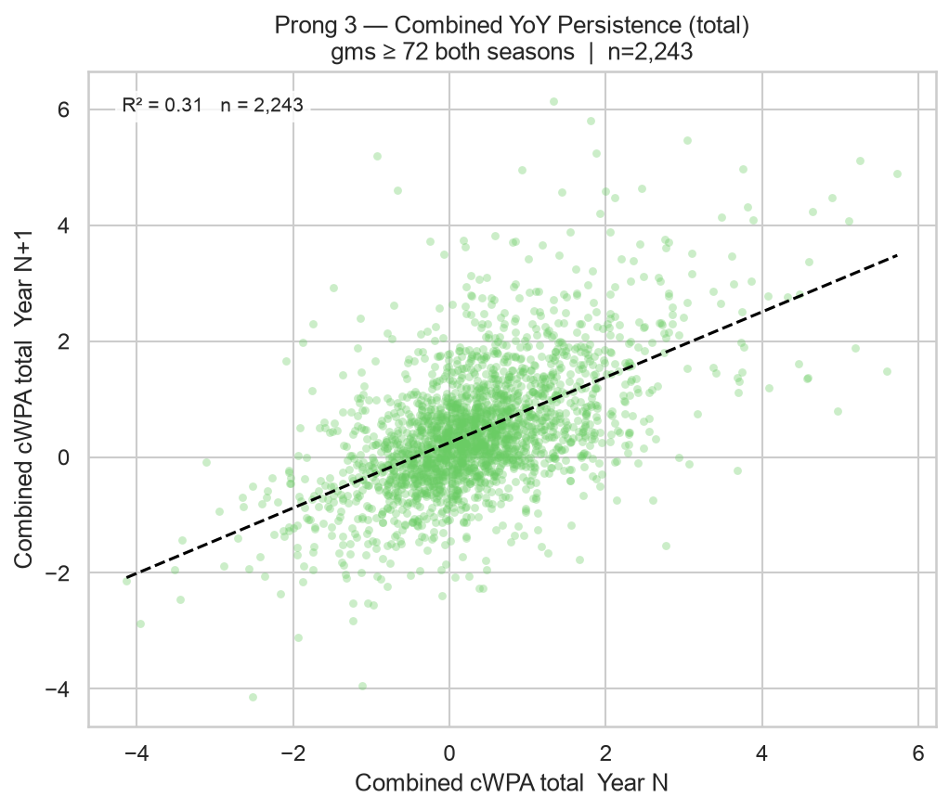
Folding regular season and playoff clutch into a single combined figure raises the year-over-year signal to R² = 0.31 across 2,243 pairs. A player who is clutch in both settings in the same year gives stronger evidence of a real skill than either number alone. Combined cWPA is the best single predictor of future clutch performance available in this dataset.

What Box Scores Can (and Can't) Explain
We trained an XGBoost model on 21 seasons of data (2000-01 through 2020-21), then tested it on the five held-out seasons it had never seen (2021-22 through 2025-26). XGBoost builds an ensemble of decision trees that can handle complex, nonlinear interactions between stats. The input: 44 standard box-score statistics, narrowed to the 20 most predictive. The target: cWPA in the same season.
On those five test seasons: the regular-season model explains 46% of the variance in clutch production (test R² = 0.46). The playoff model: 27% (test R² = 0.27). Both outperform the naive baseline of predicting league-average for everyone. But more than half the variance in both cases is unexplained. That gap is where clutch separates from box-score basketball.

What the Models Learned
Regular season leans on efficiency. True Shooting % leads, followed by turnover rate, effective field goal %, scoring volume, and offensive box plus/minus. Players who convert at a high rate and protect the ball tend to produce positive clutch WPA. Efficient scorers bring their efficiency into late-game situations.
Playoffs leads with cumulative value. VORP (Value Over Replacement Player) tops the list, followed by offensive win shares, effective field goal %, free throws, and win shares. Playoff clutch production tracks more with overall player quality than with any specific efficiency split. The best players get more volume in clutch playoff moments, and that volume converts.
The underlying message from both models: good players tend to be more clutch. Not groundbreaking. But knowing how unsurprising it is clarifies what's notable about the over and under-performers.

The Players Who Beat the Model
cWPA Difference = predicted minus actual. A negative number means the player over-delivered relative to what their box score suggested.
Regular season over-performers, 2021-2025:

Season | Player | Predicted | Actual | Difference
2022-23 | De'Aaron Fox | 1.44 | 5.44 | -4.00
2021-22 | DeMar DeRozan | 2.38 | 5.84 | -3.46
2024-25 | LeBron James | 1.29 | 3.83 | -2.54
2022-23 | Dennis Schroder | 0.22 | 2.59 | -2.37
2022-23 | DeMar DeRozan | 2.32 | 4.63 | -2.31

De'Aaron Fox's 2022-23 season is the single biggest regular-season miss in the test data, a gap of four full wins of probability added between what his box score implied and what he delivered. DeRozan appears three times in the top ten over-performers across five test seasons: 2021-22, 2022-23, and 2023-24. His shot selection looks inefficient on paper. He's a mid-range-heavy player in an era that has largely abandoned the mid-range. But he converts those shots in clutch situations at a rate no box-score stat captures. The model sees a mid-range shooter and projects modest clutch output. DeRozan delivers something else entirely.
Playoff over-performers, 2021-2025:

Season | Player | Predicted | Actual | Difference
2024-25 | Tyrese Haliburton | 0.29 | 2.63 | -2.34
2022-23 | Jamal Murray | -0.09 | 1.23 | -1.32
2024-25 | Aaron Gordon | 0.22 | 1.30 | -1.08
2022-23 | Derrick White | 0.34 | 1.41 | -1.07
2022-23 | Jimmy Butler | 0.74 | 1.77 | -1.03

Haliburton's 2024-25 playoff season is the model's biggest miss in the entire playoff dataset. The projection was 0.29 cWPA, consistent with his regular-season numbers and his prior playoff performance. In 2023-24, he was actually an under-performer, posting -0.39 when the model expected 0.31. In 2024-25, he delivered 2.63, the best single playoff clutch season in 26 years. The model had no basis to predict that shift.

The Players Who Disappointed the Model
Regular season under-performers, 2021-2025:

Season | Player | Predicted | Actual | Difference
2021-22 | Donovan Mitchell | 1.63 | -0.84 | +2.47
2021-22 | Trae Young | 2.49 | 0.03 | +2.46
2022-23 | Jayson Tatum | 2.57 | 0.29 | +2.28
2022-23 | Darius Garland | 0.95 | -0.74 | +1.69
2023-24 | Cade Cunningham | 0.57 | -1.07 | +1.64

Donovan Mitchell and Trae Young share the two biggest regular-season misses in the test data, separated by 0.006 cWPA. Mitchell's efficiency stats implied a strong clutch producer. The model expected 1.63, he posted -0.84. Young's profile was similarly elite: TS%, OBPM, scoring volume all pointed toward strong clutch production, a 2.49 projection, and 0.03 actual. Neither was hurt. Both simply weren't delivering in the five-minutes-within-five-points window that season.
Tatum appears twice across the test window, 2022-23 and 2023-24, as a significant under-performer. His regular-season production and efficiency consistently suggest elite clutch output. He has consistently come in below that expectation.

What This Means
The model captures a floor of expected clutch performance based on overall quality. Efficient, high-usage players beat the average more often than not. But the over-performers list points at something the stat sheet can't measure in the aggregate: shot selection within clutch situations, how a player's tendencies shift under pressure, or simply the variance that comes with small samples.
DeRozan, Brunson, Haliburton at his 2024-25 peak all delivered beyond what their box scores implied. Trae Young and Tatum repeatedly fell short. Whether the gap is a stable skill or a combination of tendencies and noise is impossible to disentangle with this data. But the over-performers list is a reasonable shortlist of players you'd want with the ball in the final minute. Not because they'll always deliver, but because they have consistently delivered when the model gave them no particular reason to.

Conclusion
Clutch performance repeats from year to year. R² = 0.26 year-over-year. It is a real, measurable trait. The players at the top of the leaderboard in one season are more likely than not to be above average the next. Chris Paul was positive in all 13 of his qualifying regular seasons. Kevin Durant, same. That consistency doesn't accumulate by accident.
Clutch performance transfers to the playoffs at a discount. R² = 0.15 from regular season to same-season playoffs. The signal is real but 85% of playoff cWPA variance goes unexplained by the regular season. The correlation matters enough to inform expectations. It does not determine them.
Combined production, both regular season and playoffs, is the strongest predictor of future clutch ability. R² = 0.31. If you want to know who will be reliably impactful in high-stakes situations next year, look at the combined ledger.
Brunson's trajectory from -0.51 combined in 2018-19 to 4.47 in 2024-25 is a genuine outlier in this dataset. The data would have caught the signal early: his regular-season cWPA was building steadily from 2022-23 onward. What it couldn't predict was the ceiling.
Haliburton's 2024-25 postseason, 2.63 cWPA and the best single playoff clutch performance in 26 years, is a reminder that the model describes what tends to happen. It can't describe what Haliburton did, from a box-score profile that gave no indication he was about to do it.
Clutch is real. It's not deterministic. The players who do it consistently over many years are doing something that box scores partially explain and largely cannot. That's not a gap in the analysis. That's just how hard basketball is to reduce to a spreadsheet.

Data: inpredictable.com (cWPA, 2000-01 through 2025-26), Basketball-Reference (box-score stats). Analysis covers all qualifying regular-season (G≥62) and playoff (G≥10) player-seasons.

