Topics: Confidence Intervals

- For each of the following statements, indicate whether it is True/False. If false, explain why.

- The sample size of the survey should at least be a fixed percentage of the population size in order to produce representative results.
Ans- False: The produce representative results it depends on the sample(n) size number of sample size rather than percentage of the population size. A sample of n>=30 is considered a sufficiently large amount.

- The sampling frame is a list of every item that appears in a survey sample, including those that did not respond to questions.
Ans-True

- Larger surveys convey a more accurate impression of the population than smaller surveys.

Ans- True

- PC Magazine asked all of its readers to participate in a survey of their satisfaction with different brands of electronics. In the 2004 survey, which was included in an issue of the magazine that year, more than 9000 readers rated the products on a scale from 1 to 10. The magazine reported that the average rating assigned by 225 readers to a Kodak compact digital camera was 7.5. For this product, identify the following:

- The population
- The parameter of interest
- The sampling frame
- The sample size
- The sampling design
- Any potential sources of bias or other problems with the survey or sample
Ans- A. Magazine readers = 9000 readers
B. Parameter of interest= (Average rating of camera= 7.5)
C. Sampling frame = Survey of satisfaction with different brands of electronics.
D. Sample size = 225 readers
E. Sampling design = Voluntary response
F. It is possible that responses are given either from readers who are really happy with the products or unhappy with the products and also surveys conducted by the magazines often suffer from nonresponse bias . This type of problems makes sampling unreliable.

- For each of the following statements, indicate whether it is True/False. If false, explain why.

- If the 95% confidence interval for the average purchase of customers at a department store is $50 to $110, then $100 is a plausible value for the population mean at this level of confidence.
Ans-True

- If the 95% confidence interval for the number of moviegoers who purchase concessions is 30% to 45%, this means that fewer than half of all moviegoers purchase concessions.
Ans-False. The above information implies only for 30 to 45% of moviegoers at 95 % confidence further than this we do not have any knowledge. Therefore, we cannot be 100% sure for the above statement.

- The 95% Confidence-Interval for μ only applies if the sample data are nearly normally distributed.
Ans False. The 95% confidence Interval for population mean can be applied to distribution that aren’t normal, but they are easy to understand in symmetric distributions.
We can use the central limit theorem to make a normal approximation. The rule where about 95% of observations are within 2 standard deviations of the mean is only approximately true. However, it holds very well for the normal distribution. The mean of data tends to be normally distributed when the sample size is sufficiently large.

- What are the chances that ?

- ¼
- ½
- ¾
- 1

Ans- B. ½ This is only an assumption, because if we consider more than 50% for sample mean to be greater than the probability of getting a lower value gets overshadowed because sample mean has an equal chance to be lesser than population mean

- In January 2005, a company that monitors Internet traffic (WebSideStory) reported that its sampling revealed that the Mozilla Firefox browser launched in 2004 had grabbed a 4.6% share of the market.

- If the sample were based on 2,000 users, could Microsoft conclude that Mozilla has a less than 5% share of the market?
Ans- 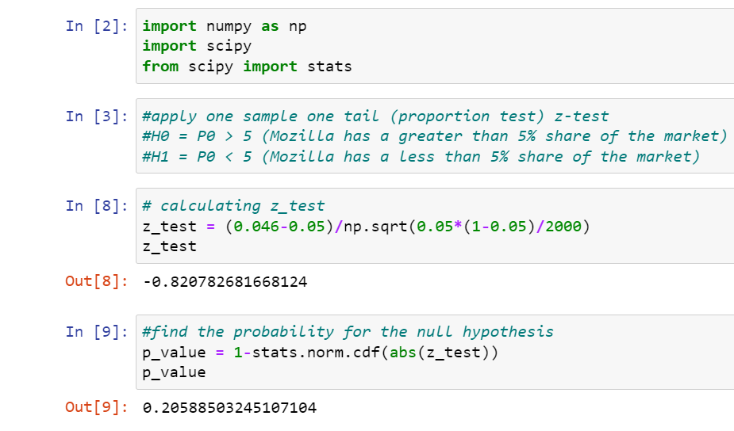
As the p_ value is greater than z_test , then do not reject null hypothesis.
Conclusion- Microsoft can not conclude that Mozilla has less than 5% share of the market based on the 2000 users.
- WebSideStory claims that its sample includes all the daily Internet users. If that’s the case, then can Microsoft conclude that Mozilla has a less than 5% share of the market?
Ans-WideSideStory has already revealed that collected sample including internet user showing 4.6% share of the market. Taking this into account Microsoft claims that Mozilla has a less than 5% share of the market.

- A book publisher monitors the size of shipments of its textbooks to university bookstores. For a sample of texts used at various schools, the 95% confidence interval for the size of the shipment was 250 ± 45 books. Which, if any, of the following interpretations of this interval are correct?

- All shipments are between 205 and 295 books.
Ans.Incorrect. 95% of the time the size of the shipment will be around 250+/-45 books.

- 95% of shipments are between 205 and 295 books.
Ans.Correct.

- The procedure that produced this interval generates ranges that hold the population mean for 95% of samples.
Ans.Correct

- If we get another sample, then we can be 95% sure that the mean of this second sample is between 205 and 295.
Ans.Correct
- We can be 95% confident that the range 160 to 340 holds the population mean.
Ans.Incorrect. as we increase the range +/- 1 sigma the % of confidence increases for a normal distribution it will be 97.5% that the mean will lie in between 160 to 340 (-3 sigma to +3 sigma).

- Which is shorter: a 95% z-interval or a 95% t-interval for μ if we know that σ =s?

- The z-interval is shorter
- The t-interval is shorter
- Both are equal
- We cannot say
Ans- A. The z-interval (1.960) is shorter. As 95% for t-interval (1.962) it increases as degree of freedom decreases.

Questions 8 and 9 are based on the following: To prepare a report on the economy, analysts need to estimate the percentage of businesses that plan to hire additional employees in the next 60 days.

- How many randomly selected employers (minimum number) must we contact in order to guarantee a margin of error of no more than 4% (at 95% confidence)?

- 600
- 400
- 550
- 1000
Ans- The population proportion is unknown. So, suppose that the population proportion is 0.50 i.e. p=0.05.
The z-value with 0.05 level of significance is 1.96 and the margin of error ‘E’ is 0.04.
Using these formula n = ( Z_{α/2} /E)² * p(1-p) and substituting the values we get, 600 randomly selected employers we must contact.

- Suppose we want the above margin of error to be based on a 98% confidence level. What sample size (minimum) must we now use?

- 1000
- 757
- 848
- 543

Ans- Using formula, n= (Z_{α/2} /E)² * p(1-p) for 98% CI with error of margin ‘E’ = o.o4.
Sample size we must use now is 848.

