**Topics: Descriptive Statistics and Probability**

1. Look at the data given below. Plot the data, find the outliers and find out $μ, σ, σ^{2}$

|  |  |
| --- | --- |
| **Name of company** | **Measure X** |
| Allied Signal | 24.23% |
| Bankers Trust | 25.53% |
| General Mills | 25.41% |
| ITT Industries | 24.14% |
| J.P.Morgan & Co. | 29.62% |
| Lehman Brothers | 28.25% |
| Marriott | 25.81% |
| MCI | 24.39% |
| Merrill Lynch | 40.26% |
| Microsoft | 32.95% |
| Morgan Stanley | 91.36% |
| Sun Microsystems | 25.99% |
| Travelers | 39.42% |
| US Airways | 26.71% |
| Warner-Lambert | 35.00% |

Ans- BOXPLOT:

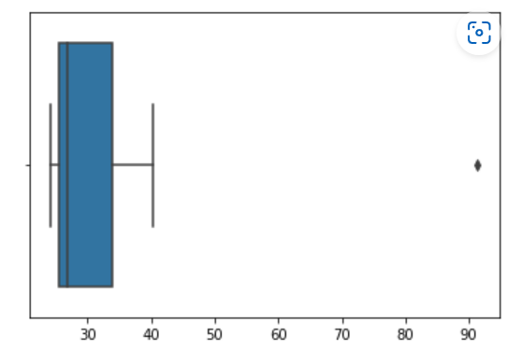

AS shown in the above boxplot there is only one outlier in the data which is Morgan Stanley – 91.36%.

Mean=33.27, Variance=287.15 and Standard deviation=16.95



Answer the following three questions based on the box-plot above.

1. What is inter-quartile range of this dataset? (please approximate the numbers) In one line, explain what this value implies.

Ans- IQR of these data is approximately 7. The middle 50% of the data is distributed within these IQR range.

1. What can we say about the skewness of this dataset?

Ans- the above distribution of the data is Positively skewed (skewed right).

1. If it was found that the data point with the value 25 is actually 2.5, how would the new box-plot be affected?

Ans- In that case there would be no outlier on the given data set and the measure of Central

tendency and dispersion would be different. Positive skewness will reduce and it can form

normal distribution.



Answer the following three questions based on the histogram above.

1. Where would the mode of this dataset lie?

Ans- The mode of the data lies between approximately 5-10.

1. Comment on the skewness of the dataset.

Ans- Above data set is Positive skewed.

1. Suppose that the above histogram and the box-plot in question 2 are plotted for the same dataset. Explain how these graphs complement each other in providing information about any dataset.

Ans- The median is easily visualized from the Boxplot and the mode Is easily visualized from the

Histogram.

1. AT&T was running commercials in 1990 aimed at luring back customers who had switched to one of the other long-distance phone service providers. One such commercial shows a businessman trying to reach Phoenix and mistakenly getting Fiji, where a half-naked native on a beach responds incomprehensibly in Polynesian. When asked about this advertisement, AT&T admitted that the portrayed incident did not actually take place but added that this was an enactment of something that “could happen.” Suppose that one in 200 long-distance telephone calls is misdirected. What is the probability that at least one in five attempted telephone calls reaches the wrong number? (Assume independence of attempts.)

Ans-IF 1 in 200 long-distance telephone calls are getting misdirected.

probability of call misdirecting = 1/200

Probability of call not Misdirecting = 1-1/200 = 199/200

The probability for at least one in five attempted telephone calls reaches the wrong number

Number of Calls = 5

n = 5

p = 1/200

q = 199/200

P(x) = at least one in five attempted telephone calls reaches the wrong number

P(x) = ⁿCₓ pˣ qⁿ⁻ˣ

P(x) = (nCx) (p^x) (q^n-x) # nCr = n! / r! * (n - r)!

P(1) = (5C1) (1/200)^1 (199/200)^5-1

P(1) = 0.0245037

1. Returns on a certain business venture, to the nearest $1,000, are known to follow the following probability distribution

|  |  |
| --- | --- |
| x | P(x) |
| -2,000 | 0.1 |
| -1,000 | 0.1 |
| 0 | 0.2 |
| 1000 | 0.2 |
| 2000 | 0.3 |
| 3000 | 0.1 |

1. What is the most likely monetary outcome of the business venture?

Ans- the most likely monetary outcome is $2000 because it has the maximum probability compare to the others.

1. Is the venture likely to be successful? Explain

Ans- the venture is likely to be successful because the probability of making profit is 0.8 i.e. it has 80% of chance that it will make profit and there is 20% of chance of loss which is affordable as the profit more as compare to the loss.

1. What is the long-term average earning of business ventures of this kind? Explain

Ans-the expected long-term earning is $800 out of $ 1000 because there is chance of 20% loss in this business venture.

1. What is the good measure of the risk involved in a venture of this kind? Compute this measure

Ans- the good measure of the risk involved in a venture is variance i.e. variability in the given data.

Variance = E(x^2)-(E(x)^2)

=2800000 – 640000

= 2160000