

**Lovely Professional University**

**INT213**

**PROJECT**

***ON***

**CHARACTER IDENTIFY GAME**

Submitted to**: Sagar Pandey**

Submission**: Nov, 2020**

Group Members**: AKSHAT (roll – 28)**

**VIBHAB SINGH (roll – 23)**

**SIDDHANT SHARMA (roll – 31)**

**BTech (CSE)**

**Section – K19HZ**

**Group – 1**

**ACKNOWLEDGEMENT**



Firstly we would like to express our special thanks to our teacher **Mr. Sagar Pandey,** who has given us this opportunity to do this exciting and helpful project in python. Since this is our very first Project, we have given our best and while doing this Project, we came across a lot new things and techniques that helped us to enhance our knowledge for further any Projects.

We are also thankful to our friends who have helped us in making this project throughout and innovative discussions with them.

We are truly making this project for our knowledge enhancement and not just for marks.

Thanks again to all who helped us.

Siddhant Sharma Vibhav Singh Akshat

BTech CSE BTech CSE BTech CSE

**Summary of the Project**



* GUI INTERFACE IS USED
* DISPLAY THE RANDOM IMAGES
* EVERY TIME USER PLAY DISPLAY RANDOM SET OF IMAGES
* USER HAVE TO ENTER THE ANSWER AS PER THE QUESTION
* CHAT BOT WILL BE PROVIDED FOR HELP OR HINT
* EVERY CORRECT ANSWER GIVES U TWO POINT
* BUT IF USER USES CHAT BOT FOR HINT IT WILL GIVE YOU NEGATIVEMARKING
* DISPLAY FINAL SCORE

**PROJECT OBJECTIVES AND RESEARCH**

Firstly, we have tried to search for all those libraries we used in GUIs so that we can take idea that what the different widgets we can use in our project. Further we have gone through the different sites and videos, and from there we took different ideas and discussed together to make our project more effective.

After all the discussions, we together made finally the rough design and decided to make our Project using Tkinter library and then we started implementing the same. During the implementation, we came to know about various techniques and used in our project also. Like adding hint bot and adding speak function t makes the project more attractive and adding background music.

The main objective of our Project is to make user identify the character in the image. User have to type the correct answer then only user will get points we have provided a hint bot for help and also add negative marking it will deduct you score the no of times you use hint bot and we have provided play again function after completion .

We have also introduced a Score label on the screen so that user will know the score.

 **PROJECT DESCRIPTION**

* We have decided to use Tkinter python library for making GUI and POTHON PILLOW IS USED TO DISPLAY IMAGES.
* Random function is used to fetch the random SET OF QUESTION from the list for display the question
* For first window,
* 1 Labels and 3 Buttons are used
* Icon and background image has been used
* For second window USER CAN CLICK ON START BUTTON TO START THE GAME,
* 4 button, 2 Labels and 2 entry box has been created
* USER HAVE TO TYPE THE ANSWER
* EACH CORRECT ANSWER WILL GIVES THEM ONE MARKS
* USER CAN USER CHAT BOT FOR HINT
* BUT USING CHAT BOT HINT WILL GIVE THEM .25 NEGATIVE MARKING
* NO MARKS FOR UNATTEMPETED QUESTION
* FINAL SCORE WILL BE DISPLAY

**IMPLEMENTATION**

* First of all we imported all the required libraries such as Tkinter and pillow PYTTSX3 ,winsound,chatterbot and functions.
* Then we created the window and changed its geometry, icon, and introduced Labels and image.
* Some functions are:
* **bol() 🡪** It will performe speak function.
* **Start_music ()🡪** for start and pause of background misic.
* **gen () 🡪** It will display random set of question.
* **evaluation ()🡪** It will calculate your score.
* **Show_result ()🡪** It will display your score.
* **hint_used ()🡪** if user use hint bot it will add 0.5 negative marking.
* **Place_game_window ()🡪** placing the bot into second window.
* **restart ()🡪** you can play again the game and Removing the items from the result window.
* **move_next ()🡪** Move to next question and calling necessary functions.
* **Start ()🡪** it will be starting the game.
* **Ins ()🡪** It will Inserting the user's input and bot response in text box (m).
* **clr()🡪** It will clear the Text box(m).
* **aut()🡪** It will bind the send button to enter key and mouse cursor.
* Further for next window, above functions and some Labels are created such as:
* **Text_Label**
* **Score_Label**
* **q_label**

**Project Contribution**

* All the group members have tried to give our best in this project
* WE all have equally contributed in the Project
* All the Discussions and implementation and modifications are done together
* WE have equally shared our ideas and sources or anything related to this project
* Initially we all have learnt about different modules and libraries and then decided and planned to finish this project.
* All the work related to this Project either Code Writing or Report Making or Presentation, we all have contributed equally from our side.
* We all are equally responsible for the pros and cons of this Project as we have given the equal efforts

**SCREENSHOTS OF THE WORKING PROJECT**

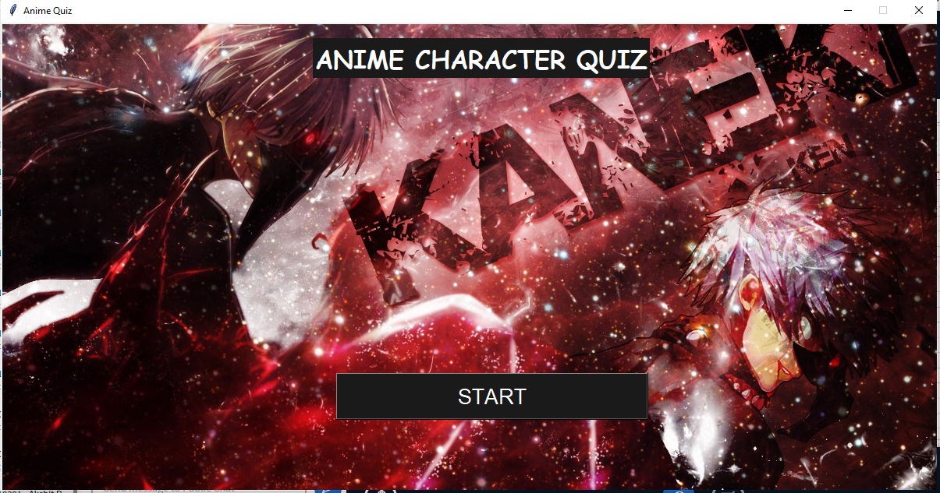

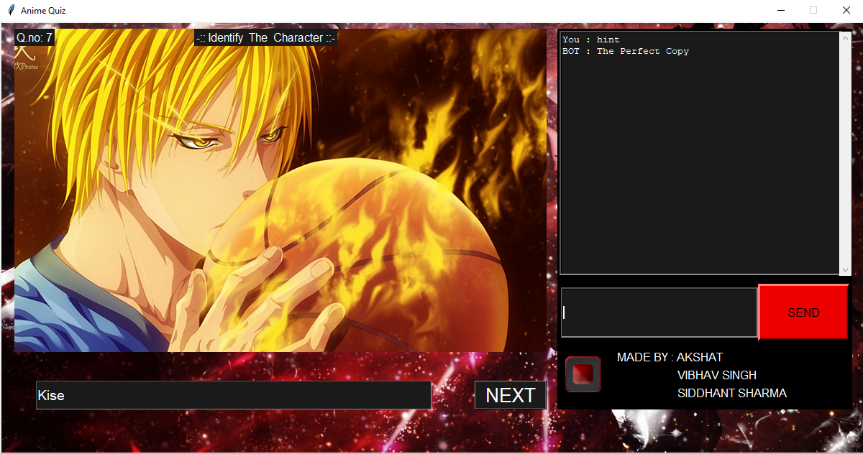

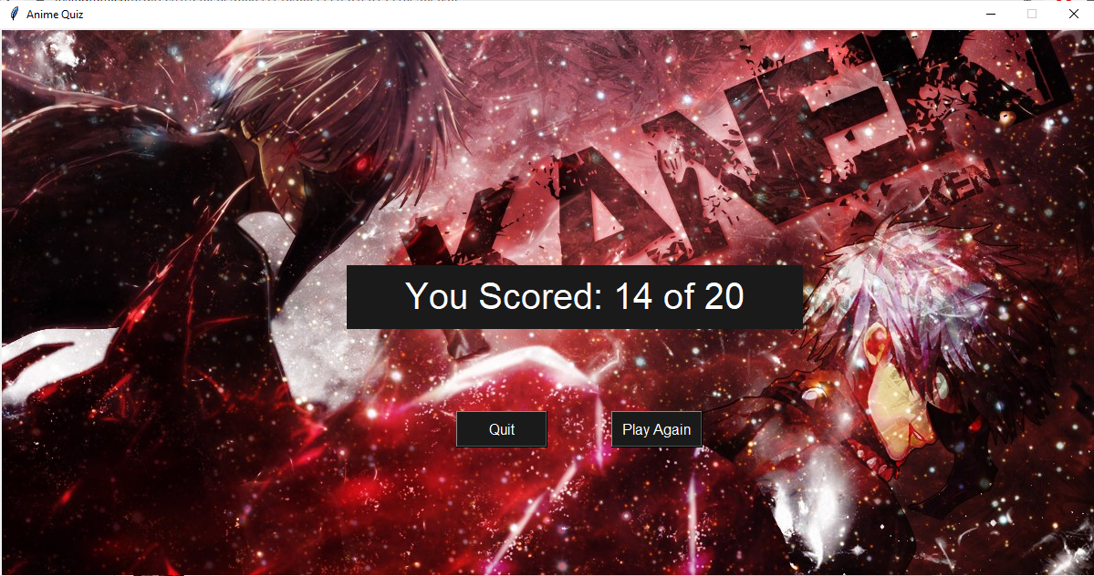

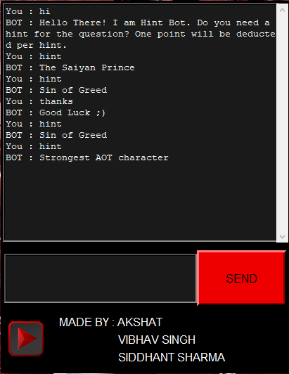

**Conclusions**

Our Project is giving the same output as we have designed in rough and expected in the very beginning.You can easily edit the contain as per you convince and it is reusable .

Anyone can use this small Python Project as a quizz game for fun and enjoy all of its intractive features.

This small Project is very simple to implement, exciting and helpful as well.

***REFERENCES***

***<https://www.geeksforgeeks.org/gui-chat-application-using-tkinter-in-python/>***

***<https://www.geeksforgeeks.org/working-images-python/>***

***<https://www.geeksforgeeks.org/python-winsound-module/>***

***<https://www.geeksforgeeks.org/python-text-to-speech-by-using-pyttsx3/>***

**THANK YOU**