WEB APPLICATION SECURITY

University Name: - National Forensic Sciences University
School Name: - School of Cyber Security and Digital Forensics
Course Name: - MSC Cyber Security
Semester: - 1
Name: - Siddhant J Chaudhary
Enrollment no: - 250103002022

Description :- TA – 2 examination in the form of practical tasks performance , for performing the labs related to given vulnerabilities I’ve used different platforms such as DVWA and Security Shepherd etc and tools like ZAP proxy and Burpsuite.

1. SQL Injection
2. Broken Authentication
3. Sensitive Data Exposure
4. XML External Entities (XXE)
5. Broken Access Control
6. Security Misconfiguration
7. Cross-Site Scripting (XSS)
8. Insecure Deserialization
9. Using Components with Known Vulnerabilities
10. Insufficient Logging & Monitoring
11. Cross-Site Request Forgery (CSRF)
12. File Inclusion
13. Clickjacking
14. File Upload Vulnerabilities
15. Server-Side Request Forgery (SSRF)
16. Insecure Direct Object Reference (IDOR)

1. SQL Injection: -

Platform Used: - DVWA-master
Tool used: - Not Any

Vulnerability :-

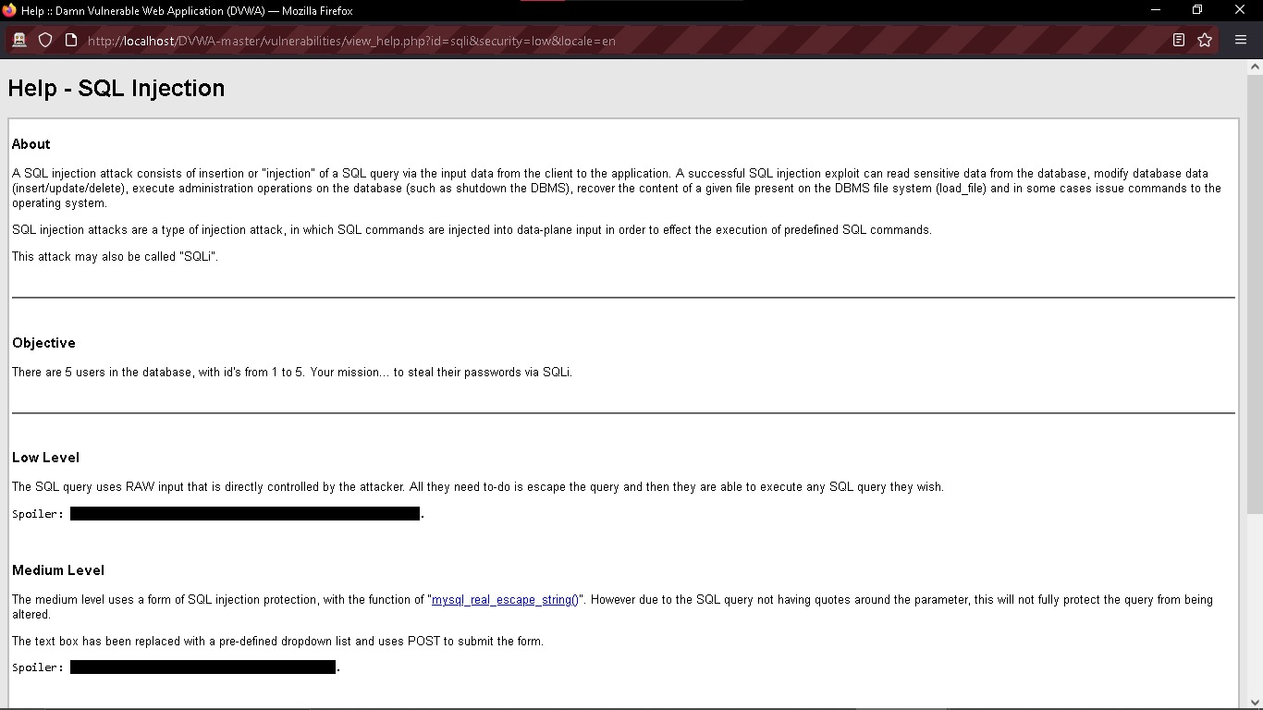

• I’ve solved this vulnerability in low level in DVWA, where the objective is to get the password of users via SQLi.
• NOTE The SQL query uses RAW input that is directly controlled by the attacker. All they need to-do is escape the query and then they are able to execute any SQL query they wish.
• For solving this lesson I was going threw https://portswigger.net/web-security/sql-injection/union-attacks#using-a-sql-injection-union-attack-to-retrieve-interesting-data so I found that in this site there is a query to perform SQLi and retrieve data from user table so I used the query

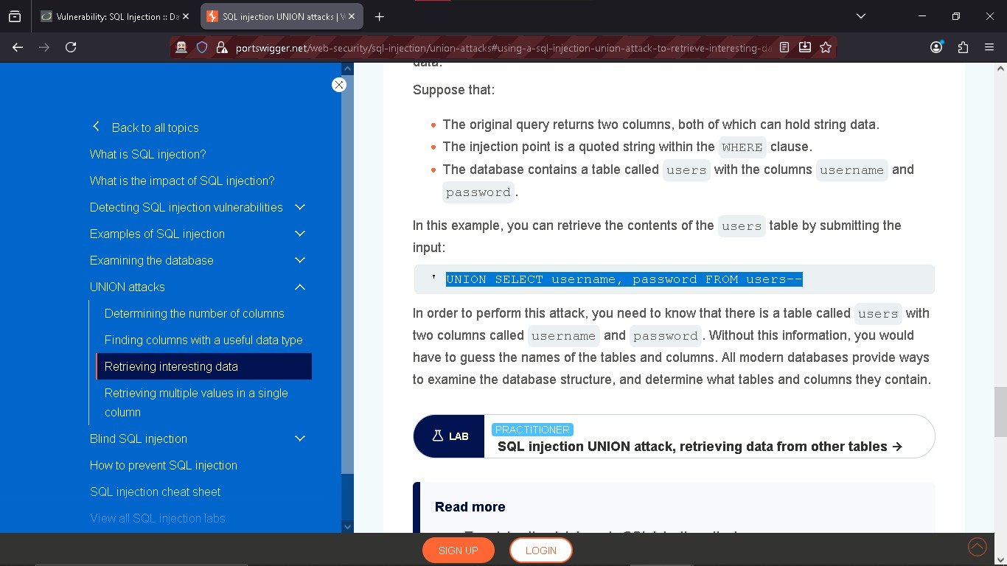
“UNION SELECT user, password FROM users#”
• This query manipulates user table to return with all the user’s passwords.
RESULTS:-
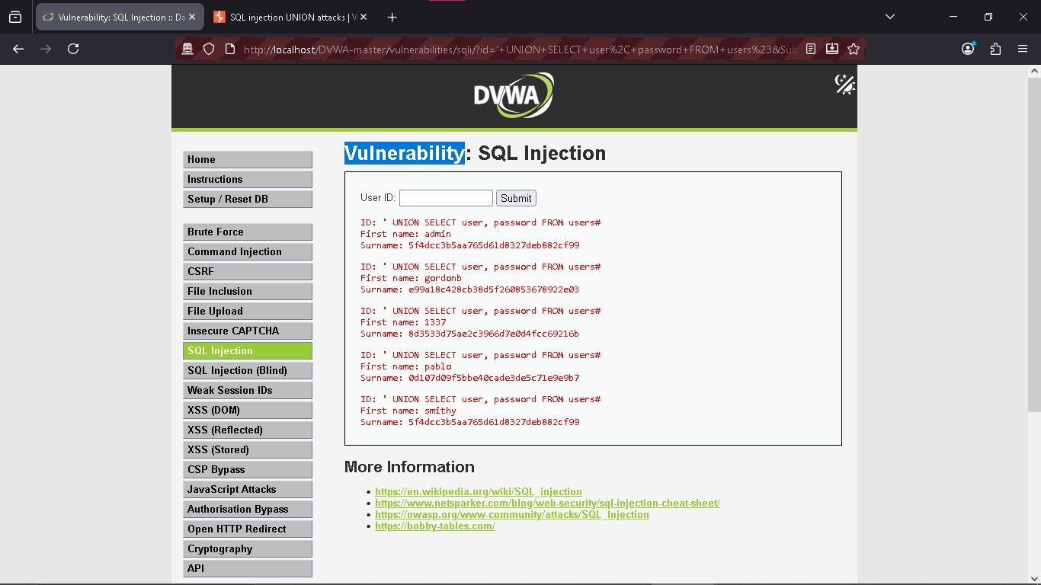

• But the passwords are in the hash formats and given as surnames so for getting the original passwords I scanned the hashed password with hash analyzer and the results were:-
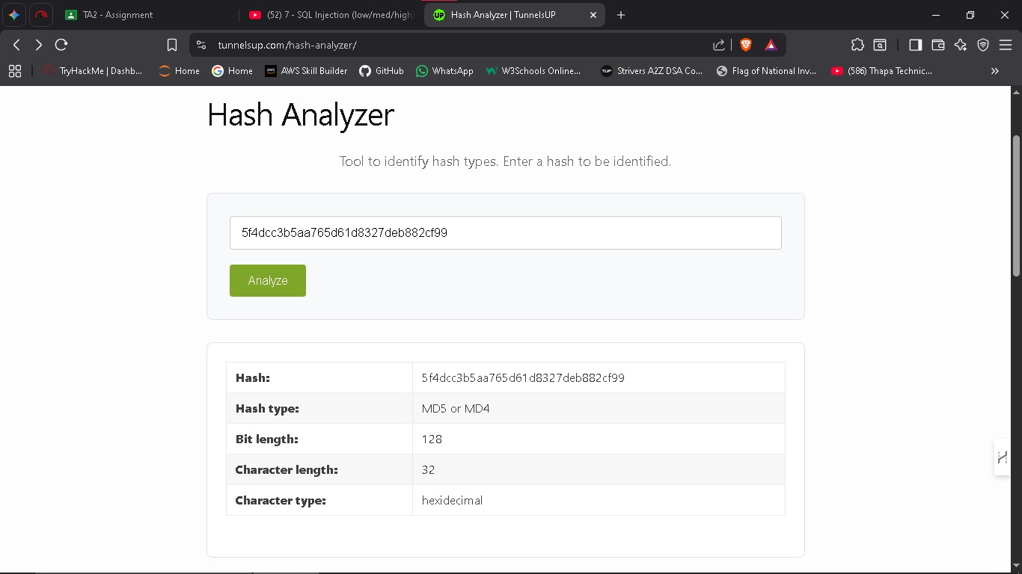

• For cracking this type of hashes one tool is very famous named CrackStation
https://crackstation.net/
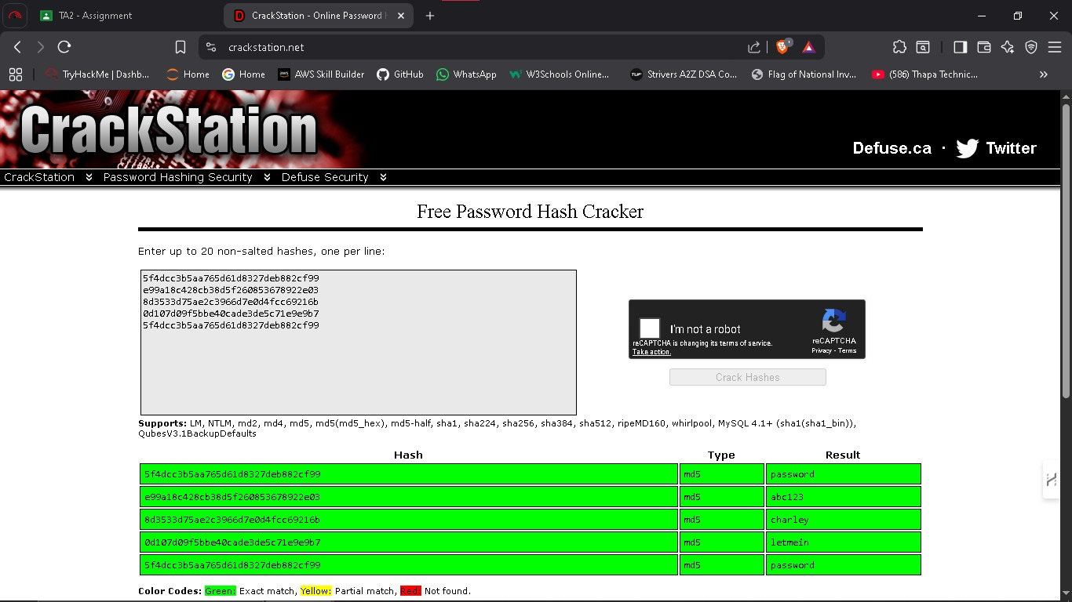
• So by performing some steps like this I’ve found the passwords from the SQL database and then decoded it to find out the original passwords using CrackStation.
2.: - Broken Authentication

Platform Used: - DVWA-master
Tool Used: - Burpsuite

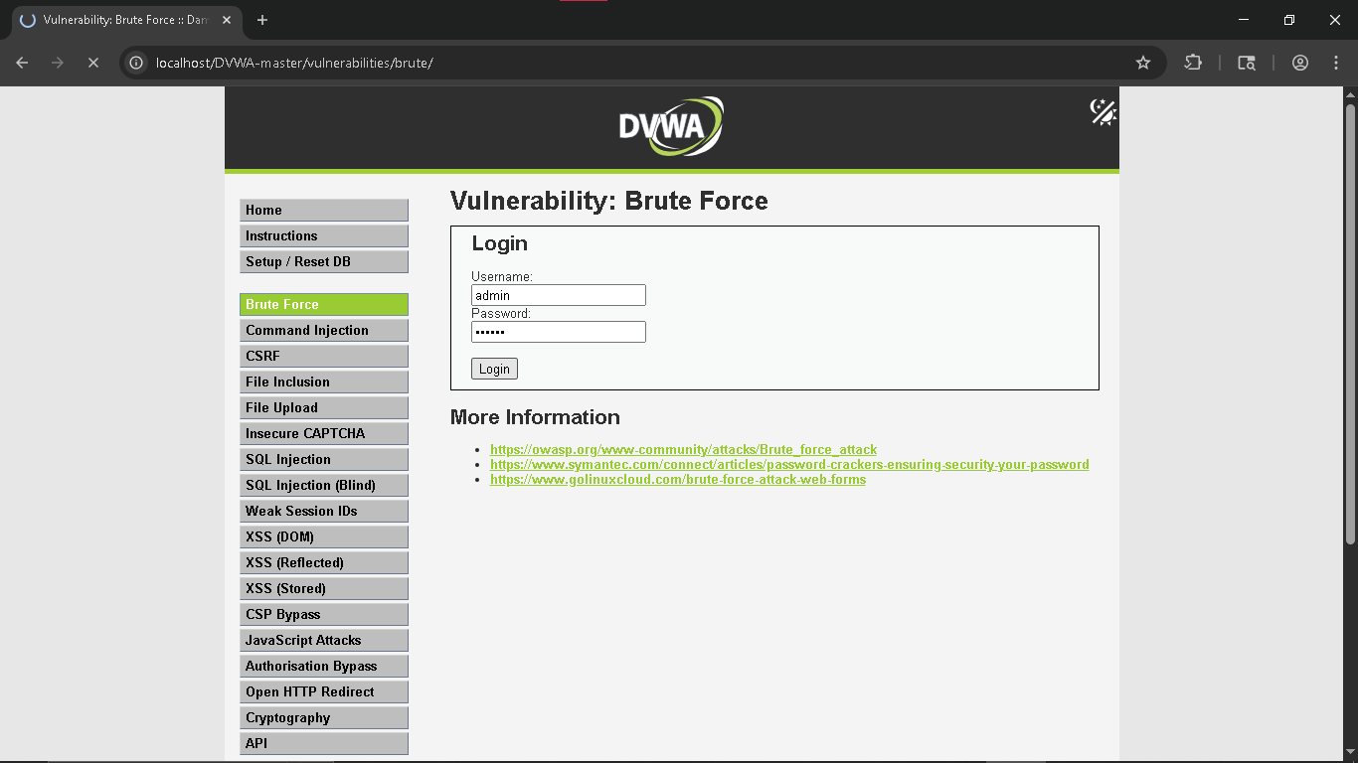
• We will prove broken authentication by using burp in this lab so entering user name and password in first step then,
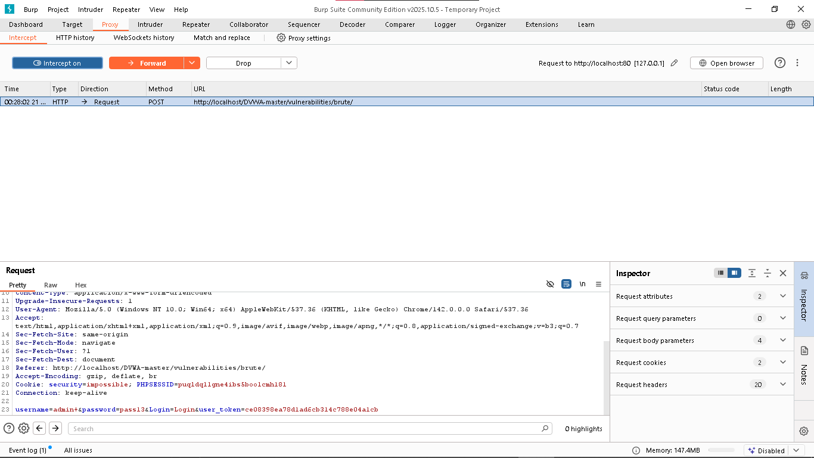
• Intercepting the request by burpsuite ( It shows admin and password we’ve just entered in DVWA)
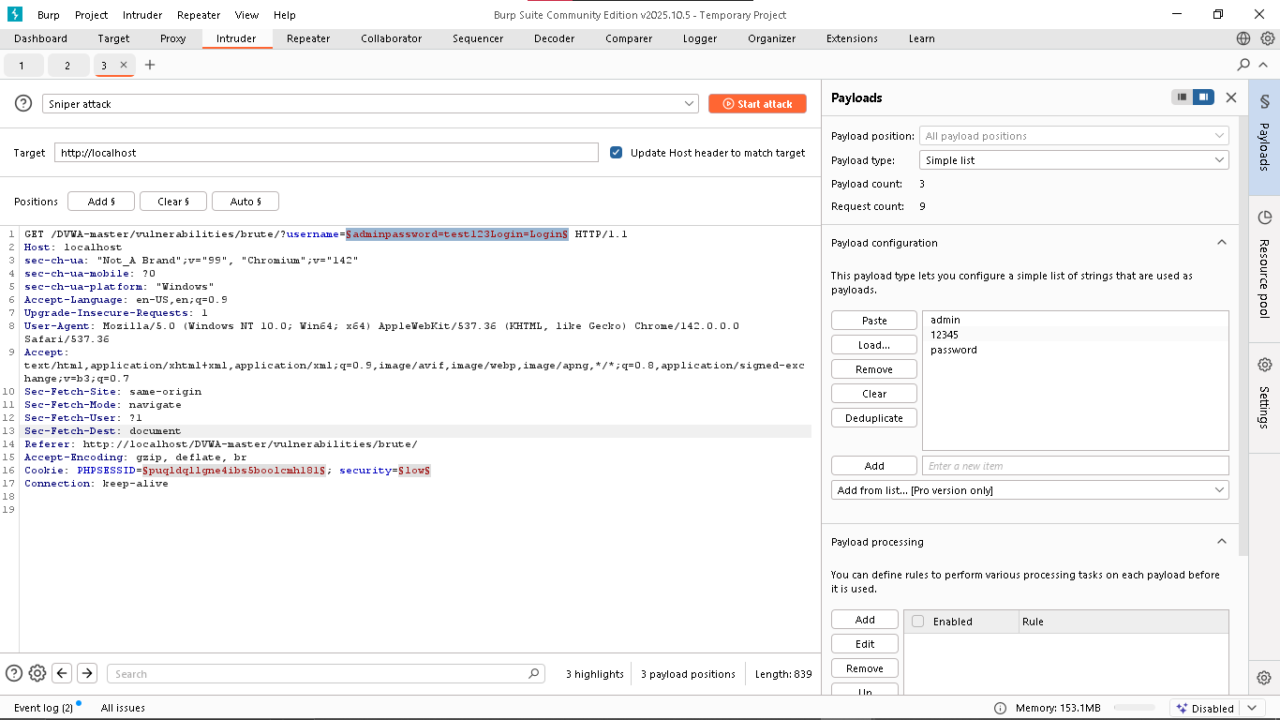
• Performing sniper attack to know the correct password and adding passwords file to payload.
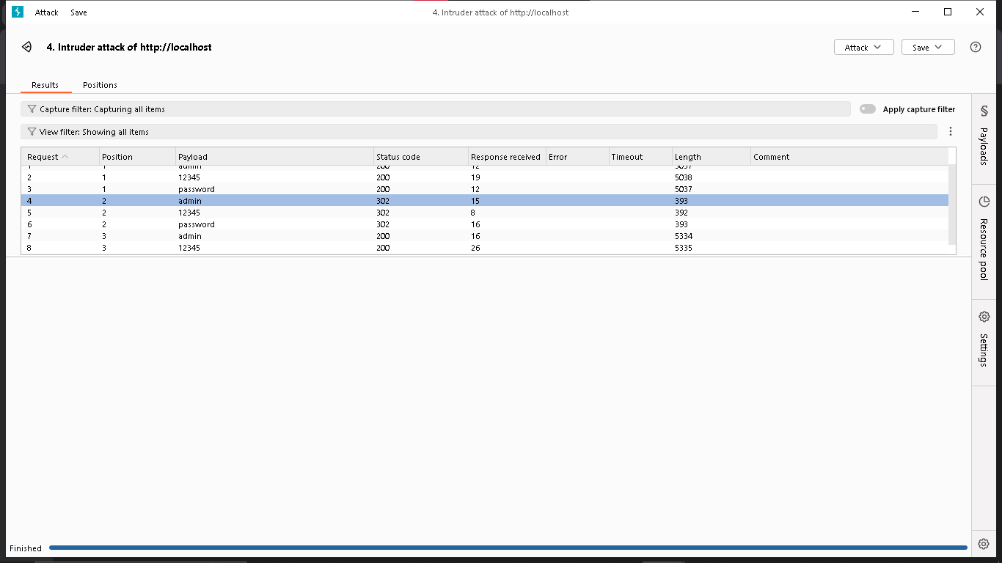
• Burp Intruder results showing a 302 Redirect status code for the payload 'password', indicating a successful login.
• So if the password is this easily crackable it is a direct example of broken authentication.
3 : - Sensitive Data Exposure.

Plateform used:- DVWA-master
Tool Used :- Not Any
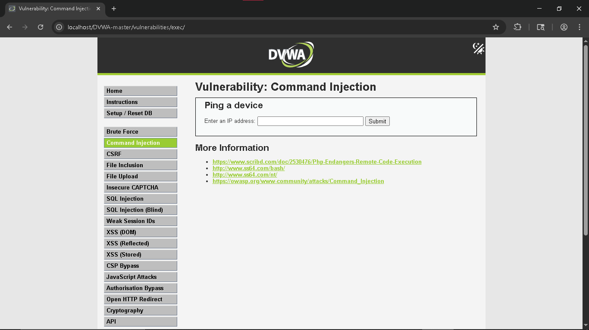
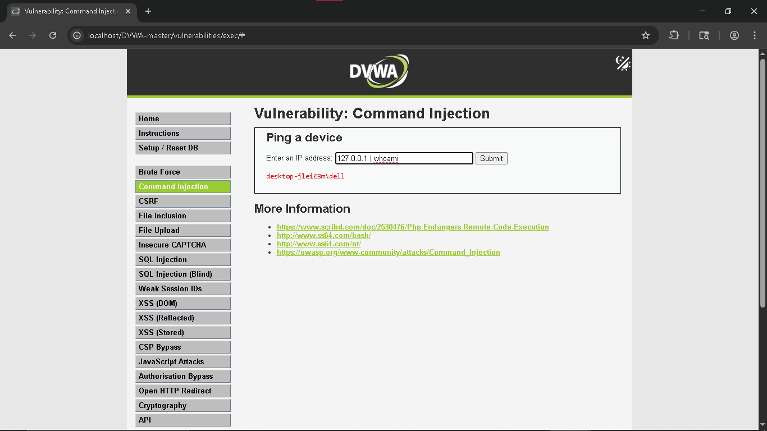
• Successfully exposing the sensitive server username using the 'whoami' command.
• The application executed the ping, but also executed my second command, revealing the username.

4. XML External Entities (XXE)
Tool Used :- Burpsuite
Plateform Used :- Portswigger.net

• XXE is any vulnerability that is in any application’s XML entity misconfiguration that is exploitable.

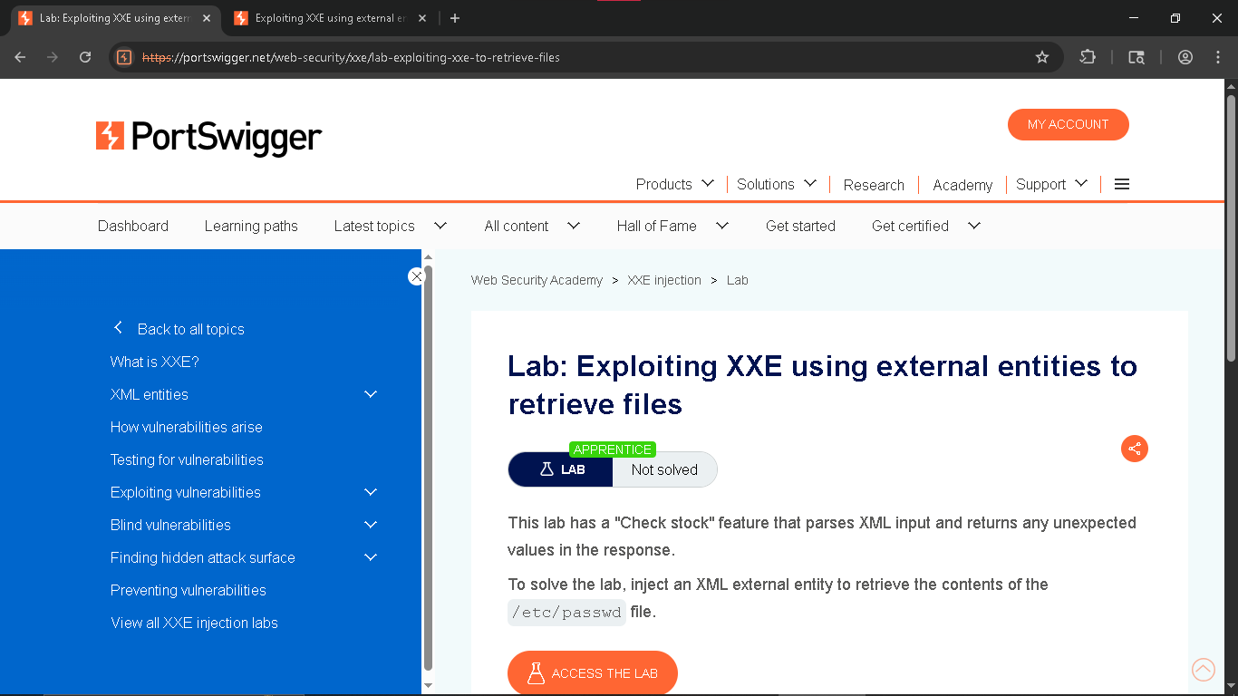
• The Description about the lab says that the check stock feature that passes the XML input and returns any unexpected values in response and to solve the lab I had to inject XML external entity for getting the contents of /etc/passwd file.

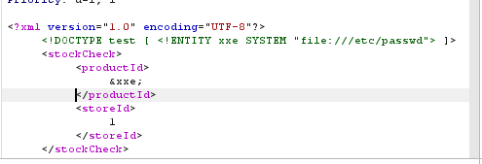
• Here I have injected a malicious DOCTYPE declaration to define an external entity named xxe. By pointing the SYSTEM identifier to the local file path file:///etc/passwd and referencing the entity &xxe; within the productID tag, the XML parser was tricked into replacing the product ID value with the contents of the server's sensitive Unix password file.
• PAYLOAD USED :-
<!DOCTYPE test [ <!ENTITY xxe SYSTEM "file:///etc/passwd" > ]>
<stockCheck><productID>&xxe;</productID><storeId>1</storeId></stockCheck>
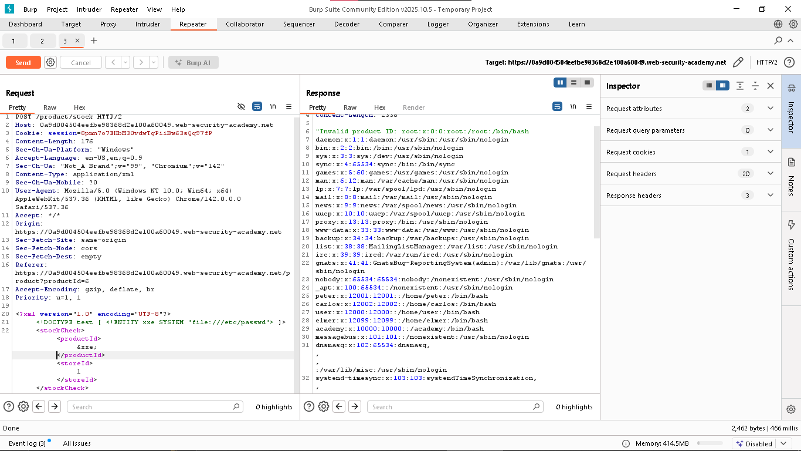
• On the left side I got the critical information including usernames and details details.
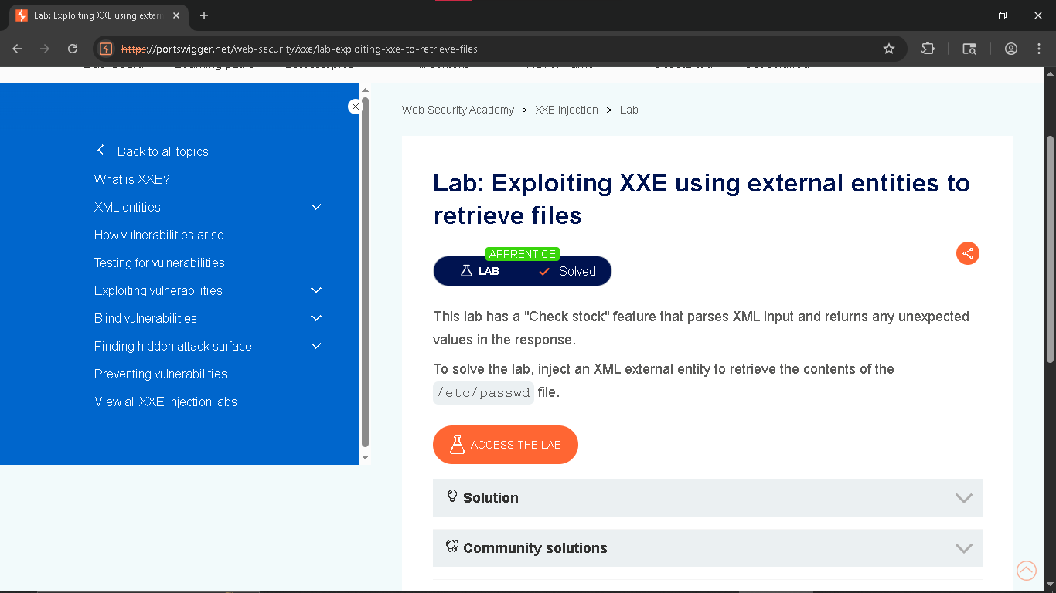

5 .Broken Access Control
• Platform used – portswigger.net
• Tool Used – Not any

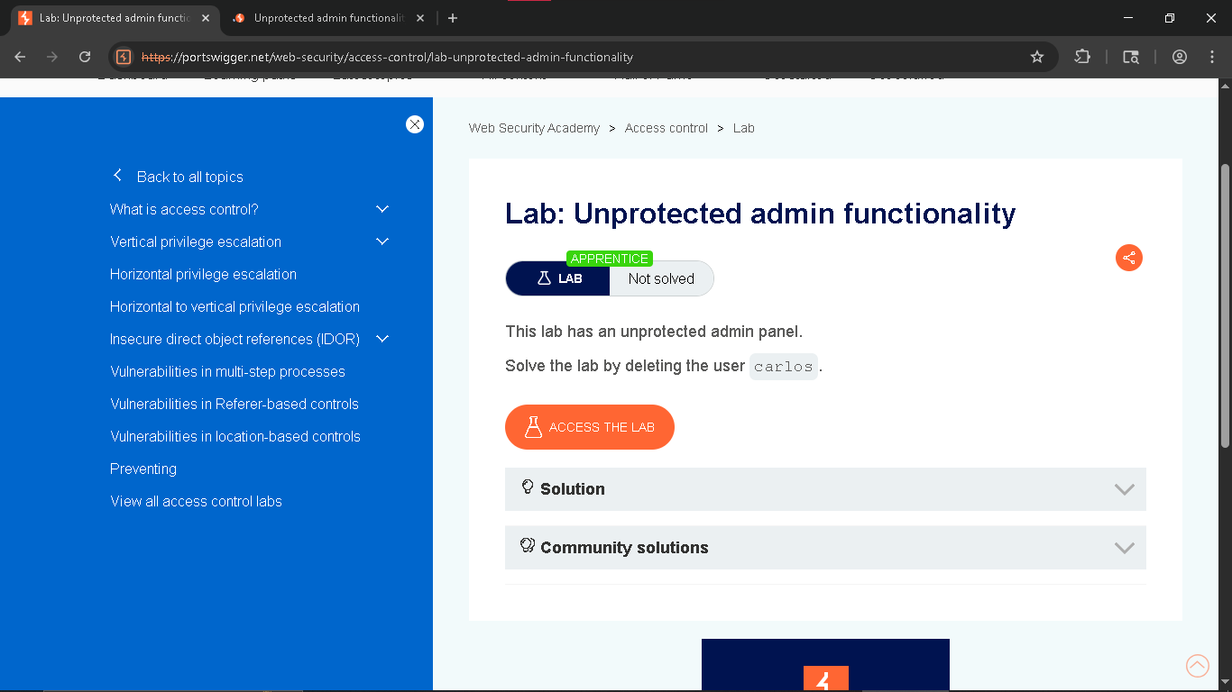

• In this lab I have to delete the user carols to prove that the admin panel is unprotected and the access control is broken

4 :- Cross Site Scripting (XSS)
Platform:- Security Shepherd
Tool :- None
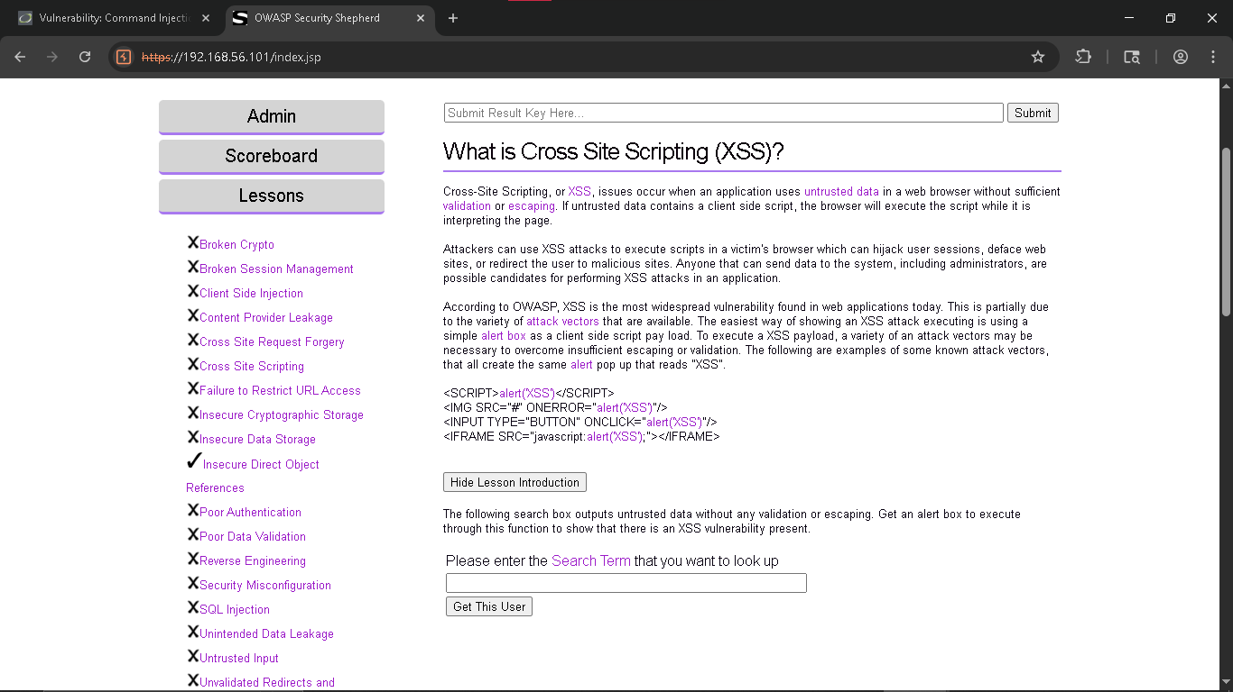
• According to the description If attacker can enter malicious or any script so the XSS attack can be performed
• <script>alert("XSS")</script> entering this script to check.
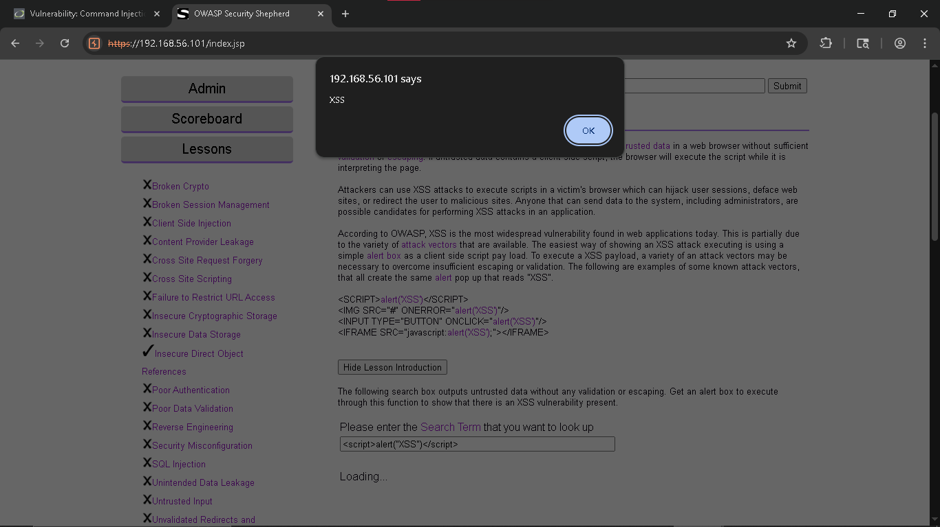

• If the alert came that means script can be injected and XSS attack can be performed
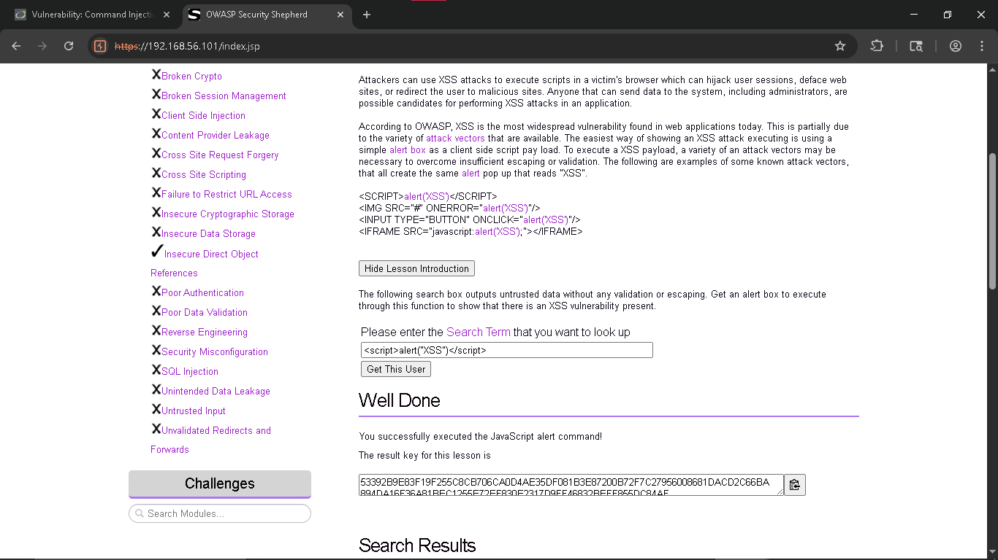
• We got the key to complete that lesson afterwards

