EXECUTIVE SUMMARY
Customer, Product, and Profitability Performance Analysis
APL Logistics Supply Chain Operations

The Bottom Line
APL Logistics is profitable overall, generating $36.8 million in revenue and $3.97 million in profit across 180,519 orders. However, this headline conceals a significant and recoverable problem: nearly one in five orders loses money, and uncontrolled discounting is quietly eroding margin across the entire business.
The single largest opportunity is discount control. Capping order discounts at 10% could recover an estimated $1.14 million in profit, lifting total profit by roughly 29%, without entering any new market or acquiring any new customer.
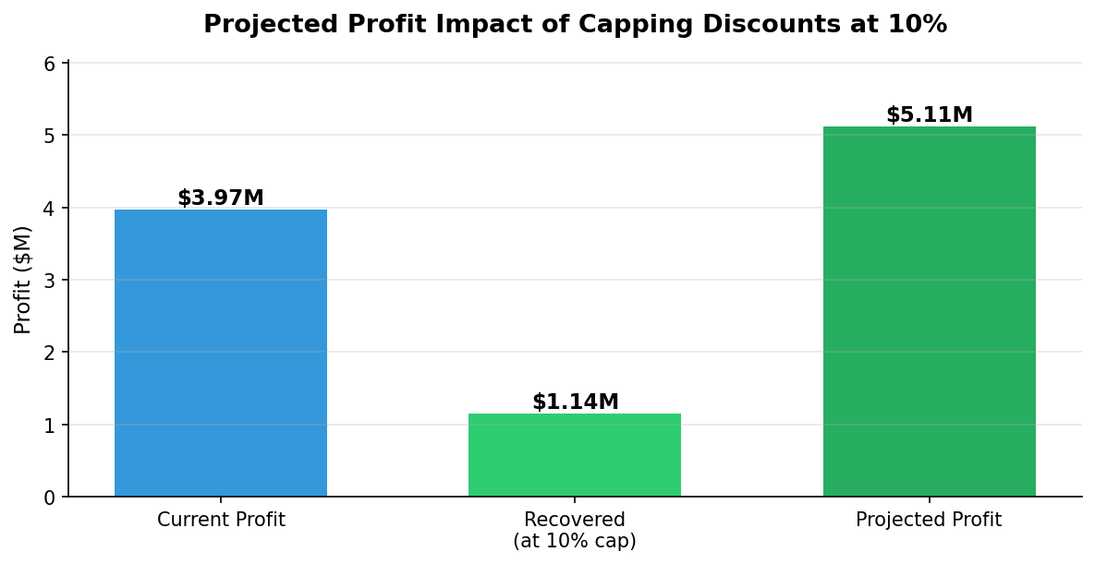
Estimated profit recovery from a 10% discount cap. Figures represent the upper-bound opportunity.

What We Found
- Profit is highly concentrated. The top 20% of customers generate 79% of all profit, while 4,069 customers lose money for the business.
- Discounting erodes margin directly. Orders with no discount earn a 13.1% margin; discounted orders earn only 10.7%. Deeper discounts steadily worsen this.
- Some high-revenue categories barely profit. Strength Training, for example, generates $54,900 in revenue but only $332 in profit, a margin below 1%.
- The problem is structural, not regional. All five global markets operate at near-identical margins (10.4% to 11.1%), so the fix is pricing policy applied consistently, not market-by-market intervention.
- Late delivery is widespread but not the margin driver. Over half of orders (54.8%) arrive late, yet this does not directly reduce margin. It is a customer-retention risk that warrants separate operational attention.

Recommended Actions
- Introduce a discount authorization policy. Require approval for discounts above a set threshold. This is the highest-value single action, with up to $1.14 million in recoverable profit.
- Tier customers by profit, not revenue. Protect and invest in the top 20% who drive most profit; review terms for loss-making accounts.
- Audit pricing on high-revenue, low-margin categories. Begin with the categories operating below a 10% margin.
- Address late delivery as a retention issue. Review underperforming shipping arrangements separately from the pricing work.

A Note on the Estimate
The $1.14 million figure represents the maximum recoverable profit and assumes that capped orders still proceed. In practice, some heavily discounted orders may be price-sensitive and could be lost if discounts are reduced. We therefore recommend piloting any discount cap on a limited set of orders to measure the real effect before a full rollout. The opportunity is substantial; the prudent path is to test, then scale.

