Customer, Product, and Profitability
Performance Analysis in Supply Chain Operations
A Margin Intelligence Study for APL Logistics

Dataset: 180,519 orders across 5 markets, 23 regions, and 164 countries

Table of Contents
Table of Contents 2
1. Introduction 3
2. Problem Statement 3
3. Dataset Description 3
4. Methodology 3
4.1 Data Validation 4
4.2 Data Cleaning and Feature Engineering 4
4.3 Exploratory and Diagnostic Analysis 4
5. Key Findings 4
5.1 Executive Overview 4
5.2 Customer Profitability 4
5.3 Product and Category Profitability 5
5.4 Discount Impact 5
5.5 Market and Regional Performance 6
5.6 Delivery Performance 7
6. Recommendations 7
7. Decision Tool: Discount Cap Simulation 8
8. Limitations 8
9. Conclusion 8

1. Introduction
This report presents a profitability and margin intelligence analysis for APL Logistics, a global logistics and supply chain operator. The analysis examines 180,519 customer orders spanning five global markets, 23 order regions, and 164 countries.
Traditional supply chain reporting focuses on operational efficiency: how fast orders are delivered, how many are shipped on time, and how much revenue is generated. This study takes a different lens. It asks not how much the business sells, but how profitably it sells, and which customers, products, and regions genuinely create value once discounts and costs are accounted for.
The objective is to move the organization from a revenue-focused view to a profit-aware view, surfacing the hidden margin erosion that high-level revenue figures conceal.

2. Problem Statement
Despite holding detailed order and sales data, APL Logistics lacks clear visibility into the drivers of its profitability. Specifically, the business faces four gaps:
- Limited visibility into profitability at the customer and product level, as opposed to revenue.
- Insufficient understanding of how discounting erodes margin.
- No systematic method to distinguish high-value customers from low-value or loss-making ones.
- A lack of market and category-level profit diagnostics.
As a result, pricing and customer strategies risk being revenue-focused but profit-blind. A customer or category that appears successful by sales volume may in fact be unprofitable once discounts are considered. This report addresses these gaps directly.

3. Dataset Description
The analysis is based on a single dataset of 180,519 order records with 40 original fields, expanded to 48 fields after cleaning and feature engineering. The data covers customer attributes, product and category details, order financials, discount information, delivery status, and geographic dimensions.
Key financial fields include order revenue, order profit, product price, quantity, and discount rate. Geographic fields span market, region, and country. Delivery fields include delivery status, late delivery risk, and shipping mode.
One important characteristic of the dataset is the absence of any date or timestamp field. This means time-based analysis, including trend analysis, seasonality, and forecasting, is not possible. All findings in this report are cross-sectional rather than longitudinal. This limitation is discussed further in Section 8.

4. Methodology
The analysis followed a structured, phased approach designed to ensure the findings rest on reliable data.

4.1 Data Validation
Before any analysis, the dataset was validated for integrity. Checks confirmed zero duplicate records, only minor missing values in non-financial fields (customer last name and zipcode), and internal consistency across financial fields. Revenue and profit fields were cross-verified against their component calculations, with differences of zero or negligible floating-point magnitude.

4.2 Data Cleaning and Feature Engineering
Minor missing values were filled. Business-friendly fields were derived, including a loss-making order flag, discount bands grouping orders into five-percentage-point intervals, and a delivery risk label. These engineered features enabled segment-level profitability analysis.

4.3 Exploratory and Diagnostic Analysis
The cleaned dataset was analyzed across six dimensions: executive KPIs, customer profitability, product and category profitability, discount impact, market and regional performance, and delivery performance. Each dimension was examined not only for what it describes, but for the business decision it informs.

5. Key Findings

5.1 Executive Overview
At an aggregate level, the business is profitable. Total revenue stands at $36.78M with total profit of $3.97M, an overall margin of 10.78%. However, this headline figure conceals significant underlying risk: 33,784 orders, or 18.71% of all orders, are loss-making, and 4,069 customers are unprofitable in aggregate.
Metric | Value
Total Revenue | $36,784,734
Total Profit | $3,966,903
Overall Profit Margin | 10.78%
Total Orders | 180,519
Total Customers | 20,652
Loss-Making Orders | 33,784 (18.71%)
Loss-Making Customers | 4,069
Average Discount Rate | 10.17%

This gap between a healthy headline margin and a high loss-making order rate is the central theme of the analysis. Profitability is uneven, and that unevenness is where both the risk and the opportunity lie.

5.2 Customer Profitability
Profit is highly concentrated. The top 20% of customers generate 79.2% of total profit. At the same time, 4,069 customers lose money for the business in aggregate. The bottom loss-making customers are particularly striking: several incur deep negative margins on single high-value orders, suggesting pricing errors or excessive one-off discounts.
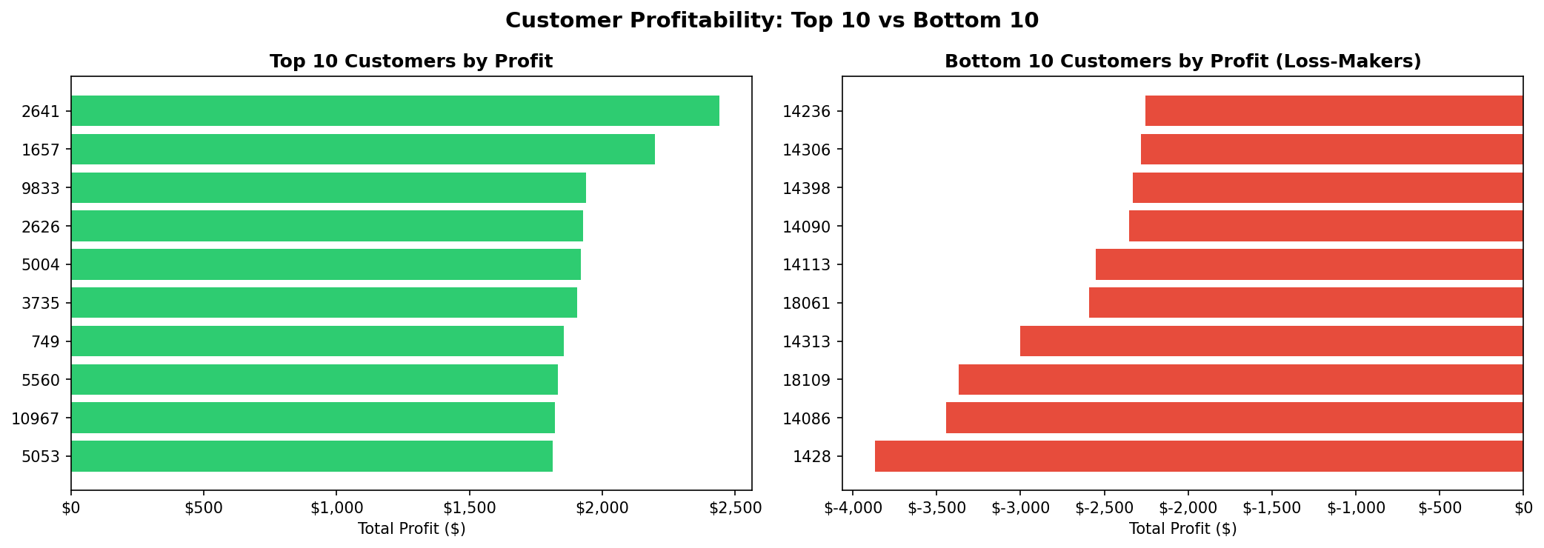
Figure 1: Top 10 most profitable customers versus the 10 largest loss-makers.
The implication is that a revenue-only view of customers masks substantial profit risk. High order volume does not equal high value.

5.3 Product and Category Profitability
Profit is not evenly distributed across categories. Fishing, Cleats, and Camping & Hiking lead on total profit. However, several high-revenue categories operate below a healthy 10% margin. The clearest example is Strength Training, which generates $54,896 in revenue but only $332 in profit, a margin of just 0.61%. Categories such as Health and Beauty, Kids' Golf Clubs, and Shop By Sport also combine high revenue with thin margins.
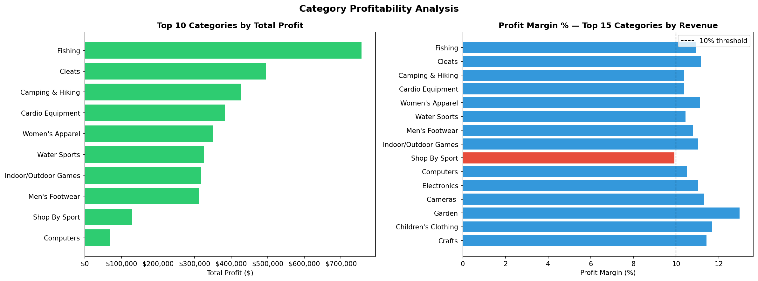
Figure 2: Top categories by profit (left) and profit margin against a 10% threshold (right).
These high-revenue, low-margin categories are the most dangerous because they appear healthy in top-line reporting while quietly consuming resources disproportionate to their financial return.

5.4 Discount Impact
Discounting has a direct and measurable effect on margin. Orders carrying no discount operate at a 13.09% margin, while discounted orders operate at 10.65%, a gap of 2.44 percentage points. As discount bands deepen, average margin compresses steadily, from 11.9% in the lowest band to 9.5% in the 20 to 25% band.
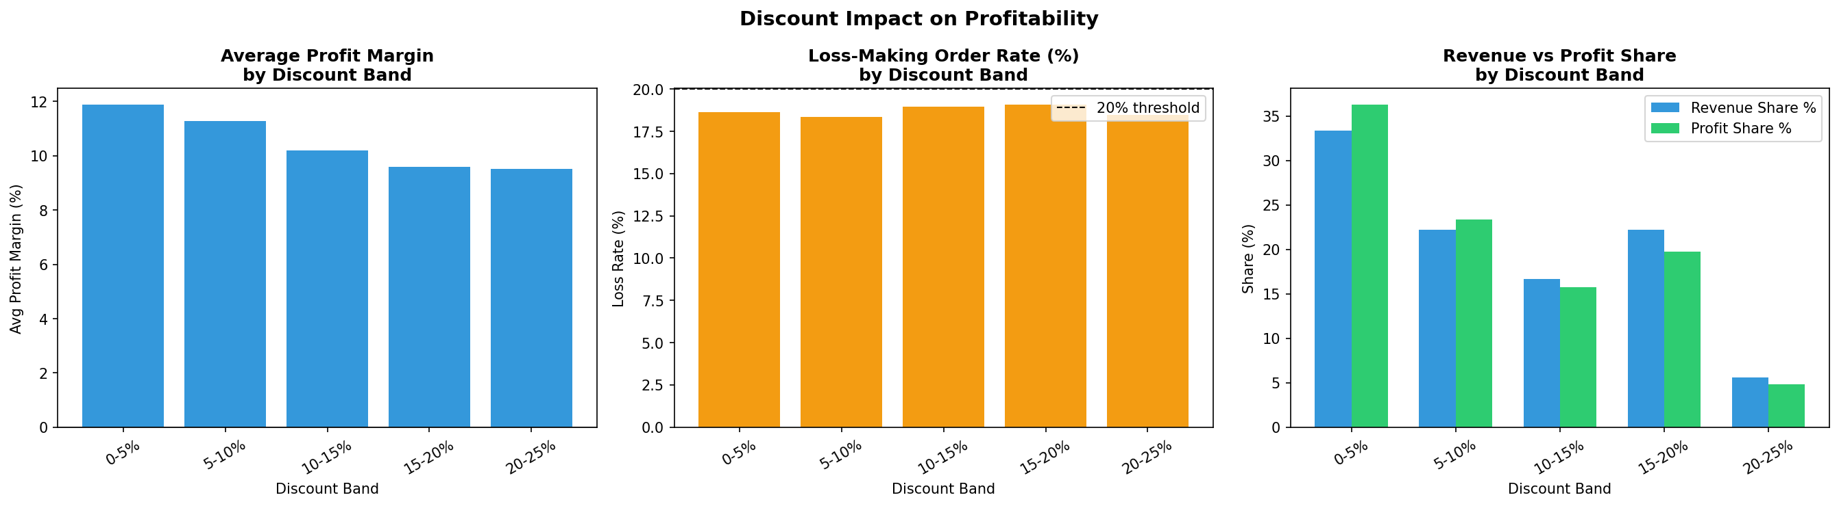
Figure 3: Average margin, loss rate, and revenue-versus-profit share across discount bands.
Notably, loss-making order rates remain broadly flat across discount bands at around 18 to 19%. This indicates that while discounting compresses margin, it is not the sole cause of losses. There is a structural margin issue that exists alongside the discounting effect.

5.5 Market and Regional Performance
Profitability is remarkably uniform across markets. All five global markets operate within a narrow margin band of 10.4% to 11.1%, and loss-making order rates cluster tightly between 18.5% and 18.9%. No single market is an outlier. At the regional level, Western Europe and Central America contribute the most profit.
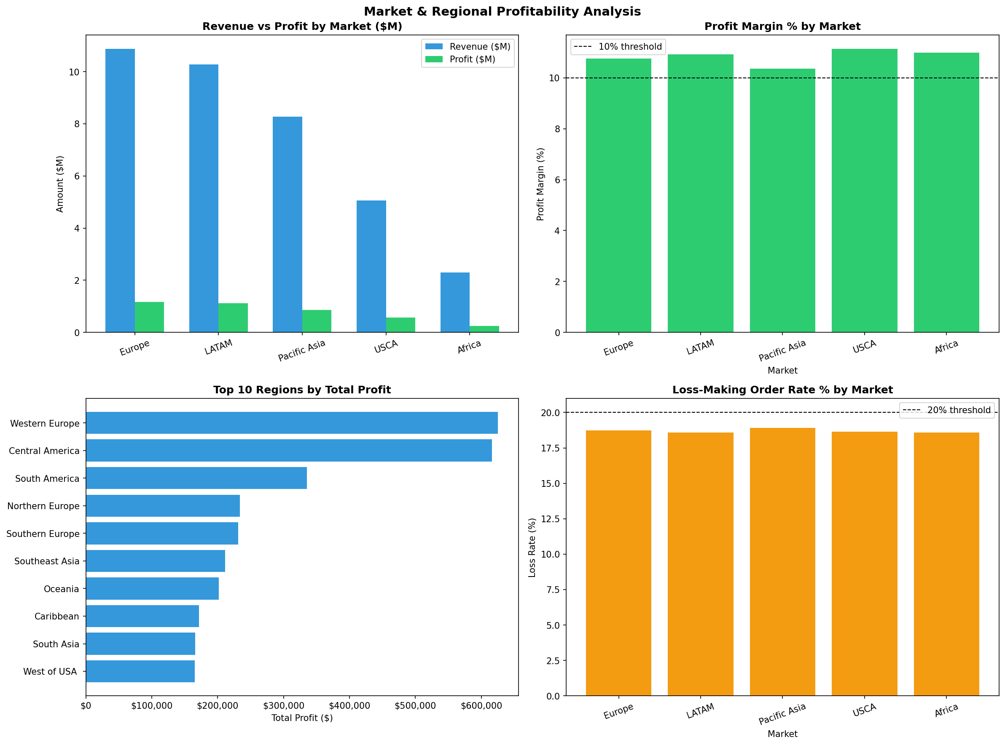
Figure 4: Revenue versus profit and margin by market, with regional profit and market loss rates.
The uniformity of margins across geographies is itself the key finding. It confirms that profitability challenges are structural rather than geographic. The levers for improvement are pricing and discount policy, not market-specific intervention.

5.6 Delivery Performance
Late delivery is the dominant operational reality. Over 54.8% of all orders are delivered late, making late delivery the single most common outcome rather than an exception. Yet margins are nearly identical across all delivery statuses, and loss-making rates are effectively equal whether or not an order carries late delivery risk.
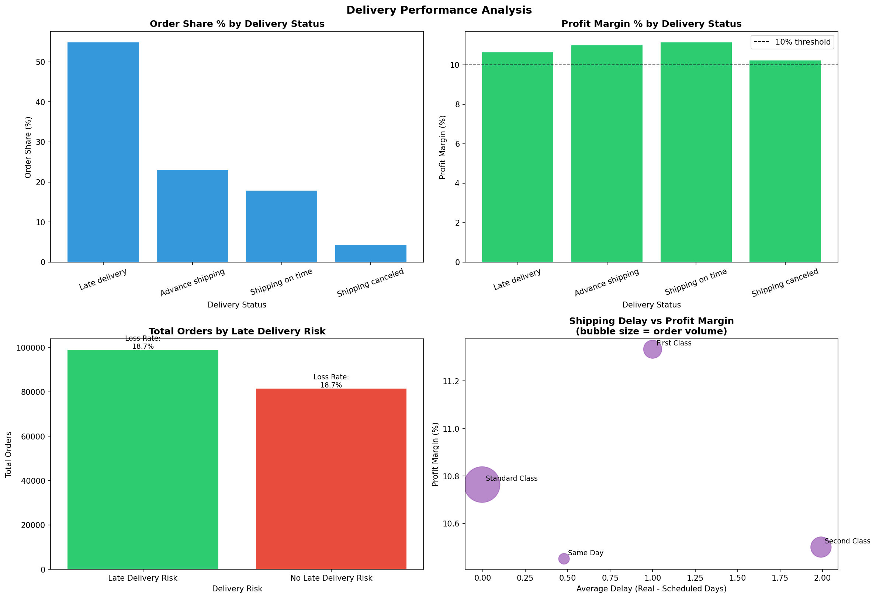
Figure 5: Delivery status distribution, margin by status, loss rate by delivery risk, and shipping mode performance.
Delivery performance and profitability are therefore decoupled in this dataset. Late delivery represents a customer experience and retention risk rather than a direct margin driver. Its financial cost is likely lagged, expressed through reduced repeat purchasing, which is not measurable without customer lifetime data.

6. Recommendations
The following recommendations are ordered by expected impact on profitability.
- Implement a customer value tier system. Classify customers into High, Medium, and At-Risk tiers based on profit contribution rather than revenue. Direct retention and service investment toward the top 20% of customers who drive 79.2% of profit, and review commercial terms for loss-making accounts before renewal.
- Introduce a discount authorization policy. Cap order-level discounts and require management approval above a defined threshold. Modeling indicates that capping discounts at 10% could recover up to $1.14M in profit across roughly 80,000 orders, an upper-bound uplift of 28.9% on current profit.
- Conduct a category-level pricing audit. Prioritize categories that combine high revenue with sub-10% margins, beginning with Strength Training, Health and Beauty, and Shop By Sport. Evaluate whether these are structurally underpriced or over-discounted.
- Treat late delivery as a retention risk. With 54.8% of orders arriving late, delivery reliability is a systemic operational issue. While it does not directly erode per-order margin today, it likely suppresses repeat purchase behavior. Investigate underperforming shipping arrangements, particularly Second Class, which combines the worst delay with the lowest margin.
- Focus reform on pricing and discount policy, not geography. Because margins are uniform across all five markets, pricing and discount changes will deliver impact globally. Pilot reforms in the highest-volume regions, Western Europe and Central America, for maximum effect.

7. Decision Tool: Discount Cap Simulation
To translate the discount findings into a decision tool, an interactive what-if simulator was built into the accompanying dashboard. It allows a decision-maker to set a maximum allowed discount rate and immediately see the projected profit recovery.
The model recalculates the discount applied to every order that currently exceeds the chosen cap, reducing it to the cap level, and flows the difference through to profit. At a 10% cap, the model projects $1.14M in recoverable profit, lifting total profit from $3.97M to $5.11M.
This figure should be read as an upper bound. The model assumes that capped orders still convert at the same rate. In reality, some deeply discounted orders may be price-sensitive and could be lost if the discount were reduced. The recommended approach is therefore to pilot any discount cap on a subset of orders and measure the conversion effect before a full rollout. This intellectual honesty about the model's assumptions is itself part of responsible analysis.

8. Limitations
Several limitations should be considered when interpreting these findings.
- No date fields exist in the dataset. Trend, seasonal, and forecasting analysis is therefore impossible. All findings are cross-sectional.
- No explicit shipping cost field is available, so the direct margin impact of shipping mode and delivery delays cannot be measured precisely.
- Customer lifetime and repeat-purchase behavior cannot be assessed, which means the lagged financial cost of late delivery is inferred rather than measured.
- The discount simulation models a maximum recoverable margin and does not account for price sensitivity or the risk of losing orders if discounts are reduced.

9. Conclusion
This analysis shifts the view of APL Logistics from operational efficiency to commercial intelligence. The business is profitable overall, but that profitability is uneven and, in places, fragile. Profit is concentrated in a minority of customers, eroded by discounting, and thinned in specific high-revenue categories.
Crucially, the problem is structural rather than geographic. Margins are uniform across every market, which means the most effective levers are pricing discipline and discount control, applied consistently across the business. Late delivery, while operationally severe, is best understood as a retention risk rather than an immediate margin driver.
By acting on the recommendations in this report, prioritizing customer value tiering, discount authorization, and category pricing, APL Logistics can convert hidden margin erosion into recovered profit, and move from selling more to selling more profitably.

